

Student Name: KRISHKUMAR BHALALA
Student ID: 2505003
Module Name: Marketing Management
Module Code: LCMB7024
Lecturer’s Name: DR. LAILA MAAZOUZ

Work Count: 2498

Term 1

Table of Contents
1. Introduction 3
1.1 Purpose and Focus of the Report 3
1.2 Importance of Analysing the Macro Marketing Environment 3
1.3 Structure and Scope of the Report 4
2. Task 1: Critical Analysis of the Macro Marketing Environment 5
2.1 Overview of the Macro Marketing Environment 5
2.2 Selection of Two External Macro Marketing Actors 5
2.3 Critical Analysis of Each Actor 7
3. Task 2: Strategic Responses of Pioneering and FollowerOrganisations 13
3.1 Pioneering Organisations’ Strategic Responses 13
3.2 Follower Organisations’ Strategic Responses 19
4. Conclusion 24
Reference list 25

1. Introduction

1.1 Purpose and Focus of the Report
Strategic marketing management is a process that helps the organisation to resonate their resources, capabilities, and market opportunities to meet sustainable competitive advantage. This report evaluates the external forces that impact strategies of marketing and performance of the organisation. The report investigates two macro-environmental actors, namely technological factors and economic factors that effect pioneering organisations (those that innovate first) and follower organisations (those that imitate or improve existing innovations). It will also analyse the opportunities and threats of the company.

1.2 Importance of Analysing the Macro Marketing Environment
For successful strategic decision-making investigation of macro environment is very important. The firms should adopt proactive measures with the development of technology, digital transformation, inflationary pressures. For example, due to acceptance and implementation of e commerce, automation and change in consumer preference the global retail market saw various shift. The global retail market is expected to grow at a CAGR of 7.6% (Thebusinessresearchcompany, 2025).
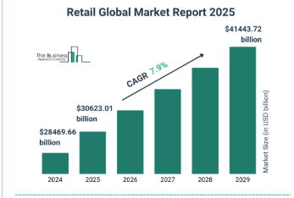
Figure 1: Global retail market
(Source: Thebusinessresearchcompany, 2025)
Investigating these factors will help the company to predict riskand align strategies of marketing with the fluctuation of expectation of customer.

1.3 Structure and Scope of the Report
This report is classified into two parts. Tas 1 evaluates the technological and economic macro-environmental actors. It also recognizes the opportunities and threats for both pioneers and followers. Task 2 evaluates the responses of pioneers and followers using models such as Ansoff’s Matrix and Porter’s Generic Strategies.

2. Task 1: Critical Analysis of the Macro Marketing Environment

2.1 Overview of the Macro Marketing Environment
The macro marketing environment can be described as an external force that impact on the decision of the organisation.These forces together help to shape the behaviour of the consumer, fluctuation of industry. This macro environment can be analysed using PESTEL framework (De Sousa and Castañeda-Ayarza, 2022). This framework has 6 dimensions-Political, Economic, Social, Technological, Environmental, and Legal. Depending on the adaptability of the firm each factors provides opportunities and threats.
To predict any change in the market these forces are important for the organisation. The firm can modify their strategies according to the changes the market environment. The PESTEL analysis help to scan the external environment. For instance, with the development of AI (Mucci, 2024), sustainability regulations and variation of economy due to inflation have changed the approach of industry.
In terms of strategic marketing management, the analysis of macro environment helps firms to incorporate long-term forecasting into market planning, product innovation, and positioning strategies. From these findings pioneer’s organisation grab the first-mover advantages. Followers’ organisation depends on them to develop the existing model.

2.2 Selection of Two External Macro Marketing Actors
Justification
This report evaluates two macro marketing actors-Technological and Economic factors. These factors are selected for the analysis because they have immediate effect on competitive advantage, ability of innovation and demand of the consumer on industries.
Relevance and current influence
Technological Factors
The change in technology is restructuring the industry globally. The operation of the business and marketing policies have changed due to rapid evolution of AI, automation, data analytics and digital platforms. It is estimated that the global spending on digital technology will soar to $2058.55 billion by 2029 (Gupta, 2025).
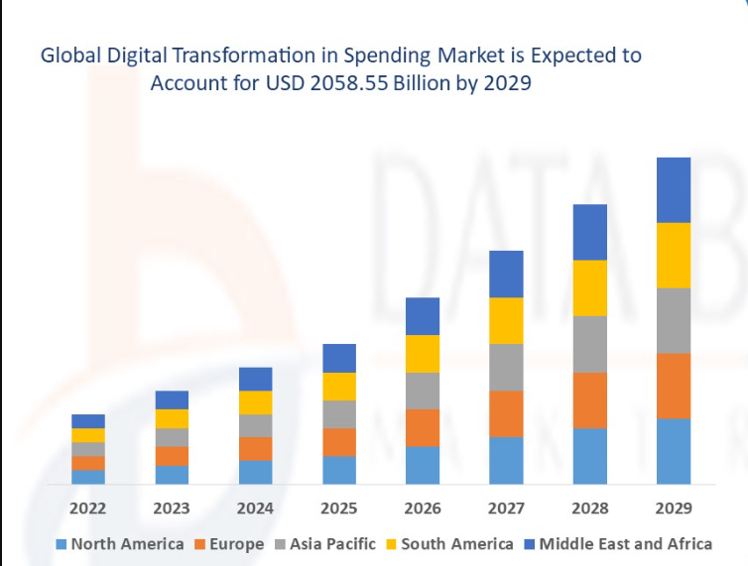
Figure 2: Digital transformation spending market
(Source: Gupta, 2025)
This shows the significance of technology in competitive strategy. In the sector of retail and consumer goods omnichannel experiences, supply chain optimisation is driven by technology. Various companies such as Amazon, Apple, and M&S have implemented Technology in their operation. This enhanced the experience of the consumer. But smaller firms struggle to keep up the pace.
Economic Factors
The business strategy is affected by seral economic conditions like rate of inflation, rate of interest, confidence of the customer and disposable income.Global GDP growth is projected to slow from 3.3% in 2024 to 3.2% in 2025 and 2.9% in 2026 (OECD, 2025).
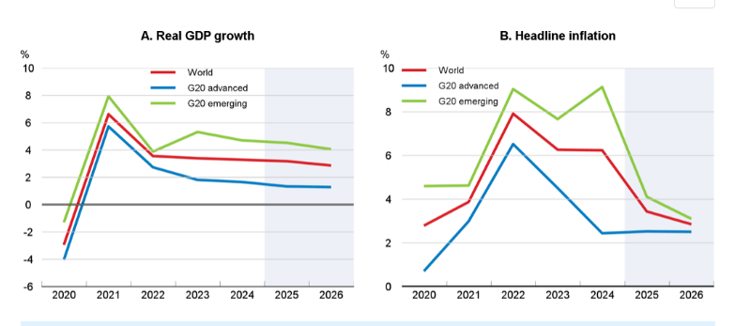
Figure 3: Economic growth is projected to weaken in G20 economies
(Source: OECD, 2025)
Beside this inflation in the G20 advanced economies is estimated to be 2.5% in 2026. These circumstances resulted in variation of consumer spending. For example, in retail industry companies like Tesco and Aldi have modified their process to tackle cost of living pressure. Premium brand is struggling to maintain profitability in this environment.

2.3 Critical Analysis of Each Actor
2.3.1 Technological Factors
Impact on Pioneering Organisations
Pioneer firms use change in technology as a source of first mover advantage. This firms majorly invest on R&D. The company launch breakthrough products or services. For example, Apple incorporated AI features in its devices (Bajarin, 2024).
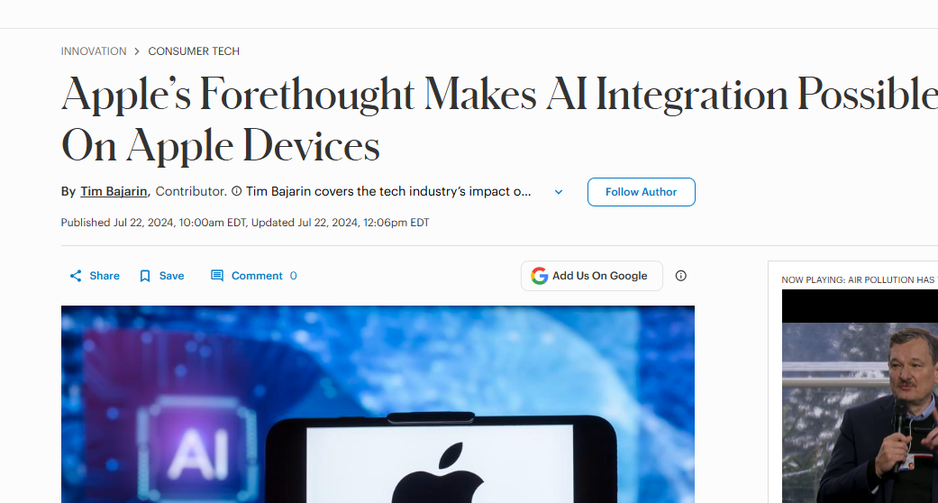
Figure 4: Integration of AI in apple devices
(Sources: Bajarin, 2024)
This justifies the premium pricing of the brand. In same way Tesla continues to dominate the market of EV by introducing autonomous driving technologies and large-scale battery production (Persson, 2024).
Opportunities and threats
Pioneers enjoy opportunities related to innovation leadership, brand prestige, and theability to shape standards of the market. The pioneers can create strong loyalty of the customer and enhance operational efficiency by implementing latest technology early.
But these advantages also come with several threats such as High R&D costs, technological uncertainty. This can decrease the profit margins of the firm. For example, at the early stage, Google’s AI chatbot Gemini faced various criticism (Comstock, 2024). This highlights the risk of launching immature technologies.
Impact on Follower Organisations
In contrast, follower organisation develops the groundwork laid by pioneers. They get saved from the cost of development and market learning. This helps them to improve existing innovation. For example, Samsung set foot on the market after Apple but it improves on existing technology. In Q4 2025 Samsung shipped more than 61.4 million units globally (Statista, 2025).
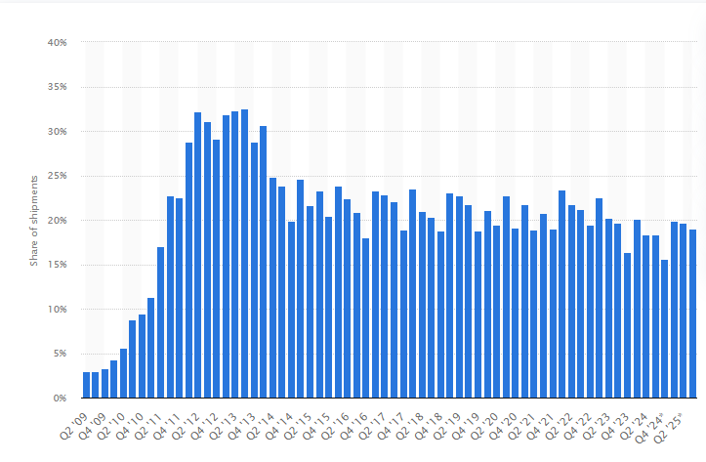
Figure 5: Samsung global share of shipment
(Source: Statista, 2025)
Opportunities and threat
Followers get many advantages such as cost efficiency, risk reduction, and fast market entry. They can take lessons from mistake of the pioneers. They also adapt innovations for local markets.
Beside advantage they also faced threats related to imitation of the brand, price competition, and limiteddifferentiation. Followers mainly face hurdle in establishing unique value propositions
Strategic Implications
To continue its leadership Pioneers must apply various product development strategy. It should invest in R&D and technology partnership. On the other hand followers succeed through
market penetration and cost leadership strategies. They offer comparable products at lower prices. For example, Xiaomi and Oppo employ cost leadership.
2.3.2 Economic Factors
Impact on Pioneering Organisations
Fluctuation in economy impact the capacity of innovation of pioneers. For example, Tesla reduces its price of the vehicle due to fall in demand by upto 6% (IEA, 2024).
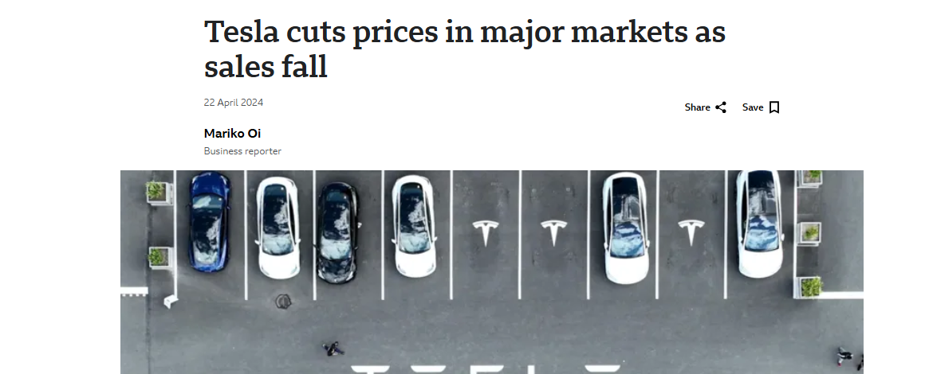
Figure 6: Tesla cut prices
(Source: Oi, 2024)
Opportunities and threats
Economic downturns also create opportunities for pioneers to restructure,diversify, or enter emerging markets.Pioneers also lead in green innovation like Unilever’s investment of €1 billion in climate, nature, and resource efficiency projects (Unilever, 2023).
Pioneers also face several threats regarding reduced consumer spending, high R&D costs, limited investment during recessions
Impact on Follower Organisations
Followers flourish in economic downturn. They provide cost-effective alternatives.For example,Aldi and Lidl have gained significant market share in the UK.
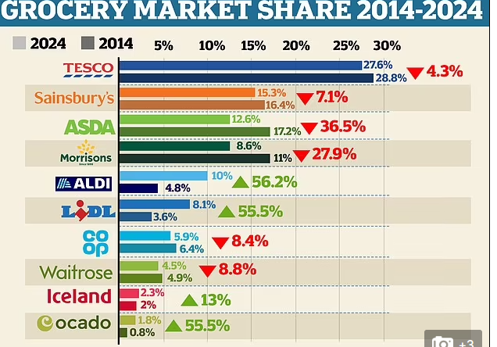
Figure 7: Grocery market share
(Source: Carrick, 2024)
Opportunities and threats
Followers get opportunities by providing affordable alternatives, attracting price-sensitive consumers, expanding market share during recessions.
But they also remain vulnerable to disruption in supply chain and fluctuation in input cost
input cost volatility. With rise in inflation continuing low price will reduce the profit margins of the firms
Strategic Implications
For pioneers, economic resilience depends on diversification and value-based marketing. pioneers can enter new internationalmarkets with stable economic conditions or launch digital products with lower overheads.Apple’s expansion into subscription-based services (Apple, 2022).
Followers focuson cost leadership and operational efficiency. For example, Tesco’s initiative of Clubcard Prices uses real-time data to modify pricing. This increase loyalty of the customer (Grocerygazette, 2025).

3. Task 2: Strategic Responses of Pioneering and FollowerOrganisations

3.1 Pioneering Organisations’ Strategic Responses
Pioneers leads in innovation entering early and impact markets by responding to external challenges like technological disruptions or economic downturns.
Growth strategies with Ansoff’s Growth Matrix
Market Penetration: Pioneers also seek deep penetration through enhanced product features, marketing and increase consumption in existing target customer base. For example Apple Inc. launches new variants of iPhone with new offers pushing customised upgrades, ecosystem ties and services to increase market share.
Product Development: Developing products are primary opportunity for Pioneers. They invest heavily on research and development to launch customised featured products. Like, Samsung Electronics increased R&D spending to 71.3% to $9.5 billion in 2024 from $5.5 billion in 2023.The company launch new products with customised features underscoring their commitment for product-development.
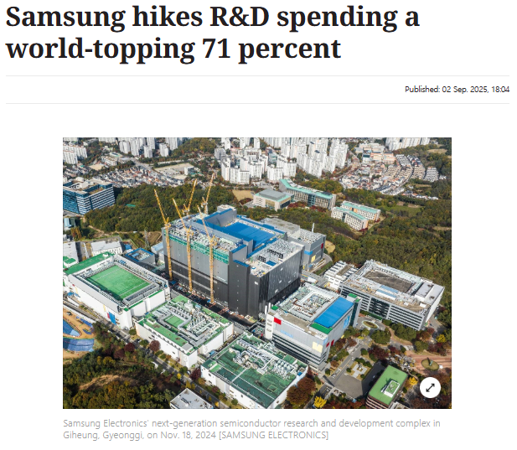
Figure 8: R&D investment of Samsung
(Source: HAE-LEE, 2025)
Market Development: Pioneers develops their market by entering in newly emerging markets or demographic increasing global footprint. Apple Inc. recently committed to invest $500 Billion in the US in the next four years to build advanced manufacturing, chip design and AI-infrastructure pushingnew market development.
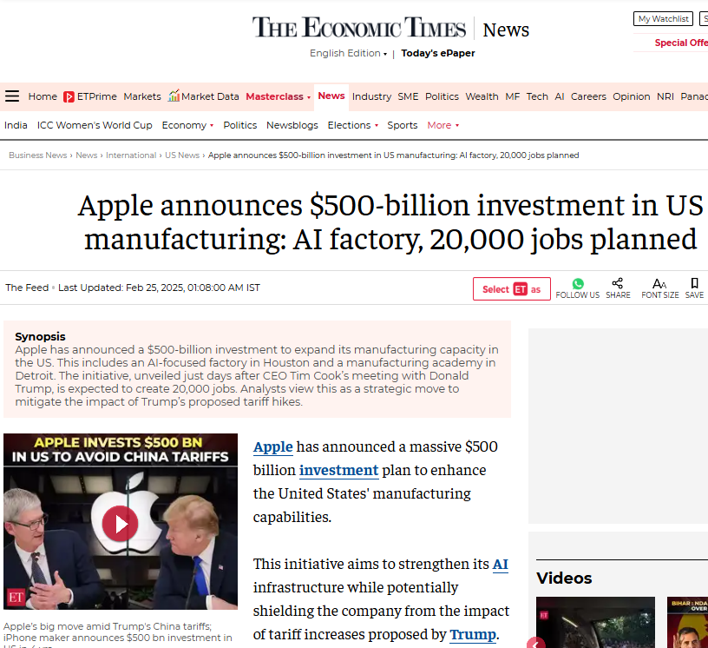
Figure 9: Investment for AI integration in manufacturing unit
(Source: The Feed, 2025)
Diversification: Pioneer firms diversify their business models like goods to services and from devices to ecosystems to build resilience. In any eventuality, such diversification helps to spread the risk probability. For example, Tata started with Steel business but now it has diversified portfolios into automobiles (commercial, passenger), IT (TCS), Tea, hotels (Taj Group), watch (Titan), lifestyle (Titan, FAstrack, Westside) both online and offline presence.
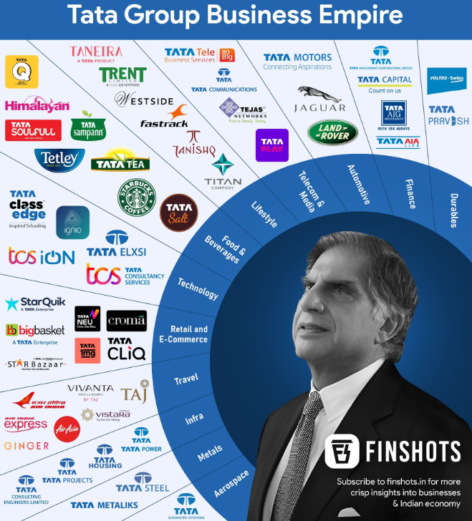
Figure 10: Differentiation strategy by Tata Group
(Source: Finshots, 2022)
Porter’s Generic Strategies: Differentiation
Pioneers adopt differentiation aiming to offer unique value, premium pricing, and exploit first-mover brand advantage. Academic research focuses that firms with unique technologies and research & development priorities gain competitive advantage. Uniqueness helps them to resist pricing challenges, gain loyalty and protect margins but carries high investment cost and risk of obsolescence.
Strategic Responses to External Technology and Economic Forces
Response to Opportunities
Pioneers actively exploit technological advancements by early investing in automation, AI-ML and data analytics to secure sustainability. They apply Ansoff’s product and market development approaches to instigate innovation and enter in new market segments. Like Apple Inc. continuously enhancing its AI capabilities through Apple Intelligence since FY2024 integrating generative AI in iPhone and Mac ecosystems.
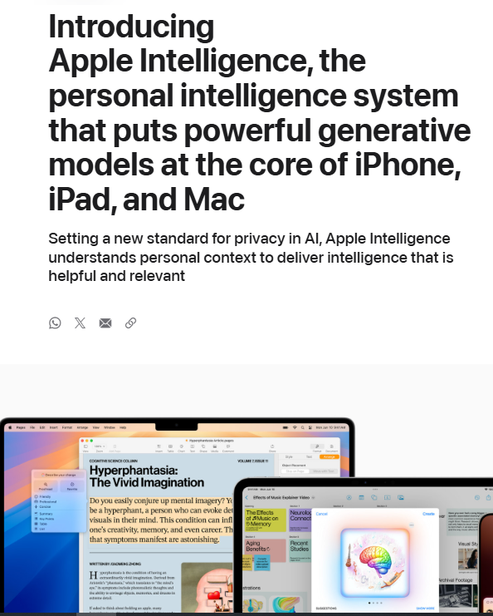
Figure 11: Apple Intelligence
(Source: Apple, 2024)
The company’s $500 Billion investment in US manufacturing facilities is highlighting its commitment to strengthen supply-chain network. Tesla focuses on AI-automation and autonomous driving to sustain product leadership in the EV sector with Q3 FY2025 revenue crossing $28.1 Billion (Investing, 2025).
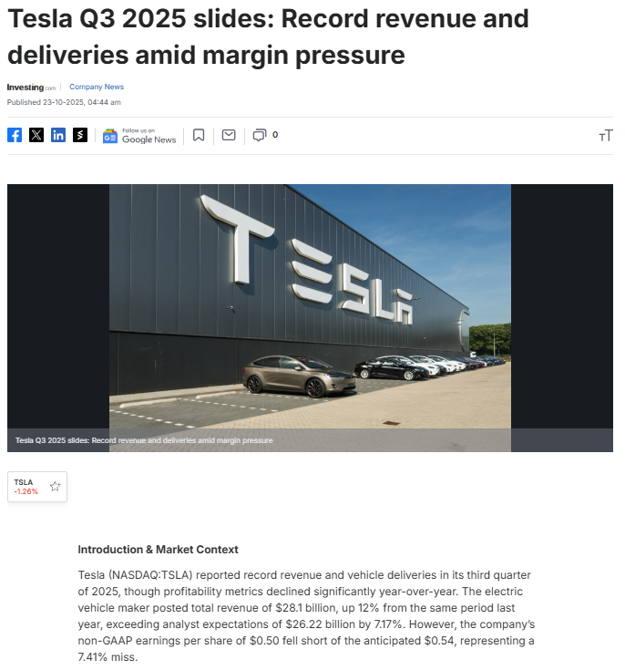
Figure 12: Financial performance of Tesla
(Source: Investing, 2025)
Both Pioneers namely Apple and Tesla have exploited the entry in emerging markets like India and South-East Asia diversifying revenue through digital services, subscriptions and ecosystem integration. This strategy enhances brand loyalty mitigating dependency on hardware and sustaining long-term competitive advantage with value creation.
Response to Challenges
Pioneers face risk in research and development costs, uncertain innovation cost surge and macro-economic volatility from inflation coupled with slow global growth. Firms optimise operational efficiency, expanding local production and hedge against global unrest. For example, Apple’s chip production localisation with TSMC Arizona has reduced dependency on East Asian supply chains (Bloomberg, 2025).
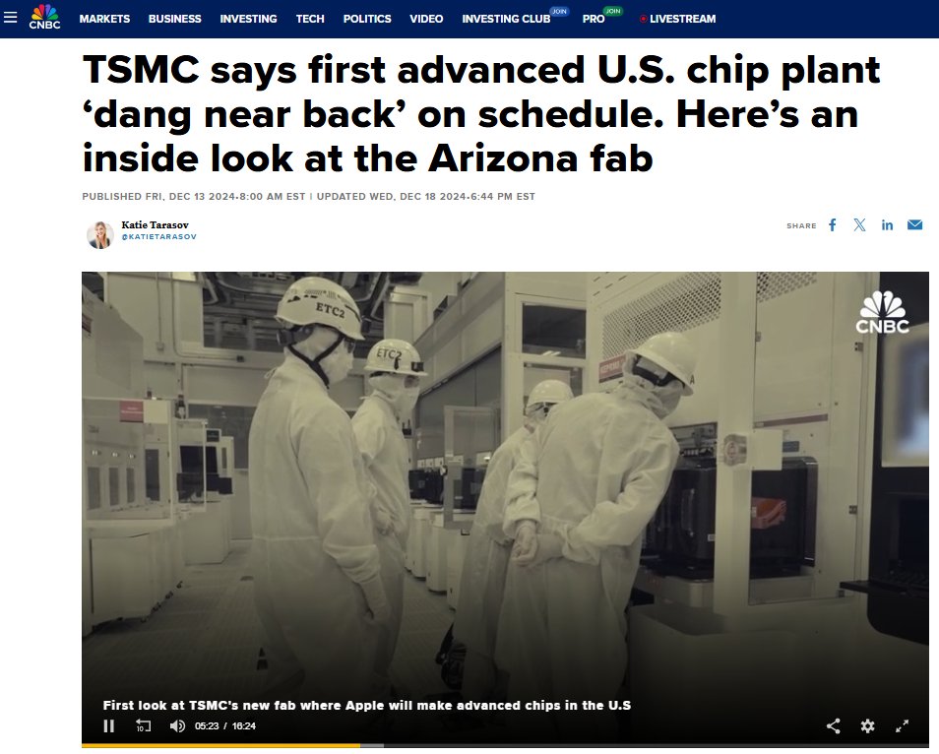
Figure 13: Apple’s chip production localisation with TSMC
(Source: Tarasov, 2024)
Pioneers sustain pricing power through innovation and ecosystem integration, to reinforce Porter’s differentiation strategy. Service revenue modelsPioneers maintain profitability and cost pressure under market uncertainty. Like Apple’s service segment increase 14% to $24.2 Billion in Q2 FY2025 giving stable margins (Spangler, 2024).

Figure 14: Growth of Apple’s service segment
(Source: Spangler, 2024)

3.2 Follower Organisations’ Strategic Responses
Followers do not lead innovation or early market entries but adapt copy and improve on the existing pioneer’s innovations.
Growth strategies with Ansoff’s Growth Matrix
Market Penetration: Followers keep presence in existing markets by offering similar pioneer’s products at low cost and more customisation for local segments. Shein followed Zara’s fast fashion model but focus on online only operations and gained 28.2% market share in the US.
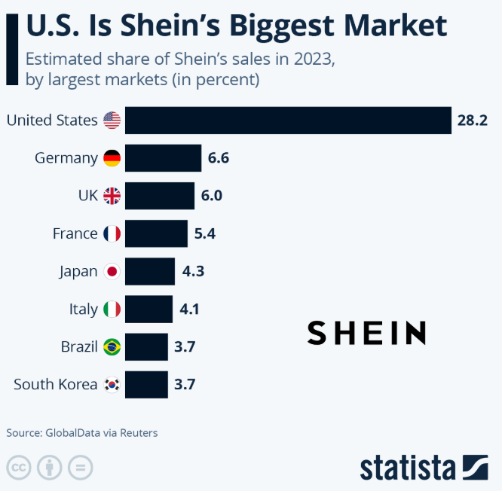
Figure 15: Shein market share in the US
(Source: Fleck, 2025)
Product Development: Followers focus on incremental product enhancements with variants rather any breakthrough with radical innovation. Lenevo followed laptop making companies like HP and IBM but focused on product improvements.
Market Development: Followers may enter underserved areas, geographies, or demographics which the pioneers overlook exploiting cost advantage or indigenisation. Tenco followed Apple’s technology but expanded in African markets with 12.72% market share as Apple has weak presence (Eghosa, 2025).
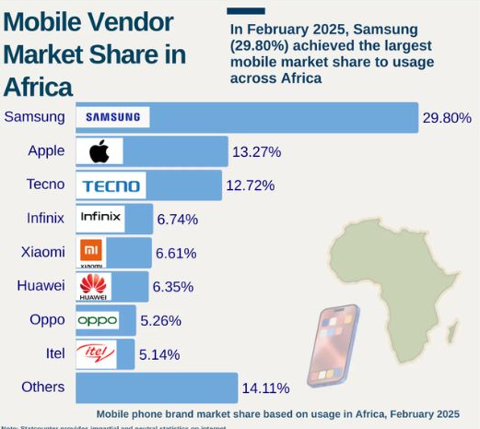
Figure 16: Market share of Tenco in Africa
(Source: Eghosa, 2025)
Diversification: Followers may diversify into adjacent segments keeping low risk with high probability of successful following of a pioneer’s model. Following the ecosystem model of Apple, Huawei introduced its ecosystem HarmonyOS.

Figure 17: Ecosystem of Huawei
(Source: Baloch, 2024)
Porter’s Generic Strategies: Cost Leadership
Cost-leadership is a highly dominant aspect for Followers as they aim to provide goods/ service at low cost, targeting price-sensitive customers, exploit scale and process efficiency. Recent strategy focuses that cost-leadership is highly relevant in hypercompetitive and price-sensitive markets. Some follower firms may adopt a cost or differentiation focused strategy serving niche segments than mass market.
Strategic Responses to External Technology and Economic Forces
Technological Adaptation
Followers sustain competition with strategic adoption of proven technologies with pioneer’s validation. It lowers innovation risk, capital expenditure and blind imitation enabling followers to prioritise process optimisation and agile integration to enhance efficiency and responsiveness. For example, pioneer Samsung integrated AI-driven production systems and 5G-enabled factories allowing flexible manufacturing and real-time quality control (Samsung, 2023). Follower Xiaomi Corporation effectively integrated this AI-backed automation improving their product performance and quality control. 8.9% increase in global Smartphone shipments has enhanced the revenue by 30.5%.
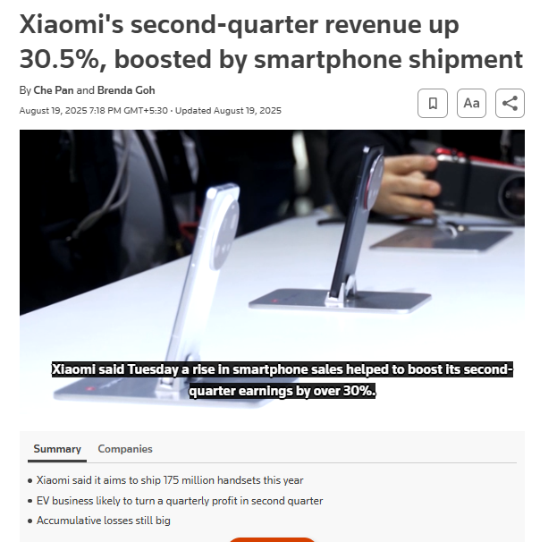
Figure 18: Financial performance of XIomi
(Source: Pan and Goh, 2025)
Revenue rose to RMB 50.6 Billion (Xiaomi, 2025) for strategic digitalisation and cost-effective innovation. Followers adopt mature technologies achieving economies of scale and improved market responsiveness omitting the research and development expense. This enables them to remain competitive against big pioneers combining affordability with near-perfect functionality with fast adoption.
Economic Adaptation
Followers excel with low-cost, value-for-money offers with near-perfect efficient operations during economic downturn and inflation among budget customers. They focus on cost-leadership and market penetration which are key aspects of Porter’s and Ansoff’s framework to sustain profitability in volatile markets. For example, Lidl’s UK sales increased 10.8% Y-o-Y in FY2025 to become sixth largest grocer focusing on private labels, bulk sourcing and streamlined logistics.
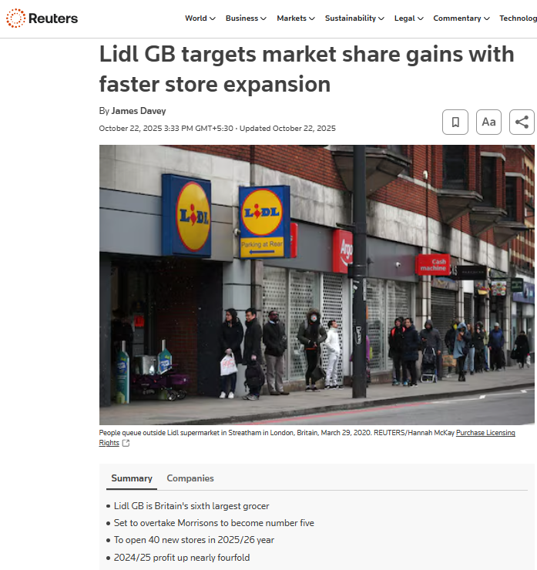
Figure 19: Market share expansion of Lidl
(Source: Davey, 2025)
Such strategies help followers gain profitability protecting margins during cost fluctuation. Followers can leverage the operational efficiency and price competitiveness to retain market share in volatility with long-term sustainability and upholding customer trust.

4. Conclusion
This report provides a strong review of how technological and economic macro-environmental factors drive and influence the strategic market movements of both Pioneers and Followers. The findings show that pioneers advance their competitive position through the early adoption of technologies that have emerged, especially AI-ML and automation and data analytics, relying on their first-mover advantage, while bearing the burden of high investments in research and development. For example Pioneers Apple and Tesla both have invested heavily in product and subsequent market development to strengthen logistics network focusing on differentiation strategy. On contrary Followers Xiaomi, Aldi and Lidl are competitive due to adopting the pioneer’s established technologies and ideas. This model focuses on and heavily relies on cost-leadership keeping focus on reducing financial exposures. This advantage provides opportunity for profit.
The analysis underscores strategic importance of current external environment assessment to identify the external opportunities and threats. Foreseeing this, the firms can adjust their macro-forces matching with their available resources in the operating market and it will create sustainable competitive advantage. Pioneers and Followers, both should focus on the strategic marketing combining their efforts with innovation and adaptability to respond external factors during technological transformation and economic downturns.

Reference list
Apple (2022). Apple services enrich peoples’ lives throughout the year. [online] Apple Newsroom (India). Available at: https://www.apple.com/in/newsroom/2022/01/apple-services-enrich-peoples-lives-throughout-the-year/.
Apple (2024).Introducing Apple Intelligence for iPhone, iPad, and Mac. [online] Apple Newsroom (India). Available at: https://www.apple.com/in/newsroom/2024/06/introducing-apple-intelligence-for-iphone-ipad-and-mac/.
Bajarin, T. (2024). Apple’s Forethought Makes AI Integration Possible On Apple Devices. Forbes. [online] 22 Jul. Available at: https://www.forbes.com/sites/timbajarin/2024/07/22/apples-forethought-makes-ai-integration-possible-on-apple-devices/.
Baloch, H. (2024). Huawei launches HarmonyOS NEXT as a complete Android replacement. [online] Notebookcheck. Available at: https://www.notebookcheck.net/Huawei-launches-HarmonyOS-NEXT-as-a-complete-Android-replacement.906044.0.html.
Bloomberg (2025).Apple to source over 19 billion US-made chips in supply chain shift. [online] @bsindia. Available at: https://www.business-standard.com/technology/tech-news/apple-to-source-over-19-billion-us-made-chips-in-supply-chain-shift-125050200118_1.html.
Carrick, A. (2024). How supermarket share has changed over a decade with Asda and Morrisons struggling. [online] This is Money. Available at: https://www.thisismoney.co.uk/money/bills/article-13738307/How-supermarket-share-changed-decade-Asda-Morrisons-struggling.html.
Comstock, F. (2024).Google Gemini | Launch, Controversy, & Facts | Britannica. In: Encyclopædia Britannica. [online] Available at: https://www.britannica.com/technology/Google-Gemini.
Davey, J. (2025). Lidl GB targets market share gains with faster store expansion. Reuters. [online] 22 Oct. Available at: https://www.reuters.com/business/retail-consumer/lidl-gb-pushes-ahead-with-expansion-profit-jumps-2025-10-22/.
De Sousa, G.C. and Castañeda-Ayarza, J.A. (2022).PESTEL Analysis and the macro-environmental Factors That Influence the Development of the Electric and Hybrid Vehicles Industry in Brazil.Case Studies on Transport Policy, [online] 10(1), pp.686–699.doi:https://doi.org/10.1016/j.cstp.2022.01.030.
Eghosa, F. (2025).Mobile phone market share in Africa by region: Brand breakdown for 2025 - Intelpoint. [online] Intelpoint. Available at: https://intelpoint.co/blogs/mobile-phone-market-share-in-africa-by-region/.
Finshots (2022).Tata’s Business Empire! [online] Finshots. Available at: https://finshots.in/infographic/tatas-business-empire/.
Fleck, A. (2025).Infographic: U.S. Is Shein’s Biggest Market. [online] Statista Daily Data. Available at: https://www.statista.com/chart/32774/sheins-main-markets/?srsltid=AfmBOopi8HyDShYG6oxOSRBr9intNs5TuDXzpSnpv3VvJzIIc03dV9W5.
Grocerygazette (2025).Tesco trials personalised ‘Your Clubcard Prices’ scheme. [online] Grocery Gazette - Latest Grocery Industry News. Available at: https://www.grocerygazette.co.uk/2025/02/05/tesco-your-clubcard-trial/.
Gupta, M. (2025).Global Digital Transformation in Spending Market – Industry Trends and Forecast to 2029. [online] Databridgemarketresearch.com. Available at: https://www.databridgemarketresearch.com/reports/global-digital-transformation-in-spending-market.
HAE-LEE, P. (2025). Page Restricted. [online] Joins.com. Available at: https://koreajoongangdaily.joins.com/news/2025-09-02/business/tech/Samsung-hikes-RD-spending-a-worldtopping-71-percent/2389595.
IEA (2024).Trends in the electric vehicle industry. [online] IEA. Available at: https://www.iea.org/reports/global-ev-outlook-2024/trends-in-the-electric-vehicle-industry.
Investing (2025).Tesla Q3 2025 slides: Record revenue and deliveries amid margin pressure. [online] Investing.com India. Available at: https://in.investing.com/news/company-news/tesla-q3-2025-slides-record-revenue-and-deliveries-amid-margin-pressure-93CH-5058555.
Mucci, T. (2024).The future of AI: trends shaping the next 10 years. [online] IBM. Available at: https://www.ibm.com/think/insights/artificial-intelligence-future.
OECD (2025).Full Report: OECD Economic Outlook, Interim Report September 2025. [online] OECD. Available at: https://www.oecd.org/en/publications/oecd-economic-outlook-interim-report-september-2025_67b10c01-en/full-report.html.
Oi, M. (2024).Tesla: EV giant cuts prices in major markets as sales fall. [online] www.bbc.com. Available at: https://www.bbc.com/news/articles/c1d4g8jz57yo.
Pan, C. and Goh, B. (2025).Xiaomi’s second-quarter revenue up 30.5%, boosted by smartphone shipment.Reuters. [online] 19 Aug. Available at: https://www.reuters.com/business/autos-transportation/xiaomis-second-quarter-revenue-up-305-boosted-by-smartphone-shipment-2025-08-19/.
Persson, E. (2024). Tesla: Leading the EV Revolution. [online] quartr. Available at: https://quartr.com/insights/company-research/tesla-leading-the-ev-revolution.
Samsung (2023).Smart Factory | Solutions | Networks | Samsung Business Global. [online] Samsung global_nw. Available at: https://www.samsung.com/global/business/networks/solutions/smart-factory/.
Spangler, T. (2024).Apple Services Quarterly Revenue Hits New Record, up 14% to $24B. [online] Variety. Available at: https://variety.com/2024/digital/news/apple-june-2024-earnings-services-quarterly-revenue-record-1236093320/.
Statista (2025).Samsung smartphone market share worldwide 2009-2025| Statista. [online] Statista. Available at: https://www.statista.com/statistics/276477/global-market-share-held-by-samsung-smartphones/?srsltid=AfmBOoorbgLT3ZQ-y-ZL1bZQhZ1TSG69Ug7vid-t04iyPmGcV8jxCIGt [Accessed 12 Nov. 2025].
Tarasov, K. (2024). TSMC says first advanced U.S. chip plant ‘dang near back’ on schedule. Here’s an inside look at the Arizona fab. [online] CNBC. Available at: https://www.cnbc.com/2024/12/13/inside-tsmcs-new-chip-fab-where-apple-will-make-chips-in-the-us-.html.
The Feed (2025).Apple announces $500-billion investment in US manufacturing: AI factory, 20,000 jobs planned. [online] The Economic Times. Available at: https://economictimes.indiatimes.com/news/international/us/apple-announces-500-billion-investment-in-us-manufacturing-ai-factory-20000-jobs-planned/articleshow/118537932.cms?from=mdr.
Thebusinessresearchcompany (2025).Retail Global Market. [online] www.thebusinessresearchcompany.com. Available at: https://www.thebusinessresearchcompany.com/report/retail-global-market-report.
Unilever (2023).Unilever Climate & Nature Fund. [online] Unilever. Available at: https://www.unilever.com/sustainability/nature/unilever-climate-nature-fund/.
Xiaomi (2025).Xiaomi Global Home. [online] Xiaomi. Available at: https://www.mi.com/global/discover/article?id=4969.

