MODEL CODE: M5X01924

COURSE TITLE: Management and Organisational Behaviour

NAME: BISWAJIT MUKHERJEE

NUMBER:1815040

LECTURER: DALE CLARKE

WRITTEN ASSIGNMENT 1


Intro…….…………………………………………………..pg2

Managerial behaviour………………………………………pg4-pg5

Managerial effectiveness …………………………………….pg6

Analysis of organization management structure……………pg6-pg7

Compare organizations critical analysis……………………..pg8

Conclusion ……………………………………………………..pg8-pg9

References ………………………………………………………pg10



This assignment based on managerial behaviour in the organisation. Before start this report need to know about more managerial behaviour in the organization that what exactly its mean? How is it work, what kind of effects can come on the organization and employee.
In according to “ Fayol's pioneering study (1916), research on managerial behaviour grew in the 1950s. Early studies, explained as the Work Activity School by Mintzberg (1973), the work activities of managers using simple categories. Carlson (1951) organized a diary analysis of the activities actually performed in four weeks by seven Swedish and two French top managers, supplemented by extensive interviews and by background knowledge.
Here need to understand that every people has different abilities and own behavioural potentials to lead the team.
The way, the managers has performed their tasks and explain their performance through to inferior employee prepared along dispositions throughout humans, and people behaviour with performance.
Their strategy also different which already mention in above.so this is very important to recognise as a manager that what steps should be taken and what effects will come after consideration. society has also ambitious themselves. Society work on their self- motivation and started to achieve their personal goals and work hard to hit the target of the organizations .As the higher standard of educational life, and changes in social aspects people are expecting more standard in their workplace, with possibilities to discussion with collaboration and opinion also influence employee. Manager also improve procedures which is particular apprehension of people attitude with inspiration.
Now it is very important to raise a question about potentials of any managers as it is very much important for any organizations to get progress.
To get continuous success in workplace, manager should continuously attached with his colleagues and organize with stability satisfactory to understand engagement principals. Manager create enthusiasm at work also better preferences provide with enthusiasm and excite people to fulfil their work targets.
In their relationships with their colleagues, managers should distract from emotional involvement.so that they could concentrate in their jobs without any hesitation and have empathy with his colleagues and give attention to every single steps taken
■
Managers could relate themselves more as conservators and regulators of the existing work with which they identify, and from which they gain rewards. Leaders work in, but do not belong to, the organisation. Their sense of identity does not depend upon membership or work roles and they search out opportunities for change
So this report explain about managerial behaviour in this this first part and next step by step will be discuss more things about this managerial behaviour of the organization. The actual the approach of the management behaviour achieved will be manipulated by the importunity of the situation, where the job offers in high demand of essential gratification or bring in a different types of tasks, an component of solve the problem and exercise of enterprise. It is actually more possible to lead to a higher level of employee determination. It is true that not only this case even for other cases also this theory applied of scientific , technical or professional reason. Responsibility to the target of the company is almost essential of membership, as an example some charitable or voluntary farm. So this things easily is showing that theory Y is more appropriate than theory X. in according to comparison of management approach in terms of two supreme dimension.
1.scrutinize for production
2. scrutinise for people.

1.scrutinize for producing is consignment of priority and executive take responsibility with challenge, obtaining great aligned of manufacturer because manager getting results or good turnover.
2.scrutinise for people is the amount of priority which the manager decided to give over power and employee as independent to their of necessity and anticipation. This is actually described the vertical axis of the grid.
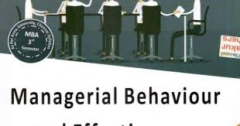
Attitude is most important part of managerial behaviour by this he can motivate the team and looks for development. It’s not necessary that everyone should have that attitude, but it may change in certain circumstances based on own’s experience and feedback from other people but only happens when an individual has concern to change his attitude. According to Milan kubr,1989, if a manager can able to motivate team to perform a new task in a challenging time, that’s reflect the technical subject skills, general management organisational skills, team leading skills, social and cultural skills, analytical subject skills, and political skills.
According to David R.W, 1996, generally managers are judge by their results, many managers can achieve the results in a different way by following different methods. By these different methods the managers are getting rate by management team like good, excellent, ned to improve, dismissed etc. A experience managers analyse efficiency also managers realise about great productivity for company’s objects. Great leader should know that which theory they need to use as every individual are different.
If we see some manager follows the way of another manager set about achieving the result through people, that manager behave as team leader and how they work out authority. A manager can be repressive and democratic, tough or soft, demanding or easy- going directive the way effects a managerial style.
Managers must finish his tasks by different way and that’s depends on management team of that organization. A management style is an global method of leadership used by a manager. Seeing things as they are Organisation, Authoritarian organisation, Participative organisation, Degree of participation.
There are three sharply contrasting styles.
Autocratic
Paternalistic
Democratic
Managerial efficiency could be different from managerial effectiveness. Effectiveness must connect to the achievement of some resolution, objective or task to the presentations of the procedure of management and the implementation of work. Most of the managers will progress a personalized managerial style after being charge for greater responsibility. The managerial style developed by these managers might have been influence by the following formal managerial training, such as leadership and management education and training. Managers adjust their style according the situation. There are some types of situational leadership that’s are: telling, participating, delegating, and selling.
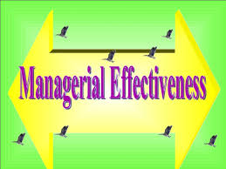
Managerial effectiveness makes human is an helpful boss of the organization. An helpful executive is the person who is strong identity, very positive in his supervisory procedure and confident and reflective in the outcome about the procedure. characteristics of this managerial effectiveness is leadership.
Human nature has some qualities, according to some psychologists those are called humanity. Customers demand are essential segment of humanity that’s included judgement, values, productivity. Might be they are different in individual but basically people have some basic needs. Manager’s responsibility is to find out these needs and focus on it to use it as motivations.


As per research, good manager always able to lead the team easily where its called According to “James B. Rieley (2006), leadership is all about creating environments in which your company employees can realise their individual and collective potential A good leadership.”
There are three types of leadership.
- Dictatorial leadership: This leadership is mainly to do various task
- Democratic leadership: This leadership is explaining making any decision allocation within the group
- Laissez faire leadership: Laissez this is actually French word. This leadership is trying to explain do it as you like.
Strategic management and leadership :
Strategic management mainly targets on making diplomatic decisions and leadership element the preferences that created by the management through effective communication to the organizations staff. Actually leadership attached in appraisal of employee performance, for productivity, they superintended and divided the jobs to their staffs and also encourage and nominated for their best performance through identify and lead by example so they can be influence by this and more can give great delivery in work. Every organizations has their own strategy , their principal , and their proposition for their company. They are the tactical thinker and they are the tactical decision makers and even also they arrange the CEO’S, MD’S President etc. to operate the company. This people are main for the company as a key worker and their responsibility for expansion of the organization.
This research found as an example of Tesco PLC where will explain about leadership and management and behaviour. One of the most important thing is that
Directorship is innovative command which is manager has own perception and affection to gather better opportunities..
This company CEO Terry Leah appeared in Tesco 1997 and also informed as idealistic superior which modified for development to the company in 2011. Company focused more to gather about great quality of food and excellent service for their customers and established the organization’s manpower through recognising for staff presentation and give preparation for leader.
Tesco always believe their managers are the main focus of their stores. Managers all are very responsible and their main duties are to satisfy the customers and give unforgettable service then next time the customer will come back again and that’s way sales of the business will be increase. Beside give the great customer service they always encourage their colleague and give motivational guidelines to their large team and the that’s why team able to deliver complicated tasks.
Tesco always believe in communication and that’s why they use so many of way to communicate with their staff and managers. Tesco’s main purpose is very easy process. They create how can be matters look good , balanced. When their plans developed , serviceable location within organization then implement sectors aims to confirm targets are obtained. The perception run organization and principals are immovable all over the tactical arrangement procedure. On the other way Tesco to gather this aims that Tesco’s main focus should be SMART, which is cover precise, computable, reachable, significant, and time scale.

Tesco  Large capital investment.  Well planned management service along with leaders.  Organised management team logically and effectively gather the resources and workflow of the organisation.  Leading including motivating, communicating well, resolving conflicts.  Tesco calculated marketing report and they used by picture so for there management its quite understandable for management team | Sainsburys  Large capital investment.  Excellent leadership including communication skills, staff management, manage conflicts.  Excellent branding and advertising.  Loyal customer base.  Sainsbury process are really complicated about marketing report which is not very understandable for management team



After analysis this report the conclusion is, management behaviour and effectiveness is very important and company’s sales, KPI, customers choice all are things depends on this management behaviour effectiveness. Basically in retail normally has six idea. They apply this six idea in most of the retail. Finance and budget allocation for all stores, investing for supply chain and good relationship with suppliers, profitability, direct relationship with all customers such as Clubcard, email, etc…., brand concept and brand culture.

So what found from this report that retail are responsible to take a very important part between manufacturer and customers in today’s market economy. So management behaviour is impacting positive way for Tesco PLC which is coming good effect on business.so management guide the organisation to amplify the production and product quality. So report is showing bellow the management structure and board structure then its easily understandable that about how easy and smooth their management whole procedure.
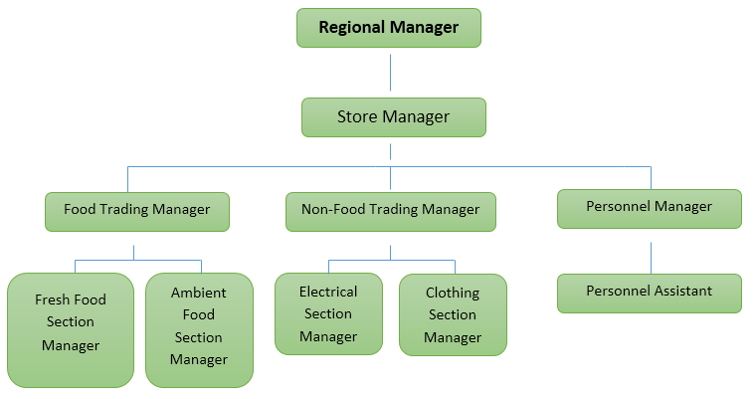
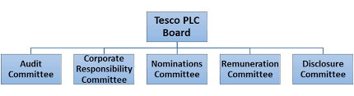


Grant, T. and Zackon, R. (2004) Executive, workplace and life coaching: ﬁndings from a large-scalesurvey of International Coach Federation members, International Journal of Evidence-Based Coachingand Mentoring, 2(2), pp. 1 – 1
Guba, E. G. and Lincoln, Y. S. (1981) Eﬀective Evaluation (San Francisco, CA: Jossey-Bass).Hamlin, R. G. (1988) The criteria of managerial eﬀectiveness in secondary schools, CORE: CollectedOriginal Resources in Education.
Hamlin, R. G. (2001) Towards research-informed organizational change and development, in:R. G. Hamlin, J. Keep and K. Ash (Eds) Organizational Change and Development: A ReﬂectiveGuide for Managers, Trainers and Developers (London: Financial Times/Pitman Publishing).
Hamlin, R. G. (2002a) Towards evidence based HRD practice, in: J. Stewart, J. McGoldrick andS. Watson (Eds) Understanding Human Resource Development: A Research-Based Approach (London:Routledge).
Hamlin, R. G. (2002b) A study and comparative analysis of managerial and leadership eﬀectiveness in theNational Health Service: an empirical factor analytic study within an NHS Trust hospital, HealthServices Management Research, 15(4), pp. 245 – 63
Hamlin, R. G. (2002c) In support of evidence-based management and research-informed HRD throughprofessional partnerships: an empirical and comparative study, Human Resource DevelopmentInternational, 5(4), pp. 467 –

