Dissertation Proposal Structure

Title: Evaluating the Impact of Dynamic Capabilities on Competitive Advantage: A Study of Digital Transformation Strategies in UK Mid-Sized Retail Firms (2020–2025)

Student Name: Abhishek Pradeep Joshi
Student ID: 2430962
Supervisor: Andry Rakotovololona
Program Manager: Hoang Dang Nguyen

Table of Contents
1. Introduction 2
1.1 Background of the research 2
1.2. Research Rationale and Problem Statement 2
1.3. Aims and Objectives of Research 3
1.4 Research Questions 3
2. Review of Existing Literature 4
2.1. Key Dynamic Capabilities in Mid-Sized Retail Firms in the UK 4
2.2. Role of digital transformation strategies in the competitive advantage 5
2.3. Limitations in Digital Transformation Strategies on the Dynamic Capabilities 6
2.4. Actionable Strategies for Managers to Strengthen the Dynamic Capabilities 7
2.5 Research Gap 7
3. Methodology 8
3.1. Research Philosophy 8
3.2. Research Approach 8
3.3. Research Strategy and Design 8
3.4. Data Collection and Analysis 9
3.5. Ethical Considerations 9
4. Expected Findings 9
5. Limitations 10
6. Time Frame 10
7. Conclusion 11
References 12

1. Introduction

1.1 Background of the research
The UK retail sector has gone through a huge disruption during the COVID-19 pandemic, which led the industry to transform from traditional, single-channel models to a more complex Omni-channel model. According to Shehadeh et al. (2023), digital transformation has been the only way to survive, which highlights the need for retailers for advanced technologies. The technologies may include AI, advanced analytics, and Omni channel that can maintain the market relevance within the UK. Moreira et al. (2025) highlighted that the process of digital transformation in small and medium enterprises has begun, while 23% of companies responded in this research (See to Figure 1). It can be interpreted that there is a need for digital transformation in the retail sector in the UK, which led the research to focus on the role of digital transformation strategies in the competitive advantage.
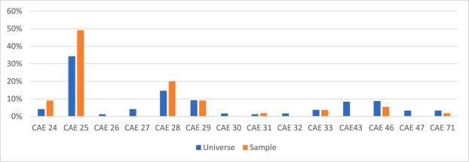
Figure 1: Digital Transformation in Small and Medium Enterprises
(Source: Moreira et al., 2025)
Figure 1 illustrates the extent of digital transformation adoption among small and medium enterprises (SMEs). It shows that only a limited proportion of firms have fully implemented digital technologies, while many are still in early or transitional stages, highlighting gaps in readiness, investment, and capability development within the SME sector

1.2. Research Rationale and Problem Statement
The present research will highlight the critical shifting period by resolving the research gap on the “productivity-capability" which has been observed in the retail sector of the UK (Yavuz, Tatlı and Bozkurt, 2025). Many mid-sized organisations also face some struggles, even if there are heavy investments in technology. Due to a lack of dynamic capabilities for this industry, these mid-sized firms are facing issues in gaining return on investment (ROI) effectively (Azzam et al., 2023). The present research focuses on the time duration of 2020-2025 to gather in-depth knowledge regarding the impact of dynamic capabilities on competitive advantage. This research will also highlight the technological uncertainty, dual innovation modes, and economic recovery by emphasising the lack of skills to implement the advanced technologies.

1.3. Aims and Objectives of Research
Aim
This recent research aims to determine the impact of dynamic capabilities, such as sensing, seizing, and reconfiguring, on competitive advantage by assessing digital transformation strategies in mid-sized retail firms in the UK between 2020 and 2025.
Objectives
The objectives of the present research are discussed below-
RO1: To identify the key dynamic capabilities, including sensing, seizing, and reconfiguring in mid-sized retail firms in the UK.
RO2: To examine the role of digital transformation strategies such as omni-channel, AI, and data analytics in achieving competitive advantage.
RO3: To analyse the challenges faced by mid-sized retail firms in implementing digital transformation strategies to enhance dynamic capabilities.

1.4 Research Questions
The research questions for this present research are-
RQ1: What are the key dynamic capabilities in mid-sized retail firms in the UK for achieving competitive advantage?
RQ2: How do digital transformation strategies (omni-channel, AI, and data analytics) contribute to competitive advantage?
RQ3: What challenges are faced by mid-sized retail firms in implementing digital transformation strategies to improve dynamic capabilities?

2. Review of Existing Literature

2.1. Key Dynamic Capabilities in Mid-Sized Retail Firms in the UK
The most important dynamic capabilities (DCs) in mid-sized retail companies in the UK are related to the use of data-driven agility, Omni channel integration, and entrepreneurial networking to respond to turbulent market conditions. Aldossary et al. (2026) examine the role of dynamic capabilities, particularly Big Data Analytics Capabilities (BDAC), in enabling mid-sized retail SMEs in the UK to innovate in highly dynamic markets. The researcher explains that dynamic capabilities have a crucial role in determining how UK retail companies sense and respond to market changes.
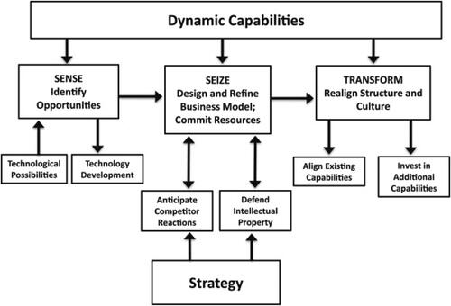
Figure 2: Dynamic Capability with Strategy
(Source: Shiferaw and Kero, 2024)
Figure 2 illustrates the link between dynamic capabilities and business strategy. It shows that firms achieve competitive advantage when capabilities such as sensing, seizing, and reconfiguring are aligned with strategic goals. This alignment enables organisations to adapt, innovate, and respond effectively to changing market conditions, strengthening overall performance.
The important competencies of mid-scale retailing companies are Big Data Analytics Capability (BDAC), flexibility in the supply chain, and managerial cognitive abilities. As per Shiferaw and Kero (2024), dynamic capabilities and strategy form the basis of a defensible business model, which determines organisational transformation (See to Figure 2). These strengths combined improve accessibility, innovation, and competitive differentiation in turbulent UK retail environments. Dynamic capabilities (DCs) are the capabilities of a given firm to perceive, capture and restructure resources in dynamic environments. These capabilities are becoming Driven by Data Analytics, Supply Chain Agility and Omni-Channel Integration in UK mid-sized retail firms. Aldossary et al. (2026) highlight the Big Data Analytics Capabilities (BDAC) in increasing the responsiveness of the market. They are however limited by poor financial and technical capacity against the bigger firms. Shiferaw and Kero (2024) claim that managerial cognition and strategic alignment are also essential. Therefore DCs cannot be considered fully technological but require leadership and integration, which results in the unfair distribution of capability between firms.

2.2. Role of digital transformation strategies in the competitive advantage
Digital transformation strategies offer a sustainable competitive advantage by leveraging different technologies such as AI and cloud computing to improve operational efficiency, speed innovation, and provide better customer experiences. According to Shao (2025), digital strategies are aligned with the overall corporate strategy, cultural adaptability, and digital skills are invested so that the companies are able to achieve sustainable competitive advantages. Digital transformation strategies with an overall corporate strategy help companies to reconfigure their routines and take advantage of new opportunities in the competitive context. As stated by Kraus et al. (2021), corporations that use various strategies together with a digital business strategy are able to gain access to different capabilities, knowledge, and resources that will enhance their reputation (See to Figure 3). In general, digital transformation that is aligned with strategy improves efficiency, innovation, and competitive advantage.
Digital strategies of transformation would allow companies to gain a competitive edge with the help of AI, data analytics, and omni-channel systems that would increase efficiency and customer experience. Kraus et al. (2021) emphasise better access to resources and innovation, whereas Shao (2025) connects the digital alignment to organisational agility. But the literature disapproves of deterministic attitudes, citing that technology will guarantee that things will happen. Saeedikiya et al. (2024) suggest that dynamic capabilities are the mediator of the results of transformation. There are also differences in the digital maturity that restrict performance, especially in the middle-size companies. Consequently, it is not the process of adoption that can create a competitive advantage but rather the strategic combination of digital tools and organisational capabilities as well as business models.
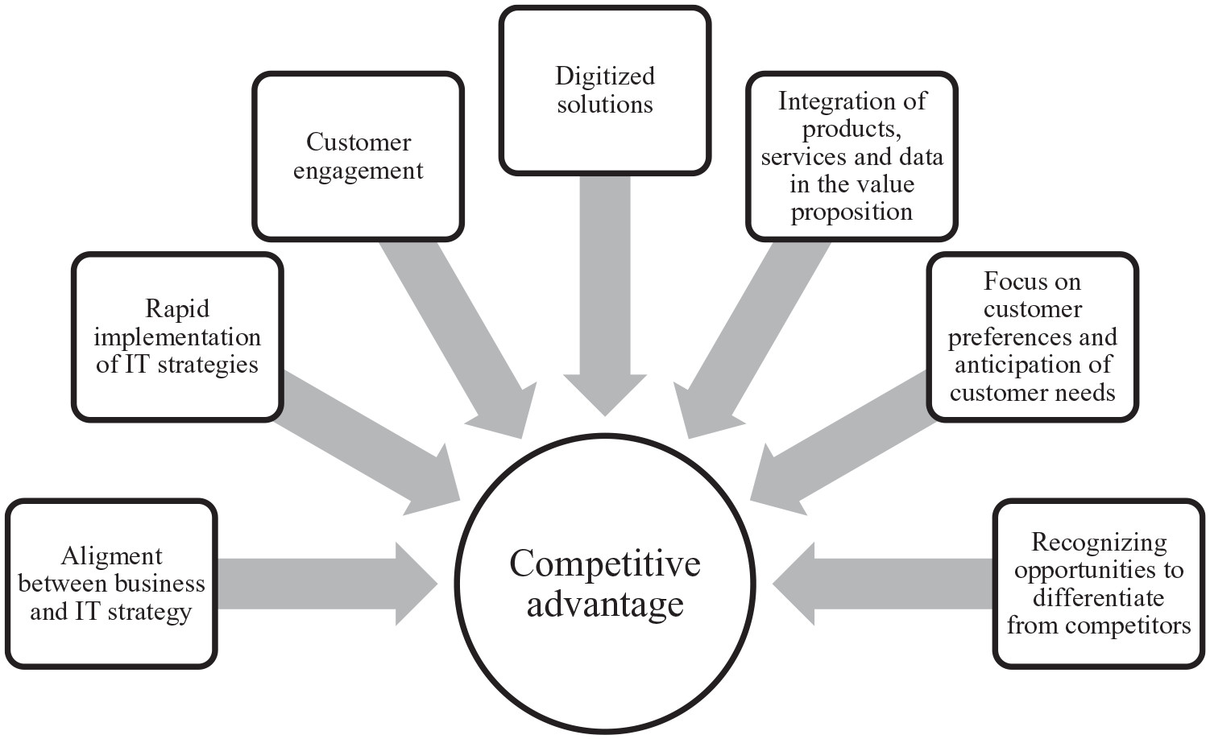
Figure 3: Competitive Advantage by Business Strategy
(Source: Kraus et al., 2021)
Figure 3: Competitive Advantage by Business Strategy illustrates how firms achieve superior performance by aligning their business strategies with digital transformation and resource capabilities. It shows that organisations gain competitive advantage when strategies such as innovation, cost leadership, and differentiation are integrated with digital tools and organisational resources. The model highlights that access to knowledge, technology, and strategic capabilities enhances efficiency, innovation, and market positioning. Importantly, it emphasises that competitive advantage is not achieved through technology alone but through the effective combination of strategy, resources, and capabilities that create sustainable value for firms.

2.3. Limitations in Digital Transformation Strategies on the Dynamic Capabilities
The limitations in digital transformation strategies, such as the absence of a vision, poor change management, and competencies, limit the dynamic capabilities of an organisation to sense, seize, and transform. According to Rizana et al. (2025), despite the strategic significance of digital transformation, there is a lack of a comprehensive set of capabilities necessary for successful transformation. A study by Saeedikiya et al. (2024) showed that dynamic capabilities enable digital transformations, digital transformations enable digitally enabled capabilities, and later this enables the performance outcomes (See to Figure 4). Various studies have pointed out individual enablers like digital leadership, change management, or digital culture, independently, leading to a gap between strategic intentions and implementation. The UK mid-sized retail companies have a major problem with the implementation of the digital transformation strategies which restricts their effectiveness. One of the obstacles is the lack of digital skills and knowledge which limits the use of new technologies (Rizana et al., 2025). Resistance to change is also another way through which organisational change is hindered since the employees and managers might be resistant to change. The integration is also limited by legacy systems which are inefficient. The economic constraints are risky because of the uncertainty of investment returns (Azzam et al., 2023). Also, the mismatch of digital strategies with business processes minimizes impact. These obstacles suggest that failure in transformation has more to do with the gaps in capabilities and organisations than her technological insufficiency.
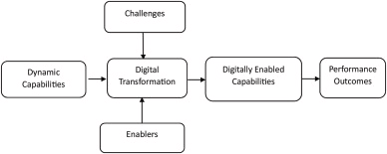
Figure 4: Digitally Enabled Capabilities
(Source: Saeedikiya et al., 2024)
Figure 4: Digitally Enabled Capabilities explains the relationship between digital transformation, dynamic capabilities, and organisational performance. It shows that digital transformation initiatives—such as AI, data analytics, and digital platforms act as enablers that build new capabilities within firms. These capabilities enhance a firm’s ability to sense opportunities, seize them effectively, and reconfigure resources in response to market changes. The model highlights a sequential process where digital transformation strengthens dynamic capabilities, which in turn drive improved business performance and competitive advantage. It emphasises that technology alone is insufficient; value is created when digital tools are integrated with organisational capabilities and strategic processes.

2.4. Actionable Strategies for Managers to Strengthen the Dynamic Capabilities
Dynamic capabilities improving, the ability to sense, seize, and reconfigure resources in response to changing environments, implies that managers must move away from optimising existing processes and towards facilitating strategic change. Crupi and Mortara (2025) demonstrate that managers can improve dynamic capabilities by adopting open innovation, which improves strategic thinking, the recognition of opportunities, and knowledge integration. The authors stress that open innovation ecosystems offer a roadmap for managers to improve dynamic capabilities. Managers can capitalise on open innovation to realise the opportunity to enhance dynamic capabilities by promoting strategic thinking, seeking opportunities, and integrating knowledge. Innovation ecosystems provide a practical method to promote organisational agility.

2.5 Research Gap
Recent research has emphasised the importance of dynamic capabilities (DCs) in coping with adaptation and innovation in turbulent environments. In mid-scale retail firms in the UK, digital transformation approaches such as cloud technology, AI, and Omni channel retailing can improve DCs by improving seizing, sensing, and reconfiguring (Aldossary et al., 2026). However, limitations such as the gap between digital strategies and organisational processes could hamper the development of capabilities (Rizana et al., 2025). Open innovation and collaborative ecosystems developed by managers can improve capabilities, which will transform digital investments into strategic agility. In general, the right use of digital strategies and managerial practices is important for the long-term development of competitive advantage.

3. Methodology

3.1. Research Philosophy
Interpretivism research philosophy will be the most suitable research philosophy for the present research. This research philosophy can help to dig through multiple articles and research to gain in-depth knowledge regarding the present research topic. Interpretivism research philosophy emphasises the subjective, dynamic and social reality in a research overview (William, 2024). Interpretivism philosophy can also help to gather in-depth context regarding the present research topic of the impact of dynamic capabilities on competitive advantage. This philosophy is very useful for a secondary qualitative research method, which justifies the literature review method to clear the understanding of the specific research topic.

3.2. Research Approach
An inductive research approach is the most suitable research approach for the present research topic of “Evaluating the Impact of Dynamic Capabilities on Competitive Advantage: A Study of Digital Transformation Strategies in UK Mid-Sized Retail Firms (2020–2025)”. Streefkerk (2023) described that the inductive research approach utilises the “bottom-up" method to collect data by observing, identifying and developing the patterns and new theories. This approach is suitable for qualitative and exploratory research, which allows the theories to align with the real-world data. The use of this research approach will help to address the impact of dynamic capabilities on competitive advantage.

3.3. Research Strategy and Design
The secondary qualitative research strategy will be the most suitable research strategy for the present research, which can help to identify the impact of dynamic capabilities on competitive advantage in the mid-sized retail firms in the UK.
The descriptive design will be the most appropriate research design for the present research, which can be used when the secondary qualitative method is used.

3.4. Data Collection and Analysis
The present research will use a literature review method to collect data effectively. Data collection and analysis in secondary qualitative data refers to the examination of already existing articles to collect data and answer the research question, to offer an alternative to primary research (Cheong et al., 2023). Since this research utilises the secondary qualitative research strategy and design, it can use secondary journals and articles from Google Scholar or other databases for assessing a literature-based case study analysis. Ahmed et al. (2025) said that for data analysis, thematic analysis will be most appropriate, as it involves different themes that need to be analysed that are related to the research questions of the research. The articles will be collected from Google Scholar and other databases, including MDPI, Science Direct, Springer Link, Research Gate, and the articles should be within the 2020 to 2025 year gap. Older than 2020 articles are excluded from this research.

3.5. Ethical Considerations
The ethical considerations in this research need to identify the risks, such as physical, psychological, and social, during the data collection process. The ethical consideration of this type of research focuses on the security of the data and adherence to the original content. Additionally, the information from the past articles about privacy and data security should be assured (Hughes and Tarrant, 2020). Secondary qualitative analysis also needs to ensure to not create any misinterpretation or misrepresentation of the information. They also need to review the ethical safeguards of the studies from which they are gathering information (Bhandari, 2024). Another major issue the researchers need to focus on is avoiding plagiarism by citing sources properly and referencing the authors.

4. Expected Findings
The study is expected to prove that dynamic capabilities have a significant mediating effect between digital transformation strategies and competitive advantage in mid-sized retail firms in the UK. Secondary quantitative data (2020-2025) might indicate positive correlations between investments in AI, data analytics, and Omni channel technologies performance. The thematic analysis of industry reports might indicate that there is a better sense of customer trends, faster decision-making, and better reconfiguration of resources. On the other hand, the findings may also indicate that misalignment, capability, and integration can be moderators. In conclusion, firms that are able to align their digital strategies with dynamic capabilities are anticipated to create a competitive advantage.

5. Limitations
However, the study could be constrained by the reliance on secondary quantitative data, which might limit the availability of strategic information specific to the firm and control over the quality of data measurement. Confined to the mid-sized retail companies in the UK from 2020 to 2025 might reduce generalisability. Moreover, the ever-changing nature of digital technologies might create issues with the timeliness of the results. There might also be limitations in testing causality between dynamic capabilities and competitive advantage because of non-experimental data.

6. Time Frame
Task | Week 1–2 | Week 3–4 | Week 5–8 | Week 9–12 | Week 13–16 | Week 17–18
Topic Selection | ✔
Literature Review |  | ✔ | ✔
Methodology Design |  | ✔ | ✔
Data Collection (Secondary Sources) |  |  | ✔ | ✔
Data Analysis (Thematic) |  |  |  | ✔ | ✔
Writing Chapters 1–3 |  |  |  | ✔ | ✔
Writing Chapters 4–5 |  |  |  |  | ✔
Conclusion & Recommendations |  |  |  |  | ✔ | ✔
Proofreading & Final Submission |  |  |  |  |  | ✔

Table 1: Gantt Chart
(Source: Self-Developed)

7. Conclusion
The conclusion of this research is that dynamic capabilities have a crucial role to play in the process of converting digital strategies into sustained competitive advantage in the UK mid-sized retail sector. Those organisations that manage to integrate digital transformation initiatives with sensing, seizing, and reconfiguring capabilities are better placed to adapt and succeed in turbulent environments.

References
Ahmed, S.K., Mohammed, R.A., Nashwan, A.J., Ibrahim, R.H., Abdalla, A.Q., Ameen, B.M.M. and Khidhir, R.M. (2025). Using Thematic Analysis in Qualitative Research. Journal of Medicine, Surgery, and Public Health, 6(6), p.100198. doi:https://doi.org/10.1016/j.glmedi.2025.100198.
Aldossary, M. and Agag, G. (2026). Data-driven agility in the UK retail sector: How SMEs innovate in dynamic environments through experimental evidence. Journal of Retailing and Consumer Services, [online] 90, p.104716. doi:https://doi.org/10.1016/j.jretconser.2025.104716.
Azzam, I.A., Alserhan, A.F., Mohammad, Y., Shamaileh, N.A. and Al-Hawary, S.I.S. (2023). Impact of dynamic capabilities on competitive performance: A moderated-mediation model of entrepreneurship orientation and digital leadership. International journal of data and network science, 7(4), pp.1949–1962. doi:https://doi.org/10.5267/j.ijdns.2023.6.017.
Bhandari, P. (2024). Ethical considerations in research | types & examples. Scribbr. Available at: https://www.scribbr.com/methodology/research-ethics/ [Accessed 25 Feb. 2026].
Cheong, H., Lyons, A., Houghton, R. and Majumdar, A. (2023). Secondary Qualitative Research Methodology Using Online Data within the Context of Social Sciences. International Journal of Qualitative Methods, 22(1), pp.1–19. https://doi.org/10.1177/16094069231180160
Crupi, A. and Mortara, L. (2025). Building middle managers’ managerial dynamic capabilities through collaborations: exploring the microfoundations in a university–industry consortium. The Journal of Technology Transfer. doi:https://doi.org/10.1007/s10961-025-10242-6.
Hughes, K. and Tarrant, A. (2020). The Ethics of Qualitative Secondary Analysis. pp.37–58. doi:https://doi.org/10.4135/9781526482877.n3.
Kraus, S., Jones, P., Kailer, N., Weinmann, A., Banegas, N.C. and Tierno, N.R. (2021). Digital Transformation: an Overview of the Current State of the Art of Research. SAGE Open, 11(3), pp.1–15. doi:https://doi.org/10.1177/21582440211047576.
Moreira, L.L., Pinto, S.S., Costa, L. and Araújo, N. (2025). Evaluating digital transformation in small and medium enterprises using the Alkire-Foster method. Heliyon, 11(2), p.e41838. doi:https://doi.org/10.1016/j.heliyon.2025.e41838.
Rizana, A.F., Wiratmadja, I.I. and Akbar, M. (2025). Exploring Capabilities for Digital Transformation in the Business Context: Insight from a Systematic Literature Review. Sustainability, [online] 17(9), p.4222. doi:https://doi.org/10.3390/su17094222.
Saeedikiya, M., Salunke, S. and Kowalkiewicz, M. (2024). Toward a dynamic capability perspective of digital transformation in SMEs: A study of the mobility sector. Journal of Cleaner Production, [online] 439, p.140718. doi:https://doi.org/10.1016/j.jclepro.2024.140718.
Shao, W. (2025). The Role of Digital Transformation in Enhancing Organizational Agility and Competitive Advantages: A Strategic Perspective. Advances in Economics Management and Political Sciences, [online] 154(1), pp.115–120. doi:https://doi.org/10.54254/2754-1169/2024.19552.
Shehadeh, M., Almohtaseb, A., Aldehayyat, J. and Abu-AlSondos, I.A. (2023). Digital Transformation and Competitive Advantage in the Service Sector: A Moderated-Mediation Model. Sustainability, 15(3), p.2077. doi:https://doi.org/10.3390/su15032077.
Shiferaw, R.M. and Kero, C.A. (2024). Dynamic capabilities view practices of business firms: a systematic literature review. Cogent business & management, [online] 11(1). doi:https://doi.org/10.1080/23311975.2024.2336309.
Streefkerk, R. (2023). Inductive vs. Deductive research approach. Scribbr. Available at: https://www.scribbr.com/methodology/inductive-deductive-reasoning/ [Accessed 25 Feb. 2026].
William, F.K.A. (2024). Interpretivism or Constructivism: Navigating Research Paradigms in Social Science Research. International journal of research publications, 143(1), pp.1–5. doi:https://doi.org/10.47119/ijrp1001431220246122.
Yavuz, M.S., Tatlı, H.S. and Bozkurt, G. (2025). Exploring the financial impact of digital transformation: A comprehensive analysis on firms. Journal of Innovation & Knowledge, 10(5), p.100795. doi:https://doi.org/10.1016/j.jik.2025.100795.

