Critical evaluation of KardiaMobile 6L as a digital innovation in UK health and social care
BMHP6026
Student name: Anourah Sonahar
Student number: 2220772
Tutor: Joanne Davies

Table of Contents
Introduction 2
Impact on the workforce 3
Alterations in work patterns and job roles 3
Training, role competency, and talents 3
Productivity, ability, and time-saving 4
Workforce perspective 4
Professional responsibility, safety and judgement 5
Real service problems of implementation 5
Influence on the patient and service user 6
Access, convenience, and effect of care 6
Earlier detection and possible health advantage 7
Fear, reassurance, and the danger of injury 7
Equity of access and digital desertion 8
Trust, privacy, and data protection 9
Conclusion and recommendations 9
References 11

Introduction
KardiaMobile is a small, handheld electrocardiogram device that captures heart rhythm and transfers the recording to an app on a smartphone or tablet for review and sharing with clinicians (NICE, 2022). KardiaMobile 6L is a six-lead version that offers more views, yet is stationary and fast to use compared to a single-lead reading (Lim et al., 2025). This technology type aids ambulatory monitoring, i.e., the ability to check heart rhythm outside a hospital, in primary care and the community (SHTG, 2022).
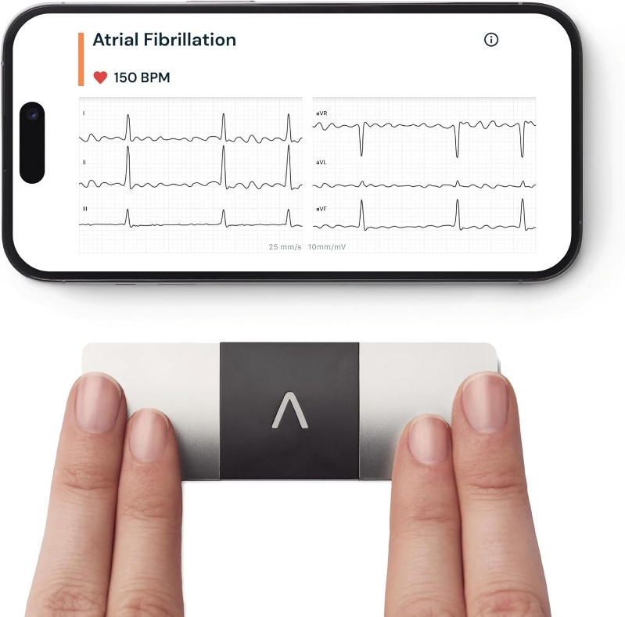
Figure 1: KardiaMobile 6-Lead Personal ECG
Atrial fibrillation is of significance to the United Kingdom since it is prevalent and increases the chances of stroke. Earlier assessment and treatment can be facilitated by better detection (NHS England, 2020). KardiaMobile has been suggested as an alternative to detecting suspected paroxysmal atrial fibrillation in individuals with symptoms like palpitations subjected to ambulatory monitoring (NICE, 2022).
The following report critically reviews KardiaMobile 6L as a digital innovation in care pathways in the UK. It is centred on two areas needed by the assessment brief workforce impact and patient or service user impact. The benefits and limitations, such as safety, training, costs, fairness of access, and data governance, are demonstrated with evidence.

Impact on the workforce

Alterations in work patterns and job roles
KardiaMobile transforms the way staff record electrocardiograms. Holter monitors can be used to monitor ambulatory patients and must be fitted, explained, and returned. KardiaMobile can be used quickly during an appointment or provided to an individual to record symptoms frequently whenever they occur (NICE, 2022). In Scotland, the recommendation states that KardiaMobile does not require fitting and can be posted, which could result in fewer hospital appointments in connection with the fitting and removal of the device (SHTG, 2022).
Community services in England have adopted KardiaMobile as an improvement. KardiaMobile can be used in an online survey study, where a community NHS Trust adopted it as an option for specialist community nursing teams to record electrocardiograms during home assessments (Emmett et al., 2024). This implies that community nurses will have expanded roles, undertaking their responsibilities that were once performed in clinics. The change can support faster decisions, but it may create additional responsibilities and workload.

Training, role competency, and talents
Using KardiaMobile is not a purely technical task. The personnel should ensure they record, control, and handle data correctly, avoiding infection and ensuring safety. They also need to comprehend how the outcome can be incorporated into a diagnostic pathway. According to NICE guidance, the results of KardiaMobile need to be discussed with a healthcare professional and utilised in making clinical decisions, and further testing is necessary (NICE, 2022). This implies that training should be provided on device use and on clinical escalation.
The workforce benefit is evident in cases where the device facilitates ECG collection at home. In NICE work regarding the use of the KardiaMobile 6L as a monitor of the QT interval in individuals taking antipsychotic medication, the device is defined as portable and applicable to community-based practitioners during home visitations. It could potentially save time and money on clinic monitoring (NICE, 2022). The quality of training, however, is uneven. In the community survey, slightly more than half of participants indicated they had adequate training and resources to adopt KardiaMobile (Emmett et al., 2024). This is an issue, as a lack of confidence can lead to mistakes, stalling, or inconsistent performance across teams. In cases where training is minimal, the staff may not use the device or may register results but find it difficult to interpret and take the next action. This can negate the assured efficiency.

Productivity, ability, and time-saving
It has been shown that mobile ECG use can enhance efficiency in certain environments. A single-lead mobile ECG quality improvement project in community monitoring showed that access to ECG checks was improved and that it facilitated local service delivery (Bray et al., 2021). Moving on to primary care, the evaluation also examined the use of mobile devices to detect atrial fibrillation (Highton et al., 2021).

Workforce perspective
The most important consideration is whether time saved in one section of the pathway creates additional workload in other areas. KardiaMobile can minimise the number of clinic visits required to complete the equipment fitting while expanding the number of recordings to be reviewed. Atrial fibrillation, normal rhythm, or unclassified recordings can result from the device (NICE, 2022). Unclassified readings may result in additional follow-up, retesting and increased time on the part of the clinician. This is most evident in general practise and cardiology, where employees already face capacity pressure.

Professional responsibility, safety and judgement
Digital instruments may pose the risk of excessive reliance on automatic output. KardiaMobile offers interpretation based on algorithms, whereas, according to NICE guidelines, clinical review is responsible and requires suitable confirmation (NICE, 2022). If the staff considers the device's output a definitive diagnosis, patient safety is at risk. False positives may result in unjustified anxiety and referrals, whereas false negatives may cause a delay in diagnosis.
The aspect of clinical accuracy is of paramount concern with handheld devices more than a regular twelve-lead ECG. The six-lead device is under development, and its validation and comparison methods demonstrate that it has some advantages, even though it is not identical to a complete clinical ECG system (Lim et al., 2025). In the case of workforce practise, it implies that there must be clear guidelines on when recording suffices and when a standard ECG or Holter monitor is necessary.
A broader systematic review of mobile health devices for atrial fibrillation detection found inconsistent detection rates and study designs, suggesting that implementation should be carefully planned and audited rather than assuming every setting will achieve the same outcome (Biersteker et al., 2021). Employees should be encouraged to use the technology safely, not as a pilot project.

Real service problems of implementation
It is a question of governance and digital assurance rather than clinical value, which influences implementation. NICE observes that its KardiaMobile direction was temporarily discontinued, as the company has halted supply to the NHS to comply with the Digital Technology Assessment Criteria. According to NICE, the criteria were then met and approved by NHS England, and supply was resumed (NICE, 2023). To the workforce, this is important because it demonstrates that information governance requirements can block the use of digital devices, disrupting pathways and staff planning.
The other challenge is incorporating records. Many digital tools still require workarounds, such as exporting PDFs and cutting and pasting them into records, which take up staff time and increase the risk of information being missed. According to NICE, wireless transfer and PDF output are included in the device process (NICE, 2022). Without effective system integration, the workforce can experience additional administrative issues, offsetting gains in time.

Influence on the patient and service user

Access, convenience, and effect of care
Convenience is a major benefit to the patients. KardiaMobile is intended to record quickly and is adaptable to intermittent symptoms, allowing recordings when palpitations occur rather than waiting to visit the doctor (NICE, 2022). According to SHTG, the device may be posted and does not require fitting, which may help save on travel and the hassle of visiting a hospital (SHTG, 2022).
In certain situations, patient comfort can be enhanced as well. KardiaMobile 6L is less intrusive in NICE work on QT interval monitoring, as it does not require conductive gel or as much undressing, which can be a significant issue for some people who find conventional ECG testing distressing (NICE, 2022).

Earlier detection and possible health advantage
The perceived health advantage is better detection of atrial fibrillation, particularly paroxysmal atrial fibrillation, which is intermittent and not easily detected. NICE suggests KardiaMobile as one of the choices when ambulatory monitoring is required due to a suspected case of paroxysmal atrial fibrillation (NICE, 2022). In practice, prompt detection would help assess stroke risk earlier and make treatment decisions in line with clinical recommendations (NHS England, 2020).
UK-based studies provide evidence of feasibility. There has been an examination of primary care of mobile device use in atrial fibrillation detection and its (practical) compatibility with the services (Highton et al., 2021). Another pilot randomised trial in primary care examined methods of mobile health screening, including KardiaMobile, demonstrating how these devices can be applied in practical contexts rather than research clinics (Callanan et al., 2022).
The survey study in community care indicates that KardiaMobile was implemented in response to increasing expectations that staff members record ECGs when assessing patients at home, suggesting a patient need that was not well met by conventional pathways (Emmett et al., 2024).
Nonetheless, there should be indications of good against a boundary. Follow-up, confirmation where needed and timely clinical action remain the key factors in treating atrial fibrillation, even when KardiaMobile presents with this issue. The resources provided by NICE and NHS emphasise that a reported atrial fibrillation outcome of a mobile device should be verified in a safe pathway (NICE, 2022; NHS England, 2020).

Fear, reassurance, and the danger of injury
Tracking using digital devices may bring a feeling of security to certain individuals, yet it may also cause anxiety. Frequent checking may make one more likely to worry, particularly when the results are unclear. KardiaMobile can deliver unclassified outcomes and could be reused by individuals with symptoms (NICE, 2022). Misunderstood deliverables may drive individuals to a desperate need for confirmation, leading to a higher demand for services and stress.
This problem is not only in the home application. Staff are also required to explain the results and manage expectations in the care setting. A comparison of pulse cheques and KardiaMobile usage has been conducted in care homes through screening, demonstrating the feasibility of these methods and the need for careful interpretation of results with older adults who are likely to have multiple conditions (Savickas et al., 2023). In the outpatient setting, routine Kardia feasibility research has demonstrated that ECG recordings can help identify undiagnosed cases; however, this requires well-organised follow-up and effective communication (Mittal et al., 2024).
A broader systematic review of mobile health devices for the detection of atrial fibrillation points out that the evidence is not homogeneous and that the performance of the devices must be evaluated in a clinical setting (Biersteker et al., 2021).

Equity of access and digital desertion
A major risk is inequality. KardiaMobile requires a smartphone or tablet. Individuals with low income, low digital confidence, or sensory or cognitive constraints might find it difficult to use the app. SHTG itself acknowledges this obstacle and states that the inability to have a smartphone or discomfort with its use should not impede KardiaMobile from being a potential option (SHTG, 2022).
In reality, fairness can be based on the mode of technology delivery. In case a service posts a device and intends to use it independently, the risk of exclusion is greater. When the device is utilised by community staff on home visits, it can minimise the risk of exclusion, but workloads shift to the staff and can restrict scale (Emmett et al., 2024).

Trust, privacy, and data protection
Heart rhythm data is personal health data. Community based and home monitoring require trust especially. NICE confirms that its guidance was suspended at some point, as supply to the NHS was halted and the company was striving to meet the Digital Technology Assessment Criteria, after which it was again supplied (NICE, 2023). That demonstrates the fact that digital assurance and data management may have a direct impact on the NHS pathways' permissibility of a technology.
For patients, such a break can lead to a lack of confidence when not properly explained. It may also interfere with care plans in case the monitoring was already established. Critical analysis must consequently go beyond the clinical value to also evaluate the authenticity of the digital product, thereby upholding the NHS's standards in the long run.

Conclusion and recommendations
KardiaMobile 6L is a handheld digital electrocardiogram device that supports ambulatory mode and is one of the products NICE suggests as an option for detecting suspected paroxysmal atrial fibrillation in the relevant pathways (NICE, 2022). Some UK-based services indicated they could assist community and primary care teams in taking electrocardiograms closer to the individual, even in the home, which may enhance access and convenience (Emmett et al., 2024; SHTG, 2022).
Critical issues remain. Reduction of workforce benefits can be achieved through limited training, when recording generates additional review effort, or unintegrated systems. The beneficial patient outcomes could decrease due to ambiguous outcomes, anxiety, and inequitable access associated with smartphone utilisation. It is also centrally governed, as indicated by the NICE statement that supply to the NHS was put on hold until digital requirements were met (NICE, 2023).
The following are recommendations for safer, fairer use:
- Standard community and primary care staff training and competency checks with refreshers and clear steps of escalation.
- Take simple local routes, with statements on when a 12-lead ECG or other monitoring is necessary.
- Provide options for assisted access to individuals who do not have smartphones or have low digital confidence, to reduce exclusion.
- Ensure information security and management are monitored, and that changes are communicated effectively to maintain confidence.

References
Biersteker, T.E., Schalij, M.J., Tops, L.F., van Erven, L. and van den Berg, M.P. (2021) ‘Impact of mobile health devices for the detection of atrial fibrillation: systematic review’, JMIR mHealth and uHealth, 9(4), e26161. Available at: https://doi.org/10.2196/26161 (Accessed: 01 February 2026).
Bray, D., Jones, C., Houlton, A. and Liyanage, H. (2021) ‘Using single lead ECGs in community monitoring: a quality improvement project’, BMJ Open Quality, 10, e001270. Available at: https://doi.org/10.1136/bmjoq-2020-001270 (Accessed: 04 February 2026).
Callanan, A., Bayat, F., Quinlan, D., Kearney, P.M., Buckley, C.M., Smith, S.M. and Bradley, C.P. (2023) ‘Facilitators and barriers to atrial fibrillation screening in primary care: a qualitative descriptive study of GPs in primary care in the Republic of Ireland,’ BJGP open, 7(2). Available at: https://doi.org/10.3399/BJGPO.2022.0110 (Accessed: 02 February 2026).
Emmett, A., Kent, B., James, A. and March McDonald, J. (2024) ‘Evaluating the use of the mobile electrocardiogram technology KardiaMobile in community settings: an online survey’, Nursing Open, 11(6), e2225. Available at: https://doi.org/10.1002/nop2.2225 (Accessed: 01 February 2026).
Highton, P.J., Mistri, A., Ng, A., Glover, K., Khunti, K. and Seidu, S. (2021) ‘Evaluating the use of a mobile device for detection of atrial fibrillation in primary care,’ The British Journal of Cardiology, 28(1), p.5. Available at: https://doi.org/10.5837/bjc.2021.005 (Accessed: 02 February 2026).
Jones, N.R., Round, T. and Rajappan, K. (2022) ‘Atrial fibrillation: NICE 2021 update and the focus on anticoagulation,’ The British Journal of General Practice, 72(717), p.193. Available at: https://doi.org/10.3399/bjgp22X718901 (Accessed: 04 February 2026).
Lim, J., Lee, H.S., Han, G.I., Kang, S., Jang, J.H., Jo, Y.Y., Son, J.M., Lee, M.S., Kwon, J.M. and Lee, S.P. (2025) ‘Artificial intelligence-enhanced six-lead portable electrocardiogram device for detecting left ventricular systolic dysfunction: a prospective single-centre cohort study,’ European Heart Journal-Digital Health, 6(3), pp.476-485. Available at: https://doi.org/10.1093/ehjdh/ztaf025 (Accessed: 02 February 2026).
Mittal, A., and colleagues (2024) ‘Mobile electrocardiograms in the detection of subclinical atrial fibrillation’, [Journal details as per PubMed record]. Available at: https://pubmed.ncbi.nlm.nih.gov/38801762/ (Accessed: 02 February 2026).
NHS England (2020) Interactive atrial fibrillation toolkit. Available at: https://www.england.nhs.uk/midlands/wp-content/uploads/sites/46/2020/01/Interactive-Atrial-Fibrillation-Toolkit-1.pdf (Accessed: 04 February 2026).
NICE (2022) KardiaMobile 6L for measuring QT interval in people having antipsychotic medication: final scope (HealthTech programme document). Available at: https://www.nice.org.uk/guidance/htg694/documents/final-scope (Accessed: 02 February 2026).
NICE (2022) KardiaMobile for detecting atrial fibrillation (HTG606). Available at: https://www.nice.org.uk/guidance/htg606/resources/kardiamobile-for-detecting-atrial-fibrillation-pdf-1809598348031173 (Accessed: 11 February 2026).
NICE (2023) ‘KardiaMobile for detecting atrial fibrillation’, Guidance overview and review notes. Available at: https://www.nice.org.uk/guidance/htg606 (Accessed: 03 February 2026).
NICE (2023) KardiaMobile 6L for measuring cardiac QT interval in adults having antipsychotic medication: early value assessment (HTE10). Available at: https://www.nice.org.uk/guidance/hte10 (Accessed: 02 February 2026).
Savickas, V., and colleagues (2023) ‘Screening for atrial fibrillation in care homes using pulse palpation and the AliveCor Kardia Mobile device: comparative cross sectional study’, [Journal details as per PMC record]. Available at: https://pmc.ncbi.nlm.nih.gov/articles/PMC10960776/ (Accessed: 03 February 2026).
Scottish Health Technologies Group (SHTG) (2022) KardiaMobile for detecting atrial fibrillation: SHTG adaptation for NHSScotland. Available at: https://shtg.scot/media/2246/20220512-kardiamobile-adaptation-final.pdf (Accessed: 03 February 2026).
Scottish Health Technologies Group (SHTG) (2022) Key points from the evidence: KardiaMobile for detecting atrial fibrillation. Available at: https://rightdecisions.scot.nhs.uk/scottish-health-technologies-group-shtg/kardiamobile-for-detecting-atrial-fibrillation/key-points-from-the-evidence/ (Accessed: 02 February 2026).

