

Therapy Assistant Practitioner
Case Report Notes

Student name: | Helen Jones
Student number: | 2316421

Purpose and Aim
This unit will enable the learner to develop scientific knowledge and understanding to allow them to undertake a specific Therapy Assistant Practitioner (TAP) role and apply this knowledge in practice. This scientific knowledge will be defined and described in detail by professional therapy services.

Learning Outcomes: | Assessment Criteria:
  2. | Know how to use research and evidence to develop scientific knowledge within own TAP role.
  2.1 | Collate current evidence from reliable sources to inform and improve profession specific scientific knowledge.
  2.2 | Analyse evidence of profession specific scientific knowledge.
  3. | Understand how to apply the scientific learning to own practice as a TAP in a wide range of clinical situations.
  3.1 | Explain how the scientific knowledge gained informs the care of individuals within own practice.
  4. | Understand the impact of the scientific knowledge on own practice.
  4.1 | Evaluate the impact of their enhanced knowledge on own practice as a TAP.
  4.2 | Explain  .

Assignment 2 explained:

Your health board is tracking the use of science within the Therapy Assistant Practitioner role. You have been tasked to deliver two case reports to the Multidisciplinary Team highlighting how science is used within your role. Please use the case notes to collate information for your verbal report. Your reports will be delivered to the MDT on…… time to be confirmed.

Case Study One
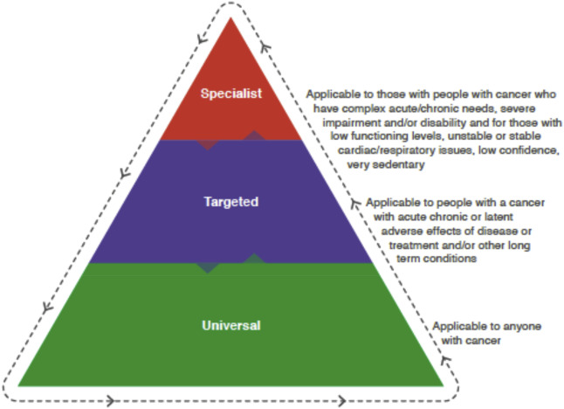
Pen picture one
Using the template below create a detailed pen picture of a case example of someone that you would typically work with, within your clinical setting. Using the biopsychosocial model, distinguish how your case examples health and wellness fits within the various sciences.
Pseudonym Name:
Saskia Pearson

Biological details:
Saskia is a Caucasian lady who is a Welsh and English speaker and is 49 years of age and is diagnosed with Endometrial cancer and for TLH + BSO + Omentectomy - surgery booked for 4 weeks time. Her past medical history includes parathyroidectomy, Cervical discectomy 2009, 2023, Lumbar discectomy 2015, Arthritis, Depression. Height : 5ft4. Current Weight : 103kg. BMI: 39. Weight has remained stable over last six months.

Psychological details:
Saskia feels she has been managing well since her diagnosis of cancer but has some concerns about her diet and what she is eating. Saskia also states she can fall asleep during the day in the chair. Goes up to bed 10:30, can take some time to get to sleep. Puts on a podcast on her phone which she feels helps to get to sleep. Once she gets to sleep she is ok, but can be woken early morning. Saskia is motivated to engage in exercise and exercises 3-4 times a week.
Declined being worried about the operation. She has some worry about if something happens to her who she feels she is leaving behind. She feels that she is managing the worries and has coping strategies in place to manage these. She feels able to speak to her husband about any concerns she has. She feels she has a good understanding of the medical procedure and what to expect and has a good understanding of needs for prehabilitation which she feels she can self manage and has many mood lift activities that she uses. She has thought about writing letters for her grandson so he knows who she is. Saskia sometimes worries about talking too much to her family about her diagnosis as does not want to cause them to feel any anxiety either.

Social details:
Saskia lives in a house with her husband who is currently working as an engineer. Saskia worked as a classroom assistant but has not worked for a while as she states she has currently been given time off work. Saskia feels supported by manager at work and colleagues and states she has explained her health situation at present. Saskia does not smoke or drink alcohol. Husband does most of the cooking at home. Enjoys sewing, enjoys puzzles and gors to yoga classes and general exercise classes 4-5 times a week. Goes for walks – variable distance and time, looks after grandson a few times a week.
Saskia also enjoys swimming and has been previously advised to avoid prior to surgery and would like to go back to swimming again.

Task one: Explain the science behind your assessments or treatment
3.1 Make notes of an assessment or observation you undertook with your case example. Make sure to name what sciences underpinned how the condition impacted the case examples presentation and what sciences informed your choice of assessment or intervention.
I spoke to Saskia to complete an initial assessment with her and this is mainly an information gathering session following patients returning their health and quality of life questionnaire after we have received a referral and that referral has been accepted into the service. This EORTC qlq-c30 questionnaire is based on epidemiological science and a number of different scientific measures to look at the health related quality of life, symptom burden and functional health (Cocks et al, 2023). Epidemiological science is data gathered around health of populations and influences on health outcomes and specific measures are drawn up and can influence public health measures, such as White Papers that can change the course of how public health and outcomes are delivered. This questionnaire has been drawn up based on continuous studies on variety of populations of cancer patients and translated into many different languages and is continually assessed for its validity. This can be useful to provide an overview of needs before meeting the people we work with and often can give us a basis on who needs to see the individual person first. The EORTC is inputted into a database to give an idea of whether an individual would need a universal, targeted or specialist approach based on the answers provided and which therapists are most suited to see them. If they need a qualified physiotherapist, dietitian or Occupational therapist or a therapy assistant practitioner input on first assessment. Therapy assistant practitioners see universal patients and targeted and a more detailed session with discussion with the person is how we hope to meet our patients needs.

An appointment was made to attend a virtual Microsoft teams meeting to complete an initial assessment with me as patient came out as targeted on anxiety, mood scale and nutrition but universal for physical function. We use a lot of computer science for our service to be able to meet patients needs and cover a large area of Hywel Dda despite being a small team. From the tools we use, such as databases, to electronically produce outcome measures from the questionnaires, databases to keep the information for the patients we see, to how we meet them using a virtual means (NHS England, 2026).
We communicate with our patients using email often to send out information following our sessions.

When completing assessments developing rapport and understanding the persons personal preferences is really important to being able to understand what they can and are able to accommodate realistically in terms of a health plan. We have gathered the information from the questionnaire and are often going over many of the same topics so this is more like an informal assessment of the patients needs. Their living situation and social history is therefore a vital part of establishing their goals. A barrier to being able to engage in prehabilitation can be lack of social support network and understanding of prehabilitation and its core benefits for recovery and tolerance of surgery and treatments (Van der Velde et al, 2023). Social science identifies an understanding of the different factors that can influence certain societies and groups in engagement with healthcare and it is useful for me to understand the capabilities that can be present from different groups that can be influenced by a variety of social, psychological and biological factors such as religion, social status, age, education and employment and to recognise that everyone does not necessarily have the same opportunities or understanding for me to be able to accommodate and ensure I am delivery an equitable service. An example of this could be access to resources for patients in the area they are in, for Saskia having a good knowledge of the area in Pembrokeshire they have free access to activity for people with particular conditions such as arthritis in certain areas and having a good knowledge of third sector charities and what can be offered can be important to be able to give people the best opportunities for prehab. Social science also identifies increasing public health knowledge for general health can be very beneficial to patients as they are more informed of what they can do for themselves.

Nutrition:
PG-SGA Score (from questionnaire):5
This patient was assessed using PG-SGA score which is a nutritional assessment for the survival prediction for elderly patients with cancer (Zhang et al, 2021).
This patient has been identified as needing targeted intervention for nutrition and therefore needed further investigation on whether she needs specialist guidance and intervention from the dietitian within our team or whether it is more appropriate for a therapy assistant practitioner to monitor and encourage self management of her nutritional needs. The science behind the PG-SGA is physiological as it’s a way of monitoring and identifying metabolic and physiological changes that can happen to patients with cancer and effectively triaging the interventions needed to avoid severe malnutrition. As patient X has remained a stable weight since filling in the questionnaire and during assessment at this time low level interventions are more necessary to monitor at this time. Through discussion Saskia states that she does not cook herself at home and her husband does most of the cooking. She prefers takeaways and eating out.
Discussed with Saskia ways she could improve on meals by ensuring protein with every meal and the importance of this and discussed her likes and dislikes with fruit and veg. She states she never plans meals but could see the benefit of this through discussion.
Discussed with Saskia how small changes now can make a big difference and she was happy to set her own goal of adding protein and 1 portion of fruit or veg per day and build upon this week by week for the future. No symptoms, bowel movements normal x 1 a day and drinks up to 2 litres of fluid throughout day. Discussed about weighing weekly to monitor and food and mood. Saskia has a high level of activity and her protein needs would need to meet this also and she appears to be motivated and understand the importance of good nutrition through discussion. Saskia was happy to have information emailed out to her as well so she had a point of reference.
Anxiety:
Behavioural science plays a large part in my screening assessment for any prehabilitation assessments – individual behaviour change and motivation to engage with behaviour change and adapt to engagement of increasing activity, improving mental health and adapting in change to improve nutritional optimisation can be improved by realising that the person must be able to engage with the intervention and making this as personalised an assessment as possible where the person can establish their own goals is essential. Discussions around mood and anxiety can open up discussions around self motivation and getting to know the individuals personal preferences and strengths and what they feel are barriers and limitations can help to form a follow up plan for patients that they can adhere to and that they are more likely to remain motivated with. Small and realistic goals and to build these up can work best (Grimmett et al, 2021). When discussing with Saskia her mood she feels assured at this time as she has more of a plan moving forward and this has given her confidence in self managing her prehab needs with basic education around health advice given.
Plan:
1. To send out universal information and why is protein important info and to follow up on patients request in a weeks time to see how she is managing with goals set to increase protein, maintain activity and making small changes herself with information given.

Patient limited in time she can engage in prehab before surgery.

Case Study Two
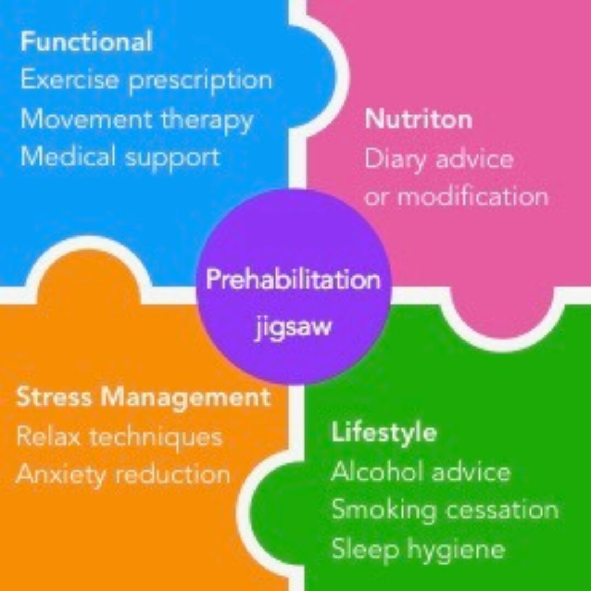
Pen picture one
Using the template below create a detailed pen picture of a case example of someone that you would typically work with, within your clinical setting. Using the biopsychosocial model, distinguish how your case examples health and wellness fits within the various sciences.
Pseudonym Name:
Clark Gable
Biological details:
Clark is a 59 year old white male who has come into the service after a diagnosis of Oesophageal (Upper GI) Cancer. Patient has had PET and CT scan and is awaiting results from this – he reports he will need chemo treatment and then surgery. His past Medical History includes: Asthma, barretts oesophagus, non-alcoholic chronic liver disease, benign essential tremor.
Height : 6ft 2. Current Weight : 132 kg. BMI: 37.4. Clarks weight has remained stable in past 6 months.
Psychological details:
Clark feels that workplace offers him stability and routine that he feels he needs at this time and he feels he does talk to family but does not want to burden them too much and worries about this. He has recently had a medical test in work which he passed without issue. Clark reports no issues with fatigue – feels generally tired at the end of a 6 day working week and needs a rest day and feels recuperated by that. He reports he can feel very unmotivated at times though. Clark reports his routine is to get around 5-6 hours of sleep as he works shifts at times he is able and he has no issues with getting that sleep. He reports he is a “natural worrier” and has concerns around his health and in particular finances – he reports that he would possibly like some support with his wellbeing and managing anxiety.
Mood:
Mood scale today: 7-8
Clark reports he is generally a positive person and he tries to remain at around that score and that does not fluctuate too much – he feels the routine and stability of work helps a lot with this. Discussed uplift activities with patient and ensuring he is finding time for himself to complete hobbies and interests that he can feel the benefits from and the importance of this to improving his general motivation and energy levels.

Social details:
Clark lives in a house he is privately renting with wife and 3 children who are 11, 14 and 18. Clark reports he is working full time as a train driver and is normally 6 days on and this is often shift work and can be night shifts – has been doing this job for 3 years. Clark reports he is used to doing shift work and has been doing this for a long time. Clark has shared with his manager his medical issues and feels he has a supportive environment in work. Non smoker and does not drink alcohol.

Task Two: Explain the science behind your assessments or treatment

3.1 Make notes of an assessment or observation you undertook with your case example. Make sure to name what sciences underpinned how the condition impacted the case examples presentation and what sciences informed your choice of assessment or intervention.
Clark completed an initial assessment with me after his EORTC was stratified and came back as universal. Clark attended the session via Teams and gave verbal consent for initial discussion. The process of getting informed consent is rooted in psychology and is a branch of the social sciences and ensures a patients understanding of any interventions they are consenting to so an explanation of our service and what we offer and ensuring an understanding that Clark would need to be engaged and understands the therapies is important (Shah et al, 2024). Informed consent is essential so that we can promote individuals making their own decisions about their care and the goals that they set based on their preferences with an understanding of all the risks, benefits and alternatives.
Clark has financial concerns which he has spoken to Kelly his key worker about. He is aware that he will be on full time pay for a certain amount of time in work and then drops to half pay and has concerns around this that affects his wellbeing, he is private renting and his rent is high also. Clark is happy to have Cancer Information and support services referral made on his behalf. Understanding the persons work/life balance and to ask about finances is important as it can give an idea of how a person may manage through a prehabilitation programme – not only will this give an idea of how much time the individual can dedicate to a plan agreed with them but also the psychology around how the person sees and identifies themselves in the world they live in. This is linked to neuroscience and social psychology – motivation is very much linked to neuroscience and social psychology focuses on needs, fairness and how collaboration boosts effectiveness and engagement. Having a purpose within the community and enjoying their work role, how they see their role and whether they feel they are supported can be important in understanding their wellbeing. As a team, we can also look at does this person need a AHP fit note and requires time off work and can we support with this also? How they see their role in the workplace and giving the person the opportunity to speak about this can offer insights into their wellbeing. Economic pressures can lead to anxiety and negative emotions but work can also provide a structure and routine that can be essential to many peoples wellbeing. When people have to take time off work this can lead them to feel a slight loss of identity also. As noted by Deci and Ryans self determination theory there are innate needs that work can satisfy that can lead to wellbeing and motivation (Bertazzi, 2010).
Clark should be under Upper Gastro Intestinal dietetic specialist team – he reports he has issues with swallowing and he has not heard from UGI team at this time – checked on wpas and there is no record of UGI DT team involvement. Did not discuss nutrition in depth at this time as he has not had the input from this team and need to discuss this with our dietitian. Clark reports he is keen to lose weight at this time. Discussed trying to keep a stable weight at this time if needing treatment. Clark reports his symptoms have improved since having 3 stretches in his oesophagus for narrowing completed in Gloucester hospital.
Clark reports he is limited in his activity and he does not do a lot at home – he feels his barriers are that he works shifts and these can change often so finds it harder to commit to attending group sessions that are same time every week. He also reports he can be very unmotivated at times and this can be due to feelings of fatigue and extreme tiredness not relived by rest. He reports he has 3 children at home which keeps him busy and he does limit the amount of time he spends sedentary but often struggles with moving around due to extreme tiredness also. Another main barrier he reports is when he attempts activity – eg a walk with his wife or if he is straightening his knees too much, his knees can often “click out of place” particularly if walking inclines, and then he cannot complete activity for a few days or is more limited in what he can do. He reports that he has seen about this and has had athroscopy and gel injections in the past and he has been told that this is to do with having no cartilage in his knees. He reports he would like to be more active and would like to see the physiotherapy team to see if he can increase his activity levels more. Discussed National Exercise Referral service with patient and charges for this and patient accepted but discussed seeing with the physiotherapist within our team if there are any functional exercises he can do around the home at this time to increase his activity levels and support him with this first. Clark agreed to follow up with physiotherapy to discuss this further if appropriate. Clark identified a barrier themselves which appears to be rooted in the science of physiology and requires intervention from physiotherapy for strengthening exercise. He was engaged with this and appears to understand the importance of physical exercise on positive outcomes after surgery (Del Bianco et al, 2024). Increasing strength and physical exercise before surgery can increase patients physiological capacity and ability to manage treatment and surgery and enhance outcomes and recovery for individuals.
Clark identified fatigue as another possible issue for him on his assessment. This is part of our initial assessment as cancer related fatigue can affect almost 90% of those with cancer (National Cancer Institute, 2026) and can be a very common problem that has an affect on how individuals may manage a prehabilitation/rehabilitation programme. When considering a programme for individuals to make it person centred and factors in their needs it can be an important factor in considering how long interventions should be, any particular times of the day that may be favourable and how motivated they may be as fatigue can impact cognitively as well as physically. The science behind this can be described in the roots of biochemistry as it can be influenced by a biochemical response as this can be contributed to the immune system when tumours release cytokines and can cause an inflammatory response (Yang et al, 2019) and cancer cells can consume nutrition and calories which can cause and energy drain for individuals – as this is happening on a cellular level this is linked to cell biology and the reactions between cells. Also, treatments like chemotherapy, radiotherapy and immunotherapy and even more advanced and emerging sciences using precision medicine to target specific mutations of a tumour that use genomics to target these cells can have affects on the body that can cause fatigue symptoms.
Clark is unable to attend wellbeing group as he works shifts and he would not be able to make wellbeing group tomorrow and cannot commit due to working hours changing. He would possibly like some 1-1 support with anxiety and fatigue management techniques in the future as he feels that this might possibly support his motivation and mood.

Task Three: Evaluate the impact of using science to understand the case study performance and your decision making.
4.1 and 4.2: Using the Gibbs reflective cycle, reflect on how your enhanced knowledge of science influenced the assessment or intervention described in task one.
Description: How did you learn about the sciences? Where did you gain the knowledge?
I have always had an interest in science generally and subscribe to Science Direct magazine monthly and read and like to keep up to date on new and emerging issues around science. I gained most of my knowledge about the different sciences and how they relate to my workplace from journals online and feel it is really important for me to keep updated and have a good understanding for my colleagues and patients. I enjoy watching specific reputable youtube videos and online resources that have aided my studies previously to keep up to date on current new findings and theories around the different sciences.

Feelings: How does having an enhanced knowledge of science make you feel when assessing or carrying out an intervention? How does it make others feel?
I feel that having an enhanced knowledge of science can keep me updated and constantly wanting to learn why I am doing what I am doing. It improves overall competence and allows for improvements if needed and to constantly re evaluate the reasoning behind any interventions I carry out. It also provides me with the curiosity to be able to see if there is anything that can be added or tested with colleagues I work with as well, as all science is ever evolving and opens doors to more opportunities all the time to offer better outcomes for the people we work with. I feel that it is reassurance to know what I am doing is evidence based and tested. I also feel it has expanded my world view about public health and social science generally and issues that are happening in the world around these subjects. I hope that my colleagues feel reassured that my contributions are competent in my work role due to this and I feel reassured when I am delivering a service to patients also. I feel it is important to everyone to have a good basis and understanding around science as this is the basis for most things that we do/see everyday.
Evaluation: What are the positive and negative aspects of gaining and understanding knowledge of science and applying to practice.
The positives of gaining a good understanding of science is that it can open doors to new innovative ideas in the workplace and hopefully better outcomes as a result. It can also make us reassess our reasoning behind what we are doing and keep things refreshed for us as we learn new things, as there is always something new to learn and we can always expand on our knowledge. This can benefit the patients we work with as we are keeping current and up to date with all new opportunities for them as well.
It can have negative impacts if applied incorrectly to a situation or if the understanding is not there and when constantly asking why we have to consider other peoples way of working and how appropriate it is to the situation in front of us. Sometimes we need to consider we have to make decisions quickly and do not always have time to look things up or test the knowledge in the workplace so adapting to what is appropriate for the moment is important. Having a passion for science I feel therefore can be a good thing to slowly gain knowledge over time with different topics and areas of science.

Analysis: What sense can you make of having enhanced knowledge of science when assessing or treating someone? What impact does it have on your overall performance?
Having an enhanced knowledge of science can provide individuals with confidence that what they are doing is evidence based and researched thoroughly so we don’t always need to. Having confidence can increase competency when delivering a service to the individuals we work with. It also provides us with the reason why and a good understanding of what we need to look for and understand out of the interventions we deliver. If you look at things with a scientific outlook we are continuously reflecting on our performance and evaluating and creating our own theories on our own practice while we work. It also allows for innovation and can allow individuals to be positive influences in making changes within their workplace.

Conclusion: What did you learn about yourself when gaining an enhanced level of knowledge of science? What did you learn about your application of scientific knowledge in your practice?
I learnt that I am a bit of a science geek! I feel that this has solidified my passion around subjects and feel that this has contributed to my passion for research and looking into things. I have very much enjoyed listening to conversations and feel that this is in many ways how we learn, and asking those important questions and having discussions around these things makes me feel invigorated with the need for knowledge and learning opportunities. Science is pretty much in everything that we do and see and I have very much enjoyed refreshing the learning and considering how much this plays a part in everything that we do.

Article Title | Author(s) | Year of publication | Journal name | Abstract  (y or n) | Methods/  instruments used | Reliable  (y or n) | Validity  (y or n) | Ethical Considerations  (y or n) | Reference list  (y or n)
‘Content validity of the EORTC quality of life questionnaire QLQ-C30 for use in cancer’ | Cocks, K. Wells, J R. Johnson, C. Scmidt, H. Koller, M. Velikova, G. Pinto, M. Tomaszewski, K A. Aaronson, N K. Exall, E. Finbow, C. Fitzsimmons, D. Grant,L. Groenvold, M. Tolley, C. Wheelwright, S. Bottomley, A | 2023 | European Journal of Cancer | Y | Interviews with participants and thematic analysis of results. | Y | Y | Y | Y
What is the role of physical exercise in the era of cancer prehabilitation? A systematic review. | Del Bianco N, Borsati A, Toniolo L, Ciurnielli C, Belluomini L, Insolda J, Sposito M, Milella M, Schena F, Pilotto S, Avancini A. | 2024 | National library of medicine | Y | A systematic search from sources included Interventional studies applying a single-arm, randomized controlled, or nonrandomized design were included | Y | Y | Y | Y
‘The Role of Behavioral Science in Personalized Multimodal Prehabilitation in Cancer’ | Grimmett,C. Bradbury,K. Dalton,S O. Fecher-Jones,I. Hoedjes,M. Varkonyi-Sepp,J. Short,C E | 2021 | Frontiers in Psychology. | Y | Evaluation of existing literature re: prehabilitation | Y | Y | Y | Y
Critique check list

Reference list

- Bertazzi, P A. (2010) ‘Work as a basic human need and health promoting factor’ National Library of Medicine. Available at : [Work as a basic human need and health promoting factor] - PubMed

- Cocks, K. Wells, J R. Johnson, C. Scmidt, H. Koller, M. Velikova, G. Pinto, M. Tomaszewski, K A. Aaronson, N K. Exall, E. Finbow, C. Fitzsimmons, D. Grant,L. Groenvold, M. Tolley, C. Wheelwright, S. Bottomley, A (2023) ‘Content validity of the EORTC quality of life questionnaire QLQ-C30 for use in cancer’ European Journal of Cancer. Volume 178, pp 128 – 138. Available at: https://doi.org/10.1016/j.ejca.2022.10.026

- Del Bianco N, Borsati A, Toniolo L, Ciurnielli C, Belluomini L, Insolda J, Sposito M, Milella M, Schena F, Pilotto S, Avancini A. (2024) ‘What is the role of physical exercise in the era of cancer prehabilitation? A systematic review’. Pubmed. Volume 198:104350. Available at: doi: 10.1016/j.critrevonc.2024.104350.

- Grimmett,C. Bradbury,K. Dalton,S O. Fecher-Jones,I. Hoedjes,M. Varkonyi-Sepp,J. Short,C E (2021) ‘The Role of Behavioral Science in Personalized Multimodal Prehabilitation in Cancer’ Frontiers in Psychology. Volume 12. Available at : https://doi.org/10.3389/fpsyg.2021.634223

- National Cancer Institute (2026) ‘Cancer fatigue’. Available at Fatigue and Cancer - Side Effects - NCI (Accessed on 30th December 2025).

- NHS England (2026) What is a virtual ward. Available at NHS England » What is a virtual ward? (Accessed 29th December 2025).

- Shah, P. Thornton, I. Kopitnik, N. Hipskind, J E. (2024) ‘Informed consent’. Stats Pearl Publishing. Available from: https://www.ncbi.nlm.nih.gov/books/NBK430827/ (Accessed 29th December 2025)

- Van der Velde M, Van der Leeden M, Geleijn E, Veenhof C, Valkenet K (2023) ‘What moves patients to participate in prehabilitation before major surgery? A mixed methods systematic review’. National Library of Medicine. Volume 21;20(1) pp75. Available at: doi: 10.1186/s12966-023-01474-6.

- Yang S, Chu S, Gao Y, Ai Q, Liu Y, Li X, Chen N (2019) ‘A Narrative Review of Cancer-Related Fatigue (CRF) and Its Possible Pathogenesis’. National Library of medicine. Volume 18; 7 pp738. Available at doi: 10.3390/cells8070738.

- Zhang, Q., Li, XR., Zhang, X. Ding, J S. Liu, T. Qian, L. Song, M-M. Song, C-H. Barazzoni, R. Tang, M. Wang, K. Xu, H. Shi, H (2021) ‘PG-SGA SF in nutrition assessment and survival prediction for elderly patients with cancer’. BMC Journals. Volume 21 pp 687. Available at: https://doi.org/10.1186/s12877-021-02662-4

