University of Wales Trinity Saint David
Wales Institute of Science and Art


Electronic Control Systems
ACHA4010 Electrical Control Systems

James Minton
2204900

21/03/2024
Contents
1 Task 2 1
1.1 Scope Time Division Calculations (4) 1
1.2 Function Generator output sine wave (3) 1
1.3 Unsmoothed Rectifier Wave (3) 2
1.4 Smoothed Rectifier Wave with capacitor (3) 2
1.5 Drop in Voltage Question (4) 3
1.6 Different Voltage Readings Question (5) 3
1.7 Rectifiers use in Automotive applications Question. (4) 3
1.8 Probing Question (4) 3
2 Task 3 4
2.1 Scope Time Division Calculations (4) 4
2.2 Function Generator output square wave (3) 4
2.3 Capacitor charge and discharge wave marked at correct points. (3) 5
2.4 Basic Capacitor Calculations (3) 5
2.5 Capacitor discharge table (4) 5
2.6 Gradient Plot and calculations (4) 6
2.7 Capacitor Uses (5) 7
2.8 Inaccuracies Question (4) 7
3 References 8

Task 2

Scope Time Division Calculations (4)
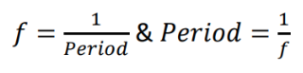
F=1/10=0.1
10 mS

Function Generator output sine wave (3)
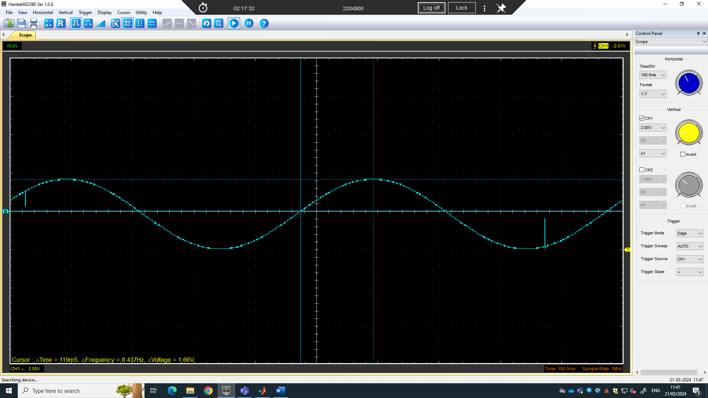
Figure 1 peak voltage
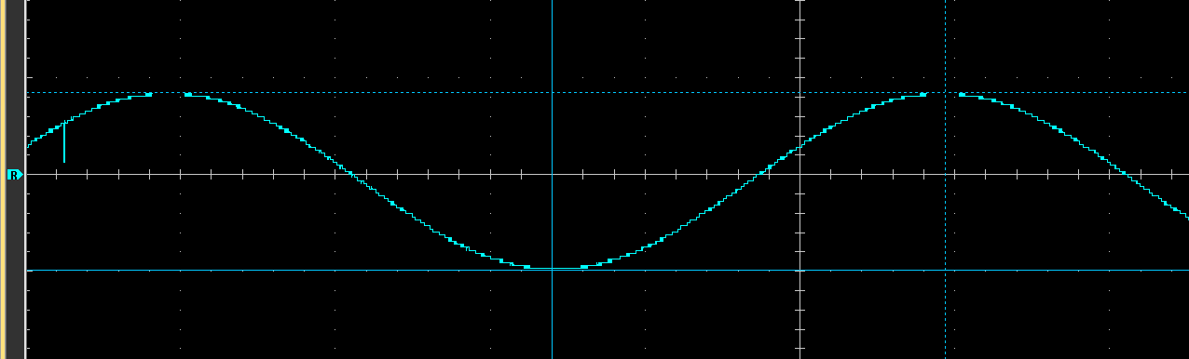
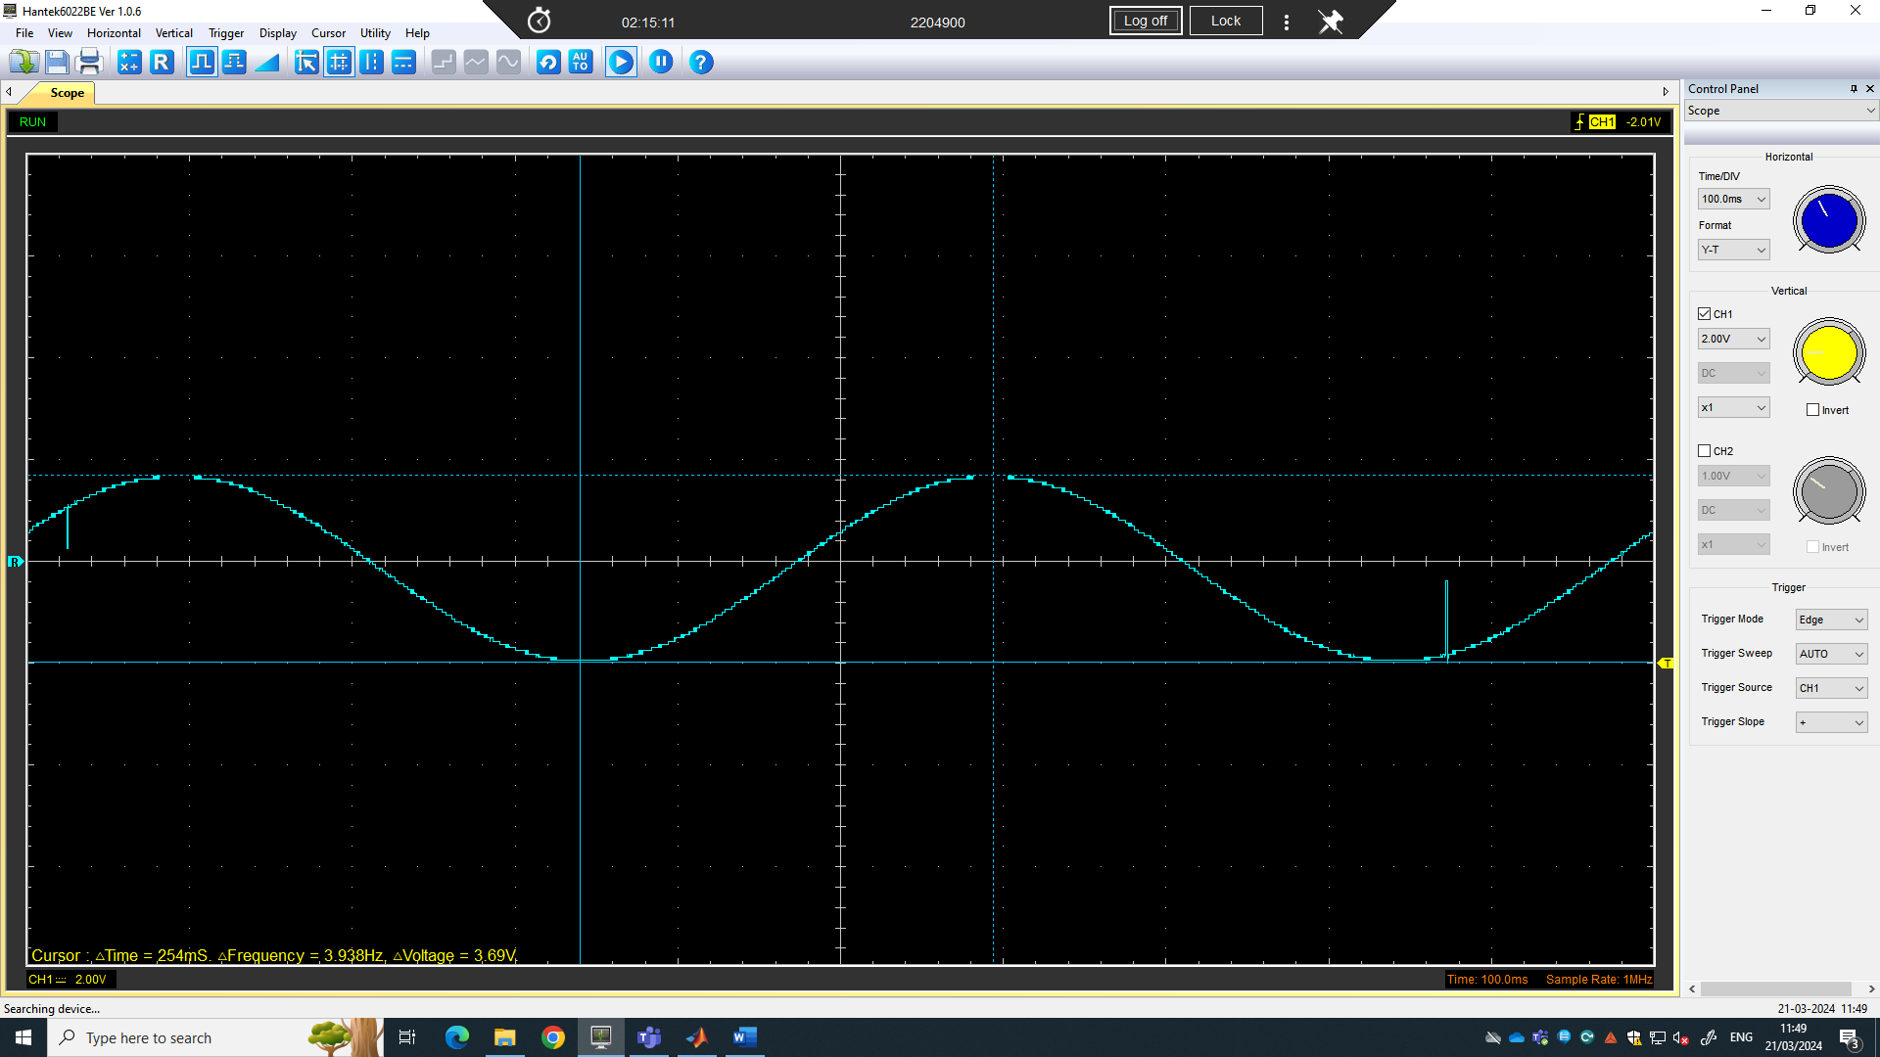
Figure 2 peak to peak voltage.

Unsmoothed Rectifier Wave (3)
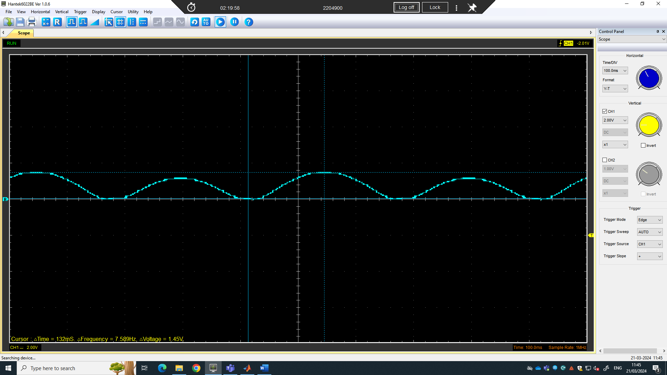
Figure 3 peak voltage.

Smoothed Rectifier Wave with capacitor (3)
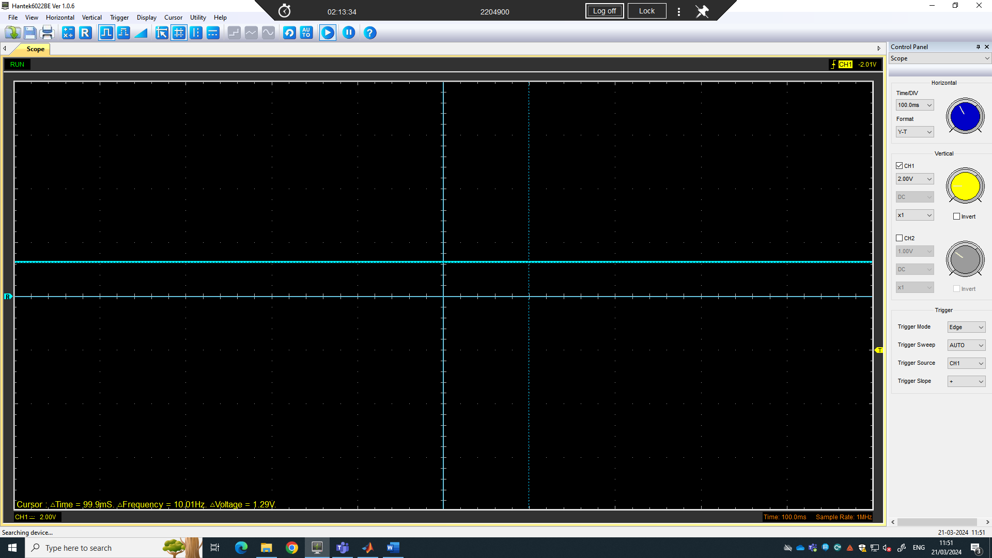
Figure 4 peak voltage.

Drop in Voltage Question (4)
The reason for the voltage drops on the full bridge rectifier is because of the two of the forward-facing diodes these each have on potential difference barrier of 0.6 volts (V.Ryan 2022), so the total voltage drop is 1.2 volts.

Different Voltage Readings Question (5)
Peak voltage = 1.66 volts
Peak to peak voltage = 3.69 volts
V_{RMS} = 1.66 / 1.414
V_{RMS} = 1.174 Volts
RMS is used to find the AC current average this then can be compared to the DC current value.

Rectifiers use in Automotive applications Question. (4)
- Rectifiers are used in the charging system of the battery Turing AC current into DC current for the battery.
- Starter motors all need rectifiers to work as they only use dc current to rotate.
- Headlights
- Radio
(Iyul Nasruddin 2023)

Probing Question (4)
Traditional oscilloscopes typically use a single ground reference point used by all channels. Probing the function generator and the rectifier simultaneously, both would be referencing the common ground in turn creating a short circuit or inaccurate measurements. Another reason simultaneous probing cannot be done is because of channel isolation oscilloscopes channels are usually not electrically isolated from each other, so when connecting different channels to different points on a circuit can make unintended signal paths or interference between channels.
Ways to allow for simultaneous probing:
- Isolation transformer: The use of an isolation transformer can electrically isolate the different parts of a circuit, including the function generator input and the rectifier output.
- Multiple oscilloscopes: using multiple oscilloscopes with separate ground will allow simulators probing.
- Differential probes: provides isolation between the oscilloscope ground and the circuit.

(Written with the help of CHATGPT)

Task 3

Scope Time Division Calculations (4)

R | 10000
C | 10
t | 100000
T | 2000000
F | 0.0000005
T/10 | 200000
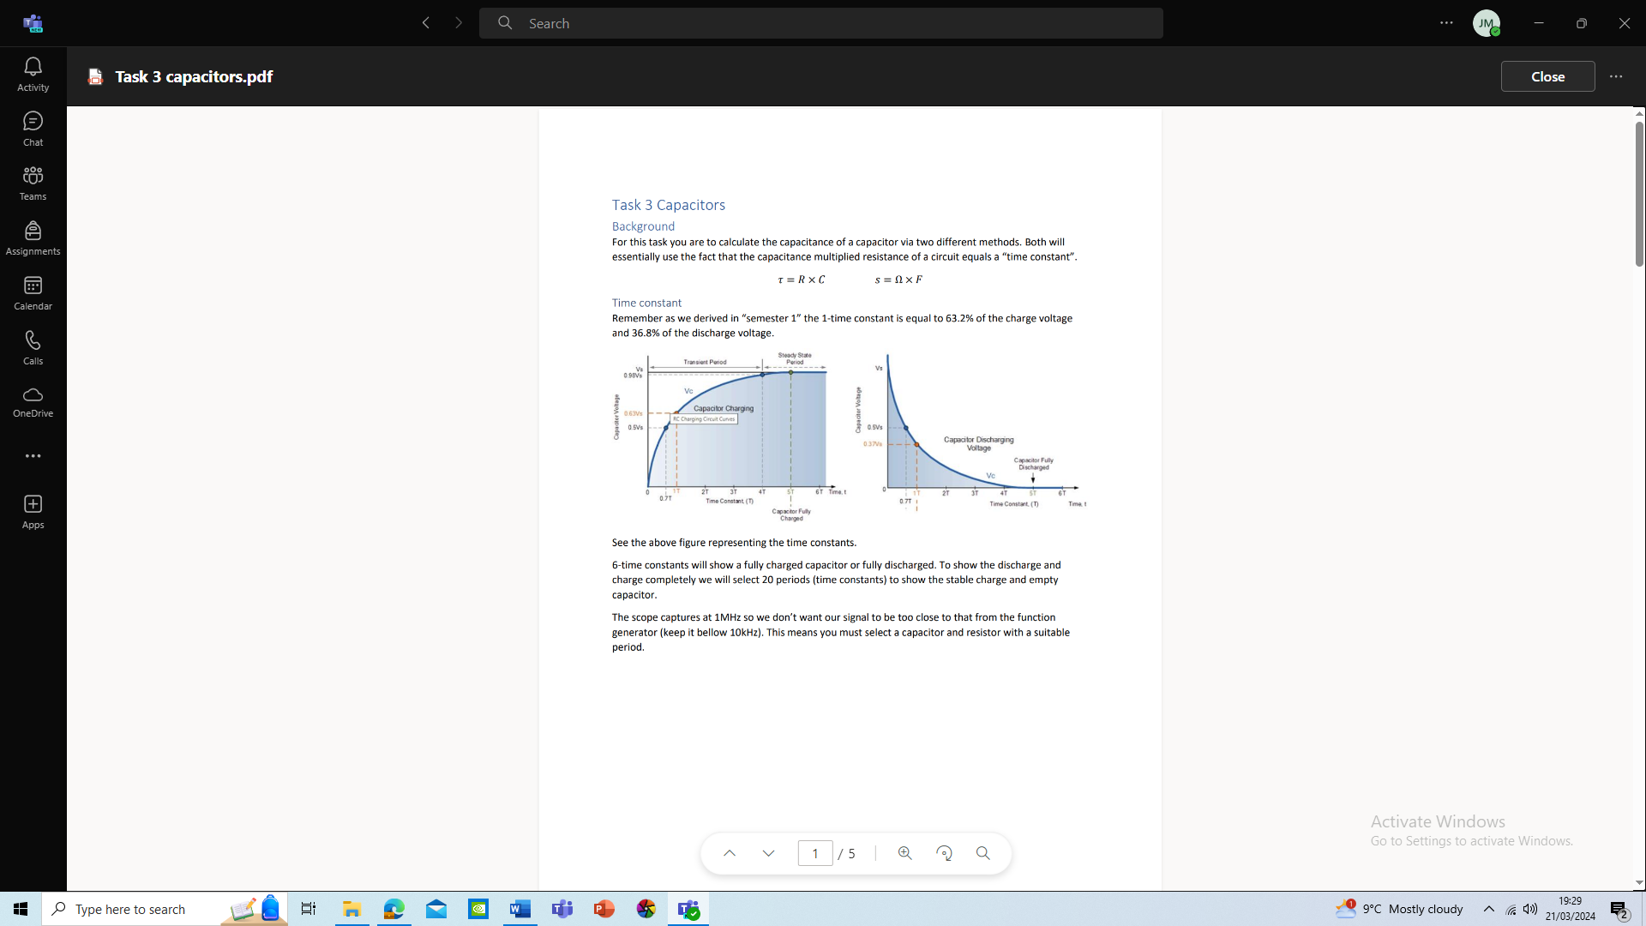
20*t=T
F= 1/T
T/10

Function Generator output square wave (3)
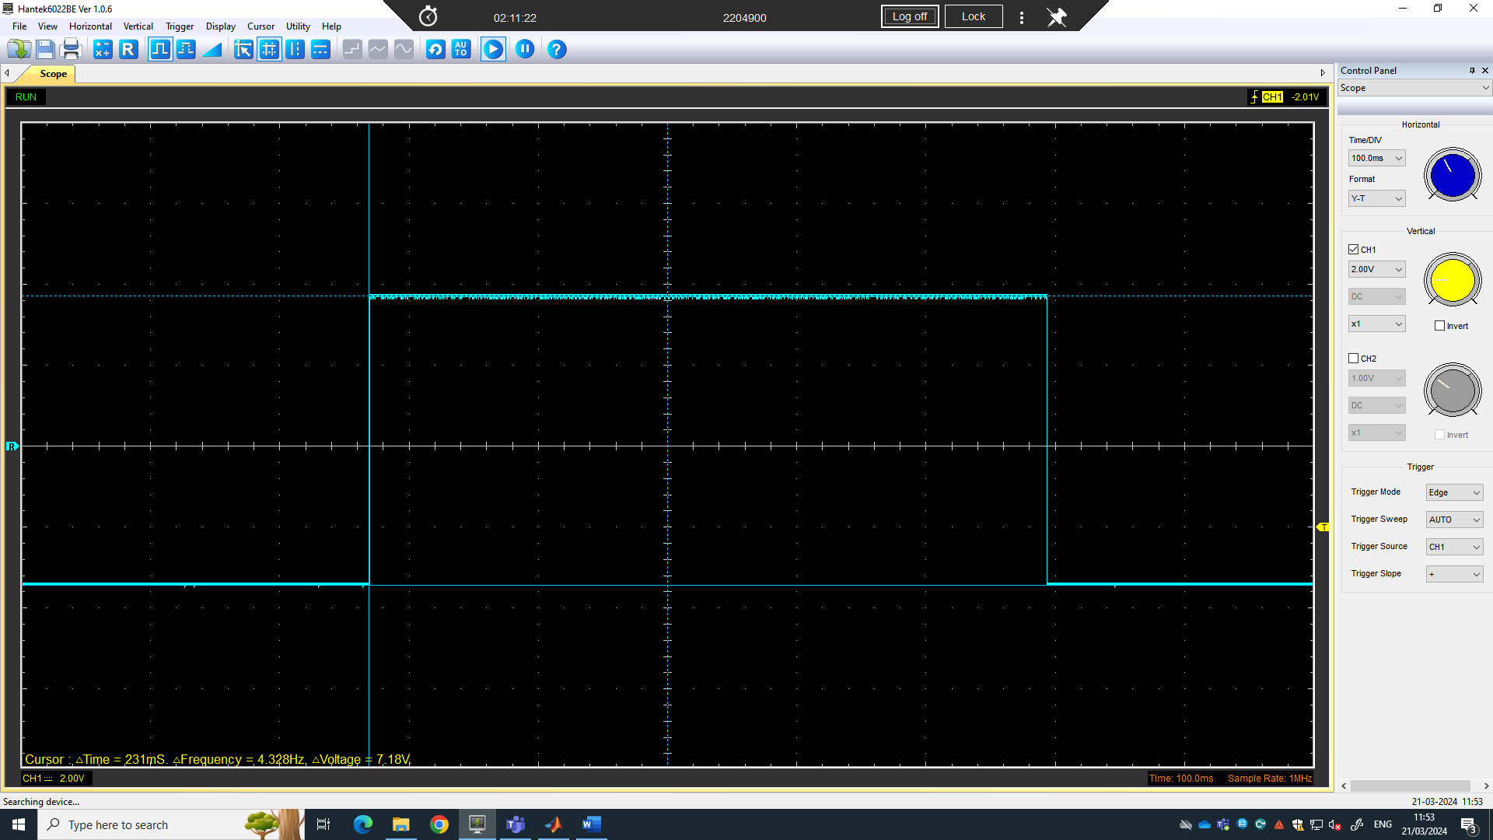
Figure 5 peak to peak voltage.

Capacitor charge and discharge wave marked at correct points. (3)
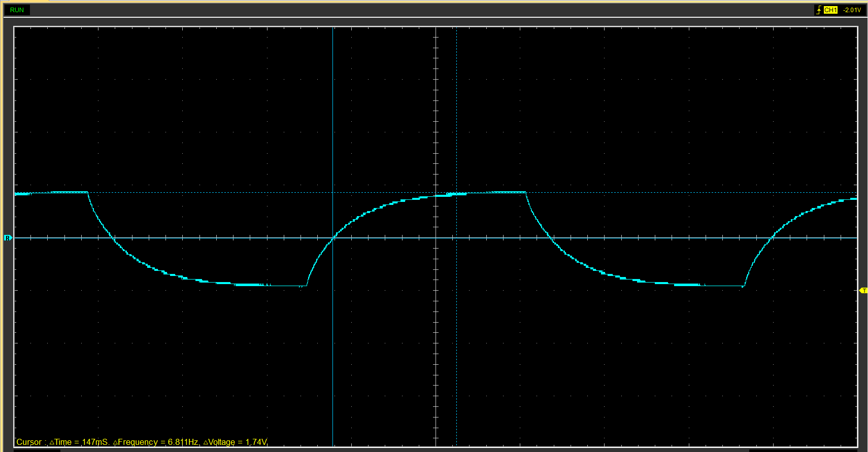
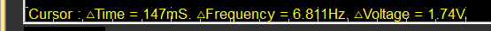
Peak v = 1.74
(1.74-0) *0.632+0 (1.74-0)*0.368+0
1.09 v 0.64v
53.2 mS 241 mS

Basic Capacitor Calculations (3)
t | 100000
R | 10000
C | 10
t/R = t

Capacitor discharge table (4)

 |  |  | time | voltage | v+ | ln(V+) | dy | dx | dy/dx
0 | 9000 |  | 0.008995 | -0.0627 | 4.9373 | 1.596819 | x | x | x
1 | 9333 |  | 0.009328 | -0.251 | 4.749 | 1.557934 | -0.03888 | 0.000333 | -116.77
2 | 9666 |  | 0.009661 | -0.3765 | 4.6235 | 1.531152 | -0.02678 | 0.000333 | -80.4267
3 | 9999 |  | 0.009994 | -0.5647 | 4.4353 | 1.489595 | -0.04156 | 0.000333 | -124.795
4 | 10332 |  | 0.010327 | -0.6902 | 4.3098 | 1.460891 | -0.0287 | 0.000333 | -86.1975
5 | 10665 |  | 0.010649 | -0.8157 | 4.1843 | 1.431339 | -0.02955 | 0.000322 | -91.7766
6 | 10998 |  | 0.010993 | -0.9412 | 4.0588 | 1.400887 | -0.03045 | 0.000344 | -88.5234
7 | 11331 |  | 0.011326 | -1.0039 | 3.9961 | 1.385319 | -0.01557 | 0.000333 | -46.7522
8 | 11664 |  | 0.011659 | -1.1294 | 3.8706 | 1.35341 | -0.03191 | 0.000333 | -95.8239
9 | 11997 |  | 0.011992 | -1.1294 | 3.8706 | 1.35341 | 0 | 0.000333 | 0

Gradient Plot and calculations (4)

Capacitor Uses (5)
- Capacitors are used in car speakers to stop the headlights dimming as the subwoofer in the speaker is activated. (martin 2023)
- Ignition system
- ECU
- Regenerative braking
- Electric motors
- Power steering
- RF communication
- Camera flashes
- Start-stop systems.
- Timing circuits e.g. clock circuits
(written with the help of CHATGPT)

Inaccuracies Question (4)
The first reason for inaccurate results would be from the function generator creating noise and interference.
The second reason would be the resistance of the measuring equipment for more accurate measurement the model of the measurement arrangement needs to be added to the capacitor model. (meettechniek.info, 2014.)
Thirdly would be Dielectric losses, these would appear as ohmic losses they are dependent on frequency and voltage. (meettechniek.info, 2014.)

References
(Format to Harvard style as per handbook)
(‌CHATGPT v3.5)
‌Improvecaraudio.com. (martin)(2023). How Do I Stop My Lights From Flickering When Bass Hits? [online] Available at: https://improvecaraudio.com/how-to-stop-lights-from-flickering-when-bass-hits/
[Accessed 15 Mar. 2024].

meettechniek.info. (n.d.). Measuring capacitance :: Electronic Measurements. [online] Available at: https://meettechniek.info/passive/capacitance.html.

technologystudent.com. (V.Ryan) (2022). DIODES USED TO DROP VOLTAGE - ZENER DIODES AND RECTIFIER. [online] Available at: https://technologystudent.com/elec_flsh/DIODES2.html.

upgradedvehicle.com. (2023). Are Cars DC or AC? - Upgraded Vehicle. [online] Available at: https://upgradedvehicle.com/are-cars-dc-or-ac/#:~:text=Batteries%2C%20especially%20the%20conventional%20lead-acid%20types%2C%20store%20and
[Accessed 15 Mar. 2024].

‌

‌

