‘You can create who you are, gender-bending is just the start.’
The exploration of gender identity represented in drag.

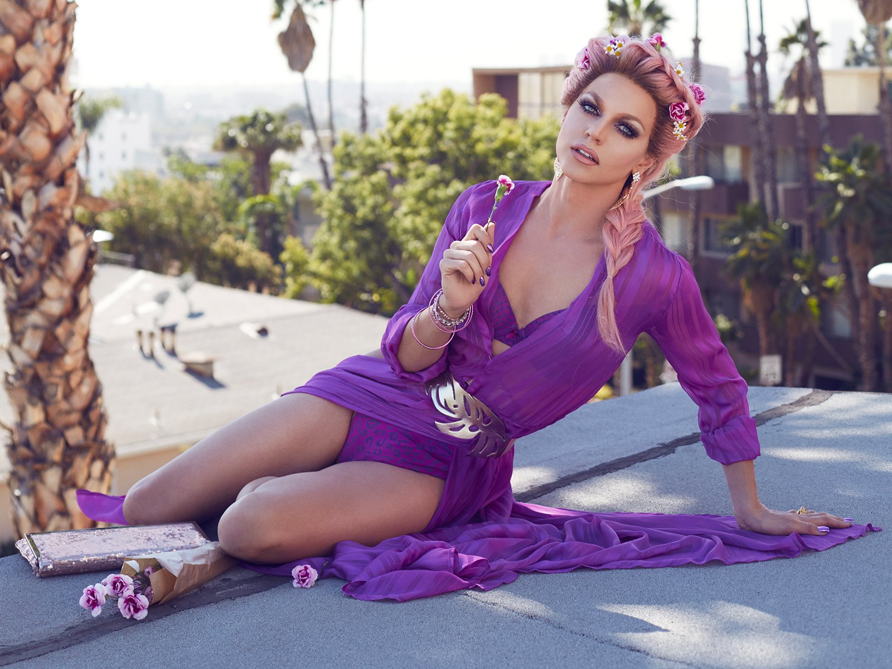

Miriam Nosworthy
P146423
BA Digital Film and TV Production
4818 Word Count
Lecturer: Robert Jones
Content

Introduction P3

Chapter One P5

Chapter Two P10

Chapter Three P16

Conclusion P21

Referencing P23

Bibliography P25

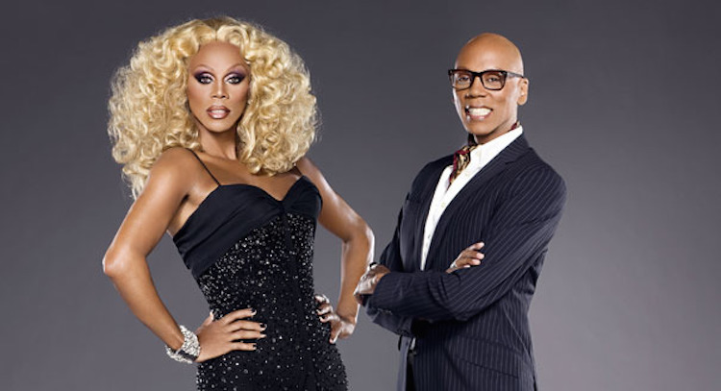
Drag has been around since 400 BC when only men we’re allowed to perform on stage. Since then drag has become bigger and more popular in mainstream culture, currently down to one queen who appeared in the 90’s, RuPaul. The supermodel of the world brought drag to everyone’s televisions with her talk show The RuPaul Show. Since then RuPaul has helped start careers for over a hundred drag queens with her competition series RuPaul’s Drag Race.

RuPaul Charles in and out of drag.

The art of drag in the past year has intrigued me, it’s something I never saw growing up but once I watched one episode of RuPaul’s Drag Race I wanted to know more about this part of gay culture. I soon realised that drag is in every city all over the world. The more I learnt about drag the more I began to realise there was a lot of debates on what drag is. For me I believe drag is for anyone no matter what their gender or sexuality is, I consider drag to be an art form that lets people express their gender and true selves through make up, fashion and performance. In this dissertation I am going to discuss drag and if gender identity and binary labels are needed to help represent drag. In the first chapter I’m going to discuss what gender is and the different kinds of gender labels people use as well as discuss the theory behind gender binaries using Queer Theory and Poststructuralism. To help discuss and explain Queer Theory and Poststructuralism I have researched into theorists Judith Butler and Michel Foucault, specifically their books ‘Gender Trouble’ and ‘The History of Sexuality.’ In the second chapter I will use the research from chapter one and apply it to the television series ‘RuPaul’s Drag Race’ debating whether the show follows the theory of Queer Theory or the theory of gender binary that Poststructuralism supports. As RuPaul’s Drag Race is such a large series I’ve chosen to specifically concentrate on only a few queens from the show who support my research. The third and final chapter will be based on my own documentary, which I am currently working on. I will use the research that I have discovered from my first two chapters and apply it to my own film. By doing this I hope to create a documentary that may look at gender differently then I originally planned, as well as help me to create questions for my subjects to discuss what they believe gender means and represents when it comes to drag. I am hoping from this dissertation I will be able to create a better understanding of what drag represents and whether drag is a form of gender expression or in fact maybe gender binaries have no connection to drag.

Gender is the social construct man and woman; although it is often thought to be the same things as sex they are two different things, Sex is the biological characteristics of women and men. Gender is determined by tasks and roles attributed to women and men in society. As Courtney Act simply explains in her Social media series ‘Courtney Act Talks…’ ‘Gender is about what’s between your ears and your sex is about what is between your legs’ (Act, C. and Jenek, S. (2017). Courtney Act Talks... Gender Terminology.)
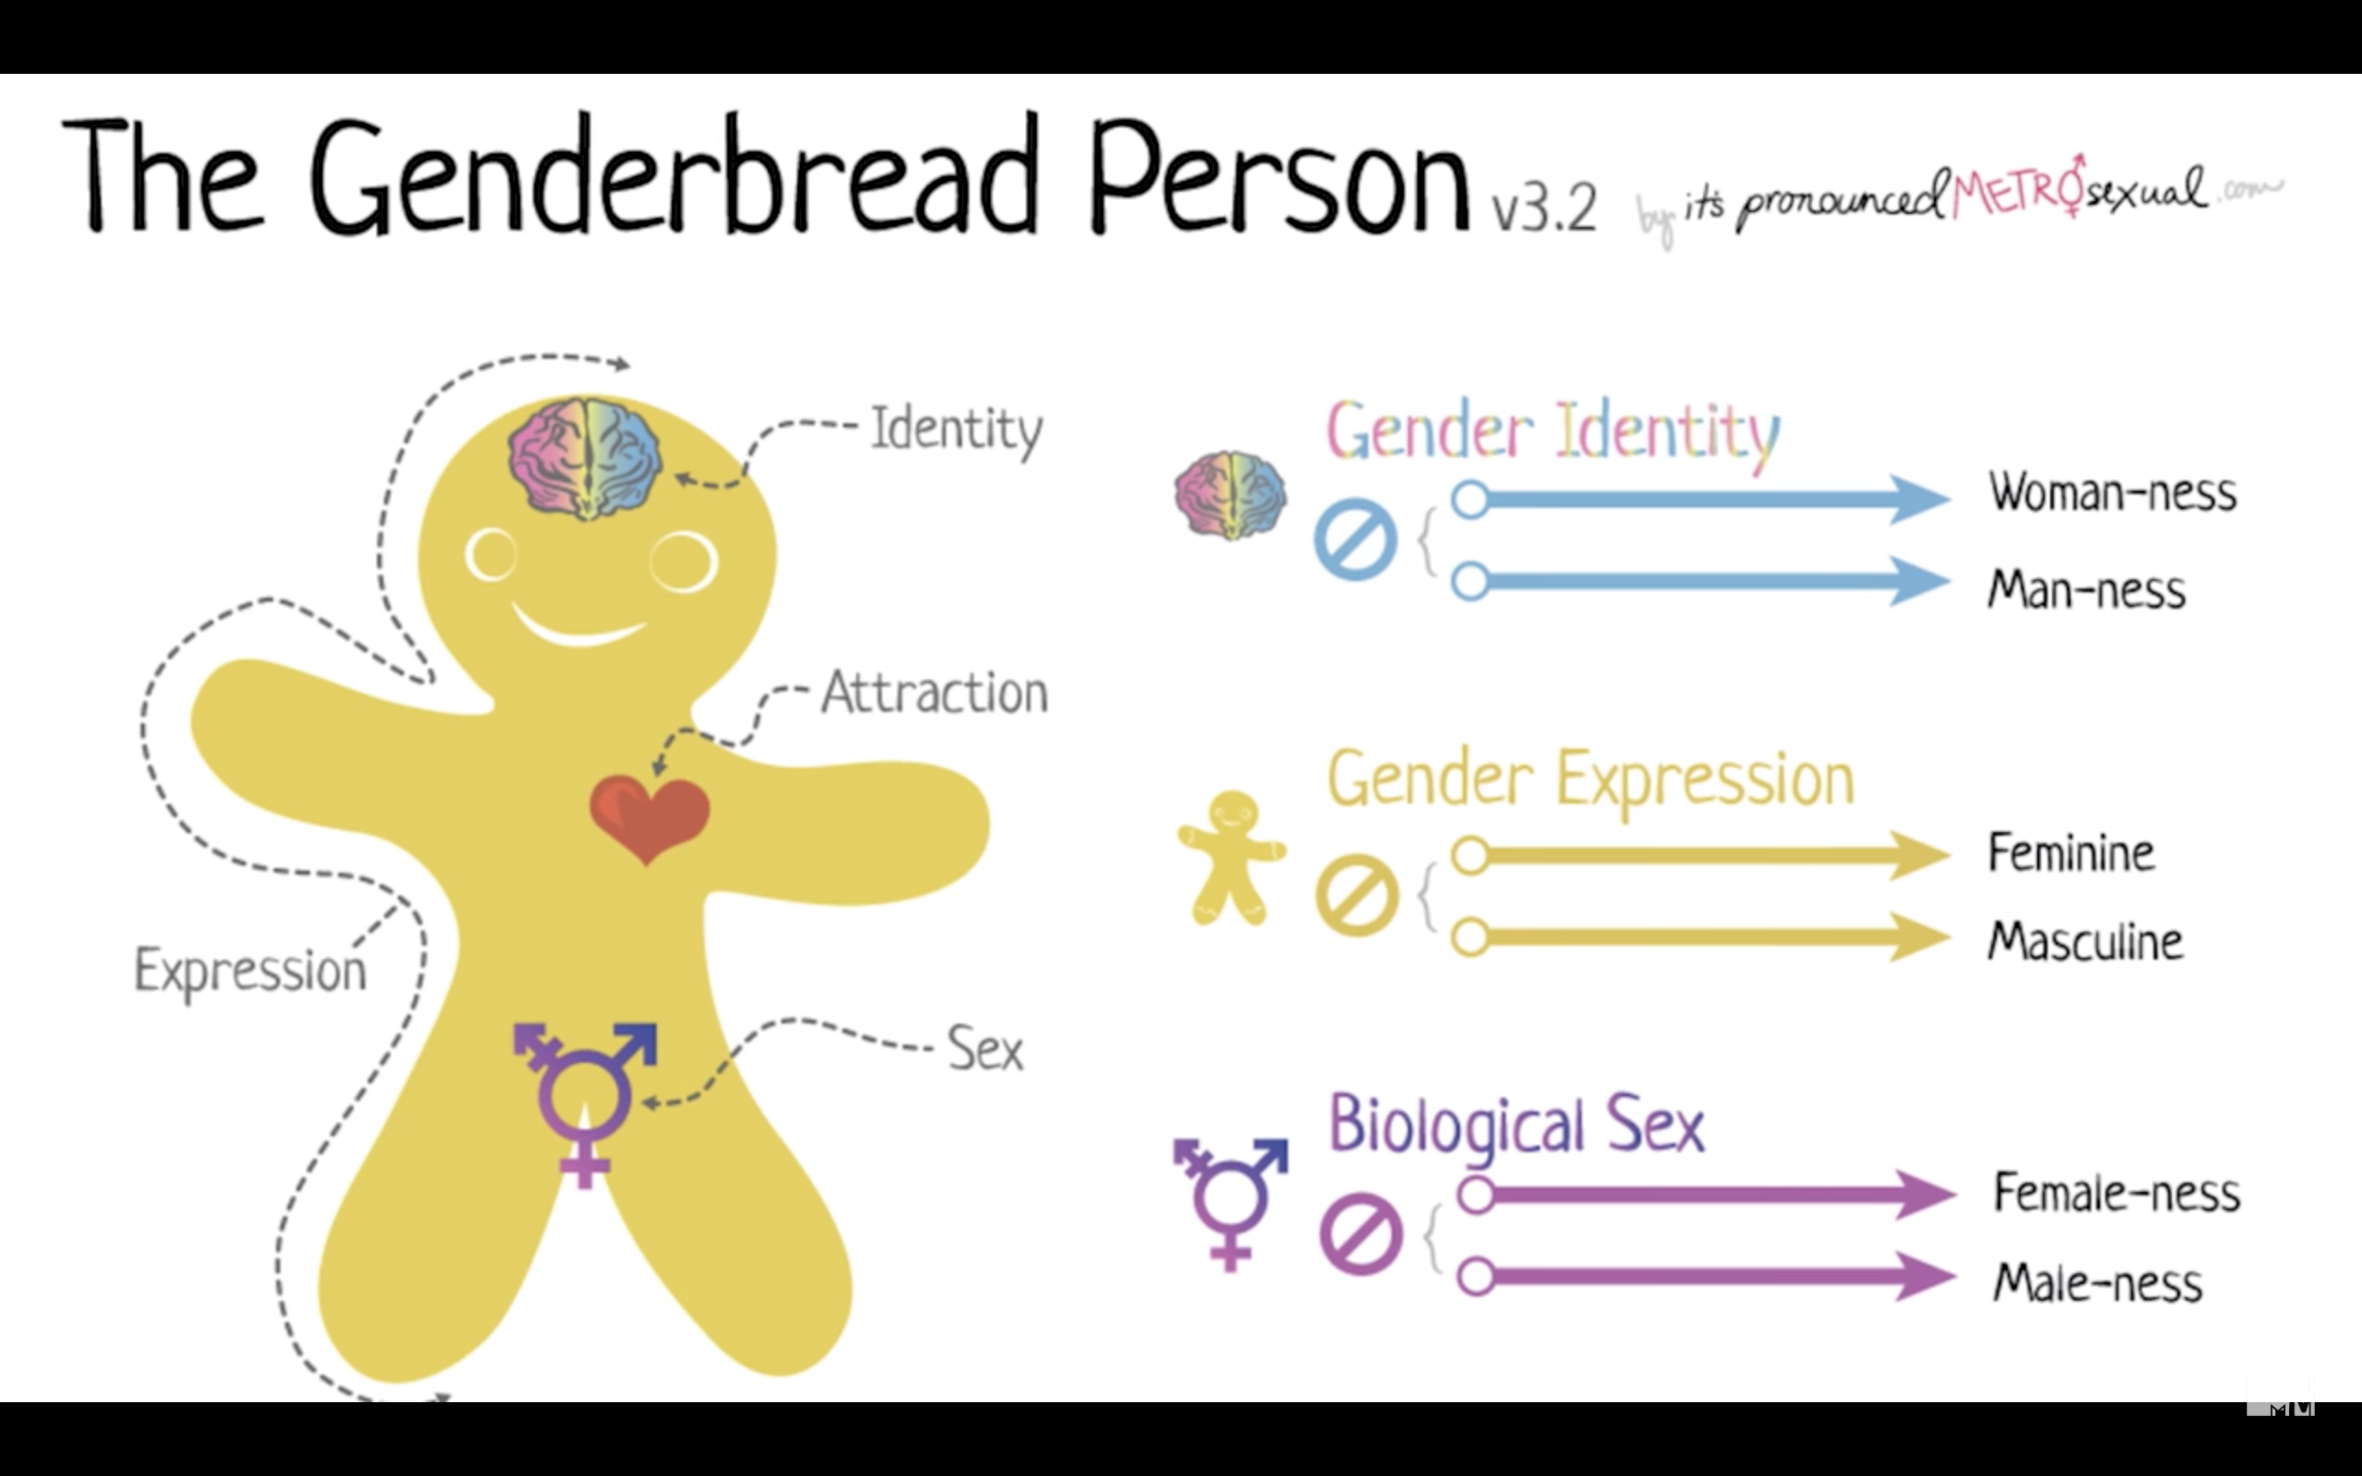

Society tells us that there are two genders, male and female, however in my dissertation I am going to discuss the idea that there are more then two genders. Some people label themselves as transgender; someone who feels they are a different gender to their given sex, and gender identity can be considered as something fluid and unique for each person.

Queer Theory celebrates the figure of the queer, or more specifically, the act of queering. What we consider as “normal” when discussing the idea of gender is socially constructed and is rejected by Queer Theory. Queer Theory is thought to be a concept that breaks capitalist ideas of gender and sexuality. It asks society, why do we have to be a specific gender? Why do I have to be only one gender? Or why do I have to choose a gender I am sexually attracted to? Queer Theory is for the people who don’t live up to their gender or sexual expectations and therefore disrupt societies narrative. As Hennssy Youngman reminds us, “it’s like your father who tells you all these stories when you’re younger. What’s good, what’s evil, etc. And then Queer Theory comes along and is like ‘fuck your father, fuck his narratives, and fuck his essential structures.” (Wolters, E. (2017). | What the Fuck is Queer Theory? Critical-Theory.com.) Judith Butler discusses the idea of Queer Theory in her book ‘Gender Trouble’ she explains that gender works through a performance, ‘There is no gender identity behind the expressions of gender;…identity is performatively constituted by the very “expressions” that are said to be its results.’ (Butler, J. Gender Trouble. P.25)

Queer Theory helps back up the initial idea I discussed earlier that there is more then two genders, many people believe in the idea of non-binary or genderqueering, the idea that your gender identity falls outside the category of man or woman. Queer Theory doesn’t only discuss the idea of identity but also sexuality; Sociologist’s generally think sexuality is only heterosexual or homosexual. As Judith Lorber a professor of sociology and Women’s studies explains, ‘sociology assumes that each person has one sex, one sexuality, and one gender, which are congruent and fixed for life;…A woman is assumed to be a feminine female; a man a masculine male. Heterosexuality is the uninterrogated norm.’ (Valocchi, S. (2017). Not Yet Queer EnoughGender &amp; Society) Queer Theory goes against this statement by explaining that like gender, sexuality is more then just heterosexual and homosexual there is a grey area between the two that can include different sexualities that help create the LGBT+ community, to name a few; Bisexual, someone who is attracted to both men and women, Asexual, someone who isn’t sexually attracted to either male nor female but may still want a romantic relationship and Pansexual, someone who is attracted to anyone no matter what their preferred gender identity may be. Although Queer Theory explains that there are different kinds of gender and sexuality post-structuralism in some way goes against what Queer Theory states and instead discusses the idea that everyone’s gender and sexuality is different and cannot be labeled as one thing or another. Although Post-structuralism does agree with Queer Theory in some ways as they both say that there is more to gender and sexuality than male/female or heterosexual/homosexual, it does contradict Queer Theory by saying that it is outdated to have terms for gender and sexuality as it places a fictitious limit on them.

Society often discusses the idea that each person has an identity that represents their true self, an inner essence, qualities beneath the surface that determines who that person really ‘is’. The French Philosopher Michel Foucault rejects this view and says that people don’t have a ‘real’ identity within themselves but instead he considers an identity as not a fixed thing but something that is a shifting temporary construction, a theory that comes from Poststructuralism. Michel Foucault discussed Postructuralism in his book ‘The History of Sexuality’ where he considers both Poststructuralism and queer theory. Poststructuralism is the rejection, or critique of humanist logic and aspirations, it helps us rethink concepts such as freedom, gender, sexuality and power. Judith Butler explains Poststructuralism as a rejection of ‘the claims of totality and universality and the presumption of binary structural oppositions that implicitly operate to quell the insistent ambiguity and openness of linguistic and cultural signification.’ (Butler, J. Gender Trouble P.76) When applying Poststructuralism with gender and sexuality it brings up the debate of whether people can define themselves as gay, straight, bisexual or Male, Female, Transgender etc. as Poststructuralism would argue that the labels don’t exist and each individuals sexuality and gender is unique depending on the person. ‘Once gender is understood as culturally constructed it is possible to avoid the essentialist idea that gender derives from the natural body in any one way.’ (Armstrong, A. (2017). Foucault, Michel: Feminism)

Although Poststructuralism rejects the idea of gender identity many people prefer to label their gender. Gender Identity is a way that people describe their gender for example, Male, Female, Transgender or Non-binary. Everyone expresses their gender self differently through gender expression, so if you identify as a girl you may wear a dress to express your gender. Drag is thought to be an art form which experiments with the idea of gender and gender expression. Courtney Act is a famous drag queen who competed in season six of ‘RuPaul’s Drag Race’, an American TV reality competition that searches for America’s next drag superstar. Courtney Act made it to top three and is now a fan favourite, on the show she was known as the “fishy queen” a term used in drag culture for a drag queen who looks like a biological woman. Courtney has struggled with her gender identity since before the show, once becoming a role model for many young people in the LGBT+ community she has expressed that she identifies as genderqueer, meaning Courtney doesn’t identify as male or female, they’re both Courtney Act and Shane Jenek in and out of drag. ‘For most of my twenties I really was trying to be a man. I felt like I had to have this muscle-y body to be valued as a man in society. I struggled with that a lot…but now I feel a little bit more free about the whole thing. I don’t have to be a man, I can just be me.’ (Writers, T. (2017). MR Round Table: Free to Be You and Me)
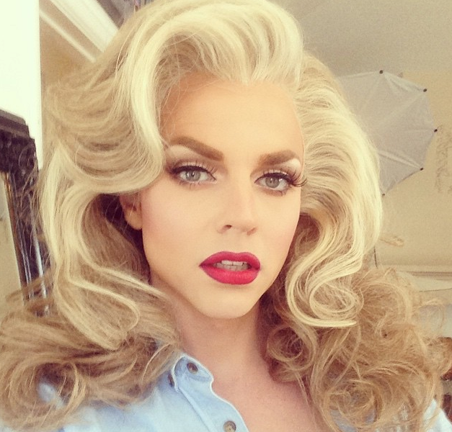
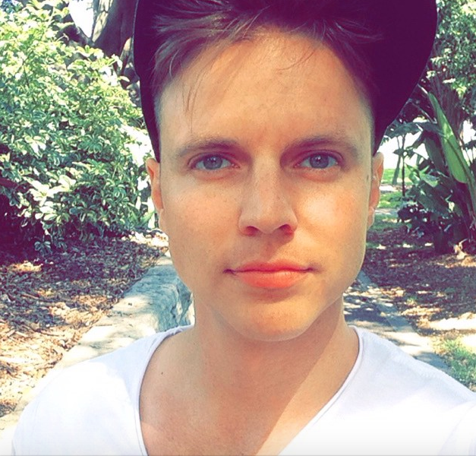

‘Shane Jenek and his drag persona Courtney Act.’

In February 2009 the first season of RuPaul’s Drag Race aired on Television and the search for the next Drag superstar began. Drag Race was the first reality competition show just for Drag queens, with the original series being Logo TV’s biggest hit. Logo went on to create two other connecting shows, ‘RuPaul’s Drag Race: Untucked’ and ‘RuPaul’s Drag Race: All Stars.’ Drag Race is currently planning its tenth season. Each season has fourteen queens competing against each other to win the crown of “America’s next drag superstar”. Whilst discussing RuPaul I will be referring to him as he or she depending whether he is in drag or not.

As discussed in the chapter before, drag can be considered as an art form that experiments with the idea of gender, if you analyse this statement with connection to RuPaul’s Drag Race you can see throughout the nine seasons how they’ve tried to destabilise gender identity. The main way the show helps bend the idea of gender is by showing all queens and RuPaul himself either in or out of drag as both “male” and “female”. ‘This very explicitly presents their transformations from male to queen for viewers and can be seen as highlighting the way gender works in our culture. But it can also highlight the way in which those very gender constructs can be subverted.’ (Daems, J. (2014). The makeup of RuPaul's drag race. P.4) Although Drag Race does show the contestants and RuPaul in and out of drag to bend the idea of gender you could debate that in fact maybe the show doesn’t highlight gender fluidity by following societies stereotypes of what can be considered as male or female. For example if we look at Courtney Act in season six compared to one of her competitors Milk, Courtney’s drag is described as very feminine, she was known as the fishy queen of her season and made it into the top three finalists. Juxtaposed to Milk whose drag style is considered more avant-garde and was labeled by fans as ‘manly drag’ and eliminated in ninth place. Femininity is a large part of RuPaul’s Drag Race, throughout the show the use of female slang and terms gives the audience an understanding of the destabilisation of gender, however using these terms backs up the presumption the show expects you to create the most feminine drag look to be America’s next drag superstar. The show judges for example will consider each contestants ‘Charisma, Uniqueness, Nerve and Talent’ or their C.U.N.Ts, articulating that the contestants must be as feminine as possible so the judges can see their metaphorical cunts.

‘What we’re looking for is someone who can really follow in my footsteps: Someone who can be hired by a company to represent their product, someone who can put together a sentence on television and present themselves in the most incredible way.’ (Daems, J. (2014). The makeup of RuPaul's drag race. P.67)
As RuPaul says in the quote above, to win the show you have to be a drag queen that is just like RuPaul herself. A queen who can create an image of respectable drag, follow the hidden policies and procedures of the show is more likely to advance through the competition, just like Courtney Act, compared to a queen who fights against the policies and procedures of the show will either be told to change or are eliminated by RuPaul herself, just as Milk was.

Judith Butler discusses drag as an example that explains queer theory, she states that gender is not as fixed as we assume, drag is the perfect connection to queer
theory as it destabilises societies idea of two genders. ‘Drag is an example that is meant to establish that “reality” is not as fixed as we generally assume it to be. The purpose of the example is to expose the tenuousness of gender “reality” in order to counter the violence performed by gender norms.’ (Daems, J. (2014). The makeup of RuPaul's drag race. P.6) Just by seeing the transformations of the queens in RuPaul’s Drag Race in each episode, demonstrates the idea of gender as something more than male or female. Throughout the series none of the queens have stated their gender, except for Monica Beverley Hillz who came out as a Trans woman in season five. RuPaul tells the contestants each episode ‘Gentlemen start your engines. And may the best woman win!’ helping the audience understand the contestants could be considered as man or woman depending on their given challenges.

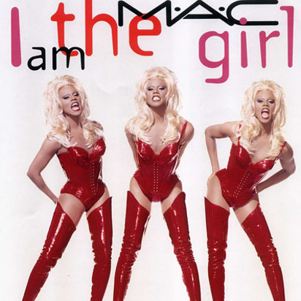
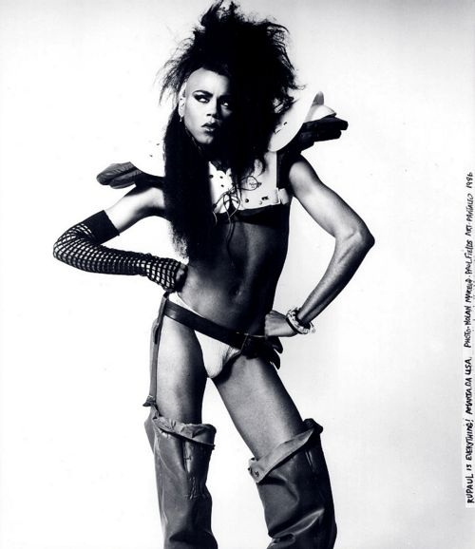
However although RuPaul’s Drag Race could be considered to support queer theory you could also argue that the show goes against what queer theory suggests. In RuPaul’s early career he was known to perform in gender fuck drag, where he would look like neither a male nor female.

RuPaul in the 80’s in gender fuck drag. RuPaul, ‘Supermodel of the world’
This look ended when she was unable to gain media attention, she shifted to her ‘supermodel of the world’ drag and her career took off. Once realising that looking like a female supermodel helped her career and paid her bills, she began to reinforce gender binary ideas. ‘RuPaul, and the producers of the show, know that her gender presentation as a queen is what sells her products.’ (Daems, J. (2014). The makeup of RuPaul's drag race. P.70) In RuPaul’s Drag Race she wants her contestants to follow her footsteps and so pushes her queens to create a feminine persona. But is a man who looks like a woman all that drag is? As RuPaul says herself ‘we’re all born naked and the rest is drag’ drag should be an art that each person can express however they wish. Forcing the idea that the contestants have to be feminine could go against drag, queer theory and Poststructuralism’s idea of gender binaries. Although feminine drag like RuPaul’s is mainstream and sells, any kind of drag still counts as an art form.

RuPaul’s Drag could be considered to support the idea of queer theory as it doesn’t define the contestants or RuPaul as either male or female, however could
the show support the gender binary theory that Poststructuralism discusses? As Poststructuralism rejects the idea of gender identity it should connect to drag well as many queens experiment with gender through their art of drag without labeling it, just like Milk who I discussed earlier. Milk’s drag is considered avant-garde as he doesn’t try to look feminine but instead creates art through fashion and make up.
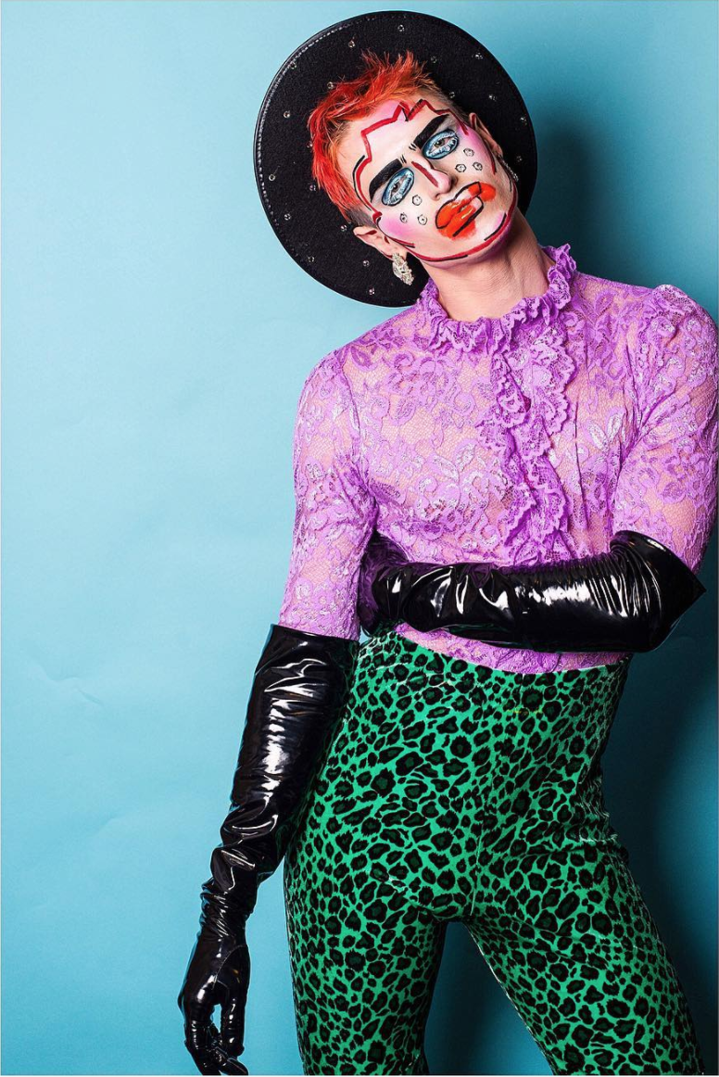
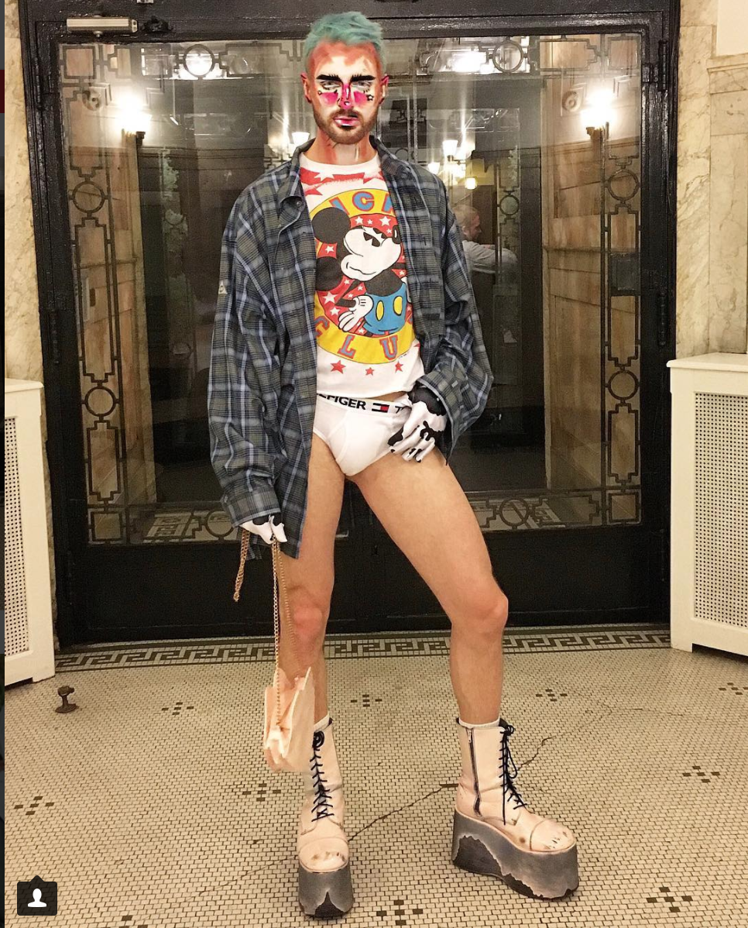

These photos of Milk above show an example of genderless drag, something I would consider as Poststructuralism, however RuPaul’s Drag Race wouldn’t tolerate this as ‘America’s next drag superstar’. As I discussed earlier, on winning RuPaul’s Drag Race the contestant must follow RuPaul’s footsteps, creating a feminine illusion. When considering Poststructuralism the show goes against the gender binary theory as it defines the idea of separate genders through drag. Where as Poststructuralism asks the question, what is gender?

Although Milk’s drag would be considered to support the theory of labeling gender within Postructuralism I would also believe that Courtney Act would support this theory. Her drag may be considered as “fishy” or feminine but her ideas of gender identity could be considered to following the theory of queer theory and/or the binary label theory within Poststructuralism. Courtney Act, as I discussed before believes that their (him/her) gender is neither male nor female but in fact they are just Shane/Courtney but may feel more masculine or feminine depending on the day. They believe that their gender isn’t defined by their sex or their appearance in or out of drag.
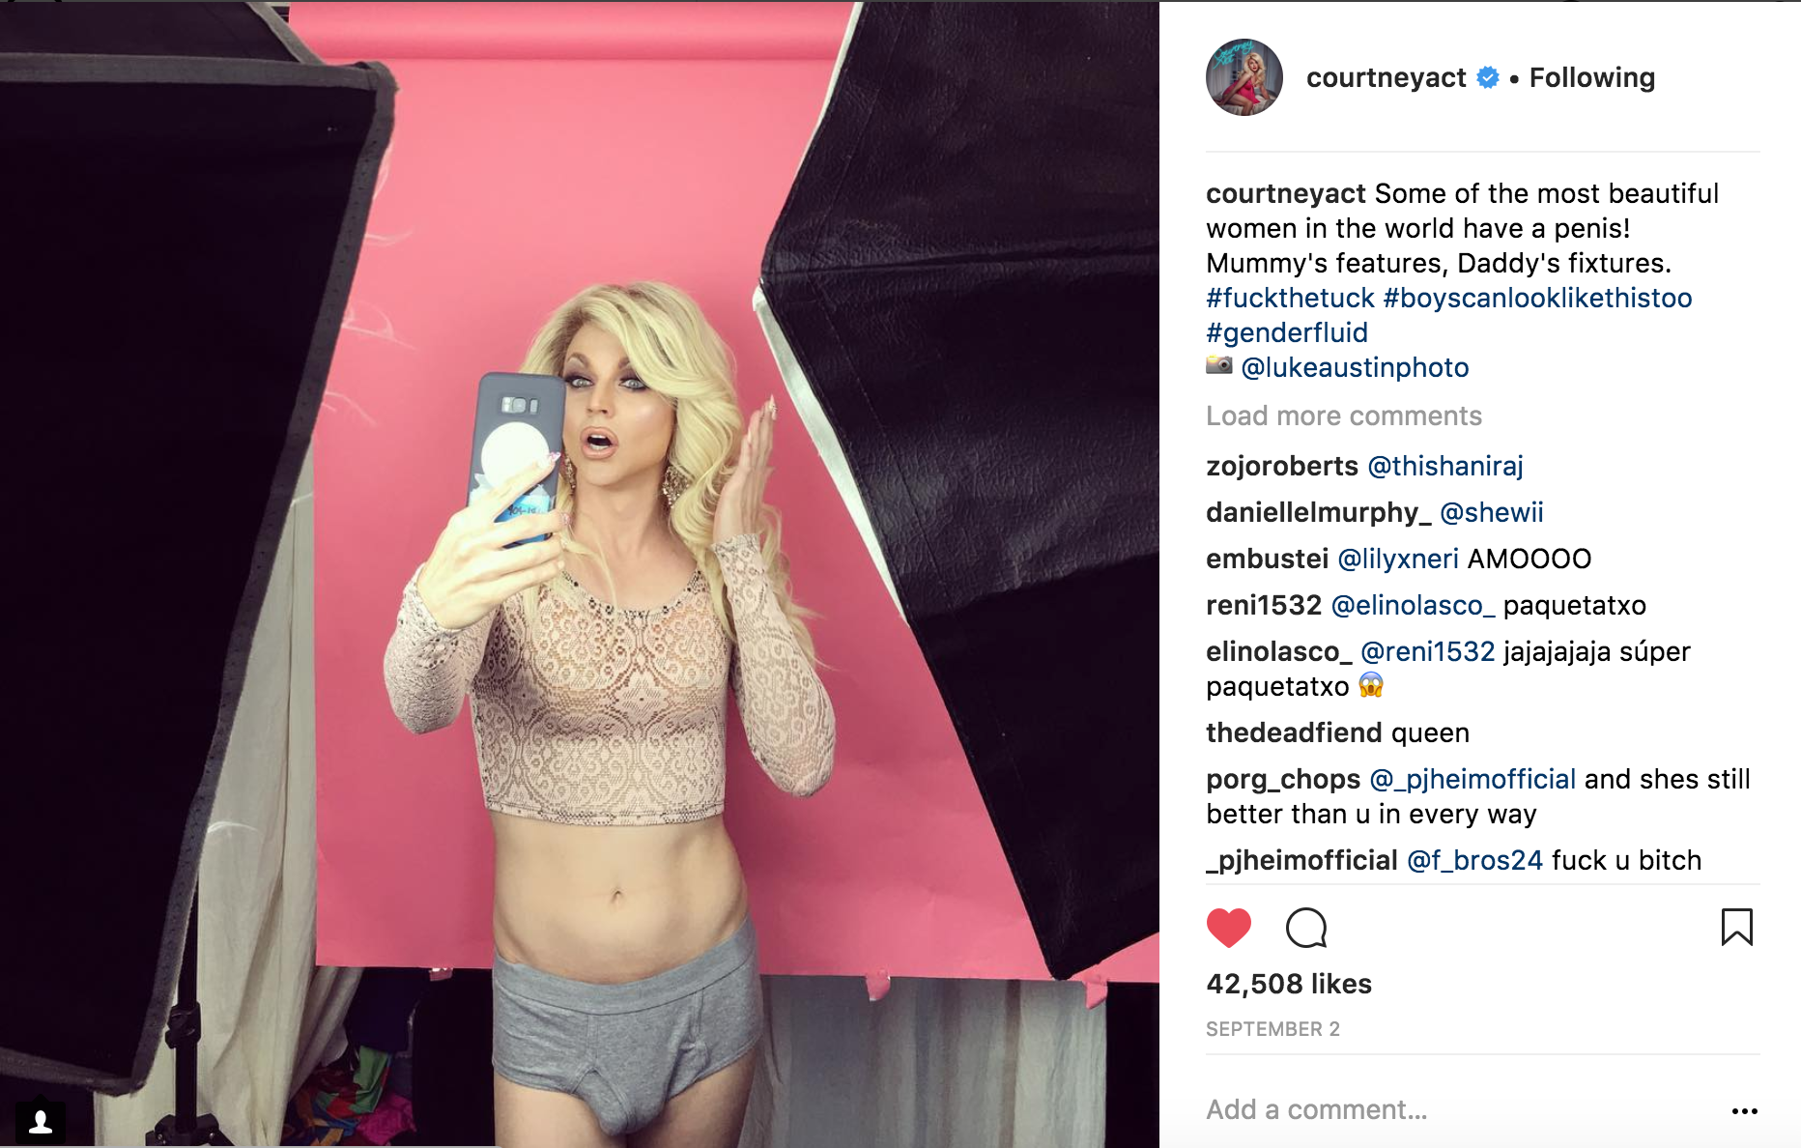

Courtney Act discussing gender on her Instagram.

After researching into the subject of drag and gender I decided to create a documentary on drag based in Cardiff. Category Is.. Is a short film documentary following two drag queens, Polly Amorous and Dixie Norm and two bio queens, Rita Mortis and Pom Pom. Bio queens are biological females who create a female persona of drag. Bio queens are often debated as being inappropriate or even to some extent homophobic. Many people wonder why a cis woman would feel the need to perform drag as they are just following the gender norm, wearing a dress and putting on make up. ‘Cis women in dresses and costume makeup shouldn’t be labeled “drag queen,” as they are simply practicing things within their own gender norms. Drag is supposed to shatter gender norms and cis women calling themselves “drag queens” can have a damaging effect on the legitimacy of the movement.’ (Pagan, N. (2017). Why Cis Female Drag Queens Are A Form Of Cultural Appropriation.) Although it is argued that a woman being a drag queen shouldn’t be labelled as drag, many people disagree and believe that drag is an art form that anyone can experiment with. I interviewed Pom Pom and asked what drag meant to her being a cis woman in the drag community, she explained that as a costume designer, a fan of theatre and drag, it was a way for her to do what she loved whilst creating a living from it. ‘I do drag because I was a theatre kid and I have a degree in costume and it’s an opportunity to utilise my skills and make a show just for me to perform and to make people happy.’ (Elstone, H. (2017) Documentary Interview.) Pom Pom believes that drag is an expression of gender even if that means an over the top expression of your own gender. ‘Drag is designed to disrupt gender norms – anyone can bind, stuff, pad and ‘perform’ gender to an exaggerated extent.’ (Hall, J. (2017). Why do some people want to stop women performing drag?)
For the past few years I have been gaining a huge interest in drag mainly as I started watching RuPual’s Drag Race. After a while I realised Drag Race was only one part of a huge global drag culture. Drag was more then just a gay man trying to be an unrealistic idea of a woman, there was a whole world of drag that I wasn’t seeing on Television, a kind of drag where gender wasn’t the point but instead a way for the person to express themselves through a style they had created. I started finding local queens and seeing different styles of drag. I found drag as an art form that helps people express themselves and their gender through performance and fashion. After talking to some of the local queens in Cardiff I realised that they each do drag for different reasons and had amazing stories of their drag careers. I decided to create this documentary to show people that drag is more than just a gay man lip-syncing on stage. Each queen has a different aesthetic and idea of what drag is. I plan to only use local queens to let people know that drag takes place in many cities.

I began working on my film whilst researching queer theory and Poststructuralism, I wanted to try and answer the question of “why drag?” to be able to connect it with my dissertation, when interviewing Pom Pom I asked her why she did drag specifically and whether she performed it as a way to represent her gender identity. Drag can be used as a way to explore gender, some drag queens have started drag and then later realised they’re actually trans or like Courtney Act, gender fluid. Queens such as Courtney Act and Milk have discussed that drag is a way for them to show their feminine side also a way to show the fluidity of their gender. Pom Pom has researched into queer theory and believes queer theory and drag work together as it experiments with the idea of gender and shows through this art form that there is more then two genders, however when it comes to drag she isn’t as such expressing her gender identity but instead creates her persona as an art form that she loves and admires. ‘Drag means a whole lot to me. It’s an art form and a way of expression. It’s the reason I know my friends that I consider family. It keeps me going.’ (Elstone, H. (2017) Documentary Interview.)
Instead of considering drag as a way to express gender it could also be considered as a persona to hide behind, many drag queens use the heels, dresses and make up to help give them the confidence they need. Drag queen Mayhem Miller discusses this when Magnus Hasting a drag Photographer asked her “Why Drag?” ‘Drag has transformed a quiet. Shy. and sensitive boy into a loud. Outgoing. Party girl! “Mayhem” was created to protect me from the harsh realities of the gay world. Now. I see that Mayhem has been feathers for that boy to make wings and finally fly, reaching the stars where he belongs.’ (Hastings, M. and George, B. (2016). Why drag?) Mayhem is just one of the queens who uses drag to be the extroverted person they want to be, showing us that drag may not only be a way to express gender identity but also give a persona to hide behind and boost confidence.

RuPaul’s Drag Race is known worldwide and has given the confidence to many people to start drag themselves, however if the show doesn’t represent drag as something more than creating a female persona, many fans and followers only see the art form through the show, insinuating the idea you have to follow drag rules and regulations. Interviewing local queens we discussed RuPaul’s Drag Race as a negative to drag and queer theory. ‘I see it as the gateway drug of drag culture, it makes my heart sad when people who don’t know anything about drag outside of drag race criticize local drag as they don’t compare to something they consider essential to drag…I also hate the fact it’s such a small type of drag allowed on the show, no bio queens or non binary performers.’ (Thrope, E. (2017) Documentary Interview.) As Rita Mortis a local Cardiff queen discusses in the quote above RuPaul’s Drag Race may be helping the LGBT+ and drag community become more mainstream but it also puts drag into a small box, labeling it as a gay man dressing as a woman and creating a feminine persona when in fact drag could and can be anything.

Category Is.. I am hoping will help people understand that drag can be seen everywhere and anywhere, it’s not only about someone dressing up as the opposite sex but in fact is in every ones day to day life, as RuPaul says herself “we’re all born naked and the rest is drag” our identity is formed from what we construct from society. Judith Butler discusses the idea of gender and drag by explaining that drag and gender identity are both constructed and neither are socially true or natural. ‘In imitating gender, drag implicitly reveals the imitative structure of gender itself – as well as its contingency.’ (Butler. J. Gender Trouble p.137) Drag may have started as men in theatre playing female roles but now it can be anything, from a guy wearing lipstick to a girl wearing a dress, drag has no rules and no gender.

I’ve discussed the idea that drag could be used to hide behind a persona instead of a way to experiment with gender or sexuality. Growing up gay sometimes an extra boost of confidence is needed in dealing with day-to-day situations and drag definitely gives that to some people. However I believe that most people don’t use drag as a way to hide their own personalities, but to give them confidence and be able to experiment with gender identity through their look and style of drag. As Courtney Act puts it ‘some of the most beautiful women in the world have a penis! Mummy’s features, Daddy’s fixtures.’

Writing this dissertation has helped me understand different ideas of gender, sexuality and binary labels to use when interviewing my subjects for Category Is.. Researching into Queer Theory gave me an understanding of the idea of different genders and sexualities especially when considering drag and genderqueer people such as Courtney Act and Milk. Although being a part of the LGBT+ community I already have a considerable understanding of different gender and sexuality labels however researching into Poststructuralism and the theory that you cannot label everyone’s gender and sexuality as each person has a unique idea of what their gender/sexuality is has made me reconsider my thoughts on these subjects. Originally I considered everyone to fall under a label of Male, Female, Transgender or Gay, Straight, Bisexual etc. but since researching into the stated theories, it has made me realise that in fact it could vary depending on the persons idea of what gender and sexuality is. Understanding this also changed my views on ‘RuPaul’s Drag Race’ I have now come to realise that in fact Drag Race may not in fact show drag in a positive view. As discussed before most queens on the show have been feminine looking and the ones who haven’t have been told to change their style of drag or been eliminated early on in the show. With Drag Race being such a huge show for drag fans this idea of putting drag in a box of what you can and cannot do is sending a negative message to the audience of what drag represents. Nevertheless in saying that, even recently ‘RuPaul’s Drag Race’ has started to come to terms with the idea of Drag being something more then a man dressed as a woman, with the current reigning queen being Sasha Velour a drag artist with the tag line of ‘Gender is a construct, tear it apart.’

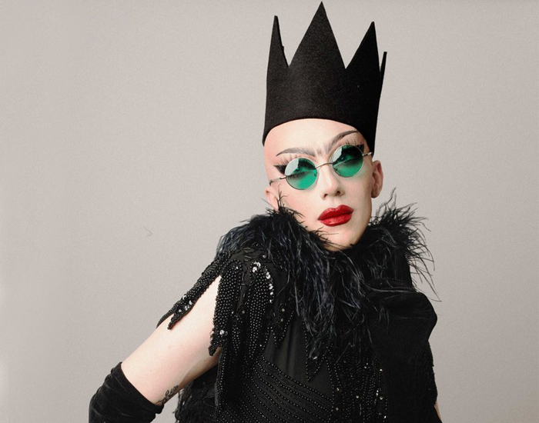
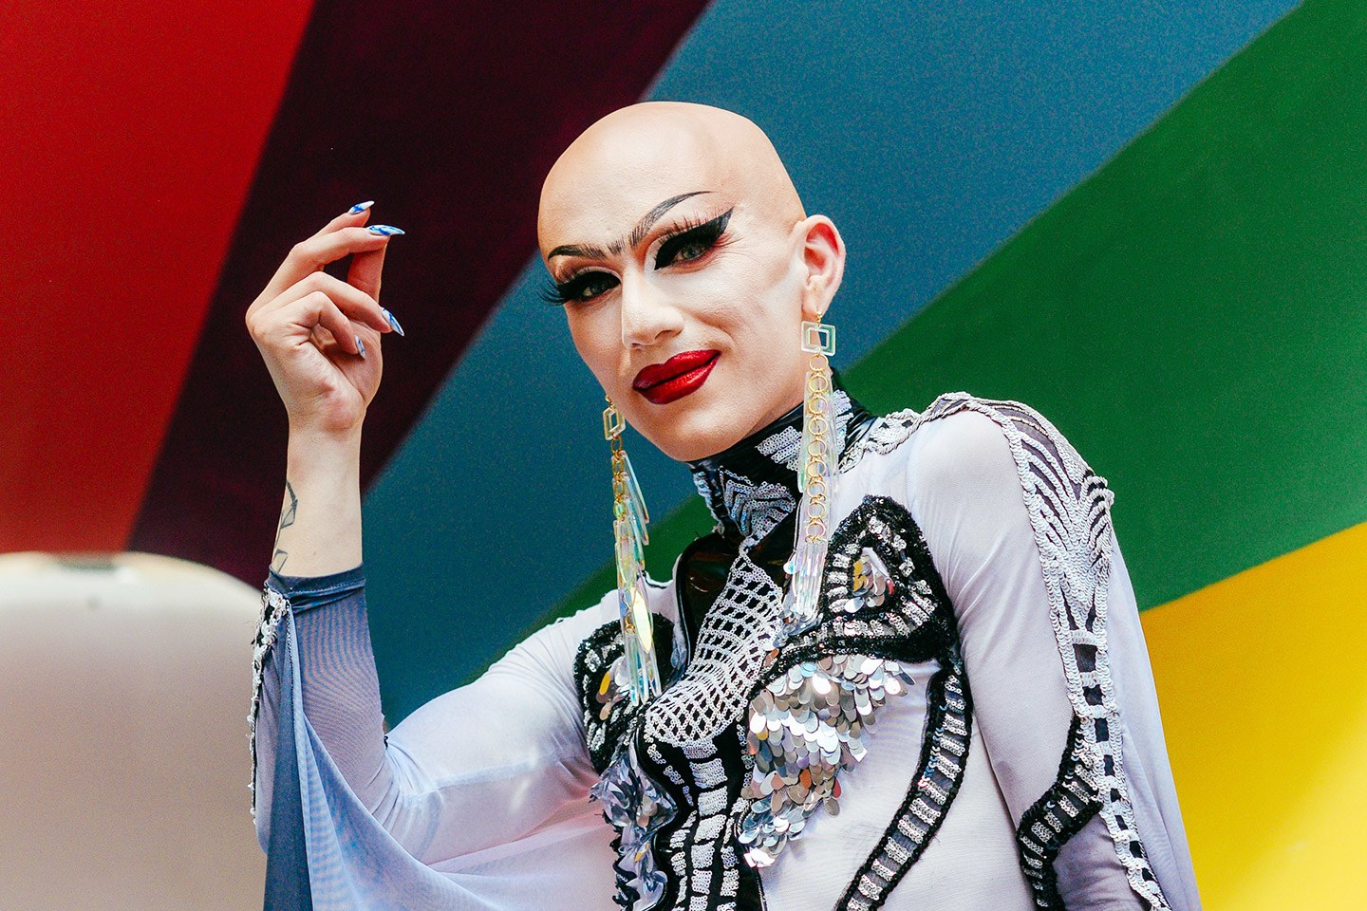

Current reigning queen of ‘RuPaul’s Drag Race’ Sasha Velour

With Sasha Velour currently one of the most popular queens to in ‘RuPaul’s Drag Race’ I hope the audience will have a wider understanding of what could be considered drag and encourage them to go and see drag artists performing in these similar styles in their own localities. I personally believe that drag doesn’t need to have gender binaries nevertheless if someone prefers to label themselves with a gender identify when doing drag that is their choice and they have every right to do so. However I do feel that some drag could be considered as an expression of gender, if you consider queens such as Milk and Courtney Act both of them are open about their gender identity and show their idea of gender through their drag. Having a new understanding of gender identity because of Poststructuralism and Queer Theory I can use this knowledge for my documentary to discuss the idea of gender and what it means to each of my drag queens. Hopefully by doing this it will help the audience realise that gender could be something socially constructed and not everyone needs to label their gender or sexuality to make it valid.

Referencing

Act, C. and Jenek, S. (2017). Courtney Act Talks... Gender Terminology. [online] YouTube. Available at: https://www.youtube.com/watch?v=wjs3MZiTkMM [Accessed 7 Nov. 2017].
Wolters, E. (2017). | What the Fuck is Queer Theory?Critical-Theory.com. [online] Critical-Theory. Available at: http://www.critical-theory.com/what-the-fuck-is-queer-theory/ [Accessed 16 Jun. 2017].

Butler, J. (2006). Gender trouble. 1st ed. Routledge. P.25

Valocchi, S. (2017). Not Yet Queer EnoughGender &amp; Society - Stephen Valocchi, 2005. [online] Journals.sagepub.com. Available at: http://journals.sagepub.com/doi/pdf/10.1177/0891243205280294 [Accessed 10 Oct. 2017].

Armstrong, A. (2017). Foucault, Michel: Feminism | Internet Encyclopedia of Philosophy. [online] Iep.utm.edu. Available at: http://www.iep.utm.edu/foucfem/ [Accessed 15 Nov. 2017].

Butler, J. (2006). Gender trouble. 1st ed. Routledge. P.76

Writers, T. (2017). MR Round Table: Free to Be You and Me - Man Repeller. [online] Man Repeller. Available at: https://www.manrepeller.com/2015/06/courtney-act-sex-gender-fluidity.html [Accessed 16 Nov. 2017].

Daems, J. (2014). The makeup of RuPaul's drag race. Jefferson, N.C.: McFarland & Co. Rupaul’s Ambivalent Appropriation of Pop Culture. P.4.

Daems, J. (2014). The makeup of RuPaul's drag race. Jefferson, N.C.: McFarland & Co. Policing the Proper Queer Subject. Kohlsdorf K. P.67.

Daems, J. (2014). The makeup of RuPaul's drag race. Jefferson, N.C.: McFarland & Co. Rupaul’s Ambivalent Appropriation of Pop Culture. P.6.

Daems, J. (2014). The makeup of RuPaul's drag race. Jefferson, N.C.: McFarland & Co. Policing the Proper Queer Subject. Kohlsdorf K. P.70

Pagan, N. (2017). Why Cis Female Drag Queens Are A Form Of Cultural Appropriation. [online] The Odyssey Online. Available at: https://www.theodysseyonline.com/why-cis-female-drag-queens-are-form-of-cultural-appropriation [Accessed 22 Oct. 2017].

Elstone, H. (2017) Documentary Interview.

Hall, J. (2017). Why do some people want to stop women performing drag?. [online] Dazed. Available at: http://www.dazeddigital.com/life-culture/article/37963/1/why-do-some-people-want-to-stop-women-doing-drag [Accessed 7 Nov. 2017].

Elstone, H. (2017) Documentary Interview.

Hastings, M. and George, B. (2016). Why drag?. Chronicle Books, pp.34-35.

Thrope, E. (2017) Documentary Interview

Butler, J. (2006). Gender trouble. 1st ed. Routledge. P.137

Bibliography

HuffPost. (2012). Art Meets Hip-Hop. [online] Available at: https://www.huffingtonpost.com/2012/01/23/huffpost-arts-interviews-_n_1223839.html [Accessed 8 Sep. 2017].

Butler, J. (2006). Gender trouble. 1st ed. Routledge.

Foucault, M. and Hurley, R. (1998). The History of Sexuality. Penguin.

Hastings, M. and George, B. (2016). Why drag?. 1st ed. Chronicle Books.

Daems, J. (2014). The makeup of RuPaul's drag race. Jefferson, N.C.: McFarland & Co.

Benshoff, H. and Griffin, S. (2005). Queer cinema, the film reader. 1st ed. New York: Routledge.

Russo, V. (1995). The celluloid closet. 2nd ed. New York: Quality Paperback Book Club.

Davies, S. (2016). Out at the Movies. 2nd ed. Oldcastle Books.

Gender.cawater-info.net. (2017). What the is gender. [online] Available at: http://www.gender.cawater-info.net/what_is/index_e.htm [Accessed 3 Aug. 2017].

Writers, T. (2017). MR Round Table: Free to Be You and Me - Man Repeller. [online] Man Repeller. Available at: https://www.manrepeller.com/2015/06/courtney-act-sex-gender-fluidity.html [Accessed 16 Nov. 2017].

Tunbridge, N. and articles..., R. (2017). Courtney Act Reveals the Grey Areas by Identifying Herself as 'Genderqueer' - theFashionSpot. [online] theFashionSpot. Available at: http://www.thefashionspot.com/buzz-news/latest-news/611037-courtney-act-reveals-the-grey-areas-by-identifying-herself-asgenderqueer/ [Accessed 3 Aug. 2017].

Harcourt, B. (2017). An Answer to the Question: 'What Is Poststructuralism?'. [online] Chicagounbound.uchicago.edu. Available at: http://chicagounbound.uchicago.edu/cgi/viewcontent.cgi?article=1029&context=public_law_and_legal_theory [Accessed 10 Sep. 2017].

Pagan, N. (2017). Why Cis Female Drag Queens Are A Form Of Cultural Appropriation. [online] The Odyssey Online. Available at: https://www.theodysseyonline.com/why-cis-female-drag-queens-are-form-of-cultural-appropriation [Accessed 22 Oct. 2017].

Ridgeway, C. and Smith-Lovin, L. (2017). The Gender System and Interaction. [online]Campus.fsu.edu.Available at: https://campus.fsu.edu/bbcswebdav/institution/academic/social_sciences/sociology/Reading%20Lists/Social%20Psych%20Prelim%20Readings/IV.%20Structures%20and%20Inequalities/1999%20Ridgeway%20Smith-Lovin%20-%20Gender%20System%20and%20Interaction.pdf [Accessed 8 Sep. 2017].

Crossman, A. (2017). Learn About Symbolic Interactionism, the Theories and Perspective. [online] ThoughtCo. Available at: https://www.thoughtco.com/symbolic-interaction-theory-3026633 [Accessed 26 Nov. 2017].

GLAAD. (2017). GLAAD Media Reference Guide - Transgender. [online] Available at: https://www.glaad.org/reference/transgender [Accessed 9 Sep. 2017].

Jagose, A. (2017). Queer Theory. [online] Google Books. Available at: https://books.google.co.uk/books?hl=en&lr=&id=nes8DAAAQBAJ&oi=fnd&pg=PA1&dq=queer+theory+sexuality&ots=IxIxo1VcpH&sig=7_nlOsXzyLXA4HJbWe7H-93OW5o#v=onepage&q=queer%20theory%20sexuality&f=false [Accessed 10 Nov. 2017].
Shmoop.com. (2017). Queer Theory. [online] Available at: https://www.shmoop.com/queer-theory/ [Accessed 10 Nov. 2017].

Smith, D. (2017). 'Queer Theory' Is Entering The Literary Mainstream. [online] Nytimes.com.Available at: http://www.nytimes.com/1998/01/17/books/queer-theory-is-entering-the-literary-mainstream.html [Accessed 8 Oct. 2017].

Spargo, T. (1999). Foucault and Queer Theory. [online] Monoskop.org. Available at: https://monoskop.org/images/b/bb/Spargo_Tamsin_Foucault_and_Queer_theory_2000.pdf [Accessed 10 Nov. 2017].

Green, A. (2010). Remembering Foucault: Queer Theory and Disciplinary PowerSexualities - Adam Isaiah Green, 2010. [online] Journals.sagepub.com. Available at: http://journals.sagepub.com/doi/pdf/10.1177/1363460709364321 [Accessed 8 Oct. 2017].

Wolters, E. (2017). | What the Fuck is Queer Theory?Critical-Theory.com. [online] Critical-Theory. Available at: http://www.critical-theory.com/what-the-fuck-is-queer-theory/ [Accessed 16 Jun. 2017].

Stephenson, K. (2017). Week 06: Poststructuralism and Queer Theory. [online] UNC Charlotte. Available at: https://clas-pages.uncc.edu/katherine-stephenson/courses/queer-theory/weekly-work/week-5/ [Accessed 11 Nov. 2017].

Armstrong, A. (2017). Foucault, Michel: Feminism | Internet Encyclopedia of Philosophy. [online] Iep.utm.edu. Available at: http://www.iep.utm.edu/foucfem/ [Accessed 15 Nov. 2017].

Monro, S. Beyond Male and Female: Poststructuralism and the Spectrum of Gender.
Available at: http://www.scribd.com/document/267241716/Beyond-Male-and-Female [Accessed 11 Nov. 2017].

Act, C. and Jenek, S. (2017). Courtney Act Talks... Gender Terminology. [online] YouTube. Available at: https://www.youtube.com/watch?v=wjs3MZiTkMM [Accessed 7 Nov. 2017].

Valocchi, S. (2017). Not Yet Queer EnoughGender &amp; Society - Stephen Valocchi, 2005. [online] Journals.sagepub.com. Available at: http://journals.sagepub.com/doi/pdf/10.1177/0891243205280294 [Accessed 10 Oct. 2017].

Hall, J. (2017). Why do some people want to stop women performing drag?. [online] Dazed. Available at: http://www.dazeddigital.com/life-culture/article/37963/1/why-do-some-people-want-to-stop-women-doing-drag [Accessed 7 Nov. 2017].

Elstone, H. (2017) Documentary Interview.

Thrope, E. (2017) Documentary Interview

