International Meetings Management for the Hotel Industry, code BMIH6007
Assignment 2: Report - Event Strategic Planning and Delivery Considerations for an International Meeting
Lecturer: Kathryn Flynn
Word count: 2,726

Roxana Maria Burlacu
Student number: 2014302

Executive Summary
The event "Outdoor Activities in London in December 2024: Ideas to make the most of the London outdoors and enjoy some fun winter activities" is a trade show aimed at the lodging sector of the hospitality industry in London. ​ It is scheduled to take place on November 1st, 2024, at Excel London, located at 1 Western Gateway, Royal Victoria Dock, E16 1XL. The event will run from 10 am to 6 pm, lasting eight hours.
The trade show is sponsored by the London Chamber of Commerce and Industry (LCCI) and aims to connect individuals and businesses with shared interests and values, fostering new business connections and generating greater shared prosperity for London, particularly in the hospitality sector. The event will feature suggestions and offers from companies that provide outdoor activities services, targeting hotels that can incorporate these activities into their vacation packages. ​
By following Event Cycle phases, the event aims to ensure thorough preparation, effective execution, and valuable insights for continuous improvement. Furthermore, SMART objectives guarantee that the event remains targeted, quantifiable, and congruent with the overarching goal of promoting business relationships and improving the hotel industry's services. By effectively managing the operational and marketing activities, the event can achieve its objectives and provide a valuable experience for all participants. ​ The event is financially feasible with a well-balanced budget. The primary sources of income are participation fees and ticket sales, while the main expenditures include venue rental, staff wages, and marketing. ​ Effective management of these costs and strategic income generation will ensure the event's profitability and success. By leveraging a PESTEL analysis, the event can strategically address political, economic, social, technological, environmental, and legal factors. This comprehensive approach ensures a well-rounded, inclusive, and engaging event that meets the demands and expectations of a diverse audience.

Table of Contents
Executive Summary 1
Introduction 3
The Event Cycle 3
Application of the Event Cycle 4
Event Concept 5
Aim and Objectives of the Meeting/Event 7
Aim 7
SMART Objectives 7
Event Management 8
Event Budget 9
Industry Trends/Issues/Impacts 12
Trends 12
Issues 12
Impacts 13
Situational and Cultural Considerations 13
PESTEL Analysis ​ 13
Reference List 14

​Table 1. SMART Objectives 8
Table 2. Breakdown of Income 10
Table 3. Expenses Breakdown 10

Figure 1. Event Cycle 4
Figure 2. EMBOK Model 9
Figure 3. ICC Maritime Suite 11

Introduction

The event "Outdoor Activities in London in December 2024: Ideas to make the most of the London outdoors and enjoy some fun winter activities" is a trade show aimed at the lodging sector of the hospitality industry in London. ​ It is scheduled to take place on November 1st, 2024, at Excel London, located at 1 Western Gateway, Royal Victoria Dock, E16 1XL. The event will run from 10 am to 6 pm, lasting eight hours.
The trade show is sponsored by the London Chamber of Commerce and Industry (LCCI) and aims to connect individuals and businesses with shared interests and values, fostering new business connections and generating greater shared prosperity for London, particularly in the hospitality sector. The event will feature suggestions and offers from companies that provide outdoor activities services, targeting hotels that can incorporate these activities into their vacation packages. ​
The event is designed as a B2B trade show, with participants including representatives from hotels and companies offering outdoor activities in London. The trade show aligns with the increasing demand for outdoor activities and wellness trends (Villa-Clarke, 2023), and it is expected to benefit both outdoor activity providers and hotel representatives in terms of brand equity and profitability. ​
The event has been chosen for several key reasons, including market demand, seasonal appeal, economic opportunity, networking and business growth, strategic location and timing, and competitive edge. Overall, the event aligns with current market trends, leverages seasonal appeal (Jaimangal-Jones, Haven-Tang, and Rowe, 2023), and offers significant economic and networking opportunities, making it a strategically chosen initiative for the hospitality industry in London. ​

The Event Cycle
The Event Cycle denotes the thorough process of organising, executing, and assessing an event. According to Holmes and Ali-Knight (2017), the event cycle describes the various event stages, from its inception to its conclusion.
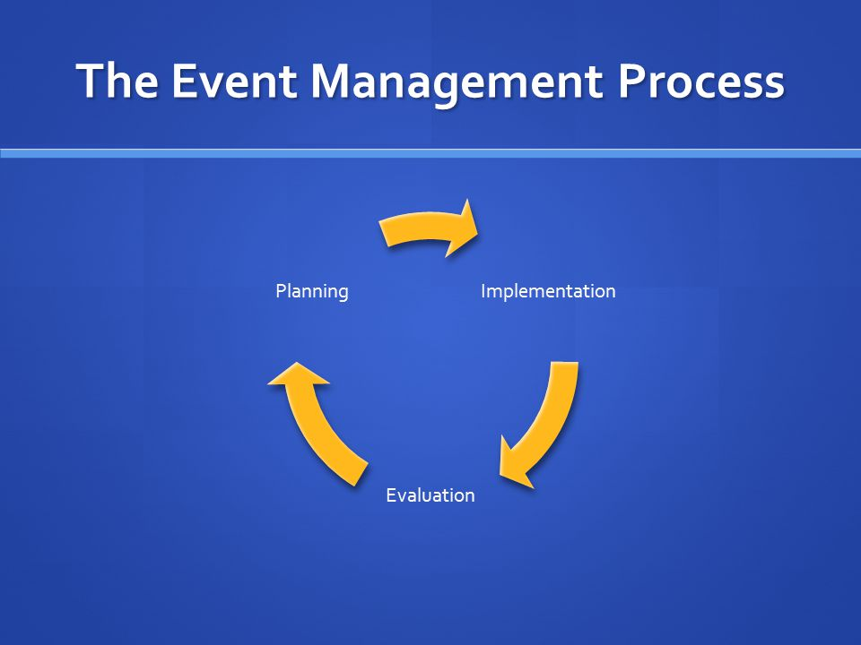
Figure 1. Event Cycle
Source: SlidePlayer, 2015
The Event Cycle characteristically includes three main phases, planning, delivery, and post-event evaluation, and it ensures that all aspects of an event are systematically managed from inception to completion, facilitating successful and impactful events (Dowson, Albert and Lomax, 2022).

Application of the Event Cycle
The planning phase includes various aspects. This phase included objective setting, by defining clear objectives (Jones, 2017), namely, to connect businesses, foster new business connections, and enhance the hospitality sector's offerings. ​It included establishing date and venue (November 1st, 2024, at Excel London) and duration (from 10 am to 6 pm; six hours). Estimated participant number was set at forty exhibitors and over two hundred businesses. ​The revenue was estimated at £120,000 from participation fees and tickets; expenses were estimated at £87,000, covering rental costs (Hire Space, 2024) wages, marketing, transportation, and other costs; lastly, the profit was projected at £33,000. ​
The marketing strategy include online marketing through search engine ads, websites, and social media platforms like LinkedIn, Facebook, and Instagram; online media content (Hollebeek and Macky, 2019).
The project team included ten experienced individuals in event management, digital marketing, and communication and forty volunteers to assist with organising the event. ​Lastly, it included vendor coordination, aiming to secure agreements with exhibitors and service providers, and to plan booth setups and other logistical details (Vitali et al., 2022).
The delivery phase (Jones, 2017) includes on-site management, event execution, and engagement aspects. Organisers aim to ensure all booths and facilities are set up before the event starts; to manage attendee registration and provide necessary materials; to oversee the smooth operation of the event, addressing any issues that arise. Secondly, they aim to adhere to the event schedule, ensuring all sessions and activities run on time; to facilitate networking opportunities for participants; to provide support to exhibitors and attendees as needed (Ahmad et al., 2012). Lastly, their goals is to organise activities and presentations that align with the event's theme; to encourage interaction between exhibitors and attendees to foster business connections (Gopalakrishna and Lilien, 2012).
The post-event evaluation phase include feedback collection, financial review, impact assessment, and lessons learned. Hence, organisers distribute surveys to participants and exhibitors to gather feedback on their experience and conduct interviews with key stakeholders to gain deeper insights (Brown et al., 2015). They make a financial review, to compare actual revenue and expenses against the projected budget, and to determine the final profit and assess financial performance. ​The impact assessment aims to evaluate the number and quality of new business connections made, to assess the impact on brand equity for both the event and participants, and to measure the event's contribution to enhancing inbound tourism in London. ​The lessons learned refer to identifying what worked well and areas for improvement and developing recommendations for future events based on the evaluation (Pearlman and Mollere, 2009).
By following these phases, the event aims to ensure thorough preparation, effective execution, and valuable insights for continuous improvement.

Event Concept
9:00 AM - 10:00 AM: Registration and Welcome Coffee
Delegates and guests arrive at Excel London, while registration desks open for badge collection. Welcome coffee and light refreshments are available in the networking area.
10:00 AM - 10:30 AM: Opening Ceremony
It starts with the welcome speech by the event organiser, followed by keynote address by a representative from the London Chamber of Commerce and Industry (LCCI).
10:30 AM - 11:30 AM: Panel Discussion - "Trends in Outdoor Activities and Wellness"
Industry experts discuss the latest trends in outdoor activities and wellness, followed by a Q&A session with the audience.
11:30 AM - 12:30 PM: Exhibition Hall Exploration
Delegates visit exhibitor booths showcasing various outdoor activities and services. ​There are networking opportunities with representatives from hotels and outdoor activity providers. ​
12:30 PM - 1:30 PM: Lunch Break
Buffet lunch is served in the dining area, while there are informal networking opportunities. ​
1:30 PM - 2:30 PM: Workshop - "Incorporating Outdoor Activities into Hotel Packages" ​
An interactive workshop is led by industry professionals. There are presented practical tips and strategies for hotels to enhance their offerings with outdoor activities.
2:30 PM - 3:30 PM: Case Study Presentations
There are presented success stories from hotels and outdoor activity providers who have successfully collaborated, and insights into the benefits and challenges of such partnerships.
3:30 PM - 4:00 PM: Coffee Break
Refreshments are served in the networking area, while there is an opportunity for informal discussions and networking. ​
4:00 PM - 5:00 PM: Roundtable Discussions
Small group discussions take place, on various topics related to outdoor activities and the hospitality industry, facilitated by industry experts.
5:00 PM - 5:30 PM: Closing Remarks and Future Outlook
A summary of key takeaways from the event is presented, along with closing remarks by the event organiser and announcement of future events and initiatives.
5:30 PM - 6:00 PM: Networking and Farewell
This is a final networking opportunity with delegates and exhibitors, including farewell drinks and light snacks.
Throughout the day, the exhibition hall is open for delegates to explore exhibitor booths and engage with representatives. There is a networking lounge, as a designated area for informal meetings and discussions. The information desk is available for any queries or assistance needed by delegates.
This itinerary ensures a comprehensive experience for delegates, combining informative sessions, practical workshops, and ample networking opportunities to foster new business connections and enhance industry knowledge. ​

Aim and Objectives of the Meeting/Event

Aim
The event’s aim is to connect the lodging sector of the hospitality industry in London with companies providing outdoor activities, fostering new business connections and enhancing the value of holiday packages offered during the winter season. ​

SMART Objectives
Please see the following table containing SMART Objectives for this event.
Objective | Specific | Measurable | Achievable | Relevant | Time-bound
Increase Business Connections | Facilitate networking opportunities between hotel representatives and outdoor activity providers. | Achieve at least 100 new business connections by the end of the event. | Utilise structured networking sessions and a dedicated networking lounge. | Enhances collaboration and business growth within the hospitality sector. | To be achieved by the end of the event on November 1st, 2024.
Enhance Knowledge and Skills | Provide educational sessions on incorporating outdoor activities into hotel packages. | Conduct 3 workshops/panel discussions with a minimum of 80% attendee satisfaction rate. | Leverage industry experts and successful case studies for content. | Equips hotel representatives with practical strategies to enhance their offerings. ​ | To be completed during the event on November 1st, 2024.
Boost Event Visibility and Engagement | Increase online engagement and visibility of the event. | Achieve 10,000 impressions and 500 interactions (likes, shares, comments) on social media platforms. | Implement a targeted digital marketing campaign across LinkedIn, Facebook, and Instagram. | Enhances the event's reach and attracts a larger audience. | To be measured from the start of the marketing campaign until the event date, November 1st, 2024.
​Table 1. SMART Objectives
These SMART objectives guarantee that the event remains targeted, quantifiable, and congruent with the overarching goal of cultivating business relationships and improving the hospitality sector's services. ​

Event Management
This section of the report discusses the skills and resources required for the event. The EMBOK is a three-dimensional framework outlining the knowledge and abilities necessary for the creation, development, and execution of an event (Embok.org, 2005)

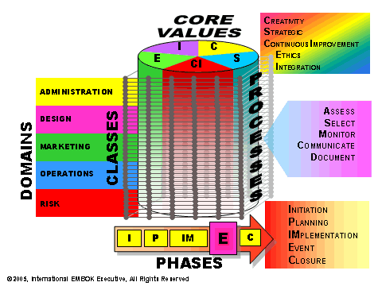
Figure 2. EMBOK Model
Source: Embok.org, 2005
​
For event management (Getz, 2008), there are requirements related to project management skills, time management and problem-solving. The project also includes digital marketing, requiring skills such as social media management, SEO, and content creation. From the perspective of communication, there are needed skills such as public speaking, networking, and customer service. Additionally, from the perspective of logistics and operations, the skills must include venue coordination, vendor management, and volunteer coordination. Furthermore, financial management requires skills related to budgeting and financial Reporting. Moreover, the resource management include skills to manage diverse types of resources, such as the project team and volunteers; venue and equipment (audio-visual equipment, furniture), promotional materials, catering, financial resources, and technology (event management software, networking platforms).
The venue setup and management include layout design, technical setup, and on-site coordination. Additionally, vendor and supplier coordination include catering services, equipment rental, and logistics. Furthermore, volunteer management involves recruitment and training and task assignment. The attendee management include registration and customer service.
Marketing activities include a digital marketing campaign ​comprising social media promotion, search engine marketing, and email marketing; content creation for promotional materials and blog posts and articles; partnerships and collaborations with industry associations and organizations to promote the event; engaging with media outlets to secure coverage and increase event visibility; and also, pre-event engagement and post-event follow-up.

Event Budget
Breakdown of Income and Expenditure
Income
Participation fee (exhibitors) £5,000 (Showplace, 2024) | £100,000
Tickets £100 (VisitBritain, 2024) | £20,000
Total | £120,000
Table 2. Breakdown of Income
Expenses
Rental at Excel London (Hire Space, 2024) | £50,000
Wages | £20,000
Marketing | £2,000
Transportation | £5,000
Miscellaneous | 10,000
Total costs | £87,000
Table 3. Expenses Breakdown
The estimated profit is £33,000. ​
The cost of renting Excel London’s Maritime Suite is significant but justified by its prime location and facilities, capable of attracting a substantial number of guests and exhibitors (Excel London, 2024). Please see the following picture that illustrates the floor plans of the chosen location.
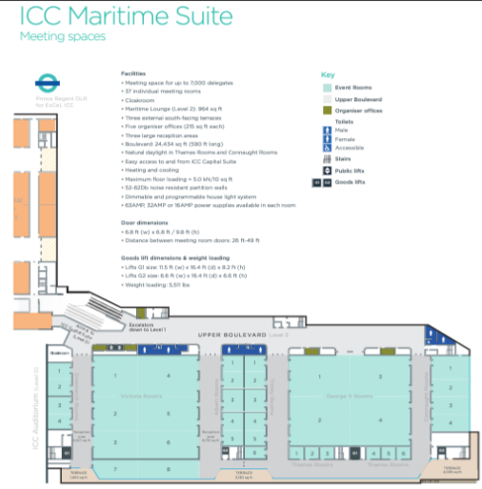
Figure 3. ICC Maritime Suite
Source: Excel London, 2024, p. 31
The ExCeL London ICC Maritime Suite takes several precautions to ensure health, safety, accessibility, and diversity. There are accessible bathrooms and public and freight elevators providing level access (Excel London, 2024). The suite has three south-facing patios for easy outdoor access. The suite has dimmable and adjustable lighting, heating, and cooling, and 52-62 dB noise-resistant partition walls. Finally, the suite has 37 meeting rooms, some with natural light and audio-visual capabilities, to accommodate different group sizes and needs (Excel London, 2024). These factors ensure the ICC Maritime Suite is safe, accessible, and inclusive for all.
The project management team’s wages are a major expense, reflecting the need for experienced professionals to ensure the event runs smoothly. Volunteer expenses cover meals, transportation, and other small costs to support the volunteers.
Digital marketing campaigns are essential for reaching a wide audience and driving ticket sales, while promotional materials include both digital and physical assets to create awareness and interest in the event. Additionally, providing food and beverages enhances the attendee experience and encourages longer participation. Moreover, high-quality audio-visual equipment is necessary for presentations, workshops, and overall event success.
Transportation costs cover the logistics of moving materials and equipment, while a contingency fund is set aside to address any unexpected expenses.
The event is financially feasible with a well-balanced budget. The primary sources of income are participation fees and ticket sales, while the main expenditures include venue rental, staff wages, and marketing. ​ Effective management of these costs and strategic income generation will ensure the event's profitability and success.

Industry Trends/Issues/Impacts

Trends
There are various industry trends such as sustainability, hybrid events, data analytics, use of new technologies, and wellness. There is an increasing focus on eco-friendly practices, such as reducing waste, using sustainable materials, and minimizing carbon footprints. Furthermore, integrating in-person and virtual components can expand audience reach and offer flexibility for participants. Additionally, tailoring experiences to individual attendee preferences can be done through data analytics and personalised marketing. Moreover, the use of advanced technologies like AI, VR, and AR enhances attendee engagement and streamline event management. Lastly, incorporating wellness activities and promoting mental and physical well-being as part of the event experience is gaining popularity.

Issues
The economic uncertainty causes fluctuations in the global economy, which can impact sponsorships, attendance, and overall event budgets. There are also security concerns, such as ensuring the safety of attendees from physical threats and cybersecurity risks. The regulatory changes require to adapt to new regulations and compliance requirements, especially related to health and safety. The climate change impact requires to address the environmental impact of events and implementing sustainable practices. There are also technological challenges, such as managing the complexities and costs associated with integrating new technologies.

Impacts
Events substantially enhance local economies via tourism, hospitality, and associated sectors. Moreover, events foster community engagement, networking, and knowledge sharing. ​Thirdly, events can have both positive and negative environmental impacts, depending on the sustainability practices adopted.
The event can reduce waste, use eco-friendly promotional materials, and promote public transportation. While essentially an in-person event, virtual aspects can expand attendance and offer flexibility. Using data analytics to customise marketing and event experiences. Digital marketing, AI for audience engagement, and VR/AR for interactive exhibitions could improve event experiences.
The event must be financially resilient with measures to handle economic volatility that could affect attendance and sponsorships. Protecting attendees and their data using physical and cybersecurity precautions is mandatory, as well as following new health, safety, and environmental regulations, promoting green practices and sustainable behaviour among guests to reduce environmental effect, and managing new technology integration to improve the event without overspending.

Situational and Cultural Considerations
The event will take place before the holidays. Strategic timing helps participants to prepare and adopt fresh holiday package concepts. Local and international attendees choose Excel London for its ideal location, facilities, and accessibility. World Travel Market London follows and competes with it, as a result, attendance and sponsorships may suffer. Additionally, in multicultural London, the event will certainly draw a diverse audience. Furthermore, London celebrates Christmas and New Year in December. Understanding and accommodating cultural preferences can boost participation by making guests feel welcome and valued. By designing around competitiveness and cultural traditions, the event may stand out and draw more people.

PESTEL Analysis ​
Political
London is a stable and secure location, which is attractive for international attendees (London.gov.uk, 2016). Compliance with local regulations and industry standards is essential for smooth operation (Hahn, 2024).
Economic
London's hospitality industry has surpassed pre-pandemic levels, indicating a strong economic environment (CLH News, 2024). ​There is a high demand for travel during the holiday season can boost attendance.
Social
The trend towards wellness and outdoor activities aligns with the event's theme. Catering to a multicultural audience is crucial for inclusivity.
Technological
Leveraging digital marketing and advanced technologies can enhance the event experience (Ryan et al., 2020). ​AI and VR/AR technologies can be used for personalized marketing and interactive exhibits.
Environmental
Implementing green practices is important to minimise the event's environmental impact (Allen, Harris, and Jago, 2022).
Legal
Adhering to tax, labour, and consumer rights laws is necessary for compliance. ​Ensuring robust health and safety measures to protect attendees is also very important.
By leveraging a PESTEL analysis, the event can strategically address political, economic, social, technological, environmental, and legal factors.

Reference List

Ahmad, N.L., Yusuf, A.N.M., Shobri, N.D.M. and Wahab, S. (2012). ‘The relationship between time management and job performance in event management’. Procedia-Social and Behavioral Sciences, 65, pp. 937-941. Available at: https://doi.org/10.1016/j.sbspro.2012.11.223
Allen, J., Harris, R. and Jago, L. (2022). Festival & special event management. John Wiley and Sons.
Brown, S., Getz, D., Pettersson, R. and Wallstam, M. (2015). ‘Event evaluation: Definitions, concepts and a state of the art review’. International Journal of Event and Festival Management, 6(2), pp. 135-157. Available at: https://doi.org/10.1108/IJEFM-03-2015-0014
CLH News (2024) London’s Hospitality Industry Tops Pre-pandemic Levels Defying “All Expectations in 2023”. Available at: https://catererlicensee.com/londons-hospitality-industry-tops-pre-pandemic-levels-defying-all-expectations-in-2023/ (Accessed: 1 November 2024)
Dowson, R., Albert, B. and Lomax, D. (2022). Event planning and management: Principles, planning and practice. 3rd edn. London: Kogan Page Publishers.
Embok.org (2005) Event Management Body of Knowledge. Available at: https://www.embok.org/ (Accessed: 8 November 2024)
Excel London (2024) Vital statistics Technical details, floor plans and capacity chart. Available at: https://www.excel.london/uploads/excel-london-%2B-icc-expansion---vital-stats---imperial.pdf
Getz, D., (2008). ‘Event tourism: Definition, evolution, and research’. Tourism management, 29(3), pp. 403-428. Available at: https://doi.org/10.1016/j.tourman.2007.07.017
Gopalakrishna, S. and Lilien, G.L. (2012). ‘Trade shows in the business marketing communications mix’. In Handbook of business-to-business marketing. Edward Elgar Publishing. Available at: https://doi.org/10.4337/9781781002445.00022
Hahn, J. (2024) What Is MICE? Your Guide to Meetings, Incentives, Conferences, and Exhibitions. Cvent.com. Available at: https://www.cvent.com/uk/blog/hospitality/what-is-mice (Accessed: 1 November 2024)
Hire Space (2024) Spaces at ExCeL London. Available at: https://hirespace.com/Venues/London/2727/ExCeL-London (Accessed: 13 October 2024)
Hollebeek, L.D. and Macky, K. (2019). ‘Digital content marketing's role in fostering consumer engagement, trust, and value: Framework, fundamental propositions, and implications’. Journal of interactive marketing, 45(1), pp. 27-41. Available at: https://doi.org/10.1016/j.intmar.2018.07.003
Holmes, K. and Ali-Knight, J. (2017). ‘The event and festival life cycle–developing a new model for a new context’. International Journal of Contemporary Hospitality Management, 29(3), pp. 986-1004. Available at: https://doi.org/10.1108/IJCHM-10-2015-0581
Jaimangal-Jones, D., Haven-Tang, C. and Rowe, S. (2023). ‘Applying the model of event portfolio tourism leverage: A study of the Volvo Ocean race in Cardiff, UK’. Event Management, 27(7), pp. 993-1009. Available at: https://doi.org/10.3727/152599523X16847420514818
Jones, M. (2017). Sustainable event management: A practical guide. 3rd edn. London: Routledge.
London.gov.uk (2016) London’s attractiveness as a location for business and people. Available at: https://www.london.gov.uk/sites/default/files/chapter5-economic-evidence-base-2016.pdf (Accessed: 8 November 2024)
Pearlman, D.M. and Mollere, L. (2009, September). ‘Meetings, incentive, convention, and exhibition evaluation practices: An exploratory study among destination marketing organizations’. In Journal of Convention & Event Tourism (Vol. 10, No. 3, pp. 147-165). Taylor & Francis Group. Available at: https://doi.org/10.1080/15470140903116633
Ryan, W.G., Fenton, A., Ahmed, W. and Scarf, P. (2020).’ Recognizing events 4.0: The digital maturity of events’. International Journal of Event and Festival Management, 11(1), pp. 47-68. https://doi.org/10.1108/IJEFM-12-2019-0060
SlidePlayer (2015) Practical Events Management Lecture Eleven: Event Evaluation. Available at: https://slideplayer.com/slide/4549864/ (Accessed: 8 November 2024)
Villa-Clarke, A. (2023, December 20) Travel Trends 2024 Report (Part 5): Wellness Wealth. Forbes. Available at: https://www.forbes.com/sites/angelinavillaclarke/2023/12/20/travel-trends-2024-report-part-5-wellness-wealth (Accessed: 31 October 2024)
Vitali, V., Bazzani, C., Gimigliano, A., Cristani, M., Begalli, D. and Menegaz, G. (2022). ‘Trade show visitors and key technological trends: from a literature review to a conceptual framework’. Journal of Business & Industrial Marketing, 37(13), pp. 142-166. Available at: https://doi.org/10.1108/JBIM-10-2021-0461

