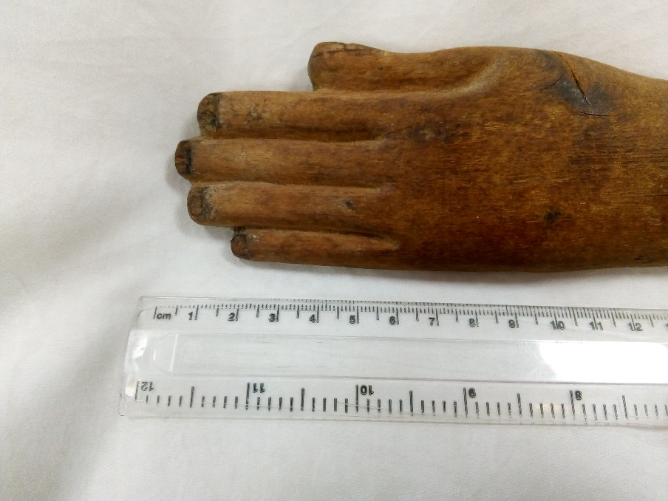
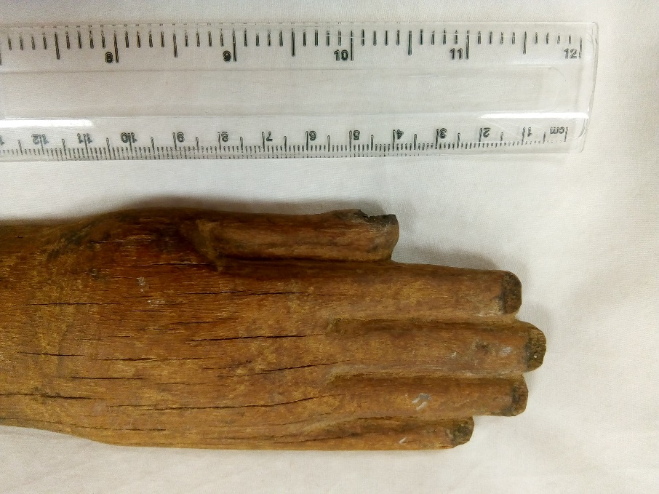
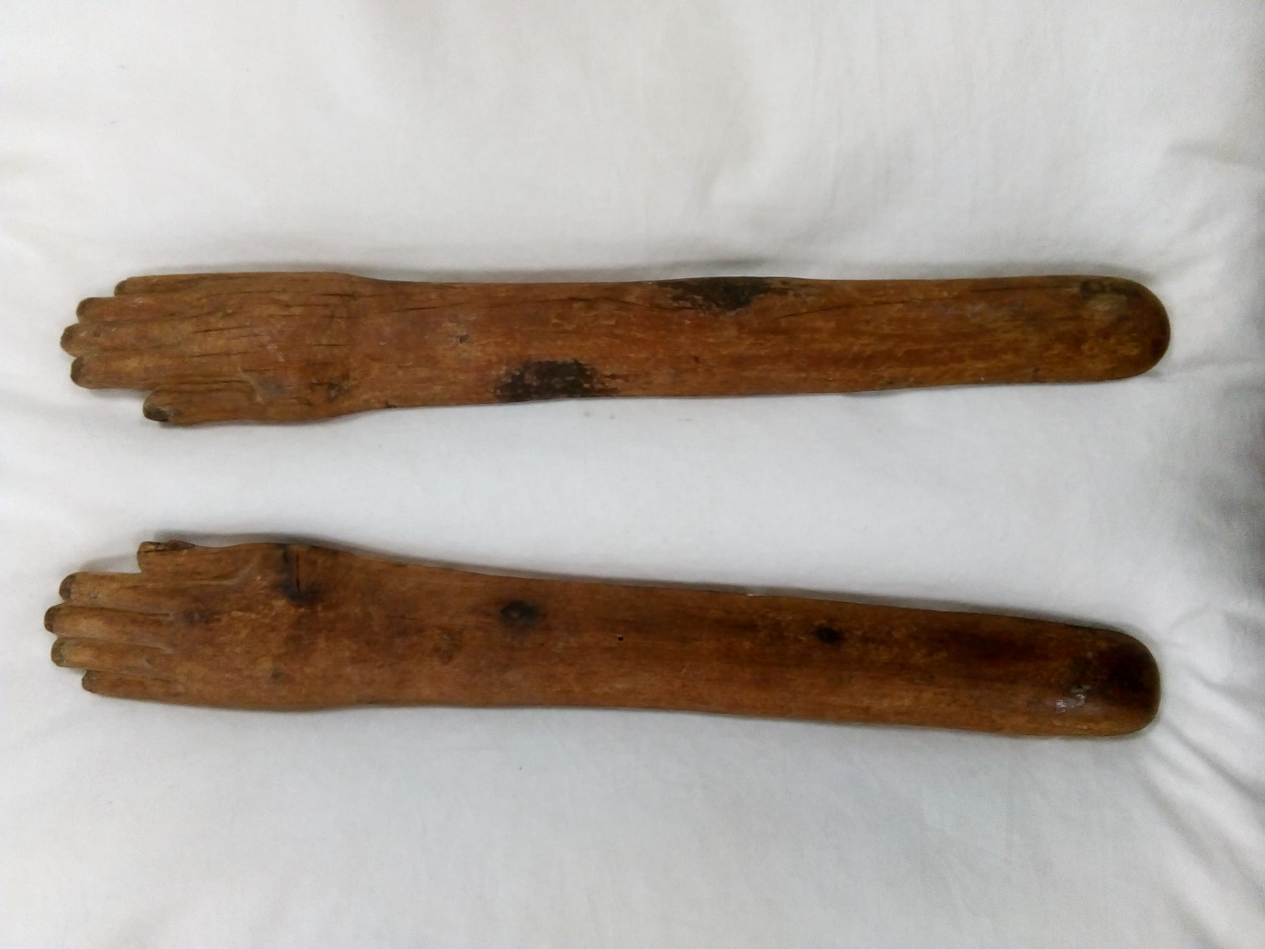
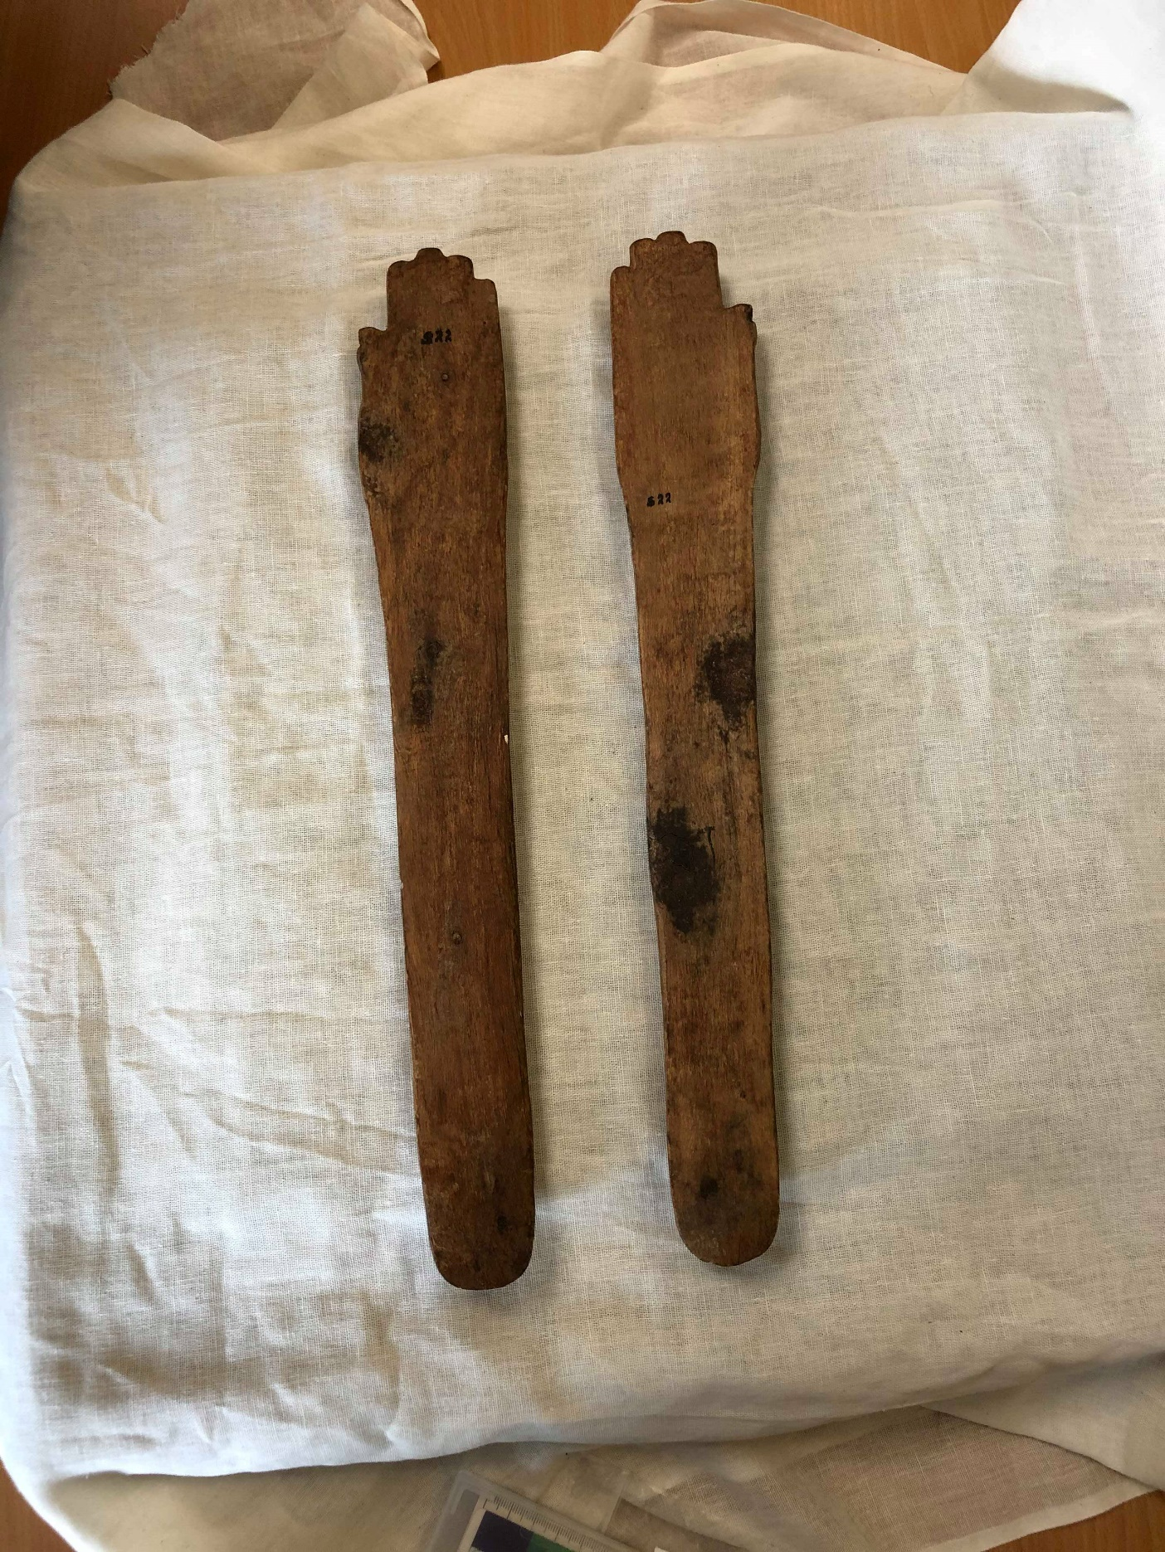
Figure 4: Left Hand (Kelly, 2020)
Figure 4: Right Hand (Kelly, 2020)
Figure 4: Both Hands, Top View (Kelly, 2020)
Figure 4: Both Hands, Base View (Welsenaer, 2020)
Clappers
Cyfarthfa Castle, Merthyr Tydfil CCM 2018.994
Object Type: Percussion Instruments
Material: Wood
Period: Middle Kingdom Ancient Egypt
Provenance: Egypt
Dimensions: Left = Total Length: 39.5cm, Hand Width: 5.5cm,
Right = Total Length: 40cm, Hand Width: 5.5cm,
Object Analysis by Lilian Earp

Description
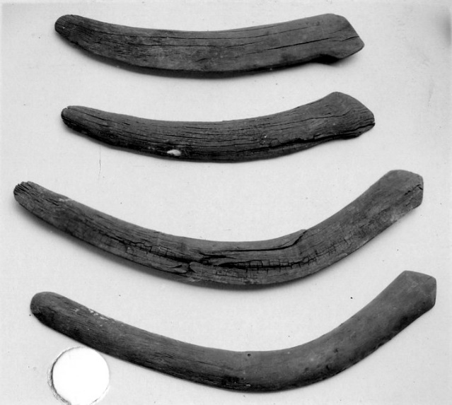
The base is flat, whilst the top, the visible surface when in use, is raised and rounded, with the detail of fingers in relief. These arms are roughly the length of an adult female forearm, but the hands themselves are proportionally slightly too small. The hands are carefully carved, with each finger is clearly defined, although very simplistic. The nails are cut out, leaving empty space where the nail might be. There is discolouration in these nail beds, and what may be remnants of glue, which suggests that maybe these hands originally had a separate material inset to highlight the nail, which has since been lost. With both clappers being made of wood, the grain and knots are clearly visible. Each arm has multiple dark and discoloured areas, which centre over the knots in the wood, suggesting that this is natural discolouration, as a result of the combination of resins in the wood and time. Both arms have cracks and fissures, which follow the grain of the wood, but the right arm has considerably more of these. There are also several spots of what appear to be white paint on both arms, this may be recent damage, as the colour is bright. Furthermore, the left arm has a patch of resin of glue near the base, again, this is unclear whether this is recent or not. Both hands have S22 written in black marker pen on the base, while the right has EYAI92 written in pencil on the top, near the end of the arm. These would all be identification marks made since excavation. The simplicity of these clappers has made dating them difficult, as all that there is to go on is the style of the hand and thumb, and the straight design, as they lack any decoration that could be used to help when dating. However, the simplicity of them does not necessarily mean that they are earlier versions, since figure 5 shows that there are very simplistic wooden clappers that where being made around the same time as the more intricate versions. These pairs are from between the late middle to early new kingdoms, and demonstrate that simplicity is not necessarily a marker of time. I would date the Cyfarthfa clappers to around the middle kingdom, since this seems to be a period from which there are many surviving examples, and because the lack of detail present on the clappers means that there is little available evidence that can be used to date them.
Figure 5: Metropolitan Museum, Pair of clappers, ca. 1802 – 1450 B.C
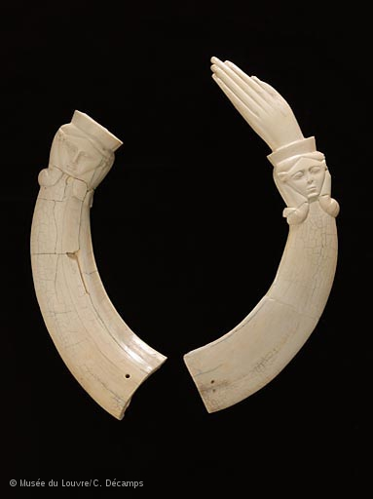
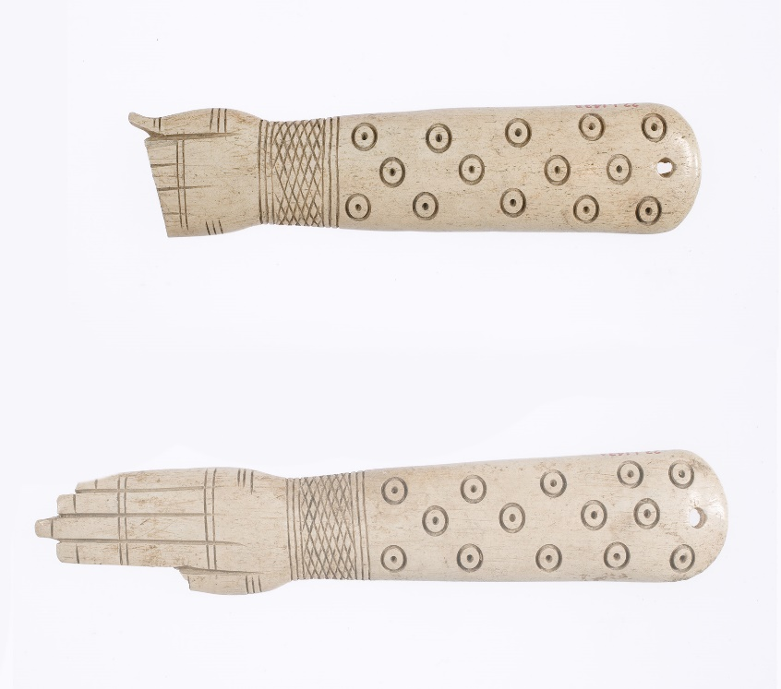
Clappers have been used in some form in Egypt for thousands of years, from the earliest development of civilisation, through until the late period. The prevalence of percussion instruments such as clappers in ancient Egypt show the importance of keeping time, of keeping the beat going when performing musical or dance performances. With their simplicity, they would have been one of the earliest instruments created, with the purpose of keeping time. They can often be found as a part of a collection of instruments used in music or dance, and is one of several used to make music whilst dancing (such as other rattles, bead necklaces). However, this example of clappers is on its own, with it not known if other instruments were present when excavated. However, clappers – although most often singular ones – have also been associated with mirrors. With their use in music and dance, both of which are associated with men and women, although dancers were more commonly female. However, clappers are very strongly associated with the cult of Hathor, which was closely associated with women. In particular, a single clapper was used alongside a mirror in a Hathoric dance that symbolised the creation of the gods.
Figure 7: Museé Du Louvre, Paire de claquoirs : mains, tête de la déesse Hathor
Figure 6: Metropolitan Museum, Pair of clappers, ca. 1900-1640 B.C

This example of clappers is much simpler than many examples, as they are plain, undecorated wood. Figure 6 shows a Middle Kingdom example, made of hippopotamus ivory, and decorated with incised lines, cross hatching, and roundels. Figure 7 is another example of a beautifully decorated pair of clappers, identified as being from either the middle or new kingdoms of ancient Egypt. This particular pair is not decorated with the simpler lines seen on fig. 6, but with carefully carved representations of Hathor on the wrists. Both pairs of clappers are of a higher quality than those from Cyfarthfa, and could be argued to be more enchanting, in that they are beautifully decorated, with lines, cross hatching, and roundels, as well as being made from ivory. Gell’s argument that objects can be “beautifully made, or made beautiful” applies to clappers, with many examples being very beautifully made and decorated, and therefore can be said to be enchanting. However, I would argue that these clappers enchant through the use of sound, since, whilst they are high quality, they lack the sort of decoration that could enchant those viewing it. Therefore, it is their use in dance, music and performance, and the sound that they make, which causes them to become enchanting.
In conclusion, clappers in ancient Egypt where an essential aspect of the performance of music and dance, and their presence would have contributed to the enchanting nature of such a presentation. The clappers from Cyfarthfa museum would almost undoubtably have been used in this way, and whilst we cannot know exactly where and when they were from, it is much easier to be sure about how they were used.

Bibliography
Casper, J, Kraemer, Jr, (1931), ‘A Greek Element in Egyptian Dancing’, American Journal of Archaeology, 35(2), pp. 125-138, Available at: https://www.jstor.org/stable/498244 (Accessed 1st March 2020)
Dadrian, E, (2020). ‘Let there be Music! Musical Instruments in Ancient Egypt’, RAWI Magazine, Available at: https://rawi-magazine.com/articles/ancientmusic/ (Accessed 29th February 2020)
Duchesne-Guillemin, M, (1981). ‘Music in Ancient Mesopotamia and Egypt’, World Archaeology, 12(3), pp. 287-297. Available at: https://www.jstor.org/stable/124240 (Accessed 16th February 2020)
Gell, A. (1992) “The technology of Enchantment and the Enchantment of Technology” pp. 40-63
Gillam, R, (1995), ‘Priestesses of Hathor: Their Function, Decline and Disappearance’, Journal of the American Research Center in Egypt, 32, pp.211-237. Available at: https://www.jstor.org/stable/40000840 (Accessed: 5th March 2020)
Mark, J, (2017) ‘Music and Dance in Ancient Egypt’, Ancient History Encyclopedia. 19th May, Available at: https://www.ancient.eu/article/1075/. (Accessed 1st March 2020)
Metropolitan Museum, Pair of clappers, ca. 1802 – 1450 B.C. [Online] Available at: https://www.metmuseum.org/art/collection/search/557212?searchField=All&amp;sortBy=Relevance&amp;ft=egyptian+clappers&amp;offset=0&amp;rpp=20&amp;pos=2 (Accessed 8th March 2020)
Morris, E, (2017) ‘Middle Kingdom Clappers, Dancers, Birth Magic, and the Reinvention of Ritual’, in Miniaci, G, Betro, M, Quirke, S. (ed). Company of Images: Modelling the Imaginary World of Middle Kingdom Egypt (2000-1500 BC), pp. 285-336. Leuven: Peeters Publishers
Museé Du Louvre, Paire de claquoirs : mains, tête de la déesse Hathor [Online] Available at: https://www.louvre.fr/en/oeuvre-notices/pair-clappers (Accessed 8th March 2020)
Stunkel, I, (2017), ‘Pair of clappers: ca. 1900-1640 B.C’, Metropolitan Museum. Available at: https://www.metmuseum.org/art/collection/search/546840?searchField=All&amp;sortBy=Relevance&amp;ft=egyptian+clappers&amp;offset=0&amp;rpp=20&amp;pos=1, (Accessed: 5th March 2020)

Image Bibliography
Image 1: Lorna Kelly, February 2020 [photograph] Taken in Class
Image 2: Lorna Kelly, February 2020 [photograph] Taken in Class
Image 3: Lorna Kelly, February 2020 [photograph] Taken in Class
Image 4: Jade Welsenaer, February 2020 [photograph] Taken in Class
Image 5: Metropolitan Museum, Pair of clappers, ca. 1802 – 1450 B.C. [Online] Available at: https://www.metmuseum.org/art/collection/search/557212?searchField=All&amp;sortBy=Relevance&amp;ft=egyptian+clappers&amp;offset=0&amp;rpp=20&amp;pos=2 (Accessed 24th February 2020)
Image 6: Metropolitan Museum, Pair of clappers, ca. 1900-1640 B.C. [Online] Available at: https://www.metmuseum.org/art/collection/search/546840?searchField=All&amp;sortBy=Relevance&amp;ft=egyptian+clappers&amp;offset=0&amp;rpp=20&amp;pos=1 (Accessed: 24th February 2020)
Image 7: Museé Du Louvre, Paire de claquoirs : mains, tête de la déesse Hathor [Online] Available at: https://www.louvre.fr/en/oeuvre-notices/pair-clappers (Accessed 25th February 2020)

MetMuseum
Duchesne-Guillemin, 1981, pp. 288
Dadrian, 2020
Mark, 2017
Morris, 2017, pp. 310
Casper at all, 1931, pp. 127
Gillam, 1995, pp. 211
Morris, 2017, pp. 307
Stunkel, 2017
Museé du Louvre
Gell, 1992, pp. 43

