

LOCATION: LONDON LLEOLIAD: LLUNDAIN
LEVEL 4 LEFEL 4
EXAMINATION PERIOD CYFNOD ARHOLIADAU
JUNE 2022 MEHEFIN 2022

MODULE CODE: ACCB4017
SOFTWARE DEVELOPMENT
TIME: 2 HOURS
ANSWER ALL QUESTIONS

NOTE: IN-CLASS TEST, TIME/DATE TO BE ARRANGED BY LECTURER

Equipment or materials required – Computers with code editor installed
Adnoddau neu ddefnyddiau sydd eu hangen – Cyfrifiraduron gyda code editor

ANSWER ALL QUESTIONS

NOTE: Student will answer the questions below using the programming language they have studied during the module. The questions/solutions shown below refer to the Python language, but some groups may be studying the module using other programming languages (such as C). Therefore the paper will be adapted to reflect this if required.

Additionally, where delivered online (eg via Moodle) questions may be drawn from a random pool, but will be in the style and of a similar difficulty level to those listed below.

1. a) Which variable type would be most suitable to store each of the following values?
g STRING ………….………….……….………….

2112 INT………….………….………….………….………….

Sarah STRING………….………….………….………….…………..

3.21 FLOAT…………..………….………….………….………….

H2 COMPLEX………….………….………….………….………….

-34.62 FLOAT………….………….………….………….………….

[1 mark each - 6 marks total]

1 b)

What errors are present in the following code for welcoming a user to a program? Line numbers are included for easy reference

1 print(Welcome to my program") double quotes are missing in the beginning
2
- print("Please enter your name: ") Data type should t be string
- myName = int(input()) myName = str(input())
5
6 print("Welcome, " myName) Missing double quotes for myName
8 print("I shall say hello to you 10 times: ")
9
- for counter in range(0, 11) Missing colon after the brackets
- print("Hello")

[5 marks]

1 c) How many iterations do the following loops have?

for i in range(1, 9, 1): ………….. 8
print("Hello")

for i in range(0, 8, 2): ………….. 4
print("Hello")

[4 marks – 2 marks each]

1. d) What is the value of the integer variable total after the following code is executed?

total = 1

for x in range(0, 8, 1):
total = total + x
if x == 5: total = 0

13

………… [3 marks]

1 e) Logic

- Given the following values x=5, y=3, z=12 is the statement below true or false?
x==y False
……

- Given the following values x=5, y=3, z=12 is the statement below true or false?
x < z/y False
……

[2 marks total]

[20 marks total for Question 1]

- Calculating the volume of a square-based pyramid

The volume of a square-based pyramid is calculated using the formula shown below:
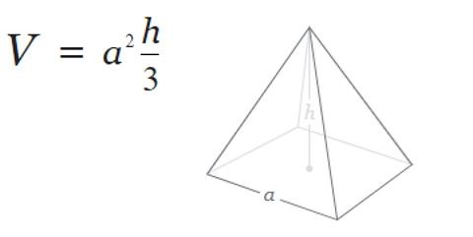

Task:
Write a program to calculate the volume of the pyramid using the above formula.

Allow the user to enter the measurements for a and h. Both a and h should be positive numbers.

Print the volume on the screen to 2 decimal places
[10 marks total for Question 2]

while (True):
a = float(input(f"Please enter your measurements for a : "))
if (float(a) < 0):
print("please try again")
else:
break
while (True):
h = float(input(f"Please enter your measurements for h : "))
if (float(h) < 0):
print("please try again")
else:
break

v = (1/3) * a * a * h
print("volume of pyramid is: {0:.2f}".format(v))

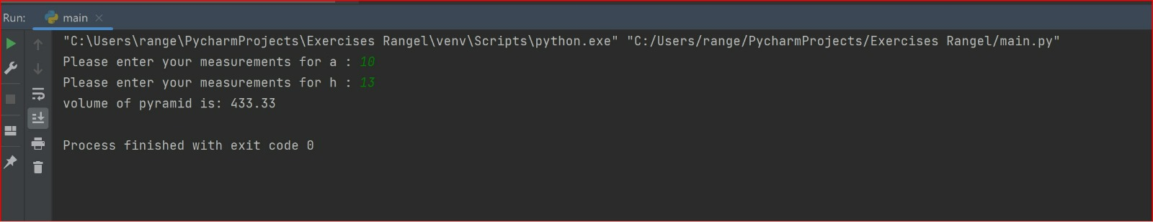

- Using lists (Python) or arrays (C etc)

Task:
Write a program designed to calculate the average age of some people in a room. There are 6 people in the room. Start by declaring an empty list eg
ages = []
- Prompt the user to enter the six ages (these should be within normal human lifespan!).
- After the ages have been entered, print each of them on the screen.
- Calculate the average age of the people in the room (to 2 decimal places) and print it on the screen.
Use loops where appropriate
Sample output:
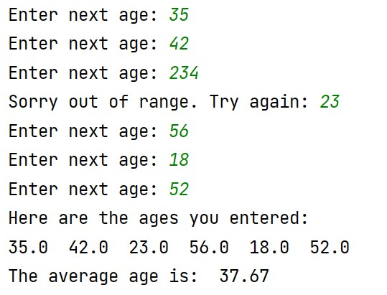

  - marks total for Question 3]

with open('ages.txt', 'a+') as f:
while True:
ages = []
for i in range(6):
while ages > [100]:
print(int(input("Try again: ")))
ages.append(int(input('Enter nex age: {}?: '.format(i+1))))
average = 'Average: {}'.format(round(sum(ages) / len(ages), 2))
print(average)
f.write('{}\n{}'.format('\n'.join([str(x) for x in ages]), average))
action = input('Press [1] to continue or [2] to exit... ')
if action == '2':

break

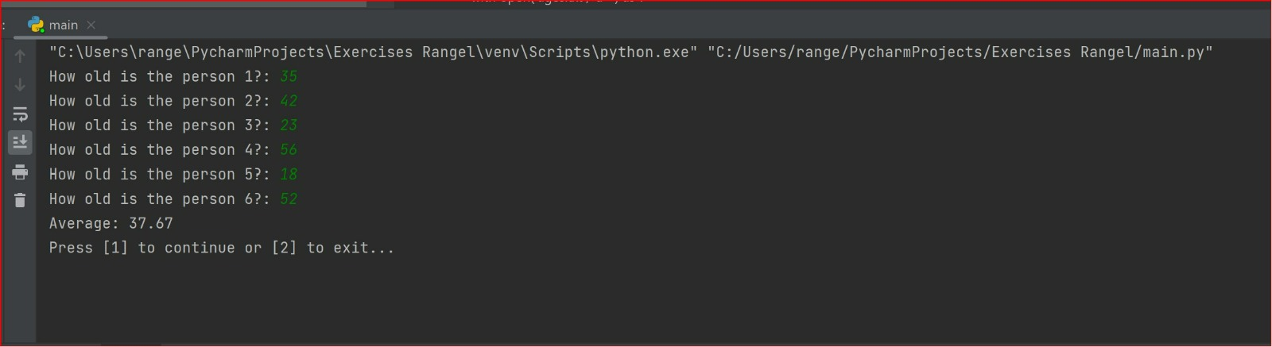
- Using Functions

Task:
Write a function called entername() to allow the user to enter the name of a conference delegate.
The function should be called 3 times, once for each of 3 conference delegates, and the (local scope) name entered returned to the main program.
Print the names entered from the main program, then calculate the total bill for attending the conference (£65 per person) and print it on the screen Sample output:
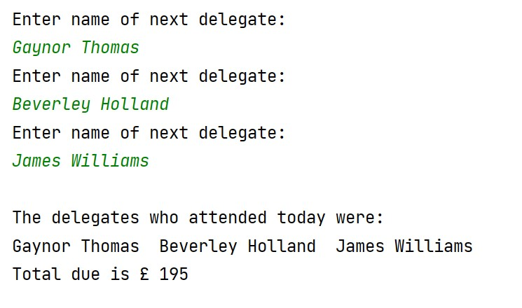

  - marks total for Question 4]

def my_function(fname()
print(fname + " £65")

my_function("Gaynor Thomas")
my_function("Beverley Holland")
my_function("James Williams")
print(" Total due is £195")

Diwedd/End

