Revision 2 (Sequential Circuits)
Q1
- Determine the reduced state diagram for the state diagram given below.

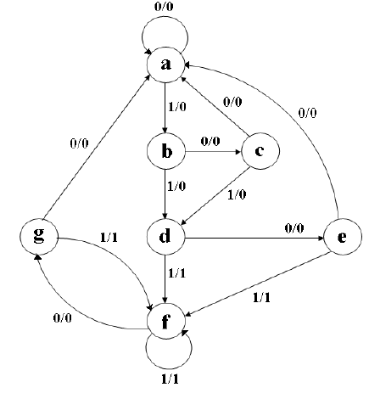

- Also, for the obtained reduced state diagram answer the following.
    - Show its state Assignment.
    - Obtain the State Table.
    - Obtain Excitation Table using any Flip- flop.
    - Output Expressions
    - Logic Circuit
Solution
State Table
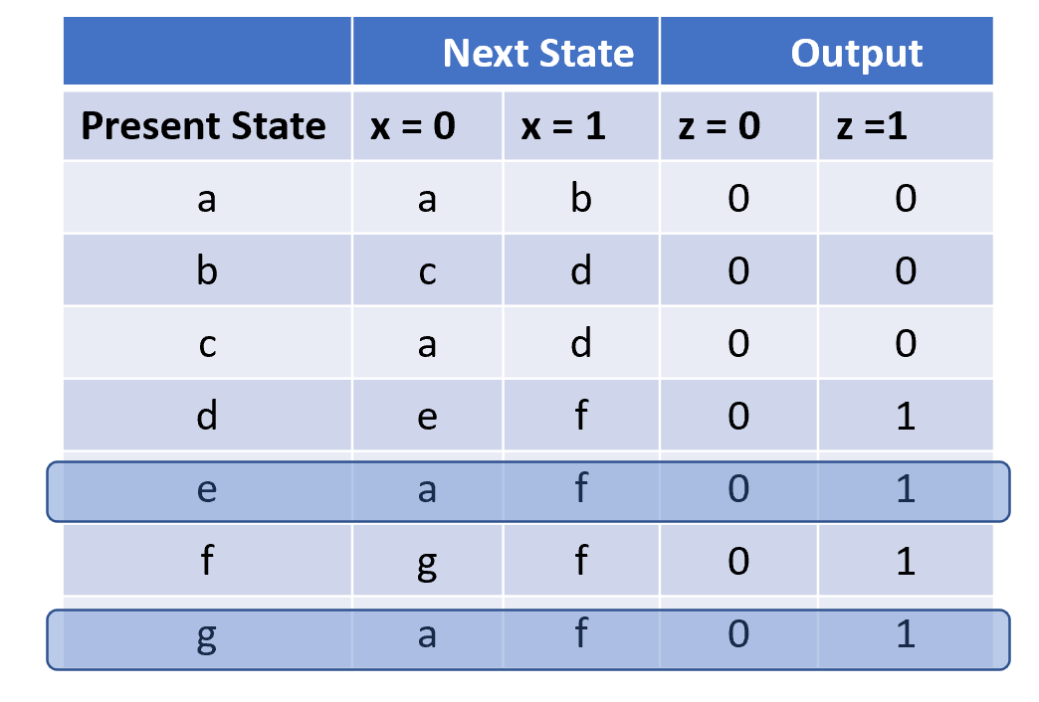
Reduced State Table
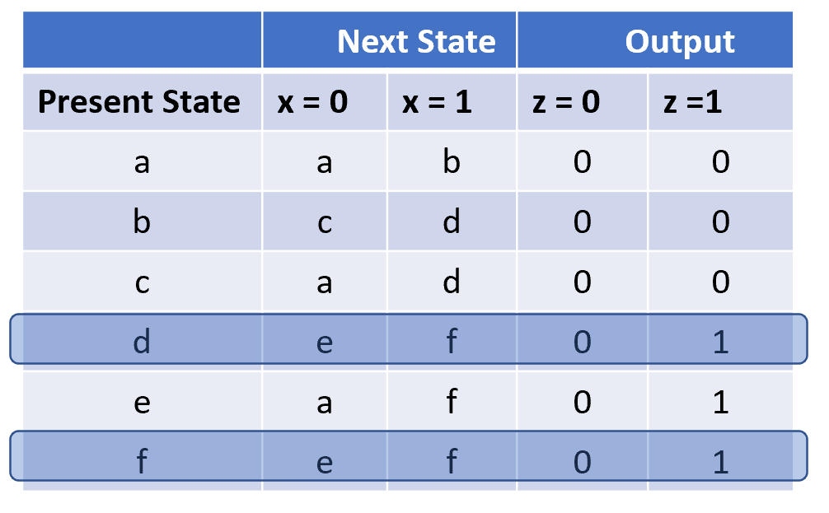
Further Reduced State Table
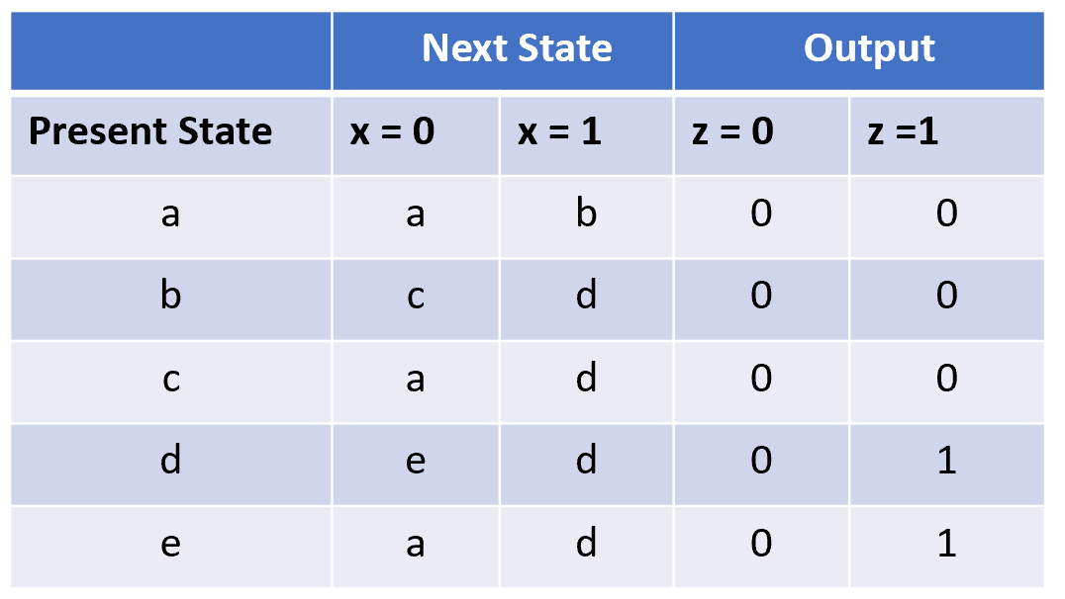
Reduced State Diagram
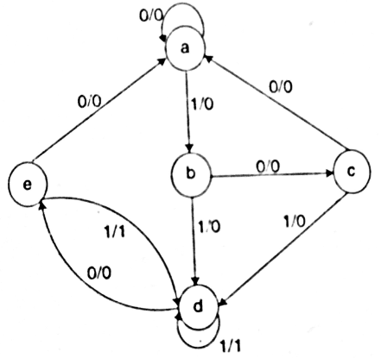
State Assignment
a ---> 000
b ---> 001
c ---> 010
d ---> 011
e---> 100
State Table

State Table
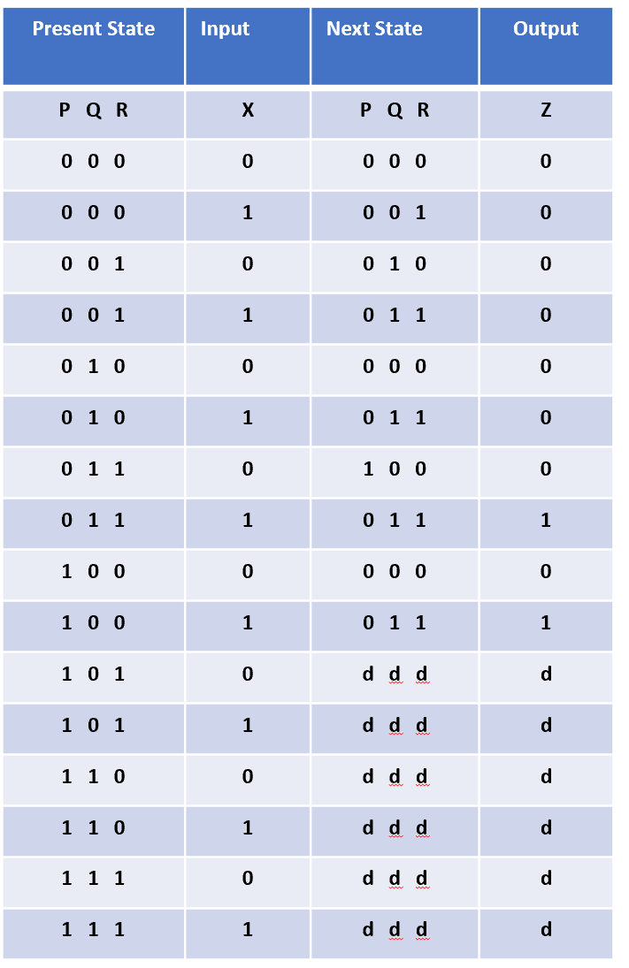

Excitation Table
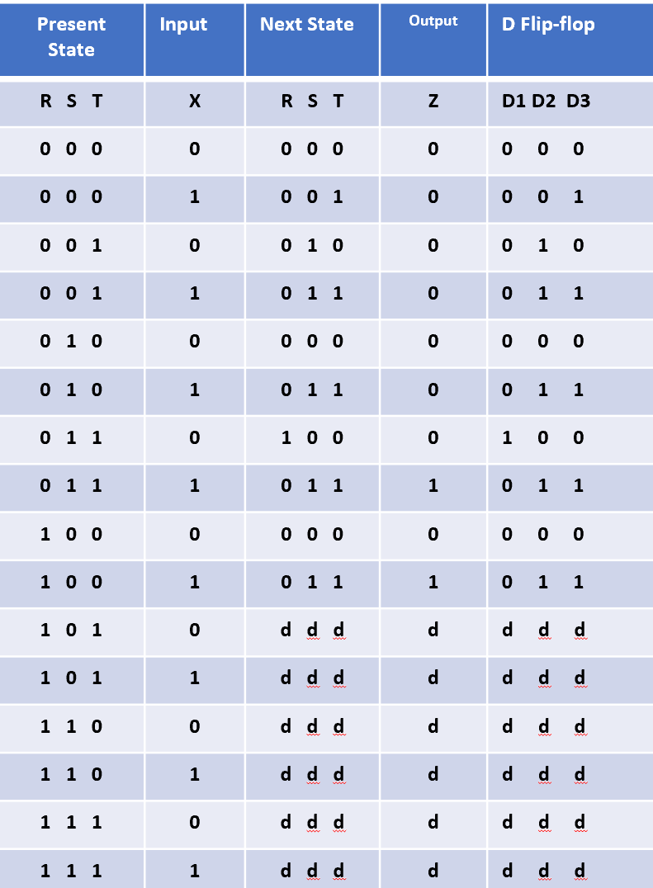

K- Map
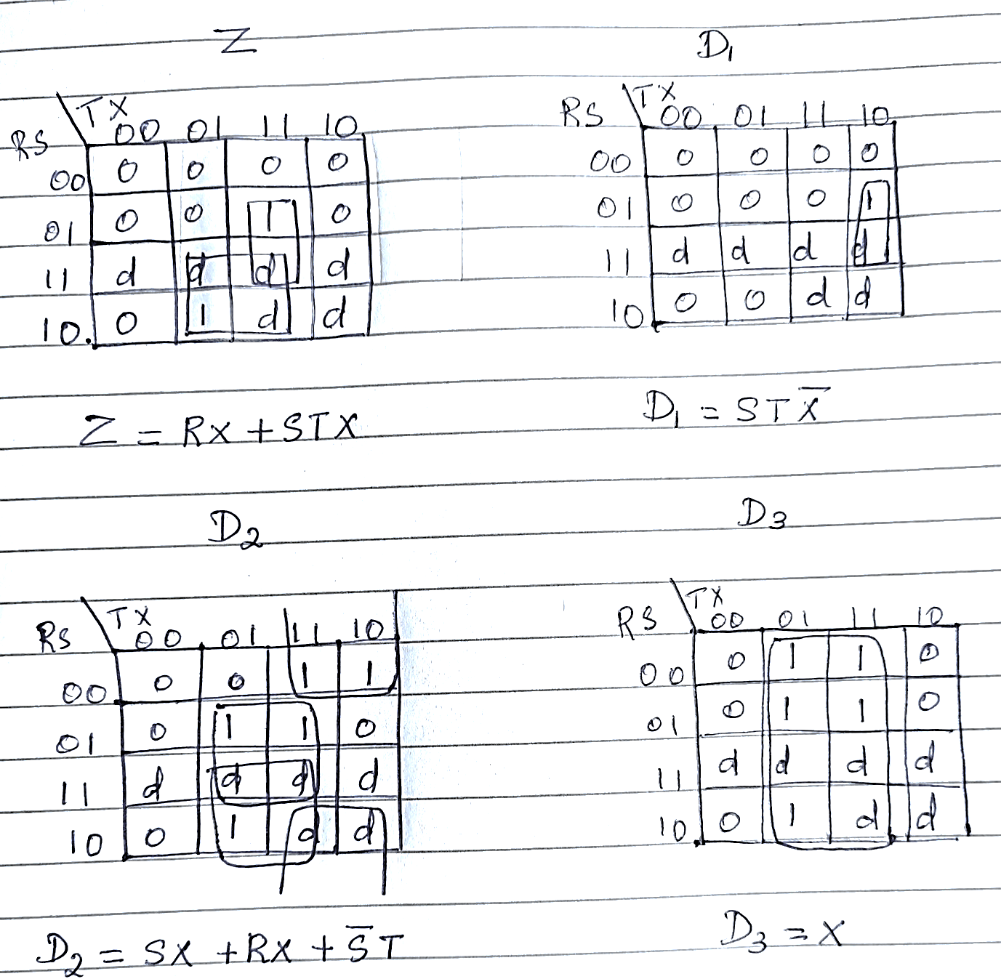

Output Expressions
$$D1=STX ̅ \\ D2=S ̅T+SX+RX \\ D3=X \\ Z=RX+STX$$
Logic Circuit
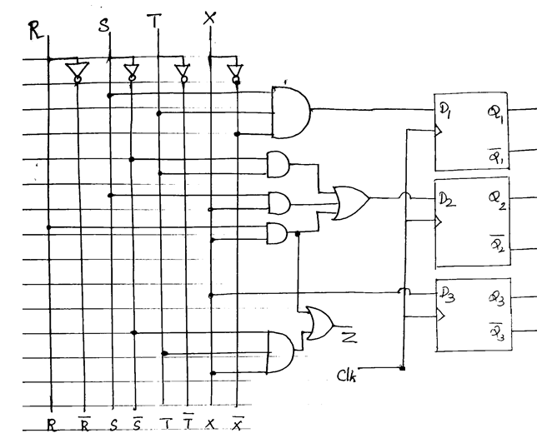

Q2
- Design a Synchronous Circuit for the Sequence Detector that produces an output ‘1’ whenever the non-over lapping sequence 1011 is detected. Also Represent the following.
- State Diagram.
- Present state, Next state, output Table.
- Excitation Table.
- Simplified K- Map Expression.
- Logic Diagram.
Solution
State Diagram
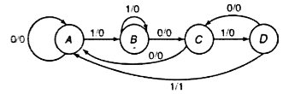
Present State(PS), Next State(NS), Output Table
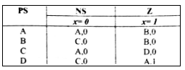

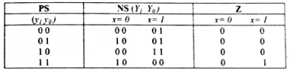

Excitation Table

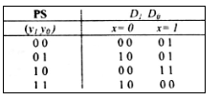
K- Map Expression
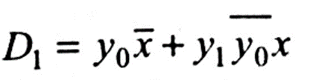
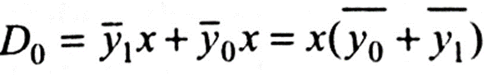
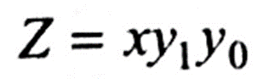

Logic Diagram
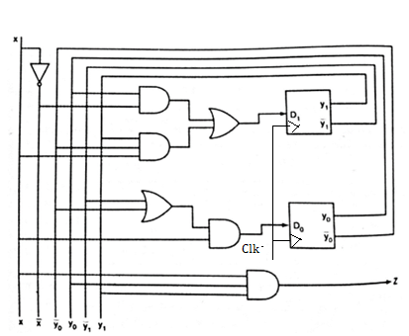

Q3
- Design a serial Adder and draw its corresponding logic circuit. Consider any two 4- bit binary numbers which are stored in two shift registers A and B respectively. The result (sum) of the adder must be stored in the register A.
Use a Full adder to add the two numbers. Answer the following questions
  - Block Diagram
  - State Diagram
  - Present state, Next state, output Table.
  - Excitation Table and Simplified K- Map Expression.
  - Logic Diagram.
Solution
Block diagram
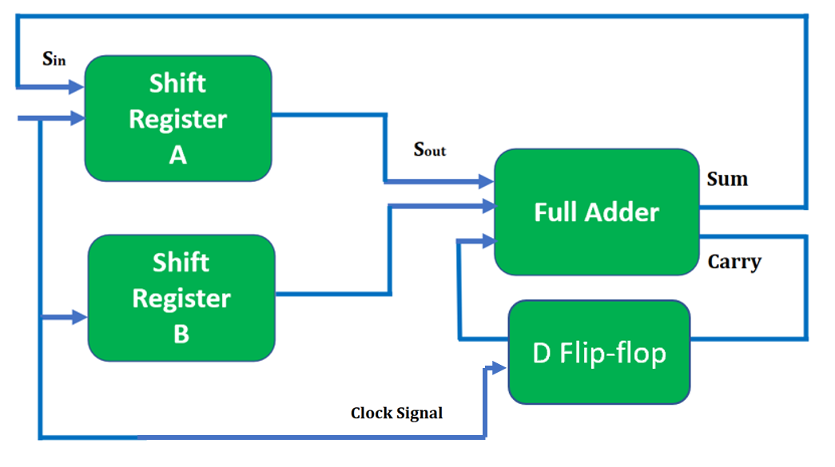
State Diagram
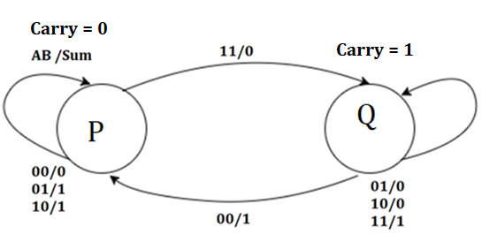

Present state, Next state, output Table
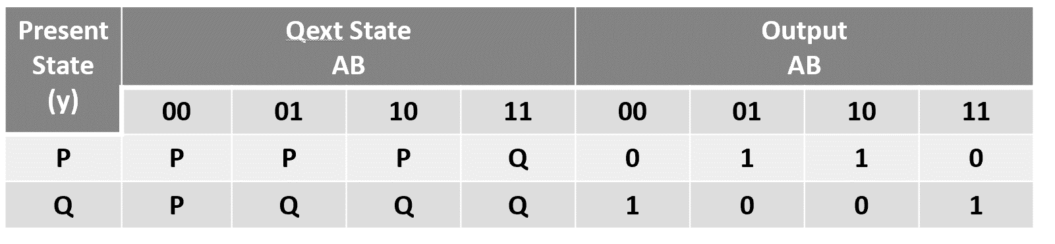
Excitation Table and Simplified K- Map Expression
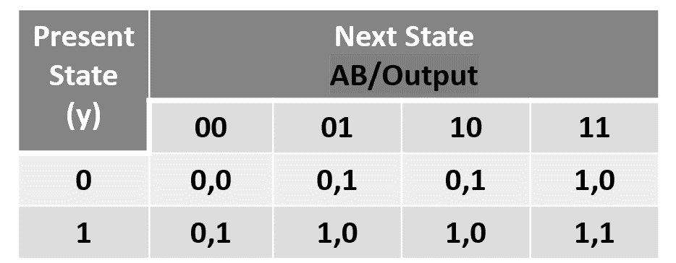
K- Map Expressions
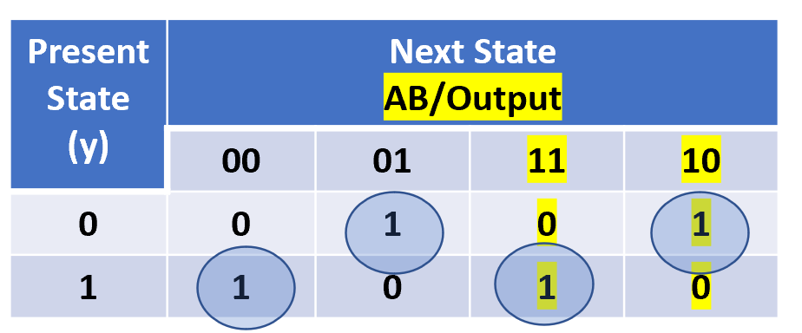
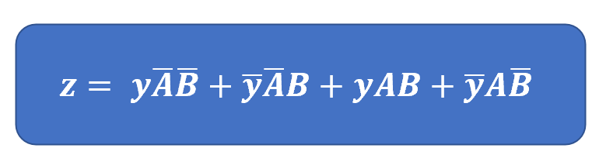
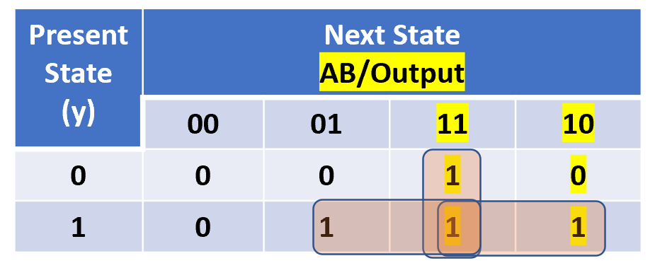

Logic Diagram


