
Skills for the Workplace
Module Assignment Submission
Student Name: | Kiel Jennings
Student Number: | 2015373
Module No: | BMSK4008
Module Title: | Academic and Research Skills

Statement of Confirmation of Authenticity
By the act of making this submission, the student declares that this is the work of the student named above. The work has not, in whole or in part, been knowingly presented elsewhere for assessment, or where assessment has been built on a previous assessment, this has been identified. Where materials have been used from other sources it has been properly acknowledged. If this statement is untrue, the student acknowledges that an assessment offence has been committed.
Attention is drawn to the plagiarism and unfair practice policies of both the University and of ILM.
Permission for ILM to use this script
ILM uses learners’ submissions – on an anonymous basis – for assessment standardisation. By submitting, both the centre and the learner agree that ILM may use this script on condition that identifying information is removed. However, if you are unwilling to allow ILM use this script, please refuse by ticking the box: □

Table of Contents
Managing Remotely: Is it the Way Forward? 3
Part 1 3
1.1 Introduction 3
1.2 Research 3
1.3 Findings 8
1.4 Conclusion 9
Part 2 10
Personal Reflection on Managing Remotely 10
2.1 Description 11
2.2 Feelings 11
2.3 Evaluation 12
2.4 Analysis 13
2.5 Conclusion 13
References 14
Appendix A 16
Appendix B 17
Appendix C 18
Appendix D 18
Appendix E……………………………………………………………………………………………… 19
Bibliography……………………………………………………………………………………………. 25

Managing Remotely: Is it the Way Forward?

Part 1

1.1 Introduction

The last year has seen tremendous change in the economy and how people work due to the Corona Virus Pandemic. The authors aim is to highlight effects on the workforce and the businesses that these people are employed by in order to assess if this will be a permanent or a medium-term trend in the workplace.

1.2 Research
Primary Data:
In the authors workplace before the pandemic there was one person working from home on a regular basis. Although attitudes to new ideas are changing in the military and more specifically in this regiment it takes time to filter through. During the first lockdown, only essential people were in work (security, catering, specific employees to receive deliveries). In the latest lockdown (Jan 2021) approximately 10% of the workforce were in work initially, increasing steadily as staff were required for various taskings. As of March 19th 2021 all employees were back in the base location. Although most have disrupted or different hours to what would have been expected 12 months ago.
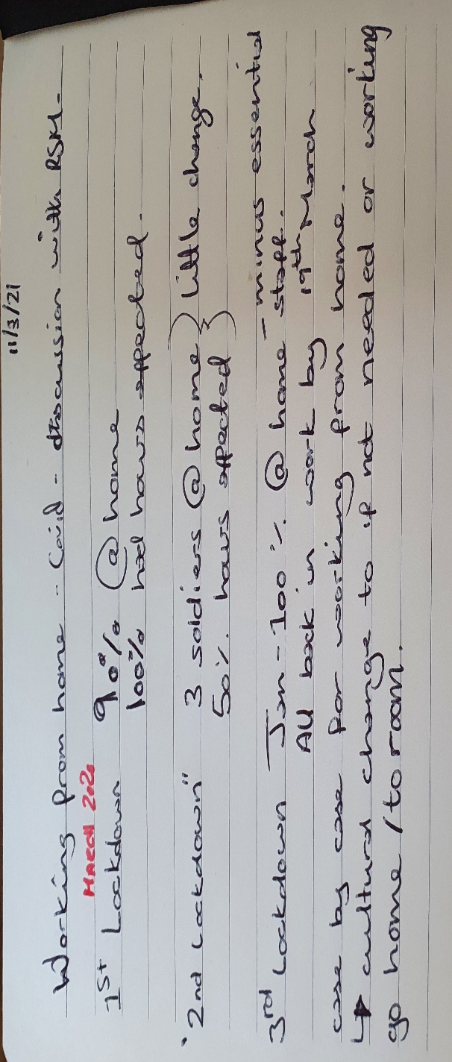

While those employees have been away from their main place of work, they have been required to use various communication and IT tools in order to stay in touch.
Zoom: Used mainly for large audiences or briefings. Zoom has the capability to have up to one thousand participants. It can be downloaded onto any device which is useful for people with no access to Laptops/PCs. It also has built in security including locking the meeting, having waiting rooms so people can be vetted before entering into the main chat, and specific passcodes to the meeting which stops people without it from joining.
Skype: Similar to Zoom but with smaller meeting capabilities (100 maximum) Skype has also been useful for connecting to employees from a PC to the phone network.

Fig.1 Number of estimated skype users registered worldwide 2009 to 2024.
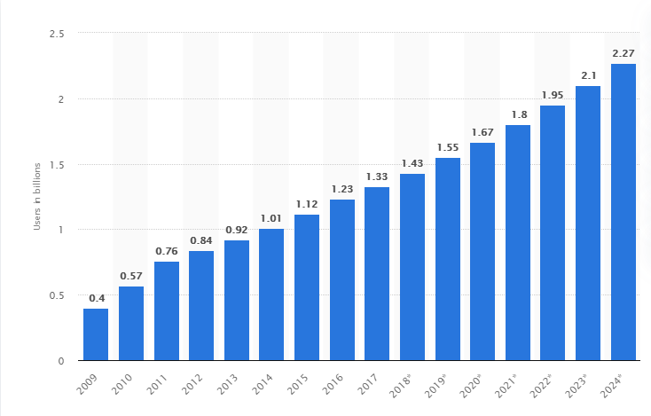
This statistic shows an estimate of the number of Skype users registered worldwide from 2009 to 2017, including a forecast until 2024. (*estimated)
Mean Average increase expected of 0.1125 billion, or 1.1million additional users per year.
The author included skype in this list as it is one of his main tools to communicate. If the receiver is online, then you can simply call them and if not, you can see their current status (In a meeting, away etc). Although looking at the future it appears that Skype will be discontinued by Microsoft in July 2021, which may create a gap in this organisation’s communication capability.

Microsoft Teams: In order to better compete with other apps, Microsoft has increased its maximum capacity on video call to 300 (paid users only, free users have a maximum of 20).
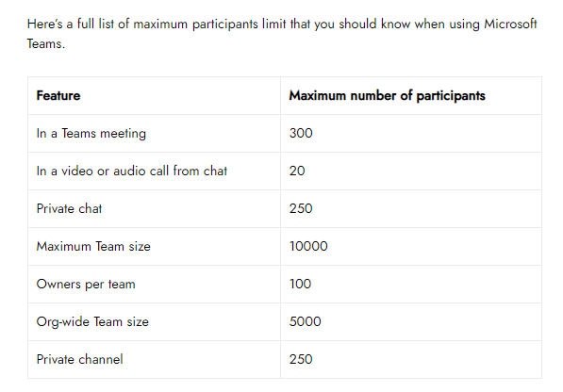
fig.2 Microsoft Teams Limits, table by Mark @ Nerdschalk.com
Microsoft teams also has the ability to freely share information, work, and documents with other members of the team almost instantaneously when used in conjunction with Office 365. This makes it the preferred method in this authors workplace for teams and departmental working.

Secondary Data:

Fig.3 Growth in Downloads of Video Conferencing Apps during week of March 15-21 2020 vs. Weekly Average of Q4 2019 During Covid 19 Pandemic
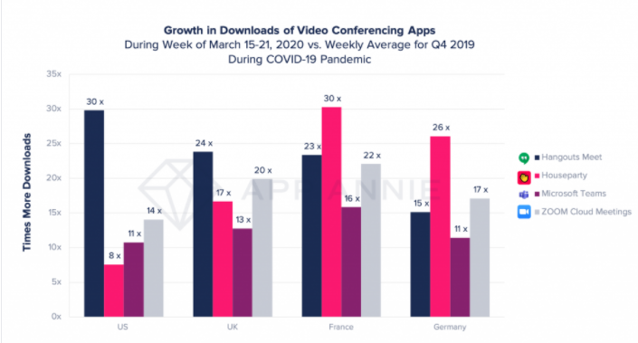
For the UK, conferencing apps on average were downloaded 18.5 times more than in Q.4 of 2019
The median for this statistic is 17 times more downloads.
8 11 11 13 14 15 16 17 17 20 22 23 24 26 30 30
Mode average, 11 17 and 30 times more downloaded all presented twice on this chart
The range is 22 (30-8).
Ipsos Mori conducted a survey into how people were finding working from home during the 2020 lockdown. Younger people look to be more affected by the remote working than older people. The top reason for finding it difficult was a lack of working space at home.

Fig. 4
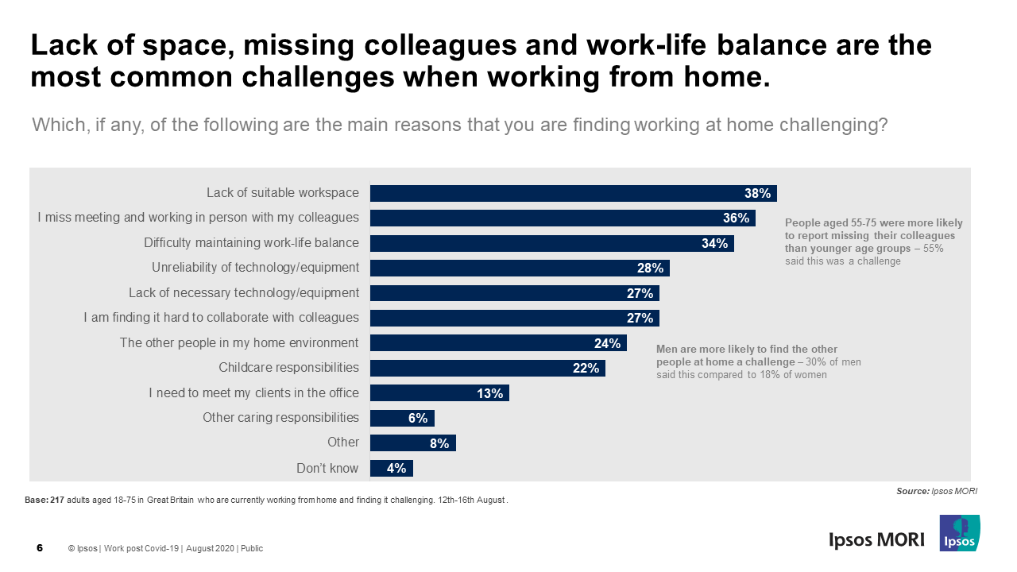
Interpersonal relations and suitable workspace (working conditions) feed directly into Herzbergs Theory. The author is linking difficulty maintaining Work Life Balance to Lack of suitable workspace.

Figure 5. LABC Warranty House Sizes (2019)
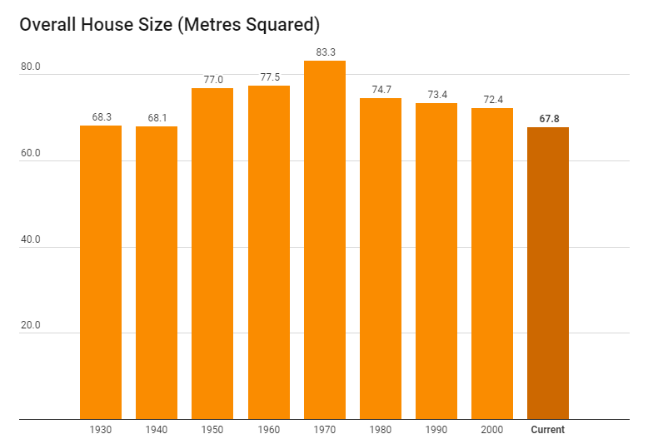
Figure. 6 Number of Bedrooms Which (2018)
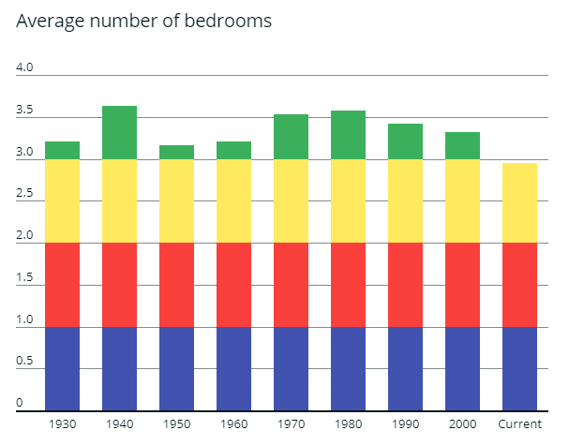
The number of bedrooms is now under 3 and is the lowest it has been since at least 1930.

1.3 Findings

The journey some people have made during the last 12 months may have had a profound impact on the way they will work for the rest of their lives. The author of this essay was told to work from home at the beginning of 2021, but isolation, unsuitable working conditions in the home, and seeing peers having to complete tasks without assistance made him come back to work at the earliest opportunity. Management of the workspace available to the team has meant that the department has formed a bubble in order to provide our services to the wider employee community. With only 3 people in the department, inter-personal management is extremely limited, but we do manage cases that come to us. These cases are now managed predominantly online, and we have not had a single person from an external agency in our office since the summer of 2020.
In Jennifer Jordan’s 2020 Webinar, if you are not managing your team face to face (f2f), you are managing remotely. Both ways have advantages and disadvantages, with f2f having greater psychological benefits (better interpretation of non-verbal cues, more warmth between members, less miscommunication). She argues that socially, remote management is more of a level playing field as team members have less inhibitions. The increased recording of communications and record keeping allow for better decision making within the team.
Parker, Knight, and Keller (2020) argue from their research that managers are finding it hard to trust their employees or are at least sceptical as to whether remote working or management would be a long-term trend after the pandemic. Some of this is related to challenges faced within their new working environment, mostly the home, and the balance that is required to be struck between working and normal family time.
One of the challenges for people and especially younger people is the lack of suitable workspace within the home environment at 38%, and difficulty maintaining work-life balance coming in at 3rd with 34% on the Ipsos Mori Poll (August 2020). Looking at data collected by LABC Warranty UK house sizes are the smallest they have been for nearly a century. Which (2018) fig. 6 also show that houses now have fewer bedrooms than at any time since the 1930’s.
With younger people more likely to buy a newer house than older people who are further up on the property ladder, they are being impacted harder during this new way of working. Forced to work in a smaller environment, with less space available they have negative impacts which may influence their mindset and how they perceive other people being able to work remotely.

The lack of trust identified from managers earlier, and poor working conditions feed directly into Herzbergs Two Factor Theory (Alshmemri, Maude and Shahwan-Akl, 2017) and will decrease job satisfaction for employees. Managers must work hard to improve, adapt, and support their subordinates during these turbulent times.

1.4 Conclusion

In normal times, change to working practices on the scale seen in the last 12 months usually takes a long time to implement. It requires cultural change and allowing people to fail in order for them to succeed later on. The Covid-19 pandemic forced many economies to adopt working from home almost as a norm, and subsequently remote management into the mainstream. While various government monetary schemes allowed companies to survive the various lockdowns seen, Global economic growth fell to -4.9% in 2020 (IMF. 2021)
For this to be a long-term change in working practices and for the economy to get back to where it was and indeed grow again, the author believes UK house sizes will have to increase in order to adopt a home office environment. Some properties could have easy solutions, such as converting a garage, a spare bedroom, or a partitioned area within the living room. Whereas others may never be suitable to be worked from home in.
While the UK construction market is dominated by private enterprise companies who are required to make a profit, and without the necessary government legislation in place and enforced to make homes larger, this issue will not go away. The other solution is for offices to evolve. Short term, changing working patterns to a staggered format maximises the amount of time an office could be used. Workers may have to change from 0900 to 1700hrs to 0600 to 1400hrs and 1500 to 2000hrs almost like a shift pattern. Longer term, redesigning the office space away from open plan and back to more cellular options is one possibility, although this may have implications on mental health and communication in the workplace. (Mudditt, 2020) says that one solution may be to have hardier materials in the office that can withstand more intense cleaning routines.

Gajendran & Harrison 2006 analysis finds that overall, the benefits to working remotely should outweigh the disadvantages provided all the elements are in place to support distributed workers and managers. The UK has sound internet capabilities, the technology and software for remote working, but it remains to be seen if the will is there to improve our homes so as to bring our work into our house and reap the benefits long term.

Part 2

Personal Reflection on Managing Remotely


Gibbs (1988)

2.1 Description

This module asked us to complete a report on ‘Remote Management’. The work was set and with wide ranging goals, organised into 4 questions.
- Demonstrate awareness of Academic & Research Skills required for your learning journey.
- Provide evidence of data handling, analysis, interpretation of basic statistics and construct an academic argument.
- Reflect on your research by using a recognised reflective model.
- Provide 10 quality sources, CRAAP Analysis, Appendices and a well laid out report.

Within this there were some what I like to call sub-goals. These included.
- Averages.
- The writing in 3rd person for the report element of the module.
- Writing in 1st person for the reflection element.

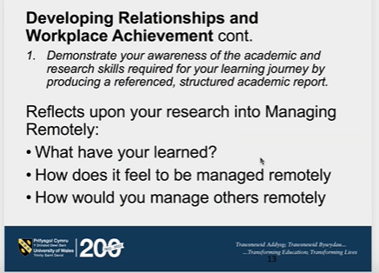

2.2 Feelings
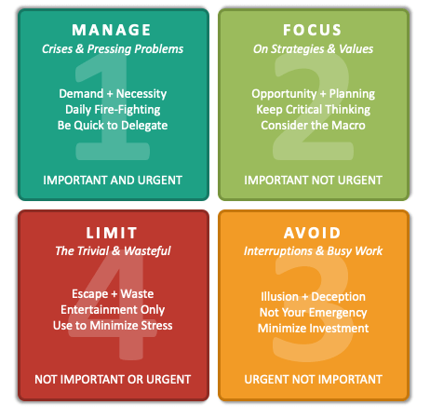
This module has fit into Manage, Focus & Limit and re-prioritised throughout the entirety of the learning journey. The issue is that it is not the only thing I have been managing, and other areas of life and work have also inserted themselves, usually with a higher priority than the learning journey I want to take.
Relatives and friends becoming ill and requiring hospital treatment has distracted me, maybe not physically with visiting but definitely mentally and drawn my focus away. This led to stress levels beginning to rise and I needed to take some time in order to maintain a healthy mental resilience to these stress levers.
Work has also distracted me during this module. While fully supportive of me gaining qualifications, I recognise I am still employed, and I work my full mandated hours. I have two main issues with work though. The first being the level of care and support we have to provide and the minimal training we have in order to give it. While I recognise most of the job is signposting onto professional organisations who are suitably qualified to deal with the problems that people present to us, there is also the morale implications and we want to ensure our colleagues and families are being looked after. This in turn leads us to heavily investing mentally into the cases. The second issue is that people contact us at the most inappropriate times, usually on a weekend, which is usually when I have my free time to study. Usually this isn’t an issue, but one of the messages called into question our professionalism and dedication and that affected me tremendously (It subsequently turns out that the case the wife was referring to was because a suicide had occurred, the other regiments welfare department were pulling out all the stops to show support to the families).
The work we undertake in the Welfare department is usually reactionary and cannot be planned into an effective schedule. While we do have planning sessions for upcoming events, fundraising, and other ideas, whatever we are doing needs to be dropped instantaneously in order to support somebody coming to us in crisis.

2.3 Evaluation

When I had the time and motivation to study, read, write, and think about what was required of me, I felt I could do some really good work. When the focus was there, I could read information, extract what I needed and put it down. On my breaks I’d be thinking of different ways of forming arguments, or re-arranging sentences to make more sense.
When I had lost that motivation, or time I found it tremendously difficult to reinvigorate myself to get back to where I needed to be in order to make that work happen. Even though I had set time aside and was planning where and when my sessions would take place, I found other things would be dragged into the fold pushing the studying time I treasure down the pecking order. Setting of SMART goals was not effective for me in this module, although at time of writing it looks like I will have the report submitted I do not feel like I have been able to give 100% of myself to it, and so I feel like I haven’t learnt as much as possible and so haven’t benefitted as much either.
Another massive benefit has been my collaboration with another student on the course. Not so much for helping with each other’s work, but for the motivation to get through difficult phases. Without her I would have really struggled on this module, even more so than what may be evident. I hope I can repay her if she ever needs my help.

2.4 Analysis

I think some of the reasons why I’ve struggled so much with this assignment is that life issues have taken a priority over my Higher Education study. Isolation from friends and family because of the lockdown has not helped but the main cause of my malaise has been work pressures. Densten (2005) says that Burnout is “a syndrome which emanates from an individual's perception of unmet needs and expectations”. Further Schaufeli, Maslach and Marek 1993 page 17, “Traditionally the major cause of burnout has been the emotionally demanding interpersonal relationships of professional caregivers with their recipients.”
As I write this final piece, I can recognise that there are imbalances that I need to address in the coming weeks in order for me to progress both in work and my studies. My study has suffered because work has had a negative impact on my cognitive abilities.
I find the setting of SMART goals not difficult but time consuming, my 1st step on addressing the imbalances that I have endured is to begin opening up to the use of goal setting in order to provide structure and targets. I also found the use of Daily Learning Logs to be initially a waste of time, but my thinking has changed to show they can be used as a measurement tool to show whether my SMART goals are on track.
My Personal Effectiveness profile (Appendix D) has the 2 lowest scores of Realistic Visioning and Social Effectiveness, and I think this feeds into the narrative that I have been struggling, isolated and tired. The positive I am taking from the questionnaire is that my highest scores are related to:
- High Personal Power- The ability to break free of procrastination or malaise.
- Focused Energy- Expending energy on tasks, but in a way that has purpose. See below
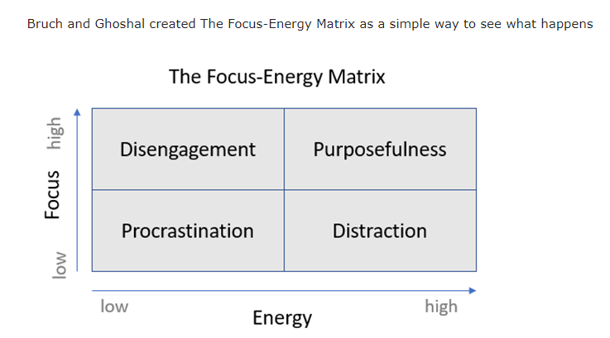
High Energy and High Focus result in Purposefulness which is the ideal use of Energy and Focus.
JD (1970) says only 10% of managers fall into this box, but I need to be careful not to fall into the disengaged box of which 20% of managers fall into.

2.5 Conclusion

I feel I have learnt more about myself than I have on the subject I reported on. I also feel more inclined to go and look for solutions to my problems and issues than to go and explore other topics that have come up over the last few weeks. Overall, I’m glad to hand this assignment in, as this time 2 weeks ago I had absolutely nothing to show. Yes, I had done some preliminary reading and research, but this did not feel like it had taken hold inside. I look forward to taking a break from being in front of a computer, or for reading for research sake, but at the same time I will be working on myself so as to improve my next score.

References

- Fig.1 Statista. (2017). Estimated Skype user numbers worldwide 2009-2024 | Statista. https://www.statista.com/statistics/820384/estimated-number-skype-users-worldwide
16th Mar. 2021

- Fig.2 Mark (2020) Microsost Teams Limit: Call Duration, Maximum Participants, Channel Size and More. https://nerdschalk.com/microsoft-teams-limit/ 20th March 2021

- Fig.3 Sarah Perez (2020) Videoconferencing Apps Saw a Record 62million Downloads During One Week In March https://techcrunch.com/2020/03/30/video-conferencing-apps-saw-a-record-62m-downloads-during-one-week-in-march/?guccounter=1&guce_referrer=aHR0cHM6Ly93d3cuZ29vZ2xlLmNvbS8&guce_referrer_sig=AQAAAF90m-YeTkMeamxhRq6tZcHv79Dl9qkkP7ARbojDTtJRMHeCkyNb-gnOuGuazc-5cWevoiecnw63LaAsdumP1_lUv8ks9eim_T-ZQyK7LXlBf11u_Id6gsgqpk1AGZsojb8dZanNovp_yCqSih1zD7lE6ERounBjyeVbZDcrU-JZ 16th March 2021

- Fig.4 Ipsos Mori (2020) Majority of Those Working From Home Are Not Finding Working From Home Challening, but Many Miss Their Co-Workers and Technology https://www.ipsos.com/ipsos-mori/en-uk/majority-those-working-home-are-not-finding-it-challenging-many-miss-co-workers-technology 23rd March 2021

- Fig. 5 LABC Warranty. (2019). Are Britain’s Houses Getting Smaller? [online] https://www.labcwarranty.co.uk/blog/are-britain-s-houses-getting-smaller-new-data/
- ar. 2021.

- Fig 6. Stefanie Garber (2018) Shrinking Homes: The Average British House 20% Smaller Than in 1970s https://www.which.co.uk/news/2018/04/shrinking-homes-the-average-british-house-20-smaller-than-in-1970s/ 27th March 2021

Jennifer Jordan (2020) Leading Teams Virtually 2.0 https://www.youtube.com/watch?v=sJhY7YmTVEI
13 March 2021

8. Parker, S.K., Knight, C. and Keller, A. (2020). Remote Managers Are Having Trust Issues. [online] Harvard Business Review. https://hbr.org/2020/07/remote-managers-are-having-trust-issues 22 Mar. 2021.
9. IMF. (2021). World Economic Outlook. https://www.imf.org/en/Publications/WEO
25 Mar. 2021.

10. Alshmemri, M., Maude, P. and Shahwan-Akl, L. (2017). Herzberg’s Two-Factor Theory. Life Science Journal, [online] 14(5), pp.12–16. http://www.lifesciencesite.com/lsj/life140517/03_32120lsj140517_12_16.pdf.

11. Mudditt, J. (2020). How offices will change after coronavirus. [online] Bbc.com. Available at: https://www.bbc.com/worklife/article/20200514-how-the-post-pandemic-office-will-change 27 Mar. 2021.
12. GAJENDRAN, R.S. and HARRISON, D.A. (2006). The Good, The Bad, and The Unknown About Telecommuting: Meta-Analysis of Individual Consequences And Mechanisms of Distributed Work. Academy of Management Proceedings, 2006(1), pp.D1–D6.
13. Gibbs, G. (1988) Learning by doing; A guide to teaching and learning methods. London: FEU

‌14. Densten, I.L. (2005), The Relationship Between Visioning Behaviours of Leaders and Follower Burnout. British Journal of Management, 16: 105-118. https://doi.org/10.1111/j.1467-8551.2005.00428.x 28th March 2021
15. Schaufeli, Maslach and Marek (1993) Professional Burnout Recent Developments in Theory & Research (1st Edition 2017) Routledge
16. JD (1970). The Focus-Energy Matrix: How Purposeful People Balance Focus and Energy. https://sourcesofinsight.com/focus-and-energy/ 28 Mar. 2021.
Appendix A
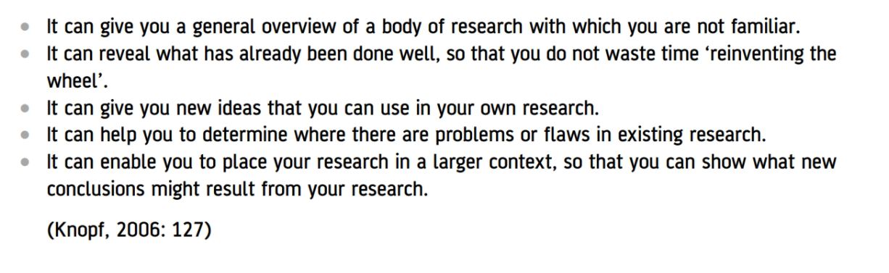
Benefits of carrying out a literature review (Maund, 2017)

Appendix B

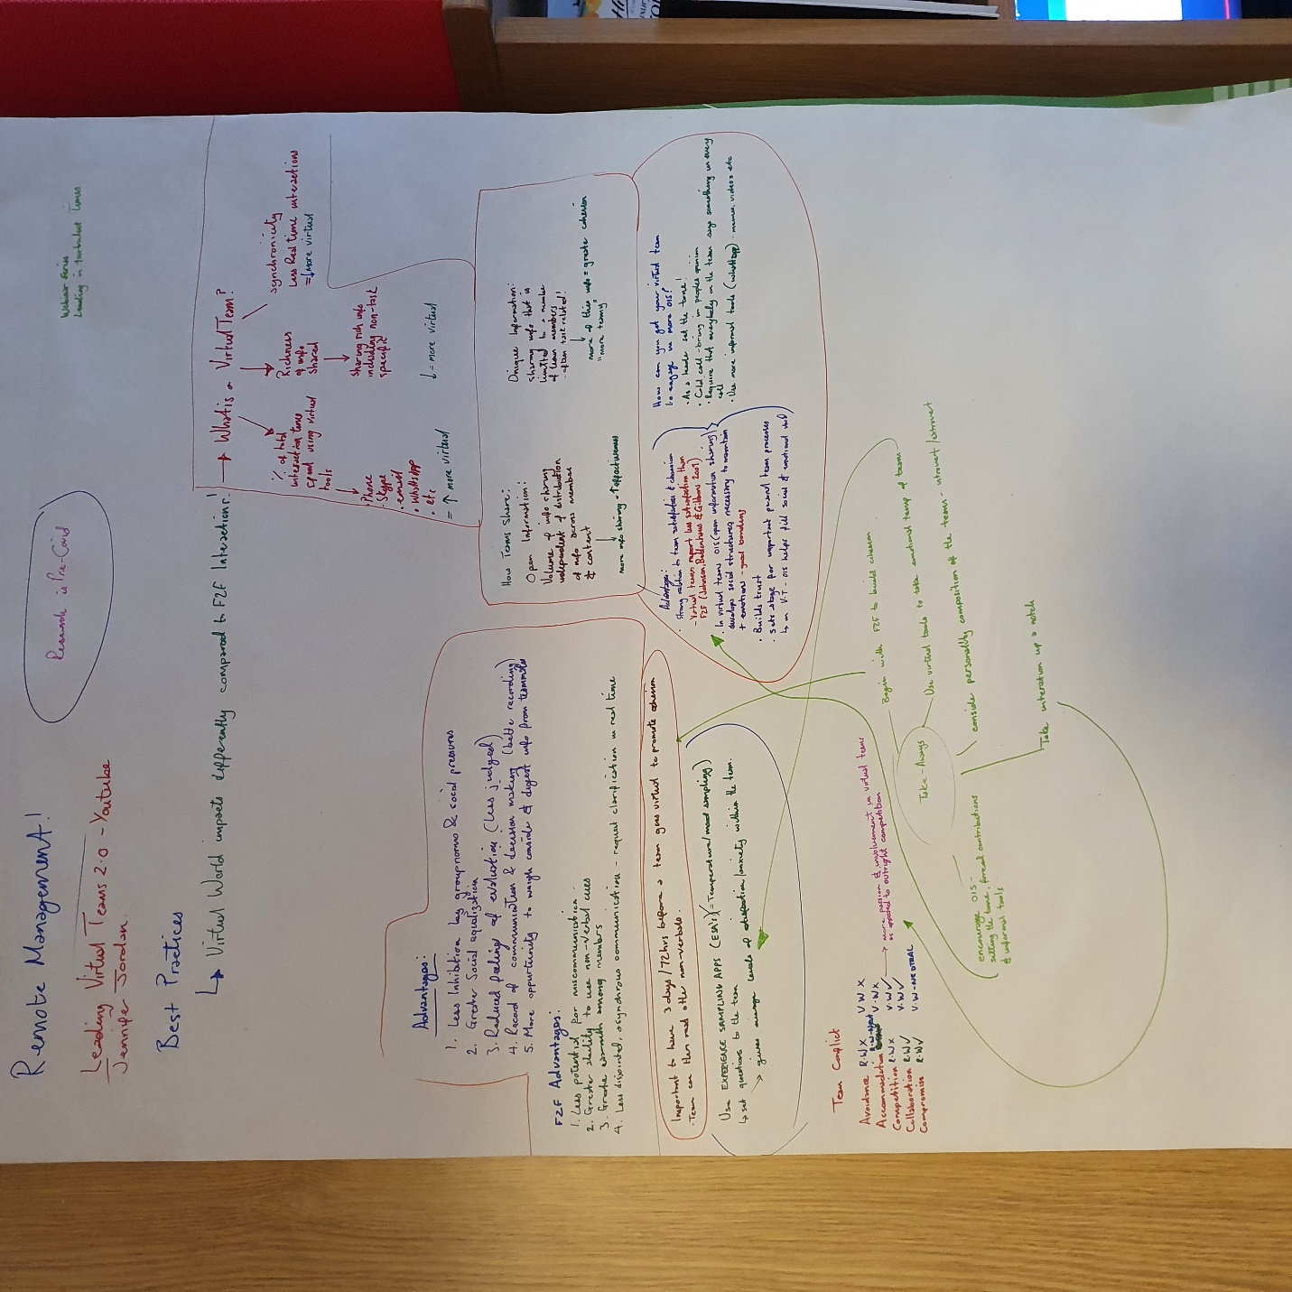

Note taking from a webinar.
Jennifer Jordan (2020) Leading Teams Virtually 2.0 https://www.youtube.com/watch?v=sJhY7YmTVEI
13 March 2021

Appendix C
CRAAP Analysis for Reference 8: Parker, S.K., Knight, C. and Keller, A. (2020). Remote Managers Are Having Trust Issues. [online] Harvard Business Review. https://hbr.org/2020/07/remote-managers-are-having-trust-issues 22 Mar. 2021.

C | Currency:-  Published in July 2020, within 12 months
R | Relevance:-  Directly relates to the evidence the author is presenting within the report.  It makes the point that managers are struggling
A | Authority:-  Harvard Business Review, a management magazine so not a scholarly journal, but is still owned by Harvard University.
A | Accuracy:-  Source has carried out a large amount of research, with different nationalities and cultures taking part. The source for their information comes from Centre for Transformative Work Design surveys of April & May 2020
P | Purpose:-  To highlight to the reader that managers are struggling during the pandemic as some of them have had remote management thrust upon them. They also aim to highlight possible solutions at the end including training and education

Appendix D

Personal effectiveness profile
20 | 20 | 20 | 20 | 20 | 20 | 20 | 20 | 20 | 20
19 | 19 | 19 | 19 | 19 | 19 | 19 | 19 | 19 | 19
18 | 18 | 18 | 18 | 18 | 18 | 18 | 18 | 18 | 18
17 | 17 | 17 | 17 | 17 | 17 | 17 | 17 | 17 | 17
16 | 16 | 16 | 16 | 16 | 16 | 16 | 16 | 16 | 16
15 | 15 | 15 | 15 | 15 | 15 | 15 | 15 | 15 | 15
14 | 14 | 14 | 14 | 14 | 14 | 14 | 14 | 14 | 14
13 | 13 | 13 | 13 | 13 | 13 | 13 | 13 | 13 | 13
12 | 12 | 12 | 12 | 12 | 12 | 12 | 12 | 12 | 12
11 | 11 | 11 | 11 | 11 | 11 | 11 | 11 | 11 | 11
10 | 10 | 10 | 10 | 10 | 10 | 10 | 10 | 10 | 10
High Personal Power | Focused Energy | ‘Stickability’ | Learning Orientation | High Empathy | Realistic Visioning | Social Competence | Situational Responsive ness | Analytical skills | Competitive Motivation
1 | ii | iii | iv | v | vi | vii | viii | ix | x

Bob sent this questionnaire to us while I was in one of my “offline” modes. I conducted and my bottom score is what I would have predicted before taking the test. I am surprised by my Realistic Visioning scoring low though, as I thought I was realistic about my targets that I set myself. Perhaps I may have to make more use of SMART goal setting in order to maximise this and bring it higher up the scoring charts. High Personal Power, Focused Energy and Stickability score highly and this shows to me Im still willing to learn and progress through this course.

Appendix E
NAME: Kiel Jennings Date: 16 /Feb / 2021

DAILY Learning Log

SUBJECT AREA: BMSK 4008 TOPIC: Remote Management

What did you learn today? or What did you do today? What were the main ideas?

A lesson from Bob, the first of the module. Bob introduced us to new students, and went over the objectives for this next module

What did you understand best? How does this relate to what you already learned in class?
Setting of SMART Goals

What questions do you still have about what you learned? How would you find more information (resources)?
What is Remote Management? For me this is a completely abstract idea and I will require my self to knuckle down and learn about this subject.
__________
Reflection: Describe the learning process or environment. Briefly summarize key concepts, terms or ideas. Describe how you felt about the lesson, class, or activity today.

NAME: Kiel Jennings Date: 20 /02 / 2021

DAILY Learning Log

SUBJECT AREA: ___________________________________________Topic_____________________________________

What did you learn today? or What did you do today? What were the main ideas?

What did you understand best? How does this relate to what you already learned in class?

What questions do you still have about what you learned? How would you find more information (resources)?

Reflection: Describe the learning process or environment. Briefly summarize key concepts, terms or ideas. Describe how you felt about the lesson, class, or activity today.

NAME: Kiel Jennings Date: 23/02 / 2021

DAILY Learning Log

SUBJECT AREA: ___________________________________________Topic_____________________________________

What did you learn today? or What did you do today? What were the main ideas?

What did you understand best? How does this relate to what you already learned in class?

What questions do you still have about what you learned? How would you find more information (resources)?

Reflection: Describe the learning process or environment. Briefly summarize key concepts, terms or ideas. Describe how you felt about the lesson, class, or activity today.

NAME: Kiel Jennings Date: 24/02 / 2021

DAILY Learning Log

SUBJECT AREA: Team Medic Topic_____________________________________

What did you learn today? or What did you do today? What were the main ideas?
We looked at most of the theory regarding the Team Medics course. There were practical elements, but all classroom based (Tourniquets, Field Dressings)
What did you understand best? How does this relate to what you already learned in class?

The course is a recap for me, so I felt entirely comfortable during the lessons and did not have to many questions. There were some updates to techniques in using some elements, but they were updates as opposed to entirely new concepts.

What questions do you still have about what you learned? How would you find more information (resources)?

To find out more I could simply watch internet videos. The theory and concept behind the elements we were taught were all simple enough though, and through feedback with the SME I’m confident that my skills are up to a satisfactory level.

Reflection: Describe the learning process or environment. Briefly summarize key concepts, terms or ideas. Describe how you felt about the lesson, class, or activity today.

Today was all classroom based, but because of the number of classes being taken at the venue there was no IT support, so most of the teaching was delivered by the SME by oral presentation.

NAME: Kiel Jennings Date: 25/02 / 2021

DAILY Learning Log

SUBJECT AREA: _______Team Medic___ Topic_____________________________________

What did you learn today? or What did you do today? What were the main ideas? 2 pts.

Today we finished off the presentations and this was conducted using IT as this had become available. The remainder of the morning was practicing scenarios, and the afternoon was everybody’s assessments

What did you understand best? How does this relate to what you already learned in class? 2 pts.

I understood all elements as it was not a particularly challenging subject. To find out more about todays lessons I could watch videos about other peoples battlefield trauma incidents or read JSP 539.

What questions do you still have about what you learned? How would you find more information (resources)? 2 pts.

I have no questions and am happy with my level of knowledge going forwards.

Reflection: Describe the learning process or environment. Briefly summarize key concepts, terms or ideas. Describe how you felt about the lesson, class, or activity today. 4 pts.
The classroom was moved today and so we had use of IT support, and the SME was able to give presentations on Heat/Cold Injuries. Practical assessments and practices were adequate but were student led. Mistakes were not picked up by the Course Leader and this detracted from the overall value of the training for me.

NAME: Kiel Jennings Date: 28/03/ 2021

DAILY Learning Log

SUBJECT AREA: BMSK 4008 Topic: Module Sweep Up

What did you learn today? or What did you do today? What were the main ideas?
I finished writing for this module.

What did you understand best? How does this relate to what you already learned in class?
Reflecting back over the last few weeks, I can see that I have developed some traits relating to Burnout.

What questions do you still have about what you learned? How would you find more information (resources)?

I have lots of questions relating to how tired/ burnt out I am. To find more information, I could read about it using online texts or the library, seek medical advice, or I could conceive my own coping strategies in order to deal with it in a better way.

Reflection: Describe the learning process or environment. Briefly summarize key concepts, terms or ideas. Describe how you felt about the lesson, class, or activity today.
I’ve moved my accommodation and learning environment around so I can practice yoga and mindfulness in a better way inside. This has also improved the amount of light coming into the room, and so literally brightened my day.
I feel nervous about handing in the work, as it hasn’t had my full attention over the last few weeks, but also relieved as I am handing it in all the same.
Looking at the previous logs, and the fact I’ve written nothing in them shows how tired and run down I had become. I need to focus on me and my recovery so as to do better next time.

Bibliography
Sandeep Kashyap () A Manager’s Guide to Manage Remote Team https://www.proofhub.com/articles/managing-remote-teams 21 Feb 2021

Proband (2020) 10 Mind-Blowing Stats About Remote Working That Every Manager Should Know
https://www.probrand.co.uk/blog/pb/march-2020/10-mind-blowing-stats-about-remote-working
21 Feb 2021.

Mark C. Perna (Feb 2021) Employees Hired Remotely in 2020 Say They are Doing Fine. The Data Says Not Really https://www.forbes.com/sites/markcperna/2021/02/16/employees-hired-remotely-in-2020-say-theyre-doing-fine-the-data-says-not-really/?sh=7dd692f6ebd2 21 Feb 2021

Mark C. Perna (2020) Why Working From Home is Tougher Than We Thought https://www.forbes.com/sites/markcperna/2020/05/11/working-from-home-is-tougher-than-we-thought/?sh=26802a561e78 21 Feb 2021

Michael T. Robinson (2020) Generations: Which Generation are You? https://www.careerplanner.com/Career-Articles/Generations.cfm 21 Feb 2021

Chavez-Dreyfuss, G. (2020). Permanently remote workers seen doubling in 2021 due to pandemic productivity - survey. [online] U.S. Available at: https://www.reuters.com/article/uk-health-coronavirus-technology-idUKKBN2772P8 [Accessed 13 Mar. 2021].
Skillsoft YouTube (2020). Understanding the Basics of Remote Management. YouTube. Available at: https://www.youtube.com/watch?v=PEUofM1Hz6U [Accessed 13 Mar. 2021].
Zachary Bosin (2020) Video Conferencing Usage During the Corona Virus Outbreak https://www.bluejeans.com/blog/video-conferencing-usage-during-coronavirus-outbreak 16th March 2021
Microsoft 365 Blog. (2020). How To Make Connections In Remote Meetings - Microsoft 365 Blog. [online] https://www.microsoft.com/en-us/microsoft-365/blog/2020/04/09/remote-work-trend-report-meetings/ 23 Mar. 2021.
Microsoft.com. (2021). The Next Great Disruption Is Hybrid Work—Are We Ready? [online] Available at: https://www.microsoft.com/en-us/worklab/work-trend-index/hybrid-work 23 Mar. 2021.
‌Zhenfeng Zhao Winter 2020 ‘Relationship between Generic Skills and Employability Skills: An Exploratory Study in the Context of New Zealand Postgraduate Education’ Management Volume 15 Number 4 Pages 291-307.

‌

‌

