Module name: Living with Care: The older people
Module code: BMHP6009
Lecturer name: Liz Tilly
Student name: Mihaela Cristina Duca
Student number: 2026748

ASSESMENT 2- WRITTEN REPORT

Table of Contents
Introduction 3
Main body 3
What is old age? 3
How, and why, the number of older people has changed? 4
Health and Social Care Needs of the Individual 6
What relevant support and intervention does your individual need? 8
Effects of the pandemic on the elderly population of the UK 9
Government and health service response to elderly people 10
Specific theories of ageing 11
Recommendation 12
Conclusion 13
References 14

Introduction

The aim of the report is to introduce the theory of old age and to explain the issues and why the number of older people changed over the years, including consideration of the effects of the pandemic and analyse the health and social care provision on the elderly population in UK.

Main body

Mary is a 68 year old women that suffers of dementia and arthritis. Mary doesn`t have kids of her own to take care of her, and she is also a widow. She lives in a small village and only has access to the GP and because of the Covid-19 pandemic the access for health care was harder to access. Because of her illnesses Mary needs professional care and medication. She doesn’t have any funds to pay for her care, so she needs the government help. Her GP referred her to a care home that can help her with the care that she needs, regarding her requirements.

What is old age?

In humans, old age, also known as senescence, is the ultimate phase of the average lifetime. From the perspectives of biological processes, demographics (the circumstances of death and morbidity), work and retirement, and sociological research, the concepts of old age are inconsistent. Still, old age is commonly seen as being 60 or 65 years of age or more for economic and public administration reasons. (The Editors of Encyclopaedia Britannica, 2023)
Because it was the legal retirement age for males and the age at which they may begin receiving their State Pension, 65 has historically been seen as the threshold for older age in the UK.

Age 65 is no longer considered to be the beginning of elder age in terms of working patterns. There is now no set retirement age, the State Pension age is growing, and more individuals are working past the age of 65. The fact that 65 years old now and 65 years old a century ago have distinct features, notably in terms of health and life expectancy, is an additional crucial factor to take into account.

It may be claimed that the onset of old age has changed in a variety of ways. (Office of National Statistics, 2019)
Most people over 65 in today's society are still highly active, healthy, and refuse to recognise that they are becoming older. Doctor who recently retired at age 65 said that he is still extremely active and working and does not want to take advantage of old age's privileges, such as the free bus ticket. Old age "creeps up," as the cliché goes, but we do not just get old with time; rather, we continue to develop as we grow until we reach a specific age, which differs from person to person since ageing is multifunctional. People often dislike the term "old" and many become unhappy when they are treated as older patients, whether as inpatients or in ambulatory care centres. However, a lot of people use the excuse of "getting old" to explain a variety of behaviours, including neglecting to complete tasks, retiring early, or claiming benefits. (British Geriatric Society, 2017).

How, and why, the number of older people has changed?

According to Edgar Klusener in an article from 2019, a change in the population's age distribution, when older individuals are becoming more prevalent, is referred to as population ageing. Falling mortality rates and low fertility rates are the major causes of this. Because there are fewer young individuals joining the population, low fertility rates. The population's ageing trend is being driven by declining death rates, especially for those over 65. [In the UK], the death rate for women in their early 80s decreased from around 120 per thousand in the 1950s to 75 by the 1990s, while the mortality rate for males in the same age group decreased from about 160 to 125 per thousand. This growth can be attributed to a variety of factors, including healthier lifestyles, medical developments, access to better healthcare, and changes to workplace situations. Overall, we may draw a connection between ageing populations and advancements in technology and knowledge that guarantee a better and safer standard of life.
According to Catherine Thompson, above three million persons in our population are above 80 years old right now. This number is anticipated to nearly quadruple by 2030 and increase to eight million by 2050.
In 2050, one in four people will be beyond the age of 65, up from one in six now.
The average life expectancy for a guy born in the UK in 1981 is 84 years. However, that rises to 89 years for a newborn boy born today, and then to 91 years by 2030. We may all rejoice at this accomplishment. However, there are also major obstacles in the future that come along with these longevity successes. To guarantee that we live longer, healthier, more active, and independent lives, we must ensure that we provide high quality health and social care.
A large portion of senior adults link weakness with getting older. This is sometimes referred to in medicine as a decline in physical function: an older population that is most at risk of negative outcomes including falls, disability, hospital admission, or the requirement for long-term care.

Figure 1. (CoolGeography.co.uk, 2023)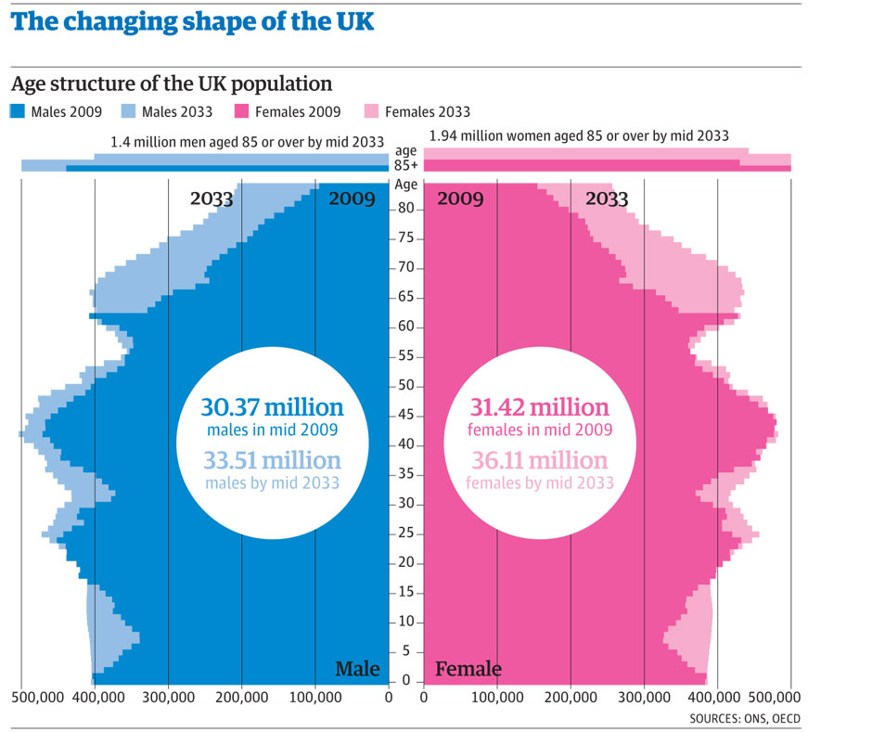

Health and Social Care Needs of the Individual

Focusing on Mary`s case, she is facing demographic problems because she lives in a small village and the access to health care is harder to obtain without help.
Both the demographics of the UK population and the demand for health care are evolving. In this Health Policy, we look at the population's present state of health, how healthcare requirements are evolving, and potential health risks in the future. The UK lags behind other high-income nations in key health outcomes, including life expectancy and infant mortality, and the prevalence of mental illness is rising. Successes do exist, such as the remarkable advancements in dental health, although health disparities still remain. The National Health Service (NHS) will encounter problems in the future related to the ageing of the population in comparison to the population of working age, the rise of multimorbidity, and ongoing health inequities, notably for avoidable disease. Future difficulties will necessitate a greater emphasis on illness prevention and health promotion, as well as a more concentrated effort to comprehend and address the numerous social, environmental, and economic issues that are at the root of health inequities. (McKee et al, 2021)
Wide-ranging activities under the umbrella of adult social care are designed to support older adults, individuals with disabilities, and those suffering from physical or mental illnesses in maintaining their independence and safety. In addition to more general support to keep individuals active and involved in their communities, it might entail "personal care," such as assistance with getting dressed, bathing, and getting out of bed in the morning. Social care includes aids and adaptations for people's homes, information and advice, support for family carers, and care provided by care homes and nursing homes (collectively referred to as "residential care"). It also includes support in people's homes (home care or "domiciliary care"). (The Kings Fund, 2021)
Although demanding, a career in health and social care may be tremendously rewarding. The need for personnel to provide high-quality, safe, and compassionate care as well as to learn new skills and stay up-to-date is growing as services and responsibilities change.

You could want to further your professional goals, hone your management and leadership abilities, or perhaps just brush up on your information and deepen your awareness of the industry. Whatever you require, we have something to support you along the way. (The Open University, n.d)

What relevant support and intervention does your individual need?

Anguish, denial, or a combination of dread, rage, and relief are all possible responses to learning that you have dementia. Assisting people to live effectively with dementia requires helping them accept their diagnosis, make decisions, and develop plans. The following part discusses daily symptom management, maintaining health, making plans for the future, protecting those who have cognitive impairment, and embracing the dementia assessment. (Social care institute for excellence, 2020)
More than merely having dementia influences how a person feels and lives life. Their connections, surroundings, and support all contribute to their overall experience. Carers, friends, and relatives may make the dementia patient feel liked are included. Assistance must be considerate to the individual receiving it. We refer to this as person-centered care. Additionally, assistance should emphasise enhancing their wellness and addressing their requirements. It's critical to keep your attention on the person's assets rather than potential losses. Instead of focusing on what they recall, pay attention to how they feel.
The reality that an individual with dementia is experiencing could be very different from the one that those around them are experiencing. Try to see things from the person's perspective and pay attention to their coping mechanisms in order to understand and help the person. (Alzheimer`s Society, 2022)
Simple, ordinary actions can frequently be unpleasant and challenging for those who have arthritis, making daily living challenging.
To have a healthy lifestyle, you can do a variety of activities. There are also a variety of services and advantages offered. If you have arthritis, eating a healthy, balanced diet is crucial. You may get all the nutrients you need and keep a healthy weight by eating a balanced diet.
If you suffer from severe arthritis and find it difficult to walk around your house or perform routine duties like cooking and cleaning, an occupational therapist can be of assistance.
They can offer advice on what tools you might need to live freely.
Your general practitioner might be able to recommend an NHS occupational therapist for you, depending on the specifics of your problem. However, your local government could be the only way for you to have access to this kind of therapy. (NHS, 2022)

Effects of the pandemic on the elderly population of the UK

As Mary`s case, when older adults (those 60 and over) expressed concern about the coronavirus (COVID-19)'s impact on their life, their top worries consisted of being unwilling to come up with commitments overall (64.5%), personal travel plans, such as vacations (53.4%), or ensuring their own health (51.4%).

The three most prevalent ways older individuals claimed the coronavirus had impacted their well-being were feeling upset or concerned (54.1%), being bored (43.3%), and worrying about the future (70%). Compared to younger individuals, older adults are dealing with some parts of the lockdown scenario differently, worried more about availability to necessities while worrying less about money. They are coping by reading, gardening, and staying in contact with friends and relatives via the internet. As a result of feeling backed by the communities where they live, they are more inclined to watch out for their neighbours. It's interesting to note that those who are approaching their 60s are the least enthusiastic regarding when life will get back to normal; more than a quarter believe it would take at least a year or never. (Office for National Statistics, 2020)

Government and health service response to elderly people

According to the case study, the only way that Mary can have access to professional care is with the government`s help, because she doesn`t have any other way to provide that for herself, and with the help of her GP Mary was referred to a good care home that can take care of her needs.
People in England are now living longer than ever thanks to improvements in healthcare. As a result, there are an increasing number of senior citizens in England, and over the next 20 years, this rise is expected to accelerate. This is great news for all of us, but it presents a problem for the NHS because as we age, we are more likely to develop chronic illnesses and require more medical and social care.
In order to help English citizens as they age well, NHS England collaborates with partners. We may always take steps to enhance our physical and mental well-being. It is especially crucial to take proactive measures to slow down or reverse some of the health difficulties for elderly persons who may be beginning to find things more challenging. The best possible care must be provided to older people when they need it in order for them to maintain their health and independence for as long as feasible. (NHS, n.d.)
Over 85-year-olds who are feeble may make up to 50% of the population and are more susceptible to accidents, illnesses, and other small setbacks. Frailty costs the UK's healthcare systems £5.8 billion annually, yet with the correct treatment and prevention, it may be slowed down or reversed. While the health care system is overburdened, neighbourhood nursing individuals are insufficiently staffed rehab programmes are operating at their optimum level, and residential and domiciliary health care facilities struggle to find and keep enough staff, investing in outreach programmes for elderly individuals may drastically decrease critical admissions to the hospital.
All elderly individuals who require rehabilitation must have their right to it protected and preserved by the government, as well as by those who provide health and social care. Elderly patients with frailty need to be mobilised as soon as they are admitted to the hospital, rehabilitation objectives must be set up quickly, and therapy must be sustained until the patient's state has stabilised. Everywhere they get treatment, older patients have the right to receive help from multidisciplinary rehabilitation teams. Rehabilitation should start in the hospital when a delay in care transfers to community rehabilitation facilities is necessary. Transferring older persons with rehabilitation goals to a care facility or community bed should only happen if adequate rehabilitation is available. (British Geriatrics Society, 2023)

Specific theories of ageing

In society, there are several methods to present the ageing process. Some of us view old age as a time to enjoy the rewards of our life's work, while others fear what old age could mean to our socioeconomic and mental health. Ageing is a universal, intrinsic, progressive and deleterious process. Understanding it is of major interest to scientist, physicians as well as to the general population. Critical to this understanding is to formulate comprehensive theories of aging with high predictive and explanatory power. More than 300 theories have been postulated and are reviewed here. The free radical theory of ageing is one of the most prominent and well-studied. (Vina et.al, 2017)
More about you than just your appearance may be predicted by your DNA. The genetic hypothesis of ageing contends that both your genes and gene-related mutations determine how long you live. Here are some important facts concerning genes and lifespan, as well as how genetics fits into the larger scheme of ageing ideas. According to the genetic hypothesis of ageing, our genes have a significant role in determining how long we live. The hypothesis holds that our lifespan is mostly decided at the time of conception and is heavily dependent on our parents' DNA. (Stibich, 2023)
According to Petra Simic in an article from 2023, with time, ageing happens in a cell, an organ, or the entire body. It is a process that all living things undergo throughout their adult lives. Gerontology, the study of ageing, is committed to studying and managing every element that affects how short each person's life is. It deals with a far larger spectrum of occurrences rather than only debility, which dominates human experience so greatly.

Recommendation

According to NHS, Your confidence and mental health will benefit by maintaining relationships with others and participating in social activities like going to the theatre or the movies, joining a choir or participating in walking groups.
An lively social life is beneficial for both you and the person who helps take care of you.
Nowadays, many neighbourhoods are dementia-friendly. For instance, theatres show the newest movies in dementia-friendly screenings, while recreation facilities provide swimming sessions and other activities in dementia-friendly settings.
The symptoms of dementia will progressively worsen as the person's brain changes as the disease progresses. The person with dementia may eventually find it difficult to do many of the tasks they formerly did. Even in the later phases, people could have brief periods of lucidity (awareness of their surroundings), and some of their talents would momentarily reappear. (Alzheimer`s Society, 2022)
It's not necessary for equipment to be expensive or sophisticated to be useful. People with dementia who live in their own homes have been shown to benefit from even little, commonplace objects.
For instance, items created to promote healthy ageing can also be quite beneficial for those with dementia. These include tools for maintaining continence and mobility assistance. A lot of goods, including memory aids, are made expressly to meet the needs of persons with dementia.
Generally speaking, it is a good idea for the user to begin using any new equipment as soon as possible so that they can become acclimated to it becoming a regular part of their routine. (Alzheimer`s Society, n.d.)

Conclusion
Mary`s case can be a difficult one because besides of her suffering with dementia she also has arthritis and she doesn`t have someone to take care of her in the comfort of her own home. With the government`s help Mary can access professional help to live the rest of her years in peace. Everyday activities like driving a car and making supper are affected by dementia. We are aware that there is no known treatment for this ailment, however drugs might momentarily ameliorate symptoms. Any harm done to the brain's neurons is therefore permanent.

References

- Alzheimer’s Society (no date) Supporting a person in the later stages of dementia, Alzheimer’s Society. Available at: https://www.alzheimers.org.uk/about-dementia/symptoms-and-diagnosis/how-dementia-progresses/supporting-person-later-stages-dementia (Accessed: 28 July 2023).
- Alzheimer’s Society (no date) Understanding and supporting a person with dementia, Alzheimer’s Society. Available at: https://www.alzheimers.org.uk/get-support/help-dementia-care/understanding-supporting-person-dementia (Accessed: 28 July 2023).
- British Geriatrics Society (2017) Is it time to redefine old age?, British Geriatrics Society. Available at: https://www.bgs.org.uk/blog/is-it-time-to-redefine-old-age (Accessed: 28 July 2023).
- British Geriatrics Society (2023) Protecting the rights of older people to Health and Social Care, British Geriatrics Society. Available at: https://www.bgs.org.uk/policy-and-media/protecting-the-rights-of-older-people-to-health-and-social-care (Accessed: 28 July 2023).
- Coolgeography (2023) Coolgeography, UK and an ageing populaton. Available at: https://www.coolgeography.co.uk/GCSE/AQA/Population/Ageing/Ageing%20UK.htm (Accessed: 28 July 2023).
- Encyclopædia Britannica (2023) Aging, Encyclopædia Britannica. Available at: https://www.britannica.com/science/aging-life-process (Accessed: 28 July 2023).
- J., V. (2007) Theories of ageing, IUBMB life. Available at: https://pubmed.ncbi.nlm.nih.gov/17505961/ (Accessed: 28 July 2023).
- Klusener, E. et al. (2019) Growing older - the impact of an ageing population on society., Global Social Challenges. Available at: https://sites.manchester.ac.uk/global-social-challenges/2019/06/06/growing-older-the-impact-of-an-ageing-population-on-society/ (Accessed: 28 July 2023).
- McKee, M. (2021) The changing health needs of the UK population - the lancet, The Lancet Journal. Available at: https://www.thelancet.com/journals/lancet/article/PIIS0140-6736(21)00229-4/fulltext (Accessed: 28 July 2023).
- Ngaire Coombs, A.S. (2019) Living longer: Is Age 70 the new age 65?, Living longer: is age 70 the new age 65? - Office for National Statistics. Available at: https://www.ons.gov.uk/peoplepopulationandcommunity/birthsdeathsandmarriages/ageing/articles/livinglongerisage70thenewage65/2019-11-19 (Accessed: 28 July 2023).
- NHS (2021) Living well with dementia, NHS choices. Available at: https://www.nhs.uk/conditions/dementia/living-well-with-dementia/ (Accessed: 28 July 2023).
- NHS (2022) Living with arthritis, NHS choices. Available at: https://www.nhs.uk/conditions/arthritis/living-with/ (Accessed: 28 July 2023).
- NHS (no date) Improving care for older people, NHS choices. Available at: https://www.england.nhs.uk/ourwork/clinical-policy/older-people/improving-care-for-older-people/ (Accessed: 28 July 2023).
- Office for National Statistics (2020) Coronavirus and the social impacts on older people in Great Britain: 3 April to 10 May 2020, Coronavirus and the social impacts on older people in Great Britain - Office for National Statistics. Available at: https://www.ons.gov.uk/peoplepopulationandcommunity/birthsdeathsandmarriages/ageing/articles/coronavirusandthesocialimpactsonolderpeopleingreatbritain/3aprilto10may2020 (Accessed: 28 July 2023).
- Social Care Institute for Excellence (2020) Support following a diagnosis of dementia, Social Care Institute for Excellence. Available at: https://www.scie.org.uk/dementia/after-diagnosis/support/ (Accessed: 28 July 2023).
- Stibich, M. (2023) Are your genes making you age?, Verywell Health. Available at: https://www.verywellhealth.com/the-genetic-theory-of-aging-2224222 (Accessed: 28 July 2023).
- The Editors of Encyclopaedia Britannica (2023) Old age, Encyclopædia Britannica. Available at: https://www.britannica.com/science/old-age (Accessed: 28 July 2023).
- The King`s Fund (2021) Key facts and figures about adult social care, The King’s Fund. Available at: https://www.kingsfund.org.uk/audio-video/key-facts-figures-adult-social-care (Accessed: 28 July 2023).
- The Open University (no date) The Open University. Available at: https://www.open.ac.uk/courses/choose/ppchealth?ps_kw=health+social+care&cid=sem-2396205319&&msclkid=c50ba685f19b1aa05123c24679565e1d&gclid=c50ba685f19b1aa05123c24679565e1d&gclsrc=3p.ds (Accessed: 28 July 2023).
- Thompson, C. (2015) Meeting the challenges of an ageing population, NHS choices. Available at: https://www.england.nhs.uk/blog/catherine-thompson/ (Accessed: 28 July 2023).

