

Management of Sustainable Construction

20-Storey Building with Underground Car Park

Name: Stuart Pugh
Student No: 1805515
Date of Submission: 09/01/2020
Module Code: ACBA5000/ACBA5007
Course Title: HND Building Surveying
Module Lecturer: Dr Juan A Ferriz-Papi
Contents

Page
1.0 Introduction 3
2.0 Excavation Works 4
2.1 Excavation Ramp Calculations 4
2.2 Excavation Works Calculations 5
3.0 Temporary Drainage 6
3.1 Environmental Agency Guidelines 7
4.0 Basement Construction 8
4.1 Design 8
4.2 The Walls 9
4.3 The Foundation and Floors 9
5.0 Vertical Envelope Design 11
5.1 Structure and Façade 11
5.2 Windows 11
5.3 Doors 11
5.4 Entrance 12
5.5 Envelope 12
5.6 Roof 12
5.7 Suspended Floors 12
6.0 Conclusion 12
7.0 References 13
8.0 Appendix 14
1.0 Introduction.
There is to be a new building constructed at Paxton Street, Swansea. The building plot is set in the existing car park. This new building is set to be a 20-storey building with 3 underground parking floors. The building will have a 30-meter side footprint and is to be placed in the centre of the plot.
I have been set the task to design the following;
- Excavation works
- Solutions for the basement construction
- Drainage systems
- Solution for the vertical envelope
For these tasks I will be providing a detailed explanation of what I suggest is the best method to complete these stages. Also, there will be detailed drawings attached. These drawings will include plans, maps and sketches (either hand drawn or drawn using Auto cad or Revit).
Paxton Street, Car Park
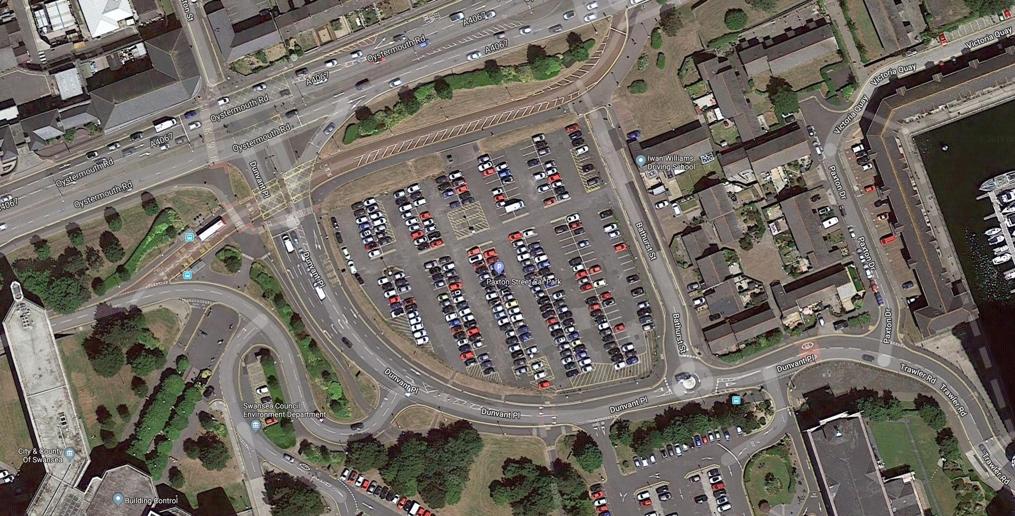
Imagery ©2020 Bluesky, Infoterra Ltd & COWI A/S, Getmapping plc, Infoterra Ltd & Bluesky, Maxar Technologies, The
GeoInformation Group, Map data ©2020
20
m

2.0 Excavation Works.
Safety Measures before work starts
- Appoint an experienced works engineer to help design the support needed for construction of the excavation. He will design the shuttering, props etc needed to support the walls during the excavation works.
- Any temporary works required will need to be included in a construction sequence.
- If the work area is to be a confined space, then provide forced ventilation for these spaces.
- Any existing underground services will need to be identified and a decision on how to protect them is needed.
- Need to identify on how to maintain and provide safe access for workers and operational plant. This also included the removal of material that has been excavated, also ground water.
Safety measure after work starts
- Installation and maintenance of all temporary works on site, these needed to be followed instructions of the works engineer.
- All sides of excavation will need supporting to prevent ground collapse and building movement.
- Provide fixed access suitable for machinery and workers.
- Sturdy barriers will need to be provided to stop access from people and plant.
(Domestic basement construction projects, 2013)
2.1 Excavation Ramp Calculations.
After the site has been excavated, a ramp must be designed so that plant can access the excavation. Calculations will be needed to work out the length, width, gradient and turn points of the ramp.
The ramp plan can be found in the appendix.
Each calculation is for each individual ramp leading into the excavation.
Below are the calculations for the ramp access;
- $\frac{12}{100}=\frac{x}{19.5}$ $100x=12×19.5$ $x=12×\frac{19.5}{100}=2.3$m
- $\frac{12}{100}=\frac{x}{7.7}$ $100x=12×7.7$ $x=12 ×\frac{7.70}{12}=7.7$m
- $\frac{12}{100}=\frac{x}{21}$ $100x=21×12$ $x=12×\frac{25.2}{100}=25.2$m
- $\frac{12}{100}=\frac{x}{18}$ $100x=12×18$ $x=12×\frac{21.6}{100}=2.16$m
- $\frac{12}{100}=\frac{x}{15}$ $100x=15×12$ $x=12×\frac{18}{100}=18$m
2.2 Excavation Works Calculations.
Once the site has been investigated, cleared and marked out the excavation works can begin. The proposed building will have a 30-meter side footprint with a 3-storey underground car park.
The calculation needed to work out the amount of earth to be removed from the site is as follows;
30 x 30 x 9 = 8,100m³ (this will be the volume of earth)
But this volume will not be the same once excavated, as earth is excavated it gains air pockets which will increase its volume once removed. The earth that is in place is classed as the original volume and the excavated earth becomes the bulk volume. This bulk volume will be the calculated amount that will be used to work out how it will be transported away from site.
To work out the bulking factor, firstly you will need to work out what the earth consists of. The ground in this instance will be made up of mostly sand, clay and some gravel. The individual bulking factor of sand and gravel are 1.05, if the sand and gravel are mixed this factor would be 1.15, the factor for clay is 1.35 or 1.40 (depending on pi), the factor for gravel and clay if they are also mixed are 1.35.
Using these baseline factor’s, you can calculate the bulking factor of each property that the excavated earth consists of (Concepts, 2019).
The calculation for these earths bulking factor will be as follows;
1.05 + 1.05 + 1.15 + 1.35 + 1.30 + 1.40 / 6 = 1.22 (this is the bulking factor) (Engineeringtoolbox.com, 2009)
Using the original volume of earth and multiplying it with the bulking factor this will give you the true amount of earth that will need to be transported.
8,100 x 1.22 = 9,882m³ (this is the true volume of earth)
This figure will be the bare minimum of earth needing to be transported once excavated.
To excavate and remove the earth from the site, the use of earth machines will be needed. The machinery needed are; hydraulic excavator and numerous dumper trucks.
Calculations will also be needed when using the excavator and the dumper trucks. These calculations will be the volume of earth each piece of machinery can remove at any given time.
Firstly, the volume the excavator can remove with each turn. In this instance the excavator bucket will have a volume of 0.8m³, the time taken for each turn of disposing the soil into the dumper will take an average of 50 seconds. The volume each dumper truck can hold is that of 30m³.
The time taken to completely fill one dumper truck is 31 minutes and 25 seconds.
This can be calculated using the following me method;
30m³ / 0.8m³ x 50 (seconds) = 1,875 (seconds) which is 31 minutes and 25 seconds.
All earth to be removed from this site in Paxton Street, Swansea will be disposed of using Stenor (which is local). The nearest site that I have located is that of Stenor, Ystrad Road, Fforestfach, Swansea (www.waters-creative.co.uk, 2020).
3.0 Temporary Drainage.
The decided temporary drainage of this site will be carried out using mechanical pumps.
This can involve;
- Removal of water from behind that has been isolated behind a temporary dam or barrier.
- Can also be used as an ongoing method of removal of isolated water from behind a cofferdam etc.
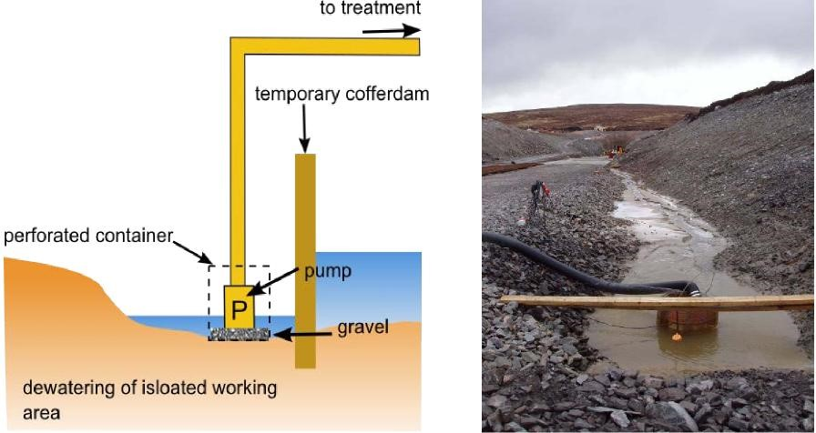
(Temporary Construction Methods, 2009)
Using a sump pump is the most basic way of groundwater control. Its works simply by being put at the very bottom of the excavation and kept submerged under the water. The ground water is then collected using a sump and is pumped away from the site.
3.1 Environmental Agency Guidelines.
To discharge water off site, you will need to obtain a permit from the Environmental Agency.
The guideline states that;
Before the commencement of work on site you must;
- Plan on how to minimise the level of contaminants.
- Consider using urban sustainable drainage methods.
- Plan on how to dispose of water entering the excavation.
- Not to plan on using machinery whilst dewatering is taking place.
The discharge must:
- Be clean, as in clear rainwater or infiltrated groundwater. (The sump pump has a filter built into it).
- Not water containing coarse or fine solids. (sump pump has filter).
- It must not last more than 3 months. If so, then another permit will be needed.
- Be made to surface water. (as in a river, sea etc).
- Must have a method statement that helps minimalize the risk of pollution.
The discharge must not;
- Pollute the surface water.
- Water must not contain any chemicals.
- Water must not be from a site that may contain oil etc.
- Result in non-native viruses and disease.
- Cause flooding.
- Contain concrete wash water.
- Cause bank or bed erosion on the receiving watercourse.
(Siltbuster Limited, 2018)
4.0 Basement Construction.
4.1 Design.
The design that has been chosen for supporting the excavation walls and which will be used for the underground car park is the secant pile.
The decision to go with secant piles is that it has an increases wall stiffness compared to other methods. These can also be installed in difficult ground conditions and can also cause less noise.
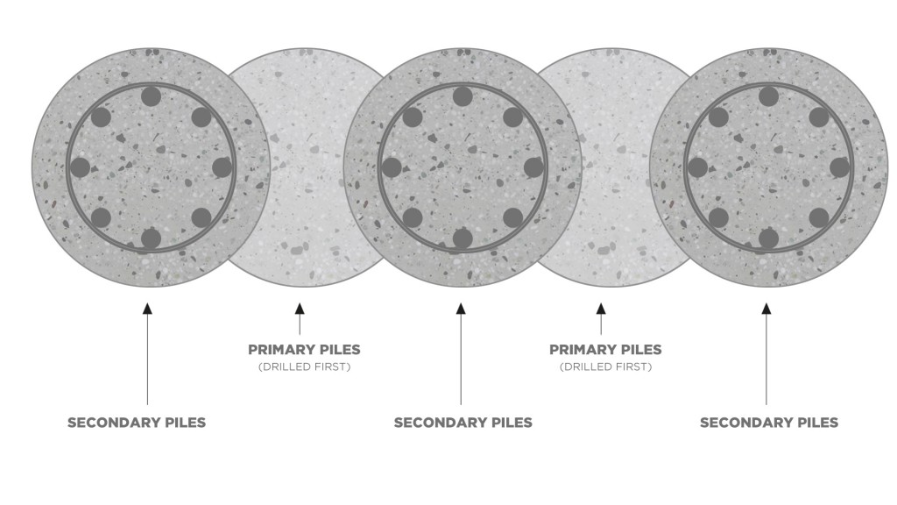
Secant Piles.

(4Site London Basements, n.d.)

4.2 The Walls.
A secant pile consists of non-reinforced or reinforced piles, the unreinforced piles are constructed first and then the reinforced piles are then constructed, and cages or I-beams inserted into these secondary piles. (Keller UK, n.d.)
After these secant piles are set, they can then be anchored into the earth behind. This is to help strengthen the secant piles. Injection anchorage will be used which a bore hole is drilled through the pile into the ground behind, then a bar is placed inside this bore hole and grout is pressured into the bore hole to anchor the bar. (Deepexcavation.com, n.d.)
To help with the excess water as the car park is below the high sea level, there will be a cavity between the secant pile and reinforced concrete panel face. The face will have a waterproof membrane on the back which will stop will the water penetration. At the base of the cavity will have gravel and a perforated pipe, this will deflect the excess water and divert it to underground pumps which will pump it back up to the surface and back into the sea.
4.3 The Foundation and Floors.
For the foundation, a reinforced blanket raft has been chosen as the earth does contain excess water and will help stabilise the whole building. This raft foundation will be connected to the secant piles which will give the building a strong, solid footing. This raft will also contain a waterproof barrier, excess gravel and perforated pipes to help divert the water to the pumps so it can be removed.
The reinforced blanket raft foundation will be constructed in as it spans a big area and may contain weaker areas of soil or different soil types.

Blanket Raft Diagram
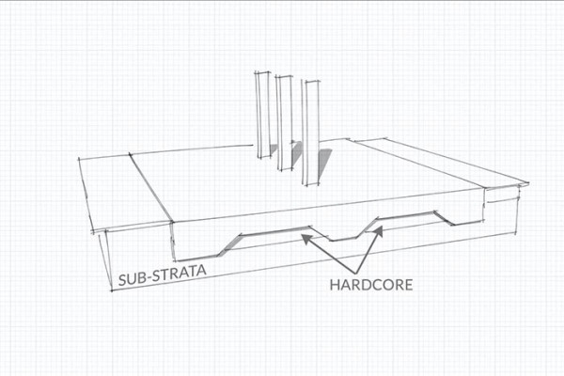
(Heaton Products Ltd : NON-MECHANICAL PLANT & BUILDING PRODUCTS SPECIALIST, n.d.)

A reinforced blanket raft is deep in design and has thicker sections in the slab. These thicker sections are excellent as they will be located at each row of structural pillers. Increasing the rigidity of the whole floor. The gravel for the foundation will need to be packed before the pouring and reinforcement of the floor.
An engineer will design and plot the structural pillars to each floor to give each floor the and strength and durability, also the ramp design for how each floor connects with each other.
Raft foundations can provide a cost-effective solution for many sites that can be built faster than traditional trench foundations. Where conditions of the site include mixed types of soil or areas of weakness, a raft solution can easily deal with these issues as tension can be transferred from low soil capacity locations to locations with higher soil capacity. Where access to the site is limited, conventional foundations can be daunting, as the plant is often too wide to dig to the appropriate depth. If raft foundations are to be built near the ground surface, much smaller equipment is needed that can be shown to be helpful in cases where there is limited access to the site (e.g. urban environment).
Although raft foundations provide a versatile and reliable alternative to traditional foundations, they have their disadvantages. Edge erosion is a key issue that can damage raft foundations, and it is necessary to treat and secure the edges of the raft to prevent this (this will be fixed also by extending the raft around the edges to cover more ground surface and to act as a counter-lever ) The more complex raft base forms may require large amounts of concrete and steel reinforcement, making them more costly than other alternatives, particularly when the quality of the soil is good. In addition, drainage under the raft slab may be required to ensure that water is not trapped there (to help this we are placing more gravel and perforated pipes to help divert the water.) In addition, from a geotechnical point of view, the use of deep foundations on piles up to a rigid soil layer can provide increased resistance to heavy earth movement. (Heaton Products Ltd.: NON-MECHANICAL PLANT & BUILDING PRODUCTS SPECIALIST, n.d.)
5.0 Vertical Envelope Design.
5.1 Structure and Façade.
- The structure is to be of made up of a basic a steel frame with a brick façade.
- Brickwork is to be made of reclaimed Victorian bricks ordinary colour mortar.
- On the façade there will be brick soldier courses over all the openings and arches, between each floor level there will be a three-course, stepped, protruding brickwork band that circulates the whole building.
- The first 4 courses from the ground level will be treated timber panelling.
5.2 Windows.
- Are to be made from recycled Upvc, sash style windows and black in colour.
- Ground floor windows will be full height of ground floor. Brick pillars around each steel column breaking up the space between each window.
- The windows on the façade will all be recycled Upvc box sash windows apart for the rooms with balconies, these will have sliding Upvc doors leading out.
- Slight tint will be added to the glass deflect some sunlight.
- All glass with be safety glass and double glazed.
5.3 Doors.
- Will also be recycled Upvc and be black in colour.
- All glass will be safety glass, double glazed and a slight tint will be added to the glass.
- Ground floor doors will have a Upvc frame with glass panels apart from storage areas.
5.4 Entrance.
- Entrance to the building will have a two-floor height arch.
- Fully glazed
- Double glazed, safety and tinted.
5.5 Envelope.
- Internal walls will be exposed, painted blockwork.
- Foiled back insulation board.
- Reclaimed, Victorian bricks.
5.6 Roof.
- Is to be made as a flat roof.
- will be lower than brick parapet walls.
- To have coping over the parapet walls.
- Guttering is to be made around the circumference of flat roof.
- The roof itself will be a corrugated, galvanized flat roof.
5.7 Suspended Floors.
- The floors are to be steel deck suspended floors.
- Poured concrete onto the floors with reinforcement.
6.0 Conclusion.
The overall aim of this design assignment was to gain an advance in understanding of construction techniques and materials, along with better understanding of the environment when trying to design a building to suit its location. Also, its important when designing you think of the maintenance of the building and what happens when it reached its end of life. Making it easy to adapt so when it does reach its end, it’s easy for someone to find a use for it without having to make drastic changes that would cost the earth.
7.0 References.
(www.waters-creative.co.uk), W. (2020). Recycling & Products. [online] Stenor.co.uk. Available at: https://www.stenor.co.uk/recycling-products [Accessed 2 Jan. 2020].
4Site London Basements. (n.d.). Secant Pile Wall - 4Site London Basements. [online] Available at: http://4sitebasements.co.uk/secant-pile-wall/ [Accessed 3 Jan. 2020].
Concepts, T. (2019). How to Calculate Earthworks Bulking Factor | Free Online Calculator. [online] THS Concepts - Land & Architectural Surveying. Available at: https://www.ths-concepts.co.uk/earthwork-bulking-volume-calculator/ [Accessed 2 Jan. 2020].
Deepexcavation.com. (n.d.). Secant Pile Walls - Tangent Pile Walls - Soldier Piles - Deep Excavation. [online] Available at: https://www.deepexcavation.com/en/secant-pile-walls [Accessed 3 Jan. 2020].
Domestic basement construction projects:. (2013).
Engineeringtoolbox.com. (2009). Soil and Rock - Bulk Factors. [online] Available at: https://www.engineeringtoolbox.com/soil-rock-bulking-factor-d_1557.html [Accessed 2 Jan. 2020].
Heaton Products Ltd. :: NON-MECHANICAL PLANT & BUILDING PRODUCTS SPECIALIST. (n.d.). Raft Foundations - Uses, Types and Cost | Heaton Products Ltd.. [online] Available at: https://www.heatonproducts.co.uk/news-information/raft-foundation-construction-uses-types-and-cost/ [Accessed 3 Jan. 2020].
Heaton Products Ltd. :: NON-MECHANICAL PLANT & BUILDING PRODUCTS SPECIALIST. (n.d.). Raft Foundations - Uses, Types and Cost | Heaton Products Ltd.. [online] Available at: https://www.heatonproducts.co.uk/news-information/raft-foundation-construction-uses-types-and-cost/ [Accessed 3 Jan. 2020].
Keller UK. (n.d.). Secant pile walls | Keller UK. [online] Available at: https://www.keller.co.uk/expertise/techniques/secant-pile-walls [Accessed 3 Jan. 2020].
Siltbuster Limited. (2018). Regulatory Position Statement - “Temporary Dewatering of Excavations to Surface Water” - Siltbuster Limited. [online] Available at: https://www.siltbuster.co.uk/news/regulatory-policy-statement-temporary-dewatering-excavations-surface-water/ [Accessed 3 Jan. 2020].
Temporary Construction Methods. (2009).

8.0 Appendix.
See attached drawings for more in-depth detailing regarding any part of the envelope or structural design.

Site Plan


