MODULE CODE/ COD Y MODIWL: BMSW4001
ACADEMIC AND EMPLOYABILITY SKILLS
STUDENT NAME: PALIMARIU OANA IULIANA
STUDENT ID:1920717
LECTUEUR’S NAME: PETER ALLEN

Abstract
This report represents the objective of understanding the need for necessary employment skills and assimilating them in a collateral way with the coursework effectively. The academic employability skills enable students to learn the module and the effective skills required for employment. This report also provides a dedicated self-assessment, a SWOT analysis and other essential skills needed for the proper placement and career growth of the student after the fulfilment of graduation degree.

Table of Contents
Introduction 4
Models and Theories related to personal development and skills enhancement process 4
Learning Models 4
VAK Learning Style 4
4MAT Learning Model 5
Learning Theories 6
Constructivism 6
Connectivism 6
Behaviourism 7
Experimentalism 7
Cognitivism 7
Employability skills required by multitude employers 8
Communication skills 8
Time management 8
Problem-solving attitude 9
Emotional quotient (E.Q) 9
Innovativeness 9
Patience 9
Team management 9
Leadership quality 10
Self-assessment and self-acquired employability skills 10
SWOT Analysis 10
Conclusion 12
References 13

Introduction
Employability skills prepare students for their future endeavours, and it enables them to create an impactful career growth. This report of academic and employability skills provides crucial learning process of a student for fetching fruitful outcomes with higher education in order to seek successful employment opportunities. Due to globalisation the competitiveness of acquiring a decent job has increased widely. The employers tend to hire eligible candidates who obtain commendable merit and professional skills for employability. Implementation of systematic soft skills and knowledge of the job market both are important for employment.

Models and Theories related to personal development and skills enhancement process

Learning Models
Pupils have the privilege to learn the module and syllabus in several ways while working on assignments for their higher education for eventually obtaining reputed employment. Models related to learning styles enables learners to improve interpersonal skills and practicality to achieve employability successfully. In this report, the VAF Learning style and Kolb's Learning style have been discussed vividly.

VAK Learning Style
VAK learning style implies Visual, Auditory and Kinaesthetic. These three ways are the most efficient process of learning. Few learners absorb concepts by the help of visual representation, for instance- diagrams, ppts and pictures, they can learn instantly with this process. Whereas, some learners prefer auditory medium for learning, such as – group discussion, debates and lectures in a classroom or with the help of some audio-visuals. Kinaesthetic learning process defines the need for learning concepts by the help of first-hand experience (Novriani and Dewi, 2019). It enables a learner to involve in a task or group project so that the learning process can be impactful. All these approaches mentioned above are exceedingly beneficial for self-development and for enhancing soft skills. It can be useful for seeking employment.

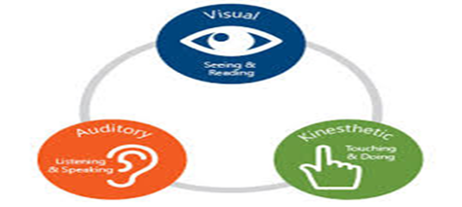
Figure 1 – VAK Learning Model
(Source – Novriani and Dewi, 2019)

4MAT Learning Model
This 4MAT learning style provides flexible and impactful learning process. This framework enables the student to gather information more effectively as well as in an experimental way. Involvement of the student and brainstorming is the most integral part of this learning process. It emphasises on four types of learners, for instance- analytic learners, common sense learners, innovative learners and dynamic learners (Tezcan and Güvenç, 2017). Innovative learners prefer teamwork and unconventional ways of learning with an immense sense of practicality. Analytic learners tend to acquire knowledge through logics, and they often get rhetoric about ideas and facts. Common sense learners prefer the first-hand experience; they learn new skills by performing teamwork and tasks. Whereas dynamic learners support working with an adequate amount of freedom, and they prefer challenging tasks for their learning procedure. This model stresses on recognising knowledge and eventually channelizing that for nurturing soft skills.
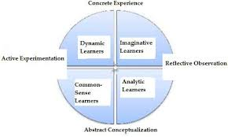
Figure 2- 4MAT Learning Model
(Source - Tezcan and Güvenç, 2017)

Learning Theories
In order to achieve impressive soft skills and knowledge, learners need to adapt to innovative techniques. The higher education and its coursework insist students to learn models and theories of learning for enabling them to be an eligible candidate for employability. During the period of learning this model, students have gathered knowledge regarding five essential learning theories. The five learning methods include- constructivism, connectivism, experimentalism, cognitivism and behaviourism.

Constructivism
This theory focuses on a learning process which includes observation and application of knowledge, by gaining new experiences. This specific learning method allows students to construct their ways of solving a task. It also encourages students to be curious for brainstorming, teamwork, group discussion and simulation. Students gradually apply these concepts on their reports, case studies and assignments (Clark, 2018). The teacher motivates students to participate in debates and for sharing innovative ideas on a particular topic. Students learn to acquire hands-on experiences with time.

Connectivism
Connectivism stands for communication, interpersonal skills and networking among students. Communication enhances the confidence and persona of a student. Incredible communication skills can be essential for increasing employment opportunities. In the era of globalisation and digital media, the demand for social networking sites, video calls, usage of web browsers and smartphones have emerged. In order to achieve impressive communication skills, new-age learners need to learn the importance of networking (Anderson, 2016). Due to the availability of the internet and social networking sites, worldwide connectivity is possible. Therefore, in order to empower employability skills, one must learn the tactics of creating networks and communication.

Behaviourism
Behaviourism portrays a philosophy which defines the psychological and philosophical approach of a person. Behaviour can be reflective, and it might develop due to a particular environmental factor (Anderson, 2016). It has both negative and positive impact on the learner. It involves the procedure of conditioning which implies that behaviour depends on the environmental condition and stimuli.

Experimentalism
The unconventional and innovative approach of learning is considered as humanism or experimentalism (Clark, 2018). It concentrates on the overall growth of a learner. It enables the students to learn skills by experiencing and observing several systematic ways of acquiring skills related to employability. Experimentalism is existing is every field as it allows people to innovate and experiment. This framework motivates learners to come up with improvised ideas, and eventually, it helps learners to develop skills relevant to employability

Cognitivism
This is a framework which draws a comparison between the human mind and a powerful computer and the notions of a student who is eager to learn new skills (Anderson, 2016). The mind tends to solve problems quickly and it gathers information logically. For instance-study materials, journals, reports, articles and other lectures.

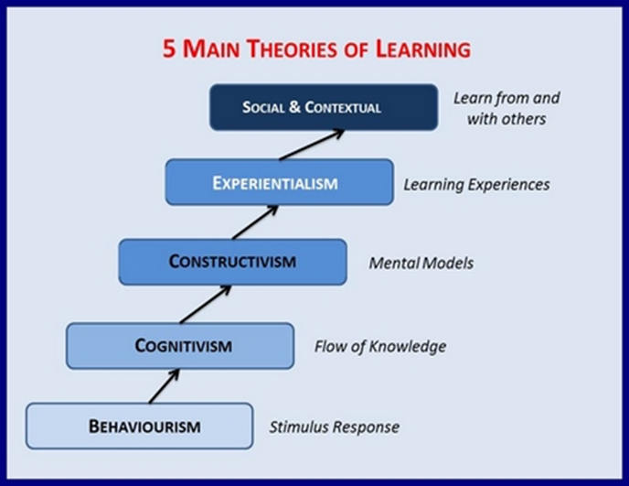
Figure 3- Theories of Learning
(Source- Anderson, 2016)

Employability skills required by multitude employers
During the recruitment process, every employer tends to hire an eligible candidate who obtains incredible professional skills and communication. In order to impress a recruiter, the candidate needs to acquire few crucial skills. Profound communication skills, time management, problem solving attitude, proper emotional quotient, innovativeness, patience, leadership quality and team management.

Communication skills
Soft skills classes have been introduced in higher education widely so that students can communicate with utmost confidence and ease, which will eventually impress recruiters at the time of placement. In order to create a bridge of communication, a learner needs to be fluent in speaking the professional language, and the pronunciations of corporate words need to crystal clear. Otherwise, the communication gap can be raised, which can eventually generate contradictions and arguments.

Time management
Punctuality is another most influential aspect of employability skills. If a candidate is not punctual and if he fails to attain an interview on time, then that creates a negative impact on the recruiters. Time management skills help a candidate to manage several tasks within a particular deadline (Suarta et al., 2017). Therefore, organising a time schedule for keeping jobs on track is mandatory. Wasting precious and productive time can be harmful to an employee as it decreases productivity and eventually slows down the pace of work.

Problem-solving attitude
Employers rely on and trust candidates who dare to take challenges without any hesitation. Recruiter praises candidates who are eager to solve problems with dedication effectively. If an employee investigates a problem and gradually unravels that with intelligence, then that is undoubtedly praiseworthy. It also increases the chances of promotion and a hike into the salary of that employee. Thus, problem-solving attitude is one of the most crucial criteria of employment.

Emotional quotient (E.Q)
In the workplace, while working in a team, a person needs to acquire proper emotional quotient to balance between personal emotions and the emotions of others surrounded in the office. Emotional intelligence helps a person to cope up with office politics and to manage teamwork. Employers nowadays emphasise on candidates who are basically empaths (Suarta et al., 2017). Those who are striving for successful employment need to learn that emotional intelligence is essential for dealing with clients and colleagues at the workplace. In the job market, E.Q is considered as a mandatory quality of an employee.

Innovativeness
Innovative minds are capable of doing wonders. Recruiters know the importance of hiring an innovative candidate who have the ability to produce experimental yet practical ideas for solving work-related issues. Improvisation in terms of solving technical problems and team management, these factors are essential for employment.

Patience
One of the most required soft skills which employers look for is the patience of a candidate. Recruiters test the patience level of a candidate during a personal interview by asking constant questions. Those who develop skills of handling these kinds of situations with utmost patience are considered as eligible candidates. Board meeting, presentation, dealing with a client all these tasks require enormous patience; otherwise, survival will be difficult at the workplace.

Team management
Recruiters look for candidates who are capable of working under pressure and who knows the tricks of working in a team. Team management is another crucial trait for a job-seeking candidate. Employers appreciate the well organised approach of an employee. People who have potentiality and perseverance for managing large numbers of the team are highly preferable by the recruiters as they know in future these candidates will be able to manage a team with dedication and hard work.

Leadership quality
Soft skills and employability traits need to learn by a job-seeking candidate or a graduate student. In a workplace adequate amount of leadership quality, the quality of being an orator and the management skills need to appropriate to survive in that organisation. Feeble and vulnerable candidates who are sacred of managing tasks with ease are not eligible for an employment opportunity. Therefore, acquiring decent leadership quality is highly required for enhancing employability.
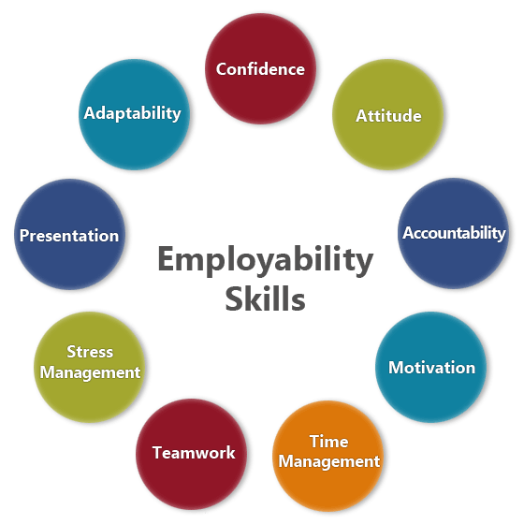
Figure 4- Employability Skills
(Source -Suarta et al., 2017)

Self-assessment and self-acquired employability skills

SWOT Analysis
Self-analysation has made me aware of my employability skills. A vivid assessment of my soft skills and professional traits has been described in the below mentioned through a SWOT analysis. My strengths and weaknesses have been pointed out here. This analysis also focuses on the competitive attitude of the job market. Practice and will power of achieving new skills would make me eligible for employment in future, I believe.
My time management skills need to improve. Since I have excellent communication skills, thus I am hopeful of creating successful networking and connection in the professional world. I am not a tech-savvy that is a threat for me. Therefore, I need to work on my technological skills, and my digital literacy needs to be developed. During the coursework, I was able to learn several practical employability skills from this module, and it taught me to be a confident speaker as well.
Self-assessment and personality development these two factors are equally crucial for employment. I also need to polish my pronunciations, and the fluency of language needs to be improved. One of the most useful qualities which I have is patience, and I do not lose my mind quickly and that I assume is an essential trait for any job-seeking candidate. The study materials and articles provided by our lecturer was exceedingly helpful.

Strengths | Weaknesses
I am a decent communicator.  I like exploring new skills by practising them regularly.  I have an adequate amount of patience.  I am an extrovert. | I am not capable of speaking a language fluently.  I am not punctual, and therefore, my time management is terrible.  I am a slow learner.
Opportunities | Threats
I was able to participate in team and group work effectively.  An opportunity has been provided to me to work on the cultural fest of my college. | Emerging competition for seeking employment is a threat as it fulfils the job vacancies fast.  Advanced technology and artificial intelligence is a threat to my employment.

Conclusion
In can be concluded that in the era of emerging digital media and globalisation, job-seeking candidates need to learn new-age technologies for fulfilling all the dreams and aspirations related to employment. Obtaining appropriate communication skills and developing time management capabilities along with other soft skills, need to consider as essential criteria for an aspirant of employment. Academic and employability skills are impeccably necessary for securing employability.

References
Anderson, T., 2016. Theories for learning with emerging technologies. Emergence and innovation in digital learning: Foundations and applications, pp.35-50.
Clark, K.R., 2018. Learning theories: constructivism.
Novriani, M.R. and Dewi, E.S.I., 2019. Development of Learning Materials with Visualization, Auditory, Kinesthetic (VAK) Model to Improve Students’ Mathematics Reasoning Ability and Self-Confidence. Development, 10(29).
Suarta, I.M., Suwintana, I.K., Sudhana, I.F.P. and Hariyanti, N.K.D., 2017, September. Employability skills required by the 21st century workplace: A literature review of labor market demand. In International Conference on Technology and Vocational Teachers (ICTVT 2017). Atlantis Press.
Tezcan, G. and Güvenç, H., 2017. The effects of 4MAT teaching model and whole brain model on academic achievement in science. Egitim ve Bilim, 42(192).

