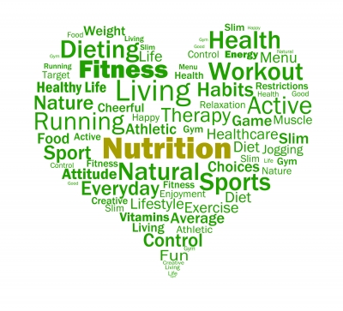

Promoting Health and Wellbeing

Workbook

Student name: | Claire Gunter
Student number:

Promoting Health and Wellbeing
Unit Code: PA94CY001
Level: Four
Credit Value: 10
Unit ID: CDN190
LDCS: PA9
Sector: 1.3
Last registration date: 31/10/2024
Purpose and Aim
This unit will enable the learner to develop an understanding of the theory of self-management and remaining well. It also covers co-production and promoting public health and examples of these principles applied within Therapy Assistant Practitioner practice.

The workbook must include citations within every task within the main body content of the work (a minimum of 8 credible sources); there is a section at the end of the booklet to compile a corresponding reference list.
Appendices can include any evidence to support content for each task, and are not compulsory.

Task One: Understand the meaning of health and wellbeing.
  - Explain the meaning of the terms health and wellbeing:
Although they are frequently combined, health and well-being can be distinguished as two distinct descriptors. How healthy we are can be quantified by the absence or presence of disease, it can be observed using clinical measures such as blood tests, BMI or death rates, it is relatively easy to observe in community settings and research to conduct health profiles of certain areas can identify health status and risk factors. Wellness looks at broader aspects of our lives, our mental health and happiness but also our satisfaction, sense of meaning and purpose, it is driven by our thoughts, actions and experiences. Caring for our wellbeing can involve social factors such as friends and family, social community connections, it also encompasses our physical health, the abilities we have to be independent and perform everyday functions. Our awareness of our own wellbeing has never been more relevant and topical, The Global Wellness Institute (2025) states that the wellness industry was worth 6.3 trillion dollars in 2023. Health and wellbeing are independent factors in so much as we can be physically unwell but still have a good sense of wellbeing, equally we can have poor wellbeing, we may have low mood and poor social connections but enjoy good health. That said, health and wellbeing can have a significant impact on each other, if we become ill for example having a heart attack or stroke, this will affect our abilities to function as normal and thus affect our mental health, social connections and general life satisfaction. Managing health and wellbeing is an ever-evolving area and challenging for both individuals, communities and health providers. Both the National Health Service (NHS) and The National Institute for Clinical Excellence (NICE) have produced guidance documents that aim to promote equality in accessing health and wellbeing services, Public Health Wales notes that continued action is needed produce legislation to promote and support people to make healthier choices within their community (Public Health Wales, 2023).

1.2 Outline the components of both the Medical Model and Health Belief Model of health, then explain any similarities and differences:
The biomedical model deals with the development of methods for illness prevention and treatment based on investigations of the physical body. When we are sick, we need to know what may be wrong with our body, effective symptom identification and analysis is used to identify the underlying cause. According to the biomedical model, health is typically defined as the absence of disease. Todd (2021) states that the biomedical model has been the foundation for the development of standardised diagnosis and treatments, however Wade (2024) points out that although it has been used for many years its shortcomings are that is assumes all illness comes from a single cause and correcting this will return a person to good health, thus the model has the ability to medicalise any condition without considering social or psychological factors, it can also mean individuals receiving treatment for their symptoms but not a diagnosis or cure for their underlying condition. The biomedical model does not account for the fact that a person is not necessarily healthy just because they don't have a recognised illness. The biomedical model works well for straightforward treatment such as replacement of a fractured hip, or treating an infection with antibiotics, but does not take into account the varying factors of more long-term complex conditions such as managing diabetes, or Fibromyalgia.

1.3 Describe a minimum of five determinants of health and provide examples of the impact of these determinants upon a person’s health and wellbeing:
The world health organisation advises that there are certain factors that can affect our health and wellbeing, and health impact assessments are needed regularly to inform these determinants, the determinants are broad and cover more than obvious things such as access to healthcare or socioeconomic status (World Health Organisation, 2025). The UK government recognises that these determinants can contribute to the health of the nation and financial status has a significant impact. The next few paragraphs will look at some of these determinants.
1, Continued learning can have positive impacts on our wellbeing, in particular our mental health, it can improve confidence and self-esteem, build mastery and discipline and while it allows us to connect with other like-minded people it can also broaden our views by exposing us to new people and opportunities. Liu et al (2024) notes that higher levels of education have a positive and significant effect on health factors such as BMI, smoking and alcohol consumption. The Health Action Research group agrees with these markers, stating that higher education both increases life expectancy and decreases the chances of health inequalities, but it points out that education has ‘little impact on a person’s general well-being or satisfaction levels’ (Meriouma, 2021).
2, There is a strong correlation between employment and health. The health foundation notes that unemployed people report some of the worst health outcomes and are more likely to have poor health (The Health Foundation, 2025). The reasons employment affects health and well-being are ambiguous and varied, theories include food quality, activities, social time, access to health care and lack of employment which can affect self-esteem. All these factors can have a negative impact on mental health and well-being and add pressure to existing medical or mental health condition. The socioeconomic landscape of Britian is changing with a growing gap between wealthy and poor families, according to the Equality Trust (2025) the poorest people in the country have experienced a decrease in their income of around 7.5%, this has led to an increase in people living in poverty.
3, Much research has identified that health outcomes can be geographically structured, meaning our physical environment and the area we live plays a role in our health and well-being. Like many countries, Britain has a mix of inner city and rural environments both with their own challenges and advantages. While rural life can allow easy access to green spaces, will have less pollution and statistically lower crime rates, it can lack a community environment and as such be more isolating. Access to facilities and transport links can affect medical care and social activities in rural regions. Areas that are more densely populated allow for easier access to all amenities including the National Health Service (NHS) leisure or community centres social activities and transport. However, the pressure on services in highly populated areas can lead to poor health care, increased pollution from factors such as industry and transport can affect air quality. While inner-city areas can have robust communities’ social isolation, poor mental health and stress is still a significant factor. An article on the Global Health platform notes that the constant presence of so many other people in city areas can be interpreted by our brain as a lack of control which heightens anxiety (Stahl, 2015). Lederbogen et al (2011) supports this suggestion noting that people living in inner city environments are more likely to suffer from anxiety disorders. In addition to our local environment our home can also affect our health, factors such as safety, a clean environment, access to reliable equipment, energy efficiency and property maintenance standards are all important. In recognition of inequalities and poor standards of both social and private housing the government recently produced a Renters Right’s Bill aimed at ensuring private landlords adhere to basic maintenance standards, it also gives renters more robust rights around eviction and rent increase (Ministry of Housing, Communities and Local Government, 2025).

4, Irrespective of where in the country we live social relationships and community life can also greatly influence our well-being. Social connections can have positive impacts on many aspects of our lives. A 2015 report by Public Health England titled A guide to community-centred approaches for health and wellbeing, notes that a strong community can have a significant impact on health conditions and health related behaviour (Public Health England, 2015), The Mental Health Foundation supports this noting that people thrive in supportive communities and experience fewer mental health problems, this may be due to a sense of belonging or purpose. Many research studies have investigated the affects the Covid 19 pandemic has had on communities and social interaction and noted a huge shift towards online resources and social media, particularly for adolescents. While access to the internet and medica platforms can provide instant information and help us to connect with people around the world, some question the effects this has on more intimate relationships and can lead to feelings of loneliness and isolation, (Smith 2020).
With this huge shift from physical connections and community activities to online groups, zoom calls and internet chat rooms the role of Public Health in engaging with people and sharing safe, evidence-based information can be challenging. Public Health Wales have produced a digital and data strategy to address this issue, they recognise that the way people access information is changing and to provide support and awareness of campaigns such as vaccinations or healthy lifestyle messages they need to share information in new and innovative ways (Public Health Wales, 2025)
In Britian the government and public health bodies work hard to promote evidence-based information and aim to influence behaviours and shape public perception, however this can be challenging as both an independent report by The Young Foundation (2010) and The Health Foundation (2020) both note that some public health messages can backfire, particularly if they do not align with people’s beliefs or there is insufficient or conflicting evidence. Robust research and repetition over time has been successful in cases such as reducing the social acceptability of drink driving.
These are just a few of the many factors that determine individual and community health and wellbeing. Governments and public health bodies need to continue their focus on reducing inequalities and promoting access to timely and effective medical care and mental health support as well as creating accessible and sociable communities.

Task Two: Understand the benefits of self-management for people and approaches that empower them to improve their health and wellbeing.
2.1 Describe the concept of empowerment and the benefits to individuals when empowered to manage their own health:

The process of empowerment in health care involves ensuring people’s rights are met, providing them with the information they need and allowing autonomy so individuals can make decisions about their own care and how they manage their health and well-being.
From a public health perspective this involves providing communities with the information and resources they need to make informed decisions and support behaviour change through education, screening programmes and promoting health messages.
On an individual level empowerment is about shared decision making, the treatments procedures and management of health conditions should be a collaborative process. Patients who are given information guidance and the autonomy to make decisions about their own care have improved outcomes, greater engagement and better adherence to care plans such as rehabilitation exercises, this is supported by Lee and Lin (2010) who note that patients who felt more supported in their autonomy rated their doctors with higher levels of satisfaction and trust.
However, there are many different forms autonomy can take and both Broer, Nieboer and Bal (2010) and Entwistle et al (2010) point out that too much emphasis on autonomy, particularly around decision making may not be beneficial for those who are capable or have capacity but who struggle to make decisions about their healthcare. The NHS in Wales continue to support patient’s empowerment and autonomy through many initiatives such as “Making Choices Together”, an empowerment project encouraging staff and patients to collaborate, it also looks at wider community-based care and promoting health and wellness.

2.2 Explain two theories of behaviour change, and include the skills required to promote behavioural change in others:
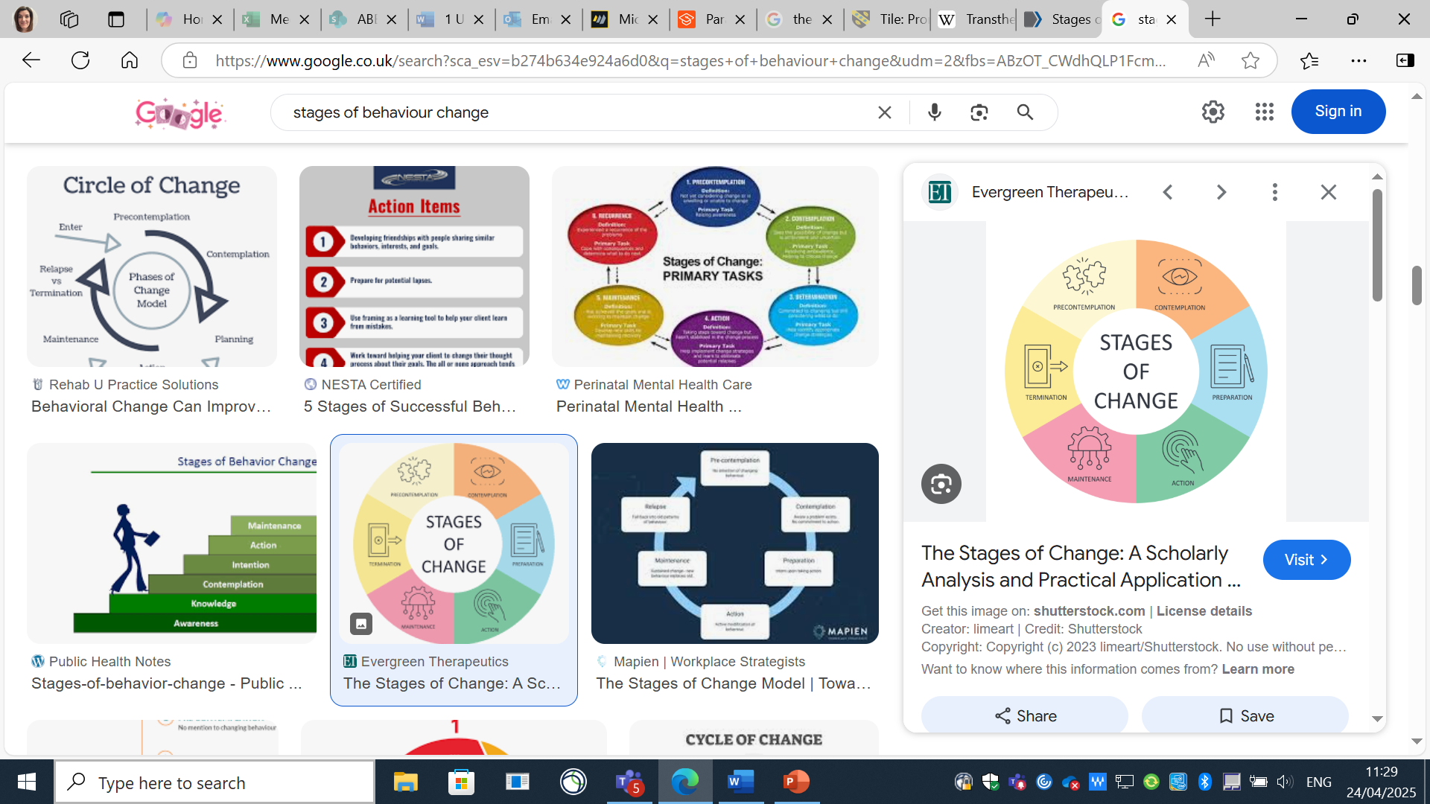
The stages of behaviour change model develop by Professors Prochaska and DiClemente at Rhode Island University during the early 1980s, it is a transtheoretical model meaning it is a theory of how people progress through the different stages or mindsets relating to a change in behaviour patterns. Prochaska and DiClemente recognised that behaviour change is a complex process which is impacted by a number of factors such as cognition and emotions. The behaviour change model has 5 main phases recognising that change happens gradually as opposed to all at once. For therapists working on behaviour change with people a knowledge of this model and awareness of which stage clients may be at can inform conversations about change, it can be applied to numerous behaviours as Zimerman, Olsen and Bosworth (2000) note that it has been successful with smoking cessation and the use of contraception, and says it provides straightforward and efficient methods that are widely used.
Evergreen Therapeutics (2024)

Pre-contemplation describes people who are unmotivated or who do not see a reason to change, there is no motivation, people in this stage may be resistant to suggestions to make changes and will identify any negatives to making changes, for example, “if I stop drinking, I won’t have fun when I go out with my friends”. Therapists working with people in pre contemplation need to focus on building good therapeutic relationships and identifying the patients’ goals. The contemplation stage is when people are aware of issues and are thinking about making a change, it can be helpful at this stage to assess the positives and negatives of making changes, focus on the improvements the change may make and discuss ways if implementing change.
When moving to the action stage of the behaviour change model clients start to look at ways to modify their behaviour, they may source information on how to implement changes, at this stage if can helpful for therapists to ensure clients are choosing realistic and relevant goals, Raihan and Cogburn (2023) points out that people frequently make inadequate plans without carefully analysing how the change will affect their lives, effective planning will help when moving to the action stage as Raihan and Cogburn (2023) further explain that achieving goals can positively impact motivation, self-confidence and will power. For many people implementing new behaviours or stopping an unhelpful behaviour is easy, maintaining the new action is the difficulty. Many papers and organisations including the University College London (2009) suggest that it takes 66 days or around 3 months for a new action to become a habit, once the habit or automatic behaviour is formed new neural pathways are created in the brain making the new behaviour easier with each repetition. Over time a new habit or absence of negative behaviour becomes a person’s new identity, for example a person changes from someone who is trying to quit smoking to someone who does not smoke, this is the maintenance stage of the behaviour change model. In the maintenance stage people’s confidence can build further, particularly if they are seeing positive effects such as weight loss from dietary changes. It is worth noting that people can experiences lapses, brief setbacks in the behaviour change or relapses which may represent moving backwards through the stages such as action to contemplation, someone may try increasing their activity, find it very difficult and then question if this is the right action to improve their health. Because it is challenging to accomplish the termination stage is not frequently included in the stages of transition, this would be when a person truly believes they can continue their goal and there is no chance of relapsing

The Social Cognitive Theory (SCT)
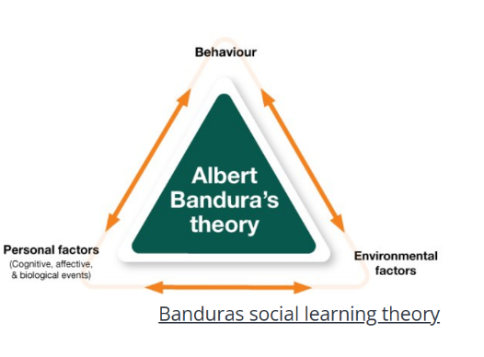
Albert Bandura’s Social Cognitive Theory began as a theory in the 1960s but was first published in his 1985 book, Social Foundations of Though and Action: A Social Cognitive Theory and views human behaviour as an ever-evolving interplay between people’s behaviour, their actions and surroundings. It highlights that social engagement, experiences and observations are the foundations of how people learn and that cognitive processes such as self-regulation, self-reflection, perceptions and many other cognitive processes allow peoples to control their own behaviour. The reciprocal relationship between personal factors, environmental factors and behaviour shape a person’s beliefs and identity. Therapists can use this model to recognise the way clients absorb knowledge, how they internalise it and how they behave as a consequence.
Structural Learning (2025)

2.3 Please describe two examples of where your health board, or local authority, support the health and wellbeing of their employees:
Aneurin Bevan Health Board supports its employees through a number of programmes, it prides itself on an inclusive and respectful culture and promotes equal opportunities, diversity and dignity (Aneurin Bevan Health Board, 2025). The health board also has several employee wellbeing programmes where staff can access support for a range of issues such as mental health and counselling services, menopause, occupational services, financial support and managing work-based issues. The health board counselling service is available to anyone and accessed through self-referral, staff are offered up to 8 sessions of psychological therapy and issues do not have to be work related.
Blaenau Gwent council offer a range of services to support the local community and have a dedicated wellbeing web page that helps local residents find the information and support they need, they also provide links to other local and national services such a Melo cymru, Social Business Wales, Citizens Advice and financial organisations. The council also runs a Day Service Provision which offers support to people with learning disabilities or mental health problems through local day centres, they promote social events and education and also help with job training. The day service provision is also able to offer individual support and their aim is to empower individuals to exercise their rights and be active in their community (Blaenau Gwent County Borough Council, 2025)

Task Three: Be able to use a person centred approach when promoting population health.

3.1a Reflect on an example of a person centred approach you have used within your workplace, to promote health and wellbeing of either individuals or groups. Ensure you use a recognised model for reflection and make recommendations for improvement.
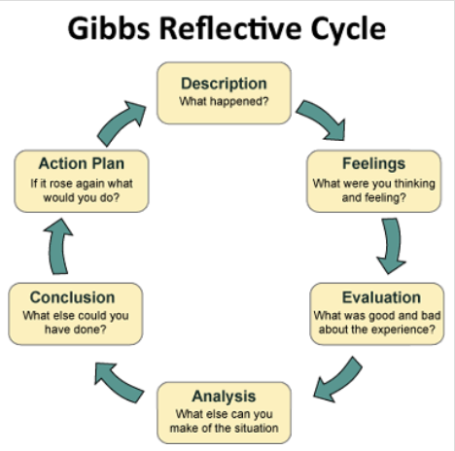
The following is a reflection of a group education session centred around healthy eating for pregnant women. For the purpose of this reflection, I will be using the Gibbs reflective cycle.
Description:
An education group delivered to pregnant women regarding balanced eating and maintaining a healthy weight during pregnancy. The group was specifically designed for women who were in their first trimester with a BMI over 35 and was offered to women during their ante natal appointments, attendance was optional. There was a focus on engaging with women in the community and giving them a space to share experiences concerns and goals. The group followed a structured plan of healthy eating and safe activity advice during pregnancy but was also designed to support women to set goals and empower them to make changes and feel confident about their health during and after their pregnancy.
Crowe Associates Ltd (2025)
Feelings:
Initially I felt anxious as it was my first time to run a group with pregnant women. I was surprised and relieved at how well the women bonded, sharing their experiences and encouraging each other.
Evaluation:
The participants asked about my experiences of pregnancy and as I have not been pregnant, I could not share in their stories or offer advised from my own personal perspective. The group session flowed well, all participants engaged with the content and shared experiences, many women who already had children shared valuable advice and support to new mothers in the group.
Analysis:
I feel my rapport and the participants and their trust in me was negatively impacted by the fact that I do not have personal experiences of pregnancy, despite this I was able to provide them with research and evidence-based messages about healthy pregnancy.
Conclusion:
I learned a great deal from this first session but also recognise that I need to research more about the wider aspect of pregnancy not just the topics covered in the group as there were questions and conversations about many pregnancy related concerns that I struggled to engage with due to my lack of knowledge.

3.1b Reflect on a second example of a person centred approach you have used within your workplace, to promote health and wellbeing with either individuals or groups. Ensure you use a recognised model for reflection and make recommendations for improvement.
The following is a reflection of an appointment with a patient on weight loss mediation, the purpose of the appointment was to discuss management of the medication, dietary changes and activity levels. For the purpose of this reflection I will be using the pseudonym Rachel and using the Gibbs Reflective Model. I chose the Gibbs reflective Model as it provides clear stages of reflection and is helpful when evaluating experiences and provides a simple structure for understanding experiences, Ahmadpour, Shariati, and Moghadam (2025) note that the model can give therapist a greater understanding of client’s problems and foster empathy.
Description:
A telephone consultation with Rachel who is taking weight loss mediation, during this appointment we discussed dietary changes. Rachel wanted a structured plan to follow, we discussed the limitations of prescribed meals plans and how they are not flexible to everyday life, the negative effects and emotions that can be experienced if the plan is not followed and the diet mindset that prescribed meal plans can illicit. Rachel and I talked through evidence-based approaches such as Mediterranean and low GI eating plans. Following our discussion Rachel opted to follow the Mediterranean meal plan and I gave her resources and links to support her with this.
Feelings:
Initially I felt frustrated as my past experiences and significant research shows people will struggle to maintain a regimented eating plan, Dyke, Murphey and Drinkwater (2024) observed in their article from 2024, that understanding the cause of present behaviours and barriers to changes is essential and I was concerned Rachel was not addressing these issues.
Evaluation:
I felt Rachel was happy with the appointment as we had talked through her current eating pattern and discussed options. I gave Rachel the information she needed to follow the Mediterranean plan.
Analysis:
I feel Rachels engagement in the conversation was affected as she may have felt I was discouraging her from the plan she wanted, I believe we talked through this and at the end of the session I had empowered Rachel with the information she needed to make an informed decision. Following this conversation, I am aware that while my own views are valid it is ultimately the patient’s decision as to how they make changes.
Conclusion:
I feel this consultation has highlighted to me the importance of building strong therapeutic relationships to develop trust and using evidence-based practices such as Motivational interviewing to find appropriate ways of sharing information such as the “ask share ask” technique as this allows for the sharing of information in a way that promotes cooperation, independence and deference.
3.1c Reflect on a third example of a person centred approach you have used within your workplace, to promote health and wellbeing with either individuals or groups. Ensure you use a recognised model for reflection and make recommendations for improvement.
The following is a reflection of an appointment with a patient who is taking weight loss mediation through a weight management service and does not want to weigh. For the purpose of this reflection, I shall use the pseudonym Evan.
I am using the Gibbs reflective Model as I find it simplistic and give clear instructions for evaluation experiences, despite this the model does have some drawbacks and may not be the best strategy for critical thinking or for situations where greater flexibility is required. The Simply Psychology website give a detailed description of the model and notes that it can inadvertently promote giving too many unrelated details, introducing prejudice and an emphasis on emotional reactions and failing to bring up important details about clients or the environment (Simply Psychology, 2025)
Description:
A weight management service appointment to discuss starting weight loss medication. During my discussion with Evan I explained the mechanisms of the medication, dietary and lifestyle changes he would need to make and prescribing rules for starting and continuing the medication, Wegovy (Semaglutide) as set out by the National Institute for Health and Care Excellence (National Institute for Health and Care Excellence, 2023) which includes achieving 5% of initial weight to be lost at 6 months. Evan was upset about this as he does not like to weight himself or know what his weight is, Evan stated he had a very obsessive personality and, in the past, had weighed himself up to 9 times a day, becoming extremely anxious and upset about the results. I explained that we would not be able to prescribe the medication without being able to check his weight regularly, we agree that Evan would come to clinic more frequently than normal to be weighed, we would record this in his medical notes but that Evan would not have to know hie weight and we would not need to discuss this with him unless there was an issue. We further discussed only informing Evan of his weight when he reached certain milestones such as each stone lost.
Feelings:
I felt empathy for Evan as he described his struggles with weighing, I could sense how anxious Evan was even discussing the topic. I initially felt anxious myself as I was unsure how we would resolve the situation but remembering similar experiences with other clients I was relieved that we had a plan and felt I had reassured Evan that we would work with him around this situation. I felt glad after the appointment that a solution had been reached.
Evaluation:
I feel the conversation caused Evan to become anxious and stressed which made me feel unsettled and concerned, this may have initially affected Evans confidence and trust in our service, however as we were able to find a solution I hope this showed our commitment to person centred care and that we are willing to work around any obstacles, which hopefully assured Evan that we will support him on his journey.
Analysis:
This situation has highlighted the complexities of the clients that attend weight management services, and the strong prevalence of emotional issues related to weight, weight loss and self-image.
Conclusion:
I feel that if a similar situation arose for me in the future I would be more confident in exploring alternative options with people, they would understand that checking their weight is not an absolute and this would alleviate some fears or anxiety about the weight on the scale.

Task Four: Know how to use a co-production approach when promoting health and wellbeing.

4.1 Outline the principles of co-production (explain a minimum of 2 of these in-depth)
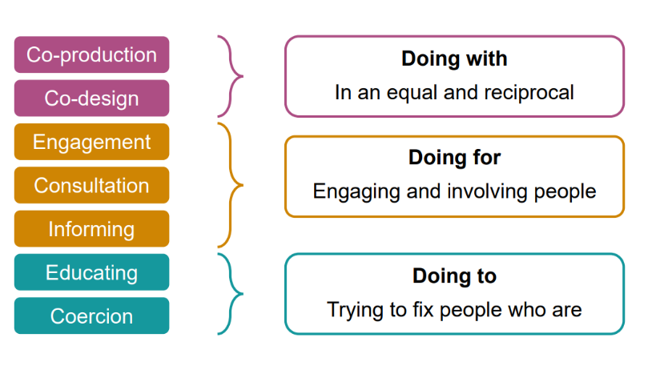
Co-production focuses on designing services to work on a collaborative way, by developing service that are more receptive to service users it helps to promote engagement, equality and diversity and accessibility. Co-production ultimately seeks to improve services by working with individuals’ needs and preferences. The Social Care Institute for Excellence (2022) recognise that co production can be difficult to implement and needs to include both managers and practitioners in order to implement thoroughly throughout an organisation. There are many facets to co production such as equality and accessibility. Equal access to care and equality of the care people receive, means any differences such as social background, ethnicity, age, gender or beliefs should not have a detrimental effect on the care someone receives. Accessibility shares some of these factors and aims to reduce any discrepancies or inequalities in people accessing information. People of lower socioeconomic backgrounds are shown to have less access to healthcare, possibly due to financial situations, transport, access to information or potential bias. A recent paper by Matin et al (2021) looking at women with disabilities noted that there were many societal, economic and structural factors that affected women’s ability to access healthcare. To help support co production in healthcare NHS Wales has produced a toolkit to help inform delivery of care and engagement, it shows how as a large organisation the NHS can move from “doing to – trying to fix people who are passive recipients of service” to “doing with” or “doing for” (Public Health Wales, 2025)
Public Health Wales, 2025

Task Five: Understand the role of public health in promoting health and wellbeing..

5.1 Describe the 3 domains of contemporary public health practice:
There are 3 distinct areas of public health practice, health protection, health improvement and health services, the fundamental roles of public health such as workforce development academic public health and health knowledge underpin these areas. Health protection is focussed on protecting the public from avoidable health risks, such as immunisation against diseases or outbreaks. Health improvement looks at ensuring quality in standards of care, ensuring care if efficient and timely, to support this all health boards have a dedicated quality, safety and improvement directorate to safe and effective care system (NHS Wales, 2025). Health services enhance public health by ensuring quality of care and evidence-based practice and support the creation of frameworks, training and practice, it helps to develop core values and professional boundaries.

5.2 Select one piece of current legislation and explain how it helps to improve public health:
There are many pieces of legislation designed to improve and protect public health, some overarching policies such as the Equality Act 2010 and the Health and Social Care Act 2008 look at large issues and cover a wide range of situations and circumstances. In each individual discipline of the NHS there will be particular pieces of legislation that are more relevant to promoting and protecting health. For therapists working in areas that promote healthy eating the introduction of the Soft Drinks Industry Levy (SDIL) in 2018 highlighted the unnecessary amounts of sugar in foods, particularly soft drinks. Numerous illnesses have been linked to sugar consumption and a vast body of modern research has concluded that although sugar is associated with several conditions, its role in their cause is unclear.
The alarming rates of childhood obesity and the governments recognition that many soft drinks are specifically marketed to youngsters served as the impetus for the SDIL tax’s introduction. While the main aim of the SDIL tax was to encourage manufacturers to reformulate their products with lower sugar levels it was also intended to alter customer behaviour by incentivising people to opt for the less expensive lower sugar dinks (Institute for Government, 2022). Lean, Garcia and Gill (2018) note that while the SDIL tax has been effective in reducing purchasing of high sugar drinks it is unlikely to have a significant or long-lasting impact on obesity.

5.3 Outline how public health policies and strategies can help you as a practitioner to promote health and wellbeing in your workplace.
There are many health policies that support practitioners in promoting health and wellbeing. The Wellbeing of Future Generation Act 2015 is an all Wales policy designed to support and inform businesses and organisation when planning for the future, it focuses on increasing social, environmental and cultural wellbeing through sustainable development (Future Generations Commissioner for Wales, 2025). For NHS organisations there are policies such as the NHS health and wellbeing framework, designed to support staff at all levels, it explains what health wellbeing means in the NHS and provides detailed information and links to resources to help people access services and promote a culture of support and transparency (NHS England, 2022).

Reference List:
Ahmadpour, N., Shariati, A. and Moghadam, M, P. (2025) ‘ Effect of narrative writing based on Gibbs’ reflective model on the empathy and communication skills of nursing students’, BMC Medical Education, 25(10) Available at: Effect of narrative writing based on Gibbs’ reflective model on the empathy and communication skills of nursing students | BMC Medical Education

Aneurin Bevan Health Board (2025) Working for us. Available at: Working for us - Aneurin Bevan (Accessed 24 April 2025)

Blaenau Gwent County Borough Council (2025) Day Service Provision. Available at: Day Service Provision | Blaenau Gwent CBC (Accessed 25 April 2025)

Broer, T., Nieboer, A, P. and Bal, R, A. (2010) ‘Quest for client autonomy in improving long-term mental health care’, International Journal of Mental Health Nursing, 19(6), pp. 358 – 393. Available at: Quest for client autonomy in improving long‐term mental health care - Broer - 2010 - International Journal of Mental Health Nursing - Wiley Online Library

Crowe Associates Ltd (2025) Gibbs Reflective Cycle. Available at: Gibbs Reflective cycle | Crowe Associates (Accessed 24 April 2025)

Entwistle, V, A., Carter, S, M. and McCaffery, K. (2010) ‘Supporting Patients Autonomy: The Importance of Clinician-patient Relationships’, Journal of General Internal Medicine, 25, pp. 741 – 745. Available at: Supporting Patient Autonomy: The Importance of Clinician-patient Relationships | Journal of General Internal Medicine

Equality Trust (2025) The Scale Of Economic Inequality In The UK. Available at:https://equalitytrust.org.uk/scale-economic-inequality-uk/#:~:text=UK%20Income%20Inequality,-The%20UK%20has&text=The%20media (Accessed 3 April 2025)

Evergreen therapeutics (2024) The Stages of Change: A Scholarly Analysis and practical Application. Available at: The Stages of Change: A Scholarly Analysis and Practical Application - Evergreen Therapeutics (Accessed 24 April 2025)

Future Generations commissioner for Wales (2025) Well-being of Future Generations Act 2015. Available at: Well-being of Future Generations Act 2015 - Future Generations Wales (Accessed 25 April 2025).

Global Wellness Institute (2025) Wellness Economy Statistics and Facts. Available at: Statistics & Facts - Global Wellness Institute

Health Action Research Group (2021) The role of education in reducing health inequalities. Available at: Does higher education matter for health in the UK? – ScienceDirect (Accessed 13 March 2025)

Institute For Government (2022) Sugar tax. Available at: Sugar tax | Institute for Government (Accessed 28 April 2025)

Lean, M, E, J., Garcia, A, L. and Gill, T. (2018) ‘Sugar taxation: a good start but not the place to finish’, The America Journal of Clinical Nutrition, 108(3), pp. 435-436. Available at: Sugar taxation: a good start but not the place to finish - The American Journal of Clinical Nutrition

Lederbogen, F., Kirsch, P., Haddad, L., Streit, F., Tost, H., Schuch, P., Wust, S., Pruessner, J, C., Rietschel, M., Deuschle, M. and Meyer-Lindenberg, A. (2011) ‘City living and urban upbringing affect neural social stress processing in humans’, Nature, 474, pp. 498-501. Available at: https://www.nature.com/articles/nature10190#

Lee, Y. and Lin, J, L. (2010) ‘Do patient autonomy preferences matter? Linking patient-centered care to patient–physician relationships and health outcomes’, Social Science and Medicine. 71 (10), pp 1811 – 1818. Available at: Do patient autonomy preferences matter? Linking patient-centered care to patient–physician relationships and health outcomes – ScienceDirect

Liu, B., Ji, S. and Zhu, Z. (2024) ‘Does higher education matter for health in the UK?,’ SSM Popul Health, 25. Available at: Does higher education matter for health in the UK? – ScienceDirect

Matin, B, K., Williamson, H, J., Karyani, A, K., Rezaei, S., Soofi, M. and Soltani, S. (2021) ‘ Barriers in access to healthcare for women with disabilities: a systematic review in qualitative studies’, BMC Women’s Health, 21(44). Available at: Barriers in access to healthcare for women with disabilities: a systematic review in qualitative studies | BMC Women's Health

Ministry of Housing, Communities and Local Government (2025) Guide to the Renters’ Rights Bill. Available at https://www.gov.uk/government/publications/guide-to-the-renters-rights-bill/guide-to-the-renters-rights-bill#:~:text=achieve%20their%20potential.-,Overview%20of%20bill%20measures,increases%20without%20fear%20of%20eviction (Accessed on 3rd April 2025).

NHS England (2022) NHS Health and Wellbeing Framework. Available at: NHS England » NHS health and wellbeing framework (Accessed 30 April 2025).

National Institute for Health and Care Excellence (2023) Semaglutide for managing overweight and obesity. Available at: 1 Recommendations | Semaglutide for managing overweight and obesity | Guidance | NICE (Accessed 25 April 2025)
NHS Wales (2025) Quality, Safety and improvement. Available at: Quality, Safety and Improvement - NHS Wales Executive (Accessed 28 April 2025)

Public Health England (2015) A guide to community-centred approaches to health and wellbeing. Available at: A guide to community-centered approaches for health and wellbeing (Accessed 17 April 2025).

Public Health Wales (2025) Improvement Cymru Academy Toolkit Guide. Available at: phw.nhs.wales/services-and-teams/improvement-cymru/improvement-cymru-academy1/resource-library/academy-toolkit-guides/co-production-toolkit-guide/ (Accessed 28 April 2025)

Public Health Wales (2025) Public Health Wales Digital and Data Strategy. Available at: Public Health Wales Digital and Data Strategy - Public Health Wales (Accessed 22 April 2025)

Public Health Wales (2023) Our Wellbeing Statement 2023. Available at: A4 Branded Word (Accessed 13 March 2025)

Raihan, N. and Cogburn, M. (2023) ‘Stages of Change Theory’, STATPEARLS. Available at: Stages of Change Theory - StatPearls - NCBI Bookshelf

Simply Psycholgy (2025) Gibbs Reflective Cycle. Available at: Gibbs Reflective Cycle (Accessed 25 April 2025).

Smith, D., Leonis, T. and Anandavalli, S. (2021) ‘Belonging and loneliness in cyberspace: impacts of social media on adolescents’ well-being’, Australian Journal of Psychology, 73(1), pp 12-23. Available at: Full article: Belonging and loneliness in cyberspace: impacts of social media on adolescents’ well-being

Social care institute for excellence (2022) Co-production: What it is and how to do it. Available at: Co-production: what it is and how to do it – SCIE (Accessed 25 April 2025).

Stahl, G. (2015) Health Impact: The Pros and Cons of Living in a City. Available at: Health Impact: The Pros and Cons of Living in a City (Accesses 3 April 2025)

Structural Learning (2025) Social Cognitive theories. Available at: Social Cognitive Theories | Reciprocal Determinism | Structural Learning (Accessed 24 April 2025)

The Health Foundation (2020) Making messages work. Available at: Making messages work | The Health Foundation (Accessed 16 April 2025)

The Health Foundation (2025) How employment status affects our health. Available at: How employment status affects our health | The Health Foundation (Accessed 3 April 2025)

The Mental Health Foundation (2025) How community benefits your mental health. Available at: Why is community important for our mental health and wellbeing? | Mental Health Foundation (Accessed 17 April 2025)

The Young Foundation (2010) Influencing Public Behaviour to Improve Health and Wellbeing. Available at: Influencing Public Behaviour to Improve Health and Wellbeing (Accessed 23 April 2025)

Todd, C. (2021) ‘Each of our patients is unique: the limits of biomedical entities’, British Journal of General Practice, 71(704), pp.128. Available at: Each of our patients is unique: the limits of biomedical entities | British Journal of General Practice

University College London (2009) How long does it take to form a habit?. Available at: How long does it take to form a habit? | UCL News - UCL – University College London (Accessed 24 April 2025)

Van Dyke, N., Murphy, M. and Drinkwater, E, J. (2024) ‘ “We know what we should be eating, but we don’t always do that” How and why peoples eat the way they do: a qualitative study with rural Australians’, BMC Public Health, 24(1240). Available at: “We know what we should be eating, but we don’t always do that.” How and why people eat the way they do: a qualitative study with rural australians | BMC Public Health

Wade, D, T. (2004) ‘Do biomedical models of illness make for good healthcare systems?’, British Medical Journal, 329, pp. 1398-1401. Available at: Do biomedical models of illness make for good healthcare systems? | The BMJ

World Health Organisation (2025) Determinants of health. Available at: https://www.who.int/news-room/questions-and-answers/item/determinants-of-health#:~:text=To%20a%20large%20extent%2C%20factor (Accessed 3 April 2025)

Zimmerman, G, L., Olsen, C, G. and Bosworth, M, F. (2000) ‘A ‘Stages of Change’ Approach to Helping Patients Change Behaviour’, American Family Physician, 61(5), pp. 1409 – 1416. Available at: A ‘Stages of Change’ Approach to Helping Patients Change Behavior | AAFP

