

Module: ENTREPRENEURSHIP
Module code: LCMB7004

Assignment Title: Assessment 1

Lecturer(s): Jaya Gopalkrishnan
Student Name: MOHAMMED SHOEB
Student ID: 2214606

Table of Contents
Introduction 3
Critically application and evaluation of concepts and knowledge about enterprise and entrepreneurship from a range of perspectives 3
Evaluation of the traits, characteristics, attributes and motivations of entrepreneurs 3
Differentiation between ‘for profit’ and ‘not for profit’ small organizations 7
Conclusion 10
References 11

Introduction
Entrepreneurship is referred to as the readiness and the ability for developing, operating, and organizing a venture along with considering any uncertainties for making a profit. Although, there are different types of ventures developed by entrepreneurs such as profitable and non-profitable businesses. In this following assignment, the main focus would be highlighted on unwrapping the concept of entrepreneurship and intrapreneurship in detail through which their traits, motivation, characteristics, and others can be determined. Additionally, as the assignment progresses, differences between such businesses that operate for profit and non-profit would be presented considering certain instances of organizations. Through these, the beliefs, values, and attributes of the entrepreneurs would be understood in detail.

Critically application and evaluation of concepts and knowledge about enterprise and entrepreneurship from a range of perspectives

Evaluation of the traits, characteristics, attributes and motivations of entrepreneurs
An entrepreneur is referred to as an individual with the desire and ability for establishing and succeeding in a startup venture considering the risks entitled in such a venture. Entrepreneurs are known as the source through which new ideas of innovation are brought forth in the market by replacing the old ones. Some of the key traits or characteristics of entrepreneurs are readiness to take risks, resilience, flexibility, adaptability, confidence, decision-making, curiosity, creativity, social skills, and others (Suri, 2022). In this ever-changing environment with various challenges thrown from the working environment, it becomes essential for being flexible while developing businesses. Through flexibility, encountering different risks through flexible measures becomes feasible. Additionally, in this high-competition market, having a trait of resilience and confidence is essential for achieving success through the risks and challenges present.
Furthermore, in terms of the characteristics of an entrepreneur, they need to have the skill or knowledge of money management, product knowledge, the ability to network, and others (Indeed, 2022). Through these characteristics, an entrepreneur is able to develop effective products that can be demanded more by consumers through effective networking and can also manage the money efficiently for developing ventures further. Additionally, some of the main attributes of an entrepreneur are that they are highly innovative, have leadership skills along with that possess the ability and willingness to work hard (SBBC, 2023). Entrepreneurs are extensively passionate about the things that they are currently doing which makes them more efficient and engaging in work. Through these traits, characteristics, and attributes, entrepreneurs become successful in the competitive market.
These three terms, traits, characteristics, and attributes somewhat possess the same meaning that helps in developing an entrepreneur for building a successful venture in the market. Although, it needs to be understood that entrepreneurs have certain motivators which intrigue them towards becoming an entrepreneur such as increasing income, being the boss of oneself, having independence, feeling a level of personal satisfaction, and others (BBC, 2023). Thus, it can be understood that due to these motivators an individual moves towards becoming an entrepreneur. Although, it is the traits, characteristics, and attributes of oneself that become a stepping stone for making success in becoming an entrepreneur. Thus, it is essential for having both the motivators and characteristics for becoming an entrepreneur.
In this context, McClelland’s need for achievement theory can be aligned in a substantial manner. As per the understanding of this theory, the justification of the intriguing factor of entrepreneurs towards developing businesses has been provided. The theory is typically based on two psychological factors that are noticed by an individual for achieving success and the motive for avoiding failure (Saif and Ghania, 2020).
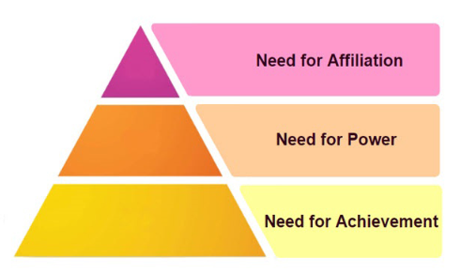
Figure 1: McClelland’s theory of achievement
(Source: Acquah et al. 2021)
From the above figure, it can be determined that the theory of entrepreneurship has three main aspects that are needed for affiliation, power, and achievement (Acquah et al. 2021). Every individual is influenced by one of the three motivators for becoming an entrepreneur. This motivator is not determined as to be gained from hereditary; although, individuals typically grow them as per the cultures, experiences of life, and society they live in. Thus, the factors through which an individual gets intrigued towards becoming an entrepreneur can be understood in detail.
One of the most efficient profit organizations that are noticed to disrupt its way through the competition is Cafepod Coffee co. This company runs with the spirit of competitiveness along with that operates with a single-minded ambition like no other company (Real Business, 2018). Cafepod Coffee co. is a highly competitive company with a constant focus on innovation, pushing its boundaries for becoming the number one coffee shop in the UK.
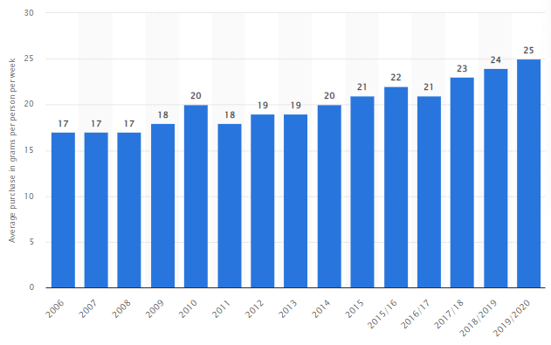
Figure 2: Average purchase of coffee per person per week
(Source: Ridder, 2022)
From the above figure, the increase in purchasing coffee per week since 2006 can be noticed vividly from 17 grams per week in 2006 to 25 grams per week in 2020 (Ridder, 2022). This demonstrates the positive prospects of coffee market growth in the UK. Cafepod Coffee co. is paving its way through the intense competition that is highlighting the achievement of its founder in being a successful entrepreneur. From this, it can be understood that the entrepreneur in the version of the founder of Cafepod Coffee co, Peter Grainger is highly enthusiastic and innovative in nature. The person had become the finalist of the NatWest Great British Entrepreneur Awards 2018 in the segment of ‘Small business entrepreneur of the year’ (Elite, 2018). Thus, the presence of entrepreneurial traits, characters, and attributes in the person is analysed to be extensive in this entrepreneur due to which, the company has been growing at a phenomenal pace in this present market competition.
Additionally, in contrast to the concept of entrepreneurs, the existence of intrapreneurs is there in the market that are basically individuals working in an organization with the task of creating and innovating new products. They have the authority to use the available resources of the company they work in and develop their tasked products. There is a fine line between entrepreneurs and intrapreneurs that differentiates them from one another; although they have the same aim of innovation (Coursera, 2023). An intrapreneur is known to innovate for a company in which they are employed; whereas, an entrepreneur is a person that innovates for themselves by seeking assistance from external resources and support for developing their respective innovative product. One of the most efficient and significant examples of an intrapreneur is Paul Buchheit who developed the application while working for Google (Gadgets 360, 2019). The application started with an initial storage capacity of one gigabyte per user, which further developed into a suite of enterprise products that includes processing software along with the presentation (Gadgets 360, 2019).
Thus, the significance of entrepreneurs in an organization can be understood to a major extent. In terms of traits, intrapreneurs, and entrepreneurs share much in common with a difference of one working for others and one for themselves. Additionally, in terms of the characteristics of intrapreneurs, they are risk takers that are known to risk their time and effort for the company they work for (Coursera, 2023). Additionally, intrapreneurs are innovative and creative in nature. Furthermore, they share their glory of success with their company.
Finally, the concept of the policymaker is essential to be understood as they create such plans and ideas that are specially carried out by a governmental body or business. Policymakers or support providers play a major role in shaping the operations of a company. Policymakers impact substantially transforming the business model of small and medium enterprises (Development, 2018). Efficient policies can impact a company being green in nature which can ultimately result in increasing demand for products from consumers. In this present era of increasing focus on sustainability, consumers are intensively inclined toward such businesses that are green in nature (Costa et al. 2021). Thus, through the contribution of policymakers and support providers, an entrepreneur or an intrapreneur can work forward in developing green products through innovation for their respective businesses and venture, resulting in a higher valued outcome. In terms of discussing the characteristics of policymakers, it needs to be grasped that they are intelligent consumers of evidence and perceive a wide range of backgrounds, varied knowledge, and expertise (Public engagement, 2020). These assist in developing rational, relevant, and efficient policies impacting both entrepreneurs and intrapreneurs with their innovations.

Differentiation between ‘for profit’ and ‘not for profit’ small organizations
In the modern competitive environment with evolved approaches towards conducting businesses, thriving through the competition, different types of ventures are present that operate for profit and also not for profit. In such businesses that work for profit, their primary aim is referred to as earning and maximization of profit. Whereas, the aim of such organizations that work not for profit, visions to serve the people. One of the key differences between profit organizations and non-profit organizations is that profit organizations make profit directing through the selling of products and services; whereas, non-profit organizations sell goods in the form of donations, membership fees, or subscriptions (Srivastav, 2023). Additionally, the financial statement of profit organizations contains cash flow statements, income statements, and balance sheets. On the contrary, non-profit organizations' financial statements contain balance sheets, income & expenditure accounts, and receipt & payment accounts.
For instance, in terms of profit organizations, Marshfield bakery operating in small and medium scale enterprises can be noticed to be operating for enhancing products through maximization of sales figures (Real business, 2018). This company basically operates with the vision of selling the best quality handmade bakery goods to consumers. In terms of revenue, the company has earned $15 million despite having intense competition in the market with top competitors like The Cake Crew Ltd, Fiona Cairns Ltd, Sweet Tooth Factory, and others (Zoom Info, 2023). Thus, the primary vision of the company for earning profits can be noticed and determined.
The value and beliefs of an entrepreneur in terms of profitable organizations are mainly oriented towards the generation of revenue through bringing forward new innovations in the working areas. Additionally, their focus is on increasing leadership skills for motivating people to work for accelerating performances and bringing honesty to work for increasing an organization’s reputation and others. Leadership skills are extensively essential for increasing motivation among employees (Paais and Pattiruhu, 2020). With an increased level of motivation, creativity in working can be generated that would ultimately result in achieving success paving through competition and earning higher profits. Additionally, when expanding a business, honesty is essential and can solidify the foundation pillar of an organization in the face of stakeholders, impacting transparency, collaboration, and efficiency.
Additionally, in terms of non-profit organizations in the UK, RSPCA (Royal Society for the Prevention of Cruelty to Animals) can be analysed to understand the operations they undertake for providing a higher value to the environment. RSPCA is basically a non-profit organization that has been operating for rescuing animals and for the welfare of animals in the UK (RSPCA, 2023). Additionally, in order to operate an organization, funding is essential. As these organizations are non-profitable, generating capital through other sources becomes essential for running an organization. Specifically discussing RSPCA, they arrange funds through self-funding along with that raise money through crowdfunding (RSPCA, 2023). In the aspect of non-profit organizations, the values, and beliefs of an organization become limited to providing value to the environment rather than focusing on the generation of profits. The intrinsic value of such entrepreneurs focusing on building non-profit organizations is perceived to have a high purpose and value in the environment.
Additionally, the perceived value of such an organization from the viewpoint of customers also remains extensively high. As it is noticed that RSPCA has a popularity of 71% among the population. Furthermore, fame is also at 95% (You Gov, 2023). Thus, it can be understood that consumers are also drawn towards such companies that are attempting to have a positive impact on the planet. Thus, the way through which profit and non-profit organizations operate in the market is noticed along with the values and beliefs of entrepreneurs in both settings. Moreover, in terms of profit organizations, the seed capital is arranged by founders, and business owners; whereas, in terms of non-profit organizations, capital is arranged through sourcing government grants, donations, and others (Srivastav, 2023). In this context, the triple-bottom-line theory can be efficiently aligned which can assist in providing enhanced insight into the areas that their companies are attempting to focus mainly.
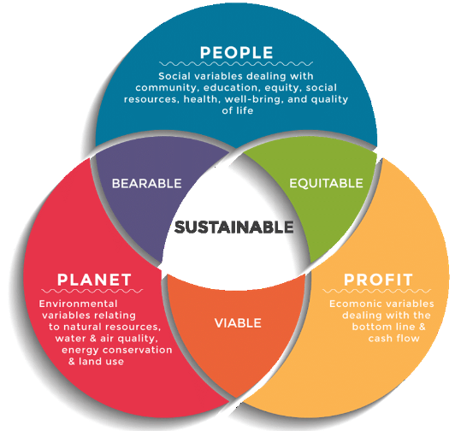
Figure 3: Triple bottom line theory
(Source: Birkel and Müller, 2021)
From the above figure, the three different concepts gathered from the triple bottom line theory with the profit, people, and the planet is noticed (Birkel and Müller, 2021). Different companies have different focuses through which sustainability is achieved in the long run. In terms of a non-profit organization, as noticed in the RSPCA, the company rather than generating profits is focusing on serving the plant and its people the most. Through working forth towards the welfare of the animals, the company is putting substantial effort into enhancing the bio-diversity aspect of the overall planet through which its primary focus of serving the planet is getting accomplished. Additionally, certain people are also getting employed in the company with a basic amount of stipend, and through this providing value to people is a success.
Additionally, by providing a higher purpose to the people working in the organization, the satisfaction rate of people is also increasing, impacting the mental well-being of people as well (Guillen-Royo, 2019). Additionally, from the aspects of profit generation, the organization is indirectly providing a high value to its surrounding people and environment which can be acknowledged as an indirect profit. Thus, it can be understood that in relation to such organizations that are non-profitable, the main vision is towards enhancing the welfare of the planet and people, leading to achieving ultimate sustainability. On the contrary, profit organizations mainly focus on the generation of profit or the economic layer primarily and then move toward sustainability, which is the reverse in the case of non-profit organizations (Gazzola et al. 2019).
Thus, the main differences between entrepreneurs in profitable and non-profitable organizations have been efficiently understood along with the ways through which different types of organizations work in an environment providing value to people, and the planet along with earning profits. Different individuals have a different sense of understanding towards profits, which has been understood through theoretical understanding.

Conclusion
From the above discussion, a substantial conclusion can be drawn that in order to become an entrepreneur, it is very essential for having certain traits, characteristics, and attributes that can result in making an individual a successful entrepreneur. Additionally, with the influence of one of the three motivators such as the need for affiliation, power, and achievement, an individual is intrigued about becoming an entrepreneur. Due to the entrepreneurs, innovations in the market have certainly increased to a vast extent, resulting in different development around the market with digitalization and others. Additionally, through profit and non-profit organizations, different areas of the society and environment are getting benefitted, which is assisting in keeping balance on the planet.

References
Acquah, A., Nsiah, T.K., Antie, E.N.A. and Otoo, B., (2021). Literature review on theories of motivation. EPRA International Journal of Economic and Business Review, 9(5), pp.25-29.
BBC, (2023). Business enterprise. [Online]. Available at: https://www.bbc.co.uk/bitesize/guides/zjc22sg/revision/4#:~:text=Reasons%20might%20include%20personal%20satisfaction,of%20a%20hobby%20or%20interest. [Accessed 19 March 2023]
Birkel, H. and Müller, J.M., (2021). Potentials of industry 4.0 for supply chain management within the triple bottom line of sustainability–A systematic literature review. Journal of Cleaner Production, 289, p.125612.
Costa, C.S.R., da Costa, M.F., Maciel, R.G., Aguiar, E.C. and Wanderley, L.O., (2021). Consumer antecedents towards green product purchase intentions. Journal of Cleaner Production, 313, p.127964.
Coursera, (2023). What Is an Intrapreneur? Definition, Examples, and More. [Online]. Available at: https://www.coursera.org/articles/intrapreneur [Accessed 19 March 2023]
Development, (2018). How Can Policy Makers Promote Green Business? [Online]. Available at: https://development.asia/explainer/how-can-policy-makers-promote-green-business [Accessed 19 March 2023]
Elite, (2018). Peter Grainger. Co-Founder & CEO of CafePod: Looking back on my five year journey as an entrepreneur. [Online]. Available at: https://www.elite-network.com/news/peter-grainger-co-founder-ceo-of-cafepod-looking-back-on-my-five-year-journey-as-an-entrepreneur#:~:text=Peter%20Grainger.,journey%20as%20an%20entrepreneur%20%7C%20ELITE [Accessed 19 March 2023]
Gadgets 360, (2019). Gmail Turns 15 Today, Here's a Short History of Google's Email Service. [Online]. Available at: https://www.gadgets360.com/internet/news/gmail-turns-15-today-heres-a-short-history-of-googles-email-service-2015822 [Accessed 19 March 2023]
Gazzola, P., Vătămănescu, E.M., Andrei, A.G. and Marrapodi, C., (2019). Users' motivations to participate in the sharing economy: Moving from profits toward sustainable development. Corporate Social Responsibility and Environmental Management, 26(4), pp.741-751.
Guillen-Royo, M., (2019). Sustainable consumption and wellbeing: Does on-line shopping matter?. Journal of Cleaner Production, 229, pp.1112-1124.
Indeed, (2022). 10 Entrepreneur Characteristics That Lead To Success. [Online]. Available at: https://in.indeed.com/career-advice/career-development/characteristics-of-an-entrepreneur [Accessed 19 March 2023]
Paais, M. and Pattiruhu, J.R., (2020). Effect of motivation, leadership, and organizational culture on satisfaction and employee performance. The Journal of Asian Finance, Economics and Business, 7(8), pp.577-588.
Public engagement, (2020). Policy makers. [Online]. Available at: https://www.publicengagement.ac.uk/do-engagement/understanding-audiences/policy-makers#:~:text=Policy%20makers%20are%20often%20intelligent,the%20quality%20of%20your%20research. [Accessed 19 March 2023]
Real Business, (2018). The best small companies with a turnover of up to £10m in the UK. [Online]. Available at: https://realbusiness.co.uk/the-best-small-companies-with-a-turnover-of-up-to-10m-in-the-uk [Accessed 19 March 2023]
Ridder, M., (2022). Weekly household consumption of coffee in the United Kingdom (UK) 2006-2020. [Online]. Available at: https://www.statista.com/statistics/284489/weekly-household-consumption-of-coffee-in-the-united-kingdom-uk/ [Accessed 19 March 2023]
RSPCA, (2023). Flat-faced dogs need your help. [Online]. Available at: https://www.rspca.org.uk/ [Accessed 19 March 2023]
Saif, H.A. and Ghania, U., (2020). Need for achievement as a predictor of entrepreneurial behavior: The mediating role of entrepreneurial passion for founding and entrepreneurial interest. International Review of Management and Marketing, 10(1), p.40.
SBBC, (2023). 5 Key Attributes Successful Entrepreneurs Possess. [Online]. Available at: https://smallbusinessbc.ca/article/5-key-attributes-successful-entrepreneurs-possess/ [Accessed 19 March 2023]
Srivastav, A.K., (2023). Nonprofit vs For Profit Organizations. [Online]. Available at: https://www.wallstreetmojo.com/for-profit-vs-nonprofit-organizations/#:~:text=Key%20Differences,-The%20for%2Dprofit&text=A%20nonprofit%20organization%20can%20be,%2C%20subscriptions%2C%20or%20membership%20fees. [Accessed 19 March 2023]
Suri, K., (2022). Key Traits of Successful Entrepreneurs. [Online]. Available at: https://www.entrepreneur.com/en-in/entrepreneurs/key-traits-of-successful-entrepreneurs/423216 [Accessed 19 March 2023]
You Gov, (2023). The Most Popular Charities & Organisations (Q4 2022). [Online]. Available at: https://yougov.co.uk/ratings/politics/popularity/charities-organisations/all [Accessed 19 March 2023]
Zoom Info, (2023). Marshfield Bakery Ltd. [Online]. Available at: https://www.zoominfo.com/c/marshfield-bakery-ltd/507346543 [Accessed 19 March 2023]

