

Student name: MODUPEOLA OYENAME AWODESU
Student ID:2442429
Module name: Introduction to Health and Social Care
Module code: LCHS4003
Lecturer name: Mr Muhammad Aliyu

Content page

Element 1 …………………………………………………page

Task 1

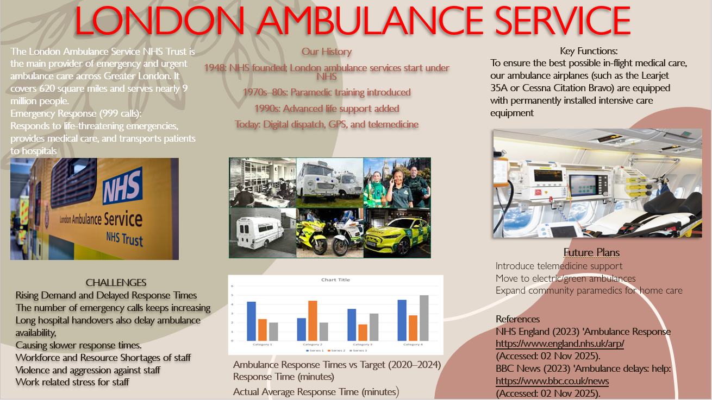

Task
Element 2

The Origins and Structure of the National Health Service (NHS)
The NHS was set up in the United Kingdom on 5 July 1948 to provide free healthcare for every citizen. It was based on the idea that everyone should have access to good healthcare, no matter how much money they have. Today, over 75 years later, the NHS is still a key part of British society.

History and Origins
Before the NHS was created, many people in Britain struggled to access healthcare because they had to pay for treatment. Poorer families often went without care, and only some workers were covered by limited insurance schemes such as the National Insurance Act of 1911 (Rivett, 1998). Charity hospitals helped a few people, but many still had no regular access to doctors or hospitals. Public attitudes changed during the Second World War, when hospitals were organised under the Emergency Medical Service, showing that a national system could work effectively (Webster, 2002). The war also increased the desire for a fairer society.

1942 Beveridge Report five major issues
The 1942 Beveridge Report identified five major social problems that limited people’s opportunities: Poverty, Poor Education, Inadequate Housing, Unemployment, and Insufficient Healthcare. Beveridge recommended a welfare system that was universal, compulsory, and contributory, designed to protect citizens throughout their lives and reduce inequality. His proposals became the foundation of the modern Welfare State and strongly influenced plans for a national health service. Aneurin Bevan, the Minister of Health, later oversaw the creation of the NHS, which was built on three central principles: that healthcare should be universal, comprehensive, and free at the point of use. These principles, introduced in 1948, continue to guide the NHS today and reinforce its commitment to fairness, accessibility, and improving public wellbeing for all.
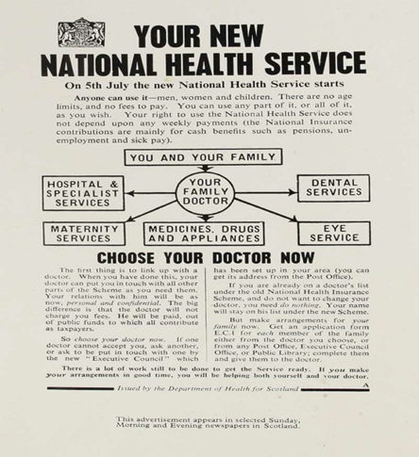

Current Structure and Functioning of the NHS
The NHS began as one organisation but later divided into four national systems: NHS England, NHS Scotland, NHS Wales, and Health and Social Care Northern Ireland. Each service is run by its own government but continues to follow the foundation values introduced in 1948 (The King’s Fund, 2023). In England, the Department of Health and Social Care (DHSC) offers leadership, while NHS England manages budgets and oversees services. Healthcare is delivered through three main levels. Primary care includes GPs, dentists, and pharmacists. The secondary care is provided by hospitals and dedicated teams. Tertiary care offers highly focused treatments for complicated conditions, usually in advanced hospitals or specialist centres.

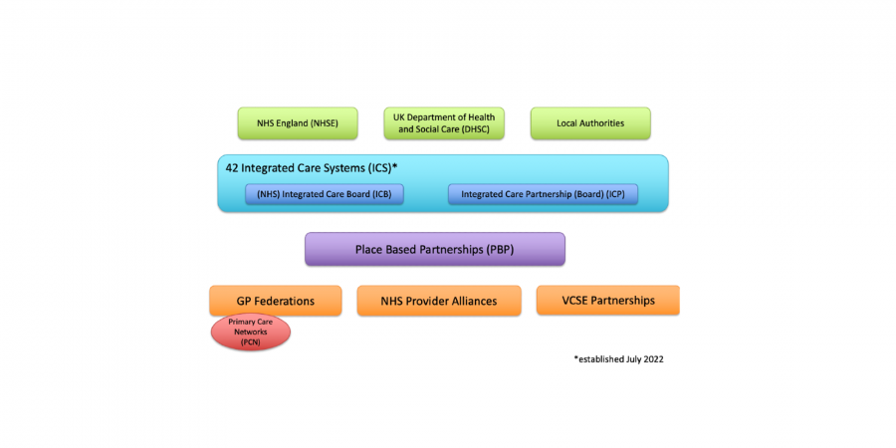

The NHS also uses Integrated Care Systems (ICSs) to bring together hospitals, GPs, community care, mental health services, and local councils to improve coordination and deliver more joined-up care closer to where people live.

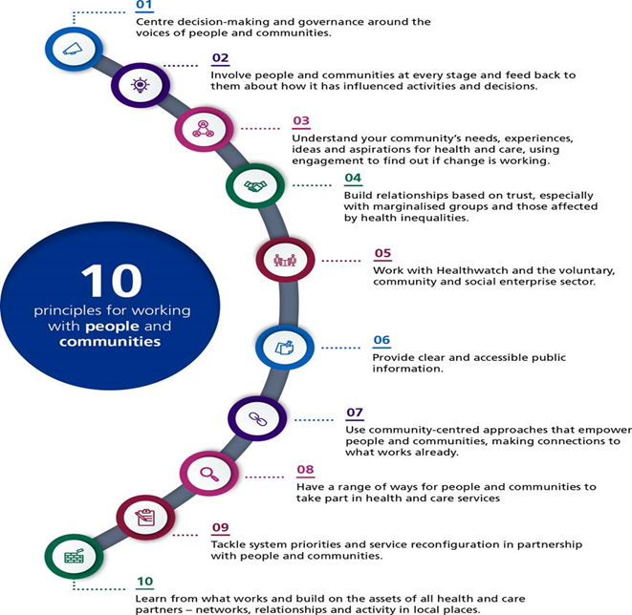

Challenges Facing the NHS
The NHS is experiencing major pressures that affect its ability to deliver efficient and safe care. Ongoing shortages of doctors, nurses, and social care staff make it harder to reduce waiting times and maintain high standards. Financial constraints add further strain, contributing to delays, overcrowded hospitals, and limited capacity. Large treatment backlogs for operations and GP appointments continue to impact patient health. An ageing population and increasing numbers of people with long-term illnesses place growing demand on services. Additionally, difficulties in joining up health and social care services lead to inconsistent support, especially for older and vulnerable patients who rely on coordinated and continuous care.

Conclusion
The NHS founded to provide care based on need, remains a symbol of fairness in British society. To serve future generations, it must address workforce, financial, and demand challenges. With strong leadership and strategic investment, the NHS can adapt while upholding its core values.

References
- https://www.nuffieldtrust.org.uk/health-and-social-care-explained/the-history-of-the-nhs: Rivett, G. (1998) From Cradle to Grave: Fifty Years of the NHS. London. (Accessed 06 November 2025).
- https://www.kingsfund.org.uk :NHS England (2023) NHS Long Term Plan.
(Accessed 06 November) 2025).
- https://scholar.google.co.uk/scholar?q=Webster,+c.+(2002) The national health service: a political history. (Accessed 06 November 2025).
https://www.gov.uk/government/organisations/uk-health-security-agency
- UK Health Security Agency (2023) Infection Prevention Guidance. London: UKHSA. (Accessed 06 November 2025).

