
Module Title: Enhancement and Development of Science subject knowledge for effective teaching of Science at Key Stage 3 and 4

Module Code: ECLS6002

Graduate Diploma in Professional Learning: Science

LEVEL 6

MarV2

Yr Athrofa 2020
- Points of contact

If you need to discuss anything relating to the module contact:

Name: Sue James (Programme Director)
Email: sue.pellew-james@uwtsd.ac.uk

Name: Lilian Martin

Name: Lesley Morgan
Email: Lesley.morgan@uwtsd.ac.uk

2. Our expectations

We hope that you will enjoy the module and programme and are here to help. You should:
- Make good use of the University facilities and resources
- Attend and participate in sessions
- Act responsibly
- Meet assignment deadlines
- Engage and Participate in all sessions

Please read the University Regulations for Students.
With regard to your personal privacy, the university has clear guidelines on General Data Protection Regulations (GDPR). Please use the link below to find out more:
Privacy Policy: https://www.uwtsd.ac.uk/privacy-and-cookie-policy/

3. Aims and Learning Outcomes
AIM(S)

- To develop Science subject knowledge and understanding of non-specialist teachers to enable them to teach Science effectively to Key Stage 3 and 4 pupils.
- To develop the skills and confidence necessary to reflect on and critically analyse their own Science subject knowledge.
- To support their professional development into Science teacher roles within the profession.

LEARNING OUTCOMES

Upon the successful completion of this module, the student should be able to critically analyse:
- the nature of misconceptions in Science, their development and resolution including cognitive conflict;
- task design, Scientific structure;
- the nature of Science thinking and problem solving, including developing and planning investigations;
- the use of practical Science to effectively reinforce teaching;
- the action research and lesson study process and their application to curriculum innovation in Science.

INDICATIVE CONTENT
Students will:
  - Complete a subject knowledge audit and action plan under the support and guidance of the tutor. One of the standards for the award of QTS - S2.1 states that trainees must demonstrate that they have secure knowledge and understanding of the subject(s) they are trained to teach. They are required to reflect upon their scientific knowledge and become aware of their strengths and weaknesses (KS3 and 4) by conducting an audit. Following on from this audit they then need to make an action plan indicating how and when they are going to fill in the gaps in their knowledge. This is to ensure that they will be able to demonstrate that they are competent in ‘gaps’ in using Science in their teaching by the end of the course;
  - study the varying interpretations of ‘understanding’ in Science;
  - consider the big ideas in Science and the significance of Science structure for task design;
  - explore strategies for developing scientific thinking, problem solving and planning investigations;
  - explore strategies for developing effective practical tasks that reinforce scientific knowledge and understanding;
  - engage in school-based learning which involves teaching of Science and develops subject specific knowledge.

LEARNING AND TEACHING STRATEGY

Short presentations will sometimes be used to introduce key concepts, principles and practices. Seminar discussions will then be used to probe and critically analyse issues arising. Students will also be asked to read research papers in advance of seminars and then engage in dialogues based on tutor prompts. Students will be expected to draw on professional knowledge from their own work environments to illustrate and challenge the issues under discussion.
The allocation of teaching to deliver the module is:

Activity type | Hours | Percentage
Scheduled learning | 88 | 30%
Independent learning | 100 | 33%
Placement learning | 112 | 37%
TOTAL | 300 | 100%

ASSESSMENT
Assessment Component 1 – 100%
Science Curriculum Development and Enhancement

Purposes:
- To enable you to demonstrate your ability to evaluate a specific aspect of your Science teaching, applying theory to practice.
- To explore in depth an aspect of the teaching and learning of Science.
- To develop the capacity to generate curriculum materials.

EDUCATION FOR SUSTAINABLE DEVELOPMENT (ESD)

Does the module contribute to ESD? | Yes
- be able to appreciate the importance of environmental, social and political contexts to their studies;
- be able to solve or ameliorate real life problems through employing holistic as well as reductionist approaches, as appropriate to the issue;
- be able to think creatively, holistically, and systemically and make critical judgments on issues;
- be able to develop a high level of self-reflection at a personal and professional level;
- be able to understand, critically evaluate and adopt thoughtfully sustainability values;
- be able to apply theory to practice and vice versa.

4. Background reading/tasks

Classification | Reading List entry | Electronic*
Essential | Ross, K. and Lakin, L. (2015) Teaching Secondary Science: Constructing Meaning and Developing Understanding. | ☐
Essential | Science guidance for KS3  http://learning.gov.wales/docs/learningwales/publications/140624-science-in-the-national-curriculum-guidance-en.pdf | ☒
Essential | WJEC Science  http://www.wjec.co.uk/qualifications/science/science-gcse/ | ☒
Essential | WJEC Guidance for teaching science  http://www.wjec.co.uk/qualifications/science/gcse/science-double-gcse-2016/WJEC%20GCSE%20Double%20Award%20Guidance%20for%20Teaching.pdf?language_id=1 | ☒
Essential | British Educational Research Association  http://www.bera.ac.uk/ | ☒
Further | McDaid, I. (2015) 100 Ideas for Secondary Teachers: Outstanding Science Lessons. | ☐
Further | Gibbs, K. (2011) The new resourceful physics teacher | ☐
Further | Big Ideas in science Education | ☒
Further | Developing thinking | ☒
Further | IOP | ☒
 | RSC

Where electronic copies are available to the public, a copy will be shared to the students.
This list will be added to and shared via the MS Teams site.

5. Module summary

The order of these sessions may change according to circumstances and there will
be overlap in the themes covered.

Session | Session of Themes: | Notes
1 | Wider resources – STEM etc | 10/3/20
2 | Crystallisation / Practical work/ Electrolysis | 10/3/20
3 | Differentiation incl Frayer model and Solotaxonomy | 10/3/20
4 | Knowledge Audit / RSC CPD/ Safety / CLEAPSS | 10/3/20
5 | Planning to microteach / dealing with misconceptions | 10/3/20
6 | Microteach session | After Easter
7 | Planning to microteach/ 4 purposes & 12 pedagogical principles | 25/3/20 ++before microteach
8 | LNF/DCF in science. Cross curricular responsibilities/ progression
9 | SciTech AOLE
10 | Assignment workshop

6. Intersessional tasks

Task 1 | Set up Teams
Task 2 | Decide microteach lesson and research chosen topic
Task 3 | Plan to deliver microteach lesson and prepare resources to teach it. (support/adaption 27/3/20)
Task 4 | Reflect and join in discussion – prepare to write up assignment.

MODULE CODE | MODULE TITLE | MODE OF ASSESSMENT
ECLS6001 | Enhancement and Development of science pedagogical knowledge for effective teaching of science at Key Stage 3 & 4 | Presentation – 60%  Written – 40%

MODULE CODE | MODULE TITLE | MODE OF ASSESSMENT
ECLS6001 | Enhancement and Development of science pedagogical knowledge for effective teaching of science at Key Stage 3 & 4 | Presentation – 60%  Written – 40%
Assessment Summary |  | Breakdown
 | Microteach (4500 words) | 60%
 | Written assignment (3000 words) | 40%
 | TOTAL (7500 words) | 100%

7. Assessment tasks and Guidance

Key Dates
Microteach | After Easter  (Online)
Submission deadline (via Turnitin) | 15th May 2020 23:59 TBC

Assessment Guidance
There are distinct sections to this assignment.
- Introduction to the school and context (300)
- a review of the relevant literature on your chosen topic; (1500)
  - 4 purposes
  - 12 pedagogical principles
  - Cross curricular (if applicable)
  - Differentiation
  - Dealing with misconceptions in the chosen topic.

c) a clearly identifiable "topic pack" of teaching approaches and materials for use in school for your hypothetical microteach; (worth 4500 words). You can use your school/UWTSD lesson plan. Whichever you prefer as long as you can justify your choices and use them in the written assessment. It is a big chunk of your assessment and your effort in your planning should reflect that. You should also include a detailed risk assessment and know what your school procedure is as well as your personal risk assessment is for the class. Where it doesn’t exist, an exemplar will be provided. Engagement with CLEAPSS is expected. Demonstration of differentiation will be discussed so you may prepare questions/resources to show you are aware of how to differentiate for your chosen topic. E.g. details of question choices and why you chose them. Link(s) to 4 purposes and 12 pedagogical principles are expected. AFL technique(s) MUST be chosen and justified. Online discussion of your microteach lesson will be organised to help inform analysis and evaluation.

d) an analysis of your microteach. (500)
e) an in-depth evaluation of, and suggestions for the revision of the approaches and materials; (500)
f) a reflective conclusion. (200)

The word count for each section is just a guide but in total should be 3000+/- 10% words

Please note: extracts from your own school policies and documents should only be used with the permission of your head teacher. Please treat this assignment with a high degree of professional care and make references to schools and colleagues anonymous as far as possible.

Date of Microteach: TBA
Assignment Deadline: 15th May TBC
DO not send a copy of your assignment to Lesley.
PLEASE BE AWARE THAT YOUR TURNITIN SUBMISSION IS YOUR OFFICIAL DEADLINE SUBMISSION. Turnitin will be available for submissions two weeks prior to this date. In addition, there will be a Draft Turnitin repository this will be available until the day before the Final Turnitin assignment submission. This will be an opportunity for you to get an originality report and make any amendments, prior to submission. You will be able to use this facility multiple times to address any issues arise – please make use of this!

If you experience any problems contact the Moodle Team, who will help with any concerns.

If you need to complete an extenuating circumstance form, please find the information on Moodle under the Course Information tab.

Moodle submission guidance:
🔎 Moodle Course ECLS6002
Click the tile

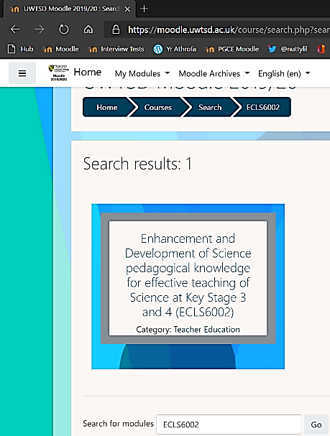
Try out on Draft 1st if you prefer:
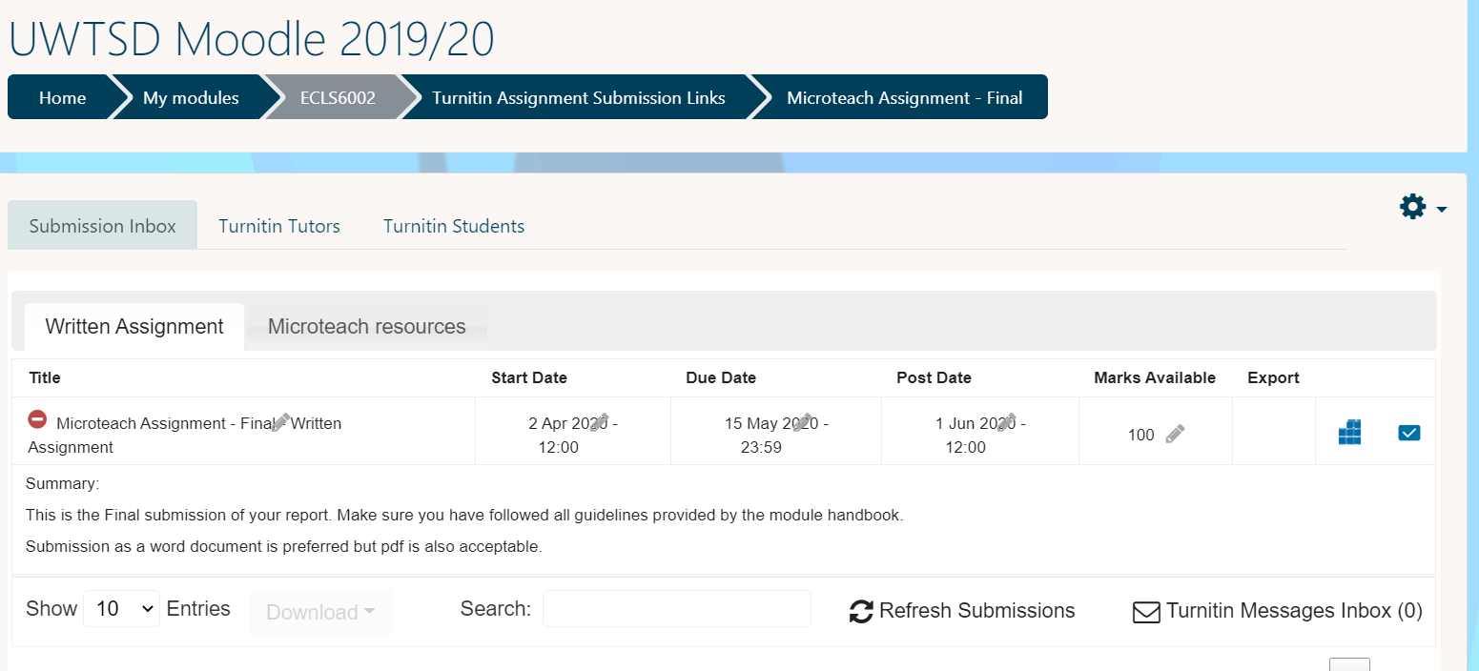
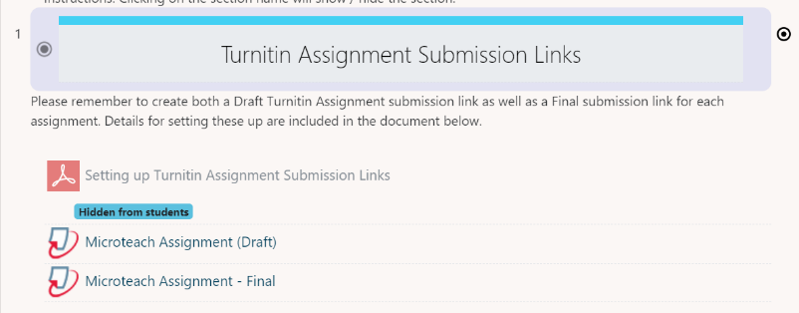
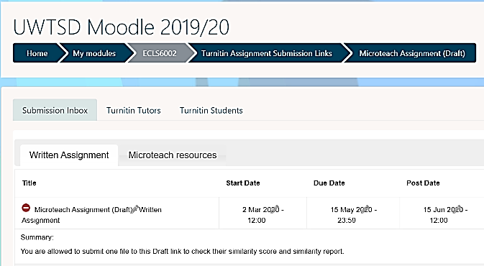
Due date is currently set to 15 May.

The post date is set to 15 Jun but will be shared earlier if possible.
Upload your written assignment in the “written assignment” tab
Upload your resources as 1 file into the “microteach resources” tab

8. Assignment Criteria

GUIDANCE FOR Students IN THE COMPLETION OF TASKS

NOTE: The guidance offered below is linked to the five generic assessment criteria overleaf.

- Engagement with Literature Skills
Your work must be informed and supported by scholarly material that is relevant to and focused on the task(s) set. You should provide evidence that you have accessed a wide range of sources, which may be academic, governmental and industrial; these sources may include academic journal articles, textbooks, current news articles, organisational documents, and websites. You should consider the credibility of your sources; academic journals are normally highly credible sources while websites require careful consideration/selection and should be used sparingly. Any sources you use should be current and up-to-date, mostly published within the last five years or so, though seminal/important works in the field may be older. You must provide evidence of your research/own reading throughout your work, using a suitable referencing system, including in-text citations in the main body of your work and a reference list l at the end of your work.

Criteria specific to this assignment:
Thoroughly engage with the Curriculum for Wales. LNF/DCF documents of the “2008” curriculum could also be used as it is still valid. Engagement with 12 pedagogical principles including AFL is expected so these MUST be backed up by literature. You will use the literature to justify your choices in your microteach lesson plan.

- Knowledge and Understanding Skills
At level 6, you should be able to demonstrate coherent and detailed knowledge and a systematic understanding of the subject area, at least some of which is informed by the latest research and/or advanced scholarship within the discipline. You should be aware of the uncertainty, ambiguity and limits of knowledge. Your work must demonstrate the growing extent of your knowledge and systematic understanding of concepts and underlying principles associated with the subject area. Knowledge relates to the facts, information and skills you have acquired through your learning. You demonstrate your understanding by interpreting the meaning of the facts and information (knowledge). This means that you need to select and include in your work the concepts, techniques, models, theories, etc. appropriate to the task(s) set. You should be able to explain the theories, concepts, etc. meaningfully to show your understanding. Your mark/grade will also depend upon the extent to which you demonstrate your knowledge and understanding; ideally each should be complete and detailed, with comprehensive coverage.

Criteria specific to this assignment:
You will use the literature to justify your choices made in your microteach lesson plan.

- Cognitive and Intellectual Skills
You should be able to critically evaluate evidence, arguments, assumptions, abstract concepts and data (that may be incomplete), to make judgements. Your work must contain evidence of logical, analytical thinking, evaluation and synthesis. For example, to examine and break information down into parts, make inferences, compile, compare and contrast information. This means not just describing what! But also justifying: Why? How? When? Who? Where? At what cost? At all times, you must provide justification for your arguments and judgements. Evidence that you have reflected upon the ideas of others within the subject area is crucial to you providing a reasoned and informed debate within your work. Furthermore, you should provide evidence that you are able to make sound judgements and convincing arguments using data and concepts. Sound, valid conclusions are necessary and must be derived from the content of your work. Where relevant, alternative solutions and recommendations may be proposed.

Criteria specific to this assignment:
Considering you are experienced teachers, try not to rely on your gut instincts. Research other points of views. Make convincing arguments to discuss limitations and justify your choices. Triangulate your data as much as possible.

- Practical Skills
At level 6, you should be able to accurately deploy established techniques of analysis and enquiry within a discipline, using your conceptual understanding to devise and sustain arguments and/or to solve problems. You should be able to frame appropriate questions to achieve a solution - or identify a range of solutions. You should be able to demonstrate how the subject-related concepts and ideas relate to real world situations and/or a particular context. How do they work in practice? You will deploy models, methods, techniques, and/or theories, in that context, to assess current situations, perhaps to formulate plans or solutions to solve problems, or to create artefacts, some of which may be innovative and creative. This is likely to involve, for instance, the use of real world artefacts, examples and cases, the application of a model within an organisation and/or benchmarking one theory or organisation against others based on stated criteria. You should show awareness of the limitations of concepts and theories when applied in particular contexts.

Criteria specific to this assignment:
Make conclusions based on your reflections and discussions regarding your microteach. How can you deploy an idea better? Is it transferable to other topics? How has it changed your practice? Evaluate linking to literature review. CLEAPSS – Safety. How would it work in a REAL classroom situation?

- Transferable Skills for Life and Professional Practice
Your work must provide evidence of the attributes expected in graduate-level professional practice. This includes demonstrating the exercise of initiative and personal responsibility; professional development; that you can initiate and complete tasks and procedures, whether individually and/or collaboratively; use appropriate media to communicate effectively in a suitable format; fluency of expression; clarity and effectiveness in presentation and organisation. Work should be coherent and well-structured in presentation and organisation.

Criteria specific to this assignment:

Harvard referencing. Clear logical structure. Appendices.

Level 6 | FAIL | MARGINAL FAIL | SATISFACTORY  (3rd / Pass) | GOOD  (2.2 / Pass) | VERY GOOD  (2.1 / Merit) | EXCELLENT  (1st / Distinction) | EXCEPTIONAL  (1st / Distinction)
Category | 0-29% | 30-39% | 40-49% | 50-59% | 60-69% | 70-84% | 85-100%
Engagement with literature (including reading, referencing,  academic conventions and  academic honesty) | Little or no evidence of reading and/or reliance on inappropriate sources.  Views and findings mostly unsupported and non-authoritative.  Referencing conventions used incoherently or largely absent. | Poor engagement with essential reading. No evidence of wider reading. Reliance on inappropriate sources, and/or indiscriminate use of sources. Heavily reliant on information gained through class contact. Inconsistent and weak use of referencing. | Engagement with a limited range of mostly relevant and credible sources. Some omissions and minor errors.  Referencing conventions evident though not always applied accurately or consistently. | Engagement with an appropriate range of research-informed literature, including sources retrieved independently. Some over-reliance on texts. Referencing may show minor inaccuracies or inconsistencies. | Engagement with a wide range of research-informed literature, including sources retrieved independently.  Selection of relevant and credible sources. Very good use of referencing, with no/very few inaccuracies or inconsistencies. | Engagement with an extensive range of relevant and credible literature, informed by the latest research. Consistently accurate application of referencing. | Exceptional engagement with an extensive range of relevant and credible literature, informed by the latest research. High-level referencing skills consistently and professionally applied.
Knowledge and understanding (Coherent and detailed knowledge and systematic understanding of the subject area, at least some of which is informed by the latest research and/or advanced scholarship within the discipline.) | Major gaps in knowledge and systematic understanding of the subject matter. Substantial inaccuracies. No awareness of knowledge of the latest research and/or advanced scholarship within the discipline. | Gaps in knowledge, with only superficial systematic understanding. Some significant inaccuracies and/or irrelevant material. No awareness of knowledge of the latest research and/or advanced scholarship within the discipline. | Limited knowledge and systematic understanding of the relevant concepts and principles within the subject area which to some limited extent, is informed by current research and scholarship. | Knowledge is reasonably detailed, accurate with a good systematic understanding of the field of study and to some extent, current research and scholarship. | Knowledge is reasonably extensive coherent and detailed. Exhibits very good understanding of the breadth and depth of established views, and the work is, at least in part, well-informed by current research and scholarship. | Excellent coherent and detailed knowledge and systematic understanding of the principles and theories of current research and scholarship. Clear awareness of challenges to established views and the limitations of the knowledge base. | Exceptionally coherent and detailed knowledge and systematic understanding of the principles and theories of the subject, well-informed by current research and scholarship. A critical, sophisticated and nuanced awareness of the ambiguities and limitations of knowledge.
Cognitive and intellectual skills  (Conceptual and critical thinking, analysis, synthesis and evaluation of research, assumptions, abstract concepts and data (that may be incomplete); logic, argument and judgement.) | Wholly or almost wholly descriptive work. Little or no analysis, synthesis or evaluation.  Failure to develop arguments, leading to illogical or invalid judgements. Unsubstantiated generalisations, made without use of any credible evidence. | Largely descriptive work, with superficial use of critical evaluation. Weak development of arguments and judgements. Information accepted uncritically, uses generalised statements made with scant evidence and unsubstantiated opinions. Ideas sometimes illogical and contradictory. | Limited attempt at critical thinking, analysis, synthesis and evaluation, tending towards description.  Some evidence to support emerging arguments and judgements but these may be underdeveloped or with a little inconsistency / mis-interpretation.  Asserts rather than argues a case. | Some critical thinking, analysis, synthesis and evaluation. Can analyse new and/or abstract concepts and data without guidance.  An emerging awareness of different stances and ability to use evidence (that may be incomplete) to support the argument.  Mostly valid arguments and logical judgements. Some tendency to assert/state opinion rather than argue on the basis of reason and evidence. | Sound critical thinking, analysis, synthesis and evaluation demonstrating critical thinking. Ability to devise and sustain persuasive arguments, and to review the reliability, validity and significance of evidence (that may be incomplete) to make mostly appropriate and valid judgements. | Excellent critical thinking, analysis, synthesis and evaluation. Ability to investigate contradictory or incomplete information and make strong, persuasive, arguments and sophisticated judgements. Some evidence of independent thought and ability to ‘see beyond the question’, suggesting a grasp of the broader field and wider concepts. | Exceptional critical thinking, analysis, synthesis and evaluation based on judiciously selected evidence.  Ability to investigate contradictory or incomplete information and make strong, persuasive, arguments and sophisticated, nuanced, judgements. Evidence of independent thought and ability to ‘see beyond the question’, suggesting an outstanding grasp of the broader field and wider concepts.
Practical skills  (Apply/deploy accurately established tools and techniques; initiate and carry out projects; formulate solutions to solve problems in complex and unpredictable contexts.) | Limited or no use of methods, materials, tools and/or techniques.  Little or no appreciation of the context of the application.  Limited understanding of the application of theory to practice or making appropriate links between the two.  Very weak problem-solving skills in complex and unpredictable contexts. | Rudimentary application of methods, materials, tools and/or techniques but without consideration and competence. Flawed appreciation of the context of the application.  Weak understanding of the application of theory to practice, with only occasional evidence of making appropriate links between the two. Weak problem-solving skills in complex and unpredictable contexts. | An adequate awareness and mostly appropriate application of well-established methods, materials, tools and/or techniques.  Basic appreciation of the context of the application. Theoretical knowledge and understanding applied in practice, but not always making logical links between the two.  Can identify problems and propose basic solutions in complex and unpredictable contexts without fully appreciating the complexity. | A good and appropriate application of standard methods, materials, tools and/or techniques.  Clear appreciation of the context of the application. Mainly consistent, accurate and logical application of theory to practice, making appropriate links between the two  Can identify problems and propose mostly appropriate solutions in complex and unpredictable contexts. | A very good application of a range of methods, materials, tools and/or techniques.  Very good consideration of the context of the application, with perceptive insights. Can identify problems and propose appropriate solutions in complex and unpredictable contexts.  Evidence of some innovation and creativity. | An advanced application of a range of methods, materials, tools and/or techniques.  The context of the application is well considered, and insightful.  Application and deployment extend beyond established conventions. Can identify complex problems and propose excellent solutions. Innovation and creativity evident. | Exceptional levels of application and deployment skills in unpredictable, practical contexts, drawing skilfully on the latest research within the discipline. Can identify complex problems and propose sophisticated solutions. Assimilation and development of cutting edge processes and techniques.
Transferable skills for life and professional practice  (Exercise of initiative and personal responsibility; professional development; initiate and complete tasks and procedures: individually and/or collaboratively; use appropriate media to communicate effectively; fluency of expression; clarity and effectiveness in presentation and organisation.) | Communication medium is inappropriate or misapplied.  Work is poorly structured, disorganised and/or confusingly expressed. Very weak use of language and/or very inappropriate style. Little or no evidence of autonomy (or collaboration, where relevant) in the completion of tasks. Little or no evidence of the skills required in graduate employment. | Communication medium is poorly designed and/or not suitable for the audience.  Work is poorly presented in a disjointed manner. It is loosely, and at times incoherently, structured, with information and ideas often poorly expressed. Weak use of language and/or inappropriate style. Weak independent initiative (or collaboration, if relevant). Limited evidence of the skills required in graduate employment. | Can communicate in a suitable medium but with some room for improvement.  Mostly ordered presentation and structure in which relevant ideas / concepts are reasonably expressed. Work may lack coherence in places. Can work as part of a team, but with limited involvement in group activities.  Demonstrates the basic skills required in graduate employment, with some areas of minor weakness. | Can communicate effectively in a suitable format, but may have minor errors.  Mostly coherent, organised work, in a suitable structure and is for the most part clearly expressed. Can work effectively independently and/or as part of a team, with clear contribution to group activities.  Demonstrates the skills required in graduate employment, with some areas of strength and some of minor weakness. | Can communicate well, confidently and consistently in a suitable format.  Work is coherent, fluent, well-structured and organised. Can work very well autonomously and/or as part of a team, with very good contribution to group activities.  Demonstrates very good graduate employment skills, with just occasional minor weakness. | Can communicate professionally confidently and consistently in a suitable format.  Work is coherent, very fluent and is presented professionally. Can work autonomously with initiative. Where relevant can work professionally within a team, showing leadership skills as appropriate, managing conflict and meeting obligations. Demonstrates excellent graduate employment skills and an appetite for further development. | Can communicate with an exceptionally high level of professionalism.  Work is exceptionally coherent, very fluent and is presented professionally. Can work exceptionally well and professionally within a team, showing advanced leadership skills. Demonstrates exceptional graduate employment skills and an appetite for further development.



