University of Wales
Trinity Saint David

Unit: Marketing Essentials
Marketing Information System

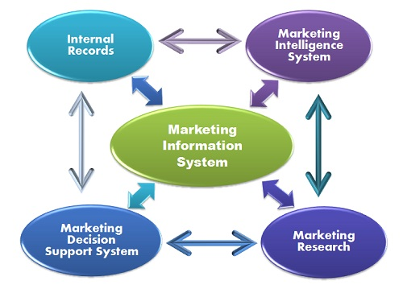

Student: Aneliya Dimitrova-1816842
Lecturer: Dale Clarke
13.12.2019

CONTENT PAGE:

- Introduction
- Internal Records System
- Marketing Intelligent System
- Marketing Research System
- Marketing Decision Support
- Kip Hotel
- Conclusion
- References

I have been assigned to write an essay relating to Marketing Information System and I will explain my understanding of its importance.
MIS-Marketing Information System is a tool used for gathering, managing, processing, accessing and disseminating data. Jobber (2007) defines it as a "system in which marketing data is formally gathered, stored, analysed and distributed to managers in accordance with their informational needs on a regular basis."
Improvement and perception of Marketing Information System is highly important because it helps companies to understand better the specific needs of the customers.
Kotler, et al (2006) identify it as “A marketing information system (MIS) consists of people, equipment’s, and procedures to gather, sort, analyse, evaluate, and distribute the needed, timely, and accurate information to marketing decision makers.”
The information is like a driving power of every business. Proper decisions depend on the correct type of information. The right information is a guarantee for quality decisions which are done on time.
The information is a connection between internal and external marketing participants-stakeholders, customers, competitors, staff, suppliers. Nowadays marketing environment is constantly changing. The managers of the companies need to be aware and well informed what is taking place in the market. Accurate information is a common tool used by marketing decision makers to improve their marketing planning, implementation and control. MIS is a system(provision) for regular, reliable, relevant and adequate information, delivered on time for making proper marketing decisions.
According to Philip Kotler there are four components that comprise Marketing Information System-Internal Reports(Records), Marketing Intelligence, Marketing Research and Marketing Decision Support.

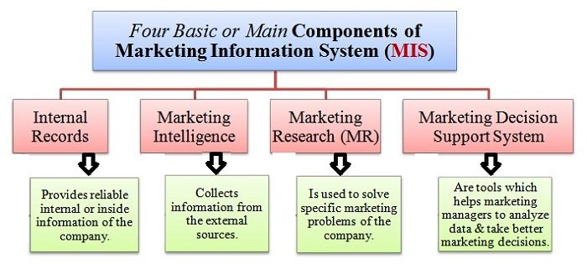

- Internal Records System(IRS):
Internal Records System is a main source of information because it is easily accessible. All records of marketing operations within the organizations are available in IRS. The system deals with gathering, analysing, interpreting and distributing information from records of different departments of the company. Main sources include divers records about purchases and sales, about orders, costs, inventory control, staff, the past research work. Internal databases records include information on demographics base, sales transactions, website visits. Most of the companies have loyalty programmes as a way to collect an information.
The organization can collect an information throw its internal records including customer database, sale data, database of product, operations data, financial data, etc. The information can be obtained from documents as billing documents or invoices. Current sales data and data of the inventory level on a regular basis assists the managers to build their future sales strategy.
Nowadays the organizations collect and maintain different databases:
- Database of the customer-contains of information about the customer’s name, address, phone number and email address, the frequency of purchase and so on.

- Database of product-contains information about the product name, its price, variants and features, in stock or out of stock.

- Database of the employee-contains name, address, phone number and email address, start data, awards and penalties.

- Database of suppliers-contains name, phone number and email address, a product or a service used, frequency of order.

All data is stored and used when needed. The managers can turn the data into useful information for the company’s need.
Computer technology is extremely helpful collecting and processing quick and accurate information. The data in IRS can be updated regularly with less costs and efforts. The managers can find the latest information about marketing operations within the company. If the system is attuning properly, it is easy to manage.
Benefits of Internal database are:
- Quickly access to the information.
- Relative cheap method.
Limitations of Internal database:
- Information may be incomplete.
- Age quickly.
- Require highly sophisticated equipment and skilled employees.

2.Marketing Intelligent System:
Marketing Intelligent System provides an information outside of the organization about external environment. Marketing Intelligent System is a complex of sources and procedures used to gain newest information about external marketing environment, relating to our business. Marketing Intelligent System comprises the information about the change of customer’s choice, new products emerge in the market, promotions and pricing strategy of competitors, constantly changing market trends, etc.
Marketing Intelligent System is gathering and analysing of information about consumers, competitors and developments in the marketing environment. The information is publicly available and we can obtain the data from annual reports, discussions on blogs or social media.
In order to improve Marketing Intelligent System, the companies have to provide appropriate training to all involved people.
The managers can use various methods:

- Talking to customers, workmates, suppliers and other involved parties, and asking for their feedback, suggestions and recommendations.

- Talking to other managers and employees of their organizations and other companies, specially competitors.

- Reading newspapers, books and different publications, relating to their business, as well as surfing internet, watching TV and hearing radio.

- Maintaining good relationship with agencies and other officials.

- Using useful information from professional sources even purchasing the information if needed.

- Important marketing tasks to be assigned to professional agencies.
Marketing Intelligent System supports managers to make effective decisions, to understand better customers’ needs, to predict competitors steps and anticipate their actions. Marketing Intelligent System gives huge advantages to avoid problems or at least to minimize them and solve them quickly and effectively.
Limitations:
- The information we need may not be available.
- If the information is available may not be accurate.

- Marketing Research System:
Marketing research is an independent sector of the Marketing Information System. To resolve a specific problem in particular cases, the managers need detailed and specific information. Marketing research is a separate discipline which contains of collecting primary and secondary data from different advisors, using divers tools and methods for certain period of time, analysing information and represent data as a report. It is obtained by external professionals or internal expert staff.
Marketing research gives a glance of customer motivation, customer purchase behaviour and customer satisfaction.
- Marketing Decision Support System(MDSS):
Marketing Decision Support System is also known as Analytical Marketing System. While three elements listed above deal with gathering information, the MDSS provides processing and analysing of collected data. MDSS consists of software programs which boost results and performance of whole Marketing Information System. Using computers help managers to process enormous quantity information for short time and make effective marketing decisions.

In order to complete my assay, I have chosen my ex workplace – Kip Hotel. It is a small family hotel, situated next to Hackney central station. It consists of 105 rooms, without any food facilities. I worked there two years as a housekeeper. I became a senior housekeeper but there was not possibility to develop my carrier there and I started working in one of Hilton hotels as a supervisor in housekeeping department.
I worked in Kip hotel since it has been opened. The owners have rented an agency to design the rooms. All management team was very helpful and we have been properly trained. We have been asked about what the customers are saying about their experience in the hotel, about our ideas and recommendations. We had many great online feedbacks about excellent customer service and spotless cleaning. The management of the Kip knows how to inspire and motive the staff. They are well familiar with customers’ needs and their competitors. Even next to Kip hotel there is another hotel Kip was fully booked almost all times. My opinion is that they effectively used Marketing Information System and it gives them many advantages.

REFERENCES:
Kotler, Philip; Keller, Kevin Lane (2006). Marketing Management (12 ed.). Pearson Education.
Jobber, David (2007). Principles and Practice of Marketing (5 ed.). Mc Graw – Hill Education.
Anon, (2019). [online] Available at: https://www.quora.com/What-are-some-examples-of-marketing-information-systems [Accessed 13 Dec. 2019].
Business Jargons. (2019). What is Marketing Information System? definition and meaning - Business Jargons. [online] Available at: https://businessjargons.com/marketing-information-system.html [Accessed 13 Dec. 2019].
Google Books. (2019). Marketing. [online] Available at: https://books.google.co.uk/books/about/Marketing.html?id=8qlKaIq0AccC&redir_esc=y [Accessed 13 Dec. 2019].
Google.com. (2019). marketing information system images - Google Search. [online] Available at: https://www.google.com/search?q=marketing+information+system+images&client=firefox-b-d&sxsrf=ACYBGNTclk8w0XFCIXMFDmPd4zcpy81YKg:1576230088682&tbm=isch&source=iu&ictx=1&fir=gA3Nj15e9S7n8M%253A%252CHqRKM4UtHprOIM%252C_&vet=1&usg=AI4_-kTwt_DileNvYsB0quAO63DoYaotgw&sa=X&ved=2ahUKEwjUqZTUqrLmAhWkURUIHcxUCugQ9QEwAHoECAkQFA#imgrc=UU4jN9XH2Ip-NM:&vet=1 [Accessed 13 Dec. 2019].
Google.com. (2019). marketing information system images - Google Search. [online] Available at: https://www.google.com/search?q=marketing+information+system+images&client=firefox-b-d&sxsrf=ACYBGNTclk8w0XFCIXMFDmPd4zcpy81YKg:1576230088682&tbm=isch&source=iu&ictx=1&fir=gA3Nj15e9S7n8M%253A%252CHqRKM4UtHprOIM%252C_&vet=1&usg=AI4_-kTwt_DileNvYsB0quAO63DoYaotgw&sa=X&ved=2ahUKEwjUqZTUqrLmAhWkURUIHcxUCugQ9QEwAHoECAkQFA#imgrc=9POFqwWBPSlI8M:&vet=1 [Accessed 13 Dec. 2019].
Quizlet. (2019). Marketing information Systems Flashcards | Quizlet. [online] Available at: https://quizlet.com/71643140/marketing-information-systems-flash-cards/ [Accessed 13 Dec. 2019].
Youtube.com. (2019). YouTube. [online] Available at: https://www.youtube.com/watch?v=3KBiMQAuZ94 [Accessed 13 Dec. 2019].

