University of Wales Trinity Saint David
Wales Institute of Science and Art


Portfolio: Applied GIS and RS
Geographical Information Systems (GIS) and Remote Sensing Technologies ACNA6003

Ysabelle Tuddenham
2205445
May 2026
Contents
1 Introduction 1
2 Background 1
3 Component 1: digitisation and visualisation 2
3.1 Site description 2
3.2 Digitisation; Vectors 2
3.3 Points 2
3.4 Lines 2
3.5 Polygons 2
3.6 Rasters 3
3.7 Discussion: GIS Mapping in Habitat Management 3
3.8 Summary 3
4 Component 2: spectral analysis 3
4.1 Introduction to Spectral Analysis 3
4.2 Methods 4
4.3 Results 4
4.4 Interpretation of Spectral Signatures 5
4.5 Applications in Environmental Monitoring 6
4.6 Critical Evaluation 6
4.7 Summery 7
5 Component 3: GIS field data collection 7
5.1 GIS Field Data Collection Methods 7
5.2 Data Management and Processing 7
5.3 Results and Mapping Outputs 8
5.4 Desktop Digitisation vs Field Collection 8
5.5 Role of GIS in Site Management 8
5.6 Critical Evaluation 9
5.7 Summery 9
6 Conclusion 9
7 References 11

Figure 1. Spectral reflectance curve of healthy vegetation and unhealthy vegetation showing absorption and strong NIR reflectance (Tuddenham, 2026). 5
Figure 2. Spectral reflectance curve of surfaces compared with natural land cover types (Jeffries, 2026). 5
Map.1. a map showing paths, council boundary and Ph data points shown as continual data. 9

Introduction
This report explores how Geographic Information Systems (GIS) and remote sensing can support habitat and landscape management. The purpose of the portfolio is to demonstrate how spatial technologies are used to collect, analyse, and display environmental data for conservation and land management. GIS is a system used to store, manage, and analyse geographic data, helping identify patterns and relationships within landscapes through the use of different environmental data layers (Calka and Szostak, 2025). Remote sensing involves collecting information about the Earth’s surface from satellites, aircraft, or drones, allowing environmental features and changes to be monitored over time (NASA Earth Observatory, 1999). Together, these technologies provide valuable tools for mapping habitats, monitoring environmental change, and supporting decision-making in conservation and land management (Pangtey, Kumar and Padalia, 2025).
This portfolio focuses on Kilvey Hill as the chosen study site. The area was selected because it contains a variety of natural and human landscape features, making it suitable for GIS mapping, remote sensing, and field data collection. The portfolio is divided into three components. The first investigates GIS digitisation and mapping techniques used to create and visualise spatial data. The second explores remote sensing and spectral analysis to examine how environmental features and habitat conditions can be identified and monitored. The final component focuses on GIS field data collection, using mobile mapping methods to record landscape and habitat features directly on site. Overall, the portfolio demonstrates how GIS and remote sensing can be applied together to support habitat monitoring, landscape management, and environmental decision-making.

Background
Natural environments are facing increasing pressure from human activity and environmental change. Climate change is contributing to higher temperatures, altered rainfall patterns, and more frequent extreme weather events, all of which affect habitats and species distributions (Mostafa, Owes and Ghoniem, 2025). Habitat fragmentation caused by roads, urban development, and agriculture divides natural areas and reduces wildlife connectivity. In addition, flooding and land-use change can damage ecosystems and reduce habitat quality (Hou et al., 2025). These pressures contribute to biodiversity loss through habitat destruction, pollution, and environmental stress, threatening ecosystem health and resilience.
GIS and remote sensing provide effective methods for monitoring these environmental pressures and supporting habitat and landscape management (Mir Muhammad Nizamani et al., 2023). GIS enables the analysis and visualisation of spatial information, while remote sensing provides up-to-date environmental data collected from satellites, aircraft, and drones. Together, these technologies can be used to monitor land cover change, vegetation condition, flooding, and habitat distribution across large areas efficiently. As a result, they play an important role in environmental monitoring, conservation planning, and sustainable landscape management (ESRI, 2024; USGS, 2025).

Component 1: digitisation and visualisation

Site description
Kilvey Hill is located on the eastern side of Swansea, overlooking Swansea Bay and the surrounding urban area. The site contains a range of habitat types, including grassland, woodland, scrub, and areas of disturbed ground linked to its industrial history (Kilvey Hill Walking Route, no date). Land use across the site is mixed, with natural habitats, public footpaths, recreational use, and areas affected by past industrial activity. This creates a varied landscape suitable for environmental analysis. The site was selected because of its habitat diversity, accessibility, and evidence of environmental change, making it appropriate for GIS mapping, remote sensing analysis, and field data collection (Kilvey Hill woodland volunteers, 2026).

Digitisation; Vectors
Vector data was used within GIS to map and represent features across Kilvey Hill. Vector data stores spatial information using points, lines, and polygons, allowing different landscape features to be mapped accurately. Point data can be used to represent individual features such as trees, benches, or sampling locations. Line data is used for linear features including footpaths, streams, and boundaries. Polygon data represents larger areas such as woodland, grassland, scrub habitats, or disturbed land. Using vector layers allows features to be clearly organised and linked to attribute data, such as habitat type, land use, or site condition. This makes vector data useful for habitat mapping, environmental monitoring, and landscape management within GIS (Dempsey, 2022; Dinkins, 2024; QGIS, 2026).

Points
Point vector data was used within the GIS map to represent specific features across Kilvey Hill. In this project, points were used to identify the location of the roundhouse and site exit points. Using points allows exact locations to be mapped accurately within the landscape. Each point feature can also contain attribute information linked to the site, helping organise and manage spatial data within the GIS. Point data is useful in habitat and landscape management because it allows important features and access locations to be clearly identified and analysed (gisnavigator, 2024; QGIS, 2026).
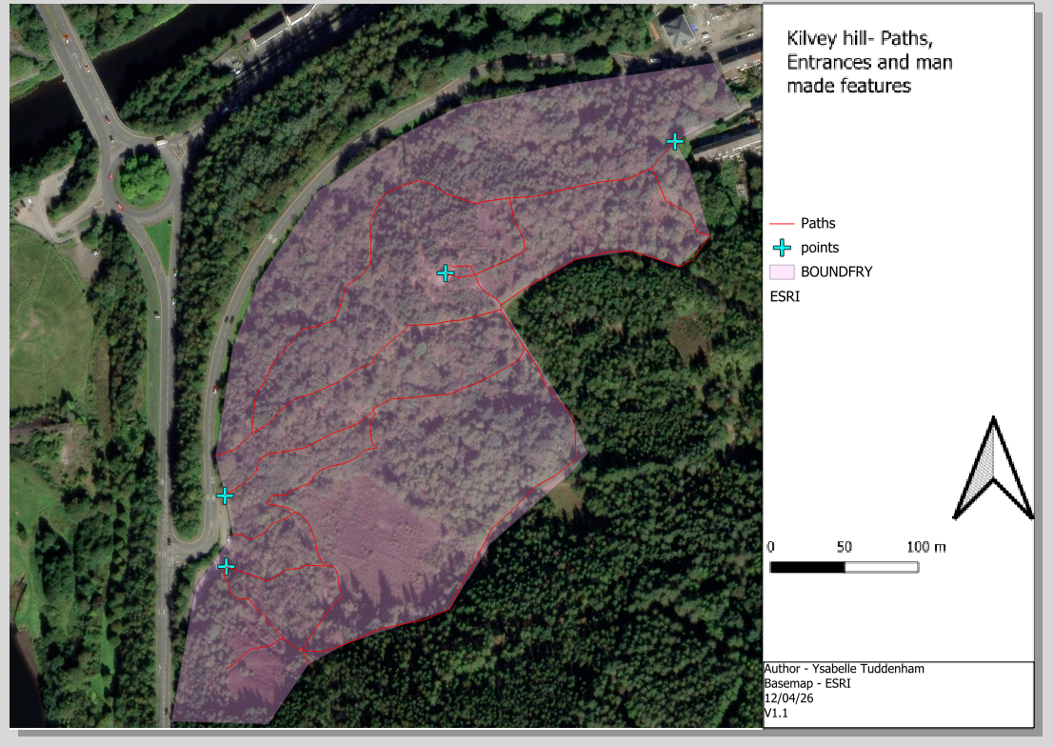

Lines
Line vector data was used within the GIS map to represent the paths across Kilvey Hill. Lines are used in GIS to map linear features by connecting multiple points together, allowing paths and routes to be displayed accurately across the landscape. Mapping the paths helped show access routes and movement through the site. Line data is useful because it can also store attribute information, helping organise and manage spatial features within the GIS. In habitat and landscape management, line data is important for understanding accessibility, site connectivity, and the relationship between different areas of the landscape (GemGIS, 2023).
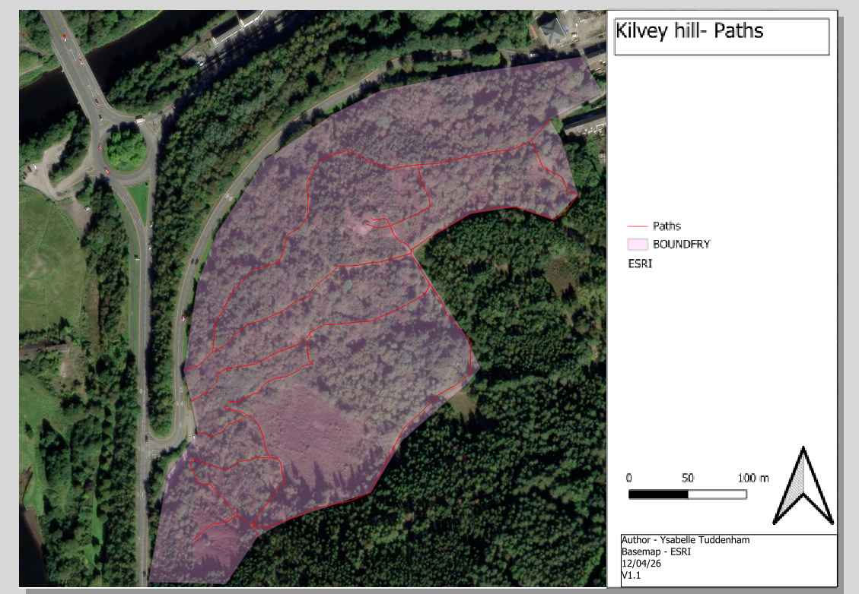

Polygons
Polygon vector data was used within the GIS map to represent the site boundary at Kilvey Hill. Polygons are created by connecting lines to form enclosed shapes, allowing areas to be mapped accurately within GIS. Using a polygon to map the site boundary helped define the extent of the study area and organise the spatial data collected throughout the project. Polygon data can also store attribute information linked to the mapped area. In habitat and landscape management, polygon data is useful for defining habitat areas, land use zones, and site boundaries for analysis and monitoring (Gimond, 2025).
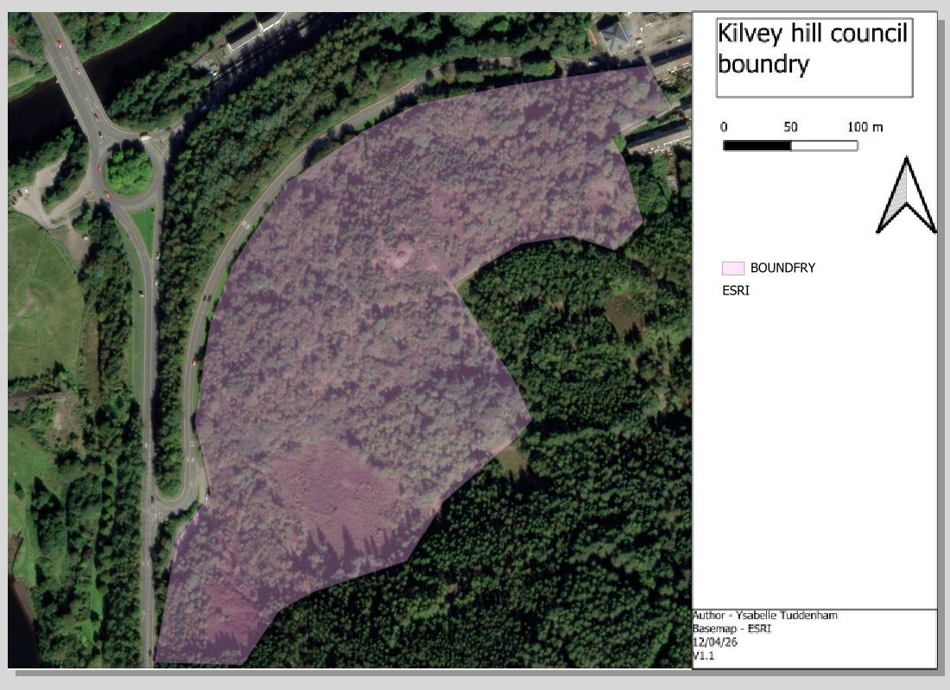

Raster
Raster data was used within the GIS project in the form of a Digital Surface Model (DSM) for Kilvey Hill. A DSM is a raster dataset made up of grid cells that store elevation values, showing the height of the Earth’s surface and features such as vegetation and buildings. The DSM helped show changes in elevation and topography across the site, providing a better understanding of the landscape structure and terrain. Raster datasets such as DSMs are useful in habitat and landscape management because they allow terrain, surface features, and environmental patterns to be analysed across large areas (ESRI, 2021).
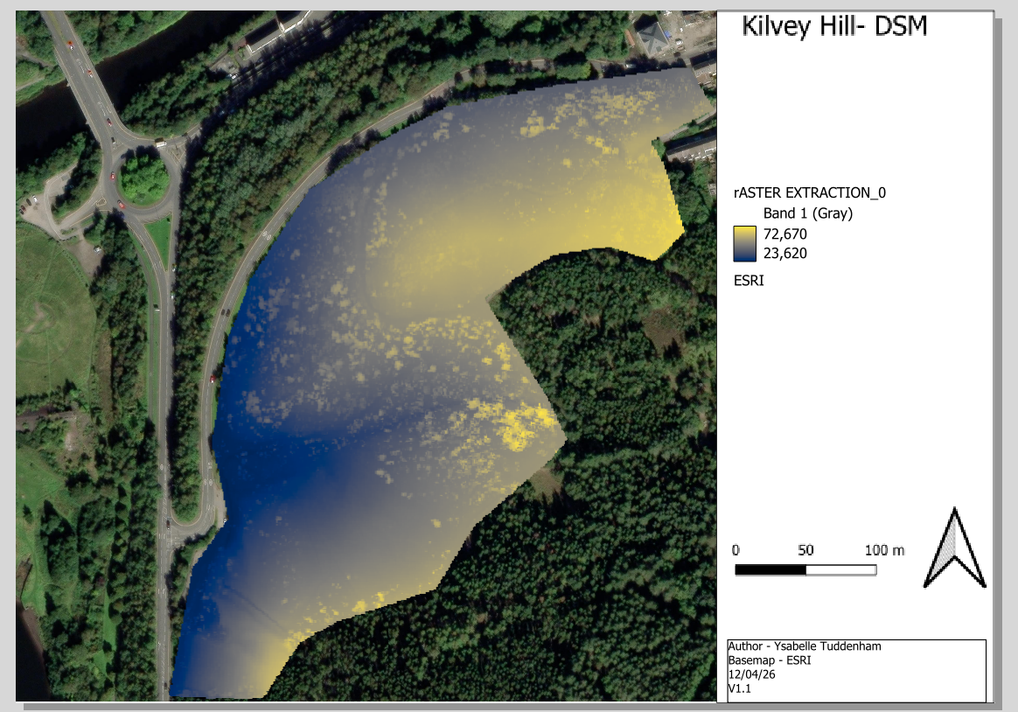

Discussion: GIS Mapping in Habitat Management
GIS mapping provides several advantages for habitat and landscape management. Vector data allows features such as paths, boundaries, and site features to be mapped accurately using points, lines, and polygons, while attribute tables allow additional information to be stored and organised efficiently. Raster data, including the DSM used in this project, is useful for showing continuous environmental information such as elevation and topography across large areas (EcoServants, 2024). Together, these datasets improve spatial analysis and visualisation within GIS. Compared to traditional methods such as Phase 1 Habitat Surveys, GIS mapping is generally faster and more efficient for collecting, storing, and updating environmental information(GISuser, 2025). Digital maps can be edited regularly, shared easily, and used for long-term monitoring. GIS also improves accessibility to spatial data and allows large areas to be analysed more quickly than manual mapping methods (Kim, 2025).
However, GIS mapping also has limitations. Accurate mapping depends on the quality and resolution of the data used, and GPS inaccuracies can affect precision in the field (Dhruwa and Garg, 2025). GIS software and high-quality datasets can also be expensive, while effective use of the technology requires specialist training and technical knowledge. Traditional methods such as Phase 1 Habitat Surveys still provide important ecological detail through direct field observation, which may not always be visible within GIS or remote sensing datasets(Cherrill and McClean, 1999). For this reason, GIS is most effective when used alongside traditional survey methods to support habitat management and environmental decision-making.

Summary
This component demonstrated how GIS digitisation can map features across Kilvey Hill using vector and raster data. Points, lines, and polygons represented landscape features, while the DSM added topographic detail. The process improved the organisation, analysis, and visualisation of spatial data, making environmental information easier to store and update than paper-based methods. However, accuracy depended on data quality and GPS precision, and GIS software required technical skills. Despite these limitations, GIS digitisation remains valuable for habitat and landscape management.

Component 2: spectral analysis

Introduction to Spectral Analysis
Spectral analysis is a remote sensing technique used to identify and analyse materials based on how they interact with electromagnetic radiation (Biology insights, 2025). The electromagnetic spectrum includes different wavelengths of energy, ranging from visible light to infrared and microwave radiation (The european space agency , no date). Remote sensing technologies detect these wavelengths to gather information about the Earth’s surface. When electromagnetic energy reaches a surface, some energy is reflected, some is absorbed, and some may be transmitted. Reflectance refers to the amount of energy reflected from a surface, while absorption is the amount of energy absorbed by that material. Different materials reflect and absorb energy differently depending on their physical and chemical properties. These differences create spectral signatures, which are unique patterns of reflectance and absorption across wavelengths. Spectral signatures allow different surface materials such as vegetation, soil, and water to be identified and analysed within remote sensing data. This makes spectral analysis useful for habitat mapping, environmental monitoring, and landscape management (NASA, 2010; Canada, 2025).

Methods
The spectroradiometer practical investigated the spectral reflectance characteristics of vegetation using leaf samples. A spectroradiometer measures the intensity of reflected electromagnetic radiation across a range of wavelengths, allowing the spectral properties of surfaces to be analysed. The practical focused primarily on wavelengths within the visible and near infrared (NIR) regions of the electromagnetic spectrum. These wavelengths are important in vegetation analysis because chlorophyll strongly absorbs red wavelengths while healthy vegetation reflects high levels of NIR radiation (votatera, 2024).
Fresh green leaves were used as the main sample surfaces during the practical. The spectral reflectance curves collected from the leaves demonstrated how vegetation interacts differently with electromagnetic radiation depending on its biochemical and structural properties. Differences in reflectance can be used to infer vegetation health, moisture content, and chlorophyll concentration. Data collection involved positioning the spectroradiometer above the leaf samples and recording reflected radiance across multiple wavelengths. The spectral measurements were then visualised as spectral reflectance curves to compare the response of the vegetation samples. Controlled lighting conditions were important to reduce variation in reflectance measurements.

Results
Spectral reflectance curves illustrate how different surfaces reflect electromagnetic radiation across varying wavelengths. The reflectance characteristics of a surface are influenced by its physical and chemical properties, resulting in unique spectral signatures that can be used for identification and classification.
Healthy vegetation exhibits a characteristic spectral reflectance pattern, with low reflectance in the blue and red regions due to chlorophyll absorption, moderate reflectance in the green region, and high reflectance within the Near Infrared (NIR) region caused by the internal structure of leaf cells. This distinctive response enables vegetation health and density to be assessed using remote sensing techniques and vegetation indices such as NDVI.
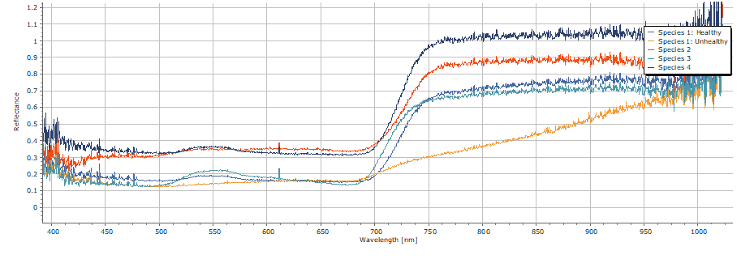
Figure 1. Spectral reflectance curve of healthy vegetation and unhealthy vegetation showing absorption and strong NIR reflectance (Tuddenham, 2026).
Unhealthy surfaces generally display smoother and more gradual reflectance curves compared to vegetation. Reflectance commonly increases with wavelength and varies according to moisture content, mineral composition, and organic matter. Healthy leaves typically exhibit higher reflectance values than unhealthy leaves.
Materials such as driftwood produce flatter spectral reflectance curves with less variation between visible and infrared wavelengths. Unlike vegetation, materials do not exhibit strong NIR reflectance, making urban surfaces distinguishable within multispectral imagery.
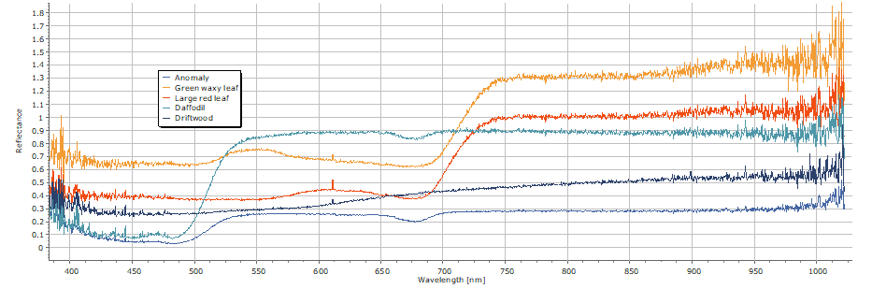
Figure 2. Spectral reflectance curve of surfaces compared with natural land cover types (Jeffries, 2026).
The comparison of spectral reflectance curves demonstrates how remote sensing can differentiate between vegetation, soil, water, and artificial surfaces. These spectral differences form the basis of land cover classification and environmental monitoring using Earth Observation imagery from sensors such as European Space Agency Sentinel-2 and NASA Landsat-8.

Interpretation of Spectral Signatures
Different materials reflect electromagnetic radiation differently because of their physical and chemical properties. This creates unique spectral reflectance signatures that can be used to identify surfaces in remote sensing (Climate change academy, 2025). Vegetation absorbs blue and red wavelengths through chlorophyll for photosynthesis, while reflecting green wavelengths, which is why plants appear green. Healthy vegetation also strongly reflects Near Infrared (NIR) radiation due to leaf cell structure (NASA, 2010a).
The NIR region is important because healthy vegetation reflects high amounts of NIR energy, whereas stressed vegetation reflects less. This makes NIR useful for monitoring vegetation health and biomass (Gutman, Skakun and Gitelson, 2021). Vegetation health can be measured using the Normalised Difference Vegetation Index (NDVI), which compares red and NIR reflectance values (DEFRA, 2024). Healthy vegetation produces high NDVI values because it absorbs red light and reflects NIR radiation. Moisture content also affects reflectance. Water absorbs much of the infrared spectrum, so wetter vegetation and soils usually have lower infrared reflectance values (Abhi, 2026).

Applications in Environmental Monitoring
Remote sensing and spectral analysis are widely used for environmental monitoring because different surfaces produce unique spectral reflectance signatures. Earth Observation imagery from sensors such as European Space Agency Sentinel-2 (European Space Agency, 2024) and NASA Landsat-8 (Landsat Project Science Support, 2023) allows large areas to be monitored consistently over time. Habitat monitoring is an important application of remote sensing (Corbane et al., 2015). On Christmas Island, Australia, multispectral imagery was used to assess habitat loss caused by phosphate mining and land clearing. Approximately 25% of the island’s original rainforest has been removed, contributing to declines in species such as the endangered Abbott’s booby (Papasula abbotti) (Christmas island national park, 2024).
Vegetation classification and forestry monitoring use differences in spectral reflectance to distinguish healthy vegetation, degraded vegetation, soil, and artificial surfaces. Healthy vegetation strongly reflects Near Infrared (NIR) radiation due to leaf cell structure, making NIR wavelengths useful for mapping forest cover and vegetation condition. In agriculture, remote sensing is used to monitor crop health, vegetation stress, and moisture content. Spectral indices such as NDVI compare red and NIR reflectance to identify vegetation condition and biomass (Chang et al., 2026).
Flood monitoring also benefits from spectral analysis because water absorbs large amounts of NIR radiation, allowing flooded areas to be distinguished from surrounding land. Similarly, wildfire assessment uses changes in vegetation reflectance and NDVI values to identify burned areas and evaluate environmental damage after fire events. The Christmas Island case study demonstrated how multi-temporal satellite imagery and NDVI differencing can detect vegetation loss and habitat change over time, highlighting the importance of remote sensing in environmental management and conservation (Bhargavi et al., 2025).

Critical Evaluation
Although remote sensing provides valuable environmental monitoring capabilities, there are several limitations that affect data quality and interpretation. Atmospheric interference can affect the accuracy of remotely sensed data because radiation recorded by satellite sensors may include both surface and atmospheric effects (Dubovik et al., 2021). Atmospheric particles, haze, and moisture can alter reflectance values and reduce image quality. Cloud cover is a major limitation of optical satellite imagery. Clouds, cloud shadow, and haze can obscure the Earth’s surface and introduce errors into spectral measurements and indices such as NDVI. Even low percentages of cloud cover may affect important areas of analysis (Han et al., 2024).
Spatial resolution also limits the ability to identify small features accurately. Mixed pixels occur when multiple surface types exist within a single pixel, reducing classification accuracy and detail (Lee, 2025). Temporal resolution is another important limitation because satellites revisit locations at fixed intervals. Rapid environmental changes may occur between image acquisitions, reducing the ability to monitor short-term events effectively. Sentinel-2 has a combined revisit period of approximately 5 days, while Landsat-8 revisits every 16 days(Blog Ongeo Intelligence, 2024). Equipment and data costs can also restrict remote sensing applications. Although some datasets are freely available, higher-resolution commercial imagery and specialist equipment such as spectroradiometers can be expensive (Kumar, Bassill and Rani, 2026).
Finally, remote sensing data interpretation can be complex. Spectral reflectance varies depending on surface composition, moisture, illumination conditions, and atmospheric effects, requiring specialist knowledge and processing techniques to interpret results accurately (ODonohue, 2024).

Summery
The practical showed how spectral analysis identifies differences in surface reflectance, especially in vegetation. Healthy leaves absorbed red wavelengths and reflected high Near Infrared (NIR) due to chlorophyll and leaf structure. Remote sensing supports habitat monitoring, vegetation mapping, agriculture, flood monitoring, and wildfire assessment using imagery such as Sentinel-2 and Landsat-8. The Christmas Island case study highlighted its use in monitoring habitat loss from phosphate mining and rainforest clearing. Limitations include cloud cover, atmospheric interference, resolution constraints, costs, and complex data interpretation.

Component 3: GIS field data collection

GIS Field Data Collection Methods
Field data was collected using the Mergin Maps mobile application, which allowed spatial data to be recorded directly in the field using GPS-enabled devices. The workflow involved preparing GIS layers before fieldwork, collecting data on site within the application, and synchronising the information back into the GIS project for analysis and map production. GPS collection methods were used to record the location of sample plots across Kilvey Hill. The application displayed live positioning during the survey, helping improve the accuracy of data collection and navigation around the site.The field survey followed a systematic approach by moving through accessible areas of the site and recording sampling locations digitally. Point data was used to map the pH sample plots, allowing each sampling location to be stored accurately within the GIS alongside associated environmental information. Using Mergin Maps improved the efficiency of field data collection because information could be recorded digitally in real time, reducing the need for manual recording and simplifying data transfer into GIS software. (Tutorial: Field surveys using Mergin Maps | OCWGIS, 2026)

Data Management and Processing
Spatial data collected during fieldwork were imported into GIS software for processing and analysis. Data layers, including field observations, GPS points, and environmental features, were added into the project and organised into separate thematic layers. This allowed different habitat and landscape features within Kilvey Hill to be visualised and analysed efficiently. Data cleaning and editing were carried out to improve accuracy and consistency. Errors such as duplicate records, missing values, and incorrectly positioned points were identified and corrected. Attribute tables were reviewed and updated to ensure that habitat descriptions, site observations, and classification information were complete and standardised. Effective attribute management improved the organisation of spatial data and supported accurate analysis and map production. Projection systems were also considered during processing to ensure that all datasets aligned correctly within the GIS environment. A consistent coordinate reference system was applied to maintain spatial accuracy and reduce positional errors between layers. Using a common projection system ensured reliable mapping, measurement, and spatial analysis throughout the project (CDC, 2024).

Results and Mapping Outputs
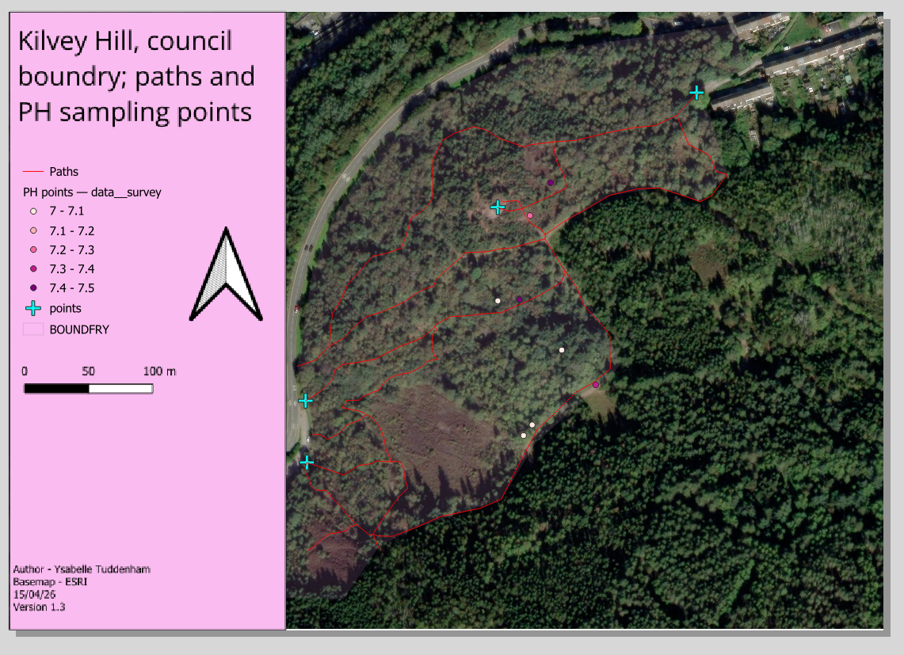
Map.5. a map showing paths, council boundary and Ph data points shown as continual data.

Desktop Digitisation vs Field Collection
GIS field data collection using Mergin Maps provided an effective way to record spatial information across Kilvey Hill. GPS methods improved field accuracy by allowing sample locations to be recorded directly on site, although accuracy could still be affected by vegetation cover and signal quality. The digital workflow was time efficient because data could be collected and synchronised automatically, reducing the need for manual data entry(Kushwaha, 2025). Mergin Maps also improved accessibility by allowing spatial data to be viewed and edited easily during fieldwork. The method was generally reliable as information was stored digitally within the GIS project, reducing transcription errors. However, practical limitations included battery life, weather conditions, and the need for technical knowledge to use the software effectively. Some features were digitised remotely using aerial imagery because they could be identified clearly without field verification, improving efficiency. In contrast, sample plot locations were collected in the field because accurate positioning required direct site investigation. Combining both methods improved the overall quality of the GIS dataset (Locate press, 2024).

Role of GIS in Site Management
GIS plays an important role in site management by supporting conservation planning, habitat monitoring, and environmental decision-making. Spatial data allows important habitats and environmental features to be identified, helping managers prioritise areas for protection or restoration(EcoServants, 2025). GIS also supports habitat monitoring by allowing environmental change to be tracked over time through updated maps and spatial datasets. Changes in vegetation, land use, and habitat condition can be monitored more efficiently than with traditional paper-based methods. In infrastructure planning, GIS helps assess how developments such as paths, roads, or buildings may affect surrounding habitats and landscapes. This supports more sustainable planning and reduces environmental impacts (Team Harbinger Content, 2025). GIS is also valuable for ecological surveys because field data can be collected, stored, and analysed accurately within one system. Survey locations and environmental observations can be mapped clearly and updated when required. For long-term management, GIS provides an organised and reliable method for storing environmental information, supporting ongoing monitoring, future planning, and conservation management (Nowak et al., 2020).

Critical Evaluation
Although GIS field data collection provides many advantages, there are several limitations that can affect the accuracy and reliability of results. GPS accuracy may be reduced by dense vegetation, uneven terrain, or weak satellite signals, causing recorded locations to be less precise. Weather conditions such as rain, fog, and strong wind can also make fieldwork more difficult and reduce the quality of data collected on site. Survey bias is another limitation because the data collected can depend on the experience of the surveyor and which areas of the site are accessible during fieldwork. Some features may be missed or recorded inconsistently (Pascual, 2022). There are also technical limitations linked to the use of digital devices and GIS software. Battery life, software errors, poor mobile signal, and device performance can all disrupt field data collection and reduce efficiency. In addition, GIS software requires technical knowledge and training to use effectively. Despite these limitations, GIS remains a valuable tool for habitat and landscape management. However, GIS is most effective when used alongside traditional surveying methods rather than replacing them completely, as direct field observation still provides important ecological information and site knowledge (Lee, 2025a).

Summery
Field GIS proved to be an effective method for collecting and managing spatial data across Kilvey Hill. Using Mergin Maps improved the efficiency of recording sample locations and allowed data to be stored digitally for analysis within GIS software. The method provided practical value by improving organisation, accessibility, and long-term monitoring of environmental information. However, there were limitations, including GPS accuracy issues, weather conditions, device dependence, and the need for technical knowledge to operate the software effectively. Despite these challenges, field GIS remains a valuable tool that works best alongside traditional ecological surveying methods.

Conclusion
This portfolio successfully demonstrated the application of GIS and remote sensing technologies in habitat and landscape management using Kilvey Hill as the study site. Across the three components, GIS digitisation, spectral analysis, and field-based data collection methods were used to investigate environmental features and spatial relationships within the landscape.
The portfolio demonstrated how vector and raster datasets can be used to map and visualise environmental information effectively. Points, lines, and polygons allowed key landscape features to be represented accurately, while the DSM raster layer provided additional understanding of topography and surface variation across the site. Remote sensing and spectral analysis also showed how reflectance patterns can be used to identify and monitor environmental features and habitat conditions. In addition, field GIS methods using Mergin Maps demonstrated how spatial data can be collected efficiently and integrated directly into GIS software for analysis and management.
Overall, the portfolio highlighted the usefulness of GIS technologies for environmental mapping, monitoring, and decision-making. GIS improves the organisation and storage of spatial information while allowing environmental change to be monitored over time. These technologies also support conservation planning, habitat assessment, and infrastructure management by providing accurate visual representations of landscapes and environmental features. Compared to traditional paper-based methods, GIS is generally faster, more efficient, and easier to update, making it valuable for long-term environmental management.
However, the portfolio also identified several limitations and barriers associated with GIS and remote sensing technologies. The accuracy of GIS analysis depends heavily on the quality and resolution of the spatial data used, meaning poor-quality datasets can reduce reliability. GPS accuracy may also be affected by vegetation cover, terrain, and signal limitations during fieldwork. Technical issues such as software errors, battery life, and device performance can further affect field data collection.
There are also financial and practical barriers to the use of GIS technologies. High-quality software, specialist equipment, and commercial datasets can be expensive, while effective use of GIS requires technical skills and training. As a result, these technologies may not always be accessible to smaller organisations or projects with limited resources. Despite these limitations, the portfolio demonstrated that GIS and remote sensing are highly valuable tools for habitat and landscape management. However, they are most effective when used alongside traditional ecological surveying methods rather than replacing them entirely, as direct field observation remains essential for collecting detailed ecological information and validating spatial data.

References
Abhi (2026) Spectral Reflectance of Vegetation, Soil and Water, Scribd. Available at: https://www.scribd.com/presentation/438578619/Spectral-Reflectance-of-Vegetation-Soil-and-Water (Accessed: 15 May 2026).
Bhargavi, K., Roy, D., Nakkeeran, G. and Reddy, N.G. (2025) ‘A review of remote sensing and GIS applications in flood monitoring and management’, Sādhanā, 50(4). Available at: https://doi.org/10.1007/s12046-025-02971-z.
Biology insights (2025) Advancements in Spectral Analysis and Its Applications, BiologyInsights. Available at: https://biologyinsights.com/advancements-in-spectral-analysis-and-its-applications/.
Blog Ongeo Intelligence (2024) What Is Temporal Resolution in Earth Observation?, OnGeo | Intelligence. Ongeo Intelligence. Available at: https://ongeo-intelligence.com/blog/temporal-resolution-in-satellite-earth-observation# (Accessed: 15 May 2026).
Calka, B. and Szostak, M. (2025) ‘GIS-Based Environmental Monitoring and Analysis’, Applied Sciences, 15(6), p. 3155. Available at: https://doi.org/10.3390/app15063155.
Canada, N.R. (2025) Radiation - Target Interactions - Natural Resources Canada, Canada.ca. Available at: https://natural-resources.canada.ca/maps-tools-publications/satellite-elevation-air-photos/radiation-target-interactions.
CDC (2024) Geographic Information System Data, Field Epidemiology Manual. Available at: https://www.cdc.gov/field-epi-manual/php/chapters/gis-data.html.
Chang, B., Lim, W., Ko, D.W., Kang, W. and Cheon, K. (2026) ‘Enhanced forest monitoring through mapping with integrated seasonal canopy and spectral reflectance features’, Frontiers in Forests and Global Change, 9. Available at: https://doi.org/10.3389/ffgc.2026.1768700.
Cherrill, A. and McClean, C. (1999) ‘The reliability of “Phase 1” habitat mapping in the UK: the extent and types of observer bias’, Landscape and Urban Planning, 45(2), pp. 131–143. Available at: https://doi.org/10.1016/S0169-2046(99)00027-4.
Christmas island national park (2024) History | Christmas Island National Park | Parks Australia, Christmasislandnationalpark.gov.au. Available at: https://christmasislandnationalpark.gov.au/discover/history/.
Classification Algorithms and Methods (no date) seos-project.eu. Available at: https://seos-project.eu/classification/classification-c01-p05.html.
Climate change academy (2025) Spectral Signatures: Identifying Earth’s Features • Climate Change Academy, Climate Change Academy. Available at: https://climatechange.academy/climate-change-assessment-tools/spectral-signatures-identifying-earth-features/.
Corbane, C., Lang, S., Pipkins, K., Alleaume, S., Deshayes, M., García Millán, V.E., Strasser, T., Vanden Borre, J., Toon, S. and Michael, F. (2015) ‘Remote sensing for mapping natural habitats and their conservation status – New opportunities and challenges’, International Journal of Applied Earth Observation and Geoinformation, 37, pp. 7–16. Available at: https://doi.org/10.1016/j.jag.2014.11.005.
DEFRA (2024) Defra Data Services Platform, Data.gov.uk. Available at: https://environment.data.gov.uk/dataset/dca6a441-cbf0-4955-90fa-120aa2cca8d1# (Accessed: 15 May 2026).
Dempsey, C. (2022) Types of GIS Data Explored: Vector and Raster, Geography Realm. Available at: https://www.geographyrealm.com/geodatabases-explored-vector-and-raster-data/.
Dhruwa, L. and Garg, P.K. (2025) ‘Accuracy assessment of selected contemporary geospatial tools for real world mapping’, Survey Review, pp. 1–17. Available at: https://doi.org/10.1080/00396265.2025.2465920.
Dinkins, P. (2024) Vector Geometry Types, GISDATA.io Docs. Parker Dinkins. Available at: https://docs.gisdata.io/vector-geometry-types.html.
Dubovik, O., Schuster, G.L., Xu, F., Hu, Y., Bösch, H., Landgraf, J. and Li, Z. (2021) ‘Grand Challenges in Satellite Remote Sensing’, Frontiers in Remote Sensing, 2. Available at: https://doi.org/10.3389/frsen.2021.619818.
EcoServants (2024) Conservation GIS: The Effective Use of Geographic Information Systems in Environmental Conservation – EcoServants®, EcoServants®. Available at: https://ecoservantsproject.org/conservation-gis-the-effective-use-of-geographic-information-systems-in-environmental-conservation/# (Accessed: 14 May 2026).
EcoServants (2025) ‘Conservation GIS: The Effective Use of Geographic Information Systems in Environmental Conservation | EcoServants’, Ecoservantsproject.org [Preprint]. Available at: https://doi.org/1086113/et-core-unified-tb-1084457-deferred-1086113.
ESRI (2021) What is raster data?—ArcMap | Documentation, desktop.arcgis.com. Available at: https://desktop.arcgis.com/en/arcmap/latest/manage-data/raster-and-images/what-is-raster-data.htm.
ESRI (2024) What is GIS? | Geographic Information System Mapping Technology, Esri.com. ESRI. Available at: https://www.esri.com/en-us/what-is-gis/overview.
European Space Agency (2024) Sentinel-2, www.esa.int. Available at: https://www.esa.int/Applications/Observing_the_Earth/Copernicus/Sentinel-2.
GemGIS (2023) What is vector data? — GemGIS - Spatial data processing for geomodeling, Readthedocs.io. Available at: https://gemgis.readthedocs.io/en/latest/getting_started/whatiswhat/vector.html (Accessed: 14 May 2026).
Gimond, M. (2025) Chapter 2 Feature Representation | Intro to GIS and Spatial Analysis, mgimond.github.io. Available at: https://mgimond.github.io/Spatial/chp02_0.html.
gisnavigator (2024) Understanding Vector Data in GIS: A Comprehensive Guide, GIS Navigator. Available at: https://gisnavigator.co.uk/vector-data-in-gis/.
GISuser (2025) Key Methods of Analysis in GIS: A Complete Guide - GIS user technology news, GIS user technology news. Available at: https://gisuser.com/2025/09/key-methods-of-analysis-in-gis-a-complete-guide/.
Gutman, G., Skakun, S. and Gitelson, A. (2021) ‘Revisiting the use of red and near-infrared reflectances in vegetation studies and numerical climate models’, Science of Remote Sensing, 4, p. 100025. Available at: https://doi.org/10.1016/j.srs.2021.100025.
Han, H., Liu, Z., Li, J. and Zeng, Z. (2024) ‘Challenges in remote sensing based climate and crop monitoring: navigating the complexities using AI’, Journal of cloud computing (Heidelberg), 13(1). Available at: https://doi.org/10.1186/s13677-023-00583-8.
Hou, W., Zhang, J., Peng, Z. and Walz, U. (2025) ‘Assessing habitat fragmentation in highly urbanized area: Implications for mitigating landscape dissection and habitat restoration’, International Journal of Applied Earth Observation and Geoinformation, 139, p. 104557. Available at: https://doi.org/10.1016/j.jag.2025.104557.
Jeffries, I. (2026) spectrometer reflectance graph.
Kilvey Hill Walking Route (no date) www.gps-routes.co.uk. Available at: https://www.gps-routes.co.uk/routes/home.nsf/RoutesLinksWalks/kilvey-hill-walking-route.
Kilvey Hill woodland volunteers (2026) Kilvey Hill, Kilveyhill.co.uk. Available at: https://www.kilveyhill.co.uk/ (Accessed: 13 May 2026).
Kim, J. (2025) Digital Mapping: The Future of Geographic Data & GIS Mapping Explained, GeoComm. Available at: https://www.geocomm.com/digital-mapping-guide-using-gis-data/.
Kumar, D., Bassill, N.P. and Rani, K. (2026) ‘Challenges and Future Trends of Data Analytics and Remote Sensing Based Analysis for Sustainable Development’, Advances in Science, Technology & Innovation/Advances in science, technology & innovation, pp. 175–187. Available at: https://doi.org/10.1007/978-3-031-98095-4_13.
Kushwaha, R. (2025) Global Positioning System in Surveying – Applications, Benefits, and Accuracy - Civil Tutorials, Civil Tutorials. Available at: https://civiltutorials.com/global-positioning-system-in-surveying/#google_vignette (Accessed: 15 May 2026).
Landsat Project Science Support (2023) Landsat 8, NASA Science. Available at: https://science.nasa.gov/mission/landsat-8/.
Lee, S. (2025a) Mastering Field Data Collection in GIS, Numberanalytics.com. Available at: https://www.numberanalytics.com/blog/ultimate-guide-field-data-collection-gis (Accessed: 15 May 2026).
Lee, S. (2025b) The Impact of Spatial Resolution on Geospatial Analysis, Numberanalytics.com. Available at: https://www.numberanalytics.com/blog/impact-spatial-resolution-geospatial-analysis.
Locate press (2024) Collecting Field Data with QGIS and Mergin Maps, Locatepress.com. Available at: https://locatepress.com/book/mergin-maps.
Mir Muhammad Nizamani, Zhang, Q., Ghulam Muhae-Ud-Din, Muhammad Awais, Qayyum, M., Farhan, M., Muhammad Jabran and Wang, Y. (2023) ‘Application of GIS and Remote-Sensing Technology in Ecosystem Services and Biodiversity Conservation’, CRC Press eBooks, pp. 284–321. Available at: https://doi.org/10.1201/9781032646268-12.
Mostafa, A.R., Owes, A.M. and Ghoniem, S.A. (2025) ‘Interconnected impacts of climate change on biodiversity, agriculture and human health.’, Advances in Basic and Applied Sciences, 4(1), pp. 43–63. Available at: https://doi.org/10.21608/abas.2025.362577.1059.
NASA (2010a) Reflected Near-Infrared Waves - NASA Science, science.nasa.gov. Available at: https://science.nasa.gov/ems/08_nearinfraredwaves/.
NASA (2010b) Wave Behaviors | Science Mission Directorate, science.nasa.gov. NASA. Available at: https://science.nasa.gov/ems/03_behaviors/.
NASA Earth Observatory (1999) Remote Sensing, NASA Science. Available at: https://science.nasa.gov/earth/earth-observatory/remote-sensing/.
Nowak, M.M., Dziób, K., Ludwisiak, Ł. and Chmiel, J. (2020) ‘Mobile GIS applications for environmental field surveys: A state of the art’, Global Ecology and Conservation, 23, p. e01089. Available at: https://doi.org/10.1016/j.gecco.2020.e01089.
ODonohue, D. (2024) Understanding Spectral Reflectance In Remote Sensing - February 15, 2025, mapscaping.com. Available at: https://mapscaping.com/understanding-spectral-reflectance-in-remote-sensing/.
Pangtey, D., Kumar, M. and Padalia, H. (2025) ‘Pixel to Preservation: Harnessing Remote Sensing and GIS for Biodiversity Conservation’, Biodiversity Conservation and Land Degradation Neutrality, pp. 89–103. Available at: https://doi.org/10.1007/978-981-96-7210-3_6.
Pascual, M.S. (2022) GIS Data: A Look at Accuracy, Precision, and Types of Errors, Geography Realm. Available at: https://www.geographyrealm.com/gis-data-a-look-at-accuracy-precision-and-types-of-errors/.
QGIS (2026) 3. Vector Data — QGIS Documentation documentation, Qgis.org. Available at: https://docs.qgis.org/3.44/en/docs/gentle_gis_introduction/vector_data.html.
Rosen, D. and Dumayne-Peaty, L. (2001) ‘Human impact on the vegetation of South Wales during late historical times: palynological and palaeoenvironmental results from Crymlyn Bog NNR, West Glamorgan, Wales, UK’, The Holocene, 11(1), pp. 11–23. Available at: https://doi.org/10.1191/095968301668586235.
Team Harbinger Content (2025) 4 Strategies for Effective GIS Mapping for Habitat Conservation, Harbingerland Blog. Available at: https://blog.harbingerland.com/4-strategies-for-effective-gis-mapping-for-habitat-conservation/ (Accessed: 15 May 2026).
The european space agency (no date) The electromagnetic spectrum, www.esa.int. Available at: https://www.esa.int/Science_Exploration/Space_Science/Integral/The_electromagnetic_spectrum.
Tuddenham, Y. (2026) Typical leaf spectral reflectance curve across visible and infrared wavelengths .
Tutorial: Field surveys using Mergin Maps | OCWGIS (2026) Gisopencourseware.org. Available at: https://courses.gisopencourseware.org/mod/book/tool/print/index.php?id=15 (Accessed: 15 May 2026).
USGS (2025) What Is Remote Sensing and What Is It Used for?, www.usgs.gov. USGS. Available at: https://www.usgs.gov/faqs/what-remote-sensing-and-what-it-used.
votatera (2024) Spectroradiometers | Precision, Earth Study & Data, Modern Physics Insights: Discover, Understand, Innovate. Available at: https://modern-physics.org/spectroradiometers/ (Accessed: 14 May 2026).

