Reflections from Carmarthen Museum

Alison Evans Autumn 2025
The rain clung in droplets to my fringe. My hair tapped my forehead in the wind releasing a cold dribble down my face. Hardly an inspiring start to my day let alone a 3 year degree journey.
Students huddled together in groups of twos and threes, some under small umbrellas but most just accepting the rain which could not decide to fall downwards or be pushed sideways. The sort of rain I had become accustomed to in my 24 years of living here. The sort of rain that seeps and bleeds into each crevice and leaves dampness that no amount of radiator drying can rectify.
The lecturer his hood up showing little care for our discomfort continued to speak. “ So the day is yours, make sure you take the time to notice, listen and observe, what do you see and hear ….artefacts….exhibits…..welsh life….cafe” he chuckled at the last remark about sandwiches and coffee and my attention returned momentarily. It was a rhetoric no doubt said a thousand times before about observation and learning, 5 hours of site visit to the little welsh museum that housed a myriad of odd collections.
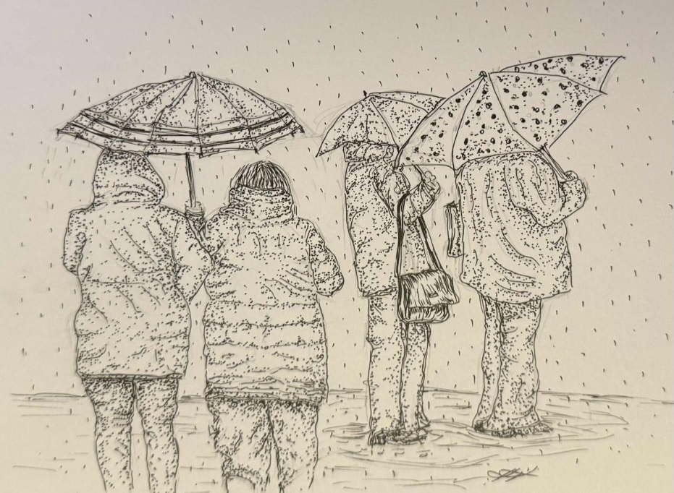
I knew this because I had visited so many times with my children on precisely days like this: a form of free entertainment on rainy days, and on sunny days, the rambling garden that grew some huge specimen trees and provided a natural playground for us all.
After some more guidance we moved off towards the building walking around its soggy exterior and into the main entrance. Its old wood wormed doors now replaced with the modern glass etched panels that promise a bright warm experience. We crowded in, dripping around the shop displays, neatly laid out on a central table. I felt oppressed, all those wet people. I hung back waiting, wanting some space to gather my thoughts.
Museums are full of ghosts. There is a reverence I have always felt. Exhibits have souls, long gone but somehow lingering, an almost magical quality that deserves politeness and respect.
I closed my eyes I could hear my children and smell their hair. Little faces, the younger ones excited the older ones patiently bored, allowing the expedition to continue with the knowledge that they would be rewarded with a toy from the shop and possibly an ice cream. Little rewards for my adult sanity.
Now, today I had left my adult role at home. I am the learner the eager participant, a student of humanities, a student of humanity.
Walking into the grand hall I always marvelled at the staircase, a magnificent structure overpowering the room. The stair rises are so shallow and the step so wide the ladies of the day would have found the assent and descent much easier in their wide gowns and high shoes. No gold or ornate decor bestowed on the banisters, more the dark wood and simple carving on the newels that I thought most Welsh.
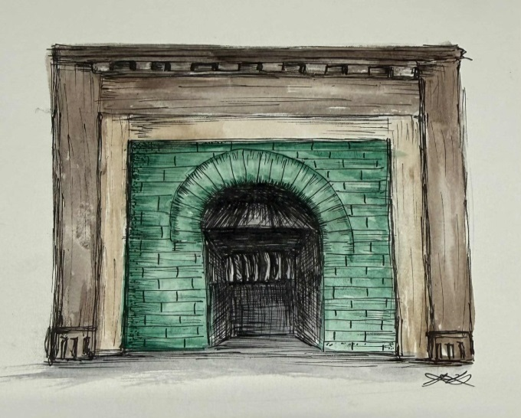
The disappointment of the fireplace always irritated me. Incongruous green glazed bricks that could have come from a 1930s council house. No grandiosity here.
Of course, the baby grand piano is still in its place, as it has been for the 24 years I had known it. Maybe it has not moved in many more decades. When was the last time its light notes filled the air and dancing or singing echoed around: a Christmas party or maybe a ball. The laughter and merriment, of my fancy, fades. Was it always tuneless and dead?
Picton’s freeze on the left gable end brings sadness to this room: ghosts of imperialism, the monstrous cruelty he inflicted on the innocent. The time honoured battle depictions. the clever labour of the carvers, stonemasons never recognised. Did they know? Were they proud? Were they rewarded?
I gently climb the stairs to leave the oppressed room behind, floating my fingers on the banister rail with the lightest touch, as if a heavy hand would block any feelings the old world and the old wood might communicate to me I’m no surer I believe in vibrations than I do in ghosts.
I’m literally on the up, I tell myself.
I had certainly felt blundering during my first week’s lectures at University. What was I doing? 56 years old with my career behind me now putting myself forward for ….what? A foolish adventure, an academic test, a life’s ambition? I chose to do this? Certainly, a journey but I yet had to find what, if any, my destination may be.
The stairs reached the landing, levelling out, leading to the right. My feet fell softly onto modern office carpet, hardwearing and unremarkable, but clean. White walls, a body of windows on the right with modern blinds supposedly to keep natural light to a minimum to protect exhibits from the damages of UV light. Two modern blue office chairs were placed under the windows; a radiator ran along the wall and ended next to an empty glass cabinet.
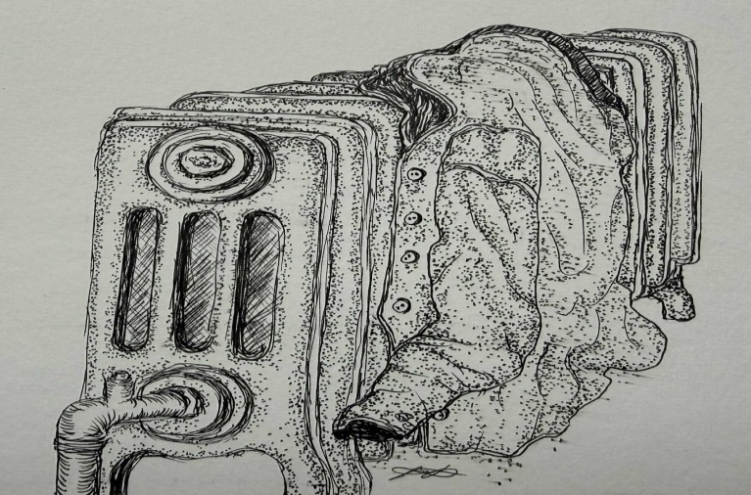
I took off my coat and hung it on the radiator and placed my bag on the chair next to me. I sat for a minute and stared ahead at the wall of glass reflecting back at me. Two large cabinets to ceiling height about 2 ft wide and a foot deep divided by a modern de humidifier. Of course this is Wales and the damp, oh yes, the damp, was an enemy to precious objects and humans alike.
Students shuffled past in a little group talking excitedly, “look there, Eeew! Can you imagine what that was like?” and “did you find clue 4? I think it’s the pistols” like my kids once did: the buzz of a first year field trip lifting in the air like the notes of the piano and fading gently away.
An old couple walked slowly into another room. They looked like they were married but maybe they weren’t; maybe they were on a date, a clandestine affair, lovers from long ago meeting after 50 years and rekindling their passion. Maybe like me they needed the museum to house their emotions, their thoughts: in a safe house, a house of ghosts and protectors, a house of the past that can promise a future.
This was where I wanted to be, this was my place.

Illustrations kindly provided with full permissions by Kara Hughes currently studying fine art at USWC. (October 22 2025)

