

Independent Project: The Impact of Technology Adoption on Business Efficiency in UK Small and Medium- Sized Enterprises.

Dissertation

Created by: Vladimir Stoyanov (2219021)
Module Code: LCBB6014
Lecturer’s name: Dr Anupam Mazumdar

1. Introduction

1.1 Background of the study

Digital technology has gained paramount significance in the operational, competitive, and decision-making processes of contemporary businesses. Technologies such as cloud computing, Enterprise Resource Planning (ERP) systems, artificial intelligence (AI), automation, and data analytics enable businesses to optimise processes, enhance information accessibility, and facilitate more effective utilisation of organisational resources. For small and medium-sized enterprises (SMEs), these competencies are especially crucial as smaller companies sometimes function with more limited financial, technological, and human resources compared to bigger entities. Investigations on SME digitalisation thus link the deployment of technology to enhancements in innovation, competitiveness, and organisational efficacy (Radicic, 2023; Parra-Sánchez, 2024).

Small and medium-sized enterprises constitute a significant element of the United Kingdom's economy, rendering their technical advancement pertinent both at the organisational level and to overall national production. Recent research conducted by the UK Government has focused on the integration of productivity-boosting digital technologies into SMEs and has pinpointed variations in the phases enterprises undergo while contemplating, implementing, and utilising technology (Department for Business and Trade, 2025). The sustained emphasis on policy is evidenced by the SME Digital Adoption Taskforce, which, in its 2025 final report, recommended strategies aimed at augmenting SME utilisation of productivity-boosting digital technologies, succeeded by an additional governmental update in 2026 (Department for Business and Trade, 2025; 2026).

The implementation of technology can yield numerous efficiency advantages for small and medium-sized enterprises. Cloud-based solutions can diminish dependence on substantial physical IT frameworks; however integrated enterprise systems can enhance information dissemination across organisational functions. Automation has the potential to diminish monotonous administrative tasks, while data analytics can facilitate more evidence-driven managerial decisions. Digitalisation might consequently influence organisational efficiency via multiple interrelated mechanisms instead of relying on a singular technology or procedure (Radicic, 2023; Parra-Sánchez, 2024).

Artificial intelligence is progressively gaining significance in organisational technology plans. Data from UK companies suggests that the adoption of AI is influenced by organisational traits and managerial practices, with businesses encountering diverse motivators and obstacles in their implementation efforts (Office for National Statistics, 2025). This underscores the need of analysing technology adoption not merely by the presence of technology in firms, but also by how organisational competencies affect its efficient use.

Nonetheless, the implementation of technology does not inherently result in increased efficiency. Small and medium-sized enterprises may have monetary limitations, inadequate digital competencies, challenges in execution, and ambiguity concerning the advantages of specific technology. The research conducted by the Department for Business and Trade on UK SMEs reveals deficiencies in information throughout the technology-adoption process, while ongoing studies persist in uncovering organisational and capability-related obstacles to digital innovation (Department for Business and Trade, 2025; Xu, 2026). Thus, the correlation between technology adoption and corporate efficiency necessitates empirical examination instead of presuming that increased digitalisation invariably yields superior organisational results.

This dissertation investigates the influence of technology implementation on operational efficiency within UK SMEs. Special emphasis is placed on operational efficiency, employee productivity, and organisational decision-making, in alignment with the factors outlined in the initial research proposal.

1.2 Research Problem

Despite the considerable prospects presented by digital transformation, the assimilation of technology varies significantly among small and medium-sized enterprises. Lesser enterprises can vary significantly in their fiscal resources, administrative methodologies, workforce competencies, and technology preparedness. UK data further suggests that management practices correlate with variations in technology and AI use, illustrating that organisational elements can affect how companies interact with technological advancements (Office for National Statistics, 2025).

Moreover, technology is advancing at an accelerated pace. Cloud services, artificial intelligence, automation, and sophisticated analytics are becoming more readily available, indicating that previous data may not accurately reflect the current technology landscape faced by small and medium enterprises. Recent governmental initiatives regarding the digital adoption by SMEs further illustrate that strengthening the utilisation of productivity-boosting technologies continues to be a pertinent policy issue in the UK (Department for Business and Trade, 2025; 2026).

This dissertation investigates whether the adoption of technology correlates with significant enhancements in company efficiency among UK SMEs, especially with operational procedures, employee productivity, and organisational decision-making.

1.3 Research Aim

The aim of this study is:

To examine the impact of technology adoption on business efficiency in small and medium-sized enterprises (SMEs) in the United Kingdom.

1.4 Research Objectives

The study has four objectives:

1. To identify the types of digital technologies commonly adopted by SMEs in the UK.
2. To evaluate the impact of technology adoption on operational efficiency within SMEs.
3. To analyse the relationship between technology usage and employee productivity.
4. To provide recommendations to improve technology adoption among UK SMEs.

1.5 Research Questions

The research addresses the following questions:

- What types of technologies are commonly adopted by SMEs in the UK?
2. How does technology adoption influence operational efficiency in SMEs?
3. What is the relationship between technology adoption and employee productivity?
4. To what extent does technology adoption improve business efficiency?

  - Research Hypotheses

Consistent with the quantitative approach established in the proposal, the study investigates the following hypotheses:

H1: Technology adoption has a significant positive impact on business efficiency in UK
SMEs.
H2: The adoption of digital technologies improves operational efficiency in SMEs.
H3: Technology adoption has a positive relationship with employee productivity.
H4: Digital technologies enhance decision-making processes within SMEs.

The corresponding null hypothesis assumes that technology adoption has no statistically significant impact on business efficiency.

1.7 Theoretical Foundation

This study is grounded in two well-established theories: the Technology Acceptance Model (TAM) and the Diffusion of Innovation Theory (DOI). TAM suggests that the acceptability of technology is significantly affected by its perceived utility and perceived user-friendliness (Davis, 1989). These ideas are pertinent as employes tend to interact more efficiently with technologies they perceive as beneficial for their tasks and relatively simple to use.

The Diffusion of Innovation Theory enhances the Technology Acceptance Model by examining how the traits of innovations affect their acceptance across individuals and organisations (Rogers, 2003). The two theories were chosen in the sanctioned proposal to offer supplementary viewpoints on personal acceptance and broader organisational technology implementation.

1.8 Significance of Study

This research possesses both scholarly and practical significance. This study enhances ongoing research on SME digital transformation by analysing technology adoption in relation to many aspects of company effectiveness. This is significant since recent studies indicate that the digital transformation of SMEs continues to be a vibrant and evolving field of scholarly inquiry (Parra-Sánchez, 2024).

In practical terms, the study could assist SME managers in comprehending the connection between digital technologies and operational efficiency, productivity, and decision-making. The subject possesses policy significance since enhancing digital technology uptake among SMEs continues to be a clear priority of UK Government initiatives (Department for Business and Trade, 2025; 2026).

1.9 Dissertation Structure

The thesis is comprised of five sections. Chapter 1 presents the research issue, purpose, goals, enquiries, and hypotheses. Chapter 2 provides a critical analysis of literature related to technology adoption, digital transformation, corporate efficiency, and the theoretical framework. Chapter 3 elucidates and rationalises the research technique. Chapter 4 elucidates, examines, and deliberates on the research outcomes in connection with the literature and hypotheses. Ultimately, Chapter 5 presents the conclusions, recommendations, constraints, and proposals for subsequent research.

2. Literature Review

2.1 Introduction

The integration of technology has grown progressively vital for the efficacy, competitiveness, and enduring viability of small and medium-sized organisations (SMEs). Digital technology can assist companies by automating repetitive tasks, enhancing communication, bolstering information accessibility, and expediting management decision-making. Contemporary studies link digitisation to innovation and enhanced performance in SMEs, however the degree of these advantages is contingent upon organisational competencies and the environment of technology implementation (Radicic, 2023; Soomro et al., 2024).

The UK Government has recognised the digital adoption of SMEs as a significant productivity concern. The SME Digital use Taskforce was formed to investigate methods for assisting smaller enterprises in the use of productivity-boosting technology, and its conclusive report outlined a 10-step action plan aimed at promoting digital adoption within UK SMEs (Department for Business and Trade, 2025). Recent governmental efforts have perpetuated this initiative, indicating that the digitisation of SMEs is still a pertinent policy problem in the UK rather than a settled matter (Department for Business and Trade, 2026).

This section thoroughly examines the existing literature on technology adoption and organisational effectiveness. Special emphasis is placed on digital transformation, cloud computing, Enterprise Resource Planning (ERP) systems, artificial intelligence (AI), automation, data analytics, employee productivity, and the obstacles that could hinder successful implementation. The chapter then explores the Technology Acceptance Model (TAM) and Diffusion of Innovation Theory (DOI), pinpoints the research need, and formulates the conceptual framework for the dissertation.

2.2 Technology Adoption in SMEs

The assimilation of technology can be defined as the procedure by which businesses recognise, execute, and integrate technical advancements into their functions. For small and medium enterprises, the embrace of technology is progressively moving beyond fundamental communication tools to encompass integrated platforms, cloud computing, business analytics, artificial intelligence, and automated systems.

The significance of adoption is associated with the resource constraints frequently encountered by SMEs. Minor enterprises might have diminished financial resources, a scarcity of specialised personnel, and a more constrained technology framework compared to larger corporations. Digital technology can mitigate these drawbacks by allowing SMEs to function more effectively and access resources that would otherwise necessitate substantial expenditure. Soomro et al. (2024) investigate the use of digital technologies in small and medium-sized enterprises, linking this adoption to the generation of economic and social value, in addition to organisational performance.

Nevertheless, adoption does not inherently generate value. Radicic (2023) illustrates that digitisation can facilitate technical innovation in SMEs; nevertheless, the research also suggests that the organisational environment is significant when converting digital technologies into performance results. This differentiation is crucial as a company could obtain technology without successfully incorporating it into operational workflows.

The process of adoption consequently necessitates both technological investment and organisational transformation. Successful execution necessitates that personnel utilise systems appropriately, leaders synchronise technology with strategic goals, and organisational processes be modified as needed. Thus, the assimilation of technology ought to be perceived as a process of enhancing capabilities rather than only acquiring software or hardware.

2.3 Digital Transformation in UK SMEs

Digital transformation encompasses a more comprehensive organisational approach than the mere adoption of technologies. It encompasses the incorporation of digital technologies into commercial operations, organisational frameworks, and decision-making methodologies. In this scenario, technology is integrated into the operational framework of a firm instead of serving as a standalone instrument.

UK policy documentation demonstrates the significance of this transition.
The Department for Business and Trade recognises digital technologies as a crucial means for SMEs to enhance productivity, while the SME Digital Adoption Taskforce specifically aims to promote the utilisation of productivity-boosting technologies among smaller enterprises (Department for Business and Trade, 2025).

The UK Digital Strategy also emphasised findings indicating that SMEs employing various business-management technologies can achieve significant productivity improvements, albeit the extent of these benefits relies on successful implementation rather than mere possession of the technology (UK Government, 2022).

Digital transformation has the potential to improve organisational agility as companies may expedite information processing, synchronise operations, and react to customer or market fluctuations more efficiently. Nevertheless, it also necessitates organisational adjustment. Personnel might necessitate additional competencies, supervisors may have to reconfigure workflows, and organisations may need to allocate resources toward cybersecurity or system integration.

This generates a significant conflict inside the literary works. Digital transformation has significant potential, although its advantages are contingent. Small and medium-sized enterprises that exhibit robust management practices, enhanced digital competencies, and well-defined strategic objectives are expected to derive larger benefits from adoption compared to those without these traits. UK data further illustrates a correlation between management methodologies and the adoption of technology, indicating that organisational excellence affects digital integration (Office for National Statistics, 2025).

2.4 Business Efficiency

Business efficiency pertains to an organization's capacity to attain intended outcomes while reducing superfluous expenditure of time, labour, information, and financial assets. In small and medium-sized enterprises, efficiency might manifest as diminished operational expenses, expedited procedures, enhanced production, less errors, and more robust decision-making.

Digital technologies can facilitate these results thru many means. Process automation can diminish manual administrative tasks, integrated systems can minimise information redundancy, and analytical systems can offer managers expedited access to organisational data. Radicic (2023) illustrates that digitalisation correlates with innovative results in small and medium-sized enterprises, whereas Soomro et al. (2024) associate the adoption of digital technologies with broader value creation connected to performance.

Nevertheless, operational efficiency must not to be regarded as an assured outcome of technical expenditure. Inadequately chosen systems can elevate complexity, whilst inadequate training may diminish employee efficiency during execution. In a similar vein, technologies that do not assimilate with current processes may result in redundancy instead of its eradication.

The correlation between technology uptake and efficiency is thus dependent on the calibre of execution. The current research highlights this differentiation by investigating technology adoption in relation to results such as operational efficiency, employee productivity, and decision-making, rather than presuming that digitalisation inherently enhances corporate performance.

2.5 Clout Computing

Cloud computing allows companies to utilise software, data storage, and computational resources via internet-based platforms. This strategy is especially appealing to SMEs as it diminishes dependence on costly physical infrastructure and enables resource scaling based on organisational needs.

Bhatti (2017) highlights various elements that affect the adoption of cloud-based ERP in SMEs, indicating that both technological and organisational factors influence these adoption decisions. Cloud platforms enable smaller enterprises to utilise advanced technology without necessitating the substantial upfront infrastructure expenditure linked to conventional on-premises systems.

Cloud technologies facilitate adaptable work arrangements and cooperative efforts. Personnel can retrieve organisational data from many sites, facilitating telecommuting and expediting information transfer. This may enhance operational adaptability and minimise delays caused by location-reliant systems.

Nonetheless, the deployment of cloud technology presents obstacles. Companies might be apprehensive over cybersecurity, data confidentiality, and reliance on third-party service providers. Moreover, entities still necessitate suitable digital competencies to adeptly install and utilise cloud platforms.

Cloud computing presents considerable efficiency opportunities; yet it does not negate the necessity for organisational preparedness. The worth of cloud services is somewhat contingent upon the ability of employees, managers, and systems to seamlessly incorporate them into daily operations.

2.6 Enterprise Resource Planning Systems

ERP systems amalgamate many organisational functions via a unified digital platform. Standard operations encompass financial management, stock control, purchasing, sales activities, personnel management, and client data.

The primary advantage of ERP systems is derived from their integration. Instead of maintaining information in disparate systems, ERP platforms facilitate data sharing among departments via a centralised system. This may diminish redundancy, bolster information uniformity, and augment collaboration.
The use of ERP systems can be especially crucial for small and medium-sized enterprises seeking to enhance professionalism or expand their operations. Cloud-based ERP solutions have diminished some of the conventional financial obstacles linked to corporate technology.

Nonetheless, the execution of ERP systems continues to be intricate. Personnel may necessitate extensive training, existing procedures can require reconfiguration, and organisations could face disturbances during execution. Thus, the prospective advantages in efficiency are significantly contingent upon the preparedness of the organization and the calibre of implementation.

This reinforces the broader assertion that the assessment of technology adoption must be considered in conjunction with organisational competencies, rather than supposing that merely having an ERP system leads to enhanced performance.

2.7 Artificial Intelligence and Automation

Artificial intelligence and automation are becoming progressively vital components of SME digital transformation. Artificial Intelligence can assist in tasks like predicting outcomes, enhancing customer service, analysing data, and aiding decision-making, whereas automation can diminish the physical labour needed for routine administrative tasks.

UK data indicates that the implementation of AI differs significantly among companies. The Office for National Statistics indicates that management practices correlate with the use of technology and AI, highlighting obstacles such as expenses, challenges in pinpointing appropriate business use cases, and insufficient experience (ONS, 2025; ONS, 2026).

These obstacles are especially pertinent to SMEs, as smaller enterprises may not possess specialised technical personnel or adequate funding to explore breakthrough technology. The implementation of AI consequently offers both potential benefits and hazards.

Automation has the potential to enhance productivity by minimising repetitive tasks, decreasing the probability of human errors, and enabling employees to concentrate on more valuable endeavours. Nevertheless, inadequately executed automation might provoke employee opposition, particularly when staff see a risk to their positions.

Consequently, AI and automation must be regarded as catalysts for organisational transformation rather than mere technical remedies. The efficacy of these systems relies on managerial competence, employee endorsement, and the capacity to discern suitable business applications.

2.8 Data Analytics and Decision- Making

Data analytics empowers businesses to methodically analyse business data to discern trends, patterns, and prospective future results. For small and medium-sized enterprises, analytics can aid in making decisions regarding sales, clientele, inventory management, financial outcomes, and operational procedures.

Digital technologies enhance decision-making by accelerating and refining the manner in which managers obtain information. ERP systems and cloud platforms can offer consolidated data, whereas analytical tools facilitate the interpretation of this information via dashboards or statistical evaluations.

Nevertheless, having access to data does not ensure proficient decision-making. Managers must have adequate analytical skills to accurately understand information. Substandard data can lead to erroneous findings.

Thus, digital decision-making necessitates both technological and management proficiency. This aligns with UK data indicating that management strategies correlate with the adoption and utilisation of technology (ONS, 2025).

The current dissertation thus considers decision-making as a significant possible result of technology adoption, acknowledging that the calibre of decisions relies on the manner in which technologies are utilised rather than merely their existence.

2.9 Technology Adoption and Employee Productivity

Employee productivity constitutes a crucial element of organisational efficacy, as labour serves as a substantial asset for the majority of small and medium-sized enterprises. Technology can enhance efficiency by minimising the duration employees dedicate to monotonous duties, augmenting access to organisational data, and promoting collaboration.

Cloud platforms facilitate remote access to systems for personnel, whereas integrated systems diminish the necessity for repetitive data entry. Automation has the potential to diminish repetitive administrative tasks.

Nonetheless, the influence of technology on personnel is heavily contingent upon user approval. Davis (1989) posits via the Technology Acceptance Model that the perceived utility and perceived simplicity of usage affect an individual's readiness to embrace a technology system.
This is crucial for SMEs, as technological investments are unlikely to yield significant productivity improvements if employees view the system as challenging, superfluous, or disruptive. Consequently, training and managerial assistance emerge as crucial elements affecting the interplay between technology and productivity.

The introduction of technology could temporarily diminish production during the installation phase since employees need time to acclimatise to new processes. As a result, the association may evolve over time, with initial disturbances preceding the realisation of productivity advantages.

This indicates that employee productivity must be analysed as a result shaped by technology accessibility, usability, acceptance, and organisational backing.

2.10 Barriers to Technology Adoption

Notwithstanding possible efficiency improvements, small and medium-sized enterprises have numerous obstacles to digital integration. Monetary limitations are significant as technological investments can encompass expenses related to software, hardware, consulting, employee education, and cybersecurity.

The UK SME Digital Adoption Taskforce has clearly acknowledged the necessity of diminishing adoption obstacles and enhancing assistance accessibility for SMEs (Department for Business and Trade, 2025). Recent research from the UK highlights cost, lack of experience, and challenges in recognising suitable use cases as obstacles to AI implementation (ONS, 2026).

Digital competencies constitute a significant obstacle. Small and medium-sized enterprises may be deficient in specialised personnel who can assess or deploy innovative technologies. When personnel exhibit a deficiency in confidence with digital systems, the implementation may remain cursory despite the acquisition of technologies.

Organisational resistance is pertinent as well. Workers can favour traditional methods or apprehend that technological advancements could elevate their workload or jeopardise their employment stability. Rogers' (2003) Diffusion of Innovation Theory posits that the acceptance of innovations is affected by perceived complexity and compatibility, indicating that technologies that are at odds with current practices may see a slower dissemination.

Cybersecurity and data safeguarding raise additional apprehensions. Heightened reliance on digital platforms subjects companies to threats including data loss, cyber intrusions, and illegal access.
The literature suggests that obstacles to adoption are multifaceted. Monetary assets, digital proficiencies, workforce receptiveness, managerial excellence, and technology attributes converge to ascertain if digitalisation yields significant commercial advantages.

2.11 Theoretical Framework

This dissertation uses two theories established in the research proposal: the Technology Acceptance Model and Diffusion of Innovation Theory.

2.11.1 Technology Acceptance Model

Davis (1989) created the Technology Acceptance Model to elucidate the reasons humans embrace or dismiss information technology. The model emphasises especially on perceived utility and perceived simplicity of usage.

Perceived usefulness pertains to an individual's conviction that a system enhances labour efficiency. Perceived ease of use denotes the degree to which a system is regarded as uncomplicated to utilise.

TAM is significant as employee acceptability could influence the extent to which SMEs realise tangible advantages from technological investments. A theoretically efficient system may yield minimal outcomes if employees are reluctant to use it.

Nonetheless, TAM predominantly centres on the person. It pays insufficient regard to broader organisational elements including financial assets, managerial dedication, and competitive stress. Consequently, it is supplemented by DOI.

2.11.2 Diffusion of Innovation Theory

Rogers (2003) formulated the Diffusion of Innovations (DOI) theory to elucidate the dissemination of innovations in social and organisational contexts. The idea delineates relative benefit, compatibility, complexity, trialability, and observability as factors that affect adoption.

Relative advantage pertains to the perception of a technology as superior to the approach it supersedes, whereas compatibility pertains to its alignment with current organisational practices. Complexity denotes the perceived challenge associated with the innovation.

Trialability pertains to the capacity to evaluate the technology prior to complete deployment, whereas observability relates to the visibility of its advantages.

The DOI framework enhances the TAM model by extending its focus from individual user acceptability to factors that affect broader organisational adoption. The combined theories offer a suitable foundation for examining technology adoption in UK small and medium-sized enterprises.

2.12 Research Gap

The literature broadly supports a positive relationship between digitalisation and SME performance, but several gaps remain.

Initially, technologies persistently evolve at a swift pace. Artificial intelligence, automation, cloud computing, and sophisticated analytics have become increasingly attainable for small and medium-sized enterprises, indicating that data derived from previous technical circumstances may not accurately reflect the present landscape. Recent actions by the UK Government indicate that enhancing digital adoption among SMEs continues to be a significant policy focus (Department for Business and Trade, 2025; 2026).

Secondly, prior studies often analyse singular technology or distinct performance results in isolation. This dissertation, in contrast, investigates the adoption of technology in relation to operational efficiency, employee productivity, organisational decision-making, and overall effectiveness.

\Thirdly, small and medium-sized enterprises significantly contrast with larger corporations regarding resources, specialised knowledge, and organisational frameworks. Results derived from large enterprises cannot be indiscriminately applied to smaller entities.

Ultimately, there is merit in gathering modern quantitative data regarding employee and manager perceptions of the correlation between digital technology utilisation and company efficacy in UK SMEs.
The research thus tackles a deficiency regarding the modern interplay between technology implementation and many facets of business efficacy in the context of UK SMEs.

2.13 Conceptual Framework

The literature suggests a conceptual relationship in which technology adoption represents the main independent variable and business efficiency represents the principal dependant variable.

Technology adoption includes:

Cloud Computing + ERP + AI/Automation + Data Analytics

These technologies are expected to influence:

Operational Efficiency + Employee Productivity + Decision- Making

Which collectively contribute to:

Overall Business Efficiency

This conceptual structure corresponds directly with the four hypotheses established in the research proposal.

The framework also recognises that organisational factors such as employee acceptance, digital capabilities and management support may influence the effectiveness of adoption.

2.14 Chapter Summary

This chapter examined scholarly and policy-related literature about the adoption of technology and operational efficiency in small and medium-sized enterprises. Current research indicates that cloud computing, ERP systems, artificial intelligence, automation, and data analytics can enhance organisational processes and performance (Radicic, 2023; Soomro et al., 2024).

Nevertheless, investment in technology does not ensure enhancements in efficiency. Monetary limitations, workforce competencies, managerial effectiveness, execution intricacies, and cybersecurity issues may restrict the advantages derived from digitalisation. UK data persistently highlights obstacles such as expense, insufficient skills, and ambiguity over appropriate uses, especially regarding the deployment of AI (ONS, 2026).

TAM and DOI offer synergistic theoretical frameworks for elucidating these connections. TAM emphasises user acceptance, whereas DOI offers a more comprehensive account of organisational innovation adoption. They collectively establish the theoretical basis for the current study.
The literature thus advocates for examining the correlation between technology adoption and operational efficiency, employee productivity, decision-making, and overall company efficacy in UK SMEs. Chapter 3 delineates the methodology employed to examine these associations.

3. Research Methodology

3.1 Introduction

This chapter elucidated and rationalised the technique employed to examine the influence of technology adoption on operational efficiency in UK small and medium-sized firms (SMEs). Research methodology offers a structured approach for the collection, analysis, and interpretation of data about research enquiries and aims (Saunders, Lewis and Thornhill, 2019). The suitability of methodological choices is crucial as it affects the dependability and authenticity of the research results (Creswell & Creswell, 2023).

This thesis employed a quantitative research methodology utilising a systematic online survey. Quantitative research was suitable as the investigation aimed to quantify respondents' perceptions and analyse the correlations among technology adoption, operational efficiency, employee productivity, organisational decision-making, and overall business efficacy (Bryman, 2016; Saunders, Lewis and Thornhill, 2019).

3.2 Research Philosophy

The research employed a positivist philosophical approach. Positivism is frequently linked to quantitative research due to its focus on empirical observation, objective measurement, and statistical analysis (Saunders, Lewis and Thornhill, 2019).

A positivist mindset was suitable as the dissertation sought to ascertain quantifiable connections between technology adoption and company efficiency results. Participants' views were gathered thru standardised questionnaire items and transformed into quantitative data for statistical evaluation. This diminished the degree of subjective interpretation by researchers during the data collection process (Bryman, 2016).
Positivism was also consistent with the established hypotheses derived from previous theories and literature. Saunders, Lewis, and Thornhill (2019) assert that positivist research often entails formulating hypotheses and validating them thru actual data.

3.3 Research Approach

A deductive methodology was employed. Deductive research initiates with pre-existing theories and scholarly literature, from which hypotheses are formulated and later examined thru empirical data (Saunders, Lewis and Thornhill, 2019; Creswell and Creswell, 2023).

The research utilised the Technology Acceptance Model established by Davis (1989) and the Diffusion of Innovation Theory defined by Rogers (2003). These ideas established the theoretical basis for investigating technology acceptability and organisational adoption.

The deductive method was suitable as the study did not aim to establish an entirely novel theory. Existing theoretical frameworks were employed to formulate hypotheses regarding the correlations among technology adoption, operational efficacy, employee productivity, organisational decision-making, and overall business effectiveness.

3.4 Research Design

The thesis employed a quantitative cross-sectional survey methodology. Survey research facilitates the collection of standardised data from several respondents and is especially appropriate when quantitative comparisons and statistical analyses are necessary (Bryman, 2016; Saunders, Lewis and Thornhill, 2019).

A cross-sectional design was employed as data were gathered from participants at a specific time frame instead of being collected periodically over a prolonged duration. This methodology was suitable for the dissertation as it allowed for the exploration of contemporary views on technology adoption and business efficacy throughout the designated research period (Creswell & Creswell, 2023).

Nonetheless, the cross-sectional approach mainly revealed statistical correlations across variables without determining causation. As a result, the connections detailed in Chapter 4 were understood as correlations rather than conclusive proof that the implementation of technology led to enhancements in corporate efficiency (Bryman, 2016).

3.5 Target Population and Sampling

The intended demographic comprised employees and managers employed in UK SMEs who possessed experience with digital technology in their businesses. Both management and non-managerial participants were incorporated as technology adoption can influence personnel across several organisational tiers.

The research employed non-probability convenience sampling, as initially suggested. Convenience sampling is enlisting volunteers who satisfy the research requirements and are readily available to the investigator (Bryman, 2016).

The initial proposal sought to garner around 50 to 100 replies. Nevertheless, owing to the limited recruitment timeframe and the availability of appropriate individuals, a total of 25 valid replies were ultimately acquired.

Despite the sample being smaller than first planned, it yielded adequate data for exploratory descriptive statistics and fundamental correlation analysis. Nonetheless, the diminished sample size and the non-probability sampling technique constrained the applicability of the results to the broader demographic of UK SMEs (Saunders, Lewis and Thornhill, 2019).

3.6 Questionnaire Design

Primary data were gathered via a structured online survey featuring mainly closed-ended enquiries and Likert-scale assertions. Structured questionnaires are suitable for quantitative research as responses can be quantitatively encoded and systematically compared among participants (Bryman, 2016; Creswell and Creswell, 2023).

A five-point Likert scale is employed to assess participants' concurrence with assertions, generally spanning from 1 = Strongly Disagree to 5 = Strongly Agree. The questionnaire assessed the key characteristics outlined in the proposal: employed technologies, frequency of technology application, operational efficacy, employee output, communication, and organisational decision-making.

The survey assessed the key variables outlined in the research proposal, encompassing technology utilisation, operational effectiveness, employee output, communication, decision-making, and overall company efficiency.

A variety of Likert-scale items were employed to assess overarching constructs including operational efficiency and employee productivity. This facilitated the amalgamation of pertinent responses during evaluation and enhanced the capacity to evaluate internal consistency.

The survey also featured a multiple-response item assessing obstacles to technology adoption, such as technology expenses, employee digital competencies, reluctance to change, cybersecurity issues, and challenges in integrating new technologies.

3.7 Data Collection Procedure

The survey was developed and disseminated digitally thru an online questionnaire platform. Digital surveys were appropriate as they offered a comparatively effective and economical means of accessing participants employed across various businesses (Saunders, Lewis and Thornhill, 2019).

Respondents were notified that the survey was a segment of an undergraduate thesis investigating technology adoption and operational efficacy among UK SMEs. Participation was optional, and participants were made aware that their answers will be utilised for scholarly objectives.

The survey refrained from gathering superfluous personally identifiable data. A sum of 25 finalised and legitimate responses was acquired and used into the conclusive analysis.

After data collection, the replies were transferred to Microsoft Excel for the purposes of data organization and statistical evaluation.

3.8 Data Analysis

The gathered data were examined utilising Microsoft Excel and statistical analysis methods aligned with the approach outlined in the first proposal.

The initial phase comprised evaluating and categorising the questionnaire replies. Categorical variables were analysed thru frequencies and percentages, whereas Likert-scale responses were assessed via means and distribution of replies.

Descriptive statistics were employed to discern trends associated with technology adoption, operational efficiency, productivity, decision-making, and obstacles to adoption. Descriptive analysis offers a succinct depiction of the attributes and trends found in quantitative data (Field, 2018).

The internal consistency was assessed using Cronbach's alpha for clusters of Likert-scale enquiries evaluating interconnected constructs. Cronbach's alpha is frequently utilised to evaluate if several items designed to gauge the same construct exhibit satisfactory reliability (Field, 2018).

The exploratory hypothesis analysis using Spearman's rank correlation coefficient. This method facilitated the analysis of the relationship and intensity between technology-adoption metrics and business-efficiency results.

A standard statistical significance threshold of p < 0.05 was employed in assessing the connections. The results of these analyses were documented and elucidated in Chapter 4.

3.9 Reliability and Validity

Reliability pertains to the dependability of a research tool, whereas validity addresses whether the tool accurately assesses the intended concepts (Bryman, 2016; Saunders, Lewis and Thornhill, 2019).

The reliability was ensured by employing a standardised questionnaire that provided all participants with identical questions and response options.

Cronbach's alpha was employed to evaluate the internal coherence of multi-item constructs. The operational-efficiency components yielded a Cronbach's alpha of around 0.84, whilst the decision-making components resulted in approximately 0.79, signifying acceptable to good internal consistency (Field, 2018).

The questionnaire's content validity was substantiated by its direct derivation from the research objectives, hypotheses, theoretical framework, and the literature examined in
Chapter 2. This guaranteed that the survey encompassed the primary themes pertinent to technology adoption and operational efficiency (Creswell & Creswell, 2023).

3.10 Ethical Considerations
Ethical factors were considered during the entirety of the research process. Respondents were made aware of the scholarly intent of the survey, and their involvement was optional (Saunders, Lewis and Thornhill, 2019).

The survey did not solicit superfluous personally identifiable information, and results were presented in aggregate rather than attributing them to specific individuals or businesses.
The responses were exclusively utilised for the dissertation, and the data were managed to ensure participant confidentiality.

3.11 Methodological Limitations

Numerous methodological constraints were noted.

Initially, the obtained sample of 25 participants was less than the 50–100 responses initially suggested. The constrained sample diminished statistical efficacy and limited the applicability of the results to the broader UK SME demographic.

Secondly, convenience selection created the potential for sample bias since participants were not randomly chosen from the entirety of UK SMEs (Bryman, 2016).

Third, the research predominantly depended on self-reported judgements instead of empirical organisational performance metrics. Participants might have exaggerated or downplayed the impact of technology on efficiency and production.

Fourth, the cross-sectional methodology assessed perceptions at one specific moment, thus it was incapable of identifying how organisational performance fluctuated prior to and following the installation of technology (Saunders, Lewis and Thornhill, 2019).

Ultimately, participants originated from many sectors and organisations of diverse scales. These discrepancies may have impacted technology prerequisites and adoption results.

3.12 Chapter Summary

This chapter delineated the approach employed to examine the correlation between technology adoption and operational efficiency in UK SMEs. The research employed a positivist paradigm, a deductive methodology, and a quantitative cross-sectional survey framework (Bryman, 2016; Saunders, Lewis, and Thornhill, 2019).

Primary data were gathered using a systematic online survey, yielding 25 legitimate replies from personnel employed in UK SMEs. The data were examined using descriptive statistics, reliability assessment, and exploratory correlation analysis (Field, 2018).

Despite the restricted convenience sample diminishing the generalisability of the results, the methodology offered suitable evidence for investigating the research questions and hypotheses pertinent to an undergraduate dissertation. Chapter 4 articulated and examined the results produced by this research endeavour.

4. Findings, Analysis and Discussion

4.1 Introduction

This chapter elucidates and evaluates the core data gathered to investigate the influence of technology adoption on operational efficiency in UK small and medium-sized firms (SMEs). The survey produced 25 legitimate responses from personnel and supervisors employed in small and medium-sized enterprises across several sectors. The obtained sample, albeit less than the first suggested 50–100 participants, yields valuable exploratory insights on technology adoption, operational efficiency, employee productivity, and organisational decision-making.

The examination encompasses descriptive statistics, reliability assessment, and exploratory correlation analysis. Descriptive statistics serve to ascertain respondent traits, trends of technology adoption, perceived efficiency results, and obstacles to adoption. Spearman's rank correlation is then employed to analyse the connections between the extent of technology adoption and the key metrics of company efficiency. Spearman's correlation is suitable for exploratory research that includes ordinal survey metrics and a modest sample size (Field, 2018).

4.2 Respondent Profile

The questionnaire included employees from organisations of different sizes within the UK SME classification. Of the 25 respondents, 15 (60%) worked in organisations employing between 10 and 49 employees, 7 (28%) worked in organisations employing between 50 and 249 employees, and 3 (12%) worked in micro-enterprises employing between 1 and 9 people.

Table 4.1: Size of Respondents' Organisations:
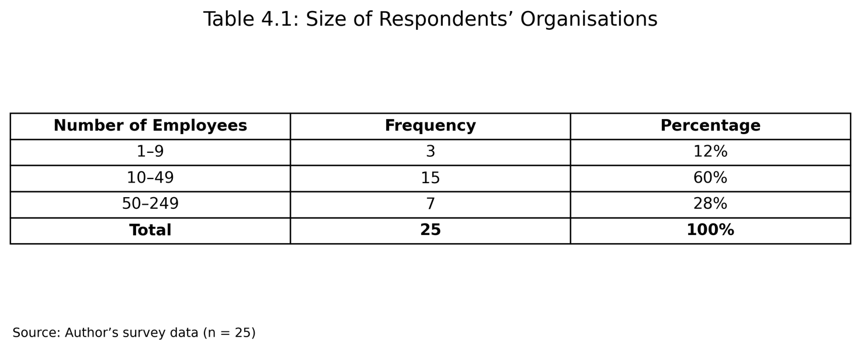

This distribution verifies that all participants were linked to organisations classified within the SME size categories pertinent to the research.

Participants also embodied various organisational positions. Seven participants (28%) held managerial or supervisory positions, six (24%) were operational staff, two (8%) were administrative personnel, and two (8%) were technical or IT staff. Eight participants (32%) chose "Other. The involvement of both management and non-managerial persons offers insights from those encountering technology adoption at many organisational tiers.

The sample encompassed many sectors. Hospitality had the highest share with six participants (24%), succeeded by transport and logistics with five (20%), retail with four (16%), construction with three (12%), IT and technology with three (12%), other sectors with three (12%), and manufacturing with one respondent (4%). The variety of sectors is advantageous as digital technologies are becoming progressively pertinent across many types of SME operations instead of being confined to technology-driven businesses.

Nonetheless, the disparate allocation among sectors indicates that the results should not be seen as indicative of any one UK industry.

4.3 Patterns of Technology Adoption

The primary research aim was to ascertain the varieties of digital technologies frequently utilised by SMEs in the UK.
Participants were permitted to choose various technologies employed by their businesses. Collaboration tools including Microsoft Teams, Zoom, and Slack were the most cited, chosen by 14 participants (56%). Thirteen participants (52%) utilised cloud computing or cloud storage.
Eleven respondents (44%) indicated the use of artificial intelligence tools and data analytics/business intelligence systems, whereas ten respondents (40%) acknowledged utilising automation software. Eight participants (32%) utilised Customer Relationship Management (CRM) systems, six (24%) employed ERP systems, and six (24%) used accounting software.

Chart 4.2: Technologies Used by Respondents' Organisations:

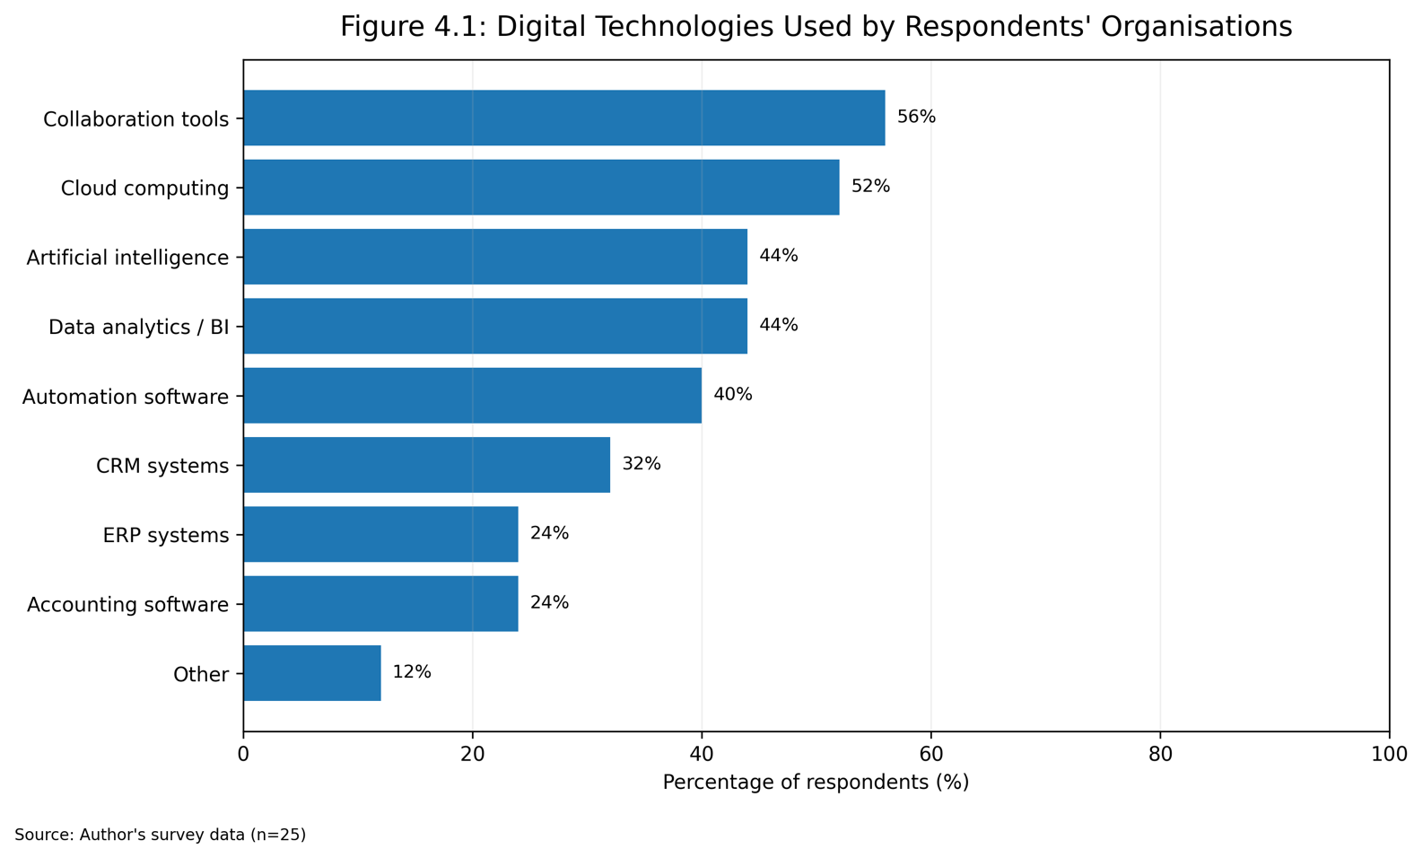

Percentages surpass 100% when participants were permitted to choose multiple technologies.

The findings indicate that the adoption of technology within the sample is varied rather than focused on a certain system. Participants indicated an average of roughly 3.3 technology categories utilised per organization, implying that numerous SMEs employ a blend of technologies.

The significance of cloud technology bolsters Bhatti's (2017) assertion that cloud-based solutions can grant SMEs access to digital capabilities while minimising the necessity for extensive internal IT infrastructure. In a similar vein, the extensive adoption of collaboration technologies aligns with the overarching trend toward digitally facilitated communication and adaptable work arrangements.

The existence of AI in 44% of the surveyed businesses is also significant. It indicates that sophisticated technologies are no longer exclusively confined to major corporations. Nonetheless, due to the limited convenience sample, this percentage ought not to be seen as a representation of AI adoption over the full UK SME demographic.
Most of the respondents frequently utilised technology. Twelve participants (48%) indicated that they frequently utilised digital technologies, whereas four (16%) stated that they used them regularly. Consequently, 64% of participants frequently or very frequently utilised digital technologies. A total of six participants (24%) indicated "occasionally," while three respondents (12%) chose "rarely.

These findings indicate that technology constitutes a consistent element of employment for most participants in the study.

4.4 Technology Adoption and Operational Efficiency

The secondary research aim focused on the correlation between technology adoption and operational efficacy.

The replies offer compelling descriptive proof that participants viewed technology favourably in this domain. Twenty-three participants (92%) concurred or strongly concurred that digital technology enhanced operational efficiency. The average response was 4.20 on a scale of 5, signifying a substantial degree of consensus.

In a similar vein, 92% concurred or strongly concurred that digital technology had facilitated the optimisation of organisational operations, yielding an average score of 4.28. Additionally, 88% concurred that technology diminished mistakes and redundancies, while 88% asserted that technology facilitated faster work completion for employees.

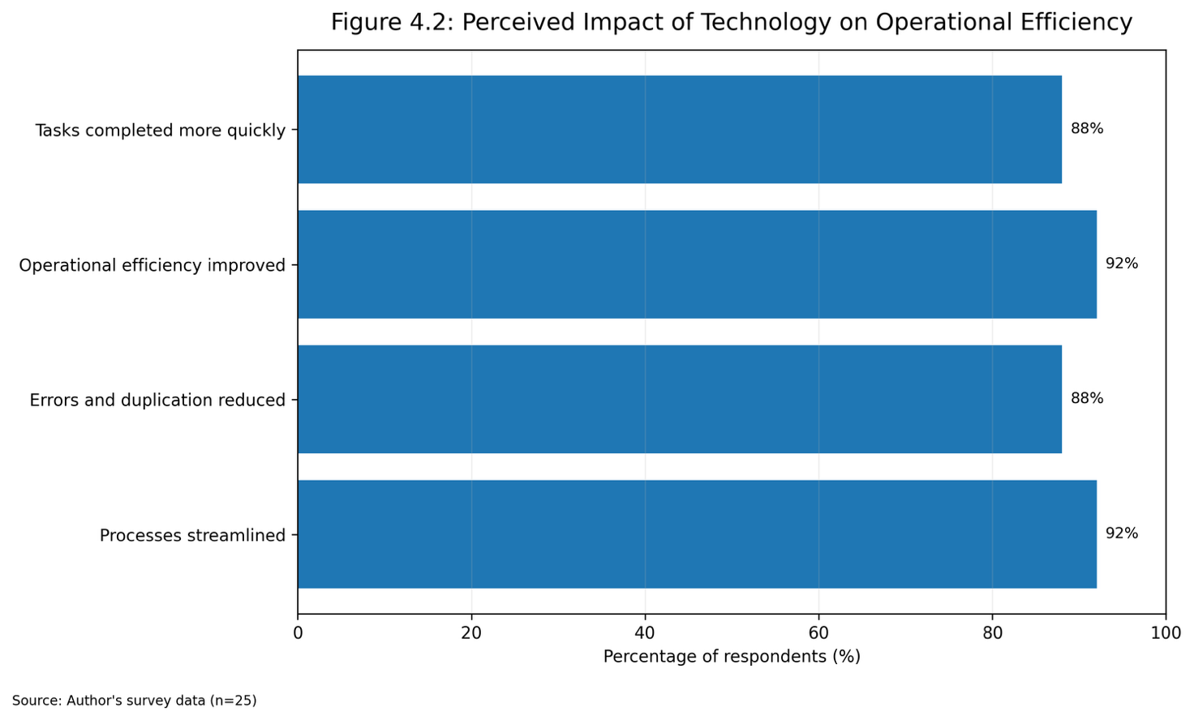
Chart 4.3: Operational Efficiency Results:

The four operational-efficiency metrics yielded an average of almost 4.23, indicating uniformly favourable perceptions.

The evaluation of internal consistency was conducted utilising Cronbach's alpha. The four operational-efficiency metrics yielded = 0.839, signifying strong reliability (Field, 2018). This indicates that the enquiries were uniformly assessing a connected fundamental notion of operational efficiency.

These results align with Radicic (2023), who links the digitisation of SMEs to enhanced organisational competencies and performance. Their findings align with Gessa et al. (2023), whose study emphasises the significance of integrated technological systems in enhancing organisational processes and commercial efficacy.

A significant interpretation is that the apparent advantage of efficiency seems to transcend merely accomplishing tasks more swiftly. Participants also linked technology to minimising redundancy and enhancing process cohesion. This reinforces the assertion made in Chapter 2 that digitalisation has the potential to transform the structure of work instead of merely automating discrete tasks.

In exploratory inferential analysis, the variety of technology categories chosen by each participant served as a measure of adoption breadth. A Spearman correlation indicated a statistically significant positive association between the extent of adoption and the composite of operational efficiency (ρ = .513, p = .009).

This substantiates H2: the integration of digital technologies enhances operational efficiency in small and medium-sized enterprises. Nonetheless, due to the study's cross-sectional design and reliance on a limited convenience sample, the findings indicate a correlation rather than confirming causation.

4.5 Technology Adoption and Employee Productivity

Employee productivity constituted the third principal domain examined.
Seventeen participants (68%) concurred or strongly concurred that digital technologies enhanced employee productivity. The average response was 3.72, indicating a positive outcome although falling short of the related operational-efficiency metrics.

Nonetheless, 80% concurred or strongly concurred that digital technologies facilitated employees in accomplishing a greater volume of labour in the same timeframe, yielding a mean score of 4.08. An identical percentage concurred that technology facilitated employees in executing their responsibilities efficiently, yielding an average score of 4.04.

The amalgamated productivity framework consequently yielded an average of roughly 3.95. The Cronbach's alpha was roughly 0.697, nearing the widely accepted 0.70 benchmark for internal consistency (Field, 2018). Considering the restricted quantity of objects and sample size, it may be deemed sufficient for preliminary undergraduate investigation, however less robust than the operational-efficiency metric.

The diminished direct production score is significant. Although participants predominantly felt that technology facilitated more efficient task execution, a smaller number were willing to assert definitively that overall employee productivity had enhanced. This suggests that the connection between technology and workforce productivity could be more intricate than its association with process efficiency.

One elucidation is offered by the Technology Acceptance Model. Davis (1989) contends that the perceived utility and perceived simplicity of usage influence persons' readiness to adopt technologies. Technology possesses the potential to enhance production; but rapid improvements may not occur if employees need training or face challenges in adjusting to new systems.

This analysis aligns with Lokuge and Duan's (2021) focus on organisational competencies in the digital transformation of SMEs. Investment in technology by itself cannot guarantee enhanced employee performance, since digital competencies, organisational backing, and successful integration are also crucial.

Exploratory Spearman analysis revealed a positive correlation between the extent of technology adoption and the productivity composite (ρ = .400, p = .047). This association is less robust than the one noted for operational efficiency, however it satisfies the traditional p < .05 threshold.

As a result, the results offer conditional endorsement for H3: the use of technology correlates positively with employee productivity. The unassuming correlation and the subdued descriptive outcome suggest that productivity advantages may be more contingent upon human and organisational elements.

4.6 Communication and Organisational Decision-Making

Technology was likewise assessed favourably concerning organisational information and decision-making.

Nineteen participants (76%) concurred or strongly concurred that digital technology enhanced communication and teamwork. The average score was 3.96.
A more significant consensus was observed regarding managerial information. A total of twenty-three participants (92%) concurred or strongly concurred that digital technologies furnish managers with enhanced information for decision-making, yielding an average score of 4.12.

In a similar vein, 22 participants (88%) concurred or strongly concurred that digital technology enhanced the efficiency and calibre of organisational decision-making, yielding a mean score of 4.08.

The two main decision-making enquiries yielded an aggregate mean score of 4.10, with a Cronbach's alpha of roughly 0.793, signifying acceptable to good internal reliability (Field, 2018).

These results align with Moreira et al. (2025), who underscore the significance of digital transformation and data application in improving organisational decision-making processes. Digital technologies provide managers prompt access to operational data and facilitate evidence-driven decisions instead of solely depending on intuition or past reports.

The findings further substantiate the discourse on ERP and data analytics presented in Chapter 2. Integrated systems can amalgamate organisational data, whereas analytical technologies can aid managers in discerning trends and evaluating organisational efficacy (Gessa et al., 2023; Moreira et al., 2025).

A statistically meaningful positive correlation was identified between the extent of technology usage and the composite of decision-making (ρ = .400, p = .047). Consequently, the hypothesis H4: digital technologies improve decision-making processes in SMEs is corroborated by the sample data, however the same constraints regarding sample size and causation are relevant.

4.7 Overall Business Efficiency and H1

The primary assertion of the dissertation posits that the incorporation of technology markedly enhances overall corporate efficiency.

Out of 25 respondents, 21 (84%) concurred or strongly concurred that the implementation of technology enhanced overall corporate efficiency. Sixteen participants indicated agreement, while five expressed strong agreement. Two individuals maintained a neutral stance, but two others expressed disagreement or strong disagreement.

The average score was 3.92, indicating a generally favourable evaluation.
Crucially, the extent of adoption exhibited a statistically significant positive relationship with perceived overall business efficiency (ρ = .596, p = .002). This was the most robust of the primary associations analysed.

The use of technology was positively correlated with the overall perception of efficiency (ρ = .398, p = .049), however this association was less robust.

The findings thus substantiate H1: the adoption of technology exhibits a considerable positive correlation with business efficiency in UK SMEs.

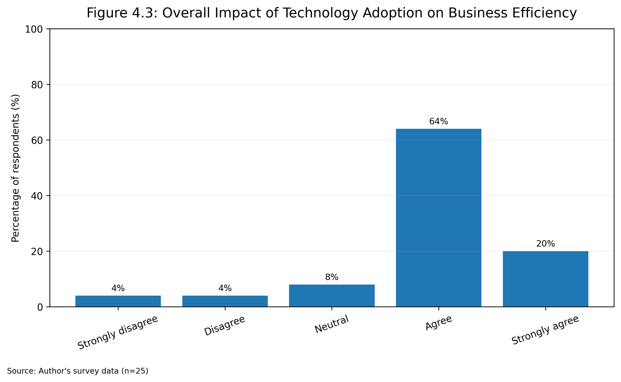
Chart 4.4 Perceived Impact of Technology Adoption on Overall Business Efficiency:

The results consequently provide evidence in favour of H1: technology adoption has a considerable positive connection with business efficiency in UK SMEs.

The discovery aligns with Radicic (2023) and Soomro et al. (2024), who link SME digitisation to organisational success and value generation. Nevertheless, the results indicate that the extent of adoption could be significant. Entities employing a broader array of digital technology generally indicated enhanced efficiency results.
This does not indicate that merely incorporating additional technology will inherently enhance performance. Successful integration is crucial. The implementation of multiple inadequately interconnected systems may elevate complexity instead of enhancing efficiency. The affirmative link must thus be understood in conjunction with organisational preparedness, employee proficiency, and managerial effectiveness, as highlighted by Sagala et al. (2025).

4.8 Barriers to Technology Adoption

Participants were additionally requested to pinpoint obstacles hindering increased technology use.

The predominant obstacle recognised was the deficiency of employee digital competencies, cited by 11 participants (44%). Ten responders (40%) identified employee opposition to change and challenges in integrating technology with current systems.

Nine respondents (36%) reported elevated technological expenses, whereas cybersecurity apprehensions and challenges in selecting suitable technologies were each noted by seven participants (28%). Six participants (24%) indicated a lack of adequate managerial support.

Chart 4.5: Main Barriers to Technology Adoption:
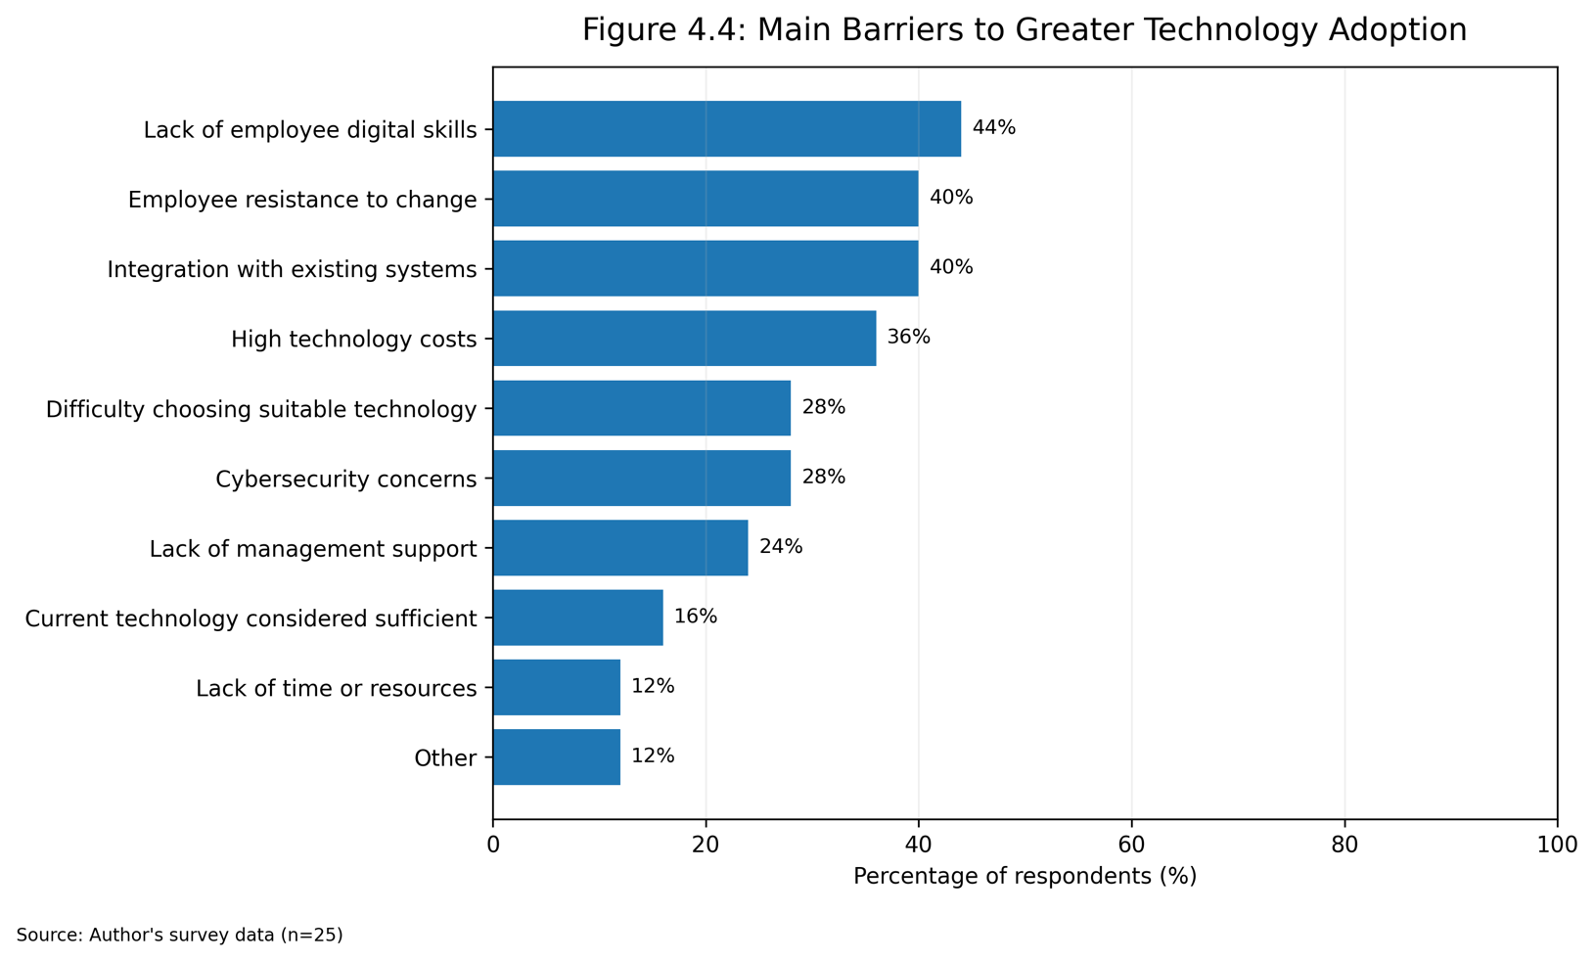

These results significantly bolster the assertion that the digitisation of SMEs transcends mere financial or technological concerns. The predominant concern highlighted was related to human capabilities, with opposition to change being similarly significant.

This corroborates Xu's (2026) analysis of obstacles to digital innovation in SMEs and Sagala et al.'s (2025) focus on organisational readiness during digital transformation. It further emphasises the significance of TAM and DOI. Davis (1989) illustrates the significance of user acceptance, but Rogers (2003) contends that complexity and compatibility affect the adoption of innovations.

The 40% recognising integration challenges is notably significant. It implies that the procurement of new technology constitutes merely one phase of digital transformation. Small and medium-sized enterprises must guarantee that new platforms align with current procedures and systems. Inadequate integration may diminish the prospective efficiency advantages highlighted in other sections of the survey.

4.9 Hypothesis Summary

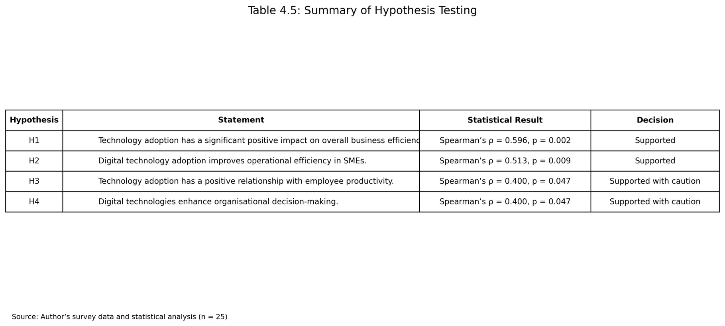
Chart 4.6: Summary of Hypothesis Findings

In general, the exploratory study provided backing for all four hypotheses. Nonetheless, the robustness of the evidence fluctuated. The most significant correlation pertained to overall business efficiency, succeeded by operational efficiency. Productivity and decision-making exhibited diminished associations that were marginally beneath the traditional significance level.

These results should thus not be regarded as conclusive evidence of causal connections. The sample comprised merely 25 participants selected via convenience sampling, and the metrics predominantly reflect perceptions instead than objective markers of organisational productivity. Nonetheless, the alignment among the descriptive results, correlation examination, and prevailing literature offers a solid foundation for addressing the study enquiries.

4.10 Chapter Summary

This chapter examined 25 survey results regarding technology use in UK SMEs. The results indicate a significant utilisation of collaborative tools, cloud computing, artificial intelligence, automation, and data analytics, with most participants frequently employing digital technologies.

Participants predominantly viewed digitisation favourably. Ninety-two percent said that technology enhanced operational efficiency, sixty-eight percent indicated a direct increase in employee productivity, ninety-two percent noted improved information for management decision-making, and eighty-four percent felt that the adoption of technology had elevated overall organisational efficiency.

Exploratory correlation analysis additionally revealed substantial positive associations between the extent of technology adoption and operational efficiency, employee productivity, decision-making, and overall business efficacy. The outcomes thus lend credence to H1–H4, however the results must be regarded with caution due to the limited, non-random sample.

Simultaneously, participants recognised significant barriers to enhanced digitisation, notably inadequate employee digital competencies, reluctance to change, challenges in integration, and expenses related to technology. The findings thus reinforce a key assertion derived from the literature review: technology has the capacity to enhance SME efficiency, although organisational competencies dictate the extent to which this potential is actualised.

5. Occlusion and Recommendations

5.1 Introduction

This chapter delineates the comprehensive conclusions of the research about the influence of technology adoption on operational efficiency in small and medium-sized firms (SMEs) in the UK. The chapter consolidates the primary results from the quantitative survey, assesses the degree to which the research aims and hypotheses were fulfilled, and offers suggestions for managers of SMEs. It also recognises the constraints of the research and highlights potential avenues for subsequent investigation.

5.2 Summary of Main Findings

The study sought to investigate if the adoption of technology correlated with enhancements in operational efficiency among UK small and medium-sized enterprises. The survey produced 25 legitimate replies from personnel and supervisors operating in various SME industries.

The results indicated that most participants frequently utilised digital technologies. Collaboration instruments and cloud computing emerged as the most cited technology, but artificial intelligence, data analytics, and automation were all significantly prevalent in the sample.

The findings revealed notably robust views on technology's role in enhancing operational efficiency. A significant proportion of participants concurred that digital technology enhanced operational efficiency, optimised organisational procedures, and minimised errors or redundancies. These results align with earlier studies indicating that digitisation can enhance SME operations and organisational efficacy (Radicic, 2023; Gessa et al., 2023).

employee productivity had a favourable correlation with the deployment of technology; however the results were less robust compared to those associated with operational efficiency. Participants largely concurred that technology enabled employees to accomplish greater volumes of work and execute their responsibilities more efficiently. Nevertheless, the relatively mild productivity outcomes indicate that investment in technology does not inherently lead to prompt enhancements in employee performance. This corroborates the Technology Acceptance Model, emphasising the significance of perceived utility and user-friendliness in influencing employees' effective adoption of technological systems (Davis, 1989).

Technology was viewed favourably about organisational decision-making. Most participants concurred that digital technology offered managers enhanced information and expedited the quality and speed of decision-making. These results bolster the assertion that technology like ERP systems, cloud solutions, and analytical instruments can enhance information accessibility and facilitate evidence-driven management (Moreira et al., 2025; Gessa et al., 2023).

The results substantiated all four research assumptions. The extent of technology usage shown statistically significant positive correlations with overall business efficiency, operational efficiency, employee productivity, and decision-making. The most significant correlation pertained to overall operational effectiveness.

5.3 Conclusions in Relation to the Research Objectives

The primary aim was to ascertain the digital technologies frequently utilised by UK SMEs. The results indicated that the organisations of the respondents employed several technologies, notably collaborative tools, cloud computing, artificial intelligence, analytics, and automation. This indicates that the digitisation of SMEs increasingly incorporates several technologies instead of standalone systems.

The secondary aim was to assess the influence of technology implementation on operational effectiveness. This aim received substantial backing. Participants indicated enhancements in task execution, process optimisation, and decreases in mistakes, while the statistical evaluation revealed a favourable correlation between the extent of adoption and operational efficacy.

The third aim investigated the correlation between the use of technology and the productivity of employees. The results indicated a favourable albeit diminished correlation. This indicates that enhancements in productivity are affected not solely by technology but also by elements like employee competencies, training, and receptiveness.

The fourth aim was to offer suggestions for enhancing technology uptake among UK SMEs. The assessment revealed that insufficient digital competencies, reluctance to adapt, challenges in integration, and technological expenses are the main obstacles. These results establish a solid foundation for actionable suggestions.

5.4 Recommendations

UK SMEs ought to emphasise the enhancement of employee digital competencies in conjunction with technical investments. The predominant obstacle cited was inadequate digital competencies among employees, indicating that technological systems are unlikely to yield their maximum advantages without suitable user proficiency. Consistent training, hands-on demonstrations, and ongoing assistance should consequently be integral to implementation efforts.

Supervisors ought to enhance their change-management methodologies. employee opposition was recognised as a major obstacle, suggesting that personnel must be engaged in technology transitions rather than only notified post-implementation.

Transparent communication regarding the objectives and anticipated advantages of new technologies can enhance acceptance and diminish ambiguity.
Small and medium-sized enterprises ought to emphasise integration and interoperability in their technology selection. The results indicated that the challenge of assimilating new technology with current systems was a significant barrier. Managers ought to assess the compatibility of new platforms with current processes prior to allocating substantial resources.

Investments in technology ought to be closely associated with discernible business challenges. Instead of embracing technology only for its trendiness, SMEs ought to define explicit goals like minimising processing duration, enhancing customer service, or bolstering decision-making. This methodology can enhance return on investment and diminish superfluous technological intricacy.

Ultimately, small and medium-sized enterprises ought to enhance their cybersecurity measures as reliance on digital technology escalates. Security must be integrated into technological design from the outset instead of being regarded as an ancillary concern.

5.5 Limitations of the Study

5.5 Constraints of the Research
The research presents numerous constraints. Initially, the conclusive sample comprised merely 25 participants, which is fewer than the initial goal of 50–100 responses. The constrained sample diminishes statistical power and implies that the results cannot be deemed typical of all UK SMEs.

Secondly, convenience sampling was employed, indicating that individuals were chosen based on their availability rather than using a random selection process. This could have resulted in sampling bias (Bryman, 2016).

Third, the research predominantly depended on self-reported viewpoints. Participants could interpret enhancements in efficiency or productivity in a manner distinct from quantifiable organisational performance metrics.

Ultimately, the cross-sectional design recorded answers at one specific moment. Consequently, it is unable to ascertain if efficiency fluctuated over an extended duration prior to and subsequent to the adoption of technology (Saunders, Lewis and Thornhill, 2019).

5.6 Recommendations for Future Research

Subsequent research may employ far larger and more representative samples of UK SMEs. Probability sampling may enhance generalisability and facilitate comparisons across various industries or organisational scales.
Longitudinal studies may also investigate the alterations in corporate efficiency prior to and subsequent to the implementation of technology. This would yield more robust evidence on causation.

Future investigators might potentially integrate quantitative surveys with interviews. A mixed-methods strategy may yield deeper understanding of the factors behind the success or failure of specific technologies and the employee experience throughout digital transformation.

Ultimately, next research might investigate technologies like generative AI, automation, or cloud-based ERP systems in isolation, as their impacts could vary significantly among SME industries.

5.7 Final Conclusion

The research determines that the implementation of technology correlates favourably with operational efficiency in the surveyed UK SMEs. The most compelling findings pertained to operational efficiency and general organisational effectiveness, but favourable correlations were also noted for employee productivity and decision-making.

Nevertheless, just investment in technology is inadequate. The results indicate that digital competencies, employee receptiveness, system integration, and managerial backing significantly affect the success of adoption. This supports both the Technology Acceptance Model and the Diffusion of Innovation Theory, which highlight that effective technological transformation relies on user perceptions and the attributes of the innovation itself (Davis, 1989; Rogers, 2003).

In general, the integration of technology can offer substantial prospects for UK SMEs to enhance their efficiency and competitiveness, although these advantages are most attainable when digital investments are bolstered by workforce development, strong leadership, and meticulous organisational planning.

6. Abstract

This dissertation explored the effect of technology adoption on business efficiency of small and medium-sized firms (SMEs) in the United Kingdom. The study explored the relationship between the usage of digital technology and operational efficiency, employee productivity, organisational decision making and overall business efficiency. The research was based on the Technology Acceptance Model and Diffusion of Innovation Theory which offered theoretical reasons for individual technology acceptance and organisational adoption.
A structured online questionnaire was used to collect quantitative data. Data were collected from 25 respondents working in UK SMEs across several industries. The questionnaire assessed the technologies utilised in organisations, frequency of technology use, views of operational efficiency and productivity, decision-making outcomes and hurdles to further technology adoption. The data acquired were evaluated using descriptive statistics, reliability analysis, and exploratory correlation analysis.

The data suggested that a favourable correlation existed between technology adoption and corporate efficiency. Respondents said operational efficiency, process streamlining and organisational decision-making were major areas of gain. Technology adoption was also positively correlated with employees’ productivity. But the survey revealed several impediments to digital adoption including lack of digital skills among employees, opposition to organisational change, integration challenges and technological expenses.

The study suggests that the adoption of technology can make a big difference to SME efficiency, but the benefits are contingent on good implementation, employee competencies and organisational support. It consequently advocates more investment in digital skills, improved change management methods and careful integration of new technology with current organisational structures.

References List

Bryman, A. (2016) Social Research Methods. 5th edn. Oxford: Oxford University Press.

Creswell, J.W. and Creswell, J.D. (2023) Research Design: Qualitative, Quantitative, and Mixed Methods Approaches. 6th edn. Thousand Oaks, CA: SAGE Publications.
Davis, F.D. (1989) ‘Perceived usefulness, perceived ease of use, and user acceptance of information technology’, MIS Quarterly, 13(3), pp. 319–340.

Department for Business and Trade (2025a) Understanding Technology Adoption Among UK SMEs. London: Department for Business and Trade.

Department for Business and Trade (2025b) SME Digital Adoption Taskforce: Final Report. London: Department for Business and Trade.

Department for Business and Trade (2026) SME Digital Adoption Taskforce: 2026 Update. London: Department for Business and Trade.

Field, A. (2018) Discovering Statistics Using IBM SPSS Statistics. 5th edn. London: SAGE Publications.

Gessa, A. et al. (2023) ‘Exploring ERP systems adoption in challenging times: Insights of SMEs stories’, Technological Forecasting and Social Change. The study specifically reports constructive effects of ERP use for SMEs and improvements in decision-making quality.

Haddara, M., Ersöz, M., Langseth, M. and Langseth, H. (2022) ‘Challenges of cloud-ERP adoptions in SMEs’, Procedia Computer Science, 196, pp. 973–981.

Moreira, L.L. et al. (2025) ‘Evaluating digital transformation in small and medium enterprises using the Alkire–Foster method’, Heliyon, 11, e41838. The verified publication reports efficiency, productivity and cost-related benefits associated with SME digital transformation.

Radicic, D. and Petković, S. (2023) ‘Impact of digitalization on technological innovations in small and medium-sized enterprises (SMEs)’, Technological Forecasting and Social Change, 191, 122474.

Rogers, E.M. (2003) Diffusion of Innovations. 5th edn. New York: Free Press.

Saunders, M., Lewis, P. and Thornhill, A. (2019) Research Methods for Business Students. 8th edn. Harlow: Pearson.
Soomro, R.B. et al. (2024) ‘The adoption of digital technologies by small and medium-sized enterprises for sustainability and value creation’, Sustainability, 16(17), 7351.

Xu, J. (2026) ‘Barriers to digital innovation in small and medium-sized enterprises’, Procedia Computer Science, 278.

