ACADEMIC AND EMPLOYABILITY SKILLS
Name Alina Georgiana Mucenic
Student number 2108840

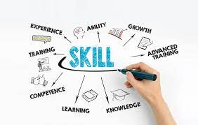
(Digital Competence: the Vital 21st-century Skill for Teachers And Students. (n.d.). SchoolEducationGateway. )

Contents

Introduction
Main Findings
Employability skills change since Covid-19 Pandemic
Resilience
Emotional Intelligence
Digital skills
Why the employability change?
Impact of individual looking for Employment
Conclusion
Bibliography

Introduction

This assessment would go over employability skills, which are the abilities that they make a person employable and might be summed up in the following way: the abilities by a person must possess in order to be considered for employment. These skills are required for a person to be hired by a company. When deciding whether to hire someone, employers frequently look at their technology and subject-matter expertise. This project also aims to provide the skills for employability with the knowledge and abilities, and attitudes necessary to succeed as a piece of equipment. They were performing to the best of their ability in areas such as communication, decision-making, self-motivation, time management, punctuality, flexibility and adaptability, resilience, emotional intelligence, and digital literacy. As a outcome, communication, decision-making, self-motivation, and time management punctuality, adaptability, resilience, emotional intelligence, and digital literacy, administrative structures of employability skills during pandemic conditions. Skills are necessary for young people to succeed in the future and stand out in what is likely to be a highly competitive job market, In this report, I will discuss the significance of academic and employability skills during the COVID-19 epidemic, as well as provide a thorough understanding of how employment has been impacted on a large scale. People's anxiety and insecurity have intensified as a result of the general possibility of job and pay loss. This project also aims at narrowing the most prevalent investigations in this regard Covid-19 pandemic, which has created a truly "adaptive platform," an unexpected there are incentives for individuals to see the effects of rapid and significant change and the negative consequences of ignoring this anomaly in daily life. The virus has altered how employees communicate with one another, as well as with customers and suppliers within businesses. Now that businesses have progressed past the crisis's rapid response, we have reached a temporary "new normal."

Main Findings

The impact of Covid-19 on employability skills

The most visible effect of COVID-19 on the labour force has been the enormous growth in remote employment. (mckinsey. Online.2021). While employment skills have grown greatly since COVID-19, there is no doubt that the pandemic illuminated and raised the importance of digital development and skills initiatives. Evaluating the function of online learning platforms and virtual hubs in the future: It will be critical to assess how successful online learning platforms and virtual hubs are in meeting the demands of learners, citizens, and enterprises. There is undoubtedly a need for mixed delivery in order to fulfil the demands of all learners, particularly those who prefer face-to-face connection. These services were built rapidly and without the customary consultation with service consumers that authorities usually engage in. It would be worthwhile to evaluate the extent to which these platforms have benefited citizens, companies, and students, as well as the extent to which they may need to adapt throughout time. Maintain flexibility for virtual work and meetings: Everyone we talked with emphasised the importance of remote work and the need to be adaptable when it is safe to return to the office. It will be very difficult to revert to "traditional methods of working," and it is critical that councils maintain the success of virtual meetings and a more nimble approach to management and service delivery.

Employability skills change since covid 19 PANDEMIC
The epidemic has had a significant influence on employability skills, particularly in the areas of collaboration and communication, among other things. Teamwork is one of the most important abilities in the majority of occupations, and it was prohibited by COVID-19 because it was rendered ineffective due to social distance. The most obvious change in Employability skills since covid-19 PANDEMIC is the dramatic increease in employees working remotely. Due to the general possibility of job and pay loss, the pandemic has increased people's fear and insecurity. Furthermore, the government's nationwide lockdown has increased cases of domestic violence and child abuse. Tourism, aviation, agriculture, construction, retail, hotels, textiles, gems/jewellery, fast moving consumer goods (FMCG), manufacturing, and start-ups are among the industries temporarily closed, resulting in significant revenue loss. ( Debata, Patnaik, P., & Mishra, A. 2020)
In accordance with (SAGE journals) it is difficult to comprehend the crisis's experience, management, and long-term impact without taking into account the crisis's rapid digitization and digital divisions.

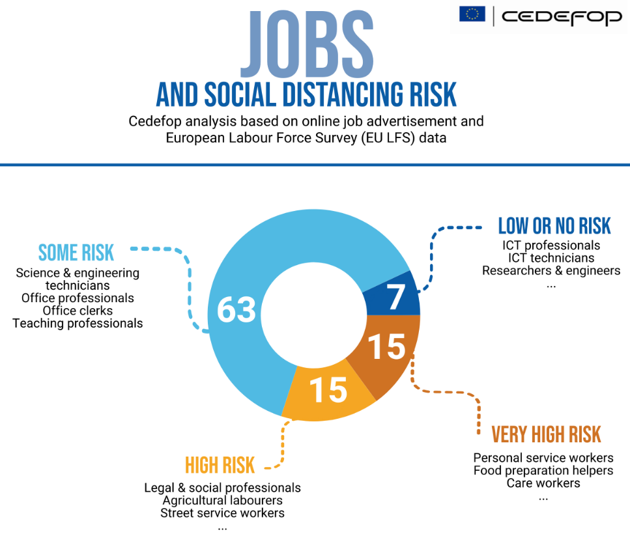

(Covid-19 and jobs: Which skills make a difference? | Skills Panorama)

Resilience

The capacity for resilience may be described as the capacity to accept and adapt to any adverse circumstance and then overcome it by moving ahead. Resilience directly translates to the ability or capacity to be able to handle situations that were previously out of their control (Osmani et al., 2019). During the pandemic COVID-19, many people lost their jobs, but a lot of them handled the situation well and had the ability to overcome barriers and obstacles. The COVID-19 pandemic has triggered one of the worst job crises since the Great Depression. There seems to be a real risk that the crisis will exacerbate poverty and widen economic inequality, with long-term consequences. Therefore, creating a stronger and more resilient employment market is a critical investment in the future and succeeding generations. (OECD,2021). Employers taking the initiative to build resilience in response to Covid-19's quick learning and development of a successful reaction, and then repeating the process as circumstances change. With reason, resilience has received a lot of attention throughout the coronavirus epidemic. COVID-19 changed the way the world operates and compelled everyone of us to adapt to a new reality in our own lives.(Gympass. Online. 2021)

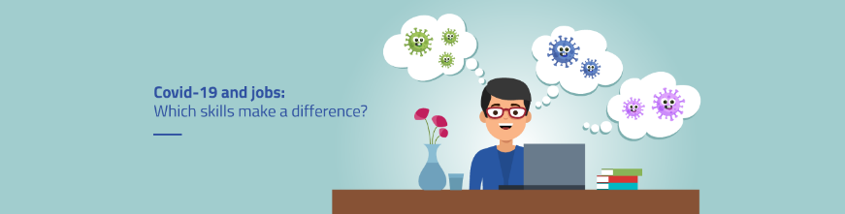
(Covid-19 and jobs: Which skills make a difference? | Skills Panorama)

In the wake of the global epidemic of COVID-19, many of the world's present systems have been found to have limitations, requiring an overhaul of the role of information technology in promoting economic development and productivity growth sience epidemic. As a result of the implementation of immigration restrictions and, in some cases, lockdowns to contain the infection, there has been a severe effect on society and the economy. To put it another way, this disruption has had a significant impact on almost every element of human existence since it occurred. (Bank Group, A.D. 2020, available online.)

Emotional Intelligence

For many of us, COVID-19 has been a life-altering experience. It has put us to the test and highlighted the necessity and significance of improving our emotional intelligence in order to successfully care for ourselves and others in these unusual times. (Axialet Online, 2021)It is critical to have good emotional intelligence in order to succeed in the workplace since COV-19. While investigating the quick emotional response to the epidemic, it is possible that two significant limitations of prior research will be relevant to the investigation. Covid-19, which is intended to boost and grow our emotional intelligence, also aids us in improving our quality of life. It assists us in empathising with other people's feelings by placing ourselves in their shoes and experiencing in our own bodies what they are experiencing in theirs. The good news is that we can teach our brains to be more in control of our emotions as a result of which we may regain our emotional health. Many aspects of the covid-19 pandemic, as well as the public health response to it in a positive reaction , will likely lead to widespread emotional distress and increased emotional intelligence in the general population. According to the incidence of melancholy, stress, anxiety, and post-traumatic stress disorder have all increased dramatically in the previous year alone. We have not yet recovered from the loss of freedom, but some localities are steadily regaining their independence, while others are still figuring out how to go ahead. For a number of reasons, the frequency and strength of good and negative emotions were not distinguished in prior research. Nonetheless, this divergence is important from a theoretical as well as a practical perspective (ScienceDirect, online, 2020). It is important to understand what emotions are and how they affect our lives. It all depends on how well we manage to regulate the unpleasant emotions that often function as a barrier between our aspirations and the way we live.

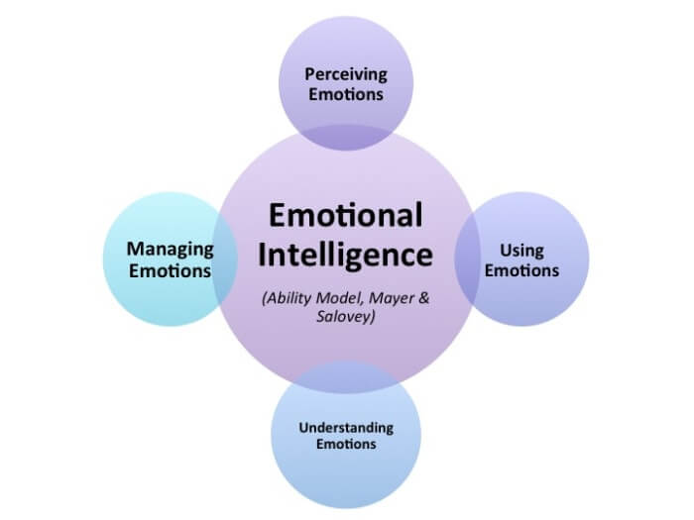
(SAGE Journals: Your Gateway To World-class Research Journals. (n.d.). SAGE Journals.) (https://journals.sagepub.com/doi/full/10.1177/00113921211023518.)

Digital skills

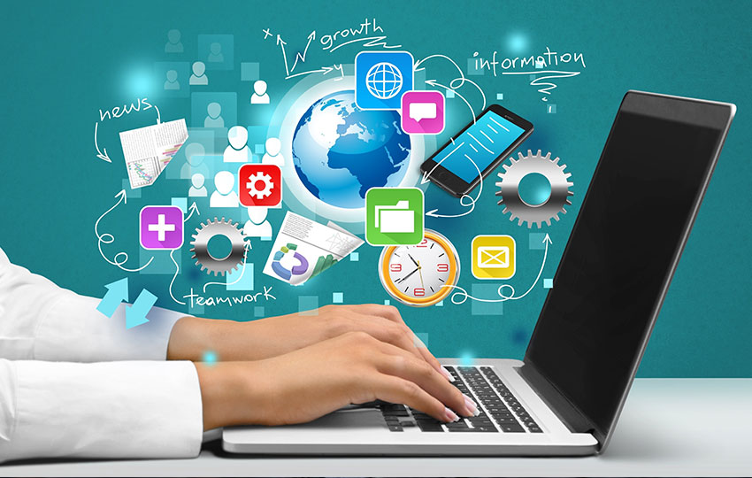
(Digital Skills for Entrepreneurs And Workers. 2017)

There are three main components of digital competency or literacy: first, technical capabilities; second, knowledge about technology; and thirdly, critical thinking, evaluation, and accountability based on this information. Digital competence is one of the eight fundamental competencies and refers to the confident and critical use of a broad variety of digital technologies for information, communication, and basic problem solving in all spheres of life. Covid-19 has a good impact on digital skills. The training they get may be incorporated as an important component of their activities and career. Additionally, as a transversal competency, digital competence assists us in mastering other critical competencies like communication, language skills, and fundamental abilities for combat Covid-19. The process of appropriating a new technology begins with motivation, which is the initial step in the process. Even if people do not want to use computers or other digital media, they will not attempt to purchase one or obtain a particular connection unless they are compelled to do so. p2 (Alexander J. A. M. et al., 2014).Covid-19 encourages people to use digital skills that are necessary to combat the spread of the virus and maintain a healthy and safe environment for everyone.

Why the employability change?
Concerning the advantages desired by prospective workers, those immediately connected to the pandemic's impacts, from those of a medical character to those related to programme flexibility and digital skills, get the highest ratings. Employees are often encouraged by the possibilities for training, growth, and development. In this unconventional setting, respondents placed a lower premium on organisational culture. direct management and teamwork. As a result of the current labour market and company context, companies are looking for candidates who can adapt quickly to the team, as well as those who can work from the company's headquarters or at home, as well as those with entrepreneurial skills or new skills. Prior to Covid-19, the most significant disruption to work was caused by new technologies and expanding trade linkages. Covid-19 has, for the first time, raised the importance of the physical aspects of the work environment. According to new study published , British business executives think that the workplace improvements brought about by Covid-19 will now become a permanent element of how we work and will alter demand for skills.

According to the report, business executives think the pandemic's dramatic influence on work life will have long-lasting consequences. The trend toward fewer workers in offices, more work from home, and virtual work is certain to continue.( Covid will change future of work and skills say business leaders &ndash; FE News. Online. 2021.)

Impact of individual looking for Employment

Employee-employer relations have shifted throughout the pandemic, both as a result of a new method of working designed to halt viral transmission and as a result of an unavoidable economic crisis that has left its imprint on the world. To recover from the COVID-19 catastrophe stronger, businesses are reskilling their workforces . This pandemic altered the world of work significantly and is likely to continue to do so. From hybrid working to changing client attitudes, objectives, and expectations for skill development. Concentrate on future skill requirements that will assist individuals in achieving their professional objectives during a pandemic. The research examines recent changes in employee telework, employer trust, and labour market participation. Despite the fact that the number of online job advertisements has decreased generally, there is a wide range of jobs and industries. As a result, although certain sectors of the economy saw an increase in demand and some businesses continued to operate as usual, others were forced to cut back or shut down completely. To combat the spread of the novel coronavirus, state governments began closing school systems and colleges across the country in 2019 for half a year. (P. Tarkar, 2020) Many things have altered as a result of the COVID-19 issue. Many studies have focused on the negative effects of long-term employment, but less attention has been paid to the possible good effects of short-term job, such as increased leisure time and caring responsibilities. ( Tušl, M. nd. 2021.)

Conclusion

Employability skills are a critical part of any human being's professional life, and this research focuses on them. A person's ability to acquire a job is an important factor in determining his or her success in life. This research focuses on four employability skills: digital skills, resilience and emotional intelligence before and after the COVID-19 pandemic. There are numerous employability skills. By having all of these talents, a person may work more effectively and upskilling in order to achieve their objective of success. As part of this study's focus on the development of employability skills it has been stated how one may succeed in becoming an experienced professional and also rise through the ranks in the workplace during the challenges posed by the COVID-19 crisis. The most important thing to keep in mind is that everyone has all of the talents listed above by leading the resilience. As a result, there is a need to acquire these abilities via the mechanisms outlined in the above research. The last component of the research focuses on current employment skills since covid-19 as well as those that existed two years ago. Compared before pandemic it shows the most significant variations between the current and previous years. This research shows how a person's employable abilities might help him or her achieve during of the impact of covid-19 in the world . We must continue investigating and monitoring the effects of the epidemic in order to have a better understanding of what the future implications for employability skills and emotional intelligence results for both current and future generations may be.

Bibliography

Bank Group, A. D. (2020, June 17).The Relevance Of Digital Skills In the COVID-19 Era | Banque Africaine De Développement - Bâtir Aujourd'hui, Une Meilleure Afrique Demain. Banque africaine de développement - Bâtir aujourd'hui, une meilleure Afrique demain. Accessed online in 29 November at https://www.afdb.org/fr/news-and-events/relevance-digital-skills-covid-19-era-36244.

Building a Resilient Post-COVID-19 Workforce | Gympass | Blog. (2021, July 15). Gympass | Blog. Accessed on 3 December at https://blog.gympass.com/en/building-a-resilient-post-covid-19-workforce/.
Covid Will Change Future Of Work And Skills Say Business Leaders &ndash; FE News. (2020, September 25). FE News. Accessed on 3 December at https://www.fenews.co.uk/skills/covid-will-change-future-of-work-and-skills-say-business-leaders/.
Debata, Patnaik, P., & Mishra, A. (2020). COVID-19 pandemic! It’s impact on people, economy, and environment. Journal of Public Affairs, article accessed 10 November available at https://doi.org/10.1002/pa.2372

Emotional Intelligence In Times Of COVID-19 - Axialent. (2021, July 7). Axialent. Accessed on 3 December at https://www.axialent.com/emotional-intelligence-in-times-of-covid-19/.

OECD 2021,The impact of COVID-19 on employment and jobs, article/ accessed on 12 November available at https://www.oecd.org/employment/covid-19.htm

Osmani, M., Weerakkody, V., Hindi, N. and Eldabi, T., 2019.Graduates employability skills: A review of literature against market demand.Journal of Education for Business, 94(7), pp.423-432.Accessed from: https://www.fearp.usp.br/images/ppgcc/PDFs/Graduates_employability_skills_-_A_review_of_literature_against_market_demand.pdf

Preeti Tarkar,2020, Impact Of Covid-19 Pandemic On Education System,International Journal of Advanced Science and Technology ,Vol. 29, No. 9s, (2020), pp. 3812-3814 article accessed on 22 November from https://scholar.google.com/scholar?

SAGE Journals: Your Gateway To World-class Research Journals. (n.d.). SAGE Journals. Accessed online in 30 November at https://journals.sagepub.com/doi/full/10.1177/00113921211023518.

The Future Of Work After COVID-19 | McKinsey. (n.d.). McKinsey & Company. Accessed on 30 November at https://www.mckinsey.com/featured-insights/future-of-work/the-future-of-work-after-covid-19.

Trait Emotional Intelligence And Emotional Experiences During the COVID-19 Pandemic Outbreak In Poland: A Daily Diary Study. (2020, August 20). Trait emotional intelligence and emotional experiences during the COVID-19 pandemic outbreak in Poland: A daily diary study – ScienceDirect. Accessed online in 30 November at https://www.sciencedirect.com/science/article/pii/S0191886920305390

Tušl, M., Brauchli, R., Kerksieck, P., & Bauer, G. F. (2021, April 17). Impact Of the COVID-19 Crisis On Work And Private Life, Mental Well-being And Self-rated Health In German And Swiss Employees: a Cross-sectional Online Survey - BMC Public Health. BMC Public Health. Accessed in 3 December on https://bmcpublichealth.biomedcentral.com/articles/10.1186/s12889-021-10788-8
.
van, Deursen, Alexander J. A. M., and Dijk, Jan A. G M. van. Digital Skills : Unlocking the Information Society, Palgrave Macmillan US, 2014. ProQuest Ebook Central, https://ebookcentral.proquest.com/lib/trinity/detail.action?docID=4828194.

