WORKPLACE CULTURE AND ITS IMPACT ON ORGANISATIONAL EFFICIENCY
COMPONENT 1 INDIVIDUAL WRITTEN REPORT

EXECUTIVE SUMMARY
The report shed light on the organisational culture, ethos and values of Google. The company is a well-known high-tech and software production company that aims to deliver customers with better products and employees with a better corporate culture. Google is known for its corporate culture and ethics which help accelerate better corporate values. Triple bottom line theory-based components such as environment, economic and social components are highly valued within Google to respond to cultural philanthropy. Considering Edgar Schein's Organisational Culture Triangle, it is seen that Google Cloud is accessible, creating local private libraries throughout the globe and saving artefacts nearby to compute resources. Moreover, at Google Workspace, all concerns are sent to the company in a single location, where the company handles registration, rather than to several agencies separately. Google also said that it will be awarding a £1 million grant through Google.org financing to promote economic opportunities for those with impairments in the UK and around Europe. Further, recommendations are made to include diversity and enhance the rapidity and effectiveness of knowledge transmission.

Table of Contents

Task 1 – Individual Written Report 4
1. Introduction 4
1.1 A brief background of Google 4
1.2 The content of the report, briefly stating what will be discussed 5
1.3 The context of the report 5
2. Discussion 6
2.1 Discuss Organisational Culture, ethos, and values of Google. 6
2.2 Would you agree with the fact that Google and its organisational cultural practices promote sustainability within the workplace? 7
3. Key ethical elements 9
3.1 Discuss the key ethical elements in organisational culture and how it can be promoted among employees, using an academic framework such as Schein (1996), McKinsey 7s, Kotler’s 8 step plan etc. 9
3.2 Discuss in detail, one ethical dilemma likely to influence the culture of the organisation. 11
4. Organisational improvement 11
4.1 Areas of organisational improvements for Google’s culture 11
4.2 Recommendations that may enhance the company’s workplace culture in the future 12
4.3 Indicate how the recommendations will positively affect organisational efficiency. 12
4.4 Discuss the key barriers and how this can be improved – provide recommendations. 12
5. Conclusion 13
List of References 14

Task 1 – Individual Written Report

1. Introduction

1.1 A brief background of Google
Google LLC is an American computer software and search engine technology-based company popular worldwide. The prime corporate mission of Google is to organise the world’s information and make it universally accessible and useful (Google, 2023a). The company is committed to making life easier with little help from the products of Google. In 2022, the revenue of Google was up to $224.47 billion and in 223 it amounted to $279.8 billion (Statista, 2022). The revenue is quite high which depicts its well-establishment in terms of business performance and customer engagement.
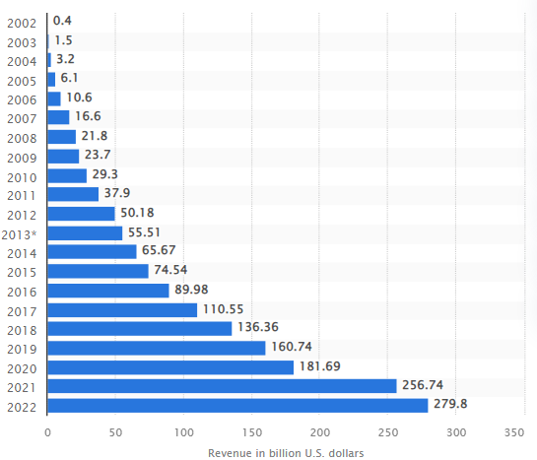
Figure 1: Revenue of Google from 2002 to 2022
(Source: Statista, 2022)
Google had a total of 156,500 full-time employees in the year 2021 showcasing better employee engagement (GlobalData Plc, 2023). This has helped detect that the company has a great culture which influences positively to the employee to retain in the workplace and contribute to the success of Google.
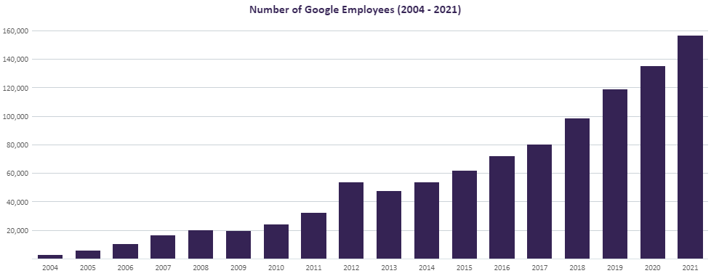
Figure 2: Employee headcount in Goole from 2004 to 2021
(Source: GlobalData Plc, 2023)

1.2 The content of the report, briefly stating what will be discussed
The study will be performed to demonstrate the background of Google along with the organisational culture, ethos and values of Google. It will further shed light on the practices of Google in terms of organisational culture in promoting sustainability in the workplace. Furthermore, ethical elements in organisational culture, its promotion towards employees' performance and ethical dilemmas will be also depicted in the study. In addition, the discussion will be oriented to the organisational improvement in the areas of Google's need to focus more.

1.3 The context of the report
The key issues regarding Google will be found within the study in which the cultural dilemma, ethical issues and others will be presented. The literature which will be used in the study will be associated with Google and organisational culture, ethics and other topic-oriented parameters. Theories and models such as Schein's organisational cultural triangle and others will be further discussed within the study to demonstrate the organisational culture and others.

2. Discussion

2.1 Discuss Organisational Culture, ethos, and values of Google.
Organisational culture is a system of values, shared beliefs, practices and behaviours that govern every personnel’s action (Indeed, 2022). The company’s personality and the collection of traits define the foundational value of the organisation. Google has performed a better role in enhancing the organisational culture, ethos and values. These aspects are elaborated below:
- Culture: According to the views of Spicer (2020), organisational culture refers to signs, symbols, shared practices and underlying assumptions of an organisation to significantly adjust the environmental realities. A well-developed organisational culture helps employees' motivation, engagement and other factors in a better manner. Google has been popularly known as the most high-tech company with the best corporate culture as recognised by the Forbes Technology Council members as the company has higher shared values (Forbes, 2023). On the other hand, the company was one of the first companies to promote flexible schedules and work on teams to unleash creativity and a greater level of productivity (Forbes, 2023). In addition, at Google employees have the freedom to be creative, fun environments are also promoted within the company, shared value across the workplace, constant innovation and others (Forbes, 2023). It outlines that the company has an extraordinary and outstanding corporate culture that helps it to boost its organisational performance in a better manner. Theory of Clan culture of the organisation, it can be observed that the human relation model has been involved within the organisational culture to promote internal and organic relationships within the flexible organisational structure (Oh and Han, 2020). This theory also states that with the help of a flexible model organisational structure, the company can build better organisational performance. In such a manner, it can be considered that flexible and shared values within Google help its corporate employees perform better and manage workplace activities in a better manner. It is also extraordinarily better to reduce any conflict arising within the organisation since a better culture cultivates better behaviour within the workplace minimising workplace demotivation.
- Ethos: The ethics of any corporate practices defined as the core set of values or operational principles which are used to set the tone for overall fundamentals and operations of a company's performance (Linkedin, 2023). Those help maintain integrity, dedication and other functions within the company. The main ethos followed by Google is “Don't be evil” which represents the identity of the company and predicts future corporate powerhouse. This is also beneficial for Google to shape the culture of Silicon Valley while maintaining high technology and corporate ethos effectively (Shirin Ghaffary and Kantrowitz, 2021). This iconic mantra of Google regarding ethos helps maintain the labour policy of the company which helps its employees to gain better cultural activities, a stress-free workplace environment, less conflict-oriented as well and many more (Nieva, 2021). The main parameter of Google is to be not orthodox in terms of employee culture and to value the employees' thinking, opinion and others effectively which help them to remain within the company and contribute to the effective performance of the company.
- Values: Values to the employees, customers and others have been required to maintain seamless corporate performance and accelerate better corporate presentation. It can be observed from Google's shared values that the company follows certain value-based factors such as integrity, usefulness, privacy, security, freedom of expression and others (Alphabet Investor Relations, 2023). The company maintains integrity by establishing better communication and interactive functions among partners, employees and customers to enhance the corporate presentation (Alphabet Investor Relations, 2023). On the other hand, usefulness refers to the wider use of products and services of Google by its customers and employees while managing the privacy of the entities in a better manner (Alphabet Investor Relations, 2023). In addition, freedom of speech in Google ensures that all the members can convey their thoughts easily and share their onion without any hesitation. These stages have contributed to the establishment of a better corporate presentation of Google and increased the value of the company in an effective manner.

2.2 Would you agree with the fact that Google and its organisational cultural practices promote sustainability within the workplace?
Organisational sustainability refers to the performance of workplaces that does not hinder the social, economic and environmental factors rather than promoting philanthropic activities to contribute to global betterment. Triple bottom line theory is a dedicated theoretical framework that outlines the organisational sustainability promoted by the philanthropic actions of the organisations. As discussed by Shim et al. (2021), the triple bottom line theory is able to address the bottom line of profits of any organisation that can be achieved through sustainable practices promoted by three key aspects such as environmental (planet), economic (profit) and social (people). The below figure 3 depicts the three components of the theory. Based on the theory, the key performance of Google is outlined below indicating the sustainability achieved by the company ensuring these three philanthropic measurements.
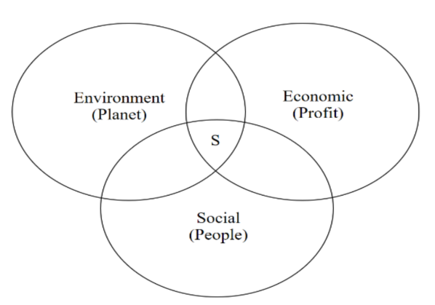
Figure 3: Triple bottom line theory
(Source: Shim et al. 2021)
- Environmental (planet):
Google has been committed to net-zero emissions through technology and innovation by using energy to power the products and to run the operation of the company including its data centres and offices (Google, 2023b). For climate action, the company purring net zero emissions across the operation and value chain by 2030 (Google, 2023b). The tokenized action plan helps the company to reduce the emission of carbon, and others in a better manner which helps maintain sustainability and environmental philanthropy.
- Economic (profit):
Google has been performing under circular economic performance in which the company is working to gear up the transition to the business liners such as environmental, economic and community values (Google, 2022). These values have been maximising the reuse of finite resources and these have been maintained through core principles such as designing out waste and pollution, keeping products and materials in use, and promoting safe and healthy materials (Google, 2022). Based on the circular economy, the company enables exorcist products to become fit for future resources, make use of most of all resources and design products that are safe for both people and the planet (Google, 2022). It helps protect the company’s profits, balancing the usage of resources and reducing extra burdens.
- Social (people):
Google’s philanthropic initiatives are associated with helping people by providing technology, funding and volunteering to better prepare communities ahead of disasters, ensure efficient relief and support long-term recovery (Google, 2019). The company donated $60 million to more than 50 humanitarian crises and an additional $100 million to the global COVID-19 responses (Google, 2019). Hence, it can be observed that with the help of such factors, the company responds towards social needs and poses a mark on philanthropic aspects in society in a better manner.

3. Key ethical elements

3.1 Discuss the key ethical elements in organisational culture and how it can be promoted among employees, using an academic framework such as Schein (1996), McKinsey 7s, Kotler’s 8 step plan etc.
According to Roscoe et al. (2019), organisational culture is commonly defined as every one of the business's beliefs, values, and perspectives, as well as whether these impact employee behaviour. In this context, regarding culture, according to the opinion of Ezra and Charles (2023), Edgar Schein's Organisational Culture Triangle states that cultures inside companies have multiple strata. There are several superficial layers that exert an influence on an organisation's culture or may provide some insight into what a culture is about. There are also additional levels that offer a far better understanding of what a culture is about.
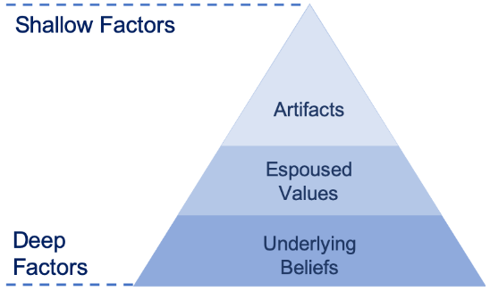
Figure 4: Edgar Schein's Organisational Culture Triangle
(Source: World of Work Project, 2021)
Artefacts: The first level consists of the organisation's qualities that people can readily see, perceive, and experience; they are referred to as artefacts. The company's objective and goal, workplace furnishings, amenities, employee conduct, and attire are all considered artefacts that significantly influence the culture of the place of employment. At Google, for instance, Runtimes and tools for Google Cloud are included, along with assistance with native artefact interfaces (Google, 2023c). Whenever Google Cloud is accessible, create local private libraries throughout the globe and save artefacts nearby to compute resources.
Values: The principles of the people who work for the business have a significant impact on the culture of the company. The way that employees think and behave has a significant influence on the culture of any given company. The culture of the office is influenced by the mentality of each worker affiliated with a certain firm. Contract openness constitutes one of Google Workspace's core values. Through Google Workspace, all concerns are sent to the company in a single location, where the company handles registration, rather than to several agencies separately (Google, 2023d).
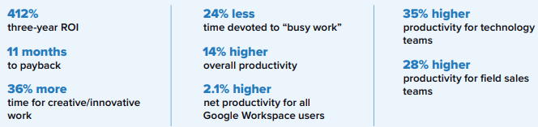
Figure 5: Google core values
(Source: Google, 2023d)
Underlying Beliefs: The third level consists of the employees' presumptive beliefs, which influence the organisational culture even if they are immeasurable. Some information and thoughts are kept secret, yet they do have an impact on the organisational culture. In contrast, male staff members tend to be more assertive and would not experience any issues with tardiness. Regarding the belief, Google said that it will be awarding a £1 million grant through Google.org financing to promote economic opportunities for those with impairments in the UK and around Europe (Google Diversity Annual Report, 2023). The third level of organisational culture encompasses the inner workings of human nature.

3.2 Discuss in detail, one ethical dilemma likely to influence the culture of the organisation.
According to the views of Al Halbusi et al. (2021), numerous external as well as internal variables influence ethical conduct in the workplace. Recognize how individual variables, cultural variables, and contextual possibilities impact ethical conduct in the workplace. For example, Google was chastised after it emerged that the business collaborated with the Chinese government on a secret initiative to filter features from certain of its websites in order to join the market (Center for Ethical Organisational Cultures, 2022). Furthermore, numerous countries are looking into and prosecuting Google over fears that its enormous influence and market dominance violate laws governing antitrust.

4. Organisational improvement

4.1 Areas of organisational improvements for Google’s culture
Whenever a company transitions from having a private to a public one, or the other way around, it generally experiences a little or major shift in its culture. In such instances, firms may be obliged to adapt their cultures in order to meet the needs of regulators. In this setting, in the opinion of Layton and Henten (2019), Google has experienced privacy issues, many of which persist to this day. Google is compelled to walk a narrow line between monetizing user data and abusing user confidentiality. Since Google can deliver customised marketing to advertisers through its data collecting, the business can give free access to the internet to its customers. At the same time, Google has engaged in dubious acts that appear to violate user rights and has faced opposition from government agencies on a number of privacy-related projects. With the potential of increased regulation, Google works to avoid legislation that is unfavourable to the firm from being approved. Because Google relies on monitoring and similar operations to be profitable, it has a vested interest in the privacy debate. Instead of viewing this purely as a disadvantage, Google may decide to strengthen its privacy standards and boost openness in its business practices. Google is responsible for ensuring that the interests of stakeholders are upheld. As per the views of Dahlander et al. (2021), although Google has achieved significant advances in ethical business practices, both the firm and society recognize that there is still space for growth. Because of its size, image, and history, Google has a unique potential for improving how businesses engage on the internet.

4.2 Recommendations that may enhance the company’s workplace culture in the future
The amplification of information sharing might be a potential benefit to Google's corporate culture. According to Lam et al. (2021), even while the characteristics of corporate culture encourage interaction and the transfer of information, the sharing of information is now carefully restricted. Google can change its organisational culture to give employees more independence in order to boost the rapidity and effectiveness of knowledge transmission. Another recommendation that can be made for the company is the inclusion of diversity in the workplace.

4.3 Indicate how the recommendations will positively affect organisational efficiency.
In order to improve the performance of the organisation application of the BEER’s model can be applied for increasing the organisational efficiency. This model will be effective for explicit the roles, responsibility and relationship of the main component for bringing the effective change within the organisational culture.
- Behaviour: Human resource programs geared to promote specialised innovation-focused tasks among staff members can help Google enhance its work culture.
- Effect: This recommendation seeks to use Alphabet's corporate culture in order to expand workers' understanding, abilities, and capacities for further capabilities in innovations in technology. This organisational culture attribute emphasises the social connections that employees have in the technology industry.
- Expectation: Google, for instance, promotes a welcoming work climate in which workers can readily converse and exchange ideas.
- Result: The goal is to harness Alphabet's organisational culture to improve internal interactions and idea creation for technology innovation. This aspect of Google's workplace culture also adds favourably to staff satisfaction.

4.4 Discuss the key barriers and how this can be improved – provide recommendations.
As per an anonymous comment, “Google always recruits the same individual profile over and over again” (Hakobyan, 2022). Hence, by adopting employee independence within the workplace, the company culture can be affected by including a diverse range of opinions from the employees. A diverse workplace, on the other hand, allows for further concepts and procedures. In the opinion of Otike et al. (2022), this diversity of talent implies that employees have a wider spectrum of talents in addition to a diversity of knowledge and opinions, which raises the possibility for enhanced productivity. According to Dover et al. (2020), a varied variety of cultures in the workplace enables businesses to deal with the various subtleties in an international marketplace. When people from distinct backgrounds and cultures collaborate, they have the ability to be more creative. This is due to the increased number of people with diverse viewpoints and responses to problems, which increases the likelihood of a practical solution to a professional issue.
Hence, in order to improve the diversity issues inside the company, Google ought to draw in a diverse range of individuals, as well as ensure that job ads and job postings are impartial and devoid of bias. Further, the company is recommended to ensure that applicants are interviewed by a variety of people inside the organisation and encourage workers to concentrate on other people's talents and form cross-functional groups so that people from all backgrounds may collaborate. Also, as per the views of Houser (2019), diversity training can help encourage employees to tolerate variations and appreciate the perspectives of others and diversity awareness education promotes and strengthens employer inclusion efforts.

5. Conclusion
In conclusion, it is seen from the report that Google's primary corporate purpose is to organise the world's knowledge and make it widely accessible and useful. Google had 156,500 full-time workers in 2021, indicating improved employee engagement. The study's literature was related to Google and organisational culture, ethics, and other topic-oriented criteria. Theories and models such as Schein's organisational cultural triangle and others have been examined in the research in order to show organisational culture and others. Google is widely regarded as the most technologically advanced firm with the greatest corporate culture, as recognized by Forbes Technology Council members. This renowned Google ethos motto serves to sustain the company's labour policy, which helps its employees obtain better cultural activities, a stress-free office atmosphere, and fewer disagreements. Google's shared values state that the corporation adheres to specific value-based aspects such as honesty, usefulness, privacy, security, and free expression, among others. Given that Schein's Google Cloud is available, construct local private libraries throughout the world and preserve artefacts close to computing resources. All concerns are communicated to the firm in a single spot via Google Workspace, where the company manages registration, rather than to various agencies individually. According to the article, Google will provide a £1 million grant through Google.org finance to develop economic prospects for people with disabilities in the UK and across Europe. However, it can be observed that Google has had privacy concerns, that Google has participated in dubious behaviours that appear to violate user rights, and that Google has received pushback from government authorities on a number of privacy-related initiatives. In this context, it is suggested that the organisation increase the speed and efficacy of information transmission while also incorporating diversity into the workplace.

List of References
Al Halbusi, H., Williams, K.A., Ramayah, T., Aldieri, L. and Vinci, C.P., 2021. Linking ethical leadership and ethical climate to employees' ethical behaviour: the moderating role of person–organisation fit. Personnel Review, 50(1), pp.159-185.
Alphabet Investor Relations, 2023. Google Code of Conduct. Alphabet Investor Relations. Available at: https://abc.xyz/investor/google-code-of-conduct/ (Accessed: 16 October 2023).
Centre for Ethical Organisational Cultures, 2022. Google’s search for solutions to privacy issues - Raymond J. Harbert ... Available at: https://harbert.auburn.edu/binaries/documents/center-for-ethical-organizational-cultures/cases/google.pdf (Accessed: 25 October 2023).
Dahlander, L., Gann, D.M. and Wallin, M.W., 2021. How open is innovation? A retrospective and ideas forward. Research Policy, 50(4), p.104218.
Dover, T.L., Kaiser, C.R. and Major, B., 2020. Mixed signals: The unintended effects of diversity initiatives. Social Issues and Policy Review, 14(1), pp.152-181.
Ezra, W. and Charles, M., 2023. Organisational Culture Among Religious Founded Schools in Enhancing Teachers’ Performance: A Case Study of Bishop Willigers Secondary School in Bugiri District, Eastern Uganda. Research and Advances in Education, 2(9), pp.61-73.
Forbes, E. 2023. Council Post: 13 Reasons Google Deserves Its “Best Company Culture” Award. Forbes, 12 September. Available at: https://www.forbes.com/sites/forbestechcouncil/2018/02/08/13-reasons-google-deserves-its-best-company-culture-award/?sh=5d74ac493482 (Accessed: 1 November 2023).
‌GlobalData Plc, 2023. Google’s Employee Headcount (2004 – 2021). Available at: https://www.globaldata.com/data-insights/technology--media-and-telecom/googles-employee-headcount/ (Accessed: 11 October 2023).
Google Diversity Annual Report, 2023. Diversity annual report - google diversity equity & inclusion, Diversity Annual Report - Google Diversity Equity & Inclusion. Available at: https://about.google/belonging/diversity-annual-report/2023/ (Accessed: 22 October 2023).
Google, 2019. Philanthropic Initiatives For Local Communities - Google.org. Available at: https://www.google.org/our-work/#:~:text=At%20Google.org%2C%20we%20 provide,the%20global%20 COVID%2D19%20response. (Accessed: 20 October 2023).
Google, 2022. Accelerating the Transition to a Circular Economy - Google Sustainability. Available at: https://sustainability.google/operating-sustainably/circular-economy/#:~:text=a%20circular%20economy-,Google%20is%20working%20to%20accelerate%20the%20transition%20to%20a%20circular,Design%2Dout%20waste%20and%20pollution. (Accessed: 18 October 2023).
Google, 2023a. Google - About Google, Our Culture & Company News. Available at: https://about.google/intl/ALL_in/ (Accessed: 10 October 2023).
‌Google, 2023b. Sustainable Innovation & Technology - Google Sustainability. Available at: https://sustainability.google/#:~:text=Pursuing%20net%2Dzero%20emissions%20through,and%20value%20chain%20by%202030. (Accessed: 18 October 2023).
Google, 2023c. Artefact registry | google cloud, Google. Available at: https://cloud.google.com/artifact-registry (Accessed: 23 October 2023).
Google, 2023d. The Business Value of Google Workspace - Google Search. Available at: https://services.google.com/fh/files/misc/business_value_of_google_workspace_whitepaper.pdf (Accessed: 24 October 2023).
Hakobyan, A., 2022. Company culture at google, Employee Experience Magazine. Available at: https://www.emexmag.com/company-culture-at-google/ (Accessed: 25 October 2023).
Houser, K.A., 2019. Can AI solve the diversity problem in the tech industry: Mitigating noise and bias in employment decision-making. Stan. Tech. L. Rev., 22, p.290.
Indeed, 2022. What Is Organisational Culture?. Available at: https://in.indeed.com/career-advice/career-development/organisational-culture (Accessed: 12 October 2023).
Lam, L., Nguyen, P., Le, N. and Tran, K., 2021. The relation among organisational culture, knowledge management, and innovation capability: Its implication for open innovation. Journal of Open Innovation: Technology, Market, and Complexity, 7(1), p.66.
Layton, R.M. and Henten, A.H., 2019. How Policy Is Failing to Secure Privacy on Platforms.
‌Linkedin, 2023. Corporate Ethos. Available at: https://www.linkedin.com/pulse/corporate-ethos-delwar-hossain (Accessed: 12 October 2023).
Nieva, R. 2021. ‘Don’t be evil’: Google’s iconic mantra comes into question at labour trial. Available at: https://www.cnet.com/tech/tech-industry/dont-be-evil-googles-iconic-mantra-comes-into-question-at-labor-trial/ (Accessed: 15 October 2023).
Oh, S.Y. and Han, H.S., 2020. Facilitating organisational learning activities: Types of organisational culture and their influence on organisational learning and performance. Knowledge Management Research & Practice, 18(1), pp.1-15.
Otike, F., Messah, O.B. and Mwalekwa, F.K., 2022. Effects of workplace diversity management on organisational effectiveness: a case study.
Roscoe, S., Subramanian, N., Jabbour, C.J. and Chong, T., 2019. Green human resource management and the enablers of green organisational culture: Enhancing a firm's environmental performance for sustainable development. Business Strategy and the Environment, 28(5), pp.737-749.
Shim, J., Moon, J., Lee, W.S. and Chung, N., 2021. The impact of CSR on corporate value of restaurant businesses using triple bottom line theory. Sustainability, 13(4), p.2131.
Shirin Ghaffary and Kantrowitz, A. 2021. Don’t be evil’ isn’t a normal company value. But Google isn’t a normal company. Available at: https://www.vox.com/recode/2021/2/16/22280502/google-dont-be-evil-land-of-the-giants-podcast (Accessed: 14 October 2023).
Spicer, A., 2020. Organisational culture and COVID-19. Journal of Management Studies, 57(8), pp.1737-1740.
‌Statista, 2022. Google revenue 2002-2022 | Statista. Statista. Available at: https://www.statista.com/statistics/266206/googles-annual-global-revenue/ (Accessed: 10 October 2023).
World of Work Project, (2021) Edgar Schein’s organisational culture triangle: A simple summary, The World of Work Project. Available at: https://worldofwork.io/2019/10/edgar-scheins-culture-triangle/#:~:text=Edgar%20Schein’s%20Organizational%20Culture%20Triangle%20details%20three%20layers%20of%20organizational,actual%20culture%20of%20an%20organization. (Accessed: 20 October 2023).

