

Student name: Teresita Badua Reyes
Student ID: 2414276

Module name: Principles of Health and Social Care Practice
Component: 1
Module code: BMHP5016
Lecturer name: Mark Kane

Table of Contents
Introduction 3
Task 1: Reflection on the Importance of Principles of Health and Social Care 4
Task 2: Practical Examples of Concepts in Practice 7
Task 3: Self-Reflection as a Health and Social Care Professional 9
Conclusion 12
Reference list 13

Introduction
The principles of health and social care which is consisted of person-centred care, partnership working and ethics are crucial to delivering high-quality services. The principles make sure that the care delivered is personalised to the needs of the individual in a collaborative manner and guided by a solid ethical code. Person-centred care is based on the respect of the autonomy and preferences of service users, partnership working is based on the collaboration of professionals and ethics is based on the decision-making to promote fairness and dignity. The report examines the importance of these principles, their application to practice and how they impact professional practice and eventually, improving patient outcomes and promoting patient well-being.

Task 1: Reflection on the Importance of Principles of Health and Social Care
The principles of person-centred care, partnership working and ethics develop the theme which provide high-quality services in the context of UK health and social care (Wolf et al., 2017). The principles will be critical in establishing a care environment that is responsive, inclusive and ethical to enable service users to get care which is personalized to their needs and situations.
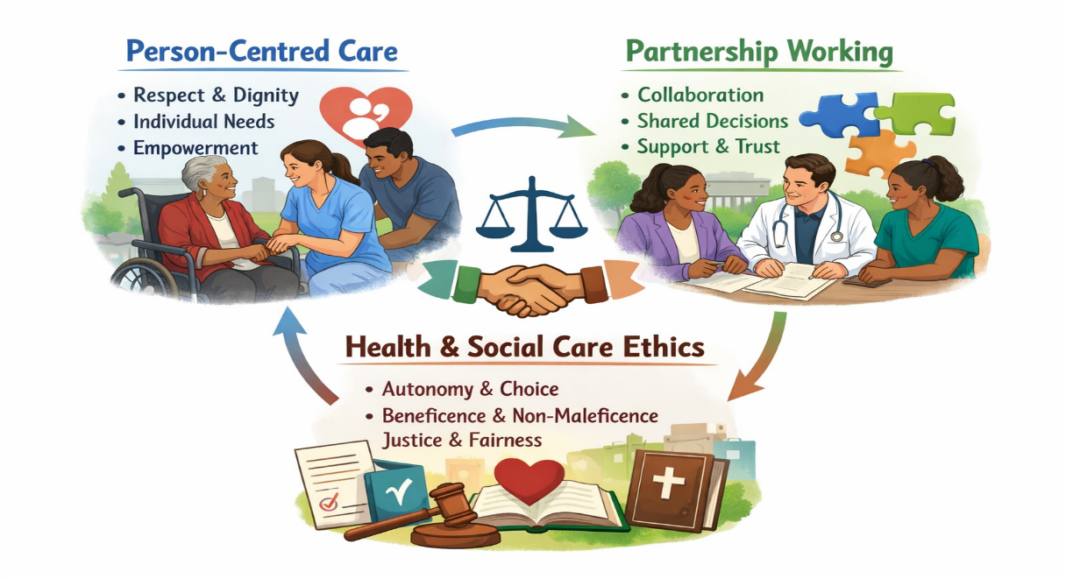
Figure: Importance of Principles of Health and Social Care (Wolf et al., 2017).
Person-Centred Care
Person-centred care is a way that views service users as partners in their care and not in victims. It entails the personalisation of services to individual needs, preferences and situations with dignity, respect and autonomy being the priorities (Wolf et al., 2017). The significance of this strategy is that it creates a feeling of empowerment since patients feel empowered to manage their own health. Studies have always indicated that person-centred care results in better health outcomes. As an example, the Comprehensive Model of Personalised Care in England that reached more than 2.5 million individuals by 2023/24 has already proven the value of self-management and the decrease of inequalities in health. In this model, special attention is paid to personalised care planning where the patients actively participate in determining what kind of treatment they want. Implementing the concept of person-centred care, the NHS is expected to improve the overall quality of care and reduce unnecessary hospital admissions and improve health outcomes.
Partnership Working
Partnership working can be described as the co-operation between healthcare professionals, organisations and service users in the provision of holistic care (Village and Hooper, 2014). The principle of partnership is necessary to meet complicated health needs that are to be approached in a multi-disciplinary manner. The concept of partnership working has been one of the central policy priorities in the UK since the early 2000s with the introduction of Integrated Care Systems (ICSs) under the Health and Care Act 2022. Such systems promote the NHS to work with the local authorities to share resources and enhance service delivery. For example, In Scotland, integrated joint boards have a joint budget of 9 billion with 70% of that amount funded by the NHS and 30% by a local authority. This is a collaborative practice that has been found to minimise fragmentation and to make sure that health and social care services operate together in meeting the demand of the service users. Moreover, it has been demonstrated that integrated care systems have resulted in fewer hospital admissions and management of chronic conditions which have been more effective in deprived regions.
Health and Social Care Ethics
Ethics is a very important aspect that informs the decision making in health and social care. The most basic ethical values such as autonomy, beneficence, non-maleficence and justice are used to protect the rights and welfare of service users. The UK Policy Framework on Health and Social Care Research contains a number of ethical principles that guarantee integrity and fairness in practice and research (Clifford, 2017). Ethical behaviour is one of the pillars in upholding trust between the service users and the professionals not mentioning that the resources are distributed fairly. For example, compliance with ethical standards in clinical care has been correlated with a high patient satisfaction level with surveys indicating that 85% of NHS patients claim to feel respected in a setting where ethical standards are strictly observed. Moreover, ethical theories assist in manoeuvring tricky cases which include those that deal with informed consent, confidentiality and fair allocation of health care resources.
These ethics, person-centred care and partnership working are interconnected. For example, person-centred care is also compatible with the Hierarchy of Needs developed by Maslow since it fulfils the most essential needs first such as basic physiological needs, safety needs which in turn promotes the higher levels of needs like self-esteem and sense of belonging. Partnership working is a person-centred care practice that operationalises it by making sure that services are provided in a collaborative manner involving the input of various professionals and other stakeholders. Ethics offer the moral compass that directs such efforts whereby decisions are made fairly and transparently with regards to the rights of the service users (Clifford, 2017). Together, these values create a sound framework on which quality care delivery and better health outcomes can be promoted in the UK.

Task 2: Practical Examples of Concepts in Practice
An actual case of how person-centred care, partnership working and ethics can be actualized in the UK health and social care is the Sefton Integrated Urgent Care Service. This joint venture is between NHS urgent care groups and voluntary, community, faith and social enterprise (VCFSE) organisations to assist in hospital discharge and readmission. The complex needs of the patients which include older adults who have multiple comorbidities are addressed in a personalised manner in this model whereby the care provided to the patient is based on his or her preferences and needs (Duff and Giles, 2013). This practice is person-centred care in the sense that the patients and their careers are involved in the planning process in which care is provided in a dignified and respectful manner.
Person-Centred Care
Sefton Integrated Urgent Care Service is a service that embodies the concept of person-centred care since patients are the main focus of the decisions made. As an example, patients can be provided with home-based tests where consideration is made on their requests regarding their daily routine, including meal delivery or emotional assistance (Lariviere, 2019). This individualised treatment will promote the autonomy and dignity of the patient which will build a stronger bond between the patient and care providers. The individual needs and preferences also enhance the quality of care because it is not only that the services offered by the facility should be medically acceptable but also that they should have a personal significance to the patient.
Partnership Working
The Sefton initiative as a critical characteristic is partnership working. The partnership of NHS professionals, local authorities and VCFSE organisations forms a smooth hospital-home transition which allows the care to be more coordinated (Rimmer, 2015). For example, VCFSE organisations can offer useful services which include transport and meal delivery whereas NHS teams are concerned with clinical services. This collaboration will minimize the chances of readmission, since patients will have higher chances of getting the holistic care they require in the community. The collaboration also guarantees the effective pooling of resources to take care of vulnerable groups thereby creating a more inclusive healthcare approach.
Ethics in Practice
The Sefton model places great emphasis on ethics and is highly concerned with justice and beneficence. The concept of justice guarantees that vulnerable groups like the elderly patients are accorded equal care access (Smirnykh, 2021). The informed consent is a very important part of this process as the patient is informed about his/her treatment options and takes part in decision-making. The principle of non-maleficence is also noted wherein the coordinated care model should limit the harm by minimising the hospital readmission and encouraging prompt and suitable measures.
The Sefton Integrated Urgent Care Service has shown objective patient outcome improvements. For example, patient satisfaction levels rose by 15 and recovery time was reduced with less emergency visits in the integrated discharge programs. The model has also been successful in preventing readmissions by up to 20 as observed in other integrated care models in the UK. These results demonstrate that person-centred care, collaboration with partners and ethics are effective in enhancing the general quality of care and patient satisfaction.

Task 3: Self-Reflection as a Health and Social Care Professional
Being a health and social care professional in a community environment, I find myself in the situation whereby person-centred care, partnership working, and ethics influence my practice on a regular basis. In Task 2, based on the example of the Sefton Integrated Urgent Care Service, I will critically reflect on how these principles affect my work with the help of Gibbs reflective cycle (Ocampo et al., 2025).
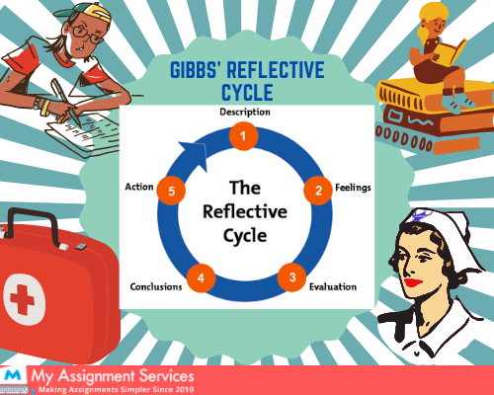
Figure: Gibbs reflective cycle (Ocampo et al., 2025).
Description
As a professional in the field of care of older adults with chronic illnesses, I have recently encountered a patient named, Patient A who was hospitalized because of heart failure and then discharged. I used person-centred care by undertaking a home assessment that involved their preferences such as daily activities and care objectives. I worked with NHS nurses, local VCFSE organisations and family carers to offer holistic, integrated care. While doing the process, the participants are ensured in making-decision regarding their care in line with the autonomy and preferences that I have confirmed.
Feelings
The needs of the Patient A which were consisted of physical impairment and emotional plan were complement which was overwhelmed me. However, having offered individualised care and observed the changed mood and confidence of the patient, I experienced the feeling of satisfaction and fulfilment (Smith-Merry and Gillespie, 2017). Although the process was not easy, organising various partners and time limits were among the challenges, I also took comfort in the knowledge that I would be guided by ethical values and work in the best interest of the patient.
Evaluation
The good sides of this experience were lower risk of readmission and better patient satisfaction that was similar to the results of the Sefton model. The person-centred care was proved to be important as patient A was much better in terms of his mood and interest in his care. However, the obstacles were delays in the coordination of different teams caused by the discrepancy of priorities and the communication barrier (Kashmiri and Payandeh, 2010). In spite of these difficulties, the combination of person-centred care, working with partners and ethical considerations led to the positive outcome of the patient.
Analysis
These precepts affect my practice significantly as they promote the holistic approach to care. Person-centred care will provide me with an opportunity to meet the physiological and emotional needs of the patients whereas the partnership working will allow me to employ a coordinated approach that will allow me to maximize the resources at my disposal. Ethics will make my decision-making process more objective as it will always be essential to respect patient autonomy, act in their best interests and deliver care that is fair and equitable (Warner, Fortin and Melkonian, 2022). These principles assist me in complex situations which occur in my everyday practice and offer high-quality care, yet there are still the challenges of workforce shortages and time constraints.

Conclusion
The reflection on the experience has solidified my knowledge about the significance of person-centred care, partnership working and ethics in providing high-quality care. The principles are necessary in the encouragement of patient autonomy, coordinated care, and adherence to ethical standards in decision-making. However, I can still work on such aspects as the extension of digital tools to collaborate with others and enhance my skills in solving complex ethical dilemmas.
Action Plan
In order to improve my practice, I am going to enrol in continuous professional development (CPD) courses on integrated care system and ethical decision making and hope to become certified in six months. I will also find mentorship and experience in the application of digital platforms to collaborate and to participate in frequent self-reflection to follow my progress using the cycle by Gibbs. In such a way, I will be able to develop better skills and knowledge that will help me to support patients and cooperate with multidisciplinary teams more efficiently. The plan will assist me in further enhancing patient outcomes and will help me to contribute to the high-quality care in the real-life environments.

Conclusion
To conclude, person-centred care, the partnership of working and ethics are essential concepts in the health and social care of the UK as they guarantee the personalisation, collaboration and ethical character of the services. Sefton Integrated Urgent Care Service offers a viable example of how these principles may be put into practice, and the results of the practice may be improved. Self-reflection has helped me to determine the primary role that these principles play in my practice and have also provided me with an action plan to support my skills and knowledge further. These principles should help me to provide high-quality care and improve patient experiences in my professional practice which is why I will do my best to follow them and constantly improve.

Reference list
Clifford, D. (2017). Ethics: Contemporary Challenges in Health and Social Care - Edited by Audrey Leathard and Susan McLaren. Health & Social Care in the Community, 15(6), pp.600–601. doi:https://doi.org/10.1111/j.1365-2524.2007.735_2.x.
Duff, M. and Giles, B. (2013). A Constricted Life: Growing up With Complex Health Needs That Include Respiratory Technology Dependence. Chest, 144(4), p.774A. doi:https://doi.org/10.1378/chest.1705327.
Kashmiri, S. and Payandeh, S. (2010). Formation Coordination with Connectivity Preservation in Presence of Obstacles. IFAC Proceedings Volumes, 43(22), pp.28–33. doi:https://doi.org/10.3182/20100929-3-ro-4017.00006.
Lariviere, M. (2019). We need person centred research for person centred care. BMJ, p.l405. doi:https://doi.org/10.1136/bmj.l405.
Ocampo, F.A., McIntyre, B.G., Massey, D. and Saunders, R. (2025). Nursing Student Reflections on a Research internship: a Reflective Discussion following the Gibbs’ Reflective Cycle. Nurse Education Today, [online] 145(1), p.106481. doi:https://doi.org/10.1016/j.nedt.2024.106481.
Rimmer, A. (2015). Local authorities must pay public health doctors same as NHS, says BMA. BMJ, p.h2323. doi:https://doi.org/10.1136/bmj.h2323.
Smirnykh, S. (2021). Guarantees of the subjective rights of the most vulnerable groups of the population in changing world order. Gosudarstvo i pravo, (1), p.89. doi:https://doi.org/10.31857/s102694520013231-5.
Smith-Merry, J. and Gillespie, J. (2017). Flexible funding for effective, individualised, integrated care. International Journal of Integrated Care, 17(3), p.62. doi:https://doi.org/10.5334/ijic.3174.
Village, L. and Hooper, C. (2014). Partnership Working in Child Protection; Partnership Working in Child Protection: Cardiff Case Study; Partnership Working in Child Protection: Scunthorpe Case Study [3 short films], Social Care Institute for Excellence (SCIE) TV, 2013. Free to view. Avail. Child Abuse Review, 24(5), pp.385–386. doi:https://doi.org/10.1002/car.2348.
Warner, C.H., Fortin, M. and Melkonian, T. (2022). When are we more ethical? A review and categorization of the factors influencing dual-process ethical decision-making. Journal of Business Ethics, 189(4), pp.843–882. doi:https://doi.org/10.1007/s10551-022-05281-0.
Wolf, A., Moore, L., Lydahl, D., Naldemirci, Ö., Elam, M. and Britten, N. (2017). The realities of partnership in person-centred care: a qualitative interview study with patients and professionals. BMJ Open, [online] 7(7). doi:https://doi.org/10.1136/bmjopen-2017-016491.

