Assignment 2 Material SCIENCE

University of Wales Trinity Saint David’s

Ryan Tillman Davies
Student Number : 1910414
Subject: Architectural Technology (Year 1)


Table of Contents
Ryan Tillman Davies 1
Task A 3
A1 - Room Index 3
A2 - Utilisation Factor 3
A3 - Number of Lamps Required 4
A4 - Suitable Layout 5
Diagram 1 – Scale 1:200 5
Layout Conclusion 5
Task B – Sound Reduction Index 6
B1 – Brick Wall and Window Calculations 6
B2 – Area Calculation 7
B3 – Sound Reduction Index Calculation 7
B4 - Implications of frequency and wavelength in internal sound management, partition wall construction technique and insulation choice. 8
Conclusion 10

Task A

A1 - Room Index

L= 60m
W= 24m
H= 8m

RI = x

$$RI=\frac{L x W}{H(L+W)}$$

$$RI=\frac{60 x 24}{8(60+24)}=\frac{1440}{672}=2.14$$

Room Index = 2.14

A2 - Utilisation Factor

Utilisation factor = 0.46

A3 - Number of Lamps Required

E=200
A= 60x24=1440
F=18000
UF=0.44
LLF=0.75

$$Number of Lamps Required=\frac{E x A}{F x UF x LLF}$$

$$Number of Lamps Required=\frac{200 x 1440}{18000 x 0.46 x 0.75}=\frac{3200}{69}=46.37681159420289$$

Lamps Required = 46.37681159420289

Lamps Required = 48 lamps (Rounded)

A4 - Suitable Layout

Smax = 1.5 x Hm
Smax = 1.5 x 7m = 10.5m
½ Smax = 5.25m

Diagram 1 – Scale 1:200
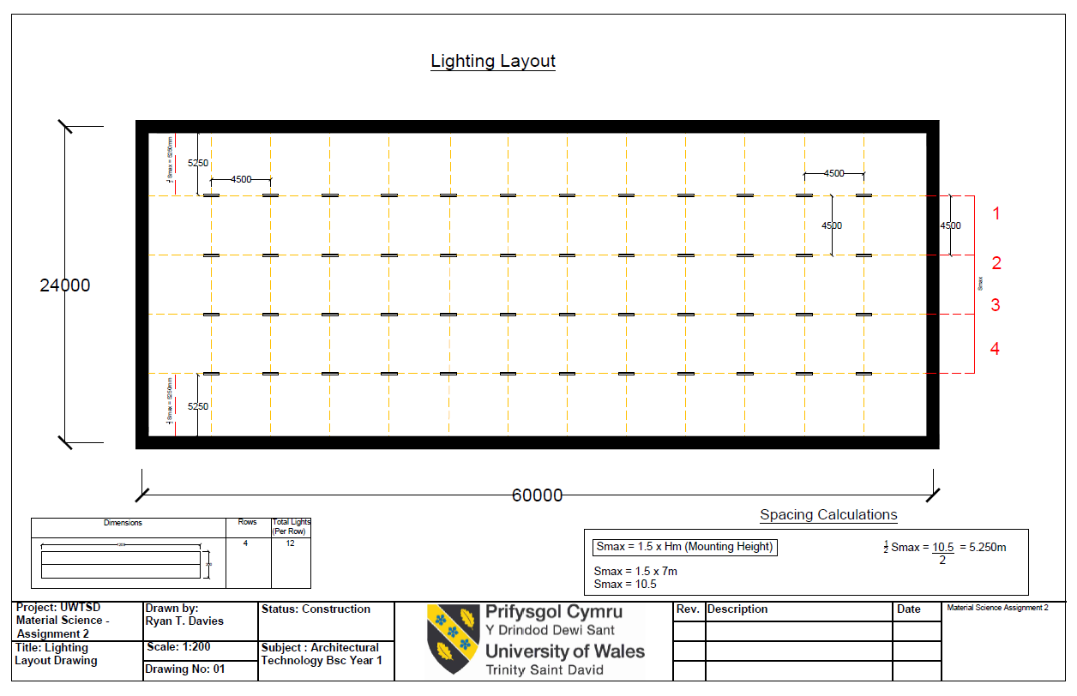
Please refer to the dwg. CAD file and scaled pdf document titled 01-Lighting Layout

Layout Conclusion

Total Lights: 48
Number of Rows: 4
Spacing Center to Center of Lights = 4500mm

Task B – Sound Reduction Index

$$SRI=10 x (Log10 \frac{1}{T1} )$$

B1 – Brick Wall and Window Calculations

Brick Wall – 16m²

$$50=10 x (Log10 \frac{1}{T1} )$$

$$5=10 x (Log10 \frac{1}{T1} )$$

$5=10 x (Log10 \frac{1}{T1} )$

$$\frac{1}{T1}={10}^{5}$$

$$T1={10}^{-5}$$

Window – 4m²

$$SRI=10 x (Log10 \frac{1}{T1} )$$

$$10=10 x (Log10 \frac{1}{T2} )$$

$$1=10 x (Log10 \frac{1}{T2} )$$

$$\frac{1}{T2}={10}^{1}$$

$$T2={10}^{-1}$$

B2 – Area Calculation

$$T_{0}=\frac{\left(T1 x A1\right)+(T2 x A)}{A1+A2}$$

$$T_{0}=\frac{\left({10}^{-5} x 16\right)+({10}^{-1} x 4)}{16+4}=\frac{\left(0.00001 x 16\right)+(0.1 x 4)}{20}$$
$$T_{0}=\frac{\left(T1 x A1\right)+(T2 x A)}{A1+A2}$$

B3 – Sound Reduction Index Calculation
$$SRI=10 x (Log10 \frac{1}{T} )$$

$$SRI=10 x (Log10 \frac{1}{0.020008} )$$

$$SRI={10 x (Log 10 (49.98008)}^{}$$

$$SRI={10x 1.698796321)}^{}$$

$$SRI=16.98796321 dB$$

Sound Reduction Index = 16.98796321dB

B4 - Implications of frequency and wavelength in internal sound management, partition wall construction technique and insulation choice.

Any pressure variation that the human ear can detect defines what sound is, typically caused by vibrations that are caused by moving objects or movement of air. This travel of sound waves spread via adjacent particles that lose energy as they travel away from the source. This speed varies depending on the medium, in air sound has a speed of approximately 340m/s. The audible range of sound for humans is typically from 20 Hz to 20,000 Hz, although, through ageing and exposure to loud sounds the upper limit will generally affect this. (Designing Buildings Wiki, Accessed 05/03/20)
Sound frequency is a quickly varying pressure wave travelling through a medium. It is measured by the number of variations passing a given point per second. Pitch is the frequency of a sound as perceived by humans. Low-pitched notes cause basal sounds which are caused by low frequency sound waves and high frequency waves cause treble sounds. Long-wavelength sounds can diffract around corners and wriggle through the tiniest cracks and openings and make them especially difficult to deter the transfer through walls. Compared to high frequency (Woodford, Accessed 01/03/20)
Diagram 2 -(Woodford, Accessed 01/03/20)
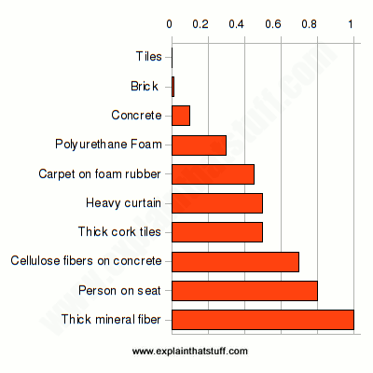

Different objects all have a natural frequency that vibrates sound waves at different rates when disturbed. Natural frequency is determined by characteristics such as shape, density and stiffness of objects. When sound is created by an external source and travels to your ears, on the journey the sound energy is transmitted right through the solid glass in windows, timber and concrete/stone that is the make up of a typical wall construction. This transmission causes vibration which allows the sound to enter a home. The cavity within a cavity wall provides a separation between the dense concrete blocks that acts as a sound insulation as sound travels slower through air/gas compared to solid materials. (Home & Renovating, No Date)

Sound transfer standards for constructions is enforced by the Building Regulations in Approved Document E and by following the Robust Details. Typical methods of reducing sound would be to block any direct air pathways internally to externally such as using double layers of glazing for windows that contain Argon a noble gas between panels that absorb sound wave energy. To increase the standard of sound efficiency ensuring that seals in windows and doors are installed correctly as they will deter sound from entering as well as more dense doors. dampen sound energy travelling through walls.

Interior design can affect the sound reflection and absorption of a space. Once the incoming sound has been reduced different furniture and materials can determine how much sound is reflected or absorbed. Carpets, blankets, pillows and soft materials act as great absorbing materials which explain how rooms sound different when they are emptied. Materials such as tiles in bathrooms reflect sound and create an echo effect when in contact with sound within a space. (Woodford, Accessed 01/03/20)

Partition Wall Design

Diagram 3 – Timber Stud Partition Wall (Isover Saint-Gobain, No date)

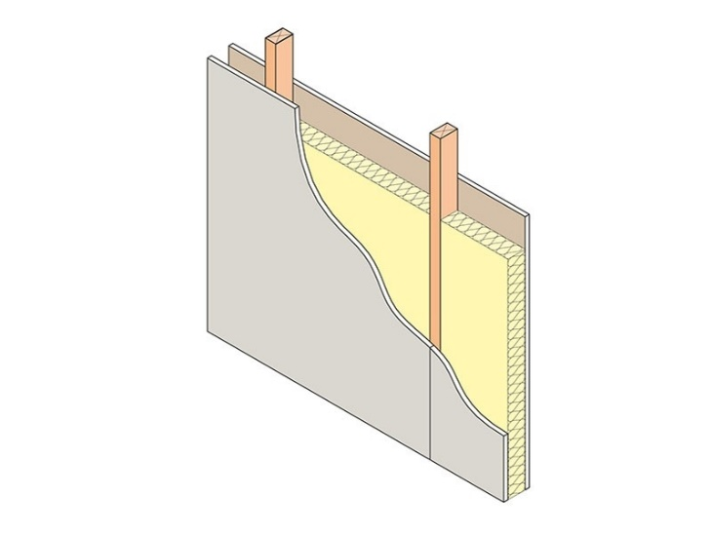
Rigid insulation types such as Kingspan / Celotex are better insulators than the alternatives and so they are thin that reduces space lost. They can also incorporate a vapor barrier but lack in breathability properties and can be considered more expensive than other types. Mineral wools are semi rigid and are widely used in batts or quilts that are more efficient at absorbing sound with fibrous make up. As stated in approved document L, a wall u-value is required to achieve 0.18. The best option for insulating a partition wall would be a fibrous insulation such as mineral fiber slabs typically 10kg per m³. (Home & Renovating, No Date)

For room such as bathrooms and bedrooms there is a requirement to achieve a minimum 40dB in approved document E but for a better-quality result it is advised to perhaps achieve a higher insulated rate for sound proofing. Which can be achieved using a 50mm x 100mm C16 softwood timber partition stud wall while incorporating a sound rated plasterboard instead of a wall board. studs are fixed vertically to the sole plate to the head plates while horizontal battens fit between them which allows the plasterboard to be fixed. Noggins will be required to strengthen the wall typically 38mm and for the 12.5mm plasterboard sheet a spacing of 600mm is required for the studs in order to fix the plasterboard correctly. To ensure air tightness for sound proofing the partition must be lined internally which can be done with a vapor barrier in perhaps aluminum or polythene products which is pinned to the studwork (Build it, 03/03/20)

Conclusion

I have calculated that there is a requirement of 48 lamps in a row of 4 spaced at 4500mm centers from each other beginning the first row with ½ Smax being 5250mm from the wall. Additionally, I have calculated the Sound Reduction Index of the space to be 16.98796321dB.

References

Build It, (03/03/20) (Accessed 20/03/20)
https://www.self-build.co.uk/insulating-soundproofing-internal-walls/

Chris Woodford, (No Date) (Accessed 05/03/20)
https://www.explainthatstuff.com/soundproofing.html

Designing Buildings (No Date) (Accessed 03/03/20)
https://www.designingbuildings.co.uk/wiki/Building_acoustics

Home Building & Renovating (09/09/19) (Accessed 03/04/20)
https://www.homebuilding.co.uk/internal-wall-insulation/

Isover Saint-Gobain (No date) (Accessed 24/04/20)
https://www.isover.co.uk/solutions/applications/internal-partition-walls-timber-stud

Kingspan (No Date) (Accessed 03/04/20)
http://www.uvalue-calculator.co.uk/confirmation/

