Individual Presentation and Marketing Plan
Student name: Larisa Afloarei
Student ID number:2243427
Lecturer’s name: Gayathri Mudiyanselage
Word Count:1349

Table of Contents
Marketing Plan 3
1. Introduction 3
2. Situation Analysis 3
Company: SWOT analysis (Microanalysis) 3
Customers: Segmentation and Targeting/ Customer profiles SimilarWeb!! 3
Climate: PESTLE (Macro analysis) 4
-Marketing Mix 4
3. Objectives 5
-SMART target 5
4. Strategy 6
VRIO analysis of Holiday Inn 6
Ansoff Matrix 7
RACE analysis 7
6. Action 8
8. Conclusion 8
9. References 9
10. Appendix…………………………………………………………………………………11

Marketing Plan

1. Introduction
As expressed by Mukonza and Swarts, (2020, p.838), A marketing plan defines as an operational document that is the potential to generate an advertising strategy that the organization can supply in its daily course to gain market position and vast consumer reach. The marketing plan could be generated for numerous reasons starting from new product launches to developing an understanding of the prevailing market environment.
The marketing plan generated in the presentation will be based on the marketing needs of the Holiday Inn. It has done a good demonstration of how the hospitality sector can build a strong market grip and the same will be discussed below.

2. Situation Analysis 5Cs
Company: SWOT analysis (Microanalysis)
Strength Holiday Inn
- The combination of leisure and comfort services provider.
- Biggest hotel chain under IHG.
- High brand and parent company value.
- Multiple subsidiary profit-making hotels.
Weaknesses Holiday Inn
- The degrading consumer review.
- The 2017 hacking of 1200 Holiday Inn franchisees has affected the reputation of the hotel.
- A huge number of potential competitors prevail in the market.
Opportunity Holiday Inn
- Exploring the new market.
- The research on the expansion of the quality service provided.
- Expanding the market by offering an affordable price range of hotels.
- The increasing market acquisition of the parent company (He, et al., 2021, p.1043).
Threat Holiday Inn
- High level of potential competitors in the market.
- Increasing legal control over the hospitality sector (Yu and Akita, 2019, p.385).

Customers: Segmentation and Targeting/ Customer profiles SimilarWeb!!
Segmentation
Holiday Inn targets the consumer on demographic as well as geographic segmentation. The hotel targets those populations who are looking for affordable hotels with comfortable stays.
The hotels target the population who are leaning toward premium pricing and luxury stay (Zhang, et al., 2020, p.400).
Targeting
Income group Middle to Rich income group.
Age group 18 to 85 years
Location Globally
Competitors: Perceptual positioning map Holiday Inn is rank low in price and high quality. (appendix 1)
Climate: PESTLE (Macro analysis)

Factors | Holiday Inn
Political factors | Labour availability and currency value decrease have resulted in more inflow of tourists in the post-Brexit. period.
Economic factors | The diversifying economy of the UK is facilitating diverse scope of experience and cuisine introduction in Holiday Inn (Zhang, et al., 2020, p.400).
Socio-cultural factors | The changing demographics of the UK are increasing the scope for diversification of the country (Scheelbeek, et al., 2020, p.705).
Technological Factors | The introduction of cloud computing and mobile technology in the operations of the Holiday Inn.
Legal Factors | Various Laws are imposed on the hospitality sector like data protection and consumer protection.
Environmental Factors | The degrading environmental condition of the UK is affecting the company widely.

-Marketing Mix

Marketing Mix | Comparison
Product | Holiday Inn provides comfortable and affordable service which suffice the need of middle-class group.
Price | Holiday Inn follows competitive pricing.
Place | The company operates on the global level but it targets Asia, Europe, and America.
Promotion | It promotes through television and digital advertisement collaboration and endorsement.
Physical Evidence | Physical evidence of Holiday Inn is generated through Ambience and amenities provided by them.
Process | The organisation analyses the consumer review using market analysis (Zhang, et al., 2020, p.400).
People | The company operates under their parent company which holds 345000 employees in total.

3. Objectives

-SMART target

Objectives | Specific | Measurable | Attainable | Realistic | Time-bound
1. To enhance the productivity of the company | Eliminate the gap for any areas of dissatisfaction. | Consumer review and feedback. | Increasing the service quality by the company. | To expand the company's reach. | 6 months
2. To raise a new marketing budget | Attain optimum cost level. | To reduce the marketing cost. | Hiring some potential marketing analysts. | To understand the competitive market. | 3 months
3. To explore new markets. | Widening the brand reach. | Wider availability of the hotel facility in different regions. | By conducting segmentation analysis. | To get a better position in the global market. | 12 months

4. Strategy

VRIO analysis of Holiday Inn

Resource | Valuable | Rare | Hard to imitate | Organized | Degree
Technology | Yes | No | Yes | Yes | Competitive Parity
Hospitality package | No | Yes | No | Yes | Temporary competitive advantage
Pricing strategy | Yes | No | No | Yes | Unused Competitive Advantages
Human resource | Yes | Yes | No | No | Long-term competitive advantage

Ansoff Matrix (appendix 2)
Market Penetration: This term is defined as the scaling of existing products in the existing market structure.
Market Development: Market development refers to the entrance of companies into a new market with their previously developed products or services.
Product Development: It is the method used by those companies which desire to launch new products in the existing market structure.
Diversification: Diversification is the major aspect of bringing growth and change. It is a way of introducing the business with a new product into a new market.

5.Tactics

RACE analysis
The RACE defines as the important activities and measures to grow and survive in the market. RACE is widely preferred as this is goal-oriented, practical, consumer-centred, and multi-channel (Ghauri, 2014). RACE analysis can be conducted as Reach, Act, Convert, and Engage. The RACE analysis can reflect the required actions of Holiday Inn.
1. Reach
Holiday Inn has a strong market grip but its approach to increasing its penetration into developing economies is a weakness for the Holiday Inn to mitigate this, it is very important for the company to formulate an attractive website that has the potential to attract the consumer to the organization so that the company reach can increase and it can result in the creation of vast demand for the organization (Indah, et al., 2019, p.42).
2. Act
This step defines the way to encourage and invite invitations on the website (Housden, 2008). Upon the proper review generation of the company, the hotel can derive benefit from the reviews. A similar approach is taken as the attraction of the website through placing ads over various social media can grab the consumer's attention towards the company (Shapetheagenda, 2023).
3. Convert
As expressed by Kotler and Kartajaya, (2017), convert explains the way to make the consumer purchase the offered product or services by the organization.
4. Engage
Engage is responsible for the creation of long-term engagement with first-time buyers to further use it as a consumer loyalty towards the brand (Suruchi and Nagar, 2022).

6. Action (appendix 3)
Setting a target is important to understand the future objective of the organization and it was discussed in the 1st week. The marketing strategy to excel in the market position has been discussed every 2nd week and the phototype is discussed in week 3. The initial service idea formulation and review have been received in the 4th week along with that market testing on the manufactured product has been conducted. The marketing channel allocation of the organization has been evaluated in week 5 and the charges deliverance by the 6th week and in the final week, the service was finalized to be launched in the market.

7. Control
As per Li, et al., (2021), to control the various elements of the required aspects of the marketing plan various strategies are applicable.
KPI of Holiday Inn
The flexibility of the average daily rate is high in the case of Holiday Inn (Chakravarty and Zowada, 2022).
The revenue generation per available room is higher in Holiday Inn as the room are provided at a premium price (Sun and Ge, 2020, P.260).
The company is known to offer an affordable price and the average length of stay is also high due to the low-price range (Gupta and Venkateswaran, 2021).

8. Conclusion
The hospitality sector possesses a huge effect from all the factors of the internal as well as the external environment. The strategies and planning of Holiday Inn is very similar to each other as they operate under the same parent company. Various analyses and models have been used to understand the competitive position of the respective organisation. The various tools used in the analysis of the market demand of both organizations have been reflected. Further, it can be concluded that in some areas Holiday Inn is holding more potential.

9. References
Journal
Chakravarty, S. and Zowada, M., 2022. Dynamics of KPI lumps. Journal of Physics A: Mathematical and Theoretical, 55(19), p.195701. https://iopscience.iop.org/article/10.1088/1751-8121/ac37e7/meta
Ghauri, P N (2014) International Marketing, 4th Ed, McGraw Hill, London
Gupta, P.K. and Venkateswaran, N., 2021. The role of KPI-121 0.25% in the treatment of dry eye disease: penetrating the mucus barrier to treat periodic flares. Therapeutic Advances in Ophthalmology, 13, p.25158414211012797. https://journals.sagepub.com/doi/pdf/10.1177/25158414211012797
He, J., Morrison, A.M. and Zhang, H., 2021. Being sustainable: The three‐way interactive effects of CSR, green human resource management, and responsible leadership on employee green behavior and task performance. Corporate Social Responsibility and Environmental Management, 28(3), pp.1043-1054. https://onlinelibrary.wiley.com/doi/abs/10.1002/csr.2104
Housden M (2008), Marketing Research & Information, Butterworth Heinemann, Oxford.
Indah, P.P.A.P., Rahmawati, P.I. and Andiani, N.D., 2019. Pengaruh Sistem Penghargaan (Reward) Terhadap Kinerja Trainee Di Hotel Holiday Inn Resort Baruna Bali. Jurnal Manajemen Perhotelan Dan Pariwisata, 2(1), pp.41-54. https://ejournal.undiksha.ac.id/index.php/JMPP/article/view/22087
Kotler,P and Kartajaya, H. Marketing 4.0 Moving from Traditional to Digital (2017) Wiley. New York.
Li, F., Larimo, J. and Leonidou, L.C., 2021. Social media marketing strategy: definition, conceptualization, taxonomy, validation, and future agenda. Journal of the Academy of Marketing Science, 49, pp.51-70. https://link.springer.com/article/10.1007/s11747-020-00733-3
Mukonza, C. and Swarts, I., 2020. The influence of green marketing strategies on business performance and corporate image in the retail sector. Business strategy and the Environment, 29(3), pp.838-845. https://onlinelibrary.wiley.com/doi/abs/10.1002/bse.2401
Scheelbeek, P.F., Moss, C., Kastner, T., Alae-Carew, C., Jarmul, S., Green, R., Taylor, A., Haines, A. and Dangour, A.D., 2020. United Kingdom’s fruit and vegetable supply is increasingly dependent on imports from climate-vulnerable producing countries. Nature food, 1(11), pp.705-712. https://www.nature.com/articles/s43016%20020%2000179%204
Sun, Q. and Ge, Z., 2020. Deep learning for industrial KPI prediction: When ensemble learning meets semi-supervised data. IEEE Transactions on Industrial Informatics, 17(1), pp.260-269. https://ieeexplore.ieee.org/abstract/document/8970515/
Suruchi, M. and Nagar, S.B.S., 2022. RELATIONSHIP MARKETING: THE MEDIATING ROLE OF CUSTOMER SATISFACTION. http://ijmer.s3.amazonaws.com/pdf/volume11/volume11-issue4(3)/6.pdf
Yu, H. and Akita, T., 2019. The effect of illuminance and correlated colour temperature on perceived comfort according to reading behaviour in a capsule hotel. Building and Environment, 148, pp.384-393. https://www.sciencedirect.com/science/article/pii/S0360132318307224
Zhang, Y., Xiong, Y. and Lee, T.J., 2020. A culture-oriented model of consumers’ hedonic experiences in luxury hotels. Journal of Hospitality and Tourism Management, 45, pp.399-409. https://www.sciencedirect.com/science/article/pii/S1447677020301790
Soelton, M., 2018. How culture, training standard and discipline on the employee performance affect hotel management. European Research Studies, 21(4), pp.378-385. https://ersj.eu/journal/1128/download/How+Culture+Training+Standard+and+Discipline+on+the+Employee+Performance+Affect+Hotel+Management.pdf

10.Appendices

Competitors: Perceptual positioning map (appendix 1)
„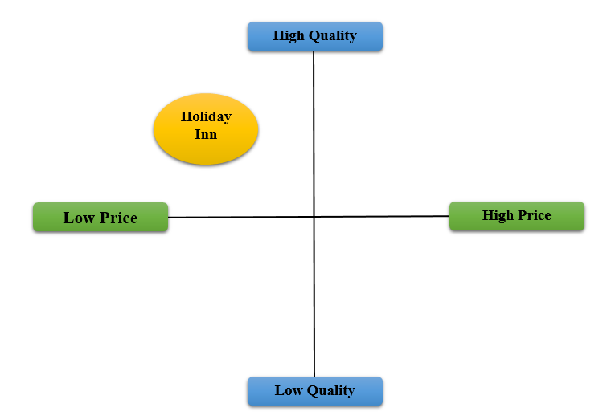

Figure 2: Positioning map of Holiday Inn
(Source: Developed by the learner)

Ansoff Matrix (appendix 2)
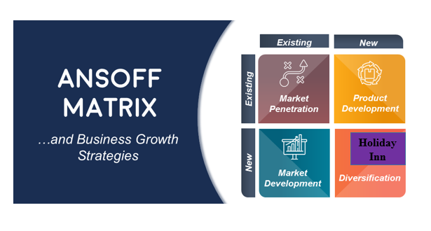
Figure 1: Ansoff Matrix
(Source: Developed by the learner)

Action Gantt Chart (appendix 3)
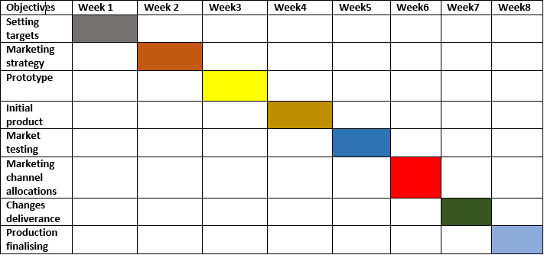

PowerPoint screenshot (appendix 4)


