

Module: Principles of Health and Social Care Practice
Module code: BMHP5016

Student Name: Vitalina Kraievska
Student ID: 2411153
.
Lecturer name: Dr Itse Olaoye
Table of Contents
Introduction 3
Development of the Chosen Concept 4
Application of the Concept in Practice 5
Recommendations for Policy and Practice 6
Conclusion 8
References……………………………………………………………………………………..9-11

Introduction
The social model of disability is a critical paradigm of health and social care, and this paradigm has been used to challenge the traditional approaches to disability. It claims that the person is not born with disability but becomes disabled due to the social barriers that impede an individual as a group of physical, attitudinal, and environmental barriers (Zaks, 2024). This model is opposed to the medical model, which describes a defect or a limitation in the person as disability.

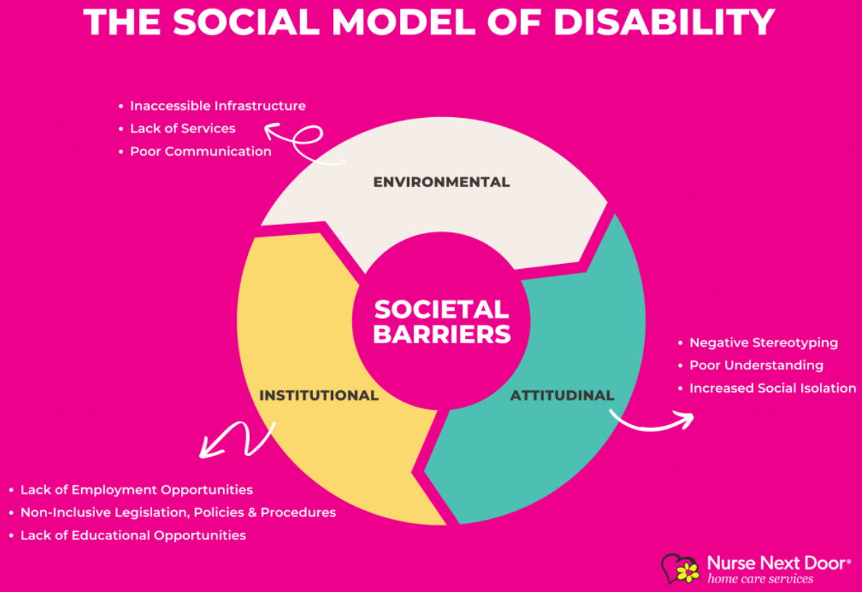
Figure: The Social Model of Disability
Source: (Nurse Next Door, 2024)

The social model has relevance in the health and social care industry, as it contributes to the need to focus not on an impairment but on the systemic obstacles that isolate and marginalise people with disabilities (Khalid et al. 2022). This philosophy encourages the elimination of such obstacles, which will help people to be involved in society as complete members, notwithstanding their physical or mental restrictions. It is inclusive, more accessible and equal, which is fundamental to the modern health and social care practice.
The social model can be dated back to the disability rights movement in the 1970s. Scholars and campaigners lobbying on disability argued that it was society that was the main cause of disability, not individual impairments. This has brought about a change of mindset, which has changed the policies and practices and has promoted more inclusivity and the rights of people with disabilities in health and social care.

Development of the Chosen Concept
The social model of disability, developed during the 1970s, is contrary to the medical model, which considered disability mainly as an individual flaw or abnormality. The original expression was by the disability rights activists, and scholars led especially by Michael Oliver, who is credited with the model having been formalised. In the 1980s, and especially in his work, Oliver described the importance of society and how societies posed the greatest contributors to disability and not individuals (Maton, 2025). The social model changed the perspective where the limitation of individuals was not the centre but the social barriers created by the society that comprised of inaccessible environments, negative attitudes in the society, and discriminatory policies (Beck, 2024).
The social model has developed over time with great development. Originally, it was utilised mostly in the setting of disability rights activism and the legal and policy contexts that resulted from the latter. By the example of the Disability Discrimination Act in the UK, which was adopted in 1995, the impact of the social model was reflected, as it focused on removing the barriers instead of medically treating them (McCusker et al. 2023). When the model became popular, it was used to cover not only physical disabilities but also cognitive and mental illnesses, making it more applicable in other health and social care practices.
The social model has been facing a number of criticisms despite its achievements. Among the key criticisms, it seems to have simplified the complicated nature of the interaction between impairment and societal barriers and has largely been unable to take into account the specifics of the lives and experiences of people with impairment (Farooqi and Ali, 2023). According to critics, the model gives excessive attention to societal change at the expense of medical interventions and the support of the personal needs of people. There have been proposals to have a more integrated approach, including the biopsychosocial model that integrates components of the medical and social models in order to give a more comprehensive picture of disability (Farooqi and Ali, 2023).
To deal with these criticisms, the followers of the social model have updated it, fitting it with a more refined definition of disability. The current trends show that intersectionality has become vital since disability is not an independent entity but exists in connection with other influences like gender, race, and socio-economic status (Maton, 2025). This expanded methodology attempts to consider the subjective experience, but with the idea that obstacles to systems and societal transformation are also considered.
The social model is still developing, and the current discussions concern its implementation on the international level and its suitability for individuals who have many and complicated needs. Continuous change of the model indicates its flexibility and its ability to impact disability policy and practice in various settings.

Application of the Concept in Practice
The Social Model of Disability (SMD) has an impact on health and social care policy and practice by repositioning the problem of impairment of an individual to social and environmental constraints that render people handicapped. The framework has been incorporated in numerous policies and practices, especially in the UK and other nations that have passed legislation on disability rights. An example of this is the National Disability Strategy in the UK, which includes the SMD since it focuses on the elimination of environmental and social barriers to disability rather than medical interventions. It also proposes complete inclusion of all areas of life, such as education, housing, and employment (Green et al. 2022). Within the medical field, SMD has served as a guiding principle in the formulation of available health services and the ability to avoid excluding the disabled in terms of providing them with proper care. Considering the prevalence statistics, say, there are 16.8 million individuals with a disability in the UK in 2023/24 (approximately a quarter of the population), the universal nature of the social model is apparent: structural inclusion has a significant effect on a significant segment of the population (House of Commons Library, 2025).
There are advantages to the Social Model being put into practice. First, it is associated with maximising equality and dignity because the disabled are placed as active, not passive, participants in society. The strategy implies changes on a system level, including accessible buildings, inclusive education, and job opportunities, which facilitate the disabled persons to live their own lives (Lindsay et al. 2024). Moreover, SMD promotes those policies that are focused on empowering people instead of rehabilitators and envisioning such an environment in which individuals are able to share their needs and choices.
Nevertheless, there are various drawbacks to the practical use of the Social Model. The continuation of the medical model in healthcare and social care has been one of the major challenges. The social model is still not fully implemented by many healthcare providers, as they still tend to focus on the diagnosis and treatment of impairments (Huda, 2021). Also, even though policies have been introduced to ensure inclusiveness, most places, including transport and accommodation, are not accessible to disabled individuals. The lack of proper funding and political will to institute the required changes is usually the cause of this gap between intention and practice as far as the policy is concerned.
The other difficulty is that the Social Model is disposed to ignore the personal and individual dimensions of disability, like the pain and necessity of medical treatment. The opponents claim that the model excessively places its emphasis on the social obstacles that fail to reflect the actual experiences of the individuals with impairments who might require medical care, as well as the environmental alterations (Jurgens, 2023). This has brought about the perception of hybrid models, such as the Biopsychosocial model, which integrates both the medical and social approaches to understanding disability more holistically.
SMD has been applied in the real world to enhance the services of the people. Indicatively, in cities with better transportation facilities, accessibility is considered with steps like ramps, elevators, and areas where wheelchairs can fit, created based on the idea of access barrier removal in the social model. Nevertheless, even in the case of these activities, most people with disabilities claim that they still have problems with access to transport because the policy is poorly set or because there are insufficient infrastructures (Jurgens, 2023). The provision of SMD in medicine has resulted in more inclusive healthcare practices, yet insufficiently trained personnel and associated stigma of disability have continued to be a barrier to effective healthcare provision.
The Social Model of Disability has indeed propelled the rights and inclusion of disabled persons in the health and social care units. Nevertheless, it is hindered by its poor implementation due to persistent structural and attitudinal obstacles and the difficulty of balancing the medical needs against social inclusion. This should be integrated in terms of treatment by looking at the medical and social requirements of the people in relation to the provision of treatment.

Recommendations for Policy and Practice
Several key recommendations can be put forward with the purpose of enhancing the application of the Social Model of Disability (SMD) in the health and social care industry. These recommendations are meant to support the issues found in the preceding part, notably dwelling on the inability to eradicate the medical model, policy-practice discrepancies and the lack of lived experience of disabled individuals.
1. The Social and Medical Models came together.
A significant suggestion is to work together using the Social Model and the medical model, putting together a more comprehensive approach to care for disability. Whereas SMD focuses on the environmental obstacles, the medical model focuses on the individual requirements of individuals, including the health care and rehabilitation needs. A combination of the two would guarantee social inclusion, and medical care would be well addressed. As an example, medical practitioners are supposed to emphasise the establishment of accessible settings in addition to providing people with impairments with the required medical services (Gréaux et al. 2023). This would be the combination that would deal with issues raised by SMD, which disability does not consider the personal aspect, like pain or requiring treatment.
2. Better Policy Implementation and Surveillance.
Although the Disability Discrimination Act in the UK and other policies founded on the Social Model have brought about a positive change, there is a tendency towards inconsistencies between the policy intentions and practice. To minimise this gap, it is paramount to enhance the implementation of policies by doing strict monitoring and evaluation. The government agencies ought to set clear access to all the governmental services, where it is assessed regularly to confirm that the rules are being followed. There should also be systems to report and deal with cases of non-enforcement of policies, especially regarding areas such as transport, accommodation and employment, where people still face barriers to access (Tobin-Tyler, 2024). A better accountability system will help to make sure that policies are not only implemented but also enacted in an effective manner.
3. Maximise public awareness and education.
The other suggestion is to raise awareness and education of the Social Model of Disability. One of the greatest obstacles in the way of inclusion is the attitude of the general public and the misconception about disability. In fighting this, social care providers, professionals and policymakers ought to initiate awareness programs to question ableist norms to propagate the advantages of inclusion to everyone (Gutterman, 2025). Healthcare worker and social care provider training should also be based on person-centred care, whereby they are taught to consider disability in terms of societal restrictions as opposed to their own constraints. Education campaigns among the disabled could also be conducted publicly to include the disabled in advocating for their rights, which would continue to support the process of self-advocacy and empower the disabled.
4. Special Issue Intersectionality in Policy and Practice.
Intersectionality should also be incorporated in the social model because people with disabilities are facing several layers as a result of their gender, race, or socioeconomic status. The policies must be more subtle and or be able to respond to various needs of the disabled people, depending on the situation. It may include offering special services to disadvantaged populations in the disabled community, including disabled people of colour or lower socio-economic backgrounds (Chatzitheochari and Butler-Rees, 2023). Intersectionality must be included in the health and social care policy so that any disabled persons in the country with other identities will be well supported.
Finally, the recommendations are aimed at enhancing the implementation of social and medical paradigms, effective policy execution, population education, and intersectionality. They would help cope with the major challenges found in the implementation of the Social Model of Disability, including the lack of interconnection between the theory and practice, and would lead to the creation of a more inclusive society.

Conclusion
Finally, the Social Model of Disability has greatly influenced health and social care policies, fostering the focus on the barriers in society instead of the impairment of an individual. Although it has contributed to the positive change in the aspects of accessibility and inclusion, several issues remain to be overcome, including the prevalence of the medical approach and policy implementation gaps. Through the combination of the social and medical model, better policy implementation, better health education, and taking into account the intersectionality, the consequences of the health and social care practices can be enhanced even more. These measures will lead to a more accepting and equitable world of people with disabilities where they are completely accommodated in their lives.

References
Beck, M., 2024. Empowering Vulnerability: The Social Model of Disability and Digital Government. Technology and Regulation, 2024, pp.273-290. Available at: https://techreg.org/article/view/18967 (Accessed: 09 December 2025).
Chatzitheochari, S. and Butler-Rees, A., 2023. Disability, social class and stigma: An intersectional analysis of disabled young people’s school experiences. Sociology, 57(5), pp.1156-1174. Available at: https://journals.sagepub.com/doi/full/10.1177/00380385221133710 (Accessed: 09 December 2025).
Farooqi, N. and Ali, M., 2023. Disability studies in social sciences: A review of paradigms and perspectives. The Critical Review of Social Sciences Studies, 1(02), pp.155-166. Available at: https://thecrsss.com/index.php/Journal/article/view/15 (Accessed: 09 December 2025).
Gréaux, M., Moro, M.F., Kamenov, K., Russell, A.M., Barrett, D. and Cieza, A., 2023. Health equity for persons with disabilities: a global scoping review on barriers and interventions in healthcare services. International Journal for Equity in Health, 22(1), p.236. Available at: https://link.springer.com/article/10.1186/s12939-023-02035-w (Accessed: 09 December 2025).
Green, C., Dickinson, H., Carey, G. and Joyce, A., 2022. Barriers to policy action on social determinants of health for people with disability in Australia. Disability & Society, 37(2), pp.206-230. Available at: https://www.frontiersin.org/journals/sociology/articles/10.3389/fsoc.2023.1305301/full (Accessed: 09 December 2025).
Gutterman, A.S., 2025. Actions by Nonprofits and Community Organizations to Combat Ableism. Available at SSRN. Available at: https://papers.ssrn.com/sol3/papers.cfm?abstract_id=5277022 (Accessed: 09 December 2025).
House of Commons Library (2025) Research Briefings Publications - House of Commons Library, House of Commons Library. Available at: https://commonslibrary.parliament.uk/research-briefings/ (Accessed: 09 December 2025).
Huda, A.S., 2021. The medical model and its application in mental health. International Review of Psychiatry, 33(5), pp.463-470. Available at: https://www.tandfonline.com/doi/abs/10.1080/09540261.2020.1845125 (Accessed: 09 December 2025).
Jurgens, A., 2023. Body social models of disability: Examining enactive and ecological approaches. Frontiers in Psychology, 14, p.1128772. Available at: https://www.frontiersin.org/journals/psychology/articles/10.3389/fpsyg.2023.1128772/full (Accessed: 09 December 2025).
Khalid, A., Ashraf, S. and Aleem, A., 2022. Social Inclusion of Persons with Disabilities into Mainstream Society: Using the Community Care Context. Review of Education, Administration & Law, 5(4), pp.509-518. Available at: http://real.spcrd.org/index.php/real/article/view/287 (Accessed: 09 December 2025).
Lindsay, S., Fuentes, K., Ragunathan, S., Li, Y. and Ross, T., 2024. Accessible independent housing for people with disabilities: A scoping review of promising practices, policies and interventions. Plos one, 19(1), p.e0291228. Available at: https://journals.plos.org/plosone/article?id=10.1371/journal.pone.0291228 (Accessed: 09 December 2025).
Maton, P., 2025. Fragility, Division And Exclusion: Identity and the Intersectional Limits of the Disability Rights Movement (Doctoral dissertation, Columbia University). Available at: https://academiccommons.columbia.edu/doi/10.7916/j7fd-pf22 (Accessed: 09 December 2025).
McCusker, P., Gillespie, L., Davidson, G., Vicary, S. and Stone, K., 2023. The United Nations convention on the rights of persons with disabilities and social work: evidence for impact?. International journal of environmental research and public health, 20(20), p.6927. Available at: https://www.mdpi.com/1660-4601/20/20/6927 (Accessed: 09 December 2025).
Nurse Next Door (2024) Understanding the social model of disability, Nurse Next Door Home Care Services. Available at: https://www.nursenextdoor.com.au/blog/understanding-the-social-model-of-disability/ (Accessed: 09 December 2025).
Tobin-Tyler, L., 2024. Stopping the Vicious Cycle: Equitable Enforcement Strategies to Achieve Safe, Stable, and Accessible Housing for People with Disabilities. Stable, and Accessible Housing for People with Disabilities (March 20, 2024). Available at: https://papers.ssrn.com/sol3/papers.cfm?abstract_id=4805065 (Accessed: 09 December 2025).
Zaks, Z., 2024. Changing the medical model of disability to the normalization model of disability: Clarifying the past to create a new future direction. Disability & Society, 39(12), pp.3233-3260. Available at: https://www.tandfonline.com/doi/full/10.1080/09687599.2023.2255926 (Accessed: 09 December 2025).

