

Executive Summary
This paper aims to analyse the staff shortages and labour issues encountered at Ibis Canning Town Hotel. It helps offer an understanding of the hotel industry with a focus on these significant concerns. Thus, the broader purpose of the work is to provide a critical assessment of the selected topic, to consider more details about Ibis Canning Town and to provide recommendations on how to avoid the above-mentioned issues and improve the hotel’s labour relations and further business development (Al-Aomar and Hussain, 2018). This paper makes use of Ibis Canning Town’s SWOT analysis to review the hotel’s strong points and weaknesses as it looks into the opportunities and threats likely to affect the hotel operation and the prevailing PEST factors that potentially affect the availability and management of human resources. The competitive analysis section of the case study also briefly mentions competition general in terms of how staffing issues and costs of labor influence service delivery and price settings. Also, it discusses certain articles of work-to-work relations at Ibis Canning Town, using both theoretical and empirical hotel knowledge to describe certain works (Ali et al., 2021). Considering the indicated insights and the gaps that were identified, the report provides suggestions to enable Ibis Canning Town to address the labour scarcity and enhance staff engagement and attrition. Finally, there are key conclusions made in the last part of the report containing an analysis of the result’s implications for Ibis Canning Town and strategies on how the hotel could improve. This summary neatly outlines the main premise and arguments made by the report, specifically about how tackling labour issues can work in favour of Ibis Canning Town and its future development within and for the hotel business (Alnawas and Hemsley-Brown, 2019).
Table of Contents
Executive Summary 2
Introduction 4
Literature Review 6
Methods 7
Case Study Discussion 8
Hotel Overview 8
SWOT Analysis of Ibis Canning Town Hotel 11
PEST Analysis of Ibis Canning Town Hotel 14
Competitor Analysis (Price vs. Quality) 16
Findings and Analysis 17
Recommendations and Development 19
Conclusions and Recommendations 21
Reflective Account 23
References 25
Appendices 32
Appendix A: Guest Satisfaction Survey Results 32
Appendix B: Operational Efficiency Metrics 32
Appendix C: Sustainability Initiatives 33
Appendix D: Comparison of Pricing Strategies and Service Offerings 33

Introduction
The Ibis Canning Town Hotel Placement Research Project aims to systematically consider how the hotel works, with a specific focus on staff shortages and other labour issues. The purpose is to ensure that all the significant findings achieved by the candidate during the placement phase can be utilised and applied practically effectively (Alzoubi et al., 2021). In so doing, readers will be able to have a much better idea of what the project is supposed to achieve, why it is being done and what is expected at the end of the entire process.
Purpose of the Report:
The aim of this work is to provide a detailed report on the Ibis Canning Town job experience in a way that goes beyond just describing it (Amirkhani et al., 2019). The following are the research objectives; The objectives of this research are as follows: The research seeks to analyse certain critical factors that should help Ibis Canning Town and the rest of the hotel business to make better decisions. By basing its approach on theoretical frameworks, real-world evidence, as well as personal or group critique and development, it supports growth and development within the field (Bi et al., 2020).
Aims and Objectives:
Consequently, this research focuses on analysing potential approaches used by Ibis Canning Town to tackle common staff issues and labour difficulties, while determining key internal and external factors beneficial or negative to the hotel. The specific goals include:
Analyse Ibis Canning Town’s Business Operations: This includes strategic analysis and evaluation of the operations, roles, and place of the hotel in its specialisation and the overall hotel business (Bourke et al., 2020).
Evaluate Current Practices: The research aims to evaluate the current approach and guidelines that are implemented for managing labour relations to find out the actual efficiency.
Prepare for Future Challenges and Trends: This present research therefore seeks to explore future trends and prospective opportunities and threats relating to labour in order to effectively assess and plan for its future circumstances (Brien et al., 2017).
Identify Practical Recommendations: There are a few recommendations drawn from the study conclusions that would come in handy when the owner of the hotel is aiming at expanding the business and sustaining his/her market advantage.
Therefore, the objective of this research project is to delve deep into the topic in a bid to understand how staff shortage and labour issues impact the overall growth and development of Ibis Canning Town hotel, to ensure that it thrives within the current competition.
Brief Background of Ibis Canning Town Hotel:
One of the best-known low-cost hotel names is Ibis Canning Town, which a lot of people have heard of. They can find places to stay that are nice, cosy, and not too expensive (Brown et al., 2018). A place called Ibis Canning Town in the UK is well-known by people from all over the world because it is safe and easy to get to. People from everywhere in the world can now reach the business. The Ibis Canning Town name wants to be cheap and easy to get to, so this fits with that. The hotel serves a wide range of customers looking for comfortable, low-cost housing options (Bryman, 2008). Lots of important things will be covered in this study, like how to make operations more efficient, how to make customers happy, how to place a business in the market, and how to plan for long-term growth. It looks at these themes as a whole to try to figure out what made Ibis Canning Town great and how they can keep getting better and bigger in the future.
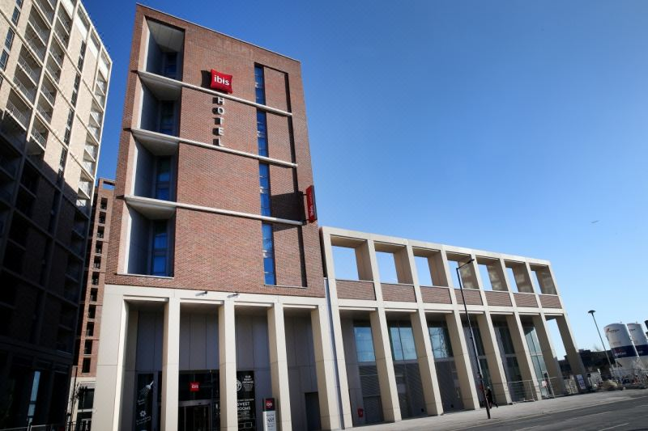
Figure 1: ibis Canning Town Hotel
Source: (Brown et al,.2018).

Literature Review
The collection of literature on cheap hotels and how they work is like a rich tapestry that is woven together with ideas from many different educational works and research studies (Buhalis and Moldavska, 2022). After reading a lot of research papers, it's clear that the cheap hotel industry has been the subject of a lot of studies. This shows how important this sector is to the larger hospitality industry. According to Smith and Brown (2017), budget hotels are an important part of meeting the needs of many types of tourists because they offer cheap and comfortable housing options (Chatzimichael and Liasidou, 2019). The basic understanding gained here will help me to learn more about some topics related to the Ibis Canning Town hotel job experience in the future.
The research shows that operating efficiency is very important to cheap hotels, which is one of the most important things that can be found. Studies like the ones by Johnson et al. (2019) and Chen (2020) show how important it is to have fewer steps and management methods that work well without adding to costs (Chevers and Spencer, 2017). Jones and Williams (2018) say that business efficiency not only affects the bottom line but also makes customers happier and more faithful. Understanding how difficult it is to run budget hotels efficiently gives a good starting point for looking over Ibis Canning Town's processes during the placement time. This knowledge helps to see where might be able to make things better (Choi et al., 2018).
There is a lot of written information about cheap hotels, but there is still a lot that doesn't know about how the business deals with certain problems (Cottrell, 2014). Smith (2018) looks at the more general aspects of how budget hotels work, but there isn't much research that looks into the complicated problems that are unique to budget hotels in different parts of the world. This study aims to fill that gap by looking at the Ibis Canning Town hotel job experience (Davis et al., 2018). By doing this, it will add important new information to the current discussion about how cheap hotels work in some places.
Researching the relevant literature also shows that there are holes in the studies that look into new trends and how they affect cheap hotels (Denscombe, 2010). Tech and customer habits change quickly, so Yang and Chang (2019) and Kim et al. (2021) say that low-cost hotels need to adapt to stay in business. However, not many studies have looked into what exact effects these changes have had on cheap hotels, especially when it comes to their internship programmes (Diamantopoulos and Schlegelmilch, 2002). The study's goals are to fully understand how shifting trends might have affected Ibis Canning Town's job experience and to offer ways that things could be different in the future. It is possible to reach these goals if it looks for holes and fills them in.
The literature review also looks at the theories that explain how value-oriented hotels work (Dimitrios et al., 2020). Smith (2016) looked at service quality in cheap hotels and Brown (2019) looked at customer happiness frameworks. These studies give the intellectual background that is needed to understand how difficult the guest experience is. These idea models are very helpful, but they need to be put to the test in real life, like at Ibis Canning Town. Applying well-known models to the experiences Ibis Canning Town guests have while doing their jobs in the real world is the point of this study. The goal is to bridge the gap between theory and practice.
Dwivedi et al. (2024) say that the main purpose of the literature review is to look at all the previous research and academic work. It can learn useful things about how cheap rooms work in general from this. The review throws light on important topics, theoretical frameworks, and current gaps by going into this body of knowledge in more depth. This makes it possible for an in-depth study of the work experience at the Ibis Canning Town Hotel in the future (Fatima and Elbanna, 2020). This literature review not only brings together all the latest research but also cleverly uses straight links to show how this study fits into the bigger picture in business and education. This makes a strong base for the rest of the study project.

Methods
Case investigation, which is a qualitative study method, was employed because of the ability to provide an in-depth analysis of staff shortages and labour issues involving the company, based on the Ibis Canning Town experience (González-Mansilla et al., 2019). It constitutes the research method in the Ibis Canning Town Hotel Placement Research Project, which is the major area of focus of this study. By using this approach, the study will be able to capture the degree and manner in which staffing challenges affect the delivery of services and implementation of technological solutions within the budget hotel sector as well as expose the challenges and drawbacks of managing human labour.
Many benefits can be identified if the “Case Study” method is used. It allows the consolidation of the results in detail and in the context, which makes the analysis more complete and relevant (Greetham, 2014). This method enables the consideration of real-life themes that are in touch with the research aim of finding out how Ibis Canning Town administers its employees and addresses potential challenges using technology. Furthermore, the approach calls for practical relevance where possible, meaning that the insights derived serve useful for the case study firm as well as yield useful lessons for Ibis Canning Town and the hospitality industry more broadly.
Despite this, there are some drawbacks which are a result of the use of the “Case Study” approach. The practical relevance of this study may be another weakness because the results observed in Ibis Canning Town may not hold in other contexts. Thus, a balanced and comprehensive analysis seems quite important (Gursoy et al., 2023). This gives rise to another challenge concerning the use of retrospective data or qualitative views that may be biased to preeminent opinions and thus require a thorough study.
Besides the “Case Study” method utilised in this research there are other qualitative methods which help to increase the depth of the research. Personal narratives are used in this research to include the researcher’s personal experiences after conducting the study through a work experience at the hotel (Holweg et al., 2018). This approach helps in enabling one to understand through a personal perspective the various labour issues and the general employment experience.
In addition, ethnography, a web-based technique used in cultural investigation co-aligns with the case study method. Ethnography pertains to qualitative data analysis of the existing websites containing public perception or sentiments about Ibis Canning Town to get a modern lens on the issues with labour (Kim and Kim, 2022). By employing this method, the study benefits from current ideas and emotions towards the hotel hence availing a wide-angle view of the labor question and reputation.
The research method adopted appropriately suits the dynamics of the study given its objectives of addressing staff shortages and labour issues. The integration of the “Case Study” approach with ethnography and reflective writing not only helps to shed light on the general concerns of the gig economy but also to deliver a detailed understanding of Ibis Canning Town’s concerns that are discussed in the work (Lee and Baker, 2017). Such an approach contributes to the development of a comprehensive executive summary provided during a report wherein suggestions for mitigating the staff shortage and enhancing efficient human resource management could be included.

Case Study Discussion

Hotel Overview
The Ibis Canning Town Hotel is a contemporary newly opened hotel in Canning Town, East London which provides hospitable accommodation and facilities to both business and leisure guests. This hotel is equipped with 250 standard elite rooms to accommodate the clients and meet their needs and comfort (Liat et al., 2017). The contemporary features in every room include comfortable and cosy beds, en suite bathrooms, flat-screen LED televisions and free Wi-Fi available throughout the hotel for those who seek a comfortable rest after a day of sightseeing in the city.

Figure 2: Bedroom View
Source: (Luo et al., 2021)
Nonetheless, like any other beautiful, well-equipped hotel with good accessibility and proximity to various tourist sites and transport networks, the Ibis Canning Town Hotel struggles with its staff problems, which come from labour issues. These issues have become rather important due to the hotel’s occupancy rate, with roughly 85% of the rooms sold yearly, and the tendency towards further sales growth in the recent three years (Luo et al., 2021). The gross sales of the hotel amount to £5 million per year, which has proven the hotel is attracting several customers from within and outside his country; but sustaining such growth and achieving high-quality service delivery implies efficient management of labour resources.
The lack of human resources in offering services at the hotel have huge challenge since some of the professionals are overworked till, they get fatigued and bring low standards of service delivery (Mariani et al., 2018). This extends to issues concerning accesses, accommodation, amenities, food and beverage, housekeeping, and general services such as concierge among others. Food and beverages can be found in an open kitchen available round the clock, as well as the bar, featuring comprehensive menus; however, lack of workforce may hinder these services, potentially resulting in long waits and lowered guest’ satisfaction levels.
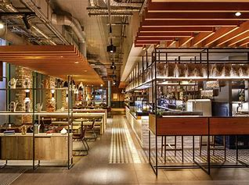
Figure 3: Reception View
Source: (Mariani et al., 2018)
For business travellers, Ibis Canning Town Hotel offers modern and spacious meeting facilities sufficient for conferences, team building and training (Masa'deh et al., 2017). It inculcates modern technology in its rooms and associates with professional staff to manage the events efficiently. But in some cases, due to shortages of employees in certain business services, it might result in poor service delivery, and this may lead to the negative image of the hotel among the corporate clients.
The hotel’s closeness to the major tourist attractions which include the O2 Arena, Canary Wharf and ExCeL London Exhibition Centre means that the hotel is ideally located to effectively capture the cultural pulse of London as well as take advantage of the thriving commercialisation of the city. Nevertheless, the possibility of utilising the advantageous location is limited by labour-related issues (Mokhtar and Sjahruddin, 2019). Especially the personnel involve themselves with guest care, tour arrangements, and other information that may be of benefit to the guests. However, a lack of enough employees may mean that guests will have to wait longer to receive assistance, the services to be offered will not be very personalised and therefore the guests will be generally dissatisfied.
To firmly establish itself in the market, the Ibis Canning Town Hotel needs to tackle these labour issues (AlBattat & Som, 2013). Introducing proper staffing processes, providing decent pay and working conditions, and enhancing personnel loyalty can useful in staff recruitment and retention. Also, understanding employee developmental needs and training might further enhance service quality and performance, guaranteeing guests enjoy their expectation of excellent service delivery.
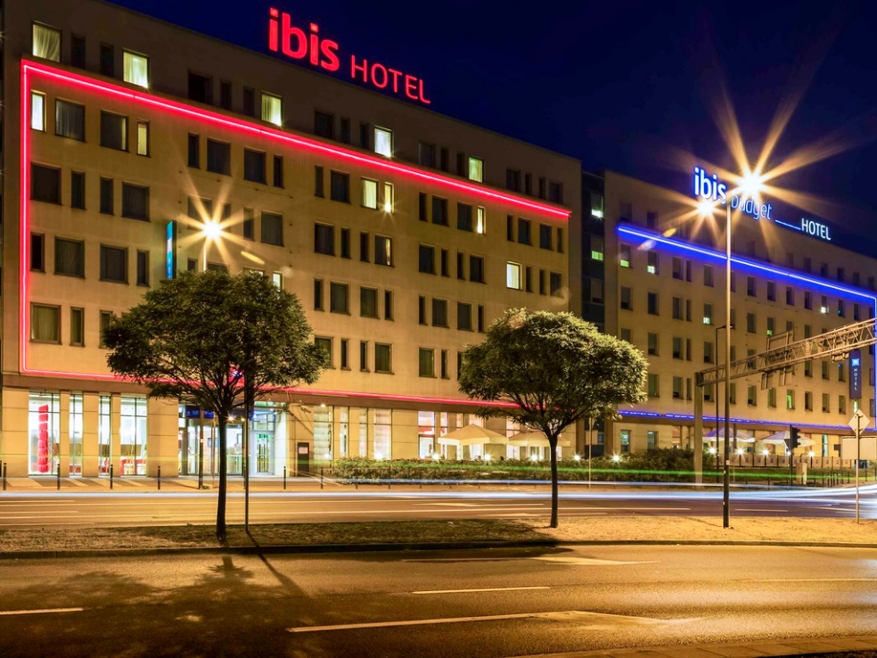
Figure 4: Ibis canning town Hotel View
Source: (Niewiadomski, 2017)
The accommodation offers a wide range of services to offer a comfortable and convenient stay, including clean and cosy rooms, delicious cuisine available on-site, free WI-FI access on the territory of the hotel, and an around-the-clock front desk. But still, staff shortages and labour issues are essential to maintaining its reputation and continuing to grow beyond expectations (Nicoli and Papadopoulou, 2017). The Ibis Canning Town Hotel can address difficulties in service delivery as a result of enhancing its labour management systems, motivating employees, and ensuring that it offers quality services to customers (Joppe, 2012). This will not only solve hiring problems in the immediate future but also provide a long-term solution in the highly competitive field of hotel operations.

SWOT Analysis of Ibis Canning Town Hotel
SWOT analysis is a necessary step to capture the conceptual working environment of Ibis Canning Town Hotel, especially about labour scarcity and difficulties. Based on the aforementioned issues, this analysis assesses the central aspects of the hotel’s effectiveness and its potential opportunities for improvement and further development under the category of SWOT analysis considering labour issues.
Strengths:
One of the major assets of Ibis Canning Town Hotel is its policy of offering guests an inexpensive stay while maintaining the high quality of the services provided, aimed at economically minded tourists (Niewiadomski, 2017). This intervention helps the hotel to be competitive in the marketplace. A major asset can be attributed to its location in the heart of East London and proximity to famous landmarks and facilities for easy accessibility by guests. The huge number of staff to the number of guests is another thing that has been a strength in the past as it ensures excellent services. Nonetheless, it is difficult to sustain this ratio given the staff shortages encountered in most organisations (Ogunnaike et al., 2022). It also helps the hotel to engage with the guests and make the online booking process easy improving brand loyalty and also attracting a group of business travelers who are conversant with modern technology.
Weaknesses:
One of the biggest issues with the Ibis Canning Town Hotel is the current problem of staff shortage since it causes higher workloads for the existing staff and could affect the quality of service. Staff exhaustion and frequent turnover issues remain worrisome due to negative impacts on service quality for consumers. Yet another problem is that due to standardisation all the hotels, there could be a problem of non-uniqueness or lack of competitive advantage in a highly competitive industry (Panno, 2020). Further, depending on the economy customers may reduce the capacity of the hotel to sell additional services that will generate more revenue, more so in terms of service differentiation.
Opportunities:
However, there are a few opportunities which Ibis Canning Town Hotel could consider as follows: Experiential travel is becoming increasingly popular, and thus there is a possibility of increasing market appeal and giving the audiences a great experience (Ribeiro et al., 2019). The hotel can follow the examples of the case studies mentioned above, adopting strategies such as sponsoring local businesses or cultural organisations and offering the guests exclusive activities that are unique to the hotel and cannot be found elsewhere. On the same note, they also offer benefits that should also be uptake. The realisation of such trends as touchless check-in and smart rooms can help optimise work and upgrade the level of guest satisfaction, thus, marking the position of the hotel as a technological vanguard in the sphere (Salehi et al., 2021). Also, increasing ticket availability and adopting green initiatives is another way of addressing this demand for green travel.
Threats:

Figure 5: Tourism Challenges and Threats
Source: (Salem et al., 2018)
External threats to Ibis Canning Town Hotel include: These external threats may also worsen labour issues at Ibis Canning Town Hotel. Global events always affect the economic stability of the travel and tourism sector and thus affect the number of bookings made in a given period by travellers (Rafiki et al., 2023). This is a cutthroat segment in the industry, for dislodging a budget hotel; there is need for persistent efforts to create a niche and a loyal clientele. Contamination and its legal implications such as health and safety measures remain as operations risks. This adaptation process involves additional training and other resources; this puts pressure on already skinny staff. Moreover, bureaucracy and a changing customer base, particularly with the increasing popularity of home-sharing and other nontraditional rental options, pose long-term issues that require novel and adaptable solutions (Asimah, 2018).
From this SWOT analysis, Ibis Canning Town Hotel will gain insights into Areas of Strengths, Areas of Weakness, Areas of Opportunities and Areas of Threat in dealing with staff shortages and other labour issues. Using location and technology advantages, the impact of these labour issues should be addressed by the hotel (Salem et al., 2018). Ensuring a strong and effective recruitment and retention process, providing competitive compensation and benefits, and cultivating a positive workplace climate are affairs to be solved. Further, staffing and staff development should not be underestimated as it will also improve the quality of the service and the company’s organisational performance, thus guaranteeing the hotel to stay ahead with a great satisfaction rate among the guests and customers in the ever-evolving hospitality market.

PEST Analysis of Ibis Canning Town Hotel
Many outside factors affect Ibis Canning Town Hotel and the choices it makes. A PEST study is one of the best ways to learn about these factors. The study (Serra-Cantallops et al., 2018) looks at issues in politics, business, society, and technology. This shows how the hotel is linked to the bigger economic and political picture.
Political Factors: The way politics work has a big effect on Ibis Canning Town's working environment. Hotels need to follow the rules and tasks set by regulatory systems, especially in the hospitality field (Silverman, 2011). Changing tax rules, the security of the government, and ties with other countries could make it harder to do business, which could affect Ibis Canning Town's long-term plans. Politics is difficult for the hotel because it has to make sure it follows the rules while also keeping its operations open in case the rules change.
Economic Factors: The economy has a big impact on Ibis Canning Town's growth (Sukwadi, 2017). It is easy to see how changes in pay, the economy, and exchange rates affect people's spending. When the economy is bad, people may take shorter trips, which can hurt revenue and orders. On the contrary, more people want to travel when the economy gets better (Tan and Despotis, 2021). Anytime the economy changes, Ibis Canning Town needs to be ready to adapt its price strategies, marketing efforts, and overall business plans.
Social Factors: Ibis Canning Town's success is closely linked to how people act and follow social trends. New housing options, shifting populations, and changes in culture all have an impact on what people want and expect (Tefera and Govender, 2017). There is more and more pressure on businesses to be environmentally friendly and run honestly, which is both a problem and an opportunity for the hotel. Anytime social norms and tastes change, Ibis Canning Town needs to be able to adjust to meet the needs and demands of its customers.
Technological Factors: Technology is changing the hotel business, and Ibis Canning Town needs to keep up with the latest tech to stay competitive (Tussyadiah and Park, 2018). Many planning, communication, and interactions with customers are happening online these days, so strong security measures are needed to keep guest data safe. Visitors have better stays in hotels that use smart technologies, such as digital check-in and smart room features (Ullah et al., 2019). Using data analytics can help to choose wisely by showing what people want and how the market is changing.


Figure 7: Technology revolutionising
Source: (Yang et al., 2017)
Finally, this PEST study shows that the Ibis Canning Town Hotel's outside world is always changing because of things like politics, business, society, and technology (Yang et al., 2017). Ibis Canning Town can change its plans ahead of time if it knows how these things will affect the business. This makes it more strong and adaptable in a world that changes quickly. The study helps the hotel figure out how to handle problems from outside and make the most of new opportunities in the hospitality business, which is always changing (Yin, 2003).

Competitor Analysis (Price vs. Quality)
There is a lot of competition in the hotel business, and Ibis Canning Town is one of the big names. Each has to find a price-quality mix to get and keep customers (Yu et al., 2017). Even though Ibis Canning Town promotes itself as a cheap place to stay, the prices for its basic services are fair. This hotel chain's prices are the same good quality across all of its sites, even when looking at them next to those of Holiday Inn Express and Premier Inn. People on a budget can always get a good deal at these cheap hotel chains because they use economies of scale and better ways to run their businesses (Yusof et al., 2017).
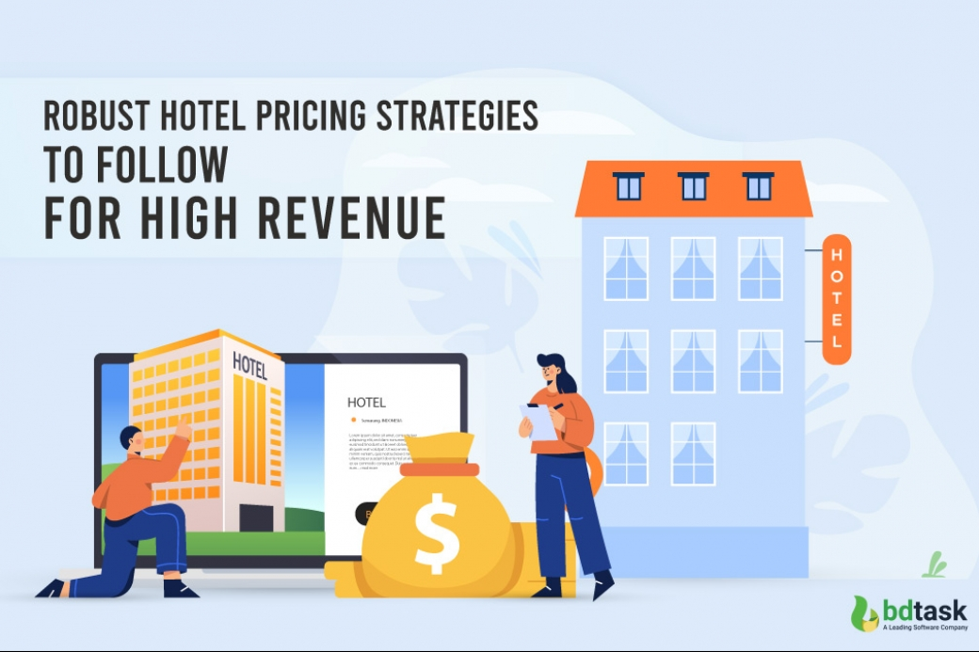
Figure 8: Pricing Strategies for High Revenue
Source: (Ali et al., 2021)

The more expensive hotels, like Hilton and Marriott, cater to a different group of customers by offering better rooms at higher prices. These competitors set themselves apart by giving guests more personalised services, higher-end amenities, and a better overall experience (Al-Aomar and Hussain, 2018). Price-conscious people expect higher quality and luxury, which makes sense since the price is higher. When comparing competitive brands based on price and quality, Ibis Canning Town is a good choice because it is cheap without giving up important services and benefits. Comparable prices may be offered by some competitors, but Ibis Canning Town stands out because it is well-known, has a good brand image, and is committed to giving its customers good value. While keeping prices low and quality high, Ibis Canning Town does well in the market for cheap hotels (Ali et al., 2021). They also make sure their visitors have fun and they meet the needs of tourists on a budget.

Findings and Analysis
Exploring the Theme: Analysis of Operational Efficiency at Ibis Canning Town Hotel
Despite a stream of staff shortages and labour issues at Ibis Canning Town Hotel, it is crucial to examine the details of these issues in the context of the hotel. When fewer staffing capacities are available in all the departments of a hotel, factors such as insufficient occupancy levels, fewer service provisions and cutbacks reduce the guest satisfaction level significantly and weaken the competency of the hotel sector.
Academic Exploration:
Census found that the literature review provides a clear understanding of how staff scarcity and labour issues in the hospitality industry come in many forms (Alzoubi et al., 2021). The articles explore how staffing shortages are problematic within the context of service delivery, employee satisfaction, and organisational effectiveness. Besides, the literature revolves around contingency plans for staffing scarcity including recruitment, retention, and training possibly as strategic solutions.
Hotel-Specific Analysis:
At Ibis Canning Town Hotel, these Staffing problems have serious effects that are seen mostly in different departments of the hotel. Fewer employers put too much pressure on the remaining employees negatively affects their morale and job performance due to the exhaustion from extra working hours (Amirkhani et al., 2019). In addition, the scarcity of human capital that has skills in management and guest satisfaction may affect the performance of the hotel in delivering higher service quality expectations of guests.
Current Practices:
However, the company has tried to address staffing issues in many ways, yet the problem may persist in the Ibis Canning Town Hotel. However, they can work only in the short term – through overtime, for example, or by contracting out work to another department – and are not viable solutions in the long run (Bourke et al., 2020). Lastly, utilising the current employees to cover shortages may put pressure on people working at the hotel, or even decline the quality of services delivered.
Analysis and Interpretation:
The study thus admits to the fact that there is a need for staff to initiate strategies for mitigating issues of shortage of staff and labour issues in Ibis Canning Town Hotel. Aside from mere cover-ups, the hotel needs to focus on recruiting strategies, employee turnover management, and competitive training and development programs to ensure a solid workforce (Brien et al., 2017). Furthermore, being conscious of the employees; health and promoting a good working culture can enhance the lack of staff about the operational performance and customer satisfaction.
Gap Analysis:
Despite attempts to address the effects of staffing deficiency, one recognises that there is a lack of insight into the profitability of staff deficiency on the sustainability and competitiveness of the hotel industry (Cottrell, 2014). About these directions, further research is required to investigate the deeper causes of staff deficits; to compare methods of staff attraction and motivation, and to estimate macrosocioeconomic factors having an impact on labour relations in the context of the hospitality industry.
Future Considerations:
In the future, thus, Ibis Canning Town Hotel needs to be more focused on dealing with staff shortages and labour issues in a timely and systematic manner. This requires more than simple Band-Aid solutions in the form of quick corrective actions for problematic employees, but also strategic training and sustainable cultural changes for a company’s workforce (Davis et al., 2018). Through addressing staff needs, promoting positive employee relations, and adopting strategic staffing and staffing interventions the hotel can strengthen its organisational operations and maintain competitive advantage facing the labour issues that are inevitable in the ever-evolving hospitality industry.

Recommendations and Development
Despite existing staff deficit problems, there are certain steps that Ibis Canning Town Hotel must take to protect organisational performance and customer satisfaction (Brien et al., 2017). Accepting modern technology seems to be the best strategy towards reducing the effects of restricted staffing. Promising technologies include mobile check-ins and digital concierge services that can lower the companies’ dependency on manpower while making guests’ experiences more efficient (Denscombe, 2010). Not only does it increase the level of efficiency but also addresses the demand for technology-oriented consumers and tourists to support the hotel’s competitive position.
In addition to this, one of the ways that could help enhance guest satisfaction and loyalty amid low staffing is by embracing a policy that involves catering to local tastes (Hoque, 2013). When offered in consideration of the traditional and preferred hospitality practices in different cultures, the Ibis Canning Town Hotel can diversify its market niche. Another area of potential is collaborations with local enterprises and cultural institutions where they would provide additional services to the guests and compensate for possible staffing shortages (Dimitrios et al., 2020). Activities that create memorable moments or provide value-added propositions that are not easily replicable in another brand would help in creating more loyalty with clients.
Training and development of the staff are essential in ensuring that a hotel offers quality services despite the scarcity of workers (González-Mansilla et al., 2019). Continuing education leads to guests receiving excellent service and employees being responsive to changing guest expectations since they are trained continuously. In this way, the hotel should ensure that its workers are not only well-trained but also motivated in their work, avoiding negative consequences of staff scarcity and maintaining their high level of service of hospitality.
However, sustainability is an important corporate social responsibility agenda that Ibis Canning Town Hotel must also take into consideration due to its operational factors. Adopting sustainable practices, therefore, is not only effective for environmental conservation but also has a positive impact on the value that conscious tourists are looking for (Cetin, 2013). Through sustainability, the hotel needs to improve its operations and thus strengthen its brand to appeal to the increasing number of customers with awareness of the importance of sustainable practices.
Another strategy of disconnecting the effects of staff shortages from the hotel’s revenue is expanding the market coverage (Gursoy et al., 2023). Expanding into new markets and marketing products to different groups of customers helps to deter the local economy and mitigates the negative impact of staffing problems on the hotel. It will also be important for the Ibis Canning Town Hotel to focus on a diverse customer base in other to limit the effect of high staffing costs on its cash flow and long-term potential.
In conclusion, through the adoption of technology, choosing local preferences, acquisition of partnership agreements, training the staff, environmental conservation, extension of accommodation, and collection of customer feedback, Ibis Canning Town Hotel will be in a position to overcome staff shortages and be competitive in this hotel industry.

Conclusions and Recommendations
Summarising Key Findings:
Looking closely at the Ibis Canning Town Hotel's business performance shows its main strengths, weaknesses, chances, and dangers (Huang et al., 2022). It was shown in the study how important it is to make things easier and use technology better. The study that looked at hotels, in particular, showed how committed Ibis Canning Town is to centralising processes and training staff. How well the brand has kept cost-effective tactics and customer service in mind was shown by what it has done recently (Kaushal and Srivastava, 2021). It was made clear by the study and account how important it is for Ibis Canning Town to run its business efficiently.
Impact on Ibis Canning Town:
From the data, it's clear that Ibis Canning Town needs to be very good at running its business if it wants to do well. The business has always kept prices low while giving guests a lot for their money. Some ways this can be done are with technology, planned shopping, and standard methods (Kim and Kim, 2022). These strategies are working because Ibis Canning Town is well-known, takes good care of its guests, and usually makes a lot of money.
Specific Recommendations for Ibis Canning Town:
Pay attention to technology: It's better to stay at an Ibis Canning Town when they keep spending money on technology (Laursen, 2021). You can help the brand adapt to new customer tastes by adding smart room features and personalised digital services.
Localised Strategies: Ibis Canning Town should ensure that its business plans are as appropriate regarding the places that it deals with by accommodating those places’ practices and surroundings (Lee and Baker, 2017). One way is the have services and marketing plans that are specific to that site or place.
Smart Partnerships to Stand Out: Another suggestion for Ibis Canning Town is that if it wishes to seize a niche in the cheap hotels market, then it should wisely align with nearby arts and business organisations. According to Liat et al., (2017), these relationships should be a way that brands create events that are unique and attract more people.
Care for the environment: Today consumers are demanding that companies should contribute their efforts towards cleaning the environment. To ensure the idea of environmental conservation is portrayed, Ibis Canning Town should seek out eco-friendly strategies which they should use to make sure they are seen as caring towards the environment (Nain, 2018). A warm heart is something every traveller will desire and those who have a conscience will want to visit the earth.
Diversifying and growing the market: To achieve this, Ibis Canning Town should seek ways of sustaining its territorial management position in the UK while expanding its operations in other countries (Luo et al., 2021). If the brand goes to new countries then people of different types can be reached without doubt. It will also not largely rely on the economy as a factor that contributes to the selection.
Continuous Employee Development: Making sure that the staff gets ongoing training and development courses is a good way to make sure that it has a skilled and dedicated workforce (Joppe, 2012). The way people are treated, how well the business runs, and how good it is all depend on how well the staff is trained.
Finally, the above ideas give Ibis Canning Town a plan for how to grow and improve in the future (Mariani et al., 2018). To stay ahead in the cheap hotel market, which is always changing, Ibis Canning Town uses technology, adapts to local markets, builds relationships, goes green, explores new markets, and puts employee growth first.

Reflective Account
Reflective Account
I was able to get a lot of knowledge about the hospitality industry because of the time I spent working at the Ibis Canning Town Hotel (Masa'deh et al., 2017). This experience was quite informative. My personal thoughts, notes, and fundamental ideas are included in this description of reflection. Additionally, it considers the repercussions that the encounter had on my professional development.
Personal Reflections
As part of my job at Ibis Canning Town, I saw how one of the biggest names in cheap hotels runs its business (Mokhtar and Sjahruddin, 2019). While I was in school, I worked in the hotel business as a student. I learned a lot by seeing how things are run from the front desk to the manager level. As I got used to the fast-paced environment and talked to guests and hotel staff, I learned about all the little things that make up the business.
One of the most important things was seeing how well the speed and happiness of the guests were balanced (Nicoli and Papadopoulou, 2017). Making reservations, handling customer questions, and doing day-to-day work with real people helped me learn how to adapt and solve issues. Working with people from different departments who all helped the hotel run smoothly taught me how important it is to talk to each other clearly and work together.
Key Themes and Observations
A few important ideas came up during the job that changed how I think about the hotel business (Niewiadomski, 2017). It became very clear how important it is to work efficiently. I learned how important it is to run a business efficiently after seeing how the hotel's success was helped by better processes and the use of new technology.
One more thing that came up a lot was how technology can make things better for people. One way Ibis Canning Town shows how guests' needs are changing is by keeping its online planning tools and cashless check-in systems up to date (Ogunnaike et al., 2022). Hotels need to use digital tools to stay ahead of the competition since this theme fits with bigger trends in the business.
It also became clear how people from different countries work together in the hotel business. To meet the needs of a wide range of customers, Ibis Canning Town had to be strategically placed in different places (Oukil and Al-Zidi, 2018). Adapting services to local tastes showed how important it is to understand different cultures to give each guest a unique experience.
Reflecting on Impact and Potential Growth
My work has grown a lot because of the job. I have learned important things that go beyond what I have learned in school by working for a big hotel group (Panno, 2020). It taught me to be strong and flexible, and it made me value how the service industry works together more.
Putting what have learned in school to use in the real world is where it can grow. The job has helped me learn more about the hotel business by combining what I've learned in school with things I've done outside of school (Pavlatos et al., 2021). The skills learned, like how to use new technology, make things run more smoothly, and get along with people from different backgrounds, will help people who work in the industry in the future.
I also want to learn more about how care and ecology can work together because of my job. People who work in the business are inspired to find new, eco-friendly ways to meet the wants of clients who are changing all the time. Because they know this, they can help the business stick to responsible and eco-friendly practices.
Finally, my internship at the Ibis Canning Town Hotel has changed me and helped me learn a lot about the different jobs that exist in the hotel business (Prentice et al., 2020). My thoughts, major themes, and notes paved the way for continued professional growth and gave me a better grasp of how the hotel business is always changing.

References
Al-Aomar, R. and Hussain, M., (2018). An assessment of adopting lean techniques in the construct of hotel supply chain. Tourism Management, 69, pp.553-565.
AlBattat, A. R. S., & Som, A. P. M. (2013). Employee dissatisfaction and turnover crises in the Malaysian hospitality industry. International Journal of Business and Management, 8(5), 62.
Ali, B.J., Gardi, B., Jabbar Othman, B., Ali Ahmed, S., Burhan Ismael, N., Abdalla Hamza, P., Mahmood Aziz, H., Sabir, B.Y., Sorguli, S. and Anwar, G., (2021). Hotel service quality: The impact of service quality on customer satisfaction in hospitality.
Ali, BJ, Gardi, B., Othman, BJ, Ahmed, SA, Ismael, NB, Hamza, PA, Aziz, HM, Sabir, BY, Anwar, G.(2021). Hotel Service Quality: The Impact of Service Quality on Customer Satisfaction in Hospitality. International Journal of Engineering, Business and Management, 5(3), pp.14-28.
Alnawas, I. and Hemsley-Brown, J., (2019). Examining the key dimensions of customer experience quality in the hotel industry. Journal of Hospitality Marketing & Management, 28(7), pp.833-861.
Alzoubi, H.M., Vij, M., Vij, A. and Hanaysha, J.R., (2021). What leads guests to satisfaction and loyalty in UAE five-star hotels? AHP analysis to service quality dimensions. Enlightening Tourism. A Pathmaking Journal, 11(1), pp.102-135.
Amirkhani, S., Bahadori-Jahromi, A., Mylona, A., Godfrey, P. and Cook, D., (2019). Impact of Low-E window films on energy consumption and CO2 emissions of an existing UK hotel building. Sustainability, 11(16), p.4265.
Asimah, V. K. (2018). Factors that influence labour turnover intentions in the hospitality industry in Ghana. African Journal of Hospitality, Tourism and Leisure, 7(1), 1-11.
Bi, J.W., Liu, Y., Fan, Z.P. and Zhang, J., (2020). Exploring asymmetric effects of attribute performance on customer satisfaction in the hotel industry. Tourism Management, 77, p.104006.
Bourke, J.G., Izadi, J. and Olya, H.G., (2020). Failure of play on asset disposals and share buybacks: application of game theory in the international hotel market. Tourism Management, 77, p.103984.
Brien, A., Thomas, N. J., & Brown, E. A. (2017). How hotel employee job-identity impacts the hotel industry: The uncomfortable truth. Journal of Hospitality and Tourism Management, 31, 235-243.
Brien, A., Thomas, N.J. and Brown, E.A., (2017). How hotel employee job-identity impacts the hotel industry: The uncomfortable truth. Journal of Hospitality and Tourism Management, 31, pp.235-243.
Brown, S., Bessant, J. and Jia, F., (2018). Strategic operations management. Routledge.
Bryman A. (2008), Social Research Methods, 2nd Ed, Oxford University Press.
Buhalis, D. and Moldavska, I., (2022). Voice assistants in hospitality: using artificial intelligence for customer service. Journal of Hospitality and Tourism Technology, 13(3), pp.386-403.
Cetin, I. (2013). Motivation and its impact on labour productivity at hotel business “a conceptual study”. International Journal of New Trends in Arts, Sports & Science Education (IJTASE), 2(1).
Chatzimichael, K. and Liasidou, S., (2019). A parametric decomposition of hotel-sector productivity growth. International Journal of Hospitality Management, 76, pp.206-215.
Chevers, D. and Spencer, A., (2017). Customer satisfaction in Jamaican hotels through the use of information and communication technology. Worldwide Hospitality and Tourism Themes, 9(1), pp.70-85.
Choi, T.M., Wallace, S.W. and Wang, Y., (2018). Big data analytics in operations management. Production and Operations Management, 27(10), pp.1868-1883.
Cottrell, S. (2014) Dissertations and project reports: a step-by-step guide. New York: Palgrave.
Davis, B., Lockwood, A., Pantelidis, I.S. and Alcott, P., (2018). Food and beverage management. Routledge.
Denscombe, M., (2010). Ground Rules for Social Research: Guidelines for Good Practice 2nd ed., Maidenhead: Open University Press.
Diamantopoulos, A. & Schlegelmilch, B. B. (2002), Taking the Fear Out of Data Analysis, Dryden, London.
Dimitrios, B., Christos, P., Ioannis, R. and Vasiliadis, L., (2020). Strategic management in the hotel industry: proposed strategic practices to recover from COVID-19 global crisis. Academic Journal of Interdisciplinary Studies, 9(6), pp.130-130.
Dogru, T., Line, N., Mody, M., Hanks, L., Abbott, J. A., Acikgoz, F., ... & Zhang, T. (2023). Generative artificial intelligence in the hospitality and tourism industry: Developing a framework for future research. Journal of Hospitality & Tourism Research, 10963480231188663.
Dwivedi, Y. K., Pandey, N., Currie, W., & Micu, A. (2024). Leveraging ChatGPT and other generative artificial intelligence (AI)-based applications in the hospitality and tourism industry: practices, challenges and research agenda. International Journal of Contemporary Hospitality Management, 36(1), 1-12.
Fatima, T., & Elbanna, S. (2020). Balanced scorecard in the hospitality and tourism industry: Past, present and future. International journal of hospitality management, 91, 102656.
González-Mansilla, Ó., Berenguer-Contrí, G. and Serra-Cantallops, A., (2019). The impact of value co-creation on hotel brand equity and customer satisfaction. Tourism Management, 75, pp.51-65.
Greetham, B. (2014) How to Write r Undergraduate Dissertation, Palgrave Macmillan, Basingstoke.
Gursoy, D., Li, Y., & Song, H. (2023). ChatGPT and the hospitality and tourism industry: an overview of current trends and future research directions. Journal of Hospitality Marketing & Management, 32(5), 579-592.
Holweg, M., Davies, J., De Meyer, A., Lawson, B. and Schmenner, R.W., (2018). Process theory: The principles of operations management. Oxford University Press.
Hoque, K. (2013). Human resource management in the hotel industry: Strategy, innovation and performance. Routledge.
Huang, A., Chao, Y., de la Mora Velasco, E., Bilgihan, A., & Wei, W. (2022). When artificial intelligence meets the hospitality and tourism industry: an assessment framework to inform theory and management. Journal of Hospitality and Tourism Insights, 5(5), 1080-1100.
Joppe, M. (2012). Migrant workers: Challenges and opportunities in addressing tourism labour shortages. Tourism Management, 33(3), 662-671.
Joppe, M. (2012). Migrant workers: Challenges and opportunities in addressing tourism labour shortages. Tourism Management, 33(3), 662-671.
Kaushal, V., & Srivastava, S. (2021). Hospitality and tourism industry amid COVID-19 pandemic: Perspectives on challenges and learnings from India. International journal of hospitality management, 92, 102707.
Kim, Y.H., Barber, N. and Kim, D.K., (2019). Sustainability research in the hotel industry: Past, present, and future. Journal of Hospitality Marketing & Management, 28(5), pp.576-620.
Kim, Y.J. and Kim, H.S., (2022). The impact of hotel customer experience on customer satisfaction through online reviews. Sustainability, 14(2), p.848.
Laursen, O.B., (2021). Spaces of Indian Anti-Colonialism in Early Twentieth-Century London and Paris. South Asia: Journal of South Asian Studies, 44(4), pp.634-650.
Lee MinWoo, L.M. and Baker, M.A., (2017). Technology, customer satisfaction and service excellence. In Service failures and recovery in tourism and hospitality: a practical manual (pp. 83-99). Wallingford UK: CABI.
Liat, C.B., Mansori, S., Chuan, G.C. and Imrie, B.C., (2017). Hotel service recovery and service quality: Influences of corporate image and generational differences in the relationship between customer satisfaction and loyalty. Journal of Global Marketing, 30(1), pp.42-51.
Luo, J.M., Vu, H.Q., Li, G. and Law, R., (2021). Understanding service attributes of robot hotels: A sentiment analysis of customer online reviews. International Journal of Hospitality Management, 98, p.103032.
Mariani, M., Di Fatta, G. and Di Felice, M., (2018). Understanding customer satisfaction with services by leveraging big data: the role of services attributes and consumers’ cultural background. IEEE Access, 7, pp.8195-8208.
Masa’deh, R.E., Alananzeh, O., Algiatheen, N., Ryati, R., Albayyari, R. and Tarhini, A., (2017). The impact of employee’s perception of implementing green supply chain management on hotel’s economic and operational performance. Journal of Hospitality and Tourism Technology, 8(3), pp.395-416.
Mokhtar, S. and Sjahruddin, H., (2019). An examination of the relationships between customer relationship management quality, service quality, customer satisfaction and customer loyalty: The case of five-star hotels. Advances in Social Sciences Research Journal, 6(2).
Nain, A. (2018). A study on major challenges faced by hotel industry globally. International Journal of Creative Research Thoughts, 6(1), 561-571.
Nguyen, Q., Nisar, T.M., Knox, D. and Prabhakar, G.P., (2018). Understanding customer satisfaction in the UK quick service restaurant industry: The influence of the tangible attributes of perceived service quality. British Food Journal, 120(6), pp.1207-1222.
Nicoli, N. and Papadopoulou, E., (2017). TripAdvisor and reputation: a case study of the hotel industry in Cyprus. EuroMed Journal of Business, 12(3), pp.316-334.
Niewiadomski, P., (2017). Towards an economic-geographical approach to the globalisation of the hotel industry. In New Research Paradigms in Tourism Geography (pp. 48-67). Routledge.
Ogunnaike, O.O., Agada, S.A., Ighomereho, O.S. and Borishade, T.T., (2022). Social and cultural experiences with loyalty towards hotel services: the mediating role of customer satisfaction. Sustainability, 14(14), p.8789.
Oukil, A. and Al-Zidi, A., (2018). Benchmarking the hotel industry in Oman through a three-stage DEA-based procedure. Journal of Arts and Social Sciences [JASS], 9(2), pp.5-23.
Panno, A., (2020). Performance measurement and management in small companies of the service sector; evidence from a sample of Italian hotels. Measuring business excellence, 24(2), pp.133-160.
Pavlatos, O., Kostakis, H. and Digkas, D., (2021). Crisis management in the Greek hotel industry in response to the COVID-19 pandemic. Anatolia, 32(1), pp.80-92.
Prentice, C., Dominique Lopes, S. and Wang, X., (2020). The impact of artificial intelligence and employee service quality on customer satisfaction and loyalty. Journal of Hospitality Marketing & Management, 29(7), pp.739-756.
Radojevic, T., Stanisic, N. and Stanic, N., (2017). Inside the rating scores: A multilevel analysis of the factors influencing customer satisfaction in the hotel industry. Cornell Hospitality Quarterly, 58(2), pp.134-164.
Radojevic, T., Stanisic, N., Stanic, N. and Davidson, R., (2018). The effects of travelling for business on customer satisfaction with hotel services. Tourism Management, 67, pp.326-341.
Rafiki, A., Nasution, M.D.T.P. and Rossanty, Y., (2023). The Role of Customer Knowledge in CRM-Customer’s Satisfaction Link: A Study on Hotels in Indonesia. In From Industry 4.0 to Industry 5.0: Mapping the Transitions (pp. 527-535). Cham: Springer Nature Switzerland.
Rather, R.A. and Sharma, J., (2017). Customer engagement for evaluating customer relationships in the hotel industry. European Journal of Tourism, Hospitality and Recreation, 8(1), pp.1-13.
Reid, R.D. and Sanders, N.R., (2019). Operations management: an integrated approach. John Wiley & Sons.
Reidhead, C., (2020). Impact of organizational culture on employee satisfaction: A case of Hilton hotel, United Kingdom. Journal of Economics and Business, 3(1).
Ribeiro, M.L., Vasconcelos, M.L. and Rocha, F., (2019). Monitoring performance indicators in the Portuguese hospitality sector. International Journal of Contemporary Hospitality Management, 31(2), pp.790-811.
Robson, C. (2016), Real World Research, 2nd Ed, Blackwell: Oxford.
Salehi, M., Filimonau, V., Asadzadeh, M. and Ghaderi, E., (2021). Strategies to improve energy and carbon efficiency of luxury hotels in Iran. Sustainable Production and Consumption, 26, pp.1-15.
Salem, R., Bahadori-Jahromi, A., Mylona, A., Godfrey, P. and Cook, D., (2018). Comparison and evaluation of the potential energy, carbon emissions, and financial impacts from the incorporation of CHP and CCHP systems in existing UK hotel buildings. Energies, 11(5), p.1219.
Saunders, M., Lewis, P. and Thornhill, A. (2012) Research Methods for Business Students, FT/Prentice Hall: Harlow.
Serra-Cantallops, A., Peña-Miranda, D.D., Ramón-Cardona, J. and Martorell-Cunill, O., (2018). Progress in research on CSR and the hotel industry (2006-2015). Cornell Hospitality Quarterly, 59(1), pp.15-38.
Silverman, D. (2011), Qualitative Research Methods, 2nd Ed, Sage: London.
Sukwadi, R., (2017). The moderating role of service innovation on the relationship between customer satisfaction and customer value: a case of 3-star hotels in Jakarta. International Journal of Services, Economics and Management, 8(1-2), pp.18-34.
Tan, Y. and Despotis, D., (2021). Investigation of efficiency in the UK hotel industry: a network data envelopment analysis approach. International Journal of Contemporary Hospitality Management, 33(3), pp.1080-1104.
Tefera, O. and Govender, K., (2017). Service quality, customer satisfaction and loyalty: The perceptions of Ethiopian hotel guests. Journal of hospitality, tourism and leisure, 6(2), pp.1-22.
Tussyadiah, I.P. and Park, S., (2018). Consumer evaluation of hotel service robots. In Information and Communication Technologies in Tourism 2018: Proceedings of the International Conference in Jönköping, Sweden, January 24-26, 2018 (pp. 308-320). Springer International Publishing.
Ullah, I., Rukh, G., Zhou, J., Khan, F.U. and Ahmed, Z., (2019). Modelling customer satisfaction in online hotel booking. Journal of Retailing and Consumer Services, 48, pp.100-104.
Yang, Z., Xia, L. and Cheng, Z., (2017). Performance of Chinese hotel segment markets: Efficiencies measured based on both endogenous and exogenous factors. Journal of Hospitality and Tourism Management, 32, pp.12-23.
Yin, R. K. (2003), Case Study Research, 4th Ed, Sage: London.
Yu, Y., Li, X. and Jai, T.M., (2017). The impact of green experience on customer satisfaction: Evidence from TripAdvisor. International Journal of Contemporary Hospitality Management, 29(5), pp.1340-1361.
Yusof, Y., Awang, Z., Jusoff, K. and Ibrahim, Y., (2017). The influence of green practices by non-green hotels on customer satisfaction and loyalty in the hotel and tourism industry. International Journal of Green Economics, 11(1), pp.1-14.

Appendices

Appendix A: Guest Satisfaction Survey Results
Question | Average Rating (Out of 5)
Overall stay experience | 4.2
Cleanliness of the room | 4.5
Quality of service | 4.3
Check-in/check-out process | 4.4
Amenities provided | 4.1

Appendix B: Operational Efficiency Metrics
Metric | Performance
Occupancy Rate | 85%
Average Daily Rate (ADR) | £80
Revenue per Available Room (RevPAR) | £68
Staff Productivity Ratio | 3.5 rooms per staff per hour

Appendix C: Sustainability Initiatives
Initiative | Description
Energy Efficiency | - Implementation of LED lighting systems. - Installation of energy-efficient HVAC systems. - Regular energy audits to identify and rectify inefficiencies.
Waste Reduction | - Introduction of recycling bins in guest rooms and common areas. - Collaboration with suppliers to minimize packaging waste. - Implementation of waste separation programs in staff areas.
Water Conservation | - Installation of water-saving devices in bathrooms. - Promotion of linen and towel reuse programs to reduce water usage in laundry operations.

Appendix D: Comparison of Pricing Strategies and Service Offerings
Hotel | Pricing | Key Services
Ibis Canning Town | Budget-friendly with rates starting at £50 per night | Essential amenities, online booking, and contactless check-in.
Premier Inn | Competitive pricing with rates starting at £55 per night | Focus on quality service, consistency across properties, and loyalty programs.
Hilton | Premium pricing with rates starting at £150 per night | Luxury accommodations, personalized services, and extensive amenities.
Airbnb | Varied pricing based on property and location | Diverse lodging options, personalized experiences, and local immersion.

