Leading and implementing change
LCLM6003
Dr Eric
By Ioana Alexia Cantaragiu

Executive Summary 3
Introduction 4
Analysis of Internal and External Environment 5
Internal Environment Analysis (SWOT) 6
Evaluation of Change Management Models 8
Strategic Change Management Plan for Jaguar Land Rover 13
Communication Plan 15
Implementation Plan 15
Conclusion 18
References 19

Executive Summary:
The automotive industry is experiencing significant disruption due to rapid technological advancement, increasing environmental concerns and changing consumer expectations. Jaguar Land Rover (JLR), one of the United Kingdom’s leading luxury automotive manufacturers, faces considerable pressure to adapt to these developments in order to maintain competitiveness and achieve long-term sustainability. Factors such as artificial intelligence (AI), digitalisation, electrification, environmental legislation and global competition have transformed the business landscape and created an urgent need for organisational change.
This report examines the internal and external factors influencing JLR’s strategic direction and analyses how these factors have affected organisational performance. A PESTLE analysis and SWOT analysis are used to evaluate the company’s operating environment and identify key opportunities and challenges. The report further evaluates major change management theories, including Lewin’s Three-Step Model, Kotter’s Eight-Step Model and the ADKAR Model, to determine their suitability for supporting organisational transformation within JLR.
The report also investigates the role of leadership and organisational culture in managing change successfully. Attention is given to transformational leadership and its contribution to employee engagement, innovation and organisational adaptability. Furthermore, the influence of organisational culture on change implementation is critically examined.
Finally, a strategic change management plan is proposed to support JLR’s ongoing transformation into a digitally enabled and sustainability-focused automotive manufacturer. The proposed plan includes strategic objectives, financial planning, communication strategies, implementation stages and performance evaluation measures. The report concludes that successful integration of digital technologies, AI and sustainable practices will enable JLR to strengthen its competitive position and achieve long-term organisational success.

Introduction:
Jaguar Land Rover (JLR) is one of the United Kingdom’s most recognised automotive manufacturers, specialising in the production of luxury vehicles under the Jaguar, Range Rover, Defender and Discovery brands. Since becoming part of Tata Motors in 2008, JLR has continued to expand its global presence and invest significantly in innovation, sustainability and technological advancement (Jaguar Land Rover, 2024).
The automotive industry is currently experiencing one of the most significant periods of change in its history. Technological developments such as artificial intelligence (AI), automation, digitalisation and electrification are reshaping both manufacturing processes and customer expectations. At the same time, increasing environmental concerns and government regulations have accelerated the transition towards sustainable transportation solutions (Porter, 2008).
To remain competitive, JLR has launched its “Reimagine” strategy, which focuses on transforming the organisation into a sustainability-led luxury automotive business. The strategy includes substantial investment in electric vehicles, digital technologies, advanced manufacturing systems and workforce development. While these initiatives present significant opportunities, they also require extensive organisational change and effective leadership.
The purpose of this report is to evaluate the factors driving change within JLR and assess how strategic change management approaches can support successful organisational transformation. The report analyses the company’s internal and external environment, evaluates change management models, examines the role of leadership and culture, and proposes a strategic change management plan designed to support future growth and competitiveness.

Analysis of Internal and External Environment

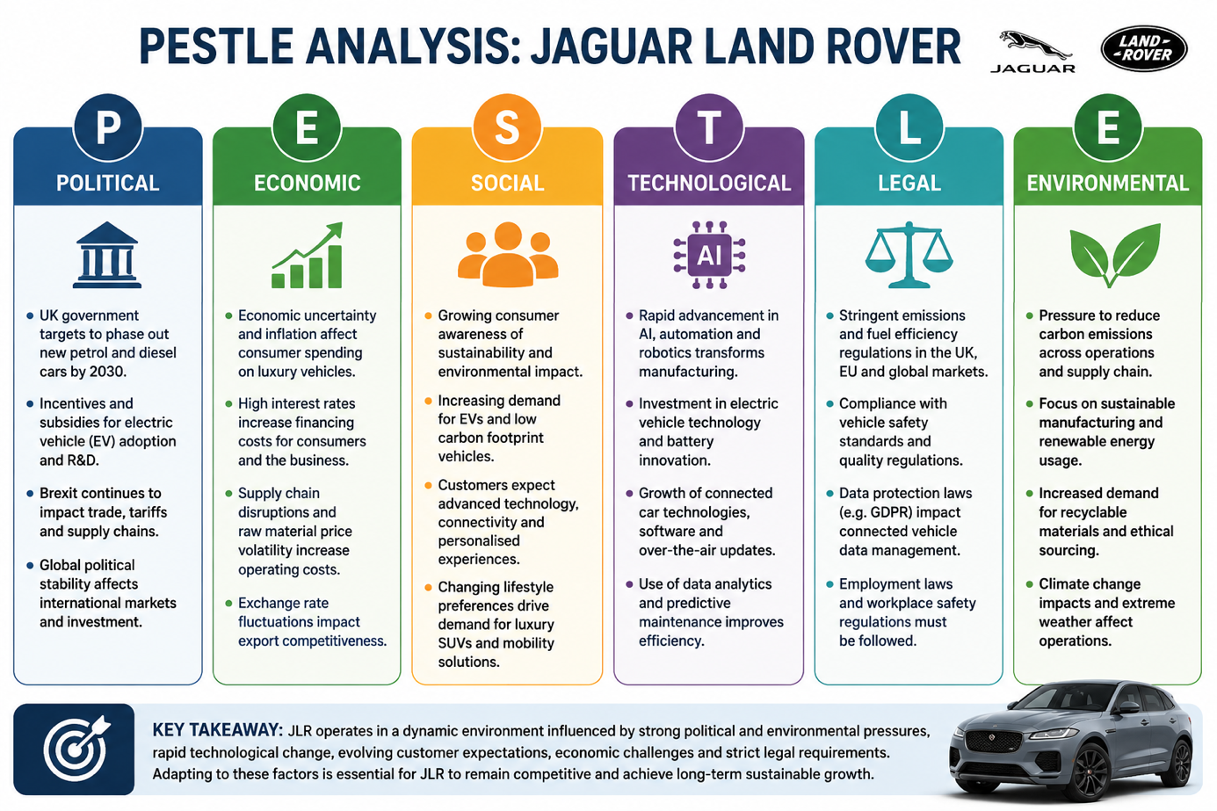

External Environment Analysis (PESTLE) :
The external environment plays a critical role in shaping organisational strategy. A PESTLE analysis provides a structured framework for evaluating the political, economic, social, technological, legal and environmental factors affecting JLR.
Political Factors
Political decisions significantly influence the automotive sector. Governments around the world are implementing stricter environmental regulations to reduce carbon emissions and combat climate change. The UK government has announced plans to phase out the sale of new petrol and diesel vehicles, creating pressure on automotive manufacturers to accelerate electric vehicle production (Department for Transport, 2023).
Additionally, Brexit has introduced uncertainty regarding trade agreements, tariffs and supply chain management. As JLR exports a significant proportion of its vehicles internationally, changes in trade policies may affect production costs and market access. Political stability and favourable trade relationships therefore remain important considerations for the organisation.
Economic Factors
Economic conditions have a direct impact on consumer purchasing behaviour and business performance. Inflation, rising interest rates and economic uncertainty have affected consumer confidence globally. As JLR primarily operates within the luxury vehicle segment, fluctuations in disposable income can significantly influence demand.
The automotive industry has also experienced supply chain disruptions following the COVID-19 pandemic. Shortages of semiconductors and rising raw material costs have increased production expenses and reduced operational efficiency (McKinsey & Company, 2023). These challenges highlight the importance of resilient supply chain management and strategic planning.
Social Factors
Consumer preferences have evolved considerably over the past decade. Modern consumers increasingly prioritise sustainability, environmental responsibility and technological innovation when purchasing vehicles. Demand for electric vehicles has grown rapidly as environmental awareness has increased.
Consumers also expect vehicles to provide advanced connectivity, personalised services and enhanced digital experiences. Consequently, organisations must continuously innovate to meet changing customer expectations and maintain competitive advantage.
Technological Factors
Technological innovation represents one of the most influential drivers of change within the automotive industry. Advances in artificial intelligence, machine learning, autonomous driving systems, robotics and big data analytics are transforming manufacturing processes and customer experiences (Westerman, Bonnet and McAfee, 2014).
JLR has invested significantly in digital transformation initiatives through AI-powered manufacturing systems, predictive maintenance technologies and connected vehicle services. These technologies improve operational efficiency, support decision-making and enhance customer satisfaction. However, technological transformation requires substantial financial investment and workforce development.
Legal Factors
The automotive industry is subject to extensive legal regulation. JLR must comply with vehicle safety standards, environmental legislation, employment regulations and data protection laws. Failure to meet legal requirements can result in financial penalties and reputational damage.
Increasing environmental legislation regarding carbon emissions has created additional pressure for automotive manufacturers to invest in cleaner technologies and sustainable business practices.
Environmental Factors
Climate change and sustainability concerns have become increasingly important for organisations across all industries. Stakeholders now expect businesses to minimise their environmental impact and contribute positively to sustainable development.
JLR has committed to reducing carbon emissions throughout its operations and product lifecycle. The company’s transition towards electric vehicle production reflects its response to environmental pressures and growing stakeholder expectations. Sustainability has therefore become a central component of the organisation’s long-term strategy.

Internal Environment Analysis (SWOT) :
Strengths
One of JLR’s greatest strengths is its globally recognised brand portfolio. Brands such as Jaguar, Range Rover and Defender possess strong reputations for quality, luxury and innovation. The company also benefits from extensive engineering expertise and strong financial support from Tata Motors.
Furthermore, JLR has demonstrated a commitment to research and development, enabling continuous innovation and technological advancement.
Weaknesses
Despite its strengths, JLR faces several internal challenges. Historically, quality control concerns have occasionally affected customer satisfaction and brand reputation. The organisation also faces significant costs associated with transitioning towards electric vehicle production and digital transformation.
Additionally, reliance on premium vehicle markets may expose the company to economic fluctuations and changes in consumer spending patterns.
Opportunities
Growing demand for electric vehicles presents significant growth opportunities for JLR. Government incentives supporting EV adoption and increasing environmental awareness are expected to accelerate market expansion.
Technological advancements in artificial intelligence, autonomous driving and digital services also provide opportunities for product innovation and operational improvement.

Threats
The automotive industry is characterised by intense competition. JLR faces competition from established manufacturers such as BMW, Mercedes-Benz and Audi, as well as newer entrants such as Tesla.
Rapid technological change, regulatory uncertainty and global economic instability continue to present significant challenges. Failure to adapt effectively could weaken the organisation’s competitive position.
Impact of AI and Digitalisation on JLR
Artificial intelligence and digitalisation have fundamentally transformed automotive manufacturing and customer engagement. AI technologies support predictive maintenance, automated production systems, intelligent supply chain management and advanced driver assistance systems.
Digitalisation has enabled the implementation of Industry 4.0 manufacturing practices, improving productivity, quality control and operational efficiency. However, successful digital transformation requires substantial investment and employee reskilling.
For JLR, the adoption of AI and digital technologies is not merely a technological initiative but a strategic necessity. Effective management of this transformation will determine the organisation’s ability to remain competitive within an increasingly complex and dynamic industry.

Evaluation of Change Management Models:
Organisational change is essential for businesses operating in highly competitive and rapidly evolving industries. For Jaguar Land Rover (JLR), technological innovation, environmental regulations, digitalisation and changing consumer preferences have created a need for continuous transformation. Effective change management enables organisations to implement strategic initiatives successfully while minimising employee resistance and operational disruption. This section critically evaluates three major change management models and examines their application within JLR.
Lewin’s Three-Step Change Model
Kurt Lewin (1951) developed one of the earliest and most influential theories of organisational change. His model consists of three stages: Unfreeze, Change and Refreeze.
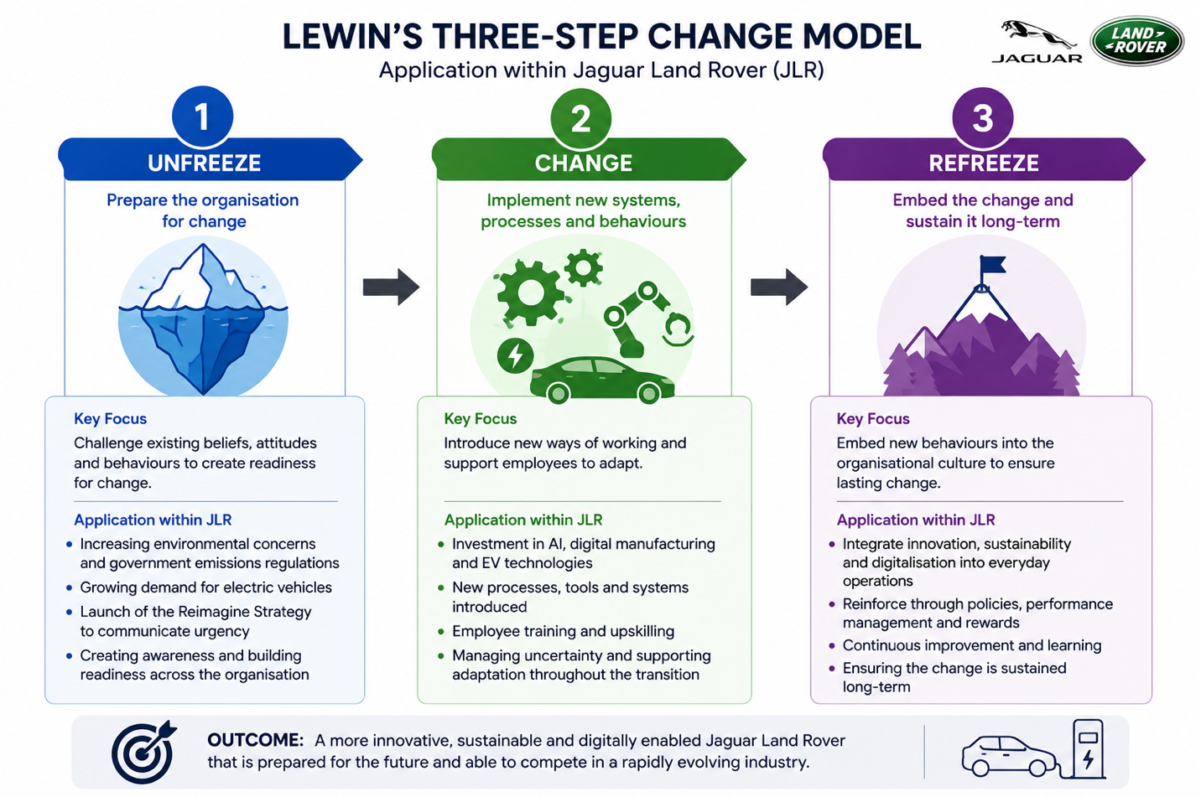
Unfreeze
The first stage involves preparing the organisation for change by challenging existing beliefs, attitudes and behaviours. Employees must understand why change is necessary before they are willing to adopt new ways of working.
Within JLR, the need for change has been driven by increasing environmental concerns, government regulations regarding emissions and the growing popularity of electric vehicles. The launch of the Reimagine Strategy reflects an attempt by senior leadership to create awareness of these challenges and communicate the urgency for transformation.
The unfreezing stage is particularly important because employees often become comfortable with existing routines and may resist new technologies or processes. By communicating the risks of maintaining the status quo, leadership can encourage employees to support organisational transformation.
Change
The second stage involves implementing new systems, processes and behaviours. During this phase employees begin adapting to new working methods and organisational structures.
JLR’s investment in artificial intelligence, electric vehicle production and digital manufacturing technologies represents the implementation stage of Lewin’s model. Employees have been required to learn new skills, adopt digital tools and embrace innovative working practices.
This stage often creates uncertainty because employees may fear failure, increased workloads or job displacement. Consequently, leadership support, communication and training become critical to successful implementation.
Refreeze
The final stage focuses on embedding new behaviours within organisational culture to ensure that changes become permanent.
For JLR, refreezing involves integrating innovation, sustainability and digitalisation into everyday organisational practices. New behaviours can be reinforced through performance management systems, reward programmes and continuous training initiatives.
Strengths of Lewin’s Model
A key strength of Lewin’s model is its simplicity. The framework is easy to understand and provides clear guidance for managing organisational change. It emphasises the importance of preparation and employee engagement before implementation begins.
Limitations of Lewin’s Model
Despite its popularity, critics argue that Lewin’s model is overly simplistic for modern organisations operating in continuously changing environments (Burnes, 2020). The concept of “refreezing” may be unrealistic because businesses rarely experience long periods of stability. Instead, organisations such as JLR must continuously adapt to new technological and market developments.
Kotter’s Eight-Step Change Model
John Kotter (2012) expanded on Lewin’s work by developing a more detailed framework consisting of eight stages:
- Establish a sense of urgency.
- Create a guiding coalition.
- Develop a strategic vision.
- Communicate the vision.
- Remove barriers to change.
- Generate short-term wins.
- Sustain momentum.
- Anchor change in organisational culture.

Application to Jaguar Land Rover
Kotter’s model aligns closely with JLR’s transformation strategy. The organisation recognised the urgency created by environmental regulations, increasing competition and technological disruption. Senior leaders subsequently developed the Reimagine Strategy to provide a clear vision for future growth.
Leadership has invested heavily in communication initiatives to ensure employees understand the organisation’s strategic objectives. Furthermore, workforce training programmes have been introduced to remove barriers and support employee adaptation.
Short-term achievements, including progress in electric vehicle development and sustainability initiatives, provide evidence that change is delivering positive results. These successes help maintain momentum and encourage continued employee engagement.
Strengths of Kotter’s Model
One of the primary strengths of Kotter’s framework is its focus on leadership and communication. Unlike Lewin’s model, it provides detailed guidance regarding implementation and employee engagement.
The model also recognises that organisational change requires cultural transformation rather than simply introducing new processes. This makes it particularly relevant for large organisations such as JLR.
Limitations of Kotter’s Model
Although Kotter’s model is comprehensive, some researchers argue that it assumes change follows a linear process (Hayes, 2022). Organisational transformation is often unpredictable and may require organisations to revisit previous stages.
Furthermore, implementing all eight stages can be time-consuming and resource intensive.
ADKAR Model
The ADKAR model was developed by Hiatt (2006) and focuses on individual employee change. The model consists of five stages:
- Awareness
- Desire
- Knowledge
- Ability
- Reinforcement
According to this model, organisational change occurs only when individual employees successfully adapt to new requirements.

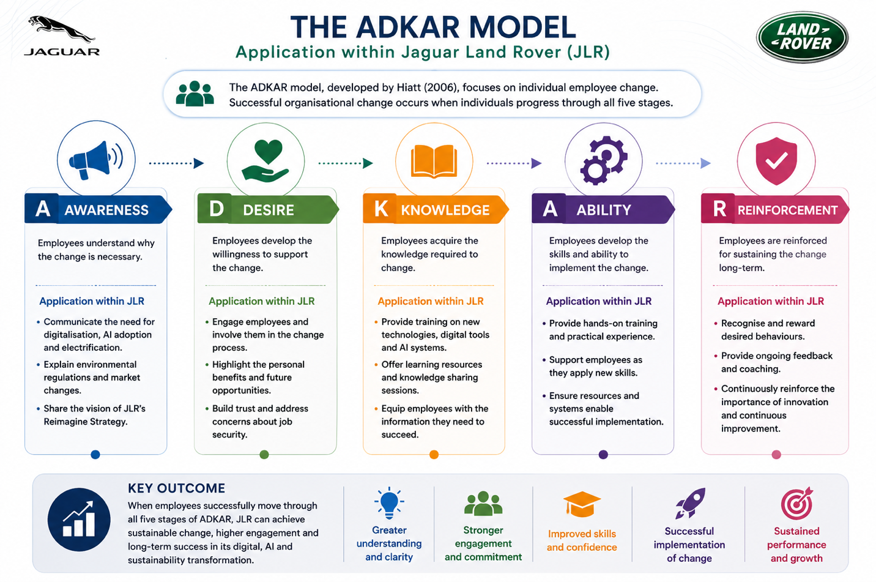
Application to JLR
The transition towards digital manufacturing and electric vehicle production requires employees to develop new technical competencies. The ADKAR model highlights the importance of ensuring that employees understand the reasons for change and possess the necessary skills to perform effectively.
JLR has invested in employee training programmes designed to improve digital literacy and technological expertise. These initiatives support the Knowledge and Ability stages of the ADKAR framework.
Strengths and Limitations
The ADKAR model provides valuable insight into the human side of organisational change. By focusing on employee behaviour, it helps organisations identify and address resistance.
However, the model focuses primarily on individual change and provides limited guidance regarding organisational structures, leadership and strategic planning.
Comparative Evaluation
Each model offers valuable perspectives on organisational change. Lewin’s model provides a straightforward framework; ADKAR focuses on employee behaviour and Kotter offer a comprehensive strategic approach.
For JLR, Kotter’s Eight-Step Model appears most suitable because it addresses leadership, communication, organisational culture and long-term transformation. However, combining Kotter’s framework with elements of ADKAR could further enhance employee engagement and change readiness.

Leadership and Organisational Culture in Managing Change
Leadership and organisational culture are widely recognised as critical determinants of successful change implementation. Even well-designed strategies can fail if employees do not support organisational objectives or if leaders are unable to communicate a compelling vision. As Jaguar Land Rover continues its transformation towards electrification and digitalisation, effective leadership and a supportive organisational culture are essential.
The Importance of Leadership During Change
Leadership can be defined as the ability to influence individuals and groups towards achieving organisational goals. During periods of change, leaders play a crucial role in motivating employees, managing resistance and ensuring strategic objectives are achieved.
Research suggests that transformational leadership is particularly effective during organisational transformation (Bass and Riggio, 2006). Transformational leaders inspire employees through vision, innovation and personal influence. They encourage individuals to embrace change and contribute actively to organisational success.
At JLR, senior leadership has demonstrated transformational leadership through the development and promotion of the Reimagine Strategy. Leaders have communicated a clear vision focused on sustainability, technological innovation and long-term competitiveness.
By emphasising purpose and future opportunities, transformational leaders help employees understand how their contributions support organisational success.
Transformational Leadership
Transformational leadership consists of four key components:
Idealised Influence
Leaders act as role models and demonstrate behaviours that employees respect and trust.
Inspirational Motivation
Leaders communicate a compelling vision that encourages employees to support organisational goals.
Intellectual Stimulation
Employees are encouraged to challenge traditional assumptions and develop innovative solutions.
Individualised Consideration
Leaders recognise individual employee needs and provide support for professional development.
These characteristics are highly relevant to JLR because innovation and adaptability are essential within the rapidly changing automotive industry.
Challenges Facing Leaders During Organisational Change
Although leadership plays a crucial role in change management, several challenges may emerge.
Employees may fear job losses resulting from automation and artificial intelligence. Such concerns can create resistance and reduce engagement. Leaders must therefore communicate openly and address employee concerns proactively.
Another challenge involves balancing short-term business performance with long-term strategic objectives. While investing in digital technologies and sustainability initiatives is necessary, these investments may initially reduce profitability.
Effective leaders must therefore manage stakeholder expectations while maintaining focus on strategic priorities.
Organisational Culture
Schein (2017) defines organisational culture as the shared values, assumptions and beliefs that influence behaviour within an organisation.
Organisational culture affects how employees respond to change, interact with colleagues and approach problem-solving. A positive culture encourages collaboration, innovation and continuous improvement.
Historically, JLR’s culture has been strongly associated with engineering excellence, craftsmanship and premium quality. While these characteristics remain valuable, digital transformation requires additional emphasis on agility, innovation and learning.
Organisational Culture and Change Management
Culture can either support or hinder organisational transformation. Employees who strongly identify with traditional ways of working may resist technological innovation.
For example, introducing AI-powered manufacturing systems may create concerns among employees who are unfamiliar with digital technologies. Resistance may arise if individuals perceive change as a threat rather than an opportunity.
To overcome these challenges, leadership must create a culture that values innovation, learning and adaptability. Employees should be encouraged to participate in decision-making processes and contribute ideas for improvement.
Recommendations for JLR
To strengthen leadership effectiveness and organisational culture, JLR should:
- Continue promoting transformational leadership behaviours.
- Increase employee involvement in strategic decision-making.
- Expand workforce training and development programmes.
- Reward innovation and continuous improvement.
- Strengthen communication between management and employees.
- Foster collaboration across departments.
By aligning leadership practices with cultural transformation, JLR can create an environment that supports long-term organisational success and sustainable competitive advantage.

Strategic Change Management Plan for Jaguar Land Rover:
Proposed Strategic Change
Based on the analysis conducted throughout this report, the proposed strategic change for Jaguar Land Rover (JLR) is the acceleration of its transformation into a fully digitalised, AI-enabled and sustainability-focused automotive manufacturer. This change is necessary to respond effectively to increasing environmental regulations, changing consumer expectations, technological advancements and growing competition within the global automotive industry.
The automotive sector is rapidly moving towards electric mobility, intelligent manufacturing systems and connected vehicle technologies. To maintain competitiveness, JLR must continue investing in digital transformation while simultaneously enhancing operational efficiency and sustainability performance.
The proposed change aligns closely with JLR’s Reimagine Strategy, which seeks to establish the organisation as a leader in luxury electric vehicles and sustainable transportation solutions.
Strategic Objectives
The change programme aims to achieve several strategic objectives over the next five years.
Objective 1: Increase Electric Vehicle Production
JLR aims to increase electric vehicle production to 60% of total vehicle output by 2030. This objective supports compliance with environmental legislation and responds to increasing consumer demand for sustainable mobility solutions.
Objective 2: Improve Operational Efficiency
The organisation seeks to improve manufacturing efficiency by 20% through the implementation of artificial intelligence, robotics and advanced manufacturing technologies.
Objective 3: Reduce Carbon Emissions
JLR intends to reduce organisational carbon emissions by 50% by 2030 through sustainable manufacturing practices, renewable energy usage and increased production of electric vehicles.
Objective 4: Enhance Workforce Capabilities
The organisation will develop employee digital competencies through comprehensive training and development programmes focused on artificial intelligence, automation and advanced manufacturing systems.
Objective 5: Strengthen Customer Experience
JLR aims to improve customer satisfaction by introducing innovative digital services, connected vehicle technologies and personalised customer experiences.
Financial Plan
Successful implementation of the proposed strategy requires significant financial investment. Investment should be viewed as a long-term commitment that supports future competitiveness and organisational sustainability.

Investment Area | Estimated Budget
Electric Vehicle Development | £2.0 Billion
Artificial Intelligence Systems | £500 Million
Digital Infrastructure | £800 Million
Employee Training and Development | £150 Million
Sustainability Initiatives | £500 Million
Research and Development | £300 Million
Total Estimated Investment | £4.25 Billion

Funding may be obtained through retained profits, strategic partnerships, government sustainability grants and investment programmes designed to support green technologies.
Although the financial commitment is substantial, the long-term benefits are expected to outweigh the costs through increased market share, operational efficiency and enhanced profitability.

Communication Plan:
Effective communication is critical to successful change implementation. Poor communication often contributes to employee resistance, uncertainty and reduced organisational performance.
JLR should adopt a multi-channel communication strategy that ensures all stakeholders understand the objectives and benefits of the proposed transformation.

Stakeholder Group | Communication Method | Frequency
Employees | Workshops, Meetings and Internal Newsletters | Monthly
Senior Managers | Strategic Review Meetings | Monthly
Investors | Financial and Performance Reports | Quarterly
Customers | Marketing Campaigns and Social Media Updates | Continuous
Suppliers | Partnership Meetings | Quarterly
Government and Regulators | Compliance Reports | Annually

The communication strategy should focus on transparency, engagement and continuous feedback.
Employees should be encouraged to ask questions and provide feedback throughout the implementation process. This approach will help build trust and reduce resistance to change.

Implementation Plan
The implementation process will occur in three phases.
Phase One: Preparation (Year 1)
The first phase focuses on preparing the organisation for change.
Key activities include:
- Conducting organisational readiness assessments.
- Identifying skills gaps.
- Developing employee training programmes.
- Upgrading digital infrastructure.
- Establishing a dedicated change management team.
During this phase, leadership should focus on building awareness and creating support for transformation.

Phase Two: Implementation (Years 2–3)
The second phase involves introducing new technologies and operational processes.
Key activities include:
- Expanding electric vehicle production.
- Deploying AI-powered manufacturing systems.
- Implementing predictive maintenance technologies.
- Introducing advanced digital customer services.
- Delivering workforce development programmes.
This phase represents the most significant period of organisational change and will require continuous communication and leadership support.
Phase Three: Consolidation (Years 4–5)
The final phase focuses on embedding new behaviours and ensuring long-term sustainability.
Key activities include:
- Monitoring performance outcomes.
- Evaluating strategic objectives.
- Reinforcing organisational culture.
- Continuing employee development initiatives.
- Identifying opportunities for further improvement.
Successful completion of this phase will ensure that organisational change becomes embedded within everyday operations.
Risk Management
All change initiatives involve risk. Effective risk management helps reduce uncertainty and increases the likelihood of successful implementation.
Employee Resistance
Employees may resist technological change due to concerns regarding job security or increased workloads. This risk can be reduced through communication, employee involvement and training programmes.
Financial Risk
Large-scale investments may affect short-term profitability. Effective budgeting and phased implementation can minimise financial pressure.
Technological Risk
Implementation failures could disrupt manufacturing operations. Pilot projects and testing procedures should be conducted before full deployment.
Market Risk
Consumer demand may fluctuate due to economic uncertainty or changing market conditions. Continuous market analysis will help ensure production remains aligned with customer expectations.
Evaluation and Control
To measure the success of the change programme, JLR should monitor a range of Key Performance Indicators (KPIs).
Financial Performance Indicators
- Revenue Growth
- Profit Margins
- Return on Investment (ROI)
Operational Performance Indicators
- Manufacturing Efficiency
- Production Output
- Equipment Reliability
Employee Performance Indicators
- Employee Engagement Scores
- Staff Retention Rates
- Training Completion Rates
Customer Performance Indicators
- Customer Satisfaction Levels
- Customer Retention Rates
- Market Share Growth
Quarterly performance reviews should be conducted to evaluate progress and identify any corrective actions required.

Conclusion:
The automotive industry is undergoing significant transformation driven by technological innovation, environmental sustainability requirements and changing consumer expectations. Jaguar Land Rover operates within a highly competitive environment where continuous adaptation is essential for long-term success.
The analysis conducted within this report demonstrates that both internal and external factors are influencing JLR’s strategic direction. Technological developments such as artificial intelligence, automation and digitalisation have created opportunities for innovation while simultaneously increasing competitive pressure. Environmental legislation and sustainability concerns have accelerated the transition towards electric vehicles, requiring substantial organisational transformation.
The evaluation of change management models highlights the importance of structured approaches to organisational change. While Lewin’s Three-Step Model and the ADKAR Model provide valuable insights, Kotter’s Eight-Step Model offers the most comprehensive framework for managing large-scale transformation within JLR. Furthermore, transformational leadership and a supportive organisational culture are essential for encouraging employee engagement and reducing resistance.
The proposed strategic change management plan provides a structured approach for supporting JLR’s transition towards becoming a digitally enabled and sustainability-focused automotive manufacturer. Through investment in technology, employee development and innovation, JLR can strengthen its competitive position and achieve sustainable growth.
Ultimately, organisations that successfully embrace change are better positioned to respond to future challenges and opportunities. By implementing the recommendations outlined in this report, Jaguar Land Rover can continue to evolve and maintain its position as one of the world’s leading luxury automotive manufacturers.

References:
- Bass, B.M. and Riggio, R.E. (2006) Transformational Leadership. 2nd edn. Mahwah, NJ: Lawrence Erlbaum Associates.
- Burnes, B. (2020) Managing Change. 8th edn. Harlow: Pearson.
- Department for Transport (2023) Decarbonising Transport: A Better, Greener Britain. London: Department for Transport.
- Hayes, J. (2022) The Theory and Practice of Change Management. 6th edn. London: Palgrave Macmillan.
- Hiatt, J. (2006) ADKAR: A Model for Change in Business, Government and Our Community. Loveland, CO: Prosci Learning Center Publications.
- Jaguar Land Rover (2024) Reimagine Strategy. Available at: https://www.jaguarlandrover.com (Accessed: 11 July 2026).
- Johnson, G., Scholes, K. and Whittington, R. (2023) Exploring Strategy. 13th edn. Harlow: Pearson.
- Kotter, J.P. (2012) Leading Change. Boston: Harvard Business Review Press.
- Lewin, K. (1951) Field Theory in Social Science. New York: Harper & Row.
- McKinsey & Company (2023) The Future of Mobility and Automotive Industry Transformation. Available at: https://www.mckinsey.com (Accessed: 11 July 2026).
- Porter, M.E. (2008) ‘The Five Competitive Forces That Shape Strategy’, Harvard Business Review, 86(1), pp. 78–93.
- PwC (2024) The Future of the Automotive Industry. Available at: https://www.pwc.com (Accessed: 11 July 2026).
- Schein, E.H. (2017) Organizational Culture and Leadership. 5th edn. Hoboken, NJ: John Wiley & Sons.
- Tata Motors (2024) Annual Report 2023–2024. Available at: https://www.tatamotors.com (Accessed: 11 July 2026).
- Westerman, G., Bonnet, D. and McAfee, A. (2014) Leading Digital: Turning Technology into Business Transformation. Boston: Harvard Business Review Press.
- World Economic Forum (2023) The Future of Jobs Report 2023. Geneva: World Economic Forum. Available at: https://www.weforum.org (Accessed: 11 July 2026).
- Yukl, G. (2020) Leadership in Organizations. 9th edn. Harlow: Pearson.
- Deloitte (2024) 2024 Global Automotive Consumer Study. Available at: https://www.deloitte.com (Accessed: 11 July 2026).

