· Welsh triumph in Paris
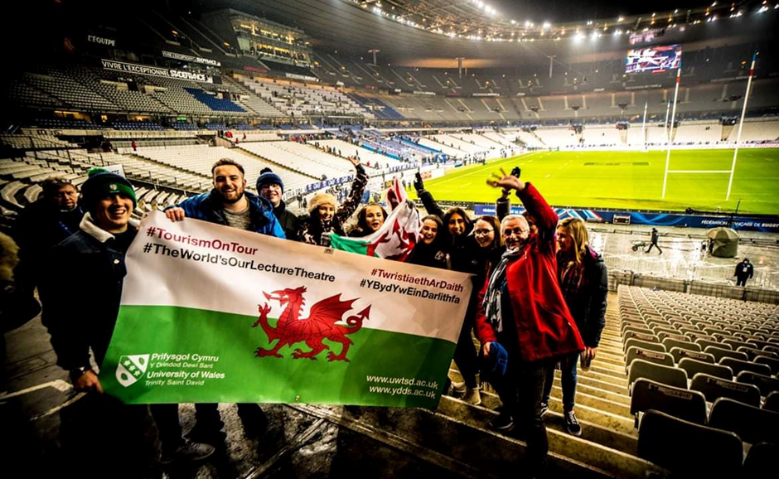
Rhodri Stranaghan 03/03/2019
The journey of a Welshman on the way to the Stade De France, including lots of rain, delays, beers and Max Boyce songs.

Sports Tourism is a form of travel which is becoming increasingly more popular, and when it comes to popular sports, Rugby is amongst the most popular worldwide. Once finding out that we were going to be in Paris on a university trip at the same time as the Six Nations opener between France and Wales, we were all excited about the possibility of watching Wales and so purchased the tickets in advance. The beauty of the national team is having the whole country behind the side, forgetting all political differences and tension in the country. For that 80 minutes all that matters is backing the team, and so being able to travel out of Wales yet still have thousands with you and the whole nation watching at home really unites Wales. The six nations is a brilliant excuse for a holiday!
The first day of travelling was tiresome leaving the snow of Swansea behind at 03:54, however we knew that we were not the only welsh making the journey, and were hoping not to follow in the footsteps of the late Windsor Davies in the ‘Grand Slam’ film where he was arrested and missed the match, which we had watched the night before. The train journey was shortened through listening to Max Boyce on the train to get me in the mood for the game.
Once arriving in St Pancras, we could see the fellow welsh supporters near the bar all excited about the game. Nervous with the delay of the Eurostar, however we kept the faith and after a couple of hours were en route to Charles De Galle on a train full of excited welsh.
After checking in to the hostel, we were all putting on our red shirts, face painted dragons however, no daffodil hats in sight this time, we then headed via metro to the Stade De France, missing a portion of welsh through cancelled flights and trains due to the snow at home so we knew we had to make up for them with an even louder rendition of the anthem.

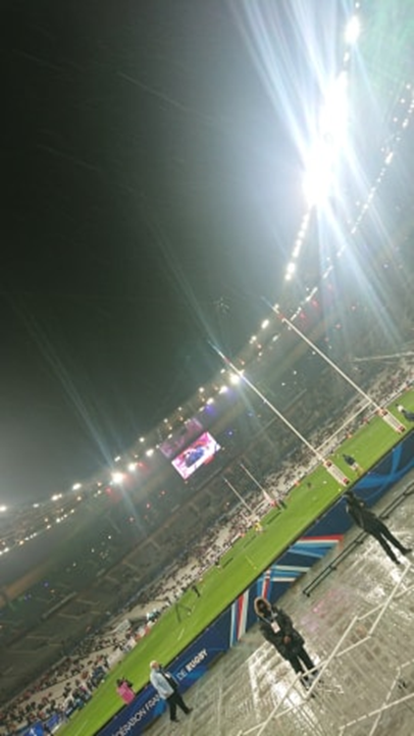
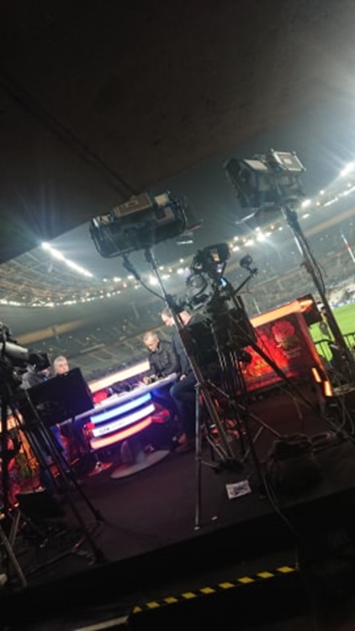

The rain was pouring down, so we had that feeling of being at home, and once arriving at the impressive stadium and found the beer, we were ready for the anthem and the game. The nerves had set in. Will I finally get to see Wales win live? The tired eyes had woken up as soon as we walked out of the concourse in to the stadium itself, and we were shocked at how close to the TV crew we were. Despite our best attempts we unfortunately were not picked up by the camera crew.
Despite a small minority of French supporters booing, we made sure we were heard once Hen Wlad Fy Nhadau had started, and the passionate voices of the fans singing Hymns and Arias and Bread of Heaven during the match inspired Wales to come from 16-0 down at halftime to win 19-24. The performance was gritty, however the feeling of being in the stadium for that memorable second half was worth sitting through the rain and the hours of travelling to get there. I will always remember Paris for the pretty attractions, stunning food and that time Wales came from behind at the Stade De France.
I definitely recommend going to the Stade De France to watch the six nations. Despite the 25 euro tickets, there were still many empty seats partly down to welsh flights and trains being cancelled through poor weather conditions back home, so there is lots to be considered in terms of fan engagement and visitor experience. The price of beer being so high was also a negative, however all in all was definitely a stadium I would visit again to watch Wales. The atmosphere was brilliant, and had the weather been nicer probably more so. However that didn’t stop the fun. The trip to the game was a great way of bonding with my classmates, and after the match we capped off an excellent evening back at the Generator Hostel bar for some celebratory drinks.
The trip further developed my passion for sports tourism, with the next stop being Switzerland which was perfect as I got to participate in Bavarian Curling as well as visiting the Olympics museum, FC Young Boy’s stadium and SC Bern’s hockey arena. But that’s for next time, see you soon.

