

University of Wales Trinity Saint David
School of Engineering

BEng Advanced Manufacturing and Operations

Factory Control 2

Amy Evans
1909135
Module Code: ACMA6001

Contents
1. Introduction 3
2. Factory Layout 3
2.1. Component’s list 3
3. Process Flow 5
4. Ladder Logic Program – Operation 6
4.1. Network 1 – PLC/HMI 6
4.2. Network 2 – Control Panel Operation & Start PLC Programme 6
4.3. Network 3 – Siren Operation 6
4.4. Network 4 – Start Conveyors 7
4.5. Network 5 – Start Emitters 8
4.6. Network 6 & 7 - Start Machine Centres & Lid & Base Production 9
4.7. Network 8 – Reset – Clamps & Pick and Place Arm 10
4.8. Network 9 – Initiate Clamps & Lid and Base Counter 11
4.9. Network 10 – Lid & Base Both Clamped 12
4.1. Network 11 – Initiate Two Axis Pick & Place - Lid & Base 12
4.1. Network 12 & 14 – Completed Component Control & Count 14
4.1. Network 13 – Initiate Pick & Place - Completed Component 16
4.2. Network 15 – Shipping Box Input Count 18
4.1. Network 16 – Total Shipping Boxes Completed Count 18
4.2. Network 17 – Lid & Base Error Count 19
4.1. Network 19 – Completed Components Error Count 20
5. Ladder Logic Program – Warnings and Alarms 21
5.1. Warnings & Warning Flag 21
5.2. Alarms & Alarm Master / Flag 22
6. HMI Control 23
6.1. Root Screen 23
6.1.1. Conveyor Operation 23
6.1.2. Counters 24
6.1.3. Warning & Alarm Flags 24
6.1.4. E-Stop Button 24
6.1.5. Reset All Counters 25
6.2. Warning & Alarm Screen 25
6.2.1. Error Count 26
6.3. Engineering Screen 26
7. References & Bibliography 27

Introduction
This project describes an automation system created that manufactures lids and bases, assembles them into a single component, and places it in a shipping box, with each shipping box containing two completed components. Raw material is emitted from opposite sides of the factory during the process, with the left side emitting blue raw material and the right side emitting green raw material. The machining centres make lids and bases.
Each part is then transported into clamps that hold it square. To pick up the id and place it on the base, a two-axis pick, and place arm is used. The finished component is then transported to the second pick and place and placed in a shipping box. Infrared (IR) sensors will be strategically placed to detect and count. The system will be controlled by a PLC and will include an HMI for operator interaction.

Factory Layout
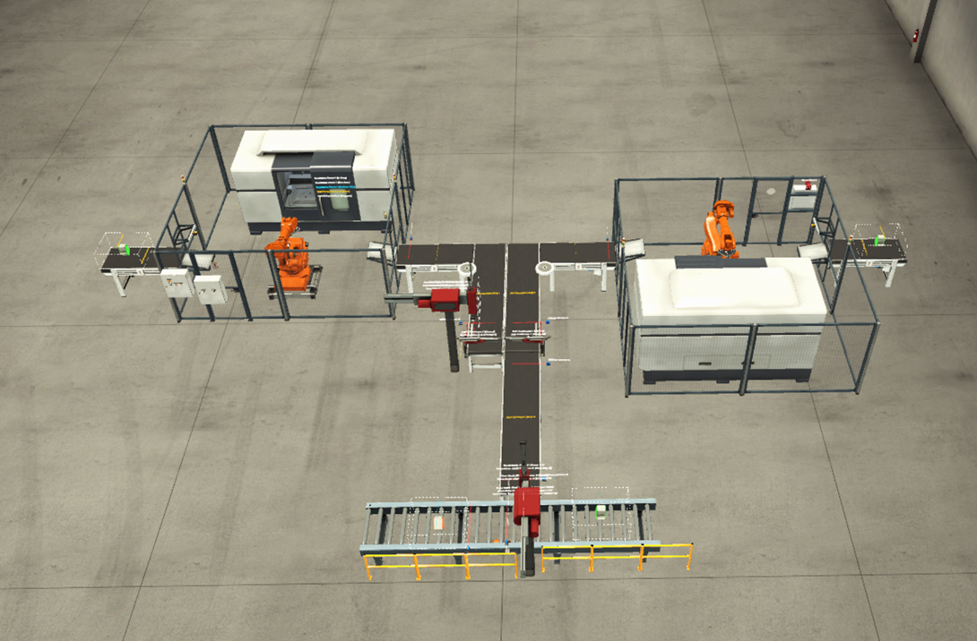
Figure 1 - Factory Layout

Component’s list
Component List | Quantity
2 Meter Conveyor | 4
4 Meter Conveyor | 2
6 Meter Conveyor | 1
4 Meter Roller Conveyor | 1
Clamps | 2
Two Axis Pick & Place | 2
InfraRed Sensor | 8
Raw Material Emitter | 2
Shipping Box Emitter | 1
Box Remover | 1
Control Panel | 1
Siren | 1
E-Stop (HMI) | 1

Process Flow
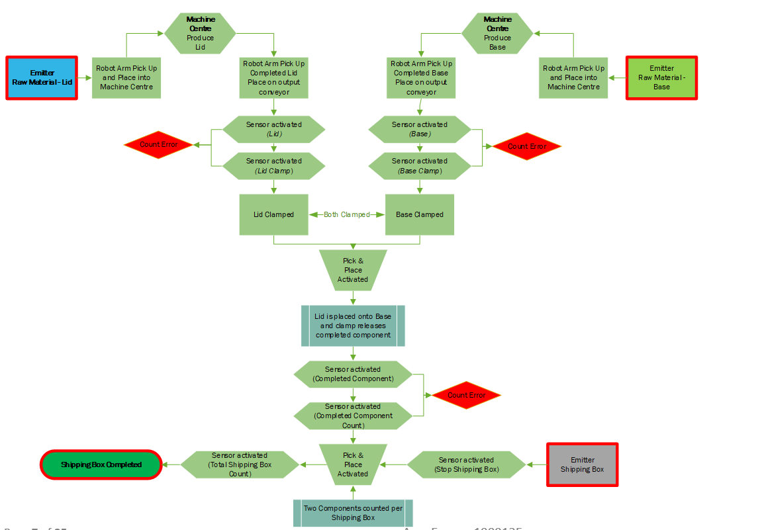

Ladder Logic Program – Operation

Network 1 – PLC/HMI
PLC connection.

Figure 2 - PLC/HMI Connection

Network 2 – Control Panel Operation & Start PLC Programme
A control panel is located on the side of the Machining Centre and includes a start/stop button to start up the system. If the 'Start Button' and 'Stop Button' inputs (I) are both TRUE (1) and the 'Alarm Master' is FALSE (0), the output (Q) is 'Operate'. ‘Operate’ will latch on to keep the start button activated. If the ‘Alarm Master’ is TRUE, the process will stop (Figure 3).
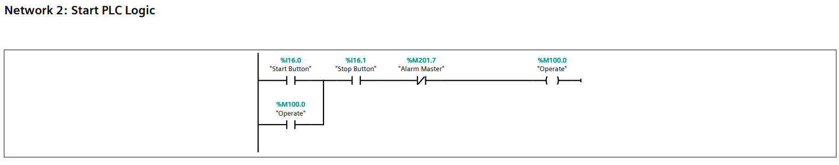
Figure 3 - Start PLC Programme

Network 3 – Siren Operation
When the 'Operate' input is set to TRUE (1) a TP (pulse timer) function is used to activate the siren, and when the result of the input (IN) changes from FALSE to TRUE, the programmed time (PT) begins. The accumulator timer accumulates time values over a period specified by the (PT) parameter. When the input changes from FALSE to TRUE, the duration PT begins, and the 'Alarm Siren' sounds for 2 seconds (Figure 4).

Figure 4 - Siren Operation

Network 4 – Start Conveyors
The conveyor system is covered in this network; when the 'Operate' tag is TRUE, both input conveyors 'Belt 2m Lid in' and 'Belt 2m Base in' will start up. A TON (delay timer) function is used for the other conveyors, which delays the Q output by the PT duration. When the input changes to TRUE, these will start. For example, the output conveyors 'Belt 2m Lid out' and 'Belt 2m Base out' will begin after a one-second delay (Figure 5). When the signal state at the input changes to FALSE, the ET output is reset. The same applies to all other conveyors, including the 4-meter belt conveyors and the finished component conveyor.
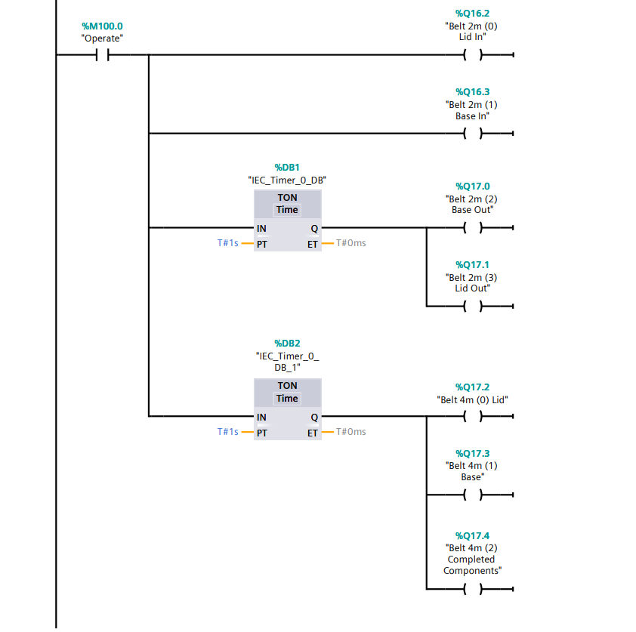
Figure 5 - Start Conveyors

Network 5 – Start Emitters
This network is responsible for activating the emitters. While the machine centres are busy, no raw material for the lid and base will be emitted (Figure 7), which is FALSE. This means that raw material will not emit unless the 'Machine Center Lid Busy' and 'Machine Center Base Busy' conditions are TRUE. This is to prevent raw material from piling up on the input conveyor and causing a build-up and crash (Figure 6). The 'Operate' tag also starts the 'Shipping Box Emitter'.
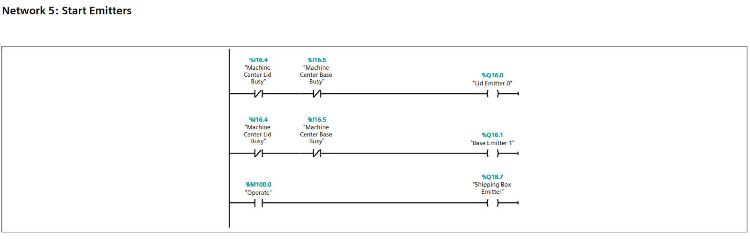
Figure 6 - Start Emitters
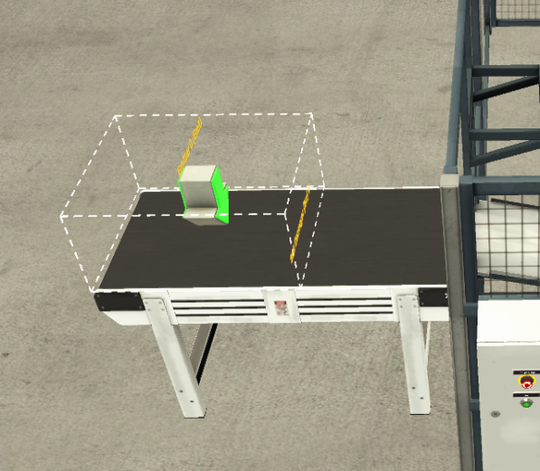
Figure 7 - Raw Material Emitter

Network 6 & 7 - Start Machine Centres & Lid & Base Production
When the 'Operate' input is set to TRUE (1), both machine centres start, 'Machine Centre Lid Start' and 'Machine Centre Base Start' (Figure 8), the robotic arm collects the raw material and places it in the machining centre. The lid and base will then be produced by machining, 'Machine Centre Make Lid' and 'Machine Centre Make Base' (Figure 9). Once the process is completed the robotic arm collects from the machine and then places the completed parts onto the output conveyor (Figure 10).
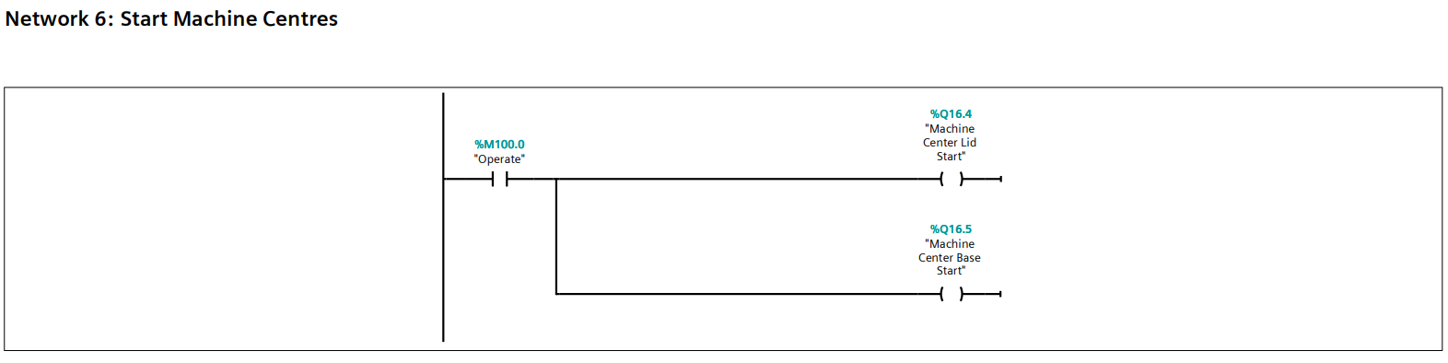
Figure 8 - Start Machine Centers
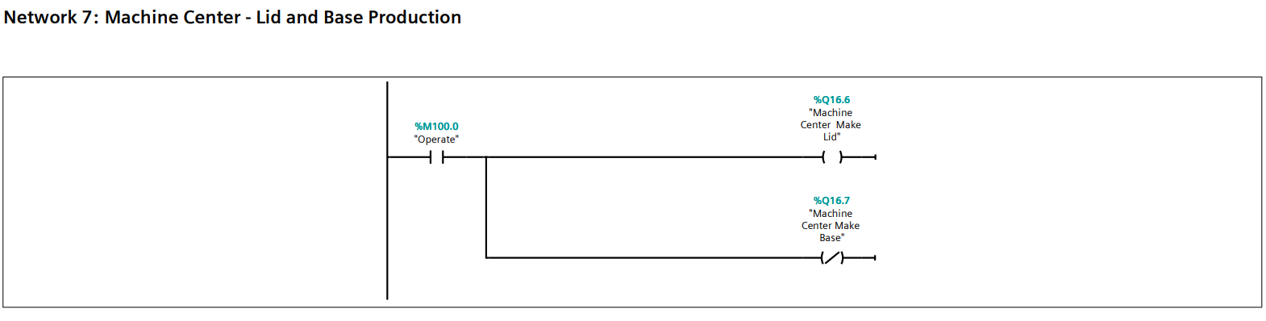
Figure 9 - Lid & Base Production
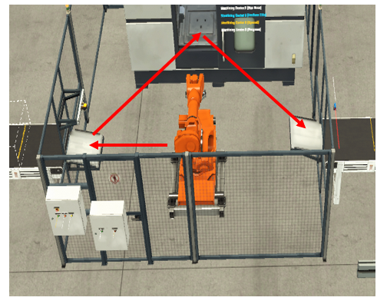
Figure 10 - Machine Center

Network 8 – Reset – Clamps & Pick and Place Arm
This network was created to ensure that the clamps that hold the components in place, as well as the place and pick & place arm that places the lid on top of the base, are in the start position whenever the system is started, and to prevent crashes. When the 'Operate' command is TRUE and the 'Reset' tag is initiated, the reset is activated. A TP (pulse timer) function is used to delay for 2 milliseconds and reset all tag outputs (R) (Figure 11).

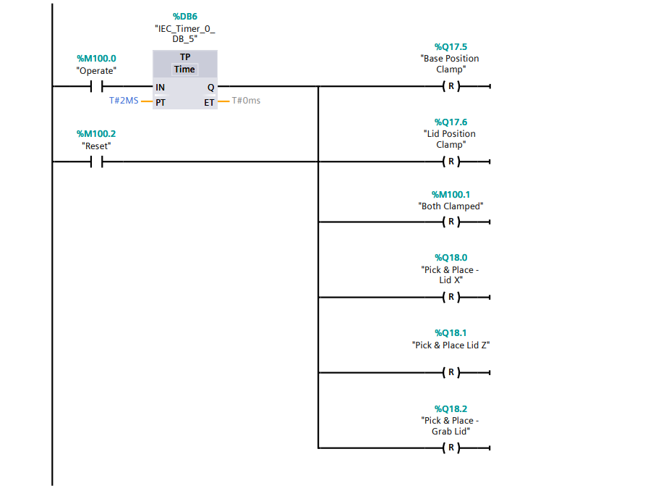
Figure 11 - Reset – Clamps & Pick and Place Arm

Network 9 – Initiate Clamps & Lid and Base Counter
Once the lid and base have been machined and are moving along the output conveyor, the clamp sensors 'Sensor 2 - Initiate Lid Clamp' and 'Sensor 1 - Initiate Base Clamp' are activated, using the TON (delay timer) function, a 500-millisecond delay is created before the output of both the 'Lid Position Clamp' and 'Base Position Clamp' are initiated and set (S). When TRUE, the sensors will also count the total for each completed lid and base using the 'CTU' function (Figure 12 & Figure 13).
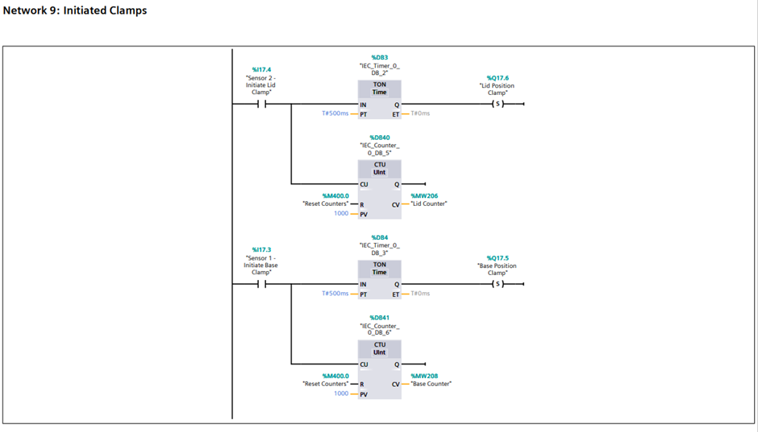
Figure 12 - Initiate Clamps & Lid and Base Counter
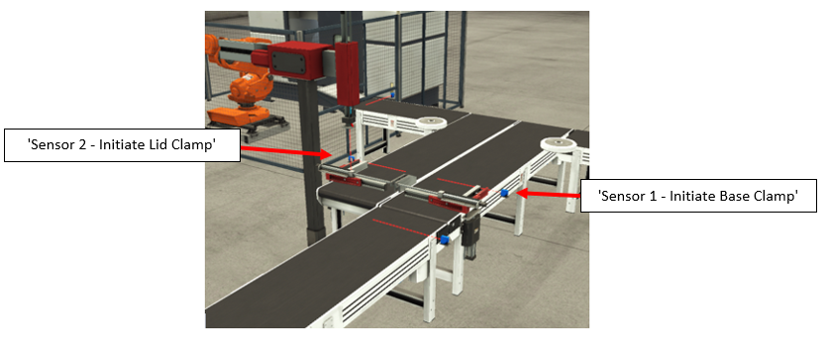
Figure 13 - Initiate Clamps & Lid and Base Counter

Network 10 – Lid & Base Both Clamped
In this network when both tags 'Lid Position Clamped' and 'Base Position Clamped' are TRUE using a TP function there is a delay for 2 milliseconds and then the output tag ‘Both Clamped’ is set (S) (Figure 14).

Figure 14 - Lid & Base Both Clamped

Network 11 – Initiate Two Axis Pick & Place - Lid & Base
Network 11 (Figure 16) controls the two-axis pick and place system, which is used to pick up the lid and place it onto the base. Using the tag created in network 10, the Pick and Place arm will be activated if 'Both Clamped' is TRUE. The arm is controlled by a TON and TP timers to ensure smooth control and that the lid sits squarely on the base.
The pick and place arm will first move downwards (along the Z axis) to the location of the lid where the output 'Pick & Place lid Z' is set (S). The ‘Pick & Place Grab Lid’ will then output to set (S), this activates the suction cup to pick up the lid (Figure 15). The arm will then move back up using the 'Pick & Place lid Z' reset (R), and the 'Lid Position Clamp' will also reset (R), returning the clamp to its home position. The arm will then move along the X-axis across to the base using 'Pick & Place Lid X' with output set (S), then move downwards using 'Pick & Place Lid Z' set (S), placing the lid on top of the base (Manual, 2022).
When the 'Pick & Place Grab Lid' outputs reset (R), the suction cup is deactivated. The arm will then move upwards and back to the home position using the same tags with the output reset (R), and the 'Base Position Clamp' will also reset (R), returning the clamp to the home position. The 'Base Position Raise' tag will then be activated, allowing the completed component to move onto the completed component output conveyor by raising the clamp.
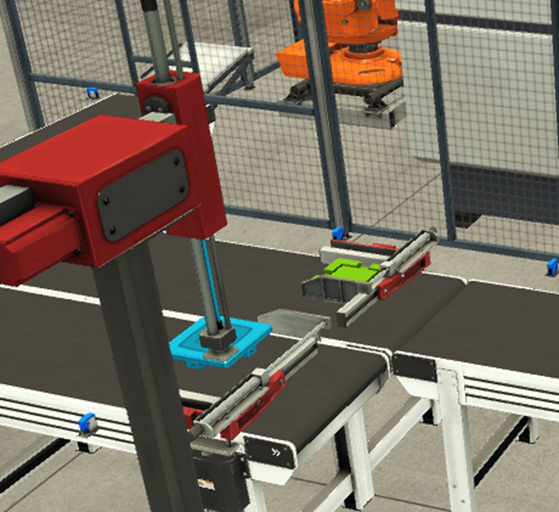
Figure 15 - Two Axis Pick & Place Lid & Base
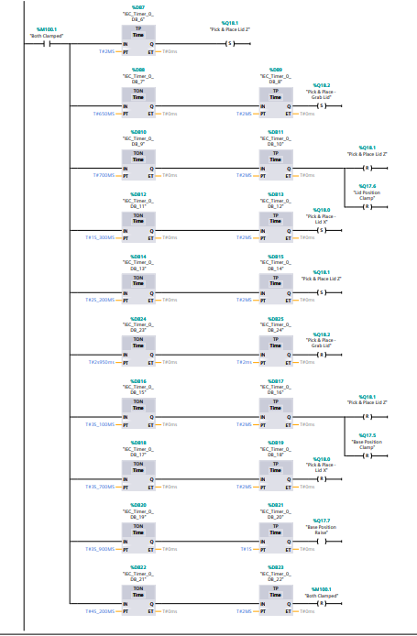
Figure 16 - Initiate Two Axis Pick & Place - Lid & Base

Network 12 & 14 – Completed Component Control & Count
The finished component is moved along the 6-meter conveyor to the second pick and place. When the 'Sensor 3 - Activate P&P & Stop Belt' sensor is activated and TRUE, the belt is stopped using the 'Belt 4m (2) Completed Component' tag with the output set to FALSE (Figure 17 & Figure 18).
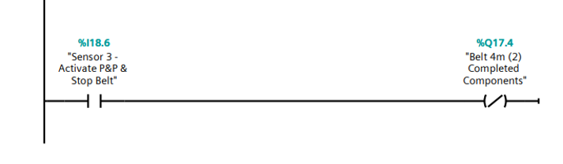
Figure 17 - Stop Conveyor Belt
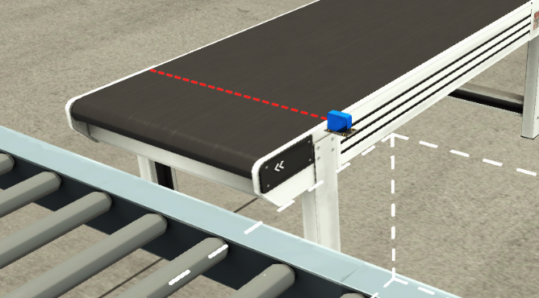
Figure 18 - Sensor - Stop Conveyor Belt and Initiate Pick & Place
This network also controls the roller conveyor; when sensor 'Sensor 4 - Stop Roller Belt' is activated and set to FALSE, the roller conveyor stops, ensuring the shipping box is under the pick and place arm. Using a comparator, if the unit count from "Sensor 3 - Activate P&P & Stop Belt" reaches a count of two (completed parts into shipping box), 'Sensor 4 - Stop Roller Belt' will change to TRUE, and the roller conveyor will restart after a 4-second delay, and the shipping box will move into the box remover (Figure 19 & Figure 20). A new shipping box will be emitted and stop when the sensor is re-activated.
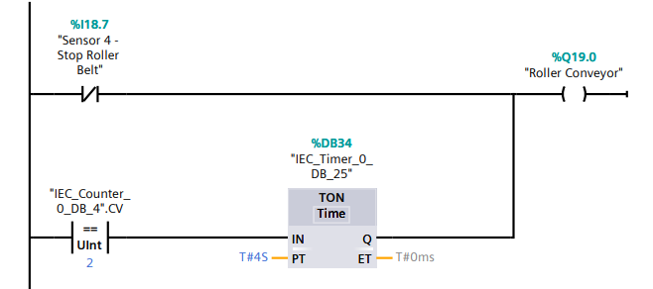
Figure 19 - Roller Conveyor Control and Box Input Count
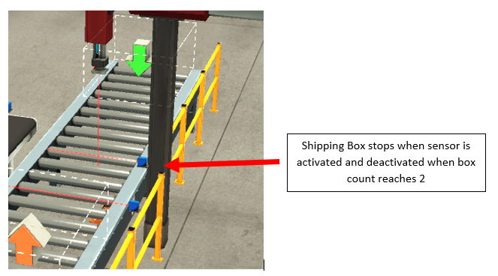
Figure 20 - Roller Conveyor Shipping Box Sensor
Network 14 counts the completed components using the ‘CTU’ function when ‘Sensor 6 – Complete Component Count’ is TRUE the ‘Completed Components’ (CV) will increment by one each time the logic is set to TRUE. To reset this counter, the ‘Reset All Counters’ tag will be used with the function (R) (Figure 21 & Figure 22).

Figure 21 - Completed Components Count
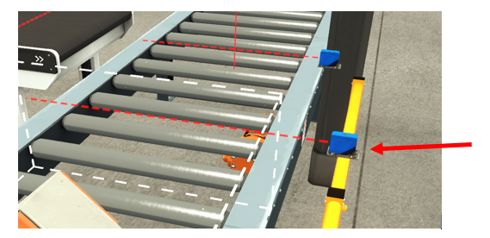
Figure 22 - Sensor Completed Component Count

Network 13 – Initiate Pick & Place - Completed Component
The logic in network 13 (Figure 23 Page 16) is similar to that in network 11. This controls the two-axis pick and place system for completed components, which is used to pick up and place into the shipping box. If 'Sensor 3 - Activate P&P & Stop Belt' is TRUE (Figure 18 on page 13), the Pick and Place arm will be activated. To ensure smooth control, the arm is controlled by a TON and TP timer and loaded into the shipping box.
The pick and place arm will first move (along the X axis) to the component location where the output 'Pick & Place Finished Component X' is set (S). 'Pick & Place Finished Component Z' will then cause the arm to move downwards (along the Z axis) (S). The 'Pick & Place Grab Finished Component' (S) will then activate the suction cup, allowing the arm to pick up the component. The arm will then move back up and backwards using the same tags but with the output reset (R).
The arm will then lower the component into the shipping box with 'Pick & Place Finished Component Z' (S), and 'Pick & Place Grab Finished Component' (R), releasing the component into the box. The arm will then return to the home position 'Pick & Place Finished Component Z' position (R) (Figure 24).

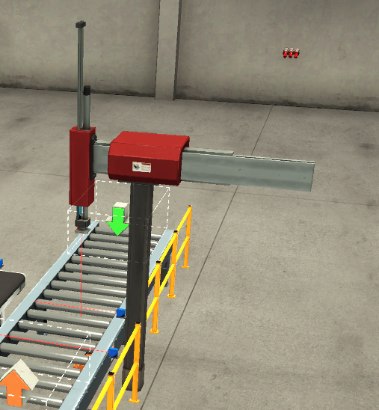
Figure 24 - Pick & Place - Completed Component

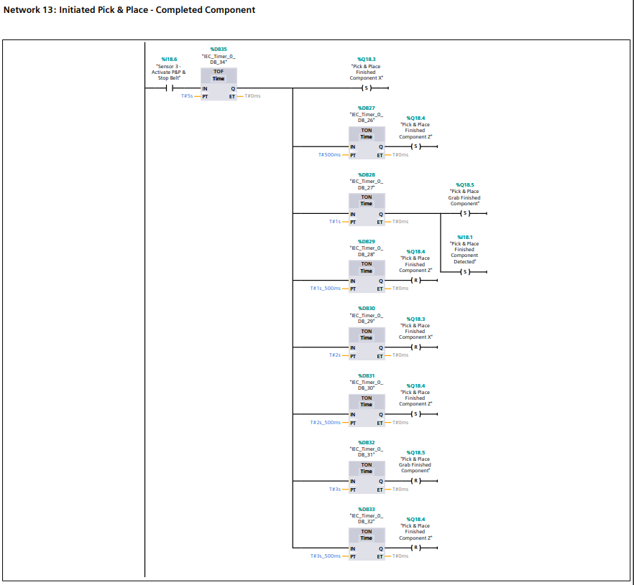
Figure 23 - Initiate Pick & Place - Completed Component

Network 15 – Shipping Box Input Count
Network 15 (Figure 25) is used to count the completed components that have been placed into the shipping box. Using the ‘CTU’ function when ‘Sensor 3 – Activate P&P & Stop Belt’ is activated TRUE the ‘Shipping Box Input Count’ (CV) will increment by one each time the logic is set to TRUE. The counter is then reset when ‘Sensor 5 – Reset P&P Counter’ is TRUE (R).

Figure 25 - Shipping Box Input Count

Network 16 – Total Shipping Boxes Completed Count
Within this network the total shipping boxes completed are counted using the ‘CTU’ function when ‘Sensor 5 – Reset P&P Counter’ is TRUE the ‘Total Shipping Boxes Completed (CV) will increment by one each time the logic is set to TRUE. To reset this counter, the ‘Reset All Counters’ tag will be used with the function (R) (Figure 26).

Figure 26 - Total Shipping Boxes Completed Count

Network 17 – Lid & Base Error Count
To highlight and Lid failures between the lid machining output and clamp (Figure 28) the 'CTUD' function is used. The 'CTUD' function counts up and down, so when ‘Sensor 7 - Lid Count’ is TRUE, the function counts up (CU), then counts down using the ‘Sensor 2 - Initiate Lid Clamp’ tag. If the counters do not align by the maximum count number determined by the operator (see HMI section 6.2.1), the output (CV) tag is 'Lid Errors’ (Figure 27). The base error count follows same principle (Figure 29).
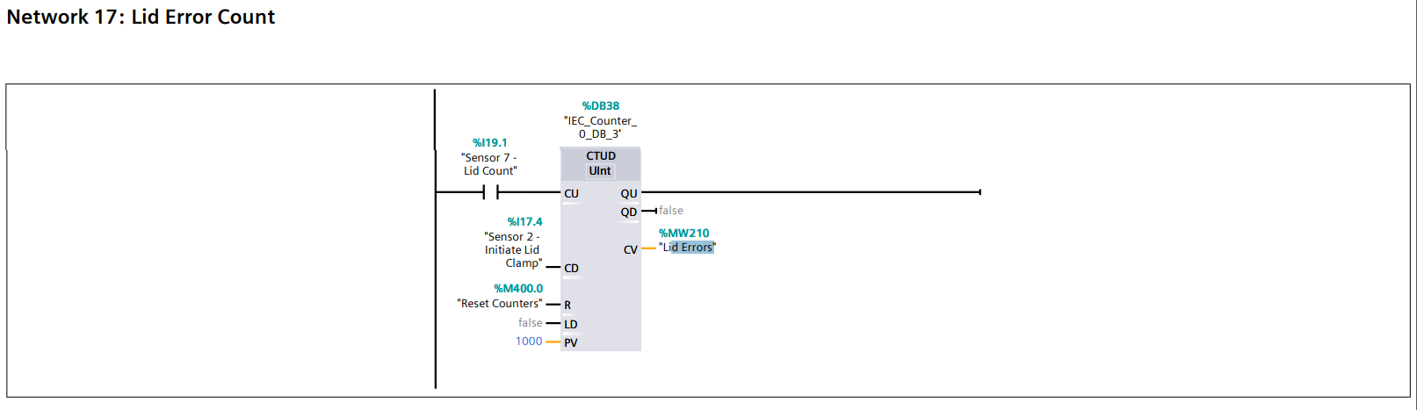
Figure 27- Lid Error Count
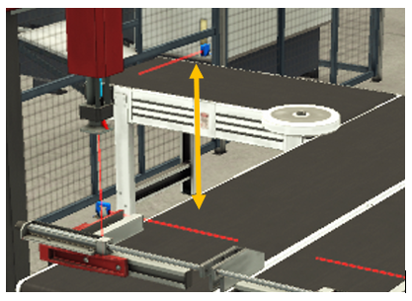
Figure 28 - Sensors Lid Error Count
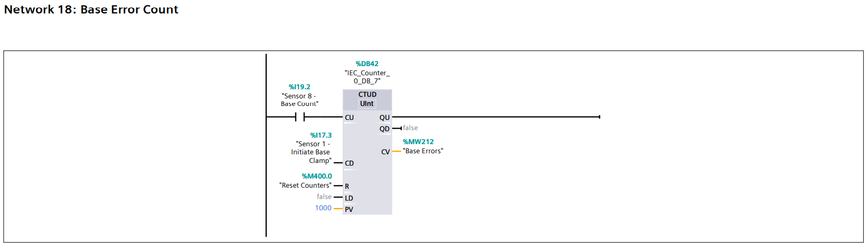
Figure 29 - Base Error Count

Network 19 – Completed Components Error Count
To highlight completed component failures between the completed parts moving from the clamp the end of the conveyor belt (Figure 31) the 'CTUD' function is used. The 'CTUD' function counts up and down, so when ‘Sensor 6 - Complete Component Count’ is TRUE, the function counts up (CU), then counts down using the ‘Sensor 3 - Activate P&P & Stop Belt’ tag. If the counters do not align by the maximum count number determined by the operator (see HMI section 6.2.1), the output (CV) tag is 'Completed Component Errors’ (Figure 30).
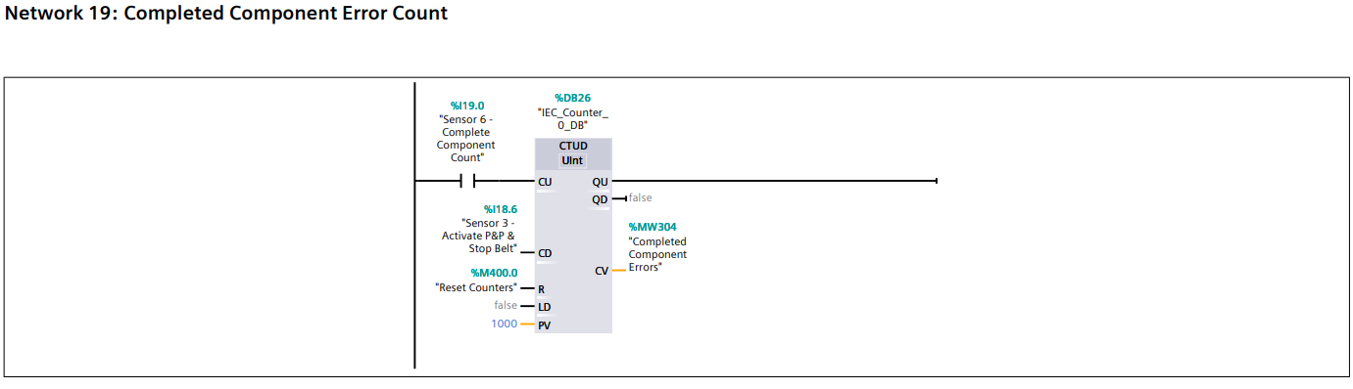
Figure 30 - Completed Components Error Count
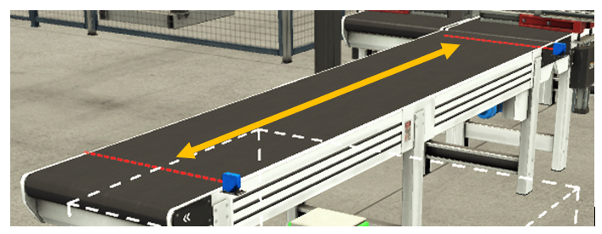
Figure 31 - Sensors Completed Components Error Count

Ladder Logic Program – Warnings and Alarms
The possibility of conveyor failures, such as lids, bases, or completed components crashing or falling off the conveyer, these failures have been incorporated into the logic.

Warnings & Warning Flag
In order to highlight warnings networks 20 to 23 were added to the logic. Firstly, in network 20 using a comparator (BYTE <>) and tag ‘Warnings’ if any warnings are initiated TRUE the output tag ‘Warning Flag’ will be initiated, this will trigger on the HMI section (Figure 32).
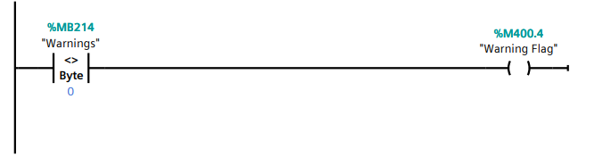
Figure 32 - Warnings & Warning Flag
For each count error warning whether lid, base or completed component, using the limits set by the operator see section (7.3) this will output a warning depending on which count limit was reached (Figure 33, Figure 34 and Figure 35).
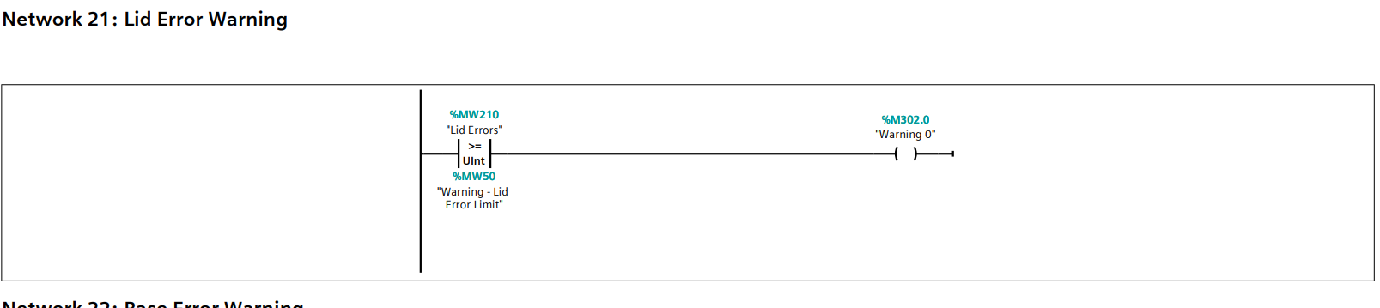
Figure 33 - Lid Error Warning
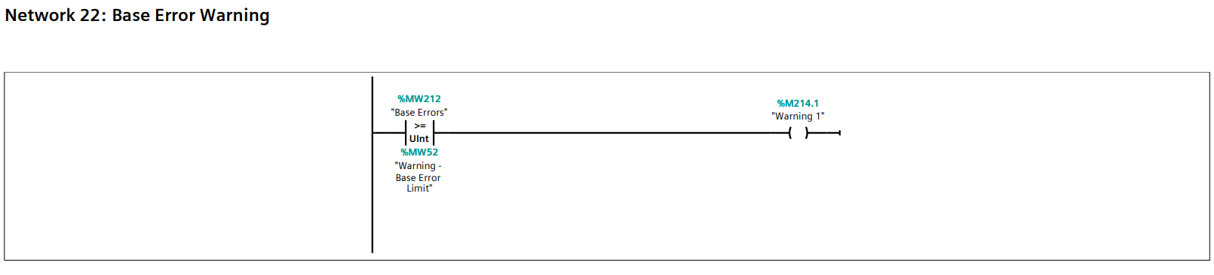
Figure 34 - Base Error Warning
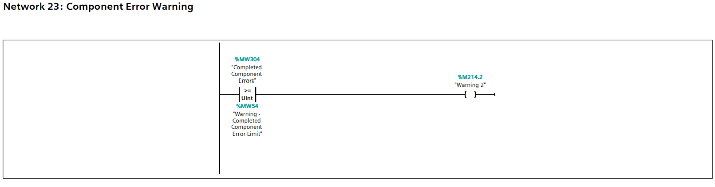
Figure 35 - Completed Components Error Warning

Alarms & Alarm Master / Flag
In order to highlight Alarms networks 24 to 28 were added to the logic. Firstly, in network 24 using a comparator (BYTE <>) and tag ‘Alarms’ if any alarms are initiated TRUE the output tag ‘Alarm Master’ will be initiated, this will trigger on the HMI but will also stop the whole system for safety and will not allow you to start the process until all alarms are cleared (Figure 36). When the ‘Alarm Master’ tag is initiated, this will also output the ‘Alarm Flag’ this will also trigger on the HMI see section (7.3).
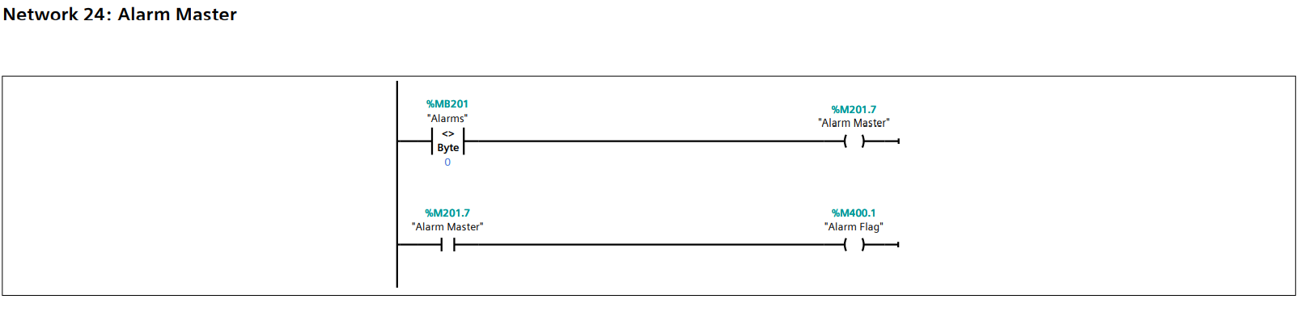
Figure 36 - Alarm Master & Flag
For each count error alarm whether lid, base or completed component (Figure 37,Figure 38 and Figure 39), using the limits set by the operator this will output an alarm depending on which count limit was reached section (6.3).
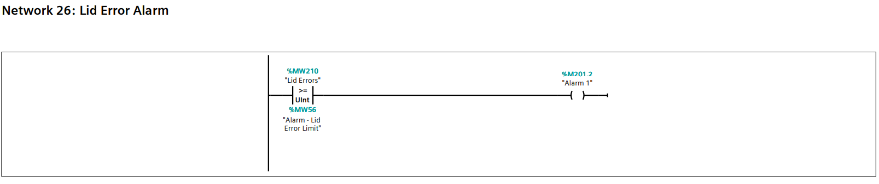
Figure 37 - Lid Error Alarm
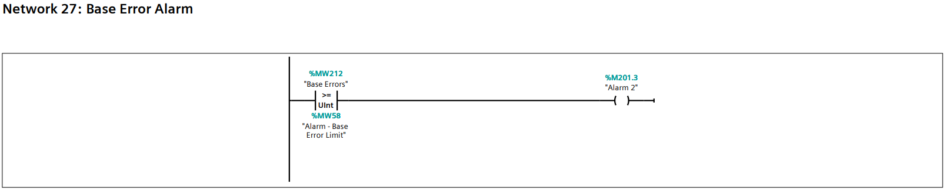
Figure 38 - Base Error Alarm
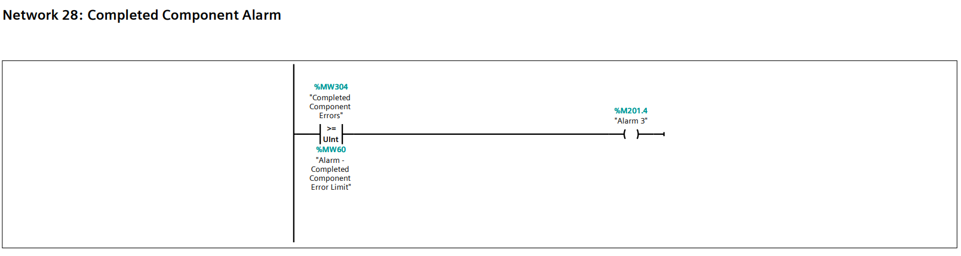
Figure 39 - Completed Components Error Alarm

HMI Control
Human machine interfaces (HMIs) allow the operator to control the system and consists of three screens: the Root Screen, the Engineering Screen, and the Warning and Alarm Screen. The HMI screens are configured in the TIA 16 software system, and buttons/icons are linked to programme logic tags.

Root Screen
The root screen acts as the main overview screen. The operator can start and stop the process, monitor total component counts, errors, and stop the process in the event of an emergency (Figure 40)
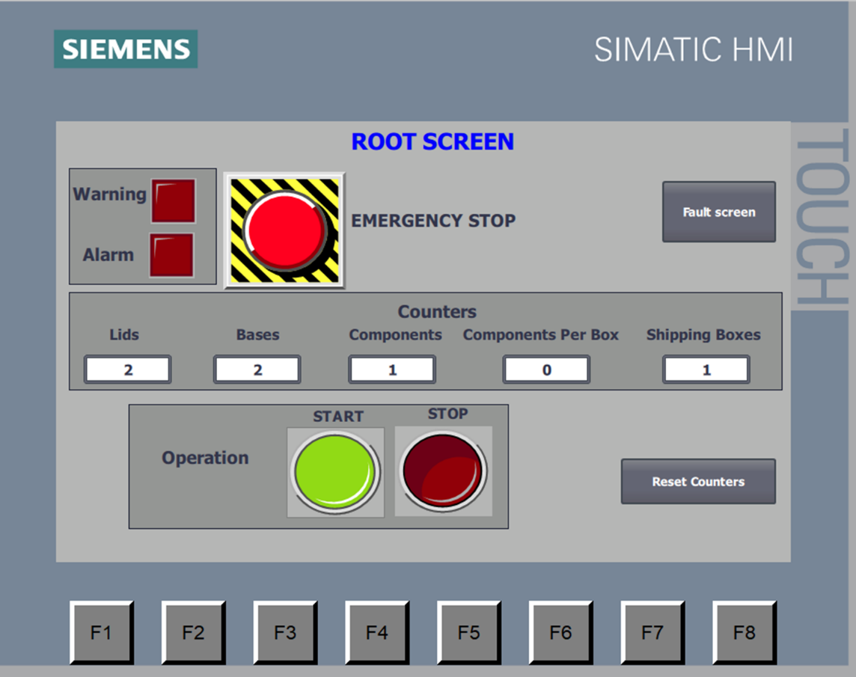
Figure 40 - Root Screen

Conveyor Operation
The start and stop buttons on the HMI will allow the operator to start and stop the process using logic from Network 2 (Figure 41).

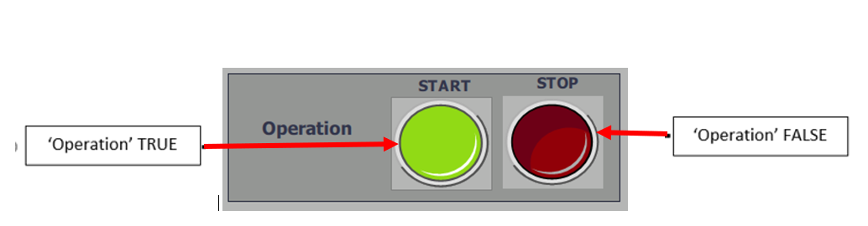
Figure 41 - System Operation

Counters
This displays the count totals taken from the count tags (Figure 42).
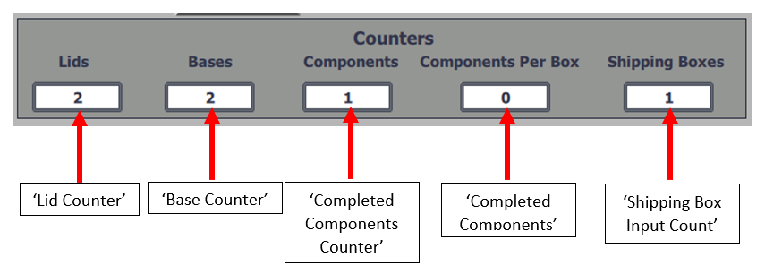
Figure 42 - Counters & Tags

Warning & Alarm Flags
The warning and alarm indicators use warning and alarm flags to notify the operator of a system error. The conveyor will continue to run while in warning mode, but if an alarm is triggered, it will stop (Figure 43).
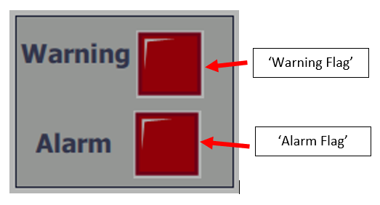
Figure 43 – Warning & Alarm Flags and Tags

E-Stop Button
The E-Stop button is there for the operator to stop the conveyor in an emergency (Figure 44).

Figure 44 - Emergency Stop Button

Reset All Counters
The reset all counter button will reset all counters within in the box counting using the ‘Reset All Counters’ tag (Figure 45).
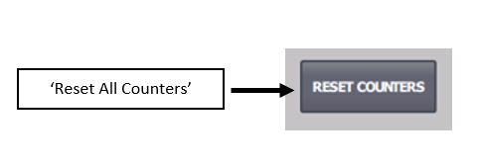
Figure 45 - Reset Counters Button

Warning & Alarm Screen
The warning and alarm screen (Figure 46) informs the operator if the system has any warnings or alarms by turning red. The warning and alarm tags were created within HMI tags and used as outputs within the logic. For example, lid errors will turn red if the ‘Lid Errors’ tag is initiated (Figure 47)
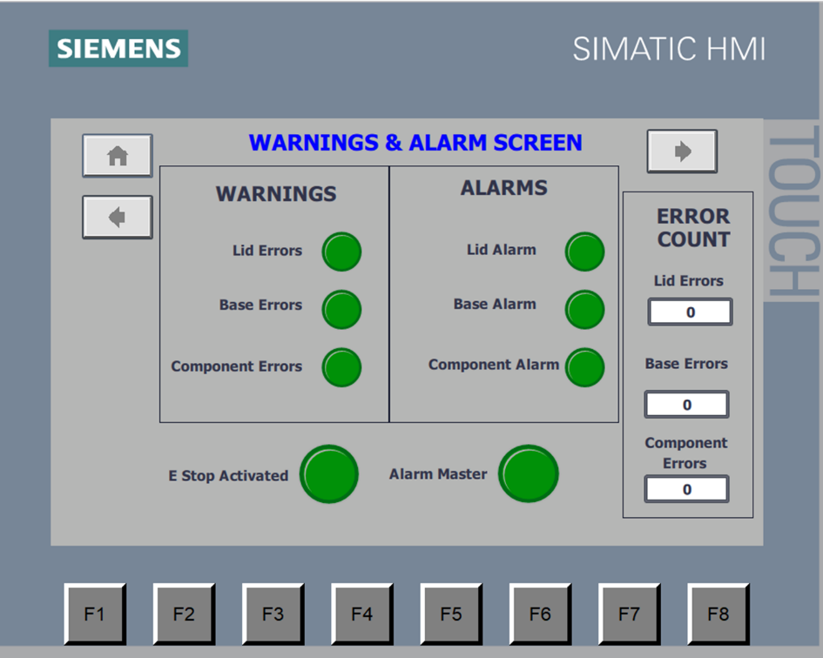
Figure 46 - Warnings & Alarm Screen

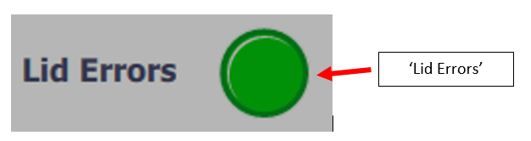
Figure 47 - Lid Errors Showing Tag

Error Count
The error count display’s the number of errors created for each part using the error tags (Figure 48).
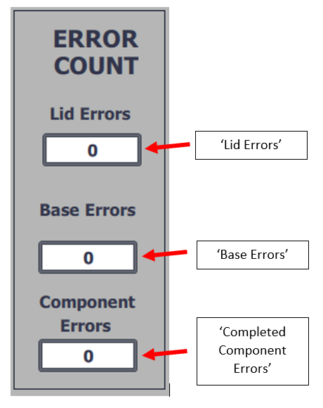
Figure 48 - Error Counts Showing Tags

Engineering Screen
The engineering settings screen (Figure 49) allows the operator to enter the count error warning and alarm limits. If any of the limits equals or exceeds the number entered in the 'Warning - Lid Error Limit,' 'Warning - Base Error Limit,' and 'Warning - Completed Component Error Limit' tags, warning and alarm lights will be highlighted on both the root and warning and alarm screens. This screen also included a reset all counters and a master reset button.
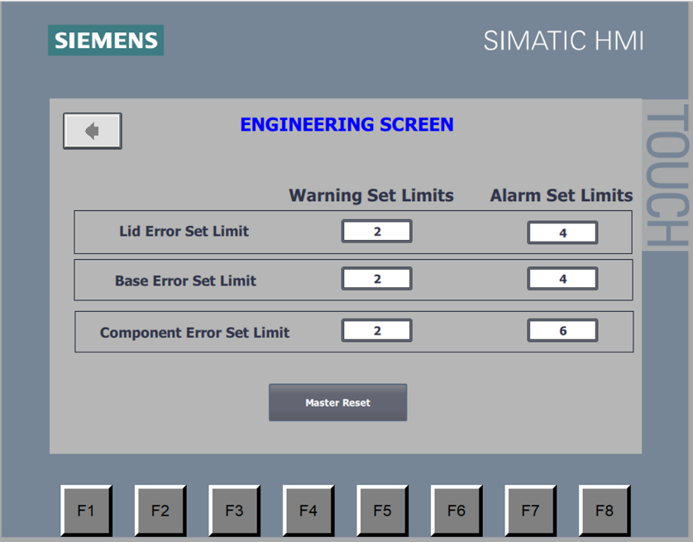
Figure 49 - Engineering Screen

References & Bibliography
Manual. (2022, September 26). Retrieved from FACTORY I/O: https://docs.factoryio.com/manual/parts/stations/
Muthukrishnan, V. (2022, July 28). Programmable Logic Controllers (PLCs): Basics, Types & Applications. Retrieved from Electrical4U: https://www.electrical4u.com/programmable-logic-controllers/#:~:text=PLC%20are%20divided%20into%20three,output%2C%20and%20Triac%20Output%20PLC.
Parr, E. A. (1998). Industrial Control Handbook. Industrial Press.

