Welcome

Title
Saturday, 21 February 2026
22:42



L5 - Changemakers: Creativity and Value Creation (ACCA5033)

Assignment 1: Innovation & Project Management



Applied Computing
Kawam de Oliveira
2412430@student.uwtsd.ac.uk

Task 1 - Ideation and Innovation

Q.1 - Innovation
Wednesday, February 4, 2026
10:36 AM

How Innovation Shapes the World

Introduction
Innovation can be defined as the implementation of a new or significantly improved product, process, service or organisational method that creates practical value [1]. However, innovation should not be understood only as dramatic technological breakthroughs. It also includes smaller improvements that accumulate over time and gradually reshape how people work, communicate and solve problems [2]. This broader understanding is important because it shows that innovation operates across both everyday life and large-scale systems. This essay argues that innovation shapes society through incremental change, the structural effects of the Fourth Industrial Revolution, the influence of emerging technologies, and creativity as a capability that supports effective problem solving.

Everyday Innovation and Its Significance
Innovation is often associated with major inventions, yet this view is too narrow. The Oslo Manual [1] presents innovation as a broad concept that includes changes in products, processes and organisational methods. This wider definition matters because many important forms of innovation do not arrive as sudden disruptions. Instead, they develop through continuous improvement. Ringberg, Reihlen and Rydén [2] argue that innovation can take incremental, radical or revolutionary forms, showing that smaller-scale changes remain an essential part of wider innovation processes. Therefore, innovation should be seen as both ordinary and transformative. In many cases, it is precisely these repeated small improvements that enable longer-term social and economic change.

The Fourth Industrial Revolution as a Structural Transformation
The broader impact of innovation becomes clearer in the context of the Fourth Industrial Revolution. Schwab describes this period as one in which physical, digital and biological technologies increasingly converge, transforming industries and societies at speed [3]. Unlike earlier phases of industrial development, this transformation is marked by scale, interconnectivity and systemic reach. This is reinforced by research on Industry 4.0, which identifies cyber-physical systems, automation and integrated data infrastructures as central features of this shift [4]. These developments are not simply improving existing systems. They are changing how organisations operate, analyse information and make decisions. This suggests that innovation now affects not only tools and processes, but the wider structures through which society functions.

Emerging Technologies and Their Societal Impact
The practical effects of this transformation can be seen in emerging technologies such as big data, the Internet of Things and digital health [5]. These technologies increase connectivity, improve real-time monitoring and strengthen data-driven decision making [4], [5]. As a result, innovation now shapes not only industrial systems but also wider social and professional life. For example, these technologies influence healthcare delivery, communication systems and how organisations respond to changing needs. However, innovation should also be considered critically. While it can improve efficiency and create new opportunities, its benefits are not always equally distributed. Schwab warns that rapid technological change may deepen inequality if access and capability remain uneven [3].

Creativity as a Developable Capability
Innovation depends not only on technology but also on human capability. Creativity is therefore significant because it supports ideation, experimentation and adaptation. Fleet and Dobson [6] found evidence of growth creative mindsets, suggesting that creativity can be developed rather than treated as a fixed trait. This is important because innovation requires individuals to test ideas, respond to failure and refine solutions. Creativity should therefore be understood as a practical capability that helps individuals participate in innovation responsibly and effectively. In this sense, creativity strengthens innovation by linking knowledge, flexibility and problem-solving in real-world contexts.

Conclusion
In conclusion, innovation shapes society through both gradual improvement and structural transformation. Incremental developments influence everyday life, while the Fourth Industrial Revolution demonstrates how converging technologies can reshape systems and institutions. Emerging technologies show the practical reach of this change, and creativity remains essential because innovation depends on the human capacity to generate, develop and apply ideas critically.

Q.2 - Ideation
Wednesday, February 4, 2026
10:36 AM

Project Ideas

Idea 1: Centralised Smart Information Platform for Reducing Cognitive Load in Daily Management
Simplify daily management and reduce cognitive load through the delivery of smart, centralised information within a single platform, enabling users to access, organise and manage essential information more efficiently.

Idea 2: Smart Study Planner for University Students
A web system that helps students organise study schedules, track progress on coursework and receive suggestions to improve productivity and time management.

Idea 3: Programming Practice Platform for Beginner Developers
A platform that allows students to practise programming through coding exercises, automated feedback and peer discussion to improve problem solving and programming skills.

Idea 4: Student Collaboration Platform for Computing Courses
A web platform designed to connect students across Applied Computing related courses, including Software Engineering, Cyber Security and Games Design. The system would support communication, collaboration and resource sharing by allowing students to ask questions, discuss assignments, share study materials and exchange information about academic opportunities, internships and employment.

Project Proposal

Project Title
Web Collaboration Platform to Connect Students Across Applied Computing Courses

Aim
Design, develop and evaluate a web platform that enables students across computing related courses to communicate, collaborate and share academic and professional resources.

Objectives
- Research comparable digital platforms that support student communication, collaboration and peer interaction in academic settings.

- Analyse the weaknesses of existing platforms and identify functional gaps, interaction issues and potential differentiating features that could deliver greater value to users.

- Design a system architecture that supports data reliability and scalability for future feature expansion.

- Develop a functional prototype that integrates the core features outlined for the proposed project.

- Test and evaluate the prototype against the project aim and objectives to assess its reliability, usability and effectiveness in supporting student communication and collaboration.

Description
This project involves the development of a web collaboration platform focused on students within the computing area. The platform will function as a centralised digital space in which users can create accounts, participate in discussions, share study materials, and post academic or professional opportunities. It will include core features such as user authentication, discussion areas, organised resource sharing, and structured post management. The system is designed to support interaction within a shared online environment, with particular emphasis on usability, accessibility, and the effective organisation of content for its target user group.

Q.3 - Research
Wednesday, February 4, 2026
10:38 AM


Figure 1. 100 Days of Code: The Complete Python Pro Bootcamp [7].

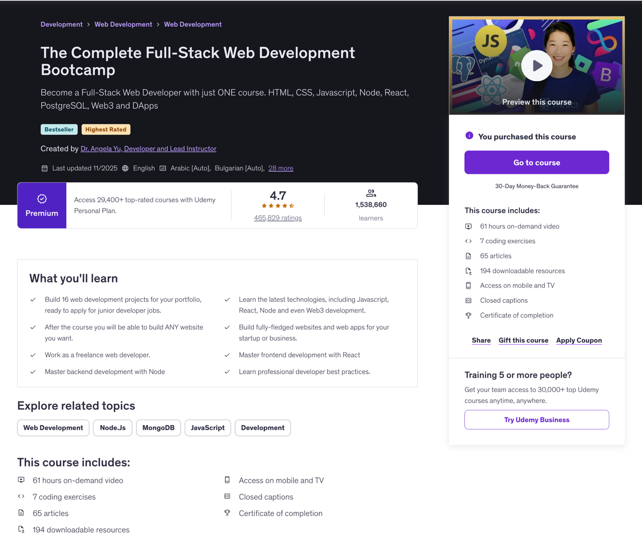
Figure 2. The Complete Full-Stack Web Development Bootcamp [8].


Figure 3. L5 - Databases and Application Development [9].

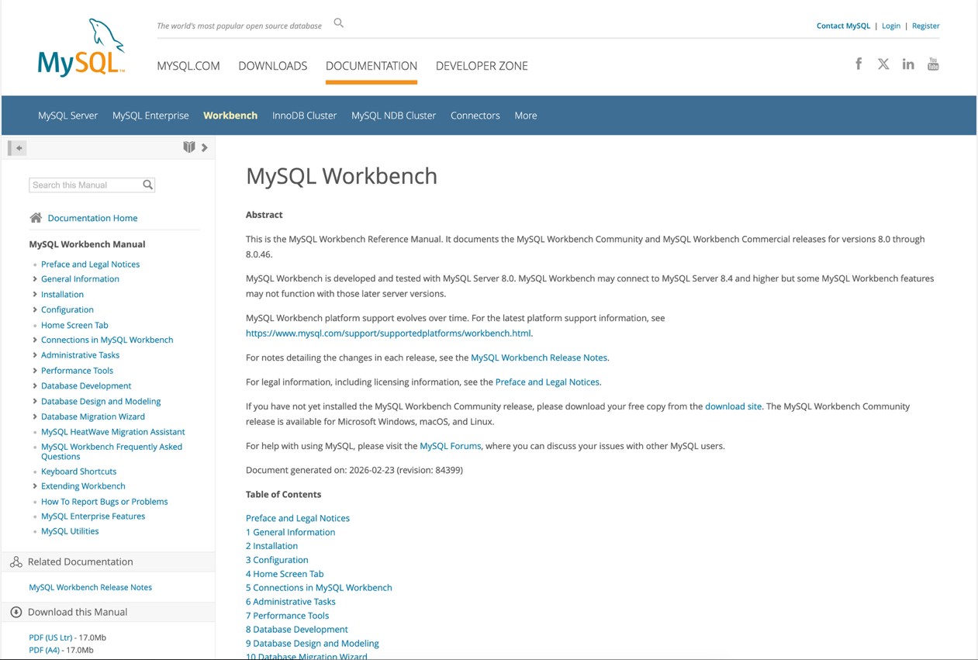
Figure 4. MySQL :: MySQL Workbench Manual [10].

Task 2 - Project Management

Q.1 - Project Scope
Wednesday, February 4, 2026
10:39 AM

Proposed Solution

The proposed solution is the development of a web collaboration platform to address the lack of interaction and communication between students across the computing area, including programmes such as Games Development, Data and Information Systems, Computer Networks and Cyber Security, Applied Computing, and Software Engineering. At present, communication is often limited to small, course-specific groups, which can create isolated student communities and reduce opportunities for wider inclusion, collaboration, and academic engagement. The platform will provide a centralised digital space through which students from different computing disciplines can interact, exchange knowledge, share academic resources, and post professional opportunities, functioning as an internal networking environment with features suited to academic and professional engagement. The proposed solution will be delivered as a functional prototype demonstrating core features such as user accounts, discussion areas, and organised resource sharing.

Required Technologies and Resources
The development of the proposed platform will require a combination of software technologies, development tools, and learning resources to support the design, implementation, and testing of the system. These resources have been selected on the basis of their suitability for web application development, structured data management, and the practical requirements of the proposed prototype.

Front-end technologies
The user interface will be developed using HTML, CSS, and JavaScript. These technologies are appropriate because they provide the core structure, presentation, and interactivity required for a responsive web platform. They will support the creation of an accessible and user-friendly environment in which students can navigate discussion areas, share resources, and engage effectively with platform content.

Back-end technologies
Python will be used to support the back-end functionality of the platform. It is a suitable choice due to its readability, flexibility, and compatibility with web application development. Within this project, Python will be used to manage application logic, user authentication, data processing, and communication between the user interface and the database.

Database technologies
A relational database management system, such as MySQL, will be used to store user information, discussion posts, and shared resources. This is appropriate because the platform requires structured data storage, reliable retrieval of information, and efficient handling of multiple data types linked to user activity. MySQL Workbench may also be used to support database design, schema creation, and general database management during the implementation stage.

Development environment
The project will require a code editor or integrated development environment, such as Visual Studio Code, to support efficient coding, editing, and debugging. Version control tools, including Git and GitHub, will also be used to manage code changes and maintain organised, secure records of development progress throughout the project.

Learning resources and documentation
Additional support will be provided through technical documentation and online learning resources such as Microsoft Learn, Udemy, and the official MySQL documentation. These resources will help strengthen the knowledge and skills required for web development, Python implementation, and database management during the practical development of the prototype.

Project Schedule

The project schedule has been structured to follow a typical software development lifecycle, progressing from initial ideation and planning to system design, development, testing, and final documentation [16]. The project stages and tasks of the project are outlined in the project schedule presented below.

Project Stage | Tasks | Start Date | End Date
Ideation and Research | • Review innovation concepts relevant to computing projects  • Identify potential project ideas  • Select the most viable project concept  • Define the initial project proposal  • Identify supporting learning resources | 04/02/2026  11/02/2026 | 10/02/2026  17/02/2026
Project Scope and Planning | • Define the proposed solution  • Identify required technologies and tools  • Define project timeline and schedule  • Conduct initial risk analysis | 18/02/2026 | 24/02/2026
Development Methodology and System Design | • Select development methodology  • Design system architecture  • Design database structure (ERD)  • Create initial interface sketches or wireframes | 25/02/2026 | 10/03/2026
Prototype Development | • Develop user authentication system  • Implement discussion functionality  • Implement resource sharing functionality  • Develop database structure | 11/03/2026 | 17/03/2026
System Implementation | • Implement back-end application logic  • Implement front-end interface  • Integrate front-end and back-end components | 18/03/2026 | 07/04/2026
System Testing and Evaluation | • Functional testing of core features  • Usability testing  • Record identified issues | 08/04/2026 | 14/04/2026
Prototype Refinement | • Fix functional issues  • Improve system usability  • Finalise prototype functionality | 15/04/2026 | 21/04/2026
Deployment Planning | • Prepare deployment environment  • Define hosting approach | 22/04/2026 | 28/04/2026
Reflection and Final Report | • Document implementation process  • Evaluate project outcomes  • Write final report | 29/04/2026 | 05/05/2026
Figure 5. Project Schedule Web Collaboration Platform.

A structured sequence of stages underpins the project plan, supporting its progression from initial concept development to final evaluation and reporting. The opening stage focuses on ideation and research, including the review of relevant innovation concepts, the identification of potential project ideas, the selection of the most viable concept, and the definition of the initial project proposal. Supporting learning resources are also identified at this stage to strengthen the knowledge base required for development. The full sequence of stages and tasks is presented in the Project Schedule and associated Gantt chart.

Q.2 - Gantt chart
Saturday, 7 March 2026
22:23

The project timeline and sequencing of the main development stages are illustrated in the Gantt charts below [17]. The chart provides a visual representation of the planned duration and overlap of each stage, supporting the structured progression of the project from initial planning and research through system design, development, testing, and final documentation.

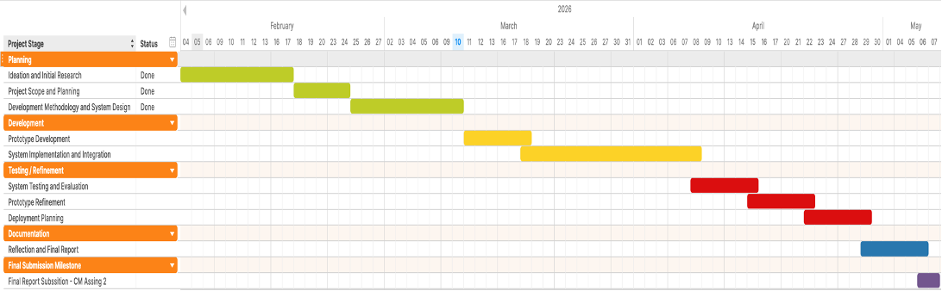Figure 6. Gantt Chart for the Web Collaboration Platform Project - Planning and Development Stages.

Q.3 - Risks and Challenges
Saturday, 7 March 2026
22:23

Project Risk Analysis

Projects are subject to risks and constraints that may affect progress, quality, or completion within the planned timeframe. Risk identification and mitigation are recognised as essential elements of software project management, as they support the anticipation of potential challenges and the minimisation of their impact on project delivery [16]. The following risk analysis identifies key challenges associated with the development of the proposed platform and outlines appropriate contingency measures to minimise their potential impact.

Risk no. | Risks | Impact | Contingencies
1 | Hardware failure and loss of project files | High | Regular backups are maintained throughout the project. Project files are stored locally and synchronised with cloud storage services such as OneDrive or iCloud, together with version control through GitHub, to support file recovery in the event of data loss.
2 | Limited technical skills with certain technologies | High | Supporting learning resources, including online courses, technical documentation, and development tutorials, are used to strengthen the knowledge required for Python development, web technologies, and database management throughout the project.
3 | Time management and project delays | Medium | A project schedule and Gantt chart are used to organise tasks and monitor project progress. Regular timeline reviews support the completion of key milestones within the allocated timeframe.
4 | Scope creep and addition of unnecessary features | Medium | The project remains aligned with the defined aim and objectives, with priority given to the core functionalities of the prototype. Additional features are considered only where sufficient time remains after the main requirements have been implemented.
5 | Integration issues between front-end, back-end and database | Medium | Development and testing are conducted incrementally to ensure that each component functions correctly prior to full system integration. Early-stage testing supports the identification and resolution of compatibility issues.
6 | Deployment or hosting difficulties | Low | The platform is initially tested within a local environment prior to deployment. Where hosting or deployment issues arise, alternative deployment solutions or hosting services are evaluated.
7 | Data security and user information protection | Medium | Basic security measures, including secure password handling, input validation, and controlled database access, are applied to reduce the risk of data exposure or unauthorised access.
8 | Poor usability or unclear interface design | Medium | Interface design is reviewed throughout development and tested to ensure that the platform remains clear, accessible, and intuitive for student use. Feedback gathered during testing supports further usability improvements.
9 | Personal or family health issues | High | Unexpected personal or family health issues may require the project schedule and task priorities to be reviewed and adjusted accordingly. Work is organised progressively throughout the project timeline to reduce pressure near deadlines and maintain consistent progress.
Figure 7. Project Risk Analysis and Mitigation Strategies.

By identifying these risks at an early stage, the project is strategically positioned to maintain progress and respond effectively to potential challenges throughout the development process.

Task 3 - Project Development method & Design work

Q.1 - Development Method
Wednesday, February 4, 2026
10:41 AM

Development Methodology

A suitable development method for this project is a hybrid approach combining Agile development principles, evolutionary prototyping, and Kanban-based workflow management. This combination provides a balanced framework that supports both structured planning and flexible development. The proposed web collaboration platform is intended to deliver a functional prototype demonstrating core interaction features rather than a fully deployed production system. Consequently, a method that supports incremental progress, experimentation, and refinement offers a more appropriate structure for managing the project lifecycle. Software engineering literature emphasises that iterative development strategies reduce implementation risk by enabling early validation of system components and progressive refinement throughout the development process [16].
Agile methodologies emphasise adaptive planning, iterative delivery, and continuous evaluation, all of which are particularly relevant to projects involving interactive systems. Unlike traditional linear models, Agile development supports repeated cycles of design, implementation, testing, and refinement. These cycles allow features to be improved gradually while remaining aligned with project objectives. This is especially beneficial in the development of web platforms, where usability, interaction clarity, and user engagement represent important aspects of overall system effectiveness [18]. In the context of this project, such flexibility is particularly significant because the value of the platform depends not only on technical functionality but also on the extent to which it supports meaningful communication and collaboration between students. The cyclical nature of this process is illustrated in Figure 8.

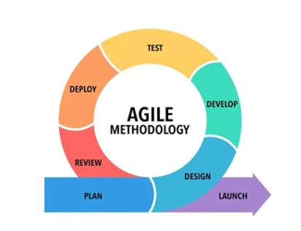
Figure 8. Iterative Agile development cycle adapted from Shutterstock [21].

Within the proposed platform, this flexibility is particularly important because the system incorporates several distinct but related components, including user authentication, discussion spaces, structured resource sharing, and the publication of academic or professional opportunities. Each of these features can be developed independently before being integrated into the wider system. An iterative development strategy therefore enables these elements to be implemented progressively, allowing technical issues and usability limitations to be identified at an early stage. It also supports a controlled approach to prioritisation, ensuring that the most essential functions are addressed before additional refinements are introduced. This is especially useful in an academic project where both time and development capacity are limited. Moreover, the staged release of features makes it possible to assess whether the platform is genuinely improving communication and collaboration, rather than simply increasing technical complexity without enhancing the user experience.
The prototyping process forms an essential part of this development method. Prototyping allows software systems to be constructed and refined incrementally, enabling design decisions to be evaluated through practical experimentation. Research on interactive software development indicates that prototyping supports user-centred design by enabling continuous evaluation of interface structure, navigation flow, and system functionality throughout development [19]. In this project, prototyping supports the gradual implementation of collaborative features while allowing the system architecture, database structure, and interface design to evolve through successive iterations. This is particularly relevant because the effectiveness of a collaboration platform depends heavily on the clarity of its discussion spaces, the organisation of shared content, and the accessibility of its interaction pathways. This process of progressive refinement is illustrated in Figure 9.

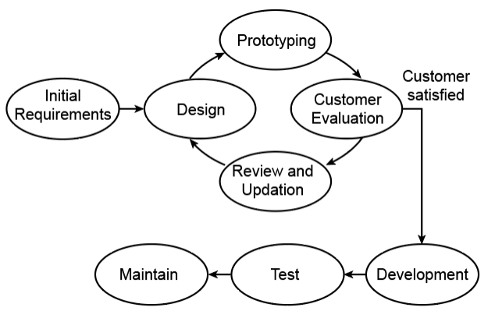
Figure 9. Prototyping process model [22].

In addition to Agile principles and prototyping, the project incorporates Kanban as a practical task management framework. Kanban supports workflow visualisation through a structured board in which tasks are organised across stages such as to do, in progress, and completed. This method improves transparency across the development process and enables activities to be prioritised according to project objectives. In contrast to more formal Agile frameworks such as Scrum, Kanban does not depend on predefined sprint cycles or fixed team roles, which makes it particularly suitable for small-scale or individual software development projects [20]. In this project, a Kanban board provides a practical mechanism for tracking the backlog of core features, monitoring progress across development stages, and preventing unnecessary overload during implementation. An example of this workflow structure is presented in Figure 10.

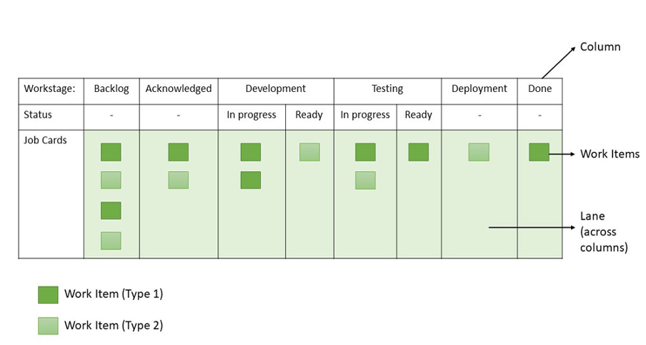
Figure 10. Kanban board workflow [23].

Alternative development methodologies were also considered during the planning stage. The traditional Waterfall model offers limited flexibility when design modifications become necessary during development, making it less suitable for a project in which interface decisions, usability considerations, and feature priorities may need to be revised as the prototype evolves. Equally, a full Scrum framework introduces a level of procedural formality that is less appropriate for an individual academic project operating within a limited timeframe. A hybrid approach combining Agile principles, prototyping, and Kanban-based task management therefore provides a more proportionate and context-appropriate solution. It supports technical delivery, structured task control, and continuous evaluative refinement, making it particularly effective for a project that must be planned carefully, implemented incrementally, and assessed continuously within an academic setting.

Q.2 - Design work
Wednesday, February 4, 2026
10:41 AM

Database Design: Entity Relationship Diagram (ERD)

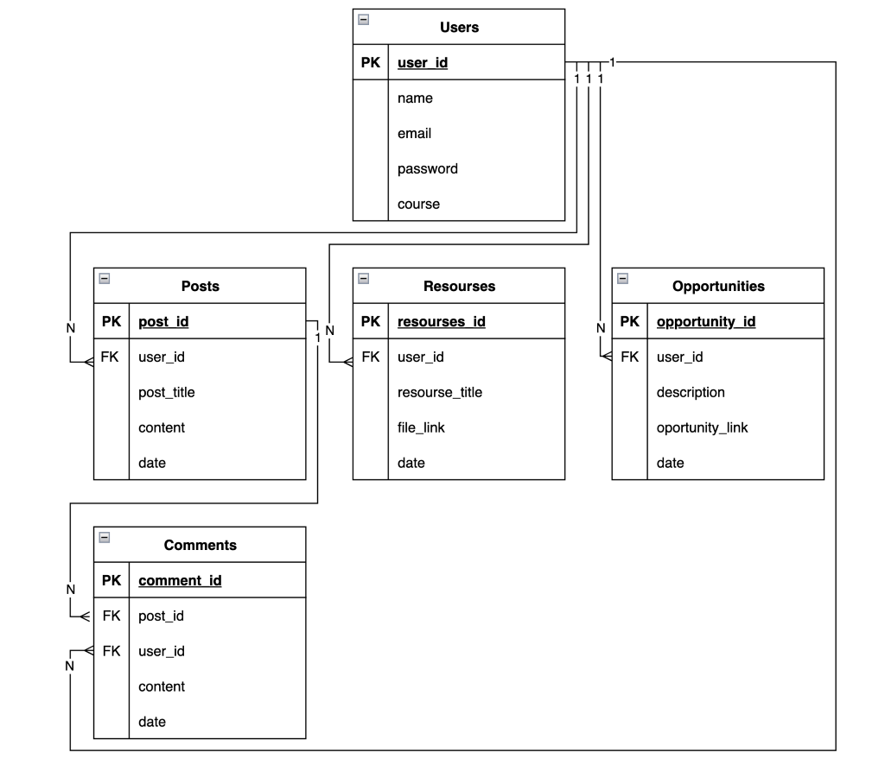
Figure 11. Entity Relationship Diagram illustrating the logical structure of the relational database.

The Entity Relationship Diagram (ERD) illustrates the logical structure of the collaboration platform database, showing how user generated content, such as posts, comments, shared resources, and opportunities, is connected through relational data structures. It also demonstrates how key entities are linked through primary and foreign key relationships, thereby supporting data integrity, efficient data retrieval, and the structured management of user activity across the platform.

Q.3 - Initial practical implementation
Wednesday, February 4, 2026
10:42 AM

Reference list

References
Saturday, 21 February 2026
22:43

[1] OECD/Eurostat, "Oslo Manual 2018: Guidelines for Collecting, Reporting and Using Data on Innovation", 4th ed. Paris, France: OECD Publishing, 2018. [Online]. Available: https://doi.org/10.1787/9789264304604-en [Accessed Mar. 6, 2026].

[2] T. Ringberg, M. Reihlen, and P. Rydén, “The technology-mindset interactions: Leading to incremental, radical or revolutionary innovations,” Industrial Marketing Management, vol. 79, pp. 102–113, 2019. [Online]. Available: https://doi.org/10.1016/j.indmarman.2018.06.009 [Accessed Mar. 6, 2026].

[3] K. Schwab, "The Fourth Industrial Revolution", Geneva, Switzerland: World Economic Forum, 2016. [Online]. Available: https://law.unimelb.edu.au/__data/assets/pdf_file/0005/3385454/Schwab-The_Fourth_Industrial_Revolution_Klaus_S.pdf [Accessed Mar. 6, 2026].

[4] S. J. Oks et al., “Cyber-Physical Systems in the Context of Industry 4.0: A Review, Categorization and Outlook,” Information Systems Frontiers, vol. 26, no. 5, pp. 1731–1772, 2024. [Online]. Available: https://doi.org/10.1007/s10796-022-10252-x [Accessed Mar. 6, 2026].

[5] World Economic Forum, “The 7 technologies changing your world,” Jan. 19, 2016. [Online]. Available: https://www.weforum.org/stories/2016/01/a-brief-guide-to-the-technologies-changing-world/ [Accessed Mar. 6, 2026].

[6] L. Fleet and T. Dobson, “Growing and fixing: Comparing the creative mindsets of teachers and artist practitioners,” Thinking Skills and Creativity, vol. 48, Art. no. 101312, 2023. [Online]. Available: https://doi.org/10.1016/j.tsc.2023.101312 [Accessed Mar. 6, 2026].

[7] Udemy, “100 Days of Code - The Complete Python Pro Bootcamp”, Jan. 2026. [Online]. Available: https://www.udemy.com/course/100-days-of-code/ [Accessed Mar. 6, 2026].

[8] Udemy, “The Complete Full-Stack Web Development Bootcamp”, Nov. 2025. [Online]. Available: https://www.udemy.com/course/the-complete-web-development-bootcamp/?src=sac&kw=the+complete+full- [Accessed Mar. 6, 2026].

[9] D. Chidambaram, “L5 - Databases and Application Development”, University of Wales Trinity Saint David Moodle Learning Platform, 2025. [Online]. Available: https://moodle.uwtsd.ac.uk/course/view.php?id=9572. [Accessed: Mar. 6, 2026].

[10] Oracle, “MySQL :: MySQL Workbench Manual,” Mysql.com, 2019. [Online]. Available: https://dev.mysql.com/doc/workbench/en/ [Accessed Mar. 6, 2026].

[11] Mozilla, “Learn Web Development,” MDN Web Docs. [Online]. Available: https://developer.mozilla.org/en-US/docs/Learn_web_development. [Accessed Mar. 7, 2026].

[12] Python Software Foundation, “Python 3 Documentation,” Python Documentation. [Online]. Available: https://docs.python.org/3/. [Accessed Mar. 7, 2026].

[13] Oracle, “MySQL Workbench Manual,” MySQL Documentation. [Online]. Available: https://dev.mysql.com/doc/workbench/en/. [Accessed Mar. 7, 2026].

[14] Microsoft, “Documentation for Visual Studio Code,” Visual Studio Code Documentation. [Online]. Available: https://code.visualstudio.com/docs. [Accessed Mar. 7, 2026].

[15] S. Chacon and B. Straub, “Getting Started - About Version Control,” Git. [Online]. Available: https://git-scm.com/book/en/v2/Getting-Started-About-Version-Control. [Accessed Mar. 7, 2026].

[16] I. Sommerville, Software engineering, 10th ed. Boston, Mass: Pearson, 2016.

[17] Tom’s Planner, “Tom’s Planner”. [Online]. Available: https://plan.tomsplanner.com. [Accessed Mar. 8, 2026].

[18] M. E. Moreira, "Being Agile: Your Roadmap to Successful Adoption of Agile". Berkeley, CA: Apress, 2013. [Online]. Available: https://link.springer.com/book/10.1007/978-1-4302-5840-7. [Accessed Mar. 9, 2026].

[19] B. Losada, M. Urretavizcaya, and I. Fernández-Castro, “A guide to agile development of interactive software with a ‘User Objectives’-driven methodology”, Science of Computer Programming, vol. 78, no. 11, pp. 2268–2281, 2013. [Online]. Available: https://doi.org/10.1016/j.scico.2012.07.022. [Accessed Mar. 9, 2026].

[20] P. S. M. dos Santos, A. C. Beltrão, B. P. de Souza, and G. H. Travassos, “On the benefits and challenges of using kanban in software engineering: a structured synthesis study”, Journal of Software Engineering Research and Development, vol. 6, no. 13, 2018. [Online]. Available: https://doi.org/10.1186/s40411-018-0057-1. [Accessed Mar. 10, 2026].

[21] Shutterstock, “Iterative project graphic”. [Online]. Available: https://www.shutterstock.com/search/iterative-project-graphic. [Accessed Mar. 9, 2026].

[22] Bartleby, “Concept of Prototyping”. [Online]. Available: https://www.bartleby.com/subject/engineering/mechanical-engineering/concepts/concept-of-prototyping. [Accessed Mar. 10, 2026].

[23] GeeksforGeeks, “Kanban Agile methodology”. [Online]. Available: https://www.geeksforgeeks.org/software-engineering/kanban-agile-methodology/. [Accessed Mar. 10, 2026].

Google Translate, private communication, 2026. [Accessed: Mar. 2026].

OpenAI’s ChatGPT, private communication, 2026. [Accessed: Mar. 2026].

Appendices

Supplementary information
Saturday, 21 February 2026
22:43

