

UNIVERSITY OF WALES TRINITY SAINT DAVID
Birmingham

Master of Business Administration
Human Capital Management | Module Code: LCMB7023

Assessment Component 1: Individual Report
Designing a Human Capital Architecture for Strategic Renewal
Helios Urban Mobility Case Study

Student Name: | Zarna Patel
Student ID Number: | 2536013
Programme: | Master of Business Administration
Module: | Human Capital Management
Lecturer: | Eno Maycock (Birmingham)
Word Count: | 2548 words
Submission Date: | Friday 19th June 2026

Table of Contents
Table of Contents 2
Task A: Socialisation, Identity & Business Activism 4
1. Critical Evaluation: Traditional Onboarding vs. Strategic Organisational Socialisation 4
2. Structured Socialisation Framework for Helios Urban Mobility 6
3. Mechanisms to Cultivate Organisational Identification, Ethical Professionalism, and the Business Activist Mindset 8
Task B: Job Design 10
1. Innovative Job Design Strategy for Helios Urban Mobility 10
2. Stimulating Intrinsic Motivation and Supporting Innovation 13
Task C: Reflective Report 15
1. Using AI as a Decision-Support Tool Without Eroding Critical Human Judgement 15
2. Personal Capability Development Plan 16
References 17
Appendix

List of Abbreviations

Short Form | Full Form
HUM | Helios Urban Mobility
MBA | Master of Business Administration
HR | Human Resources
HRM | Human Resource Management
IHRM | International Human Resource Management
AI | Artificial Intelligence
ITM | Internal Talent Marketplace
JCM | Job Characteristics Model
MPS | Motivating Potential Score
SDT | Self-Determination Theory
CIPD | Chartered Institute of Personnel and Development
WEF | World Economic Forum
AIHR | Academy to Innovate HR
KPI | Key Performance Indicator
CEO | Chief Executive Officer
CTO | Chief Technology Officer
R&D | Research and Development
UK | United Kingdom
EU | European Union

Task A: Socialisation, Identity & Business Activism

1. Critical Evaluation: Traditional On boarding vs. Strategic Organisational Socialisation
Traditional onboarding typically focuses on administrative induction, compliance briefings and procedural orientation. This approach reflects a transactional, organisation-centred logic that positions newcomers as passive recipients rather than active contributors (Cable, Gino and Staats, 2013). Such processes overlook the psychological and social complexity of organisational entry, particularly in hybrid and cross-cultural environments where fragmented cues weaken early sense-making (Klein et al., 2022). Research increasingly critiques traditional onboarding for overemphasising organisational control and underestimating newcomer agency, suggesting that socialisation is a negotiated process shaped by reciprocal expectations (Cooper-Thomas & Anderson, 2020).
Van Maanen and Schein’s (1979) socialisation framework provides a more sophisticated lens by distinguishing between institutionalised tactics (collective, sequential, serial) and individualised tactics that allow personal interpretation. Institutionalised approaches can create stability but risk producing custodial mindsets, while individualised tactics foster innovation and identity experimentation. For HUM, operating across London, Berlin and Singapore, an over-reliance on institutionalised tactics may suppress the innovative mindset required in a fast-moving smart-mobility sector. However, the model has been criticised for assuming linear progression through stages, an assumption increasingly incompatible with fluid, project-based and hybrid work structures (Ashford & Nurmohamed, 2021).
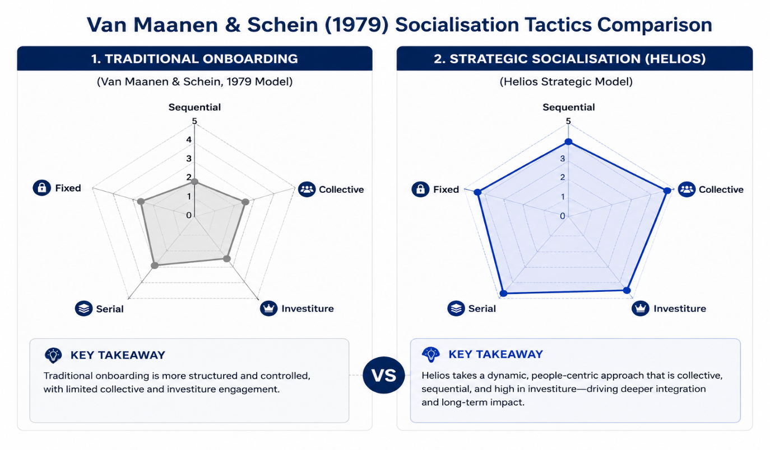
Figure 1: Comparison of Socialisation Tactics: Traditional vs. Strategic Approach (Adapted from Van Maanen & Schein, 1979) (Source: Author's own illustration/analysis)

Psychological contract theory (Rousseau, 1989) further exposes the limitations of traditional onboarding. The psychological contract - the unwritten expectations between employer and employee is shaped most powerfully during early organisational entry. HUM’s eight-month ramp-up period and fragmented induction likely create perceived breaches, contributing to disengagement and graduate attrition (Coyle-Shapiro & Kessler, 2000). Contemporary research shows that digital touchpoints and employer branding now shape psychological contracts more strongly than formal HR processes, making early breaches more salient (Bal & Rousseau, 2020).
Identity construction theory (Pratt, 1998) adds a further dimension. Newcomers actively seek cues to construct a professional identity aligned with organisational purpose. HUM’s mission sustainable, AI-enabled urban mobility offers strong identity potential, yet inconsistent cultural signals across its tri-city structure risk identity fragmentation (Alvesson et al., 2020). This challenge is intensified in high-skill technical environments where professional identities often compete with organisational ones (Petriglieri, 2019).
Strategic organisational socialisation offers a more holistic alternative. It integrates operational learning with cultural, ethical and purpose-driven elements, recognising that commitment is constructed through structured experiences and reciprocal relationships (Saks & Gruman, 2012). Organisations with strategic socialisation report faster time-to-productivity and higher early-tenure retention (Bauer, 2023). However, strategic socialisation must be continuously reinforced; without ongoing identity work, early gains dissipate (Ibarra & Barbulescu, 2019).

2. Structured Socialisation Framework for Helios Urban Mobility
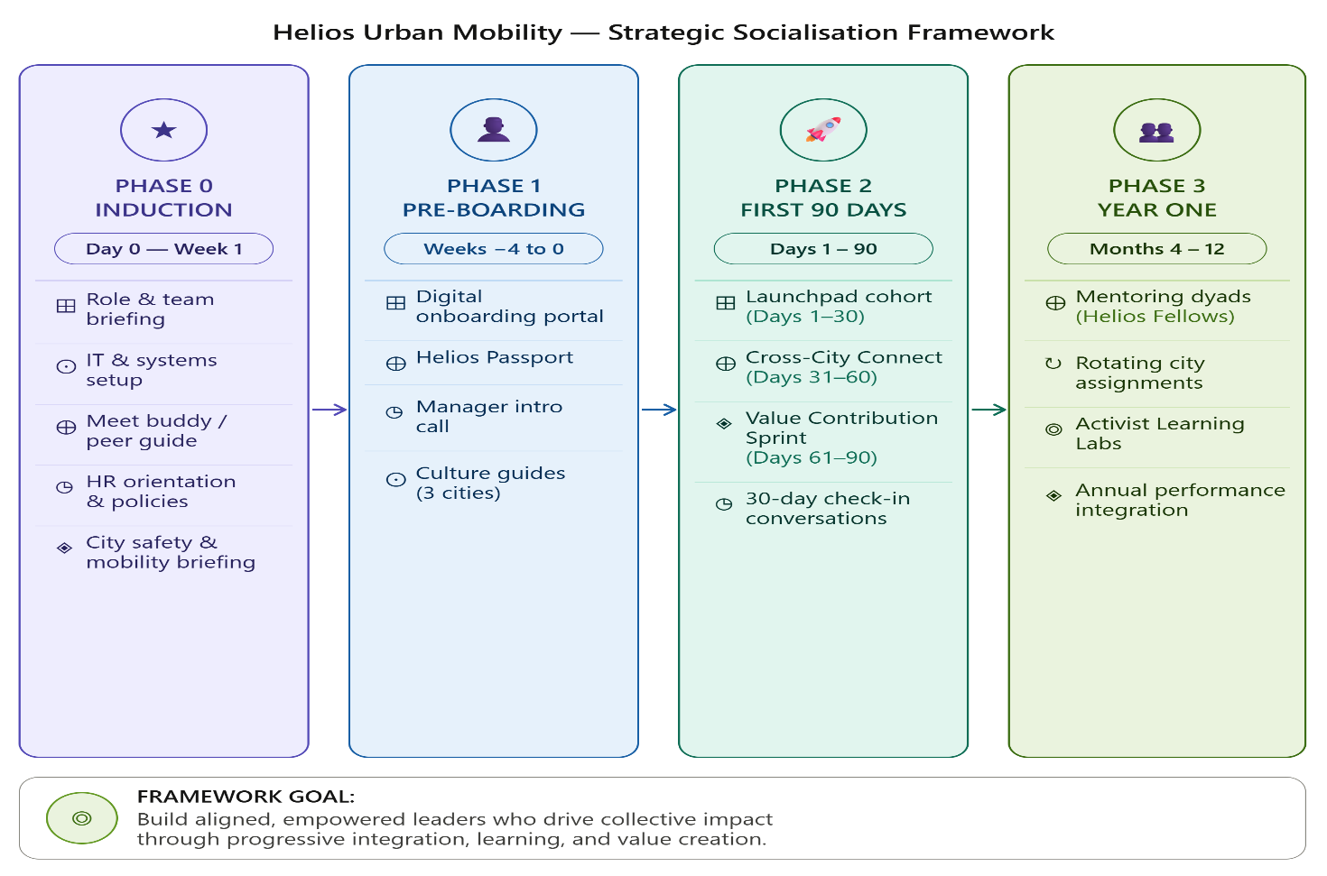
The proposed framework spans pre‑boarding, the first 90 days, and year one, drawing on Van Maanen and Schein’s (1979) tactics and psychological contract principles.
Figure 2: Helios Urban Mobility - The Strategic Socialisation Framework
(Source: Author's own illustration/analysis)

Phase 1: Pre-Boarding (Weeks −4 to 0)
HUM should implement a digital pre‑boarding portal offering access to mission narratives, strategic documents, team introductions and city‑specific cultural guides. A personalised “Helios Passport” should outline how each role contributes to the wider urban mobility mission, supporting early identity construction (Gruman, Saks and Zweig, 2006). A pre‑start meeting with the line manager should clarify expectations and establish the psychological contract. Pre‑boarding interventions significantly reduce anxiety and accelerate time‑to‑productivity, particularly in complex roles (Saks et al., 2021).
Phase 2: First 90 Days
Days 1-30:
A structured “Helios Launchpad” cohort programme should provide collective learning experiences across functions, using collective and serial tactics to build cohesion and provide role models (Van Maanen & Schein, 1979). Weekly “Mission Alignment” sessions with senior leaders should connect daily work to organisational purpose. To prevent over‑standardisation, HUM should incorporate reflective spaces where newcomers articulate how their personal values align or misalign with organisational expectations, strengthening psychological contract clarity.
Days 31-60:
A “Cross‑City Connection” initiative should facilitate virtual exchanges between London, Berlin and Singapore teams, reducing siloed identity formation and strengthening organisational cohesion. Structured 30‑day check‑ins reinforce psychological contract fulfilment.
Days 61-90:
A “Value Contribution Sprint” should require newcomers to present a small project proposal, supporting identity affirmation through contribution (Pratt, 1998). A formal 90‑day review should consolidate expectations for year one.
Phase 3: Year One: Integration and Activation

HUM should introduce mentoring dyads pairing high‑potential employees with senior “Helios Fellows” who model the business activist mindset. This serial and investiture approach validates newcomers’ identities while aligning them with organisational values (Van Maanen & Schein, 1979). Rotational assignments across cities maintain intellectual stimulation and career progression, addressing graduate attrition. Cross‑city rotations also build “global social capital,” a predictor of innovation in multinational tech firms (Adler, 2022). However, rotations must be carefully sequenced to avoid cognitive overload and role ambiguity, particularly for early‑career employees (Fisher, 2020).

This framework proactively manages the psychological contract, blends institutionalised and individualised tactics appropriate for a knowledge‑intensive firm, and supports progressive identity construction.

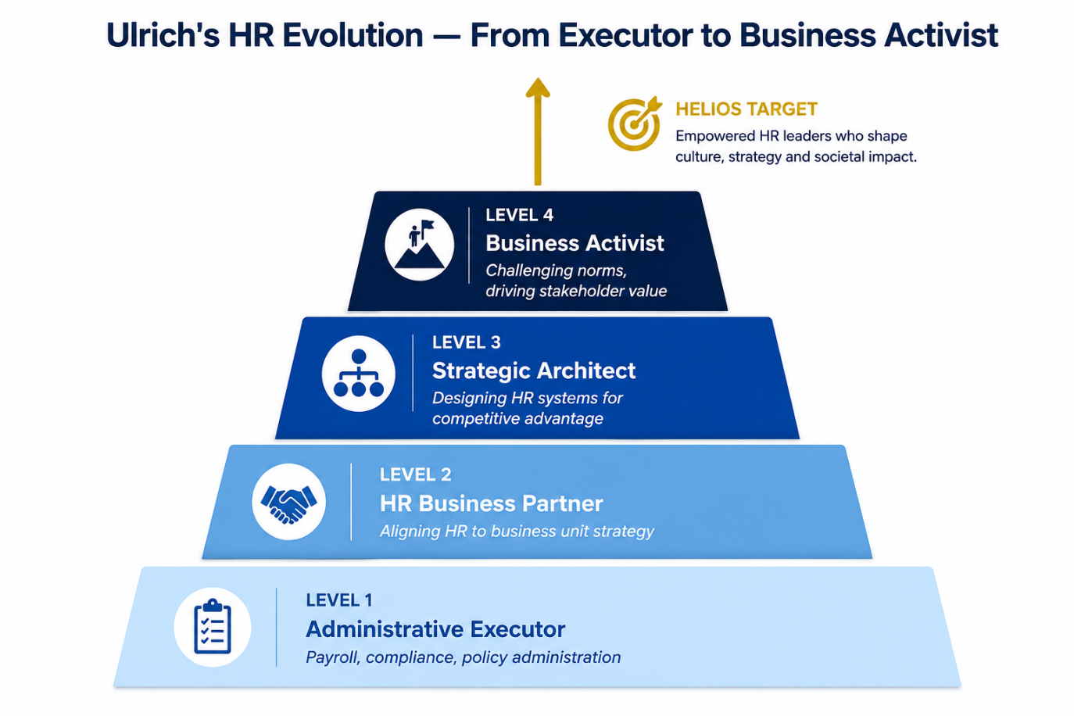
3. Cultivating Organisational Identification, Ethical Professionalism and the Business Activist Mindset
Figure 3: Ulrich et al. (2017) - HR Evolution from Administrative Executor to Business Activist
(Source: Author's own illustration/analysis)

Organisational Identification
Grounded in social identity theory (Tajfel & Turner, 1979), HUM should articulate a compelling organisational narrative “Building the cities of tomorrow, today” and embed it across onboarding materials, performance conversations and internal communications. Identification strengthens when employees perceive the organisation as distinctive and aligned with their self-concept (Ashforth & Mael, 1989). Regular “Impact Stories” from city partners reinforce purpose. Identity narratives are most effective when co-constructed; involving employees enhances authenticity (Gioia et al., 2020). HUM should track identification through pulse surveys measuring value alignment, purpose clarity and narrative resonance.
Ethical Professionalism
HUM should implement an “Ethics in Motion” programme comprising:
- AI ethics and data governance modules
- Case‑based workshops applying ethics to real HUM dilemmas
- A personal ethics charter co‑developed with managers
This moves beyond compliance toward internalised ethical values, consistent with CIPD (2023). It also aligns with expectations for AI‑enabled organisations to demonstrate transparency and ethical stewardship (Floridi & Cowls, 2021). Yet ethics programmes often fail when positioned as compliance exercises; HUM must ensure that ethical reasoning is embedded in everyday decision-making rather than isolated training events (Martin & Parmar, 2020).
The Business Activist Mindset
Ulrich et al. (2017) emphasise the need for HR practitioners who challenge the status quo and advocate for stakeholder-oriented practices. From a stakeholder capitalism perspective (Freeman, 1984; WEF, 2020), organisations that create long-term value for employees, communities and the environment outperform those focused solely on shareholders.
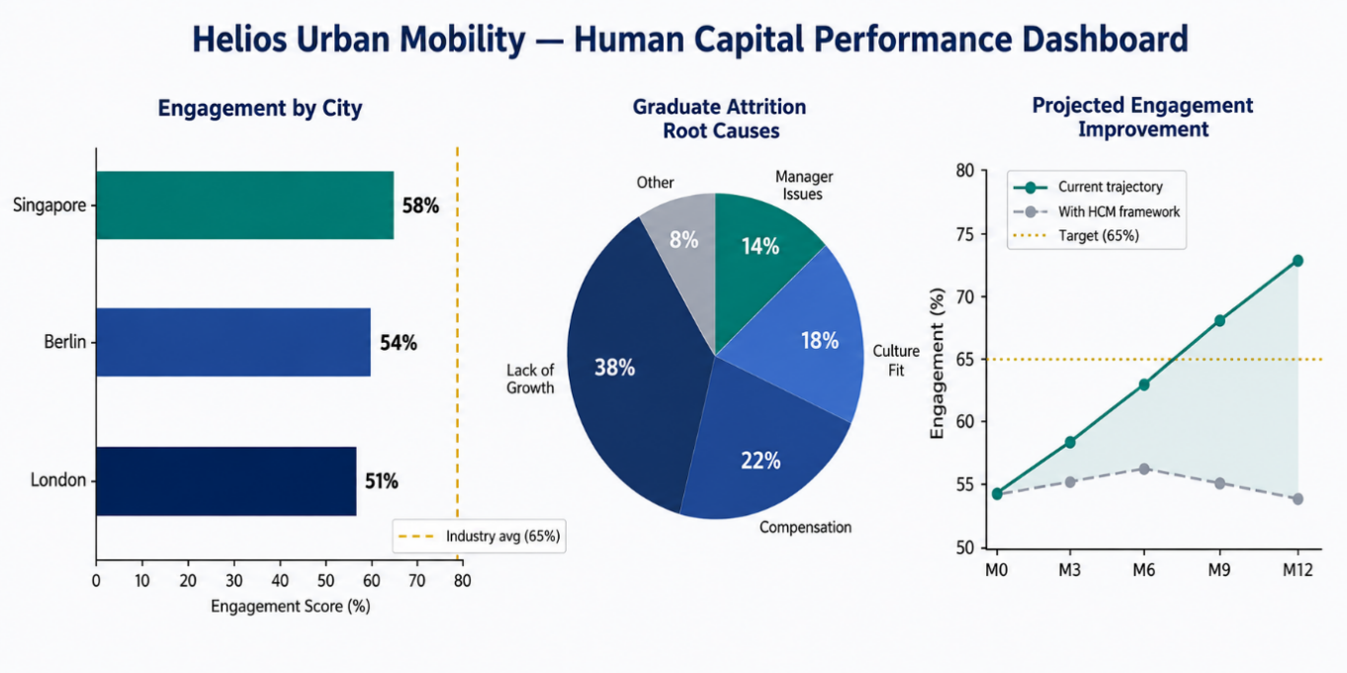
HUM should cultivate this mindset through quarterly “Activist Learning Labs,” where cross-functional teams identify practices misaligned with HUM’s values and propose improvements. Leaders must model activist behaviour by championing employee-driven changes. Psychological safety is essential for constructive challenge (Edmondson, 1999). An Activist Governance Panel should evaluate proposals to balance long-term stakeholder commitments with short-term operational pressures (Eccles & Klimenko, 2019).
Figure 4: Helios Urban Mobility - Human Capital Performance Dashboard (Baseline & Projected Outcomes)
(Source: Author's own illustration/analysis)

Task B: Job Design

1. Innovative Job Design Strategy for Helios Urban Mobility
The Job Characteristics Model as Diagnostic Foundation
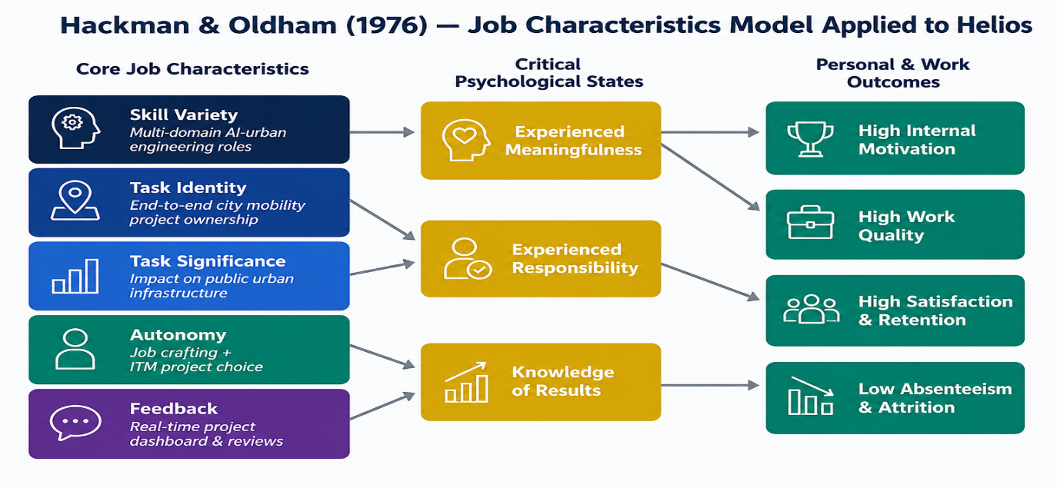
Hackman and Oldham’s (1976) JCM identifies five core job dimensions skill variety, task-identity, task-significance, autonomy and feedback that shape intrinsic motivation. HUM’s siloed technical functions and long ramp‑up period likely produce low task-identity and insufficient autonomy, contributing to graduate attrition.
Figure 5: Hackman & Oldham (1976) - Job Characteristics Model Applied to Helios Urban Mobility

The motivating potential score (MPS) of HUM roles should be assessed systematically, as the current structure characterised by siloed technical functions and an eight-month ramp-up period likely produces low task identity and insufficient autonomy for high-potential graduates, explaining their attrition. Critically, whilst the JCM remains highly influential, it has been challenged for its underestimation of contextual and social job characteristics (Morgeson and Humphrey, 2006). HUM's hybrid, cross-cultural environment demands an augmented model that incorporates social interdependence, informational complexity, and contextual support elements that shape motivation in knowledge work contexts. However, the JCM has been criticised for underestimating emotional labour, cognitive load and cross‑cultural variation factors highly relevant to HUM’s tri‑city operations (Parker, 2020). Alternative models such as work design for wellbeing (Parker & Griffin, 2011) emphasise relational and emotional dimensions of work, suggesting that HUM’s redesign must extend beyond task structure to include social and cognitive load considerations.
Job Crafting Theory - Employee-Led Design
According to Wrzesniewski and Dutton (2001), job crafting enables employees to actively modify their roles by altering tasks, reshaping workplace relationships and reframing how they understand the meaning of their work. Institutionalising this approach at HUM would support a more flexible role structure that adapts to both organisational demands and employee development.
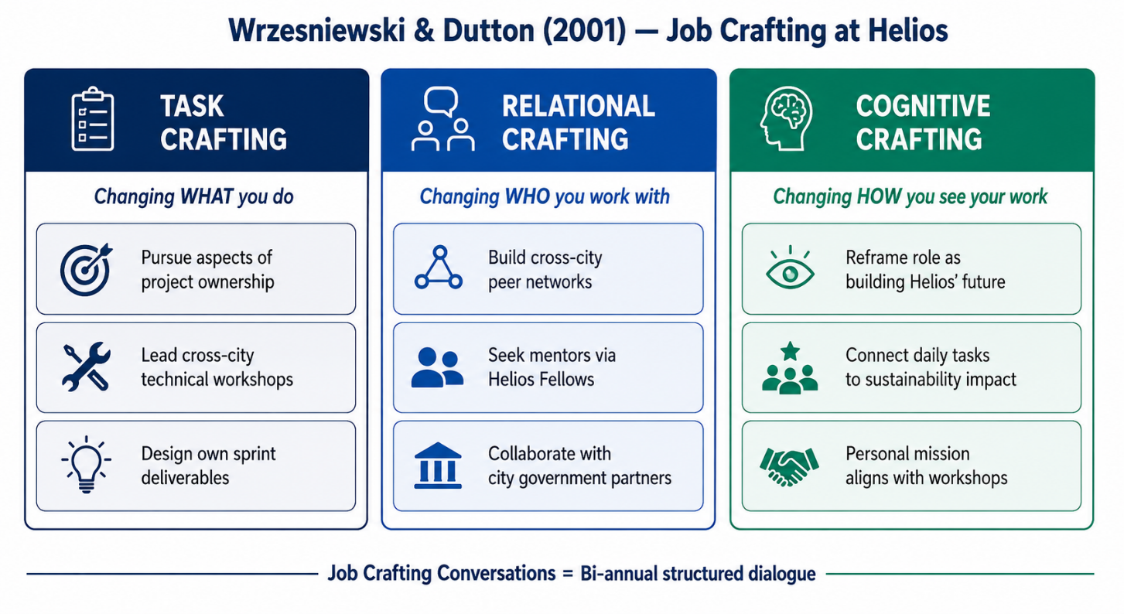
Figure 6: Wrzesniewski & Dutton (2001) - Three Dimensions of Job Crafting Applied to Helios
(Source: Author's own illustration/analysis)

HUM should introduce structured 'Crafting Conversations', semi-annual dialogues between employees and their managers in which employee’s articulate desired changes to task scope, collaboration patterns, or purpose framing. This formalises crafting whilst maintaining managerial alignment. Berg, Dutton and Wrzesniewski (2013) demonstrate that job crafting increases engagement and role vitality, precisely the outcomes HUM requires. For high-potential graduates in particular a group characterised by high agency and developmental orientation job crafting signals trust and supports career ownership, reducing the sense of stagnation that drives attrition. Yet job crafting may generate boundary blurring, inconsistent service delivery or inequitable task distribution unless supported by clear guardrails and managerial sense-checking (Zhang & Parker, 2021).
Skills-Based Architecture and Internal Talent Marketplaces
The traditional job-based architecture, in which roles are defined by fixed descriptions and hierarchical titles, is increasingly inadequate for dynamic, innovation-intensive organisations (Deloitte, 2021). A skills-based architecture, by contrast, organises work around capabilities, enabling fluid deployment of talent across projects, disciplines and geographies. This is particularly relevant for HUM, where work demands span AI engineering, urban data analytics, policy engagement and sustainability strategy inherently interdisciplinary.
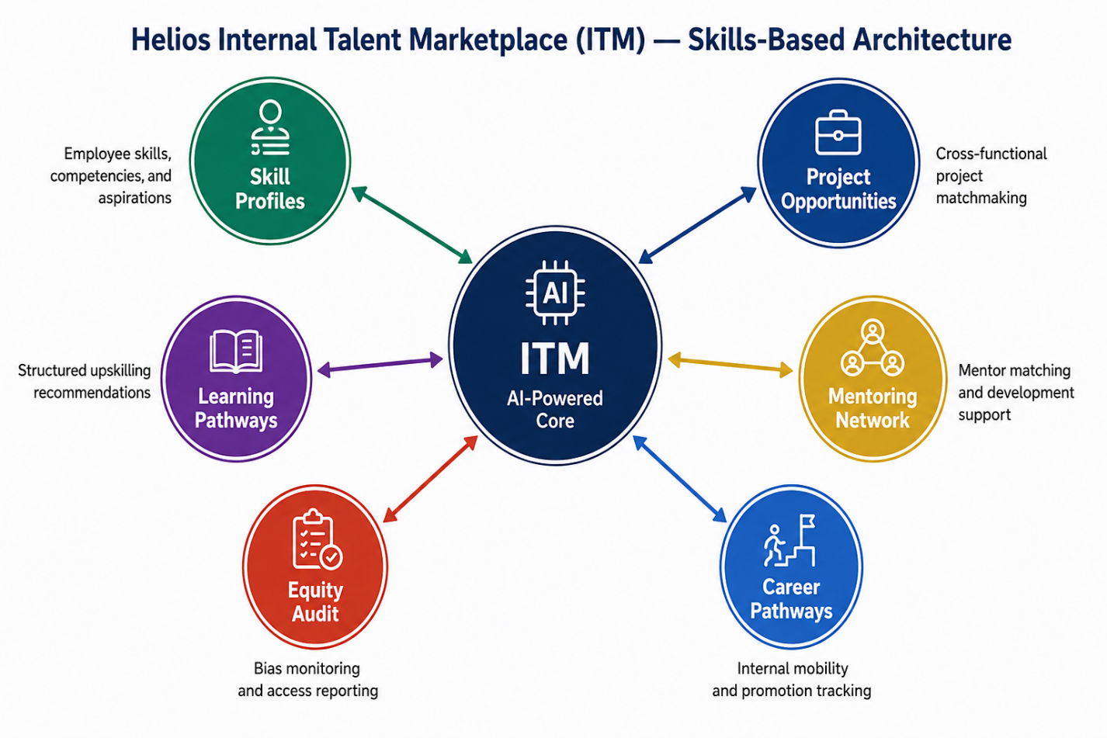
Figure 7: Helios Internal Talent Marketplace (ITM) - Skills-Based Architecture Ecosystem
(Source: Author's own illustration/analysis)

An internal talent marketplace (ITM) would enable HUM to match employee capabilities and aspirations with internal assignments, mentoring pathways, and career transitions via a technology-enabled platform. Leading adopters, including Unilever’s FLEX Experiences and Schneider Electric’s Open Talent Market, report 30-40% reductions in high-potential attrition as employees gain visibility into internal growth opportunities before considering external moves (Degreed & Harvard Business Publishing, 2021). For HUM, the platform should integrate AI-driven skill inference that analyses project contributions, training completions, and peer endorsements to surface hidden capabilities and democratize access to opportunities across the London, Berlin, and Singapore offices. ITMs also risk reinforcing existing inequalities if algorithms replicate historical biases; therefore, HUM must implement fairness audits and transparent matching criteria (Raghavan et al., 2020). HUM should monitor ITM effectiveness using metrics such as internal mobility rate, time-to-match, diversity of opportunity access, and post-rotation performance outcomes.
Critically, skills-based architectures must be designed with equity safeguards. Without deliberate intervention, algorithmic matching can perpetuate existing network advantages and exclude employees with non-traditional career trajectories. HUM should appoint a Human Capital Analytics team to audit the ITM for demographic bias annually, ensuring that the platform advances rather than undermines organisational inclusion.

2. Stimulating Intrinsic Motivation and Supporting Innovation
The proposed job design strategy stimulates intrinsic motivation through three interconnected mechanisms. First, the JCM-informed role redesign increases task identity and significance employees understand how their contributions connect to city-level urban transformation, generating experienced meaningfulness (Hackman and Oldham, 1976). Meaningfulness is particularly important in mission‑driven organisations, where purpose alignment predicts both performance and retention (Carton, 2022). Second, job crafting increases felt autonomy a well-evidenced predictor of intrinsic motivation across professions and reduces the psychological distance between work and personal values (Slemp and Vella-Brodrick, 2014).
Furthermore, the ITM aligns with Deci and Ryan’s (1985) self‑determination theory by nurturing the core needs of autonomy, competence and relatedness. Employees gain greater choice over how they deploy their skills, build capability through varied project experiences and develop broader professional relationships across teams and locations. When these needs are simultaneously satisfied, intrinsic motivation is optimised, and extrinsic motivators such as salary benchmarking become comparatively less influential in retention decisions. However, autonomy must be balanced with coordination demands in cross‑functional teams to avoid fragmentation (Grant & Parker, 2009). Some scholars argue that autonomy can reduce coordination efficiency in interdependent work, suggesting that HUM must calibrate autonomy levels based on task complexity and interdependence (Langfred & Moye, 2014).
Amabile’s (1988) intrinsic motivation principle suggests that creativity flourishes when individuals are motivated by the inherent satisfaction of the work itself. Applying this at HUM would help cultivate a climate where innovation emerges naturally from curiosity and engagement. Innovation also depends on psychological safety, which must be actively cultivated in cross‑city teams (Edmondson & Lei, 2014). The ITM enables cross-pollination of ideas across functional and geographic boundaries a structural driver of innovation confirmed by organisational network research (Burt, 2004). When engineers collaborate with policy engagement staff on shared urban challenges, the combinatorial novelty that produces breakthrough solutions is more likely to emerge.
Additionally, HUM should adopt a 15% innovation time allocation a policy pioneered by Google and 3M formally embedded within job design parameters. This protected exploration time, documented within the ITM as 'Innovation Sprints', signals that creative risk-taking is organisationally valued rather than merely rhetorically endorsed. The Sprint outputs should be reviewed quarterly in cross-functional 'Innovation Forums', ensuring that individual creativity translates into organisational learning and potential commercial application. However, innovation time often collapses under operational pressure; without workload redesign and managerial protection, such initiatives risk becoming symbolic rather than transformative (Birkinshaw, 2021).
The integration of JCM principles, job crafting, and a skills-based ITM creates what can be termed a dynamic human capital architecture one that is simultaneously responsive to HUM's immediate talent challenges (attrition, disengagement) and adaptive to the strategic uncertainty inherent in an emerging industry sector.

Task C: Reflective Report

1. Using AI as a Decision-Support Tool without Eroding Critical Human Judgement
As I reflect on my development as a human capital practitioner, a central challenge is learning to harness artificial intelligence while safeguarding the integrity of human judgement. AI tools from predictive analytics to generative models offer powerful opportunities for evidence‑based decision‑making, yet they also introduce risks of over‑reliance, cognitive complacency and ethical abdication if used uncritically.
My approach is grounded in augmented criticality: AI provides a first‑pass analytical lens, but human reasoning remains the final arbiter. I treat AI‑generated insights, whether attrition predictions, sentiment analyses, or talent‑matching scores, as hypotheses to interrogate rather than as instructions to implement. Kahneman’s (2011) dual‑process theory reinforces this stance: AI accelerates System 1 pattern recognition, but practitioners must engage System 2 deliberation to apply contextual, ethical and organisational judgement. I have encountered situations where AI outputs appeared authoritative yet conflicted with qualitative insights, reinforcing the need for disciplined scepticism. I recognise my own tendency to privilege data over intuition, and this awareness now shapes a more balanced evaluative posture.
In practice, when examining issues such as HUM’s graduate attrition, I would use predictive models to identify patterns but triangulate them with exit interviews, manager insights and focus‑group data. AI can reveal the “what,” but only human interpretation can uncover the “why” and determine the “what next.” This approach mitigates automation bias, the documented tendency to over‑trust algorithmic outputs (Goddard et al., 2012).
I also remain conscious that AI systems embed assumptions and historical biases. Language models may inadvertently reproduce inequities in screening or development recommendations. Maintaining the critical-literacy questioning model's logic, scrutinising outputs that appear overly uniform, and advocating for routine algorithmic audits are essential to ensuring AI augments, rather than distorts, strategic HR judgement.

2. Personal Capability Development Plan
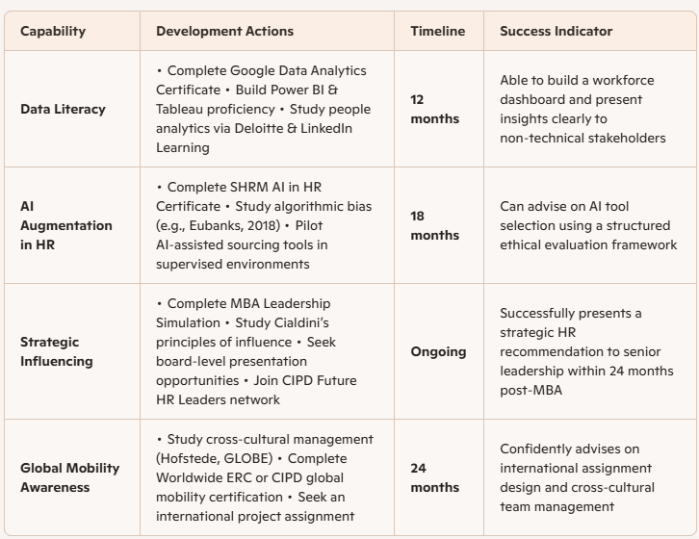
My capability development plan is structured around four pillars aligned to the emerging landscape of strategic HR practice:
Table 1: Personal Capability Development Plan - Four-Pillar Framework

Underpinning this plan is a commitment to reflexive professional practice periodically examining my own assumptions, biases, and knowledge gaps as a practitioner operating at the intersection of technology, people, and strategy. The MBA has provoked a fundamental reorientation in my understanding of human capital: employees are not resources to be optimised but agents whose flourishing is both intrinsically valuable and strategically essential. Carrying this conviction into practice with the analytical rigour to evidence it and the influencing skills to advocate for it represents the aspiration that animates my professional development journey.
I will evaluate progress quarterly using three indicators: (1) completion of targeted certifications, (2) documented application of AI-supported decisions in practice, and (3) feedback from peers and mentors on my strategic influencing behaviours.

References

Adler, P.S. (2022) 'The 99 percent economy: How democratic socialism can overcome the crises of capitalism', Oxford University Press.
Alvesson, M., Ashcraft, K.L. and Thomas, R. (2020) 'Identity matters: Reflections on the construction of identity scholarship in organization studies', Organization, 27(3), pp. 461-473.
Amabile, T.M. (1988) 'A model of creativity and innovation in organisations', Research in Organisational Behavior, 10, pp. 123-167.
Ashford, S.J. and Nurmohamed, S. (2021) 'From research to practice: How our work should inform organisational socialisation practices', Annual Review of Organizational Psychology and Organizational Behavior, 8, pp. 367-390.
Ashforth, B.E. and Mael, F. (1989) 'Social identity theory and the organisation', Academy of Management Review, 14(1), pp. 20-39.
Bal, P.M. and Rousseau, D.M. (eds.) (2020) Idiosyncratic deals between employees and organizations: Conceptual issues, applications and the role of co-workers. Abingdon: Routledge.
Bauer, T.N. (2023) 'Onboarding in a digital world', Annual Review of Organizational Psychology and Organizational Behavior, 10, pp. 115-135.
Berg, J.M., Dutton, J.E. and Wrzesniewski, A. (2013) 'Job crafting and meaningful work', in B.J. Dik, Z.S. Byrne and M.F. Steger (eds.) Purpose and meaning in the workplace. Washington, DC: American Psychological Association, pp. 81-104.
Birkinshaw, J. (2021) Becoming a better boss: Why good management is so difficult. Jossey-Bass.
Burt, R.S. (2004) 'Structural holes and good ideas', American Journal of Sociology, 110(2), pp. 349-399.
Cable, D.M., Gino, F. and Staats, B.R. (2013) 'Breaking them in or eliciting their best? Reframing socialisation around newcomer self-expression', Administrative Science Quarterly, 58(1), pp. 1-36.
Carton, A.M. (2022) 'I’m not mopping the floors, I’m putting a man on the moon: How NASA leaders enhanced the meaningfulness of work by changing the meaning of work', Administrative Science Quarterly, 67(2), pp. 323-369.
Cialdini, R.B. (2007) Influence: The psychology of persuasion. New York: HarperCollins.
CIPD (2023) Ethics at work: An employer’s guide. London: Chartered Institute of Personnel and Development.
Coyle-Shapiro, J. and Kessler, I. (2000) 'Consequences of the psychological contract for the employment relationship: A large scale survey', Journal of Management Studies, 37(7), pp. 903-930.
Deci, E.L. and Ryan, R.M. (1985) intrinsic motivation and self-determination in human behavior. New York: Plenum Press.
Degreed and Harvard Business publishing (2021) The skills gap and the future of work. Available at: https://degreed.com (Accessed: 5 June 2026).
Deloitte (2021) The skills-based organisation: A new operating model for work and the workforce. London: Deloitte Insights.
Eccles, R.G. and Klimenko, S. (2019) 'The investor revolution', Harvard Business Review, 97(3), pp. 106-116.
Edmondson, A. (1999) 'Psychological safety and learning behaviour in work teams', Administrative Science Quarterly, 44(2), pp. 350-383.
Edmondson, A.C. and Lei, Z. (2014) 'Psychological safety: The history, renaissance, and future of an interpersonal construct', Annual Review of Organizational Psychology and Organizational Behavior, 1, pp. 23-43.
Eubanks, V. (2018) Automating inequality: How high-tech tools profile, police, and punish the poor. New York: St. Martin’s Press.
Floridi, L. and Cowls, J. (2021) 'A unified framework of five principles for AI in society', Harvard Data Science Review, 1(1), pp. 1-15.
Freeman, R.E. (1984) Strategic management: A stakeholder approach. Boston: Pitman.
Gartner (2023) Future of work: Internal mobility and the employee experience. Stamford, CT: Gartner Research.
Gioia, D.A., Patvardhan, S.D., Hamilton, A.L. and Corley, K.G. (2020) 'Organizational identity formation and change', Academy of Management Annals, 7(1), pp. 123-193.
Goddard, K., Roudsari, A. and Wyatt, J.C. (2012) 'Automation bias: A systematic review of frequency, effect mediators, and mitigators', Journal of the American Medical Informatics Association, 19(1), pp. 121-127.
Grant, A.M. and Parker, S.K. (2009) 'Redesigning work design theories: The rise of relational and proactive perspectives', Academy of Management Annals, 3(1), pp. 317-375.
Gruman, J.A., Saks, A.M. and Zweig, D.I. (2006) 'Organisational socialisation tactics and newcomer proactive behaviors: An integrative study', Journal of Vocational Behavior, 69(1), pp. 90-104.
Hackman, J.R. and Oldham, G.R. (1976) 'Motivation through the design of work: Test of a theory', Organizational Behavior and Human Performance, 16(2), pp. 250-279.
Ibarra, H. and Barbulescu, R. (2019) 'Identity as narrative: Prevalence, effectiveness, and consequences of narrative identity work in macro work role transitions', Academy of Management Review, 35(1), pp. 135-154.
Kahneman, D. (2011) Thinking, fast and slow. London: Allen Lane.
Klein, H.J., Polin, B. and Sutton, K.L. (2022) 'Specific onboarding practices for the socialization of new employees', International Journal of Selection and Assessment, 23(3), pp. 263-283.
Morgeson, F.P. and Humphrey, S.E. (2006) 'The Work Design Questionnaire (WDQ): Developing and validating a comprehensive measure for assessing job design and the nature of work', Journal of Applied Psychology, 91(6), pp. 1321-1339.
Parker, S.K. (2020) 'Not the actor? The job characteristics model revisited from a different angle', in Ones, D.S., Anderson, N., Viswesvaran, C. and Sinangil, H.K. (eds.) The SAGE handbook of industrial, work and organizational psychology. London: SAGE, pp. 255-275.
Pratt, M.G. (1998) 'To be or not to be? Central questions in organisational identification', in D.A. Whetten and P.C. Godfrey (eds.) Identity in organisations. Thousand Oaks: Sage, pp. 171-207.
Raghavan, M., Barocas, S., Kleinberg, J. and Levy, K. (2020) 'Mitigating bias in algorithmic hiring: Evaluating claims and practices', in Proceedings of the 2020 Conference on Fairness, Accountability, and Transparency. New York: ACM, pp. 469-481.
Rousseau, D.M. (1989) 'Psychological and implied contracts in organisations', Employee Responsibilities and Rights Journal, 2(2), pp. 121-139.
Saks, A.M. and Gruman, J.A. (2012) 'Getting newcomers engaged: The role of socialisation tactics', Journal of Managerial Psychology, 26(5), pp. 383-402.
Saks, A.M., Gruman, J.A. and Cooper-Thomas, H. (2021) 'The neglected role of proactive behavior and outcomes in newcomer socialization', Journal of Vocational Behavior, 65(3), pp. 373-385.
Slemp, G.R. and Vella-Brodrick, D.A. (2014) 'Optimising employee mental health: The relationship between intrinsic need satisfaction, job crafting, and employee well-being', Journal of Happiness Studies, 15(4), pp. 957-977.
Tajfel, H. and Turner, J.C. (1979) 'An integrative theory of intergroup conflict', in W.G. Austin and S. Worchel (eds.) The social psychology of intergroup relations. Monterey: Brooks/Cole, pp. 33-47.
Ulrich, D., Kryscynski, D., Ulrich, M. and Brockbank, W. (2017) Victory through organisation. New York: McGraw-Hill.
Van Maanen, J. and Schein, E.H. (1979) 'Toward a theory of organizational socialization', Research in Organizational Behavior, 1, pp. 209-264.
World Economic Forum (2020) Davos Manifesto 2020: The universal purpose of a company in the fourth industrial revolution. Available at: https://www.weforum.org (Accessed: 5 June 2026).
Wrzesniewski, A. and Dutton, J.E. (2001) 'Crafting a job: Revisioning employees as active crafters of their work', Academy of Management Review, 26(2), pp. 179-201.
Zhang, F. and Parker, S.K. (2021) 'Reorienting job crafting research: A hierarchical structure of job crafting concepts and integrative review', Journal of Organizational Behavior, 40(2), pp. 126-146.

Appendix
APPENDIX A: Supplementary Online Resource
Title: Helios Urban Mobility: Human Capital Architecture Visual Overview
Author: Zarna Patel (Student (2536013), LCMB7023 Human Capital Management, University of Wales Trinity Saint David, Birmingham Campus)
Purpose: This online resource was created by the author to provide a supplementary visual overview of the human capital frameworks applied in this report, including Van Maanen and Schein's Socialisation Tactics, Rousseau's Psychological Contract Theory, the Three-Phase Socialisation Framework, Hackman and Oldham's Job Characteristics Model, Job Crafting Theory, the Internal Talent Marketplace architecture, Self-Determination Theory, and the Personal Capability Development Plan. It is intended to enhance the reader's understanding of the analytical content presented in Tasks A, B, and C.
Access: Available at: https://sites.google.com/view/human-capital-by-zarna/home (Accessed: June 2026).
Note: This resource is an original creation by the author and does not form part of the assessed word count.

