

LOCATION: Swansea | LLEOLIAD: abertawe
LEVEL 5 | LEFEL 5
EXAMINATION PERIOD | CYFNOD ARHOLIADAU
MAY 2024 | MAI 2024

MODULE CODE: ACDB5002
Electronics I

Marking Scheme

ANSWER ALL QUESTIONS

QUESTION 1
- Using the PIC16F877A with a 470Ω resistor and LED connected to each pin of Port C with the PIC sourcing current for the LED. The PIC should perform the following actions:
- Starting with all LEDs off, every second the number of LEDs should increase by one.
- When all 8 LEDs are lit, the circuit should revert to its original state of having all LEDs turned off.
- Repeats this process indefinitely.
- Use a flow chart to describe the program structure. [5 Marks]
- Design the circuit using simulation software. [10 Marks]
- Write a C program for the above scenario. [20 Marks]
- Run the Simulation. [5 Marks]

  - Use a flow chart to describe the program structure. [5 Marks]
Solution
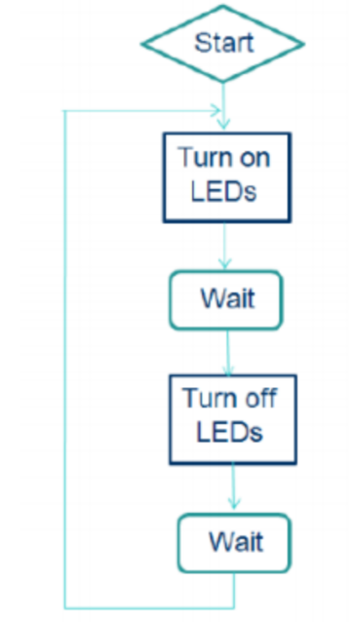
[5 Marks]
- Design the circuit using simulation software. [10 Marks]
Solution

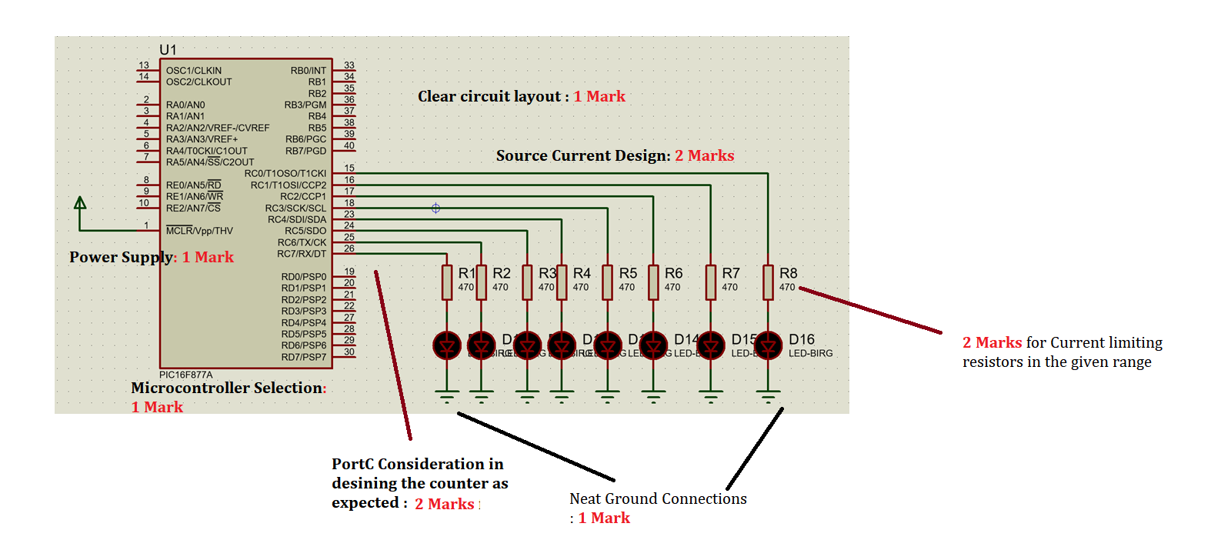
[Total: 10 Marks]
- Write a C program for the above scenario. [20 Marks]
Solution
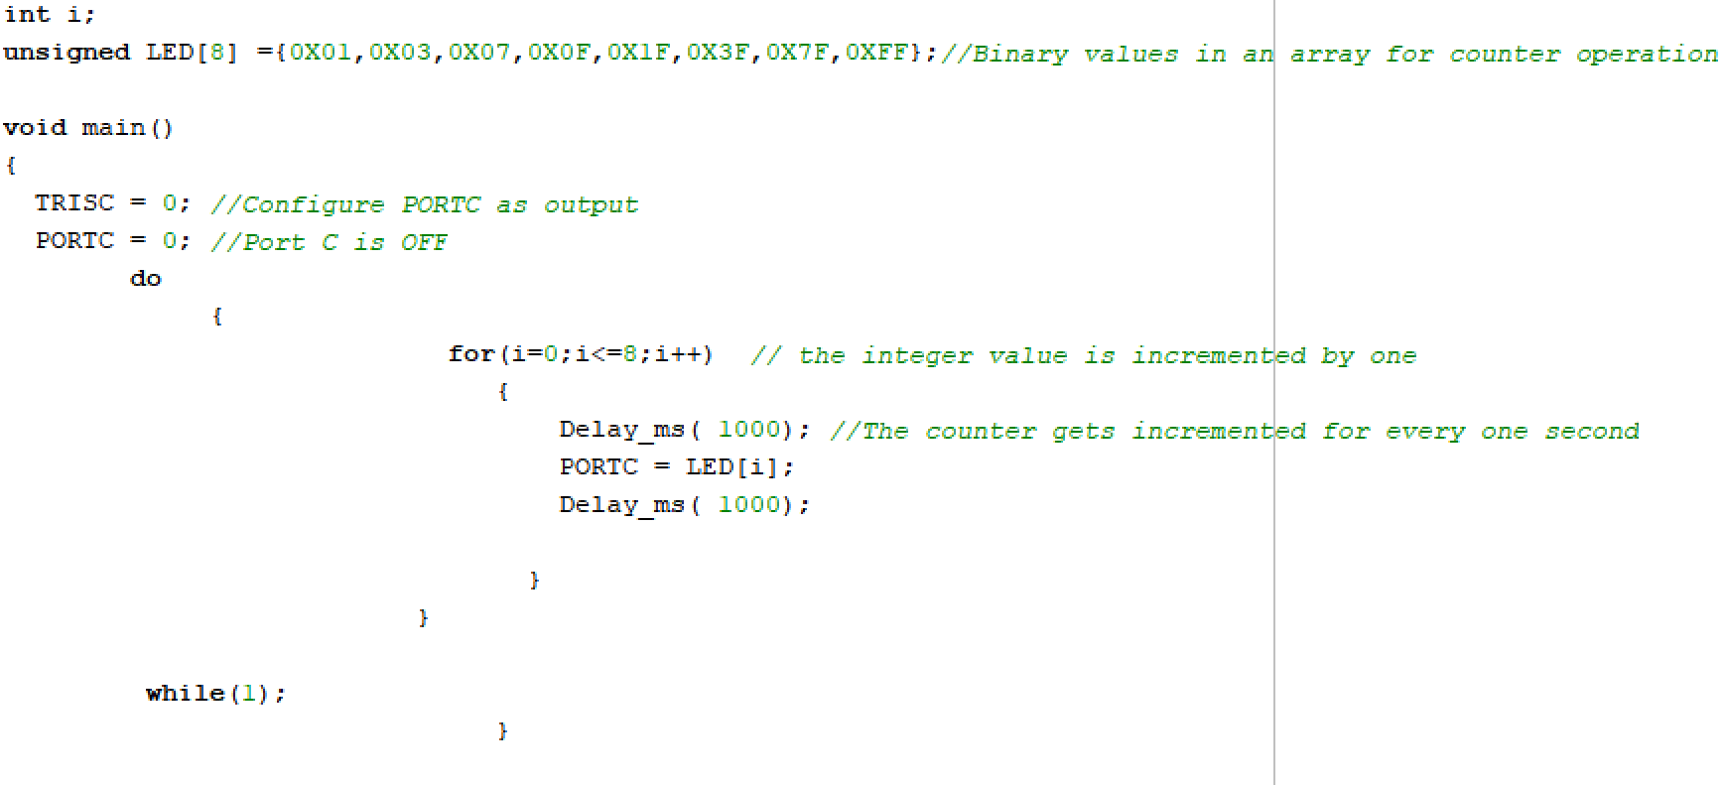
Or
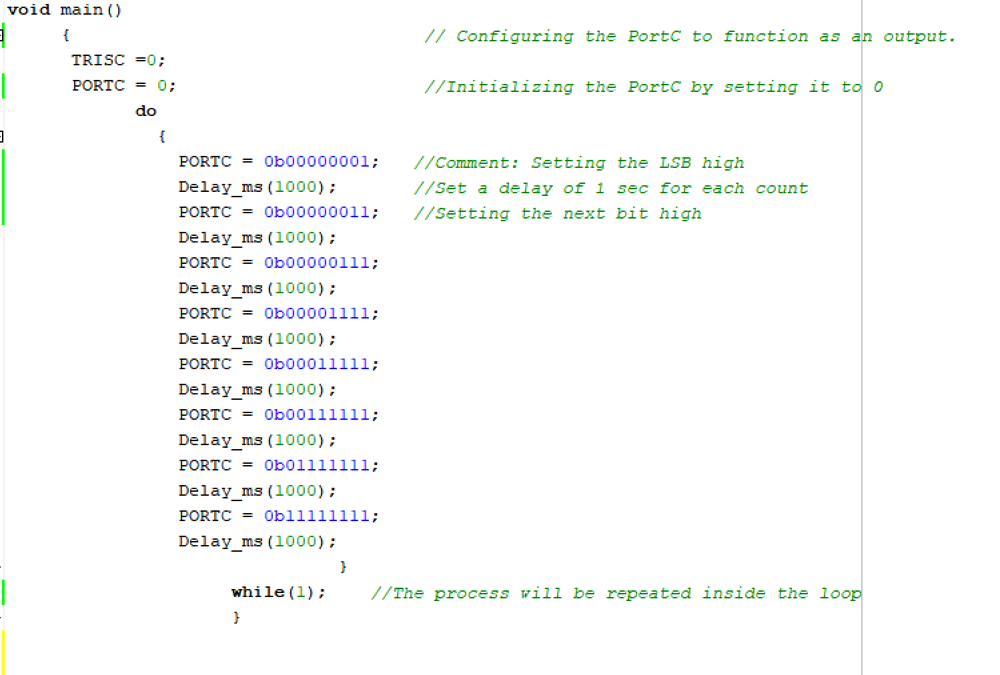

The following criteria’s could be taken into consideration while marking the programming lines :
Comments: For adding meaningful comments in the program. [3 Marks]
Variable Naming and Declaration: Considering the Ports from the question and declaring them. [ 2 Marks]
Code Structure and Readability: Marks for logical Flow and easy understandability[5 Marks]
For Setting Proper Delay as required. [2 Marks]
Correctness and Functionality: Lighting up the LED as required [5 Marks]
Code Optimization : minimizing unnecessary operations [3 Marks]
Other lines of code could also be taken into account other than the above given codes when composing the programming instructions, providing students with the freedom to think creatively. For instance, instead of repeatedly incorporating delay functions, they could be defined as constants.
- Run the Simulation. [5 Marks]
Solution
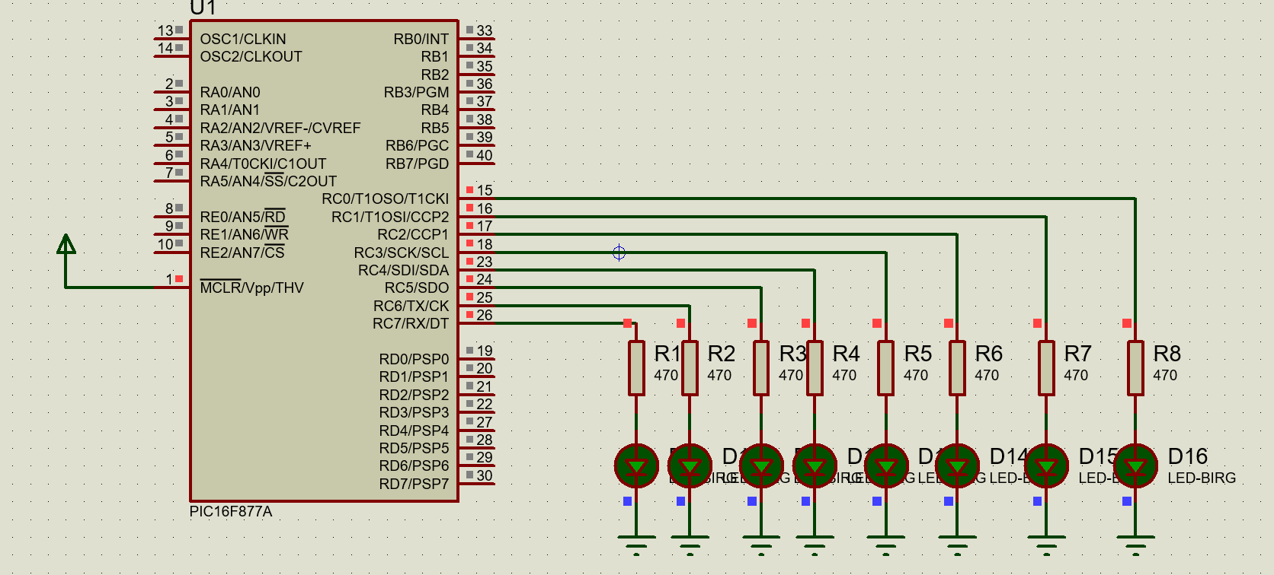
[5 Marks]
The following assessment criteria could be taken into account:
- Circuit Simulation running without any Fatal errors: [1 Mark]
- Circuit Simulation running with exact expected results: [5 Marks]
- Circuit Simulation running with only partial output observed: [2 Marks]

QUESTION 2
- For the circuit given below, Answer the following questions.
- Identify the above circuit and briefly explain the purpose of it. [5 Marks]
- Design and Simulate the above circuit diagram using Simulation Software. [15 Marks]
SOLUTION
- Identify the above circuit and briefly explain the purpose of it. [5 Marks]
- The above given circuit is the Night Light sensor Circuit. They are a type of photodetector (also called photosensors) that detect light. [2 Marks]
- Different types of light sensors can be used to measure illuminance, respond to changes in the amount of light received, or convert light to electricity.
- The purpose of Night light sensor is to make the LED ON when there is no light/ during darkness. [3 Marks]

- Design and Simulate the above circuit diagram using Simulation Software. [15 Marks]
Solution
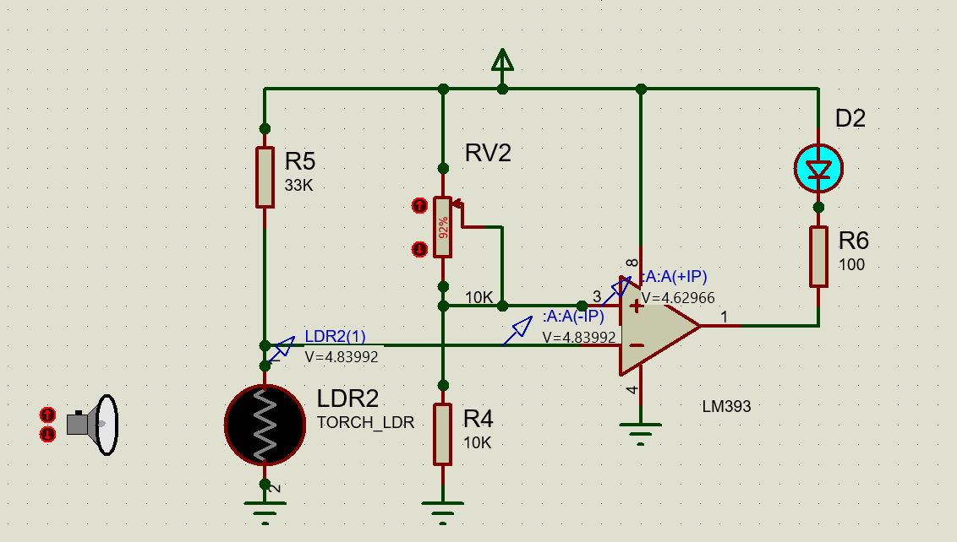
[15 Marks]

QUESTION 3

- Design a power supply circuit capable of converting a sinusoidal voltage of 240V at 50Hz into regulated DC 5V. Following are expected to satisfy this question.
  - Illustrate the block diagram of the power supply. [5 Marks]
  - Provide the Power Supply circuit diagram . [5 Marks]
  - Design and Simulate the power supply circuit using suitable simulation software, such as Proteus. [15 Marks]
  - Use the simulation oscilloscope to record the output waveforms, including the input signal, Outputs from all the Blocks of Power Supply [5 Marks]
- Illustrate the block diagram of the power supply. [5 Marks]
Solution
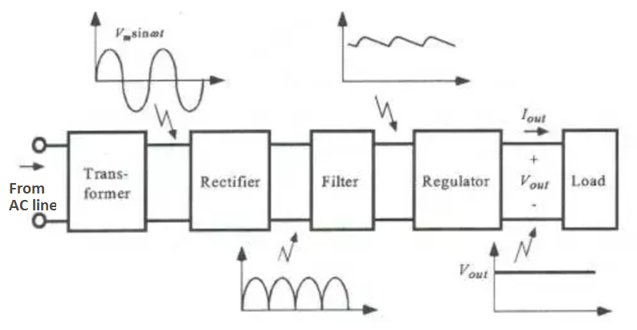
[5 Marks]

- Provide the Power Supply circuit diagram . [5 Marks]
Solution
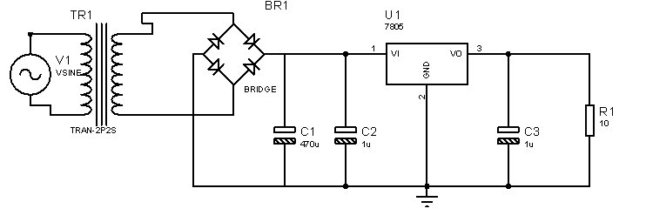
[5 Marks]
(c) Design and Simulate the power supply circuit using suitable simulation software, such as Proteus. [15 Marks]
Solution
Sample of Expected Simulation
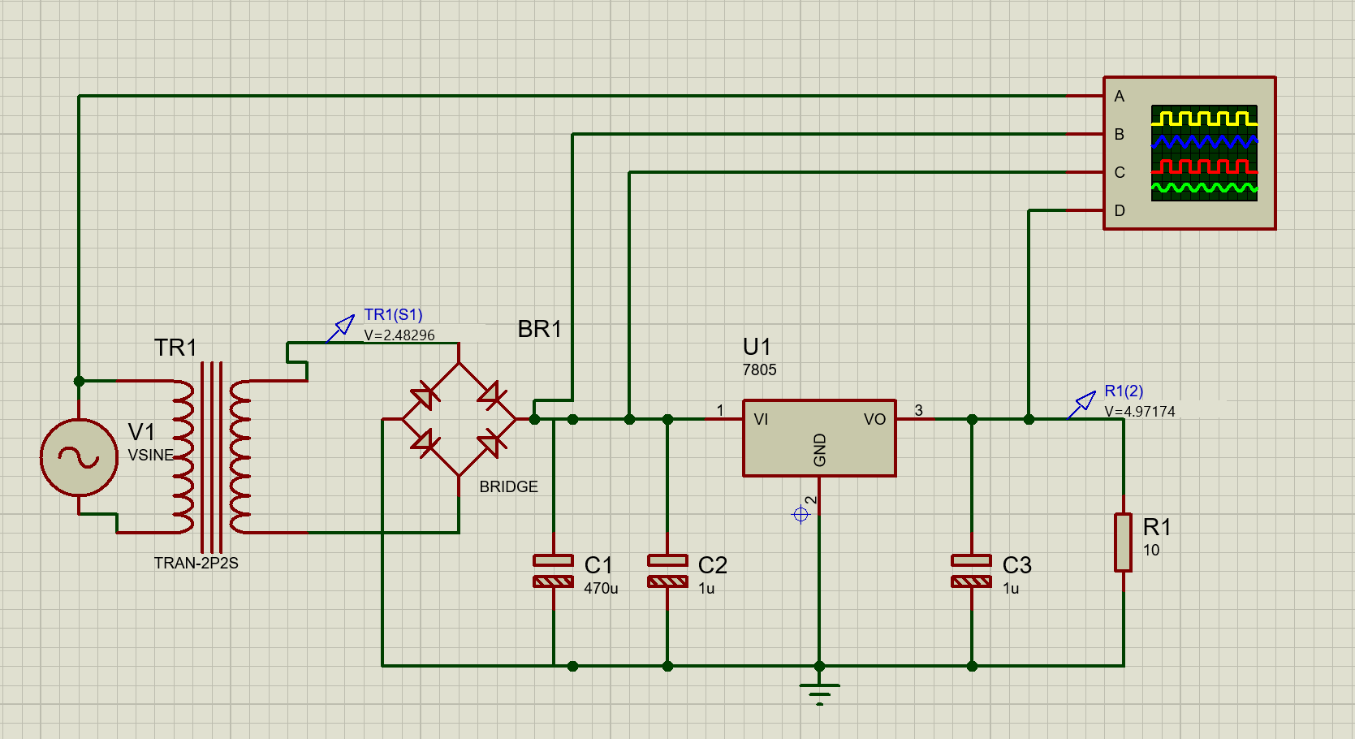 [15 Marks]
[Mark may range from 0-15 depending upon the output of the simulation]

- Use the simulation oscilloscope to record the output waveforms, including the input signal, Outputs from all the Blocks of Power Supply [5 Marks]
Solution
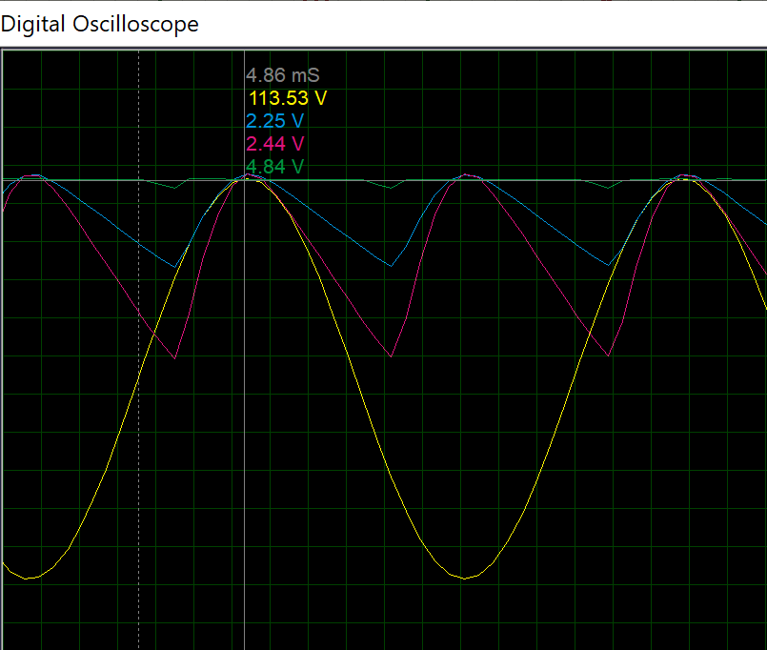
[5 Marks]
- With a help of neat diagram, explain the working principle of Full Wave Rectifier in detail. [10 Marks]
Solution
Positive half cycle
- When the positive half cycle of the input supply is given, point P becomes positive with respect to the point Q.
- This makes the diode D1 and D3 forward biased while D2 and D4 reverse biased. These two diodes will now be in series with the load resistor.
The following figure indicates this along with the conventional current flow in the circuit.
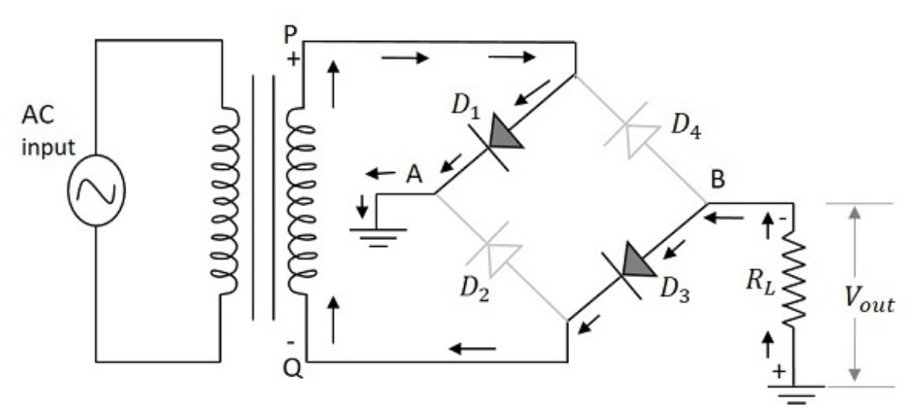
- The diodes D1 and D3 conduct during the positive half cycle of the input supply to produce the output along the load resistor.
- As two diodes work in order to produce the output, the voltage will be twice the output voltage of the center tapped full wave rectifier. [5 Marks]
Negative half cycle
- When the negative half cycle of the input supply is given, point P becomes negative with respect to the point Q.
- This makes the diode D1 and D3 reverse biased while D2 and D4forward biased.
- These two diodes will now be in series with the load resistor.
The following figure indicates this along with the conventional current flow in the circuit.
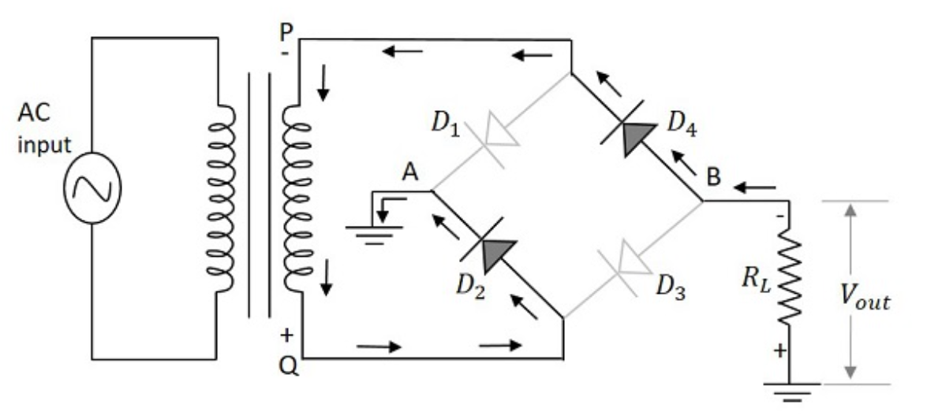
- The diodes D2 and D4 conduct during the negative half cycle of the input supply to produce the output along the load resistor. Here also two diodes work to produce the output voltage.
- The current flows in the same direction as during the positive half cycle of the input.
[5 Marks]

Diwedd/End

