Module Number: BMSW4003
Name: Zafrin Akhtar
Student Id: 2107425
Date: 11/04/2022
Research Report

Introduction
Corporations have been completely altered as a result of scientific innovations that have made their business operations more interconnected and simplified. This is especially true for small and medium-sized businesses. Small firms, which are usually run by several individuals, offer expertise more than anything else. Digital improvements have made it easier for these companies to operate their operations properly and effectively than ever before. Are you maintaining pace with the recent workplace's scientific advancement?
We turned into a modern period where innovation, particularly smart phones, is transforming how organisations generate and value for stakeholders, how and where people work, and how they maintain contact. Cloud and mobile processing, big data and pattern recognition, analytics and industrial automation, sophisticated robots and robotics, and environment protection are five advancements that are altering the fundamental foundations of international company and the organisations that drive it. These devices have made substantial differences in the way research is accomplished in businesses, not merely helping employees do activities better and quicker.
Literature Review:
Technology's Influence on the Workplace
In general, technology has a tremendous influence in the employment. Almost any project proposal, whether it's to resources that contribute employee cooperation, boost customer happiness, establish a better corporate culture, generate profitability, or remove unnecessary processes, may now benefit from a program, technology, or platform.
If you don't use technology to its full potential, your company will swiftly stagnate or, worse, fall behind the opposition. This may be quite harmful in a world where companies are increasingly engaging in different workplace technology and embracing the newest and best tools and skills.
Understanding organizational responsibilities advances and being hesitant to integrate technology in the office might offer your rivals a considerable benefit over you. This may have a detrimental impact on employee satisfaction, income, and give your company a bad image among customers.
When it comes to embracing and responding to new technologies in the workplace, today's employees are typically more innovation. Technology, on the other hand, will not fix all of your issues quickly. What makes a distinction is how your staff use the emerging innovations. You can't expect them to immediately grasp how everything works or should operate. Incorporating and implementing emerging innovations into a company's workflow benefit of service users strategy, effort, and money. Expecting staff to learn new technology immediately can lead to stressful conditions, which can lead to disconnection rather than improved relationships – 57 percent of strong work ethic also report being disconnected and less successful than they might be.
Interaction skills are very important for ways to improve efficiency, as we all know. At the same time, some businesses are hesitant to spend time and resources on software that increases inter professional collaboration. This has resulted in massive losses for business owners: misunderstanding costs organisations with 100 employees an average of $420,000 every year.
Fortunately, modern current technologies for enterprises of all sizes are available on the market: collaborative communicators, virtual meeting applications, and everything in between that may significantly improve workplace relationships and, as a result, organizational efficiency. Here are a few examples.
Chanty
Slack
Flock
Zoom
GoToMeeting
Utilizing moment software, make every event successful.
You can't enhance something if you didn't understand it. You must first comprehend your work clock in order to improve your quality and profitability. How much time do you squander throughout the workday, and what kind of diversions do you engage in? What are your most successful hours by nature? What percentage of the financial performance of the business do you contribute? With the use of time monitoring software, all of these questions may be addressed properly. You will be able to make the most of your time and, as a result, become more efficient if you use them.
The rate of technological use in the business, as well as social impact, connections, and employment equilibrium
With the widespread usage of phones and other devices that can work anywhere and at any time utilizing complimentary applications such as Discord, Google Drive, and View, the online revolution has certainly had a significant impact on employees' social lives. When a worker can perform corporate activities after hours, it benefits the firm, implying that technology innovation has an influence on the worker's social interactions. The greatest remedy for this is to establish appropriate limits between work and personal time, as well as to recognised the value of this to both employees and the firm. Additionally, features provided in the office, such as virtual work, has an impact not only on the individual's personal situation but also on the connection between coworkers. Peer relationships are vital because they promote trust in relationships abilities that the firm needs, such as management and collaboration. Furthermore, peers have a significant impact in deciding how much a worker uses advanced. Evidence of an association between social conditioning to utilize electronics and the rate of adoption.

An employee's acceptance of technology in the workplace is motivated by the desire to stay up with his or her teammates in regards of employing cutting-edge innovation and so advance in their careers.

ENHANCED BUSINESS ORGANIZATION
Team of experts assists in the seamless operation of your organisation. Emerging solutions, such as software packages, enable employees and managers to conveniently oversee and maintain records of employment practices.
These processing required aid in job delegation, monitoring, and assessment, as well as improved productivity by providing a high standard and amount of work produced. They come with built-in tools that help firms organize task effectively, allocate funds, and stay on target. Construction project software also provides a red alert when a job deviates from its original path, allowing firms to minimize construction delays.
INCREASED COLLABORATION
The way we cooperate has fundamentally altered as a result of technological advancements. With the touch of a mouse, you may now connect with any of your workers, executives, or coworkers at any time and from anytime. The significant rise in cooperation led to a higher level of interaction adaptability, propelling teaming to new heights. Increased cooperation allows supervisors and employees to effectively communicate with and govern their workers.
When it comes to teamwork, the emergence of cloud innovation has created an unprecedented universe of opportunities. Anyone may submit and modify files, and customers can be kept up to speed on the status of their projects in seconds from anywhere in the globe.
Making Business Operations More Productive
Companies today depend on the financial enterprise applications, which provide a variety of solutions to help them overcome the problems of formulating a strategy on a daily basis. It allows organizations to measure progress more quickly during each stage of accomplishment and provide timely encouragement or counseling to path of continuous and commitments on track.
This is another indication of the fact may help companies improve their efficiency and effectiveness. Exposure to additional systems has made personnel to do tasks more quickly and precisely, as well as reduce workplace interruptions, resulting in increased efficiency.
Remote Employee Onboarding
In principle, integration has a significant impact on how a new hire's involvement and competence develop over time. Workers may get familiar with your company's beliefs and standards during this time, as well as learn how to handle themselves at work and deliver their best effort.
Therefore, things become more problematic when it comes to distant personnel. Managers can no matter how many years the same form of engagement required for the review process as they could in the office. This is where your tool layer steps in to save the day and make distant location recruiting as effective as integrating workers on-site.
Enhanced cost control
Every business, depending on the industry, aspires to achieve high profitability. As a result, it's critical that you participate in the correct money management tools. Innovative payment technologies, such as surveillance gadgets and business applications, can assist you in better managing your company's money.
Integrate Automate Software
Including everything organizing and bill payment to email answers and address refresh lists may be automated with the necessary equipment. Also, include as many applications as necessary that allow you to digitize any procedures, such as compiling lists or delivering gifts.
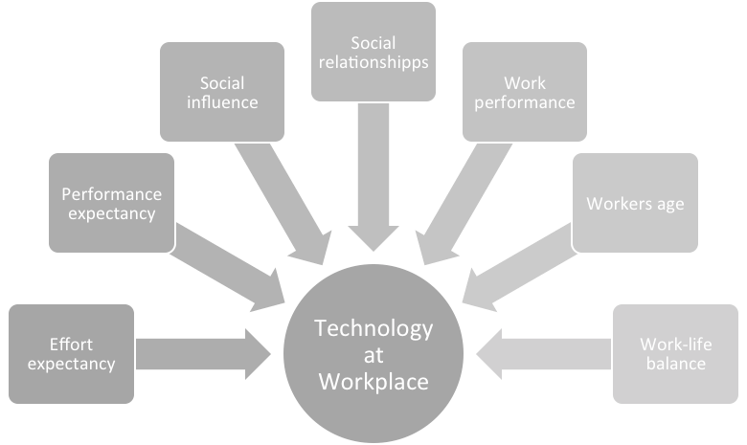

Foundation for Exploration
Null Assumption and Deterministic
H1: The use of automation has a favourable relationship with performance expectations.
H0: There is no link between workplace effort expectations and the advancement of mobile.

H2: Employees' usage of technologies in the workplace will expand as a result of significant social effect.
H0: Employees' usage of digital tools will not rise as a result of beneficial interpersonal effect.
H3: Applying information technology has a favorable overview of the relevant expectations.
H0: There is no link between job expected outcomes and the usage of technology in business.
H4: Place of work innovation has a favorable impact on employee performance.
H0: There is no link between employee productivity and the usage of automation.
H5: Technological advancement has a detrimental influence on social interactions.
H0: Information technology has no detrimental influence on social connections.
H6: Technological advancement has a detrimental impact on work-life harmony.
H0: Automation in the workplace has no detrimental influence on work coordination.
H7: The employment of innovation in the workplace is positively associated with employee age.
H0: There is no link between an individual's age and their usage of electronics in the workplace.
Methodology
We used a convenience sampling technique (workers in Saudi Arabia), which is a type of non-selecting the sample in which population can be divided who meet the necessary requirements, such as increased allocation, location, ease of access at a specific time, or opportunity to engage, are really for the objectives of the survey. It can also apply to populations study participants who are conveniently approachable to the community. We performed a survey based on our different variables, which totaled 16 questions, with broad questions coming first, followed by relevant issues on our study topic, and characteristics like sexual identity, maturity level, greatest educational qualifications, and job stability. Our study sample is made up of component and full-time Saudi Arabian workers. We employed an internet survey approach for this study, organising the questions via Google Forms and distributing it across social media platforms (WhatsApp, Snapchat, and Twitter) utilizing our team members' contact lists. Our sample size is 160, and data collection took three days. The survey was simple to complete and took only a few minutes. The data was then examined using Statistical package for social science, as well as the survey results, to investigate the hypothesis posed for this investigation.

Survey Analysis

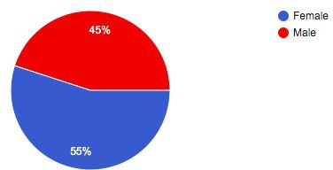
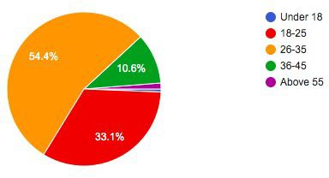

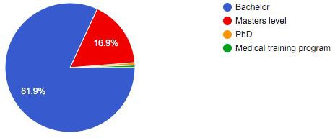

Demographics
Females made up 55% of our survey responses. Youngsters have committed the most to our survey's completion, accounting for 54 percent of all replies. The bulk of people who replied (82 percent) had a bachelor's degree, whereas only 17% had a master's degree.

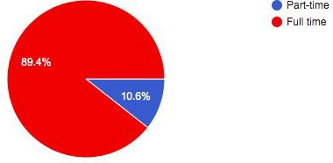
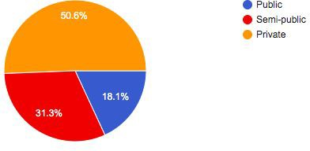

Working Status
We inquired about employability to see if working circumstances have an impact on employees' technological widespread engagement, and we discovered that the proportion of participants (89 percent) worked full-time in the financial market (50 percent ).
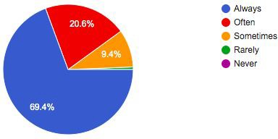
Challenges to corporate creativity dispersion the implementation of employee engagement has expanded in a fairly diversified manner, with Nordic nations and Slovenia dominating on most indices, as we concluded in the previous paragraph. We also noticed that, spite of the widespread adoption of technology in the workforce, the examination of the results from 2000 and 2010 paints a pretty stagnant picture: apart from achievement incentives, all other parts of WPI practically stopped during the sector. "You can see the information era anywhere including the performance numbers," says Nobel Laureate economist Robert Solow, referenced in the beginning. We might contend that we see organizational development everywhere including the statistics in this case! This is also why, in this research, we supplement the data with comparative methods and a thorough review of not just the scholarship but also the opinions of sociocultural scientific community in this subject.

Conclusion, recommendations and future approach:
To summarise, prior to this study, it was recognised that there are elements that impact employees' innovation adoption selections, and that this was closely connected to the desire to improve employee productivity. Furthermore, it is unknown to what degree the various factors impacts the pace of technology adoption in the working. The vast intended audience was the research's strongest asset, and we had no trouble contacting them. The study's biggest flaw was that it did not acknowledge the type of system that was being studied. Even though we inferred the relationship between relevant factors from the highly performing academic journals, they do not appear to be evident in the context of Saudi Arabia, because technological progression and practices in the workplace differ from nations where the sources of information were written than our regional objective in the survey questions. This implies that in Saudi Arabia, what literary authors consider important appears to be irrelevant. Can determine that the things should be modified more and that special updates should be established.

References:
Röcker, C. (2009). Acceptance of Future Workplace Systems: How the Social Situation Influences the Usage Intention of Ambient Intelligence Technologies in Work Environments. In: Proceedings of the 9th International Conference on Work With Computer Systems (WWCS’09), August 9 – 14, Beijing, China, CD-ROM
(2019). Retrieved 11 November 2019, from http://tigerprints.clemson.edu/cgi/viewcontent.cgi?article=1779&context=all_di ssertations
Elias, S., Smith, W., & Barney, C. (2012). Age as a moderator of attitude towards technology in the workplace: work motivation and overall job satisfaction. Behaviour & Information Technology, 31(5), 453-467. doi: 10.1080/0144929x.2010.513419
Rubel, M., Kee, D., & Rimi, N. (2019). Matching People with Technology: Effect of HIWP on Technology Adaptation. South Asian Journal Of Human Resources Management, 232209371987556. doi: 10.1177/2322093719875567
Yueh, H., Lu, M., & Lin, W. (2016). Employees' acceptance of mobile technology in a workplace: An empirical study using SEM and fsQCA. Journal Of Business Research, 69(6), 2318-2324. doi: 10.1016/j.jbusres.2015.12.048
Yin, P., Ou, C., Davison, R., & Wu, J. (2018). Coping with mobile technology overload in the workplace. Internet Research, 28(5), 1189-1212. doi: 10.1108/intr-01-2017-0016
Skoumpopoulou, D., Wong, A., Ng, P., & Lo, M. F. (2018). Factors that affect the acceptance of new technologies in the workplace: A cross case analysis between two universities. International Journal of Education and Development using Information and Communication Technology, 14(3), 209-222. Retrieved from
https://search-proquest-com.dcu.idm.oclc.org/docview/2167264555?accountid
=15753
Jacobs, J., Hettinger, L., Huang, Y., Jeffries, S., Lesch, M., & Simmons, L. et al. (2019). Employee acceptance of wearable technology in the workplace. Applied Ergonomics, 78, 148-156. doi: 10.1016/j.apergo.2019.03.003
Thomas, K. (2014). Workplace Technology and the Creation of Boundaries. Advances In Developing Human Resources, 16(3), 281-295. doi: 10.1177/1523422314532092
Short, H. (2014). A critical evaluation of the contribution of trust to effective Technology Enhanced Learning in the workplace: A literature review. British Journal of Educational Technology, 45(6), pp.1014-1022.
Singh, V. (2014). “We are not phobic but selective”: the older generation’s attitude towards using technology in workplace communications.

Development And Learning In Organizations: An International Journal, 28(4), 18-20. doi: 10.1108/dlo-10-2013-0082
WORKPLACE TECHNOLOGIES AND OLDER WORKERS: OPPORTUNITIES AND CHALLENGES. (2016). The Gerontologist, 56(Suppl_3), 208-208. doi: 10.1093/geront/gnw162.818
Etikan, I. (2016). Comparison of Convenience Sampling and Purposive Sampling. American Journal of Theoretical and Applied Statistics, 5(1), p.1.
van Diermen, O., & Beltman, S. (2016). Managing working behaviour towards new ways of working: a case study. Journal Of Corporate Real Estate, 18(4), 270-286. doi: 10.1108/jcre-11-2015-0039

Parry, E., & Battista, V. (2019). The impact of emerging technologies on work: a review of the evidence and implications for the human resource function. Emerald Open Research, 1, 5. doi: 10.12688/emeraldopenres.12907.1
Attaran, M., Attaran, S., & Kirkland, D. (2019). The Need for Digital Workplace. International Journal Of Enterprise Information Systems, 15(1), 1-23. doi: 10.4018/ijeis.2019010101
GALLIVAN, M., SPITLER, V., & KOUFARIS, M. (2005). Does Information Technology Training Really Matter? A Social Information Processing Analysis of Coworkers' Influence on IT Usage in the Workplace. Journal Of Management Information Systems, 22(1), 153-192. doi: 10.1080/07421222.2003.11045830

