Test Running Ubuntu
You can try Ubuntu without actually installing it on your computer’s hard drive. You can do this by starting up your computer with either an Ubuntu DVD in the drive or a USB stick with Ubuntu on it in a USB port. Here’s how:

- Starting Ubuntu

If using a DVD:
Put the Ubuntu DVD into the DVD-drive and restart the computer. You should see a welcome screen prompting you to choose your language and giving you the option to install Ubuntu or try it from the DVD. If you don’t get this menu, please read the booting from the DVD guide for more information.

If using a USB drive:
Most newer computers can start up from a USB stick. You should see a welcome screen prompting you to choose your language and giving you the option to either install Ubuntu or try it from the USB.
If your computer does not automatically do this, you might need to change the device from which the computer starts up to the USB. You can usually do this by watching for a message appearing before Windows starts. You should be invited to change the boot device. Once you’ve selected that option, follow the instructions on screen.
Tip: You might be able to press ‘F12’ or ‘Escape’ while your computer is starting up to change your boot device order.
Depending on your computer and how your USB key was formatted, you should see an entry for ‘removable drive’ or ‘USB media’. Move this to the top of the list to force the computer to start from USB rather than the hard disk. Save your changes and continue.
Warning!!! Crucially important: at the next stage, under no circumstances click “Install Ubuntu” – doing so will reformat the hard drive and lose all your previous work

- Choose your preferred language and click on ‘Try Ubuntu’. (You may not need to do this – on my PC it went straight ahead in English with no instruction from me).
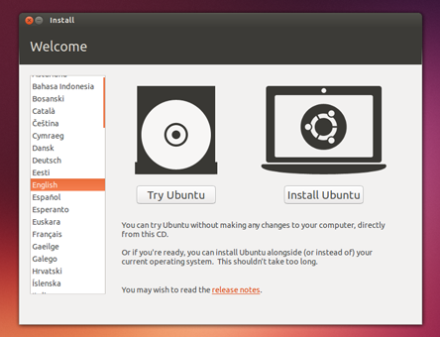
- Your live desktop should appear. Have a look around!
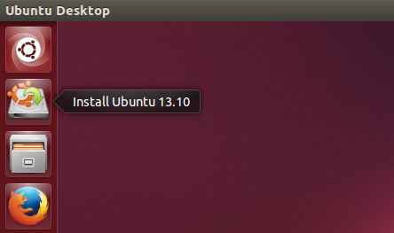
Note the current version of Ubuntu 14.10, not 13.10 as shown above. Everything in the tutorial sheet should work as previously. This is one real benefit of Linux – the underlying command line options remain very stable between versions.

- Starting a Terminal (CLI)

In Unity
Unity is the default Desktop Environment used as of 11.04. Where systems are not ready for Unity they revert to Gnome which is also used in previous releases such as Ubuntu 10.04 LTS (Lucid).
The quickest way to start the terminal (i.e. the command line interface or CLI) is via the keyboard shortcut:
Keyboard Shortcut: Ctrl + Alt + T
The “no need to remember keyboard shortcuts” way to open the Terminal is to use the 'search' function on the dash. Or you can click on the 'More Apps' button, click on the 'See more results' by the installed section, and find it in that list of applications. A third way, available after you click on the 'More Apps' button, is to go to the search bar, and see that the far right end of it says 'All Applications'. You then click on that, and you'll see the full list. Then you can go to Accessories > Terminal after that. So, the methods in Unity are:
Dash -> Search for Terminal
Dash -> More Apps -> 'See More Results' -> Terminal
Dash -> More Apps -> Accessories -> Terminal

In Gnome
Gnome is the Classic Desktop Environment for Ubuntu 11.04 (Natty) and is the default DE in earlier releases, such as Ubuntu 10.04 LTS (Lucid).
Applications menu -> Accessories -> Terminal.
Keyboard Shortcut: Ctrl + Alt + T

