

An analysis and critique on a piece of Welsh contemporary architecture: Plas Glyn-y-Weddw Cafe

School of Architecture, Built and Natural Environment

Course: BSc Architecture

Name: Mari Emyr
Student Number: 2303850
Module code: ACAA5003
Word count: 1,639
Date: 13/12/2024
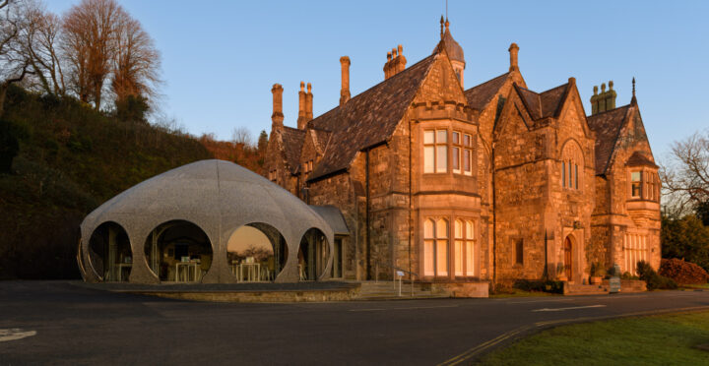
Figure 1: Plas Glyn-y-Weddw (Oriel.org.uk, 2024)

Wales has many historic and famous buildings throughout the country that shape Welsh culture. But defining Welsh architecture can be challenging, as it varies depending on opinions. While some Welsh castles, such as Caerphilly and Chepstow, were constructed by the Normans, they can still be regarded as part of Welsh architecture, given Wales’s renowned status as the country with the highest number of castles in Europe. Similarly, historical farmhouses may be considered Welsh due to their use of local materials, such as slate or clom. Furthermore, some might think Welsh architecture doesn’t have to be located within Wales; buildings designed by Welsh architects abroad could also be seen as a reflection of Welsh architectural identity. Modern-day architecture, however, is seen as a style lacking cultural identity. As quoted (Mohammed, 2021) “Designs have shifted from representing culture, to designs that demand to shape culture.” Contemporary architecture is known almost everywhere on Earth since materials can easily depart anywhere, and it is taught as a solution to the way of living. This results in buildings sharing a form and appearance and becoming the global norm. But can modern Welsh architecture still represent culture and identity?
The café extension at Oriel Plas Glyn-y-Weddw is a notable example of a modern Welsh building, completed in March 2023. It was designed by Mark Wray Architects in collaboration with Sanderson Sculptures and Fold Engineering (Architecture.com, 2024). It is an extension of an important and sensitive heritage setting, designed with a modern and organic look which contrasts with the Gothic Revival style of the Victorian house. It has won four awards, such as the 2024 RSAW Client of the Year. Oriel Plas Glyn-y-Weddw, a grade II* listed building in Llanbedrog is the oldest art gallery in Wales. It was originally built in 1857 by Henry Kennedy as a dower house for Lady Elizabeth Jones Parry of the Madryn Estate, next to a forest which carries an Ancient Woodlands status (Oriel.org.uk, 2024). Lady Elizabeth was widowed and was interested in art, hence the name meaning Glyn-y-Weddw (Glen of the widow). Later, it became a public art gallery, holiday resort, tearoom and ornamental garden under the ownership of Cardiff entrepreneurs in 1896 (Coflein, 2015). Mark Wray Architects, based in Bath, specialises in refurbishing, renovating and designing extensions for listed and historic buildings. One project they have worked on is Glebe Cottage in Somerset, a now transformed thatched cottage with a new extension. Another is Chapel House in Wiltshire where they united two grade II buildings together: a house and a former chapel (Mark Wray Architects, 2023). The Plas Glyn-y-Weddw Gallery’s Trust commissioned this project to replace the existing conservatory café, which suffered from poor insulation. The new extension has a completely different look to the old design, contrasting the mansion. The new design resembles a sea urchin, which comes from the interest in nature and organic forms of Matthew Sanderson, lead of Sanderson Sculptures. He went for a walk on Llanbedrog beach and found a lot of sea urchins and barnacles and constructed the café in very similar dimensions to a real sea urchin using the mathematics of how the shells form. He also thought that having an artistic building would reflect the purpose of the gallery (plasglynyweddw1, 2023).
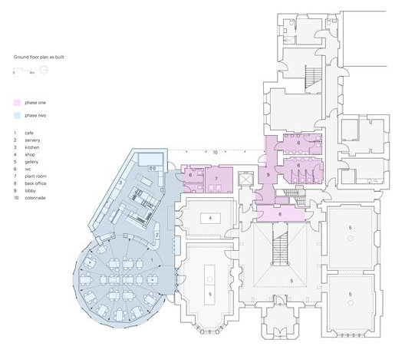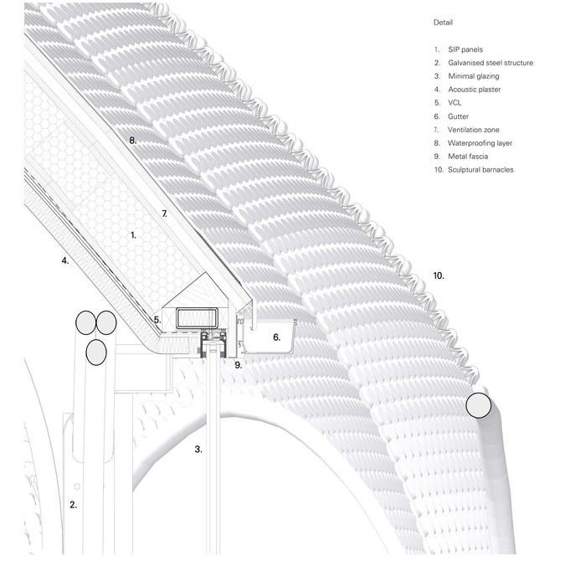
Figure 3: Wall detail (Mark Wray Architects, Sanderson Sculptors and Fold Engineering, 2023)
Figure 2: Floorplan (Mark Wray Architects, Sanderson Sculptors and Fold Engineering, 2023)

Unusually, the 19th-century mansion was built in a Gothic Revival style, which might have been one of the only examples in North Wales. It has bay windows constructed with stone masonry, some decorated with crow step gables, others with slate roofing. It has tall, stone chimneys and an octagonal bell-shaped dome, which is a Victorian detail. On the front side of the building, three decorated Gothic windows can be seen. The building has pitched roofs and has symmetrical composition but asymmetrical details. On the inside, the grand hall’s roof has exposed timber beams with flying buttresses. The balustrade on the staircase is made of dark wood with Gothic decoration and the upper floor has colourful stained-glass windows. The hall gives a strong impression of grandeur and artistic value. The old café was a long conservatory made of similar stone. The windows are less decorated than the main building but are still Gothic in style. The new café, which cost around a million pounds, is in the shape of a sea urchin. It is covered all over in 80,000 stainless steel patterns resembling barnacles (Jury, R. A., 2024). Each one was made mechanically to give it a reflective shine. The project presented technical challenges related to structure, thermal comfort, acoustics and functionality. To solve this, the dome-like roof, featuring a central oculus, is constructed from structurally insulated panels to give it excellent thermal performance. It has a layer of acoustic plaster which also works as an interior finish to give it an elegant look. Like a sea urchin, the structure has round, symmetrical openings all around which work as windows to give a full outside view. On the inside, it has a finishing touch of a biological marine-like structure underneath the top of the dome, to match with the exterior aesthetic.
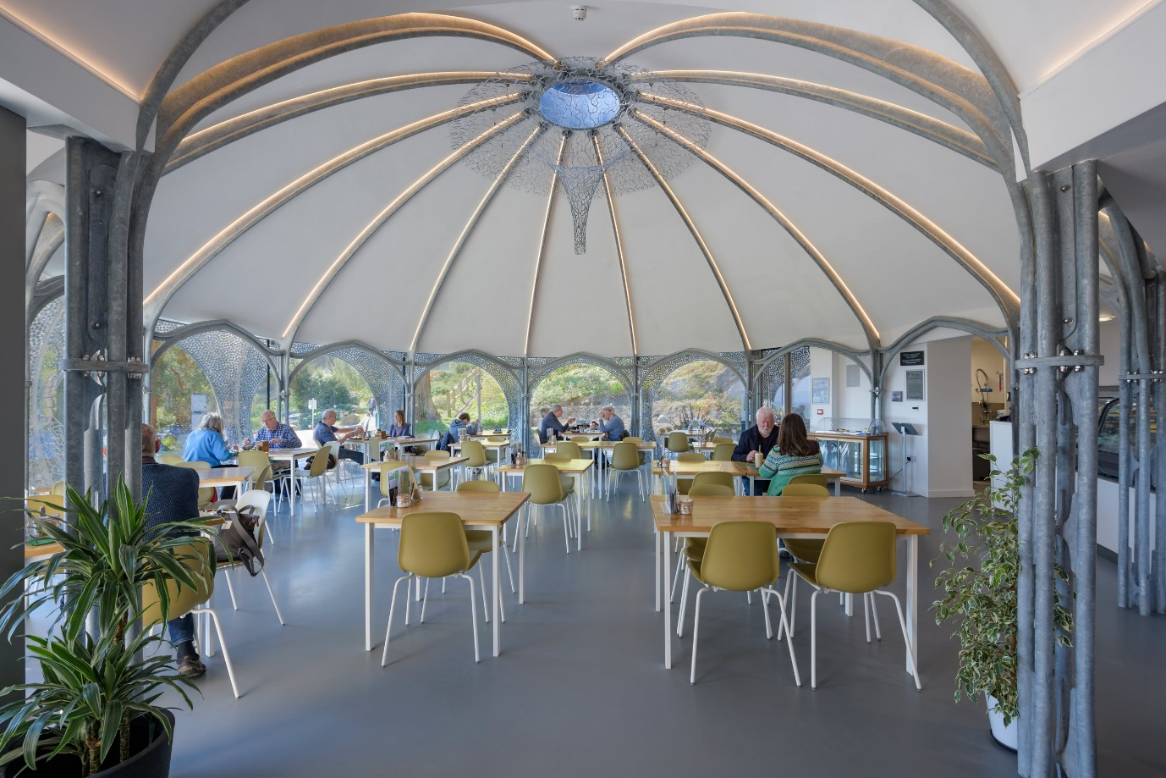
Figure 4: Plas Glyn-y-Weddw café interior (Mark Wray Architects, 2023)

Plas Glyn-y-Weddw’s café was designed to show themes like art to reflect the purpose of the gallery. The outside shell’s many small “barnacles” show the delicacy of hand-crafted artwork which the gallery promotes. The interior feels like a safe space, like how a shell’s purpose in nature is to protect the living organism inside. The urchin’s curves, natural lighting of the round windows and geometric design look very organic and natural. The café won several awards in 2024 (Architecture.com, 2024), meaning it has succeeded in satisfying the client and architects, but does it show Welsh culture? The architects and structures who worked on this project considered Welsh heritage since they explored Llanbedrog’s beach and thought of the purpose of Plas Glyn-y-Weddw’s history. Llanbedrog being a coastal village with Lady Elizabeth’s love for art has shown in the design of this building. Some famous Welsh buildings with a design based on the landscape would be the Wales Millenium Centre- its copper-coloured façade and flowing curves evoke the rugged terrain of Welsh hills and cliffs, as well as its industrial and mining heritage. The seashell design doesn’t feel random, as urchins, barnacles and other beach finds are found all over the Welsh coast. The curves and reflective metal introduce a new look to the area, and it is popular among the locals. Janet Roberts commented on Plas’s Facebook post (Plas Glyn y Weddw, 2023) about the new café’s opening, (translated from Welsh) “A great building and a lovely place for a cup of tea and some food. Well done.” Compared to the past café, the building is much better in condition, being a well-insulated, wide space with acoustic panels. It shows more Welsh culture since the design is based on an object on the site, while the past design was traditional and mirrored the mansion’s design in a more modern way to its time.
On the other hand, the urchin café was not constructed out of Welsh materials. It is either stainless steel or aluminium, but neither are materials from Wales. Materials of buildings are considered very important in some parts of Wales, for example, all roofs in Snowdonia’s national park must be constructed out of Welsh slate to keep the traditional look. Plas Glyn-y-Weddw’s gallery has a slate roof, and the stone bricks are likely to be local as well. Sea urchins aren’t a creature only found in Wales, they are worldwide, as well as a lot of other seashells. Thanks to modern architecture and AI, there are marine-inspired buildings all over the world. There is a seashell-inspired opera house on the seashore of Zhuhai Island in Guangdong Province, China. Also, there is an urchin-inspired cluster of buildings for a turtle sanctuary on the coast of Sharjah in the UAE. While the organic and marine design of the café does relate to the geographical landscape, it has no resemblance to the existing buildings in Llanbedrog. Compared to other Welsh villages, Llanbedrog does have similarities but there are noticeably more stone walls, higher chimneys and two-storey bay windows. These details resemble more of the old side of Plas Glyn-y-Weddw, meaning that they could have some significance in Llanbedrog’s characteristics. The café introduces a completely different style. One of the main purposes of the art gallery is to show visitors the artwork of Welsh artists and sculptors. But Mark Wray is from Bath, and Matthew Sanderson was raised in Herefordshire, and went to university in Northumbria. There are some negative comments on Facebook too, Margaret Taylor-Hill commented, “It's such a weird, incongruous design.” (Plas Glyn y Weddw, 2023). The urchin is an artwork sculpture in itself, but does it take away the purpose of exhibiting art from little-known Welsh artists?
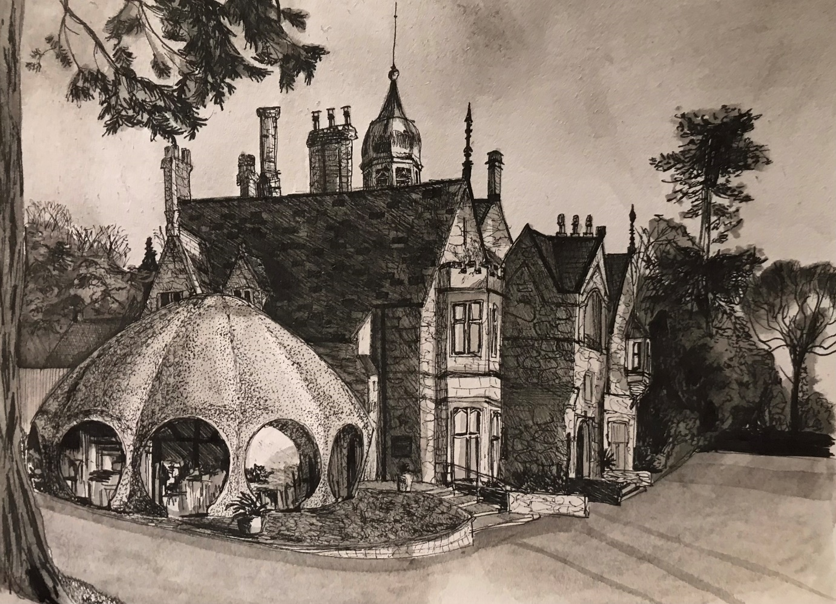
Figure 5: Plas Glyn-y-Weddw (Personal collection, 2024)

To answer if contemporary architecture in Wales shows culture, “Welsh architecture” must be defined. There are so many factors that could go into this meaning, Welsh architecture, local materials, traditional construction methods, location, etc. For a building to be purely Welsh architecture, it would be difficult or even impossible to make in the modern day. Architects in the present are influenced and taught by so many different styles that have been kept record of, use materials, transport methods and tools that will always be from a mixture of countries. Authentic Welsh architecture, perhaps created by the original inhabitants of Wales, would date back to ancient times and eventually would expire as other architecture and cultures would start to influence. This would mean that neither the new café nor the old gallery would be fully “Welsh architecture”. However, elements of culture can be shown in architecture, including contemporary. The gallery might be Gothic, but stone and slate are used, which is important in Welsh history. Similarly, the café shows historical design choices found in the nearby Welsh beach and respect for Welsh art.

References:

Websites
Architecture.com. (2024). Plas Glyn-y Weddw Arts Centre Café. [online] Available at: https://www.architecture.com/awards-and-competitions-landing-page/awards/riba-regional-awards/rsaw-award-winners/2024/plas-glyn-y-weddw-arts-centre-caf# (Accessed: 12/12/2024).
Coflein.gov.uk. (2015). English – Plas Glyn-y-Weddw, Llanbedrog. [online] Available at: https://coflein.gov.uk/en/site/16745/ (Accessed: 12/12/2024).
Jury, R.A. (2024). Plas Glyn-y-Weddw Arts Centre Café, Llanbedrog. [online] Available at: https://www.ribaj.com/buildings/riba-awards-2024-rsaw-wales-plas-glyn-y-weddw-arts-centre-cafe-mark-wray-architects-culture-entertainment-llanbedrog-gwynedd (Accessed: 12/12/2024).
Mark Wray Architects. (2023). Mark Wray Architects Plas Glyn-y-Weddw. [online] Available at: https://markwray.co.uk/plas-glynyweddw. (Accessed: 12/12/2024).
Mohammed, H. (2021). Loss of Architectural Identity‌ ‌due to changing times. [online] Available at: https://www.re-thinkingthefuture.com/fresh-perspectives/a5840-loss-of-architectural-identity%E2%80%8C-%E2%80%8Cdue-to-changing-times/. (Accessed: 12/12/2024).
Oriel.org.uk. (2024). Winllan History - Plas Glyn Y Weddw. [online] Available at: https://www.oriel.org.uk/en/winllan-history (Accessed 12/12/2024).
Plas Glyn-y-Weddw. (2023). [online] Facebook. Available at: https://www.facebook.com/profile/100057574694879/search/?q=new%20cafe&locale=en_GB (Accessed: 12/12/2024).

Videos
THE, A. (2023). 80000 BARNACLES ABOVE THE SEA. [online] YouTube. Available at: https://youtu.be/vVhkK8LiBtU (Accessed: 12/12/2024).

Figures
Figure 1: Oriel.org.uk. (2024). Become a Member - Plas Glyn Y Weddw. [online] Available at: https://www.oriel.org.uk/en/friends-2. (Accessed: 12/12/2024).
Figure 2: Architecture.com. (2024). Plas Glyn-y Weddw Arts Centre Café. [online] Available at: https://www.architecture.com/awards-and-competitions-landing-page/awards/riba-regional-awards/rsaw-award-winners/2024/plas-glyn-y-weddw-arts-centre-caf# (Accessed: 12/12/2024).
Figure 3: Architecture.com. (2024). Plas Glyn-y Weddw Arts Centre Café. [online] Available at: https://www.architecture.com/awards-and-competitions-landing-page/awards/riba-regional-awards/rsaw-award-winners/2024/plas-glyn-y-weddw-arts-centre-caf# (Accessed: 12/12/2024).
Figure 4: Mark Wray Architects. (2023). Mark Wray Architects Plas Glyn-y-Weddw. [online] Available at: https://markwray.co.uk/plas-glynyweddw. (Accessed: 12/12/2024).

