

Certificate of Higher Education in Employability Skills

Effective Teamworking and Communication (BMSW4009)

March 2025

Student: Edit Lakme Azmi
Student ID: 2412715
1007 words

Contents

- Introduction
  - What is a team?.......................................................3
  - What is teamwork?...................................................3
  - Resource Investigator and Completer-Finisher ……3

- Findings
  - Relationships and Effective Teamworking…………..3
  - Application of the models ……………………………..3
  - Tuckman’s stages of Team Development ………..3-4

- Conclusion
  - Personal learning and Development…………………4
  - Improving delegation skills……………………………4
  - Enhance time management…………………………..4
  - Final reflection………………………………………….5

- Appendix
  - Appendix A …………………………………………….5
  - Appendix B …………………………………………..6-7
  - Appendix C ……………………………………………8
  - Appendix D…………………………………………….9

- References………………………………………………….10

1.Introduction
What is team? A team is defined as “a group of people who are mutually dependent on one another to achieve a common goal” (Biech, 2008,p.1). To be part of a team you would need to collaborate, communicate, listen and have a sense of responsibility. Teams usually are viewed as a unit. What is teamwork? Teamwork refers to the actment of teamwork processes that support effective team performance (Salas, Rosen, Burke, & Goodwin, 2009). Teams work in a range of scenarios, including relationships, educational institutions, and companies. The success of a team often depends on how well individuals communicate and work together to achieve common objectives. Based on Belbin's (1981) Team Roles Model, I typically assume the role of a Resource Investigator in teams, searching for opportunities, establishing connection and stimulating the group. I also sometimes take the role of the Completer-Finisher, making sure that tasks are completed effectively and with attention to detail. I excel in these roles by ensuring that the team’s projects are finalized with great attention to detail and researching new ideas. I am trying to balance this, also knowing that I can easily become focused on the little details or listening too much other suggestions.
2.Findings
2.1 Relationships and Effective Teamworking
During this module, I have learned that team success depends on effective communication, conflict resolution, and role allocation (Forsyth, 2019). Hackman (2020) emphasizes that teams perform best when they have clear structures, shared goals, and a balance between task and social interactions. The application of several models and theories, such as Thomas-Kilmann Conflict Mode Instrument, Belbin’s Team Roles, and Tuckman’s Stages of Team Development has helped me develop a deeper understanding of how to be a more effective team member and leader. Also my communication skills have improved since applying these modules at university and work.
2.2 Application of the models
I had the chance to apply these models in a group presentation where I was able to integrate my roles as both Resource Investigator and Completer-Finisher. One of models I applied during the project was the Thomas-Kilmann Conflict Mode Instrument, which outlines five conflict-handling styles: competing, collaborating, compromising, avoiding, and accommodating (Thomas & Kilmann, 2008). During our project, we went in a situation where two group members disagreed about the style of the presentation. One of the members choose a more classic and traditional system while the other member preferred a creative, colourful presentation. At first, this led to conflict because each side had strong feelings about their idea and also came with powerful arguments.
2.3 Tuckman’s stages of Team Development
As team members display their views and ideas, interaction is normal during the storming phase of Tuckman's model, which I recognized we were in (Tuckman, 1965). Following Thomas-Kilmann Conflict model, I promoted an open dialogue in which both members could support their ideas and the rest of the group to give feedback about the entire situation and how they see it.
Tuckman’s Stages of Team Development—which include forming, storming, norming, performing, and adjourning—has provided me with the knowledge to understand the natural progression of teams and manage each phase effectively (Tuckman, 1965). Our team started with the formation phase, where we didn’t know each other and responsibilities were unclear. I tried to collaborate with my colleagues and helped to clarify that the goal was the presentation. We were able to go through the storming phase by applying Tuckman’s model, and we were able to remain calm and patient. Individuals who learn by accessing others seek advice, examples, support, or instruction from people who have faced similar challenges, or they learn by observing others (Grayson and Baldwin, 2007). One of the biggest challenges that I faced with the presentation was to be able to delegate. As a Resource Investigator I enjoy new ideas but as a Completer-Finisher, I frequently become obsessed with the small details. Because of this, I occasionally have trouble managing my time and delaying the others.

3.Conclusion
3.1 Personal learning and development
I now have a better understanding of my areas of strength and improvement because of this course. I've been able to combine creativity and attention to detail from understanding my dual roles as a Resource Investigator and Completer Finisher. Furthermore, my confidence in leadership, adaptability, and negotiation has enhanced. I will put into practice several strategies which take into consideration both my areas of ability and development to be more productive in future teams. By applying these strategies, I will be ready to work together with the team more efficiently while making sure that my contributions meet the group's goals.
3.2 Improving delegation skills
Delegation is one of my main areas for development. I have a strong tendency to be certain that everything is perfect, so I occasionally take on too much responsibility. I will try to trust my teammates and distribute the task more efficiently to achieve the common goal. "The world turns on the delegation relationship and on one party authorizing another to do a task. Social, economic, and political life is inconceivable without it."(Mitchell, 2021).
3.3 Enhance time management
Effective time management is essential to balance my two roles as a Resource Investigator and Completer Finisher. I like coming up with ideas and investigating potential opportunities as a Resource Investigator. But I am driven to focus on improving small details in order to make sure that deadlines are achieved by my Completer Finisher tendencies. I will use structured scheduling methods, such the Eisenhower Matrix, to effectively organize work in order to improve my capacity to manage time.

3.4 Final reflection
In conclusion, I will improve my own personal contributions and my ability for successful leadership by enhancing my delegation abilities, developing time management, and creating a culture where team members feel acknowledged. According to Rosenfeld (2013), Napoleon Hill, who pioneered the modern genre of personal success literature, placed significant importance on teamwork when examining the most accomplished individuals in the world. This focus on teamwork is crucial as it underscores the role of individuals in any social system. As Göker (2018) explains, the most vital elements of such a system are the people who breathe life into organizations with their knowledge, manners, beliefs, and, collectively, their “culture.

4. Appendix
4.1 Appendix A
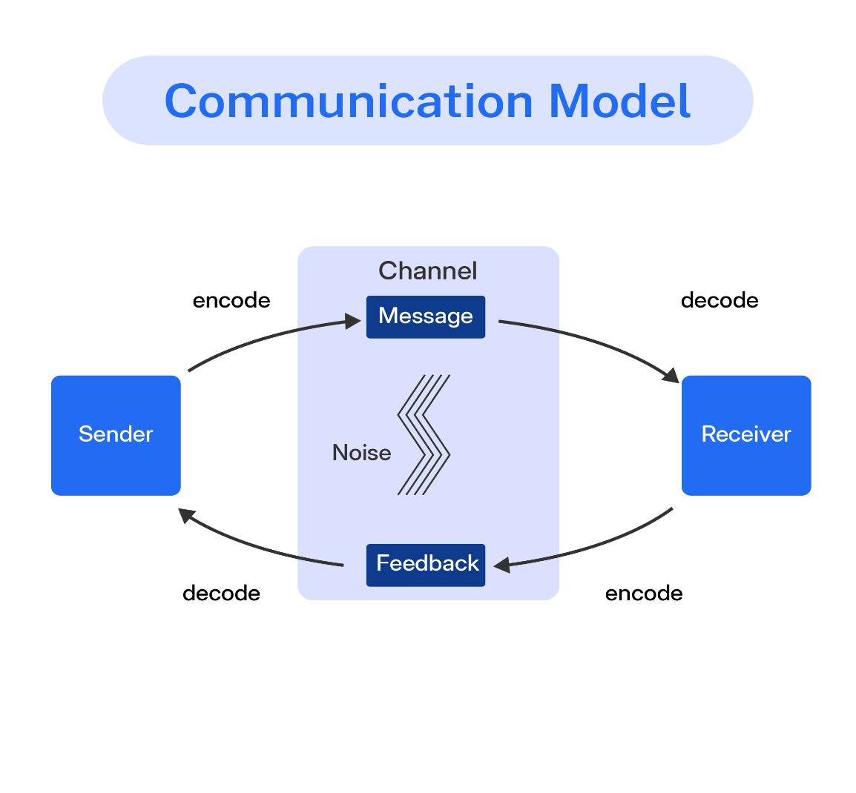

4.2 Appendix B
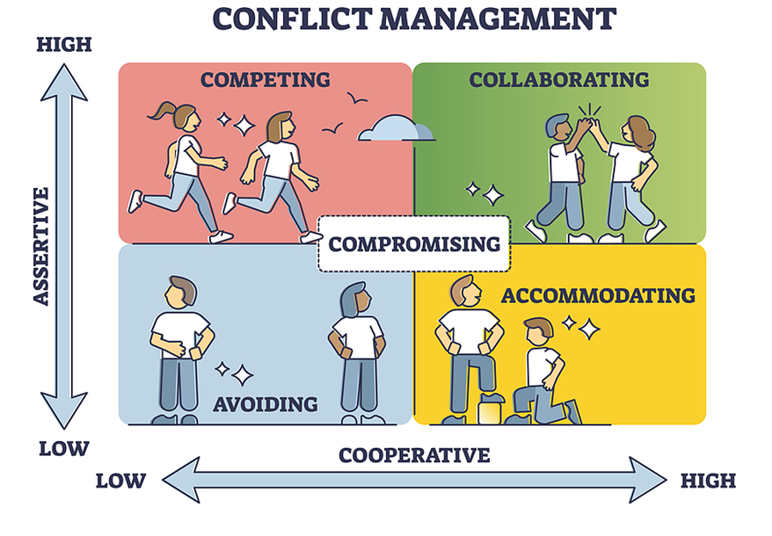

COMPROMISING (The Fox)
Compromising is intermediate in both assertiveness and cooperativeness. When compromising, the objective is to find an expedient, mutually acceptable solution that partially satisfies both parties. Compromising falls on a middle ground between competing and accommodating, giving up more than competing but less than accommodating. Likewise, it addresses an issue more directly than avoiding but doesn’t explore it in as much depth as collaborating. Compromising might mean splitting the difference, exchanging concessions, or seeking a quick middle-ground position.

Conflict Style | Situations where appropriate | Situations where inappropriate
Compromising  “The fox” | 1.Goals of parties are mutually exclusive  2.Parties are equally powerful  3.Consensus cannot be reached  4.Integrating or dominating style is not successful  5.Temporary solution to a complex problem is needed | 1.One party is more powerful  2.Problem is complex enough to need problem-solving approach

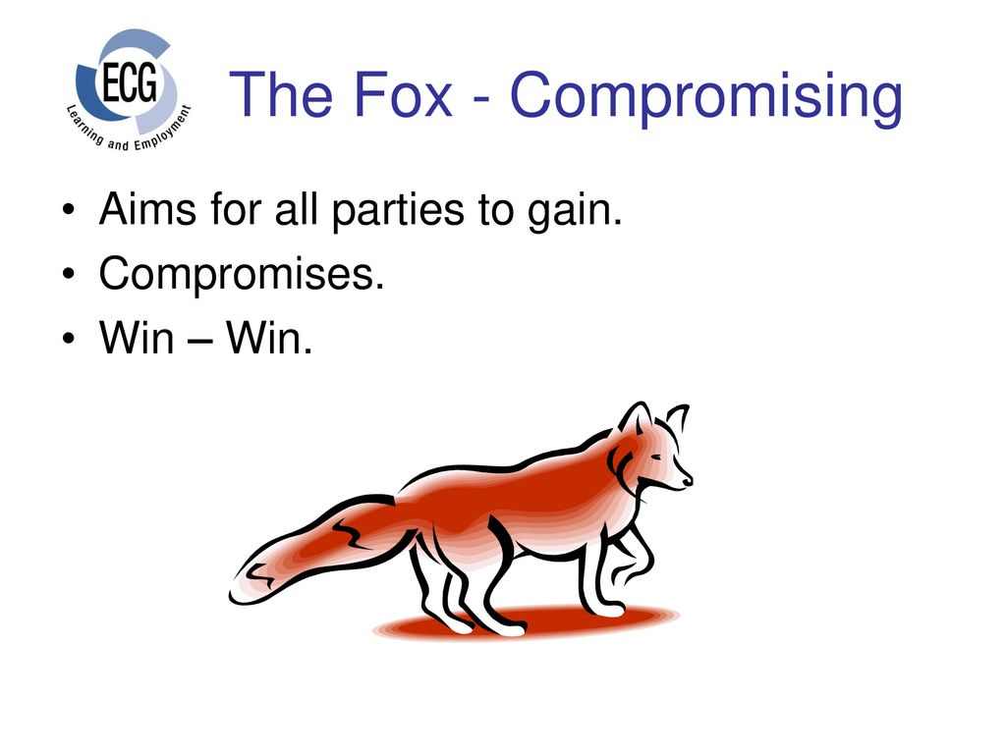

4.3 Appendix C

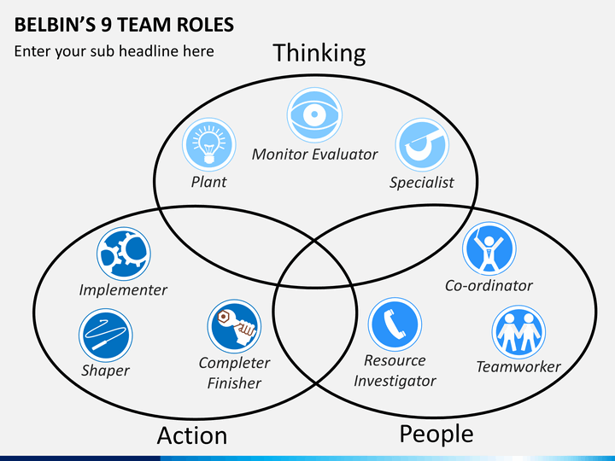

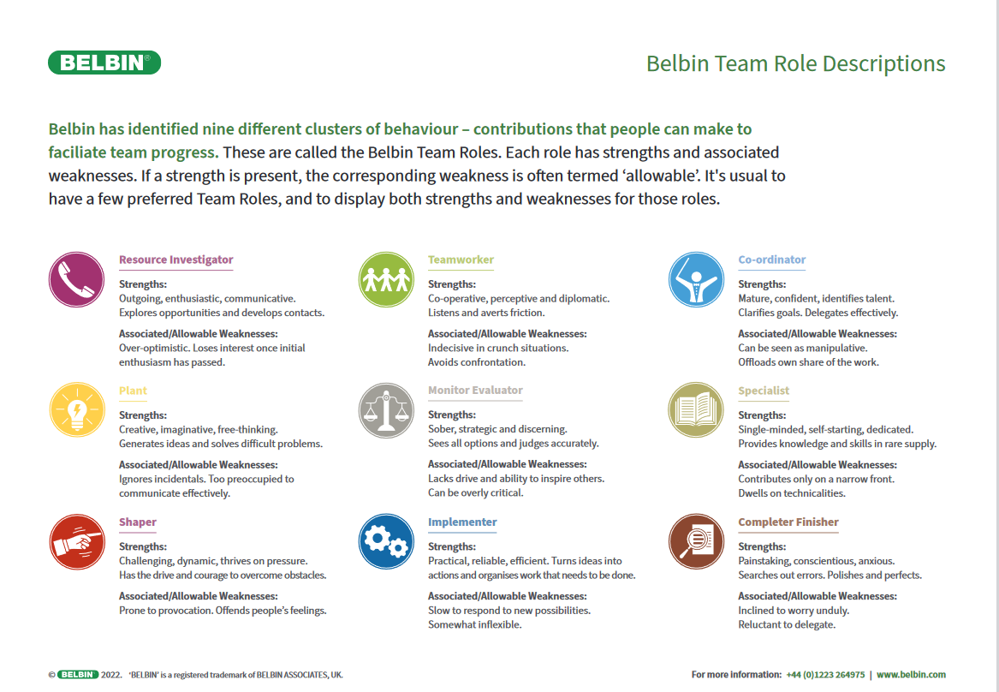

4.4 Appendix D

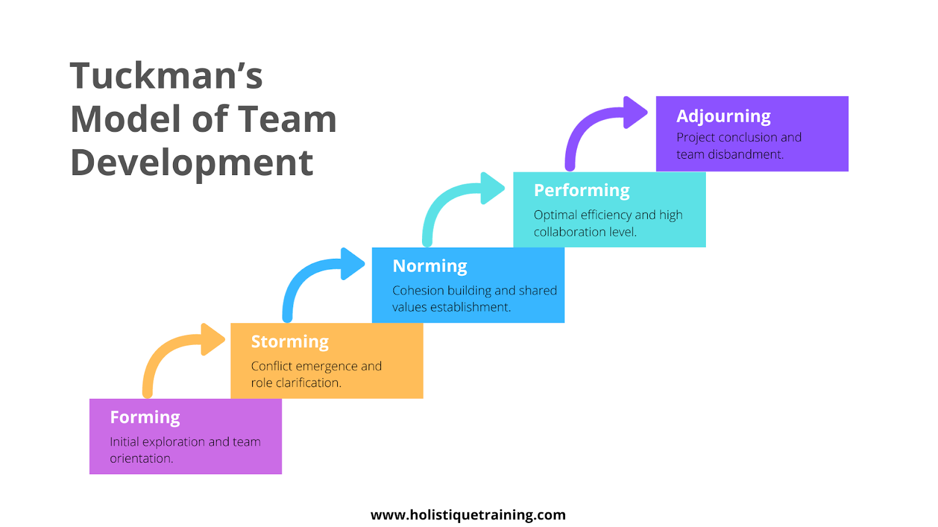

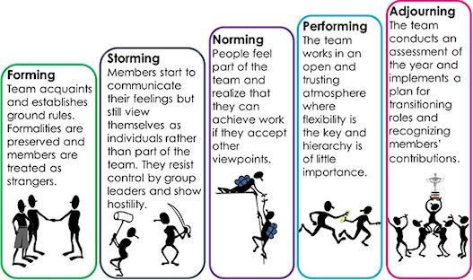

References

Belbin, R. M., 1981. Management teams: Why they succeed or fail. 1st ed. Oxford: Butterworth-Heinemann.
Biech, E. (2008) The Pfeiffer book of successful team-building tools: best of the annuals. 2nd ed. San Francisco, CA: Pfeiffer.
Forsyth, D. R. (2019). Group Dynamics. 7th ed. Cengage Learning.
Grayson, C. and Baldwin, D. (2007) ‘Strategies for Developing Your Leadership Network’, Leadership Networking: Connect, Collaborate, Create, pp. 25–28. Available at: https://research-ebsco-com.ezproxy.uwtsd.ac.uk/linkprocessor/plink?id=a7642daf-b312-3922-a498-cbafb9417e57
Hackman, J. R. (2020). Leading Teams: Setting the Stage for Great Performances. Harvard Business Review Press.
Mitchell, Neil J., 'Why Delegate?', Why Delegate? (New York, 2021; online edn, Oxford Academic, 22 Apr. 2021), https://doi.org/10.1093/oso/9780190904197.003.000.
Rosenfeld, R.M. (2013) ‘Teamwork’, Otolaryngology-head and neck surgery, 148(1), pp. 1–2. Available at: https://doi.org/10.1177/0194599812468849.
Salas, E., Rosen, M. A., Burke, C. S., & Goodwin, G. F. (2009). The wisdom of collectives in organizations: An update of the teamwork competencies. In E. Salas, G. Goodwin, & C. S. Burke (Eds.), Team effectiveness in complex organizations. cross-disciplinary perspectives and approaches (pp. 39 –79). New York, NY: Psychology Pres.
Thomas, K. W., & Kilmann, R. H. (2008). Thomas-Kilmann Conflict Mode Instrument
Tuckman, B. (1965) Bruce Tuckman’s Team Development Model.

