University of Wales Trinity Saint David

Module: Management Accounting

Assessment 1: Critical analysis of the need and process of preparing budgets

Student: Horhocea Cristiana Mara

Student no. 1604608

Lecturer: Gazi Arif

Table of contents:

- Introduction……………………………………………………………………………3
- The budgeting process and methods………………………………………4
2.1. Activity Based Costing (ABC)…………………………………………….4
2.2. Balanced Scorecard………………………………………………………….7
- Budgets…………………………………………………………………………………..8
3.1. Planning cycle…………………………………………………………………..8
- Conclusion………………………………………………………………………………9
- References……………………………………………………………………………...9
- Appendices…………………………………………………………………………….10

1. INTRODUCTION

Modern budgeting, balanced scorecard and activity based costing are three essential tools for any type of industry, whether it’s a small business or a big organization, used to keep track of income and expenses.

In the past, most of the organizations followed a similar way of doing budgeting. Nowadays, the modern budgeting process has become very popular and useful, as organizations have the opportunity to come up with their very own ideas which makes financing even easier.

This report shows a thorough and detailed understanding of cost control of the budgeting process, a detailed analysis of activity based models and the balance scorecard, as well as a practical application of budgeting in terms of strategic change.

2. The budgeting process and methods

2.1. Activity Based Costing (ABC)

Activity Based Costing is an approach for allocating overhead costs. An activity is an event that incurs costs; a cost driver is a factor or, sometimes also called an activity, that allocates all the individual activities.
It involves the following steps:
  - Identify and classify the major activities and allocate manufacturing overhead costs to the appropriate cost pools.
  - Identify the cost driver that has a strong correlation to the costs in the cost pool.
  - Compute the overhead rate for each pool.
  - Assign overhead costs for each costs to products using the overhead rates.
When the manufacturing process in a company becomes more complex, the managers of the company should consider using activity based costing.

Following the steps of the Activity Based Costing, the example below will give a clear understanding on it:

Step no. 1:
Assuming a bag manufacturing company’s accounts, company’s overheads have been allocated to relative pool through cost driver, as it follows:

GENERAL LEDGER
Payroll taxes | £5,000
Machine maintenance | £10,000
Purchasing Dept. Labour | £8,000
Fringe benefits | £6,000
Purchasing Dept. Supplies | £350
Equipment depreciation | £850
Electricity | £1,350
Unemployment insurance | £1,500

Direct labour A/C
Payroll 5,000
Fringe 6,000
Insurance 1,500
£ 12,500

Machinery A/C
Maintenance 10,000
Depreciation 850
Insurance 1,500
£ 12,350

Purchase orders A/C
Labour 8,000
Supplies 350
£ 8,350

Step no. 2:
The ledger accounts above demonstrate how the indirect cost can be added into direct cost accounts as pools. The further sums will demonstrate how the ABC has been calculated for each pool.
Assumptions: | Activity based costing rates:
Direct labour hours = 5,000 | 12,500/5,000 = 2.5 per direct labour hour
Purchase orders = 2,500 | 8,350/2,500 = 3.34 per machine hour
Machinery hours = 1,500 | 12,350/1,500 = 8.23 per purchase order

Step no. 3:
Allocation of hours to each product.
Base | Bag AD | Bag BD | Total
Labour hours | 3,000 | 2,000 | 5,000
Purchase orders | 1,500 | 1,000 | 2,500
Machinery hours | 750 | 750 | 1,500

Step no. 4:
Allocation of overhead to each product (using rates and base hours).

Bag AD
 | Rate | AD Base | Allocated amount
Labour hours | 2.5 | 3.000 | 3002.5
Machinery hours | 8.23 | 1.500 | 12.345
Purchase orders | 3.34 | 750 | 2.505
TOTAL |  |  | 17.852.5

Bag BD
 | Rate | BD Base | Allocated amount
Labour hours | 2.5 | 2.000 | 5.000
Machinery hours | 8.23 | 1.000 | 8.230
Purchase orders | 3.34 | 750 | 2.505
TOTAL |  |  | 15.735

Total basic amount of overhead = Direct Labour + Machineries + Purchasing orders
= £12.500 + £12.350 + 8.350
= £33.200
According to ABC, the amount allocated is AD + BD = £3017.35 + £15.735 = £18.752,35
From the two totals, we can notice an obvious variance of £2.117,5. This means that the allocated amount is higher than the real amount. It is considered an income, as in the end the company gets an excedent amount.
If the allocated amount would have been lower that the initial amount, the variance between them would bring extra expense to the company and it would have a negative impact on it.

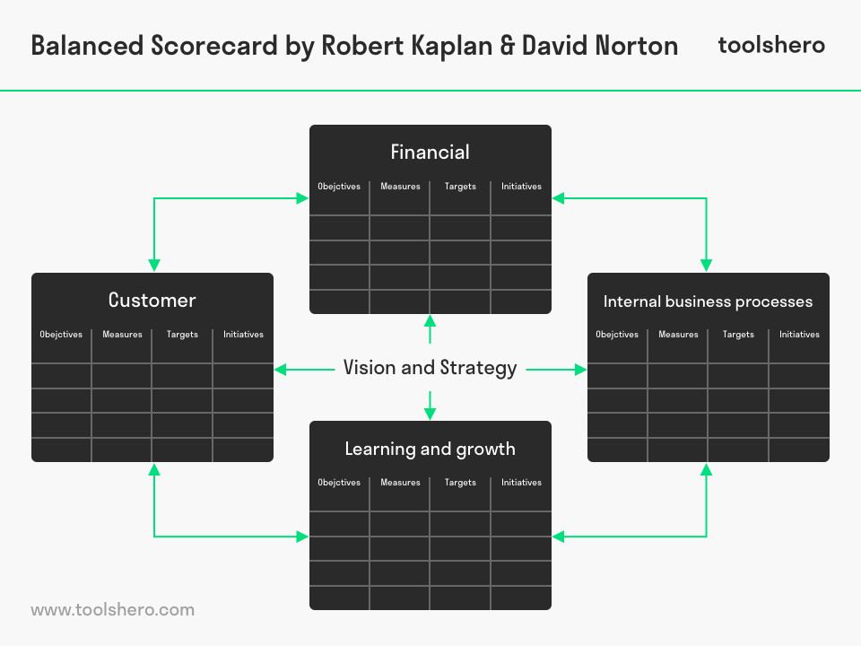
2.2 Balanced Scorecard
Figure 1 Balanced Scorecard

‘The Balanced Scorecard provides managers with the instrumentation they need to navigate to future competitive success.’ – Robert S. Kaplan
The Balanced Scorecard is a system used by the top level management in order to get a more balanced view of performance and it focuses on the big-picture strategic goals of a company from four different perspectives: Financial, Customer, Internal Business Processes and Learning and Growth.
- The financial perspective is focusing on the shareholders and the financial backers of an organization. The overall added value from the other three perspectives will be objectified in a financial success. The profit of the company is high if the added value is high as well.
- The customer perspective is focusing on how attractive the company appears to its’ customers. The customers have a significant impact, as they determine the quality, price or the service and their expectations increase if there are alternatives (competitors).
- The internal business processes are mainly focusing on the satisfaction of customers, shareholders and/or financial backers by implementing activities or added value within the organization.
- The learning and growth process of an organization refers to a continuous innovation and improvement, and is subject to legislation, rules, regulations, economic changes and competition.
3. Budgets
- Static (fixed) budgets: prepared for one level of activity, usually around the forecasts made for sales.
- Flexible budgets: a series of fixed budgets set to different levels of sales activity within which the organization may operate.

Participative budgeting is a process in which each department of an organization actively puts effort in making decisions in order to obtain an accurate, successful budget.
Each department of a company will be making its own budget and, in the end, they will all be put together as a master budget.
3.1. Planning Cycle
There are three types of budgets:
- Short term, less than 1 year
- Common, up to 5 years
- Long term, more than 5 years
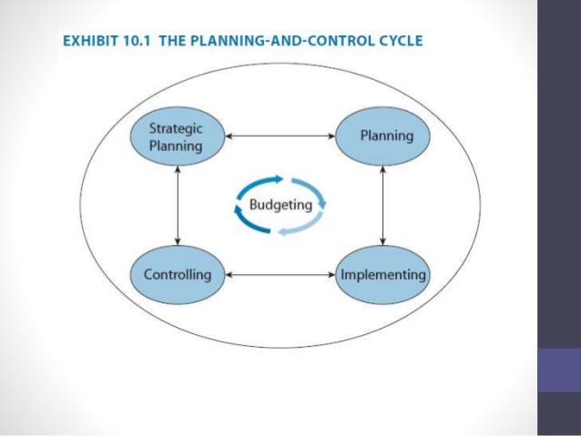
Sometimes, the length might not be according to the budget, as a company might face a variety of challenges or failures too. The management of each company is entitled to make amendments in the budget, if necessary, if there are any changes in the environment.
Figure 2 Planning Cycle

The picture above shows a clear planning cycle in budgeting. Planning/Strategic Planning is the first step, setting the goals and objectives and also considering the resources available, followed by the second step, implementing, which helps the managers to find out whether the plan is innovative enough to bring achievements to the company, or failure which has to be predicted and possibly controlled.

4. Conclusion
This report shows a clear understanding of the major role that the Balanced Scorecard, Activity Based Costing and Budgeting play in terms of decision making in the modern business world.
These measure tools help organizations to keep track of their income and expenses, to find out whether the organization is balanced or not and also to allocate the overhead cost of the production.
In my point of view, for a successful, modern business, the management should create an accurate method of budgeting and it should also create a balance between income and expenses, so that the company can smoothly move forward.

5. References
Drury, C., (2012). Management and Cost Accounting, London: Thomson Business Press
Kaplan, R.S., Norton, D.P., (1996). The Balanced Scorecard: Translating Strategy into Action. Harvard Business Review Press.
Kaplan, R.S., Norton, D.P. (1993). Putting the Balanced Scorecard to Work. Harvard Business Review, Sep – Oct pp2–16.
Pauline, W., (2013) Financial and Management Accounting. UK: Pearson
QuickScore (2019) What is a Balanced Scorecard? [online]. (Last updated 2019). Available at: https://balancedscorecards.com/balanced-scorecard/ [Accessed 25 April 2019]
Van Vliet, V. (2010). Balanced Scorecard. [online]. (Last updated 2018). Available at: https://www.toolshero.com/strategy/balanced-scorecard/ [Accessed 25 April 2019]
William, H., (2004). Accounting for Managers. New York: Mc-Graw Hill.

6. Appendices

Figure 1 Balanced Scorecard……………………………………………………………………………………………7
Figure 2 Planning Cycle……………………………………………………………………………………………………8

