

Student name: Ivy Oduro
Student ID:2524367
Module name: Introduction to health and social care
Module code:LCHS4003
Lecturer name Muhammad Aliyu
Content page

Element 1 …………………………………………………………….. page
3-How Dentistry Services Function today
Dentistry Services in the UK are available through both NHS and private dental practices. Patients can access dental care by registering with a local dentist and booking an appointment for a routine check-up or a specific dental problem. NHS dentistry provides essential treatments at set charges, while private dentistry may offer a wide range of treatments and shorter waiting times. A dental team works together to provide high quality care. The dentist examines patients, diagnoses oral health problems, and carries out treatments. The dental nurse supports the dental nursing procedures and helps care for patients. The dental hygienist focuses on preventing gum disease and improving oral hygiene through professional cleaning and advice. The dental therapist can provide some treatments, including fillings and preventive care. The dental technician creates dental appliances such as crowns, bridges and dentures in a laboratory. The patient journey usually begins when an appointment is booked. During the visit the dentist assesses the patient’s oral heath and identifies any problems. A treatment plan is then discussed and agreed upon. The required treatment is carried out and patients may be referred to a specialist if necessary. Follow up appointments are arranged when needed and patients receive advice on maintaining good oral health.
(cqc.2025)
1-Introduction and Explanation of Dentistry services
Dentistry services are healthcare services that focus on maintaining and improving oral health. They help prevent, diagnose and treat problems affecting the teeth, gums and mouth. In the Uk, dental service are available through both NHS and private dental practices. Dentists work with dental nurses, hygienists, therapists and technicians to provide high quality care for patients of all ages.
The main purpose of dentistry services is to promote good oral health is important because it supports overall health, wellbeing, confidence and quality of life.
Dentistry services provide a wide range of treatments. Routine check ups allow dentists to examine the mouth, identify problems early and offer advice on oral hygiene. Fillings are used to repair teeth damaged by decay. Extractions involve removing severely damaged or infected teeth when they cannot be saved. Root canal treatment is carried out to remove infection from inside a tooth and prevent extraction. Dentures are artificial replacements for missing teeth that help improve eating and speaking. Emergency dental care is available for urgent problems such as severe toothache, swelling, infections, or dental injuries.
(nhs.2025)
Research Poster Title Goes Here
Student Name, Course Name, Email Details Go Here

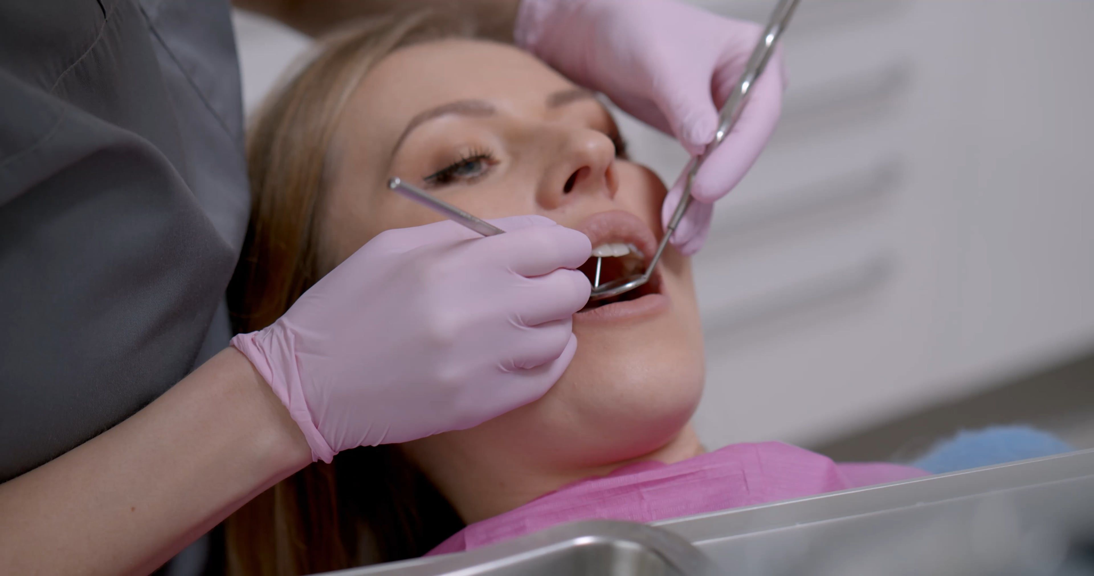

gferrddsyfg
4-Challenges and Importance of Dentistry Services
Dentistry services play an essential role in maintaining oral in maintaining health but they face several challenges. One major challenge is access to NHS dentist accepting new patients and waiting lists can delay treatment. Staff shortages have also increased pressure on dental services making it more difficult for patients to receive timely care. These issues can lead to worsening dental problems and increased demand for emergency treatment. Another challenge is oral health inequality. People living in is oral health inequality. People living in deprived areas, children from low-income families, older adults, and vulnerable groups are more likely to experience tooth decay, gum disease and tooth loss. Limited access to dental care and health education can contribute to these differences in oral health outcomes. Despite these challenges, dentistry services are extremely important. Regular dental, check ups help prevent diseases such as tooth decay and gum disease through early diagnosis and treatment. Good oral health improves nonconfidence, comfort and overall bring. Dentists also play a vital role in detecting oral cancer at an early stage, which can improve treatment outcome and survival rates. In addition, maintaining healthy teeth and gums supports overall physical health and quality of life.
2-History of Dentistry Services
Dentistry has been an important part of healthcare for many years. Before the National health service NHS was introduced, most dental treatment in the UK had to be paid for privately. This meant that many people could not afford regular dental care leading to untreated tooth decay, gum disease and tooth loss. Access to dental treatment was often limited, especially for lower income families. A major change occurred in 1948 when the NHS was established. For the first time, dental care became available to everyone regardless of their financial situation. This greatly improved access to treatment and helped improve the oral health of the population. Many people who had never been able to ess a dentist before were able to receive care. In 1951, NHS dental charges were introduced to help cover the growing cost of providing dental services. Although patients had to contribute towards some treatments, dental services. Although patients had to contribute towards some treatments than before the NHS. Modern dentistry has continued to develop through advances in technology and healthcare practices. Today dentists focus on prevention as well as treatment. Digital X rays dental implants, improved fillings and modern restorative techniques have made dental care more effective and comfortable for patients.

ing cost of providing dental services. Although patients had to contribute towards some treatments, dental care remained far more accessible than before the NHS. Modern dentistry has continued to develop through advances in technology and healthcare practices. Today dentists focus on prevention as well as treatment. Digtal X rays, dental implants, improved fillings and modern restorative techniques have made dental care more effective and comfortable for patients.
Section Head Here


Residential care homes: History, Current function and Importance

Residential care homes provide accommodation, personal care, and support for people who can no longer live independently because of age, disability, illness, or other care needs. They play an important role in the social care system by ensuring vulnerable people receive assistance while maintaining their dignity, safety, and wellbeing.
The origins of residential care homes can be traced back to the Poor Laws in England during the 16th and 17th centuries. At that time, older people, disabled individuals, and those living in poverty were cared for in workhouses. These institutions often provided poor living conditions and offered little privacy or personal choice. Following the introduction of the National Assistance Act 1948, workhouses were abolished and replaced with residential care homes that focused on providing support rather than punishment or poverty relief. Over time, attitudes towards care changed, recognising that people deserved respect, independence, and person-centred support. More recently, the Care Act 2014 strengthened the rights of people receiving care by promoting wellbeing, safeguarding adults, and encouraging independence wherever possible.
Today, residential care homes provide 24-hour care for people who require assistance with daily living but do not need the continuous medical care provided by hospitals. Staff help residents with washing, dressing, eating, taking medication, and participating in social activities. Many homes also provide emotional support and opportunities for residents to maintain relationships with family and friends. Care is planned around each person's individual needs, preferences, culture, and beliefs through person-centred care planning.
Residential care homes are regulated by the Care Quality Commission (CQC) in England, which inspects services to ensure they meet national standards for safety, effectiveness, caring, responsiveness, and leadership. Homes that fail to meet these standards are required to improve to protect residents from harm.
Although residential care homes provide many benefits, they also face significant challenges. One major issue is staff shortages, which can affect the quality and continuity of care. Low pay, high workloads, and difficulties recruiting qualified staff have created pressures across the social care sector. In addition, funding remains a challenge, as many local authorities struggle to meet increasing demand caused by an ageing population. Some residents may also experience loneliness or emotional distress after moving away from their own homes, making emotional support and meaningful activities essential aspects of care.
Despite these challenges, residential care homes make a significant contribution to improving the quality of life for service users. They provide a safe environment where individuals receive support with everyday activities while maintaining as much independence as possible. Many homes organise exercise classes, games, music sessions, and outings that help reduce loneliness and encourage social interaction. Good residential care also promotes dignity, respect, and choice, allowing residents to remain involved in decisions about their daily lives.
Families also benefit from residential care homes because they gain reassurance that their loved ones are receiving professional care. This can reduce stress and allow relatives to spend more quality time together without the demands of providing full-time care themselves. Furthermore, residential care homes help prevent unnecessary hospital admissions by monitoring residents' health and responding quickly when concerns arise.
In this case conclusion, residential care homes have developed significantly from the poor conditions of historical workhouses into modern services centred on dignity, independence, and person-centred care. Although challenges such as staffing shortages and funding pressures continue to affect the sector, residential care homes remain an essential part of health and social care. By providing safe accommodation, personal support, social opportunities, and emotional care, they greatly enhance the wellbeing and quality of life of many vulnerable people.

References

1.nhs (2025) Dental services available on the NHS - NHS, nhs. Available at:
https://www.nhs.uk/nhs-services/dentists/what-dental-services-are-available-on-the-nhs/ (Accessed: 23 June 2026)

2. nice (2014) Overview | Oral Health: Local Authorities and Partners | Guidance | Nice, Public health guideline. Available at: https://www.nice.org.uk/guidance/ph55 (Accessed: 23 June 2026)

3. cqc (2025) Find a dentist - care quality commission, care quality commission.
https://www.cqc.org.uk/care-services/find-dentist (Accessed: 23 June 2026

4.who (2026) Oral health, world health organisation. Available at: https://www.who.int/health-topics/oral-health (Accessed: 23
June 2026).

5. Arminco Inc (2019) 8 dental industry trends and how they can help your business, Arminco Inc.
https://www.armincoinc.com/blog/equipment/8-dental-industry-trends-and-how-they-can-help-your-business (Accessed: 23 June 2026)

6. Parisist (2018) The Art of Dental Practice Brokerage: Innovations and trends that paint the future – Parisist, Parisist.
: https://www.parisist.com/the-art-of-dental-practice-brokerage-innovations-and-trends-that-paint-the-future.php (Accessed: 23
June 2026)

