
APPENDIX GA36c
LEVEL 6 ASSESSMENT SPECIFICATION

Student name: | Emma Blackie | Student ID number: | 1801125
Programme: | Primary
Module: | Principles of Pedagogy
Module code: | M6X01438/C | Contribution to Overall Module Assessment (%): | 100%
Lecturer: | Siân Brooks | Internal Verifier: | Siân Brooks
Assignment Title: | ‘Describe a learning event which has happened during your recent school experience. Reflect upon what took place, connecting events to theories of learning and teaching. Make recommendations about how you could improve your own practice in the light of this. Produce a poster to illustrate how you would develop the elements of an effective learning environment.’ | Word count (or equivalent): | 5,000 or equivalent.

Principles of Pedagogy (M6X01438/C)

Describe a learning event which has happened during your recent school experience. Reflect upon what took place, connecting events to theories of learning and teaching. Make recommendations about how you could improve your own practice in the light of this. Produce a poster to illustrate how you would develop the elements of an effective learning environment.

The purpose of this essay is to provide an analysis of a critical event that I observed whilst in a classroom, and then link these observations to key learning theories and theorists in order to further understand what I witnessed. Reflecting on this will provide clarity on good teaching practice and help me to draw conclusions as to important elements to include in an effective learning environment.
For the purposes of this essay, for ethical reasons I will not be naming the school, nor giving the names of any teachers or pupils. In any transcripts, the classroom teacher will be referred to as ‘T’, and the target child will be referred to as ‘child O’. Any other children will be referred to as ‘child X’, ‘child Y’ or ‘child Z’. The school will be referred to as ‘school X’. This is to protect the anonymity of the adults and children and is in line with BERA guidelines. The UNCRC (2004) states that all children should be treated with respect, dignity, anonymity and honesty, and I will be keeping these rights at the forefront of my mind throughout. Any photos I have used in this essay, I have been given permission to use by the headteacher of the school (signed permission form at the end of this essay.)
My observation took place in a suburban school in Wales on Wednesday 19 September 2018. The school has 384 pupils, of which approximately 52% have additional learning needs and 36% have free school meals. There is a 95% attendance rate. (My Local School, 2017). The class I was in is a mixed class of higher ability year 1 and lower ability year 2 children, of which there are 21 girls and 4 boys. There were 2 adults in the class on the day of my observation; the class teacher and the teaching assistant. My observation began at 09:20 and ended at 15:20. The children were aware of my presence in the classroom, but my involvement at this stage was passive; I was sitting at a table at the side of the classroom. The children themselves were sitting on the carpet, and the teacher was sitting on a chair on the carpet at the front of the children.
The teacher began the lesson by recapping the learning that had been started the previous day. The teacher was using an ‘over to you’ technique to find out what children already knew about electricity, which was to be the topic for the next few lessons. The teacher wanted to find out who could remember the items they had drawn on the whiteboard (Fig.1) as a class the previous day.
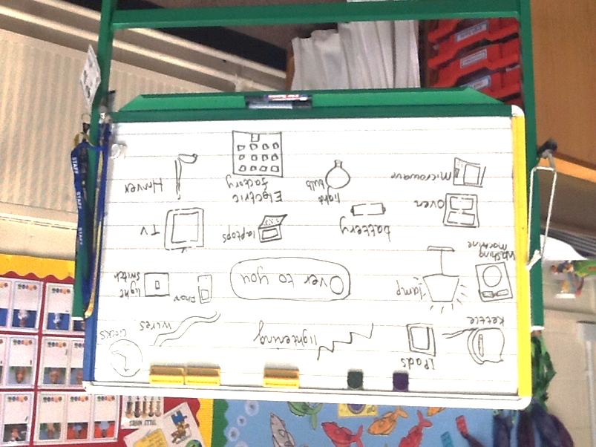
Fig.1
She told the children they could use the whiteboard to help them if they wanted, or think of an item not on the whiteboard. The teacher told the children they must raise their hand if they had an answer. One child (‘child O’) kept on calling out his answers instead of putting his hand up first:
T: Who can tell me an item that uses electricity? Yes, Y?
Y: A cooker.
T: Good – a cooker. What’s another word for cooker, that you have in your kitchen at home?
O: (Shouts out) Oven!
T: I asked you to put your hand up if you want to answer, O. X, you have your hand up, what’s your answer?
X: An oven.
T: Good – an oven. Who can give me another item that uses electricity?
O: (Shouts out) X-Box!
T: (Whispers) I asked you to put your hand up O, I won’t take your answer unless you put your hand up first. It’s a shame because you have some really good answers. Z, what was your answer?
Z: A TV?
T: Yes – a TV uses electricity. Let’s have one more answer.
O: (Shouts out) A light!
T: Well done O, that’s a really good answer.
I have selected this exchange as a significant event for a number of reasons. Firstly, the exchange demonstrates the teacher’s use of the ‘ping-pong’ questioning technique (Cox, 2018) in which she selects a child with their hand up to answer the question, acknowledges their answer, and then moves to the next child with their hand up. This shows the teacher very quickly who has remembered the previous day’s learning, but the limitations of this could be that the same children always put their hand up to answer. Secondly, the exchange shows how the teacher deals with child O’s disobedience of the rule she had stipulated. Her response is a Behaviourist one: twice she refuses to take his answer, in the hope that the child will learn that he must raise his hand in order for the teacher to accept his answer. However, the third time child O shouts out, she takes his answer. In terms of Operant Conditioning, “Learning takes place when behaviours are either rewarded or punished…and…associations are formed between behaviours and the consequences of those behaviours.” (MacBlain, 2004, p.37). However, it should be noted that when child O shouts out the answer for a third time, and the teacher accepts his answer, and rewards it with a “well done”. Child O therefore learns that if he continues to shout out the answer, rather than raising his hand as the teacher has asked, his answer will eventually be taken.
I have used a ‘written record’ (Ryder and Glover, 2018) of observation here because of the ease in which I could record what was happening at that moment. However, the conversation often flowed faster than I could write, so there was the potential for bits of conversation to be missed out, or to be written inaccurately. Due to Data Protection Law (2018), parents of some of the children in the class had requested that their child not be photographed or filmed, so in order to ensure I did not break the law, I did not use any digital media as a means of observation, although this would maybe have been my preferred method, in order to capture the critical event more accurately, and have some photographic or video evidence to support my observations.
I have also used, in part, a ‘target child’ method of observation (Ryder and Glover, 2018), because I wanted to find out how child O behaved in other situations, for example at break time in the playground, or when taking part in group work in the classroom. In the playground, child O was for the most part engaged in solitary play, unable to make connections with his peer group. According to Sheridan (1999), children at this stage of play “have difficulty understanding the need to share adult attention and toys” (Sheridan, 1999, p.27), and this was clear to see when I engaged child O in conversation and asked him to take me on a tour of the playground. Two other children were walking with me at the time, and child O was completely unable to interact with them to agree where to take me, with the result that I was pulled in two different directions. Interestingly, Child O demonstrated great knowledge of the allotment area and the various fruit trees in the playground, excitedly running over with an apple and a pear he had found, and confidently telling me the names of the vegetables growing in the allotment. Evidence of child O’s inability to interact positively could also be seen in the classroom when child O was asked by the teacher to read alone in the reading corner rather than joining the rest of the children in group play at the play dough table. However, later on in the afternoon, when the children came together for a moment on quiet on the carpet for ‘massage partners’, child O was quiet and engaged with the task of ‘massaging’ the shoulders of the child in front of him. When given a simple, quiet task for a short amount of time, child O was actively engaged. Perhaps most tellingly, whilst waiting for their parents to arrive, the children watched a series of short ‘Bananas in Pyjamas’ programmes on YouTube, and this was when child O was at his most engaged.
Through the ‘target child’ observation I was able to follow child O through various scenarios and gain an insight into his behaviour and the reasons for it, how he interacts with children and adults, and how he learns. For me this was the most effective type of observation to use for the purposes of this essay, but quite limiting in terms of seeing the ‘bigger picture’ of the class as a whole.
The importance of observation in the classroom becomes clear when applying it to Brookfield’s ‘Four Critically Reflective Lenses’ (1995). Through these four lenses of “our autobiographies as teachers and learners, our students’ eyes, our colleagues’ experiences, and theoretical literature” (ibid, p.29) practitioners can see the event from different perspectives and form a more complete picture of what has been observed, and therefore a more accurate view when it comes to assessment.
As discussed, there are three different aspects to the observation, the Behaviourism aspect where the child is being conditioned in a certain way; the questioning aspect where the teacher is using a particular technique to draw out existing knowledge and build new knowledge with the class, and the learning through play aspect upon observation of child O in the playground. For the purposes of this essay, it is the questioning aspect which will be the focus here.
Prior to Behaviourism as a theory of how children learn, it was widely believed that the learner was a passive recipient of learning (Gray and MacBlain, 2015). However, it was Lev Vygotsky who turned this theory on its head by proposing that “knowledge and thought are constructed through social interaction with family, friends, teachers and peers.” (Bates, 2016, p. 46). By this he meant that everything a child learns, it learns actively through other people, and in particular that the teacher was the “facilitator of learning.” (Gray, and MacBlain, 2015, p.108). This formed the roots of the Social Constructivist theory of learning, and it is this theory which underpins much of what went on during the exchange in the observation.
Vygotsky believed that language played an important part in a child’s thinking and learning (Vygotsky, 1930). Before the advent of books and pens, knowledge would have been passed down from generation to generation through language; story-telling, discussion, observation, questioning and so on. Therefore, it stands to reason that this is how children learn also, before they learn to read and write, forming knowledge through communication (verbal and non-verbal) between their parents, siblings, peers, teachers, and through objects. (Gray, and MacBlain, 2015). Through this communication, children listen to ideas and form their own. This is evident in the observation through the teacher’s use of questioning, in order to find out what the children already know to be objects that use electricity. Through listening to each other’s answers, the children then make connections in their own minds in order to come across objects they know to use electricity and then to volunteer their answer.
This then feeds into Vygotsky’s idea of the Zone of Proximal Development (ZPD). The ZPD described the process by which children learn, through the gap between what the child knows already, and what it can do with help from Most Knowledgeable Others (MKOs) (Bates, 2016).
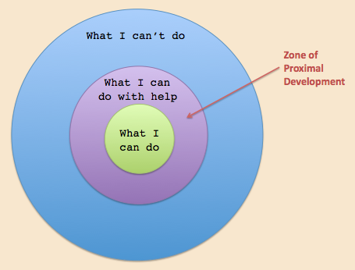
Fig.2
In the diagram above, it can be seen that in order to bridge the gap between “what I can do” and “what I can’t do”, there is a section labelled “what I can do with help”. It is in this section that Vygotsky believed that with the help of an MKO (a teacher, parent, sibling or peer) the child could build upon previous knowledge and reach a deeper level of understanding. Vygotsky called this ‘scaffolding’ (Bates, 2016). According to Bates (2016), the ZPD is one aspect of scaffolding that can be achieved by “testing prior knowledge or understanding of the subject” (Bates, 2016, p.47). This is exactly what is happening in the observation: the teacher is testing the class’s prior knowledge of the subject (electricity) by using an ‘over to you’ technique (Cox, 2018) to ascertain what they already know. The advantages of this are twofold. The teacher can very quickly see which children already have some knowledge, and which children don’t, and then can devise strategies to help each individual through the ZPD to acquire new knowledge and understanding. And the technique helps with this in that the children will listen to each other’s answers and gain new knowledge straight away. For example, the teacher used the ‘cooker’ answer to see if any children knew another word for ‘cooker’, and in doing so the children learn that another word for cooker is ‘oven’ and thus extend their knowledge.
Whilst Vygotsky offered a sound view of how children learn, his ideas weren’t without their critics. According to Fox (2001) his theories implied that if a child cannot speak, then it cannot learn (Gray, and MacBlain, 2015) and therefore doesn’t consider children with a language delay, or a child’s internal thought. Vygotsky’s theories also didn’t acknowledge that children learn through experience as well as language, and that children will develop at different rates dependent not only on their age, but also as a result of their social position. Alexander (2010, p.19) backs this up by saying that a child’s social background will impact on their ability to communicate effectively in class, and that “those from middle-class backgrounds will have been talking and communicating far earlier than those from a more working-class background.” Therefore, it would be prudent to remember this in future practice and be mindful of placing children in groups based purely on academic ability.
It was Jerome Bruner who built upon Vygotsky’s theories, and added the social element to them. He hypothesised that children learn through active engagement and finding meaning through it. He was interested in the cognitive processes and strategies that children go through to learn, and that rather than simply being ‘spoon-fed’ information, children learn better by being given a problem to solve and the necessary tools with which to solve it. (Gray and MacBlain, 2015).
According to Bates (2016, p.55) the best way to do this is by organising and allowing learners to “discover the new material to be covered so that they can make links with their own understanding of the subject.” This type of learning is evident in the classroom observation through the teacher’s use of open questions to elicit answers from the class. She doesn’t just tell the class which household items use electricity, she encourages them to draw on their own experiences to determine what they think by inviting them to share their ideas with the rest of the class. Therefore, as Gray and MacBlain (2015, p.136) note: “the contexts and experiences that practitioners create for children to learn [and] the development of vocabulary and the techniques they employ when questioning and explaining are vitally important.”
As already mentioned, it can be seen through the classroom observation that the teacher is using several strategies to develop the children’s learning. She has already touched on the subject in the previous day’s lesson, and so by re-visiting the learning with the class the following day she is strengthening their meta-cognition skills by using data-recall questioning to see what they have remembered, and also higher-order questioning by asking them to draw on what they have remembered (Brown and Wragg, 1993) and using this to see if they can come up with any new answers not already listed on the white board. It is worth noting here that the teacher is employing an oft-used method called the IRF (Initiation, Response, Feedback), where the teacher first initiates the interaction by asking the question, taking the child’s response, and then responding to the child’s response with a feedback comment (Mercer and Hodgkinson, 2008). This is good exploratory talk but could in future practice be extended further. As Alexander (2010, p.31) remarks, “discussion and scaffolded dialogue have by far the greatest cognitive potential” and Grigg (2016) extends this by saying that pupils need specific feedback on what they did well and where they need to improve, as well as to tell them what they are doing differently than before.
As Wiliam (2009) found in his research on improving learning effectiveness in schools, assessment for learning produced an extra 8 months of learning per year. Within the assessment for learning there are four elements: sharing learning criteria with the class; quality of questioning; the use and quality of feedback, and peer and self-assessment. Wiliam’s findings highlight the importance of effective questioning, and the need for two-way dialogic feedback in the classroom, so that both teachers and pupils learning from the experience.
Other higher-order questioning techniques that are often used in the classroom come from Bloom’s Revised Taxonomy (Anderson and Krathwohl, 2001) in which types of learning are arranged hierarchically, so that the skills at the bottom must be in place before the skills higher up the ladder can be achieved, as shown in the diagram below:
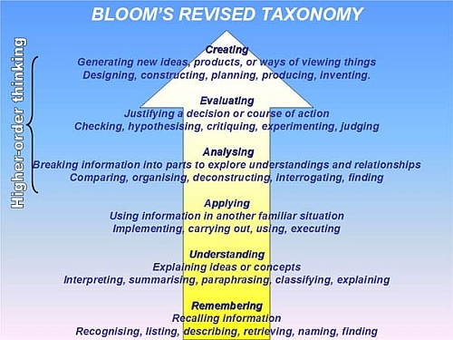
Fig.3
In the observation, the teacher is asking questions to provoke a response at the ‘remembering’ rung of the ladder, the answers of which she then uses to build upon to help the class reach the ‘understanding’ rung. In future practice, if this method is carried through, then different questioning techniques could then be used to facilitate the class’s progress right the way through to the top rung of ‘creating’. For example, the use of an ‘assertive questioning strategy’ would encourage pupils to look at things in a different way by listening to other answers in the class, building upon those and justifying their responses before coming to a new or revised decision.
Higher order thinking skills can also be achieved through the use of De Bono’s Six Thinking Hats:
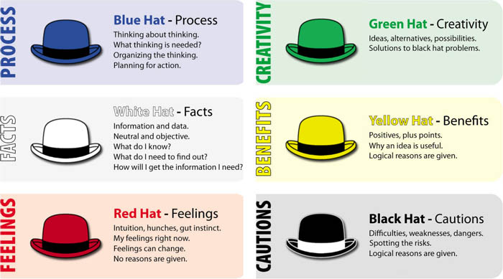
Fig.4
Using each of these hats in turn for one particular question encourages children to think in different ways, and to approach a question from different angles, which goes hand-in-hand with the ‘creating’ rung of Bloom’s Revised Taxonomy, and once again demonstrates the importance of effective questioning in facilitating learning (Cox, 2018).
Effective questioning therefore is extremely important in class since it “challenges not only children’s understanding but also our own” (Alexander, 2010, p.31) and according to Hopkins (2009) forms the ‘instructional core’ of powerful learning.
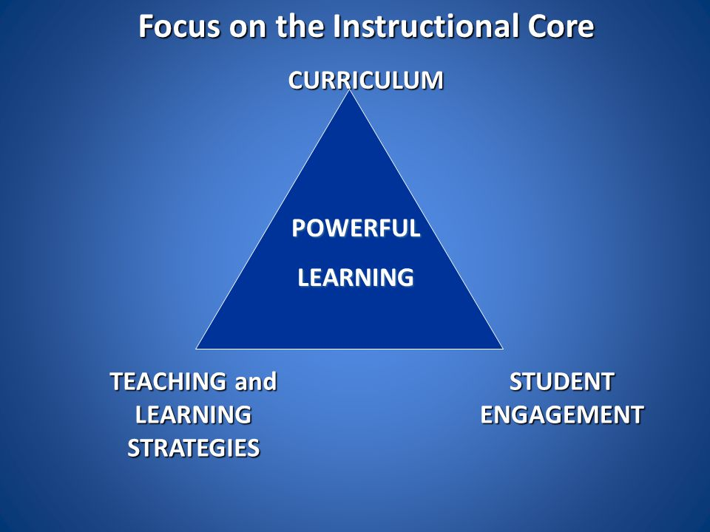
Fig.5
With powerful learning at its centre, the curriculum, student engagement and teaching and learning strategies are all connected through the use of effective questioning. Effective questioning challenges the teacher’s understanding in the observation because the answers to her questions by her pupils give her instant feedback as well, meaning she can reflect on how she is teaching the lesson and what steps (if any) she needs to take to improve her techniques, and in turn the learning outcomes of her class. As Brown, G and Wragg, E.C (1993, p.8) comment: “as well as asking questions of pupils, we do ask questions implicitly…when we are…evaluating our own performance as teachers. They provide us with lessons within lessons.” As Alexander (2010, p.25) so rightly asserts, “dialogue becomes not just a feature of learning, but one of its most essential tools.”
On reflection of my observations in part one of this essay, and through careful analysis of the theories behind what I saw in part two, I shall now use both to form the basis of what I would deem to be an effective learning environment, to take forward to my future practice.

Having researched several different types of learning environments, from those based purely indoors, to those with a combination of indoor and outdoor space, I have made the decision to base my learning environment entirely outdoors, focusing on the Foundation Phase of learning. I have done this for a number of reasons. The main reason being that having been privileged enough to spend some time in a nursery school using the Reggio Emilia method, and seeing the children actively engaging with and enjoying the outdoor facilities, with very few children spending any time at all indoors, I could see first-hand that there is very little that the outdoors cannot teach a child. This is emphasised in the Welsh Curriculum Foundation Phase Outdoor Learning Handbook (2009, p.2) which says that “being outdoors enhances all aspects of a child’s development: social, physical, creative, cultural and personal.” This therefore links directly to the Foundation Phase curriculum as a whole, with its seven areas of learning. Using the outdoors to begin a child’s education is ideal, since it taps into a child’s natural curiosity and therefore has at its heart a play-centred, experiential approach which Constructivist theorists such as Piaget and Bruner thought to be so important. I have considered the ‘Great British Weather’ with its unpredictability and would position each of the learning zones within individual biomes such as those at the Eden Project (Fig.6), to protect the zones from the elements, but give the feel of being outdoors, surrounded by plants and trees. The majority of the environment will be entirely outdoors.

Fig 6.
In terms of the classroom layout, I have taken inspiration from the relatively new construct of ‘learning plazas’, which offer a very open-plan, flexible learning space, ideal for experiential, skills-based learning, which itself links to Donaldson’s Successful Futures report, and its recommendations that the new curriculum helps equip learners with the skills necessary to become “enterprising, creative contributors, ready to play a full part in life and work.” (Donaldson, 2015, p.29). The learning plaza structure at New Line Academy in Kent was one of the first of its kind in the country, offering the pupils access to a different kind of working, where the larger classroom is split into different zones – whole class, group work, and individual, and with any given task it is the pupils who decide which zone is best for the work they need to do. Whilst New Line Academy is a secondary school, learning plazas are also used in primary schools, of which Dewstow Primary School in Monmouthshire was the first school in the UK to use learning plazas across the school. (Fig.7)

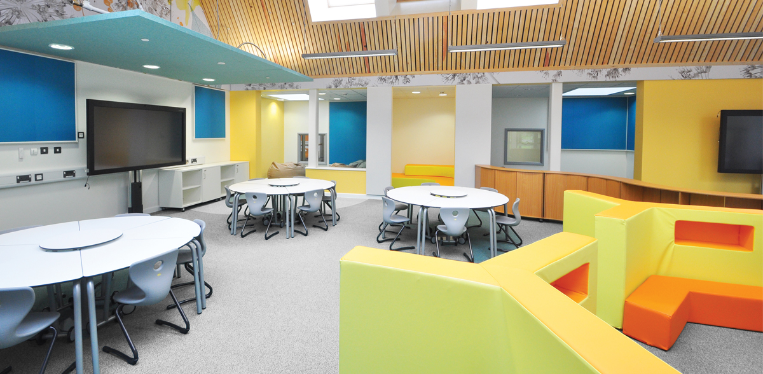
Fig. 7
Thus, in my learning environment I have included a whole class zone, a group work zone, and an individual learning zone.
In terms of a learning approach, Maria Montessori’s belief that children are active learners, capable of taking control of their own learning, in an environment which caters for the needs of all children, and with a teacher to guide them in the right direction, (Isaacs, 2012) sits extremely well with the overall layout of the classroom and the outdoor environment. The outdoors is “…the ideal environment for experiential learning because it offers unique opportunities to be creative, to move around, to be noisy and to take risks.” (Foundation Phase Outdoor Learning Handbook, 2009, p.4). Taking risks is important, because it helps children to learn their boundaries in a controlled and safe way. This is one of the reasons why I have included a fire pit within the classroom setting, as one way of learning about fire and fire safety.
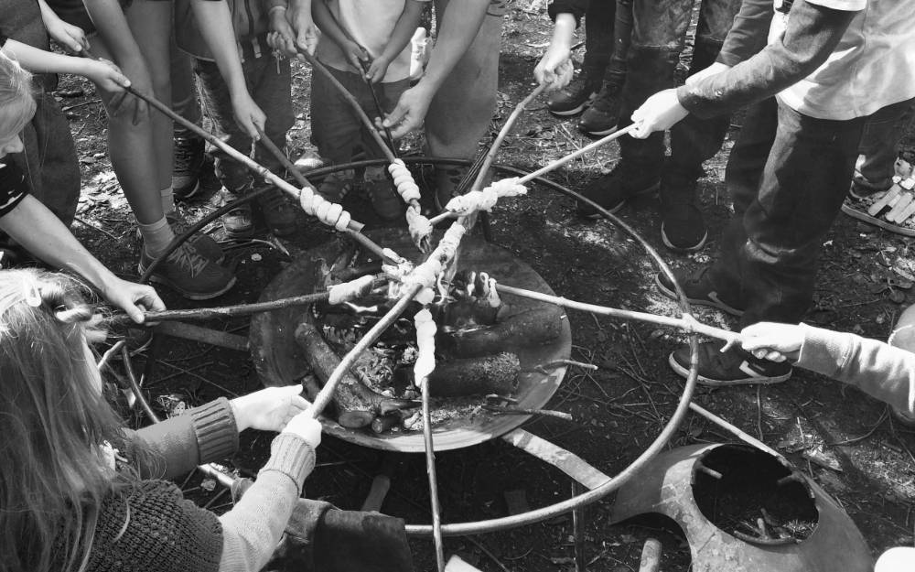
Fig. 8
Another reason is that by introducing children to ‘dangerous’ elements early on in life encourages them to be respectful, not only of those elements, but of their peers and adults also, and helps them gain confidence too (Constable, 2017). And according to Adams (2009) “there is some evidence to suggest that when a creative culture is established in schools, behaviour improves as children become more interested in learning.” (Grigg, 2010, p.347)
Turning now to the curriculum for my effective learning environment, it will incorporate all aspects of the Foundation Phase and its seven areas of learning (Foundation Phase Framework, 2015). For Personal and Social Development, Well-being and Cultural Diversity I have included an outdoor kitchen, allotment and the three learning zones. For Language, Literacy and Communication Skills, this area is incorporated into all aspects of the learning environment, including within the triangle of provision. The chalk board is for practicing mark-making, and iPads will be provided to all pupils for reading and ICT. Mathematical Development is also incorporated into all aspects of the learning environment, from measuring ingredients in the outdoor kitchen, to counting chickens in the Animal Kingdom. Welsh Language Development will be provided alongside all areas of the outdoor learning environment, with signage in Welsh, and opportunities to learn Welsh words and phrases alongside English ones within each learning area, whether continuous, enhanced or focused. For the areas of Knowledge and Understanding of the World, Physical Development and Creative Development, these three areas of learning are underpinned throughout the entire learning environment. By being outside, and having the physical space to run around, climb trees, grow vegetables, and the mental space to explore and create, the children are, by their very essence, learning about the world around them in a physical and creative way. Montessori, controversially, did not believe in the value of play in learning, instead providing “experiences that were considered to be useful for life, giving children skills of independence and decision making.” (Constable, 2017, p.3).
I will provide no formal curriculum for the children in my learning environment. Some may disagree with this, but it is my belief that until about the age of seven, children are not ready mentally or physically for formal schooling. This thinking is backed up in the Cambridge Primary Review (2009, p.168) in which some proposals “called for a starting age of six or seven, arguing that formal schooling any earlier dents children’s confidence and risks long-term damage to their learning.” Thus, experiential learning allows the children to learn at their own pace, not being afraid to make mistakes, whilst in a safe place and guided by trained professionals. Topics covered will be governed entirely by the children, in order to ensure that Pupil Voice is strong within the learning environment. In his Successful Futures report, Donaldson (2015, p.61) deems Pupil Voice to be extremely important, and that “teaching and learning methods can and should offer opportunities to choose particular activities and experiences.” Estyn Effective Practice reports show that this way of teaching is making a positive impact by “promoting pupils’ confidence, enjoyment of school and their enthusiasm for learning.” (Estyn, 2013).
In keeping with the Foundation Phase guidelines, I have included the triangle of provision, with specific areas for continuous, enhanced and focused learning. This model ensures that the child is at the centre of learning, not the curriculum (Thomas and Lewis, 2016), which links back to both the Montessori method of learning, and Donaldson’s recommendations in Successful Futures, mentioned previously. Examples of learning in these areas could be a construction area in continuous provision, as well as the resources in the Animal Kingdom, outdoor kitchen and allotment, which would be available year-round for the children to access. Enhanced provision is what is added to the continuous provision to build on the learning opportunity (Thomas and Lewis, 2016). Examples of this could be cooking or baking recipes from different cultures in the outdoor kitchen, to tie in with a topic in the Knowledge and Understanding of the World area of learning, or constructing with different materials (wood, sand, stones etc) within the construction area. Focused provision is where specific activities are provided by the teacher in order to introduce new skills and concepts, and allows for high-quality adult-child interaction, usually on a one-to-one level, but sometimes in small groups. (Thomas and Lewis, 2016). An example of this could be using the different materials from the construction area to learn about the properties of each material (smooth, rough, light, heavy etc) and then to order them in terms of weight, or using the stones and painting letters on them, and asking the children to make simple three-letter words with them (Lewis, 2018). According to the research of Ron Ritchhart (2011), the use of the See, Think, Wonder (STW) routine is useful here, in all aspects of the triangle of provision, and in particular in the use of objects to facilitate learning, to encourage children to make observations about objects and to promote higher-order thinking, by answering three questions: ‘what do you see?’, ‘what do you think about that?’ and ‘what does it make you wonder?’ (Lewis, 2018)
With regards to assessment, observation will be the main tool used. With much of the work completed by the children being practical tasks, this provides the class teacher (and teaching assistants) ample opportunity to follow each child, and really develop meaningful relationships with them.
I believe that an entirely outdoor learning environment caters for the needs of all children in Foundation Phase. It provides them with opportunities to be creative and imaginative, explore and develop their own interests, taking control of their own learning, which in term helps them to develop the skills they need for the wider world. (Outdoor Learning Handbook, 2009).
In conclusion, having considered what I learned through classroom observation, through my exploration of different learning theories, and through reflection of what I would want in my own classroom practice, there is no one method for learning or teaching. It is the knowledge and use of many different methods that will help a child to engage and learn. At the heart of this are several key elements which I believe should be carried through whichever classroom you are in, and in whichever environment. I believe that effective questioning is so important; asking the right type of question, which encourages higher order thinking, makes the difference between a child simply carrying on with their day, or seeing what has happened or what they have learned in that day in an entirely new way, which is so exciting, not just for the child, but the teacher too. Allowing children to take control of their own learning, and giving them a voice, is also incredibly powerful. Children who want to learn what you are teaching them because they have made that decision to learn it can only give them the motivation and the confidence to learn more, and that lays the foundations for their entire future.

References
Alexander, R. (2009) Children, their world, their education: final report and recommendations of the Cambridge Primary Review. London: Routledge.
Anderson, Lorin W. and Krathwohl, David R. (2001) A Taxonomy for Learning, Teaching and Assessing: A Revision of Bloom’s Taxonomy of Educational Objectives. New York: Longman.
Bates, B. (2016) Learning Theories Simplified: …and how to apply them to teaching. London: SAGE.
Brown, G. and Wragg, E.C. (1993) Questioning. London: Routledge.
Brookfield, S. (1995) Becoming a Critically Reflective Teacher. San Francisco: Jossey-Bass.
Constable, K. (2017) The Outdoor Classroom Ages 3-7: Using Ideas from Forest Schools to Enrich Learning. Abingdon: Routledge.
Cox, T. (2018) ‘Questioning’, Questioning. UWTSD Swansea 18/09/18.
Gray, C. and MacBlain, S. (2015) Learning Theories in Childhood. London: SAGE.
Grigg, R. (2015) Becoming An Outstanding Primary Teacher. Abingdon: Routledge.
Grigg, R. and Lewis, H. (2018) Teaching on a Shoestring. Carmarthen: Crown House Publishing.
Isaacs, B. (2012) Understanding the Montessori Approach: Early Years Education in Practice. Abingdon: Routledge.
MacBlain, S. (2014) How Children Learn. London: SAGE.
Mercer, N. and Hodgkinson, S. Exploring Talk in School. London: SAGE.
Ritchhart, R. et al. (2011) Making Thinking Visible: How to Promote Engagement, Understanding and Independence for All Learners. San Francisco: Jossey-Bass.
Ryder, N. and Glover, H. (2018) ‘Assessment and Observation in the Foundation Phase’, Observation and Assessment. UWTSD Swansea 18/09/18.
Sheridan, Mary D. (1999) Play in Early Childhood: from birth to six years. London: Routledge.
Thomas, A. and Lewis, A. (2016) An Introduction to the Foundation Phase. Bloomsbury.
Vygotsky, L. (1930) Mind and Society: The Development of Higher Psychological Processes. Cambridge, Mass: Harvard University Press.
Wiliam, D. (2009) Assessment for Learning: Why, What and How. IOE Press.
Websites:
British Educational Research Association [BERA] (2018) Ethical Guidelines for Educational Research, fourth edition, London. Available at https://www.bera.ac.uk/wp-content/uploads/2018/06/BERA-Ethical-Guidelines-for-Educational-Research_4thEdn_2018.pdf?noredirect=1 (Accessed: 30/09/18).
Donaldson, G. (2015) Successful Futures. Available at https://gov.wales/docs/dcells/publications/150317-successful-futures-en.pdf. (Accessed: 23/09/18).
Estyn. (2013) Giving Pupils a Voice. Available at https://www.estyn.gov.wales/effective-practice/giving-pupils-voice. (Accessed: 13/10/18).
New Line Academy Learning Plaza. Available at https://www.youtube.com/watch?v=nnPLrK1USMA (Accessed 08/10/18).
United Nations. (2004) United Nations Convention on the Rights of the Child. Available at https://downloads.unicef.org.uk/wp-content/uploads/2010/05/UNCRC_united_nations_convention_on_the_rights_of_the_child.pdf . (Accessed: 29/09/18).
Welsh Assembly Government. (2009) Foundation Phase Outdoor Learning Handbook. Available at http://learning.gov.wales/?lang=en (Accessed 02/10/18).
Welsh Assembly Government. (2015) Foundation Phase Framework. Available at http://learning.gov.wales. (Accessed: 01/10/18).
Welsh Assembly Government. (2008) Skills Framework for 3 to 19-year-olds. Available at http://learning.gov.wales. (Accessed: 13/10/18).
X Primary School information. Available at http://mylocalschool.wales.gov.uk/School/6702008?lang=en (Accessed: 01/10/18).

Appendices
Fig.1: Photograph taken at X Primary School on 19/09/18.
Fig.2: Culatta, R. (2011) Zone of Proximal Development. Available at: http://www.innovativelearning.com/educational_psychology/development/zone-of-proximal-development.html (Accessed: 28/09/18).

Fig.3: Artist Unknown. Bloom’s Taxonomy of Cognitive Levels (Revised). Available at:
https://faculty.chass.ncsu.edu/slatta/hi216/learning/bloom.htm (Accessed 28/09/18)
Fig.4: Staff Development Blog. Edward de Bono’s Six Thinking Hats. Available at:
http://tbsstaffdevelopment.blogspot.com/2014/09/edward-de-bonos-six-thinking-hats.html Accessed 28/09/18
Fig.5: Hopkins, D. (2011) Instructional Core. Available at: https://slideplayer.com/slide/4960268/ (Accessed 28/09/18)
Fig.6: Matern, J. Eden Project Biomes. Available at: https://en.wikipedia.org/wiki/Eden_Project (Accessed: 13/10/18)
Fig.7: BOF. Dewstow Primary School learning plaza. Available at:
http://www.bof.co.uk/projects/monmouthshire-county-council-dewstow-primary-school (Accessed 09/10/18)
Fig.8: Firewok (2016) Forest School fire pit. Available at: https://firewok.co.uk (Accessed 31/10/18)



