Advanced Physics – Design of Shaped Charges


Tegan Ingram

University of Wales Trinity Saint David
Ordinance, Munitions and Explosives (OME) Engineering

Supervisor: Kelvin Donne
November 2025

Table of Contents
Table of Contents 2
List of Tables 3
Table of Figures 4
Abbreviations List 4
Abstract 6
1. Introduction 6
1.1 What is a Shaped Charge? 6
1.1.1 History of Shaped Charges 6
1.1.2 The Munroe Effect 6
1.1.2 Uses of Shaped Charges 7
1.2 What is Finite Element Analysis (FEA) 8
1.2.1 Abaqus 8
1.3 Shock Physics 8
1.3.1 Gurney Theory 8
1.3.2 Bernoulli Theory 8
1.3.3 Euler Equations 10
2. Literature Review 10
2.1 Shaped Charge Design 10
2.2 Material Selection 11
2.2.1 Copper 11
2.2.2 HMX 11
2.2.3 Aluminium 11
3. Methodology 11
3.1 How to Create a Simulation 11
3.2 2D Shaped Charge-1 12
3.2.1 Part Dimensions 12
3.2.2 Material Properties 14
3.2.3 Meshing 15
3.2.4 Boundary Conditions 16
3.2.5 Interaction 16
3.3 2D Shaped Charge-2 16
3.3.1 Part Dimensions 16
3.3.2 Material Properties 17
3.3.3 Meshing 18
3.3.3 Boundary Conditions 18
3.3.4 Interaction 18
3.4 3D Shaped Charge 18
3.4.1 Changes to Design 18
4. Results 20
4.1 2D Shaped Charge Results 20
4.1.1 2D Shaped Charge – 1 20
4.1.2 2D Shaped Charge – 2 23
4.1.3 Comparison of 2D Results 27
4.1.4 Limitations of results 27
4.2 3D Shaped Charge Results 28
4.2.1 Original Mesh Results 28
4.2.2 Finer Mesh 30
4.2.3 ALE Adaptive Mesh 32
4.2.4 SPH Adaptive Mesh 39
4.2.3 Velocity 43
4.2.1 Comparison of 2D and 3D Results 43
5. Conclusion 43
Bibliography 43

List of Tables
Table 1 – Copper Parameters [15] 14
Table 2 – Aluminium Properties [16] 15
Table 3 – HMX Properties [13] 15

Table of Figures
Figure 1 – SC 1 Liner Dimensions 12
Figure 2- SC 1 HE Dimensions 13
Figure 3- SC 1 Case Dimensions 14
Figure 4 – SC 1 Meshing 15
Figure 5 – SC 2 Liner Dimensions 16
Figure 6 – SC 2 HE Dimension 17
Figure 7 – SC 2 Case Dimension 17
Figure 8 – SC 2 Meshing 18
Figure 9 – Original 3D SC Mesh 19
Figure 10 – Improved 3D SC Mesh 19
Figure 11 – S. Max Principal SC-1 20
Figure 12 - S. Max Principal SC-1 21
Figure 13 – S. Max Principal SC-1 21
Figure 14 – Jet Formation SC 1 22
Figure 15 – Velocity Time Graph SC-1 23
Figure 16 – S. Max Principal SC-2 23
Figure 17 – S. Max Principal SC-2 24
Figure 18- S. Max Principal SC-2 24
Figure 19 – S. Max Principle SC-2 25
Figure 20 – Jet Formation SC-2 26
Figure 21 – Velocity Time Graph SC-2 27
Figure 22 28
Figure 23 29
Figure 24 29
Figure 25 30
Figure 26 30
Figure 27 31
Figure 28 31
Figure 29 32
Figure 30 – Finer Mesh final step 32
Figure 31 33
Figure 32 33
Figure 33 34
Figure 34 34
Figure 35 35
Figure 36 35
Figure 37 36
Figure 38 36
Figure 39 37
Figure 40 37
Figure 41 38
Figure 42 38
Figure 43 39
Figure 44 39
Figure 45 40
Figure 46 40
Figure 47 41
Figure 48 42
Figure 49 42
Figure 50 – Velocity Time Graph 3D SC 43

Abbreviations List
2D – Two-Dimensional
3D – Three-Dimensional
ALE - Arbitrary Lagrangian-Eulerian
FEA – Finite Element Analysis
FEM – Finite Element Method
FTB – Follow Through Bomb
JWL – Jones Wilkins Lee
SC – Shaped Charge
SPH – Smoothed Particle Hydrodynamics

Abstract
This report relates 2D and 3D finite element analysis (FEA) to the design of a shaped charge munition. The strain rates experienced by a shaped charge post detonation as well as the pressures seen by all of the materials involved are captured within the report. A literature review was conducted to inform the design choices of the shaped charges. Two designs made within the 2D axisymmetric feature on the software Abaqus are compared and then further comparison is done against one of these and their identical model made within Abaqus’ 3D modelling feature.

Introduction

What is a Shaped Charge?
A shaped charge is an explosive cylinder with a hollow cavity at one end. This cavity can be in the form of many shapes such as a cone, tulip or trumpet. A liner (usually metal) is shaped to the cavity and put in direct contact with it. At the opposite end of the explosive charge, a detonator is located. When this detonator is triggered the gaseous products of the explosion are focused toward the cavity. This focus creates a localised force that thus interacts with the metal plate, which in turn creates a jet capable of penetrating a target further than a normal cylinder of explosive could [1]. This phenomenon is better known as the Munroe effect.

History of Shaped Charges
It is believed that the earliest reference to use of a mechanism, not dissimilar to a shaped charge, was in the 1790s. This was by a man named Franz von Baader. He aimed to focus the energy of an explosive blast by using a hollow charge, his experiments were unsuccessful due to the use of gunpowder, which is not capable of detonation [2]. In 1883 a man named Max Von Foerster also discovered the hollow charge and published his work, two years later Munroe made a similar discovery surrounding a hollow charge, however it was not until the 1930s that the significance of the metal liner became apparent [3].

Predicting Shaped Charge Performance
Throughout the years of shaped charge development, there has always been a desire to calculate the performance of the shaped charge. An early (yet still used) method of determining explosive performance is the Gurney Theory (see 1.3 Shock Physics). Current day technology including computer aided engineering solutions allow for these calculations to be done computationally and at the same time as many others. When this is done in a software such as Abaqus there is still a possibility of error, however it is thought to be more accurate as it takes in to account a larger number of factors than the above equations. Flash X-ray is also used by developers to visualise the shaped charge jet penetrating a target.

1.1.2 The Munroe Effect
To understand the physics behind how a shape charge takes effect, the Munroe effect must be understood. The Munroe effect is a phenomenon that takes place in an explosive in which the direction of propagation, that the detonation wave takes, is changed [4]. The blast is focussed into a specific direction (toward the cone) thus causing the jet of a shaped charge

Uses of Shaped Charges
Shaped charge warheads have many uses. These uses include but are not limited to, attack of amour, underwater weapons, defeating aircraft as well as causing building damage.

1.1.3.1 Advantages of Shaped Charges
There are many benefits of a shaped charge, and these benefits are why this type of technology is utilised in numerous areas of defence as well as other industries.

1.1.3.1.1 Under Water Weapons
In naval applications a shaped charge warhead is a highly desired option for underwater weapons. They are used often as, like on land, the Munroe effect directs energy in a specific direction thus causing damage to underwater structures.

1.1.3.1.2 Concrete Penetration and FTBs
Shaped charges are often used to penetrate concrete, this may be to allow a secondary warhead to enter through the hole created by the shaped charge. Because they can put large cylindrical holes in dense targets it creates an ideal space for another weapon to pass through. This is utilised in situations such as bunker busting as well as targeting specific areas of a building. These types of weapons are called follow through bombs (FTBs).

1.1.3.1.3 Armour Attack
The armour that tanks are constructed from grows increasingly difficult to penetrate due to high thickness and rapid technology improvement. The use of a directed energy weapon, such as a shaped charge has great results with regards to damaging the armour of a tank. The goal when using a shaped charge warhead as an anti-tank weapon is that the penetration will be substantial enough to cause damage to the armour of the tank as well as stretch far enough to damage the contents inside. These would tend to be directed at the inventory of a tank. It is very difficult to make munitions that are not susceptible to shaped charge attack, by hitting the enemies inventory with a shaped charge it is likely that the store will detonate.

1.1.3.1.4 The Oil and Gas Industry
Since shaped charges create such precise holes, the technology can be utilised in the oil and gas industry for perforating wells. The holes allow the gas and oil to flow and the use of shaped charges in this situation is very efficient, especially in tight formations [5].

1.1.3.2 Disadvantages of Shaped Charges
The performance of a shaped charge deteriorates with distance. Attenuation of the shaped charge is based off increasing distance, because at a far enough distance the jet is inadequate to cause damage to the target. As a result of this, the benefits of a shaped charge can only be exploited when and if the shaped charge is accurately positioned to the target.
Shaped charges are also used by enemy forces. This means that when designing munitions the designer must be aware that a circumstance may arise in which friendly munitions are subject to shaped charge attack. This makes designing new munitions more of a challenge as this too must be accounted for.

What is Finite Element Analysis (FEA)
Finite element analysis is the process in which calculations are undertaken based off an object and thus its behaviours are predicted. These calculations are made with the finite element method (FEM), FEA is the interpretation of these results [6]. FEA has been being used for almost a century; however, it advances quickly with the rapid growth of technology that is apparent these days. There are multiple FEA software that is used in the engineering world, however when it comes to analysing explosives only a hand full are able to calculate such reactions.

1.2.1 Abaqus
The FEA software used for the shaped charge in this report is Abaqus. This is due to it being able to handle dynamic explicit loads. Abaqus is user friendly making it accessible for the majority engineers to use, this is beneficial to companies as it means that highly skilled analysts and technologists do not have to be employed to use it.

Shock Physics

1.3.1 Gurney Theory
As previously mentions the Gurney theory is a method used for predicting explosive performance. The equation associates the mass of the explosive (c) with the mass of the surrounding material (m) in order to predict the velocity that the fragments travel. This method has a 10% and can be determined as:
Equation 1 – Gurney Equation [7]
$$V=\sqrt{2E}(\frac{1}{3}\left(\frac{2m}{c})^{2}+\frac{5m}{c}+1\right))^{-\frac{1}{2}}$$

1.3.2 Bernoulli Theory
Munition designers have the need to predict the penetration of a shaped charge in order to tailor it to the target. An idealized penetration equation exists – the Bernoulli theory. From the Bernoulli theory, the pressure of the jet at the jet-target interface is
Equation 2 [8]
$$P=\frac{1}{2}ρ_{j} V^{2_{R}}$$
where V_{R} = relative velocity of the jet and the end of hole (the end of the hole is receding from the jet at the penetration velocity, V_{P})
Equation 3 [8]
$$V_{R} = V_{j} - V_{P}$$
Therefore, the first equation can become
Equation 4 [8]
$$P={\frac{1}{2}ρ_{j }(V_{j}- V_{P})}^{2}$$
The pressure in the target at this same interface is the same, and is
Equation 5 [8]
$$P=\frac{1}{2}ρ_{T}V^{2_{P}}$$
The time it takes to complete the penetration is found from the penetration velocity and the depth of penetration.
Equation 6 [8]
$$t=\frac{L_{p}}{V_{P}}$$
This time is the same as that required to "use up" the jet, or the time it takes for the complete travel of the back of the jet past the front surface of the plate.
Equation 7 [8]
$$t= \frac{L_{j }+L_{p}}{V_{j}}$$
When you combine Equation 4 and Equation 5 you get:
Equation 8 [8]
$${ρ_{j}(V_{j}-V_{P})}^{2}=ρ_{T}V^{2_{p}}$$
And then
Equation 9 [8]
$${\left(\frac{ρ_{j}}{ρ_{T}}\right)}^{\frac{1}{2}}=\frac{V_{P}}{V_{j}-V_{P}}$$
Combining Equation 6 and Equation 7 to get:
Equation 10 [8]
$$\frac{L_{P}}{V_{P}}=\frac{L_{j}+ L_{p}}{V_{j}}$$
so
Equation 11 [8]
$$L_{P}=L_{j}\left(\frac{V_{P}}{V_{j}-V_{P}}\right)$$
Combined Equation 9 and Equation 11 give:
Equation 12 [8]
$$L_{P}={L_{j}\left(\frac{ρ_{j}}{ρ_{T}}\right)}^{\frac{1}{2}}$$

1.3.3 Euler Equations
Euler equations can be utilised for explosives to describe how mass is conserved, momentum as well as energy flow. Equation 13shows how the equation can determine mass conservation.
Equation 13 [9]
$$m=\frac{dm}{dt}=ρAu$$
m is the mass rate of flow and ρ is the density. A describes the cross section. This is when the flow is through a normal shock where the forward face is in the x-axis and the rear face of the shock is in the y-axis. Mass and flow rate as well as the area of the cross section are not changed as seen in Equation 14.
Equation 14 [9]
$$Mx=My and Ax=Ay$$
Energy conservation is a steady flow that does not take into consideration work done, energy change or heat. Equation 15 shows how the sum of enthalpy and kinetic energy in the equations stays constant and the Asterix is the reference value.
Equation 15 [9]
$$C_{p}T+\frac{u^{2}}{2}=Constant=C_{p}T*+\frac{{(a*)}^{2}}{2}$$
Momentum conservation is the forces that acts on the upstream face of shock, this is the sum of pressure ($P_{x}A)$ as well as the inertial effects that the waves have $\left(mu_{x}\right).$ This is the same in the case of the forces considered for the downstream face. When in steady flow, these forces are in equilibrium as described in Equation 16.
Equation 16 [9]
$$P_{x}A+mu_{x}=P_{y}A+mu_{y}$$

Literature Review

2.1 Shaped Charge Design
A previous Japanese study shows that a charge height of 1.5–2 times the charge diameters was concluded to be optimal for an 80-mm-diameter charge with a 64-mm-diameter, hemispherical liner and with a 2.5-mm-thick wall [2]. For this report a comparison between two 2D shaped charge models is needed. The design of these models will be based off this knowledge and thus the two charges will vary in height. One will be 120mm (80mmx1.5) and the other will be 160mm (80mmx2). It is hypothesised that the velocity of the jet created by the taller explosive will be higher. This is predicted as the mass of the explosive will be higher; therefore a larger reaction should occur.

2.2 Material Selection
Each of the materials were selected based on their individual characteristics and based on how they would benefit not only the shaped charge but the efficiency of the model. For the metals a Johnson-Cook plasticity model was chosen based upon its suitability for use when solving high strain rate problems alongside the fact that it is rate dependent [10]. For the explosive a Jones Wilkins Lee (JWL) equation of state (EOS) was added to the list of material properties. It was used for the explosive as it is capable of capturing the rapid expansion of products and release of pressure seen during a detonation, thus is one of the most commonly used EOS for modelling high explosives [11]. The JWL EOS can be expressed as
Equation 17 – JWL EOS [12]
$$p=Aexp\left(-R_{1}v\right)+Bexp\left(-R_{2}v\right)+\frac{C}{v^{w+1}}$$
In Equation 17 symbol p and v respectively denote the pressure and relative volume.

2.2.1 Copper
Copper is the most often seen metal that is used in shaped charges. A reason for this is that it has high ductility, this means that it can be formed into a liner without breaking yet also form a jet when hit with an explosive blast. It is also a dense metal; the density and elongation characteristics of copper is what makes it an ideal penetrator [13].

2.2.2 HMX
The selection of HMX played on the fact that shaped charge performance is greatly enhanced when the detonation pressure is increased. Detonation pressure is dependent on the density of the explosive and its velocity of detonation. Since HMX favours this, it is the known choice for the majority of high-performance shaped charge design [14].

2.2.3 Aluminium
An aluminium casing was chosen as the casing is not of interest to this report. The material properties of aluminium are regularly available, and the metal is sufficient to hold the explosive charge.

Methodology

3.1 How to Create a Simulation
To guarantee a successful simulation that produces reliable results, the set up must be done with a high degree of confidence. It is essential that dimensions, material assignments and properties, as well as loads and conditions are all inputted correctly to prevent any mistakes in the calculations generated by the software. There is also a need to mesh the model in a way that will give sufficient results. Mesh can directly impact the results of a simulation as well as the time it takes to compute, so it is necessary to choose a mesh that will be efficient for the results that are assumed to be gathered. Once all of the features are correctly set up, the job must be created and then ran.

3.2 2D Shaped Charge-1

3.2.1 Part Dimensions
The Dimensions of SC-1 can be seen below:
Charge diameter = 80mm
Charge height 80x1.5 = 120mm
Liner diameter = 64mm
Liner thickness = 2.5mm
Liner angle = 45°

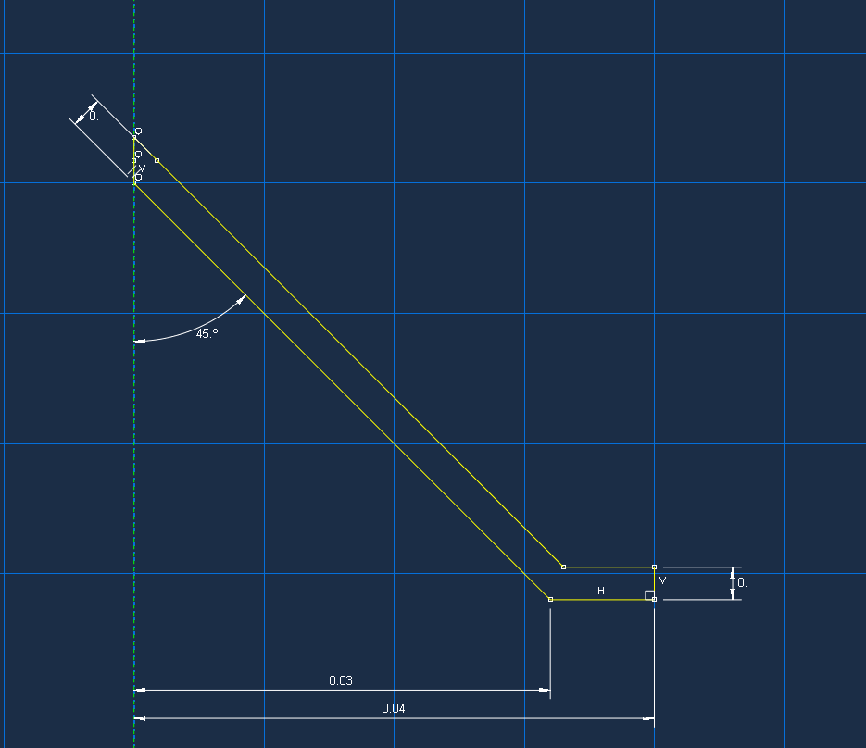
Figure 1 – SC 1 Liner Dimensions
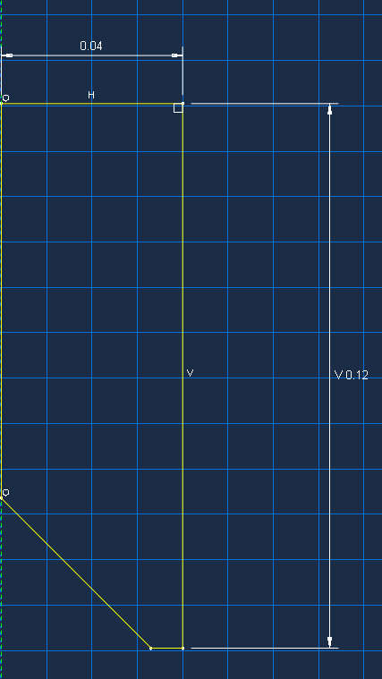
Figure 2- SC 1 HE Dimensions

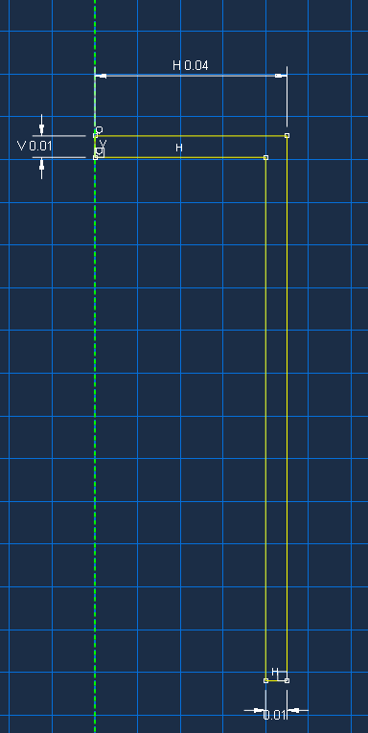
Figure 3- SC 1 Case Dimensions

3.2.2 Material Properties
The material properties for each of the simulations can be seen in the below tables. The material properties were chosen from the literature review.
Density | = 8913 kg/m³
Young’s Modulus | = 69 GPa
Poisson’s Ratio | = 0.33
Melting Temperature | = 1356 K
Transition Temperature | = 298 K
Yield Stress, A | = 90 x 10⁶ Pa
Hardening Coefficient, B | = 292 x 10⁶ Pa
Hardening Exponent, N | = 0.31
Strain Rate Coefficient, C | = 0.025
Thermal Softening Exponent, M | = 1.09
Table 1 – Copper Parameters [15]

Density | = 2700 kg/m³
Young’s Modulus | = 117.2 Gpa
Poisson’s Ratio | = 0.33
Melting Temperature | = 873 K
Transition Temperature | = 298 K
Yield Stress, A | = 324 x 10⁶ Pa
Hardening Coefficient, B | = 114 x 10⁶ Pa
Hardening Exponent, N | = 0.42
Strain Rate Coefficient, C | = 0.002
Thermal Softening Exponent, M | = 1.34
Table 2 – Aluminium Properties [16]

Density | = 2700 kg/m³
JWL EOS
𝜌0 | = 1.891
A | = 778.3 GPa
B | = 7.07 GPa
C | = 0.64 GPa
R1 | = 4.2
R2 | = 1
𝜔 | = 0.3
Table 3 – HMX Properties [13]

3.2.3 Meshing
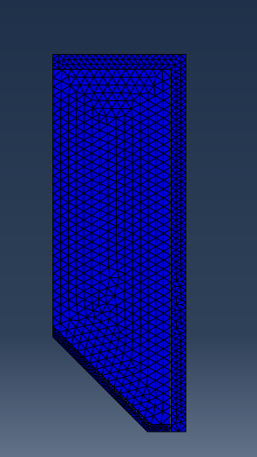
Figure 4 – SC 1 Meshing
A refined mesh for the liner was used for the 2D shaped charge. This decision is since the jet formation is a result the shock wave on the liner, thus, a high level of elemental change is to be expected within this part. A coarser mesh has been used for the explosive charge, this mesh is fine enough to show the shock wave pass through the charge without using up a large number of elements and forcing the software to take extra time to compute. The reaction and results of the aluminium case is not of interest to this report so the meshing on that part has been left relatively coarse, however, still fine enough to be able to calculate results without error.

3.2.4 Boundary Conditions
For the 2D shaped charge, a “symmetry, antisymmetry, encastre” boundary condition was added to the line that defined the symmetry, in this case everything touching the y-axis. The condition used was a XSYMM.

3.2.5 Interaction
The three separate parts must be in contact with one another for the simulation to correctly calculate the results. For this, a surface-to-surface contact between all three parts was created with the default mechanical tangential behaviour as well as normal behaviour.

3.3 2D Shaped Charge-2

3.3.1 Part Dimensions
The dimensions of SC-2 can be seen below:
Charge diameter = 80mm
Charge height 80x2= 160mm
Liner diameter = 64mm
Liner thickness = 2.5mm
Liner angle = 45°
Figure 5 – SC 2 Liner Dimensions
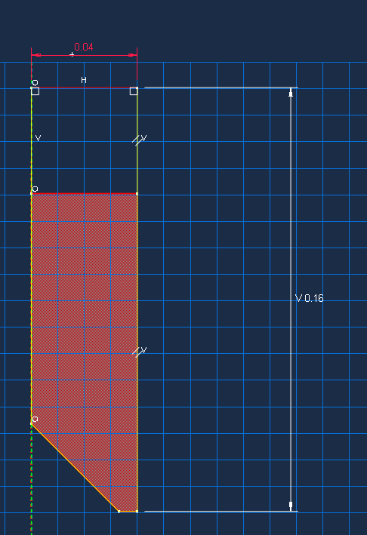
Figure 6 – SC 2 HE Dimension
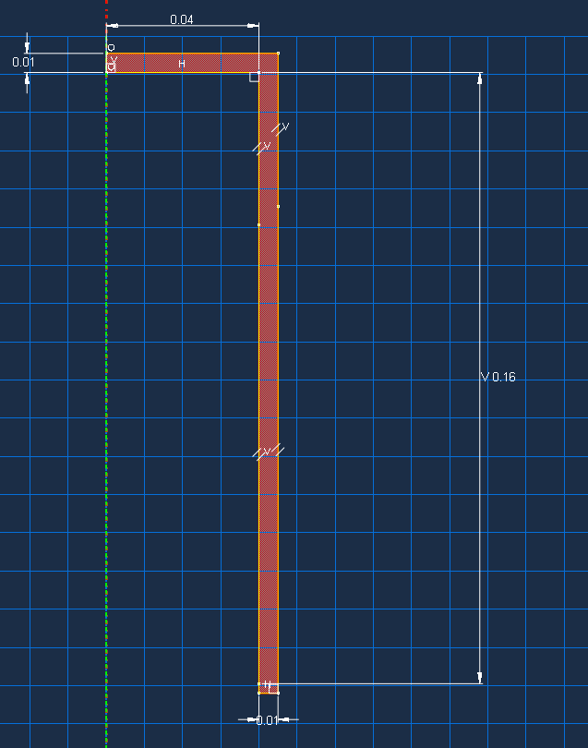
Figure 7 – SC 2 Case Dimension

3.3.2 Material Properties
The material properties for this model were taken from the previous model (SC 1). They were added to the material library database, within the localised Abaqus server, so that each property was copied over identically and did not have to be inputted multiple times. This method is more time efficient while ensuring confidence that the inputted data is identical.

3.3.3 Meshing

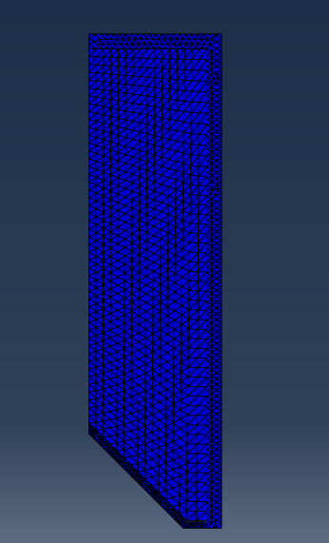
Figure 8 – SC 2 Meshing
Variation in mesh sizing and controls compared to SC-1 was kept to a minimum. Meshing was completed with the same intentions for both models.

3.3.3 Boundary Conditions
The same boundary conditions were used for SC-2 as SC-1.

3.3.4 Interaction
A surface-to-surface contact was added to the three parts with the same behaviours as SC-1.

3.4 3D Shaped Charge
The 3D shaped charge was designed based off SC-2. The dimensions were kept uniform and changes were made to the model. This was done by creating a copy of the SC-2 model within Abaqus. By doing this it allows for direct duplication yet does not prevent the use of the original model. These models are then easily swapped between when and if needed.

3.4.1 Changes to Design
It is not just as simple as copying the model and changing the model type from 2D to 3D to make the 3D SC. Everything had to be recomputed.

3.4.1.1 Part
To do this, a soft save of the part dimensions from the 2D design was undertaken, this file was then used to redraw the parts in the 3D model.

3.4.1.2 Material Properties
In this instance, due to the copying of the model the material properties were already available and the same within the model. The materials just needed reassigning to the new 3D sections.

3.4.1.3 Mesh
Initially the model was meshed while the parts of the assembly were independent, this turned out a number of issues that are addressed in 4.2. Due to this the parts were then made dependent and meshed separately, this allowed for a more refined mesh in specific areas.

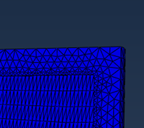
Figure 9 – Original 3D SC Mesh

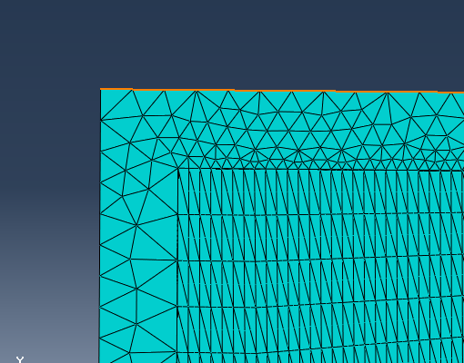
Figure 10 – Improved 3D SC Mesh
Figure 10 shows the graduated mesh used to allow each face of the part to interface with one another. As you can see by the above figure, the sizing constraints have been set at the same size along both parts. This was done after complications occurred with the original mesh. Further detail regarding the mesh can be located in the 4.2.

3.4.1.3.1 Adaptive Meshing
An “adaptive mesh” was also used for the 3D model. Adaptive meshing allows the software to capture discontinuations within elements yet does not change the relationship that the element has with the global model [17]. The benefits of this are that mesh distortion is reduced and accuracy is increased. For this simulation both Arbitrary Lagrangian- Eulerian (ALE) and Smoothed Particle Hydrodynamics (SPH) meshing techniques were used on separate occasions.

Results

4.1 2D Shaped Charge Results

4.1.1 2D Shaped Charge – 1

4.1.1.1 S. Max Principal
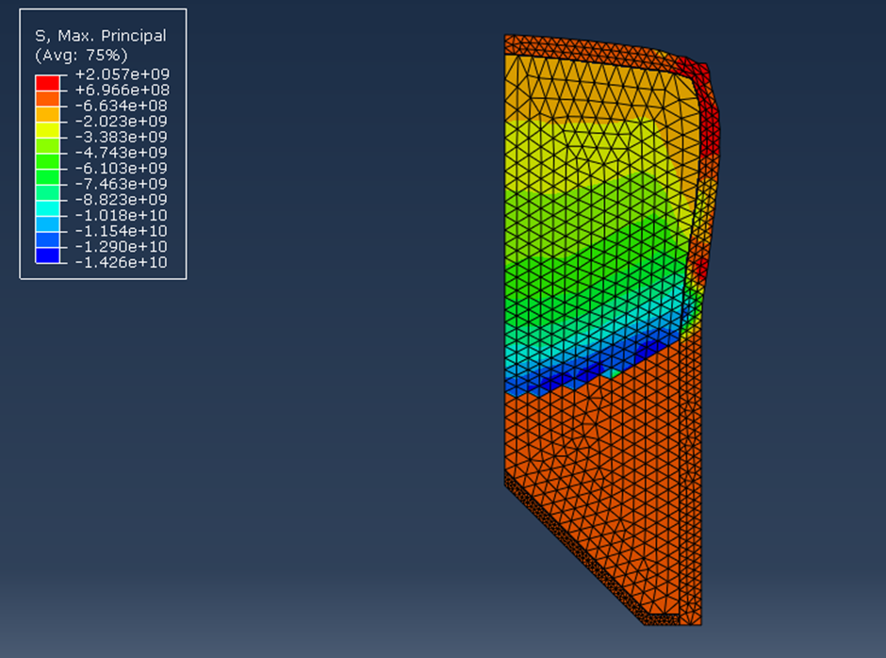
Figure 11 – S. Max Principal SC-1
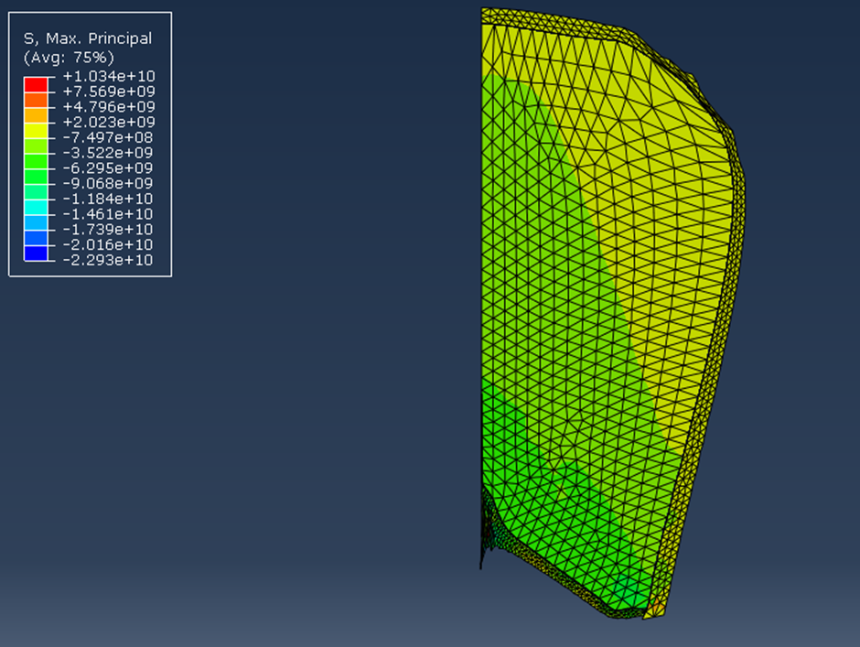
Figure 12 - S. Max Principal SC-1
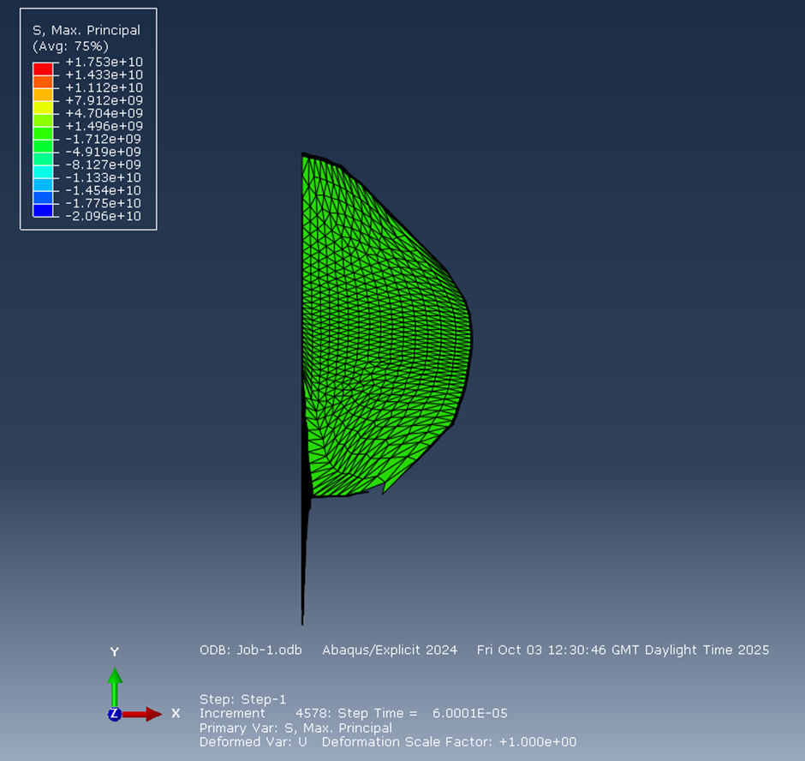
Figure 13 – S. Max Principal SC-1

4.1.1.2 Jet Formation

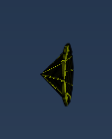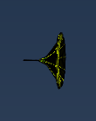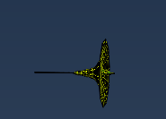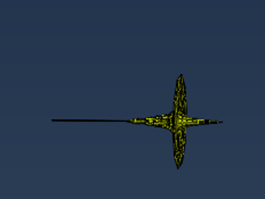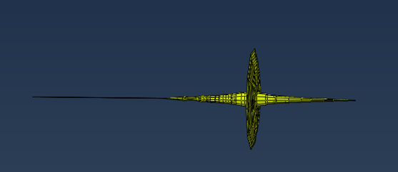
Figure 14 – Jet Formation SC 1

4.1.1.3 Velocities
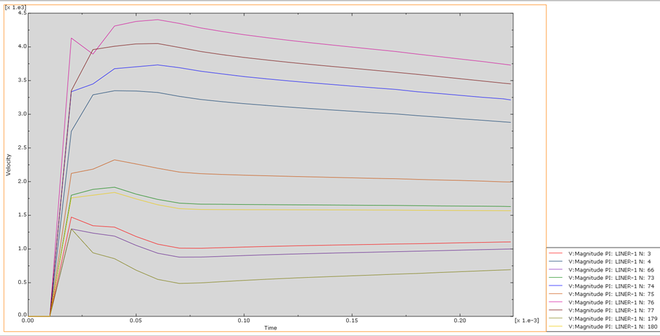
Figure 15 – Velocity Time Graph SC-1

4.1.2 2D Shaped Charge – 2

4.1.2.1 S. Max Principal
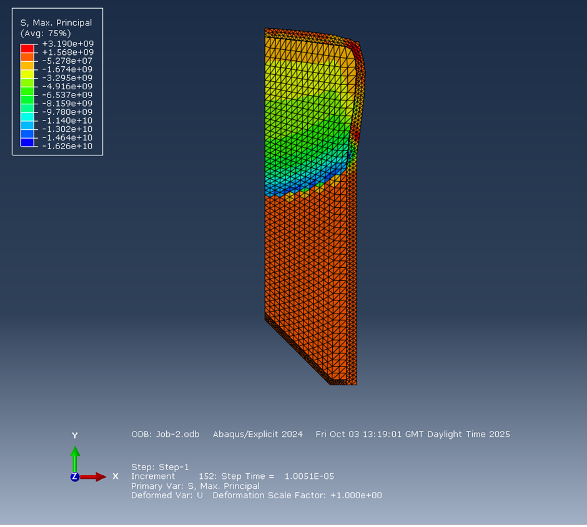
Figure 16 – S. Max Principal SC-2
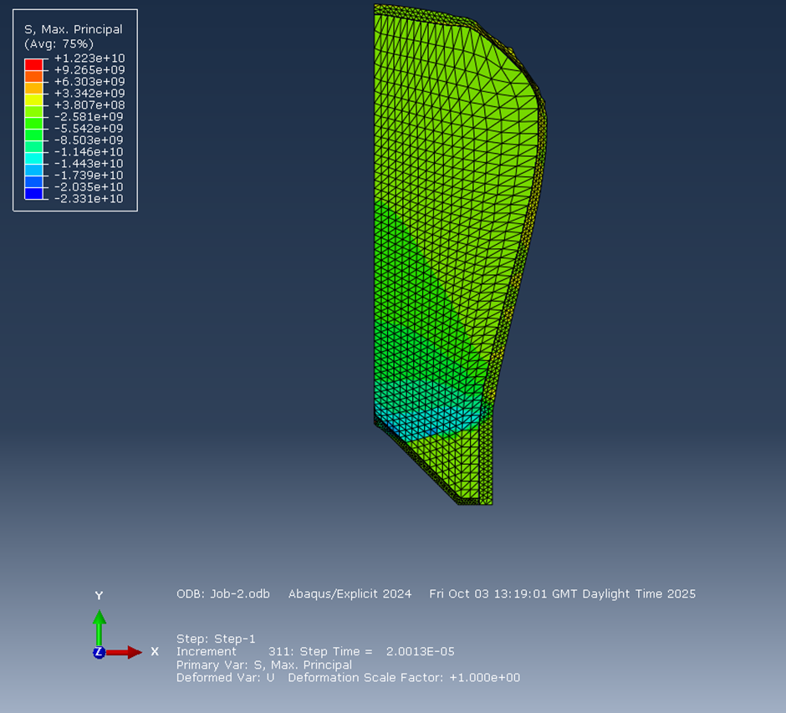
Figure 17 – S. Max Principal SC-2
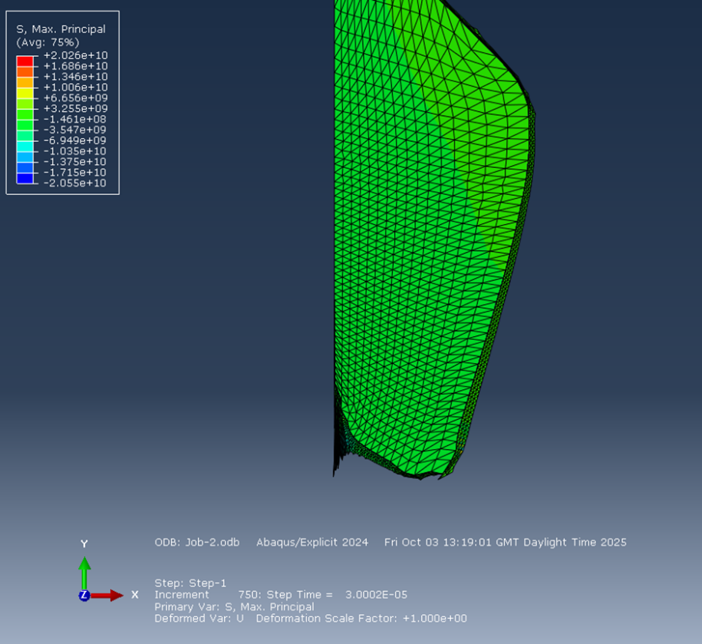
Figure 18- S. Max Principal SC-2
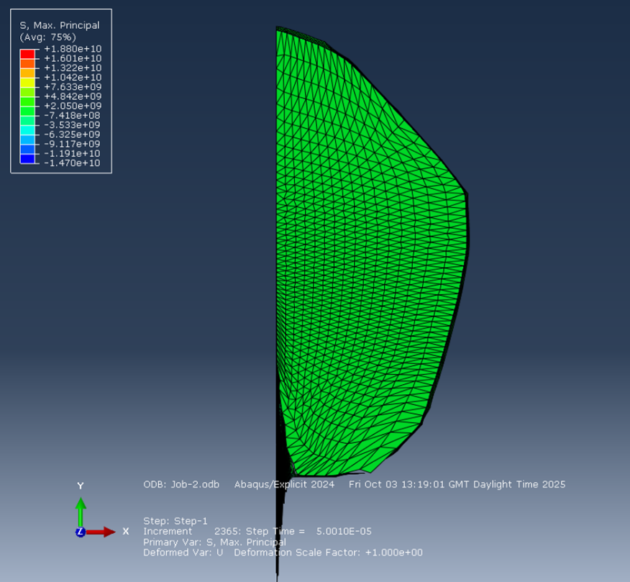
Figure 19 – S. Max Principle SC-2

4.1.2.2 Jet Formation
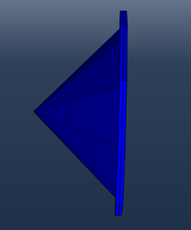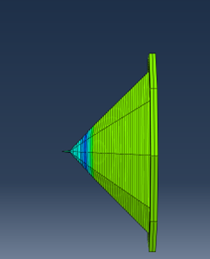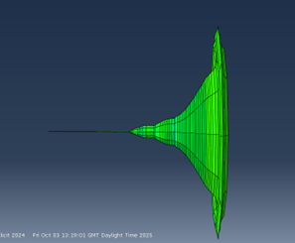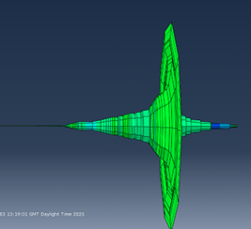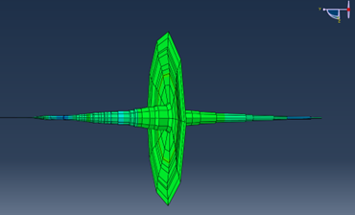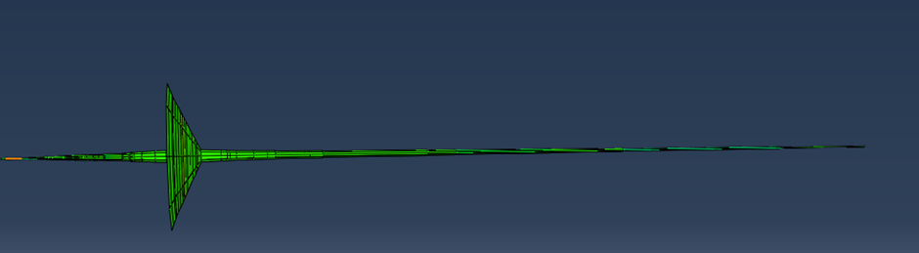
Figure 20 – Jet Formation SC-2

4.1.2.3 Velocities
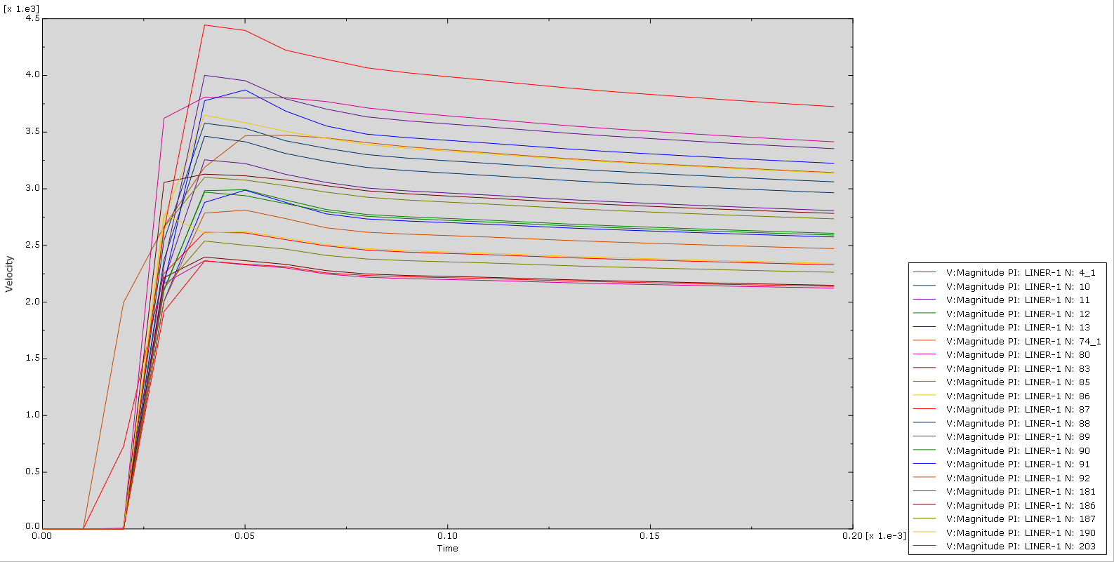
Figure 21 – Velocity Time Graph SC-2

4.1.3 Comparison of 2D Results

4.1.3.1 S. Max Principal
In SC-2 a higher result was seen in this field. This is to be expected due to the increase in the mass of the explosive used compared to SC-1.

4.1.3.2 Velocities
The velocities seen by SC-1 range between 1m/s to 4m/s. The velocities for SC-2 are seen more consistently between 2m/s and 4m/s. This disproves the hypothesis that SC-2 would have a higher velocity due to the increased mass of explosive used. Although more consistent higher speeds were exerted by elements in SC-2 the overall maximum velocity of both shaped charges are almost identical.

4.1.3.3 Visually
Visually there are minima differences between the results of SC-1 and SC-2. Both have produced similar jets that travel at similar velocities.

4.1.4 Limitations of results
Using a coarser mesh may have had a slight detrimental effect on the results as it shows less propagation of the blast as well as doesn’t allow to see the case being broken. However, for the 2D design, it improved efficiency and was beneficial to the computational cost when looking at the jet created in a 2D model.

4.2 3D Shaped Charge Results
Multiple iterations of meshing were required to obtain results that satisfied the report. Initially the only change in mesh was to be the change from standard meshing to ALE meshing to SPH meshing. However, problems were encountered that relied on a change of mesh to rectify.

4.2.1 Original Mesh Results
A coarser mesh was used originally. The benefit of using a coarse mesh is that it has a low computational cost. This is beneficial for doing a first run of the model to ensure no errors have been made when designing it.

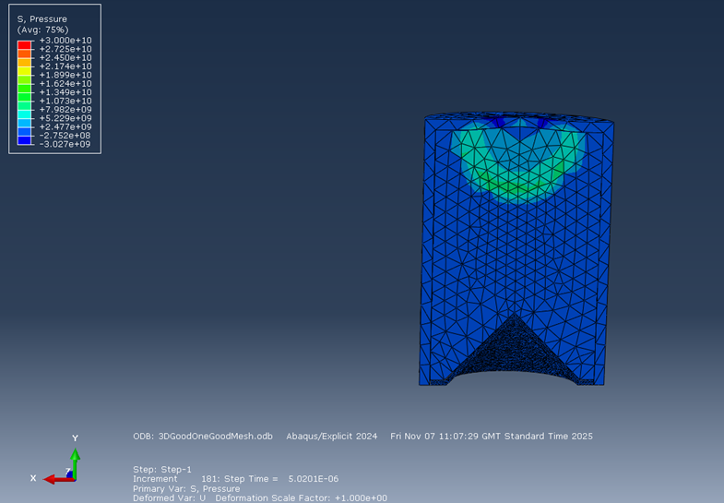
Figure 22
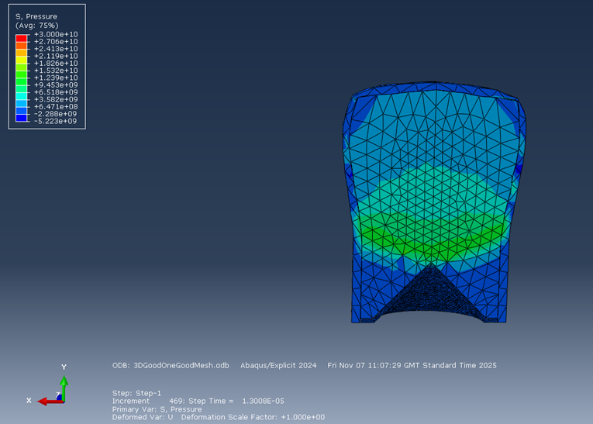
Figure 23
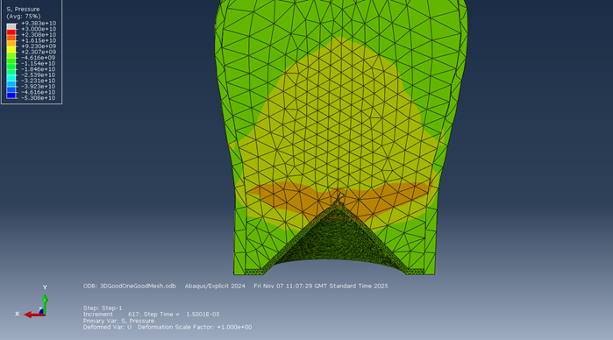
Figure 24
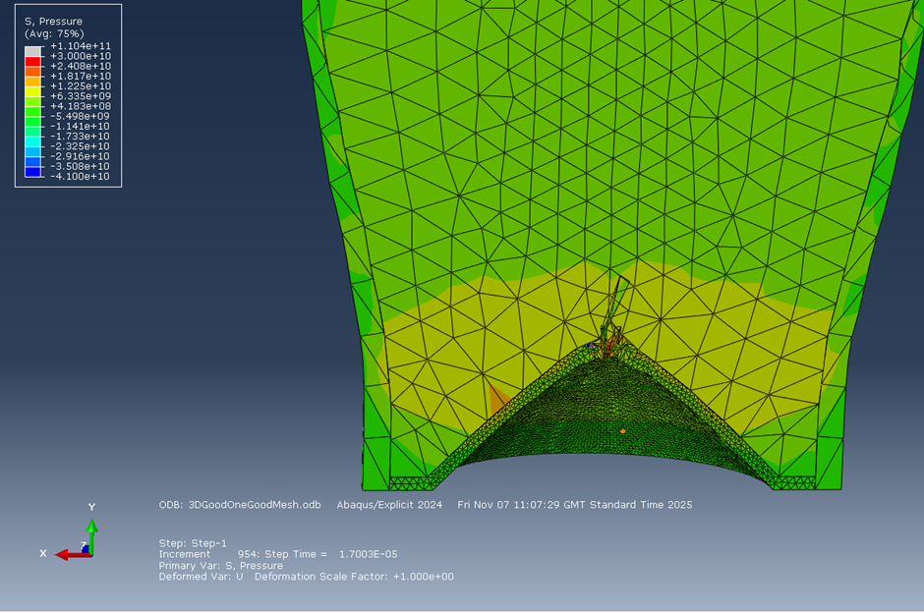
Figure 25
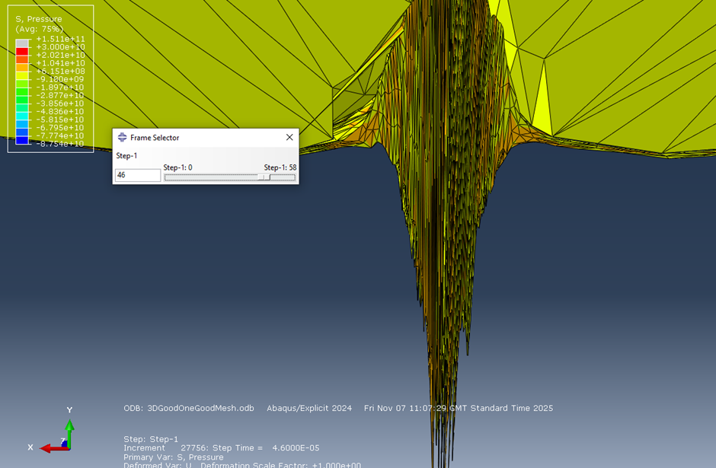
Figure 26

4.2.2 Finer Mesh
When the mesh was made finer than in Figure 22 to Figure 26 issues became apparent when running. Tweaks were made to the model to combat this. The parts were meshed as dependent parts, and a general contact was added to the outer HE and inner casing to try and limit the element distortion. This was somewhat successful, however, would only run for 90 steps.
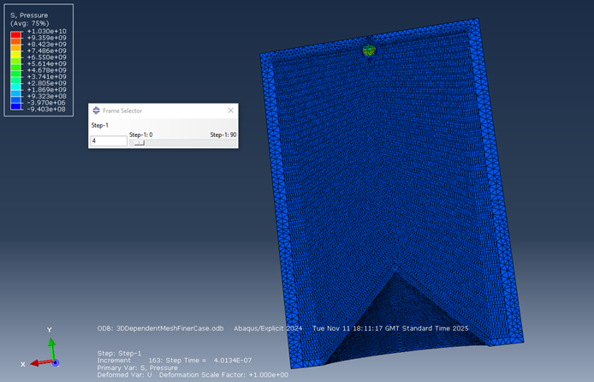
Figure 27
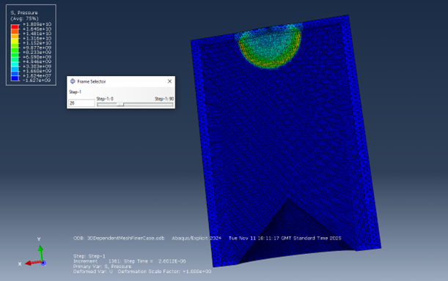
Figure 28
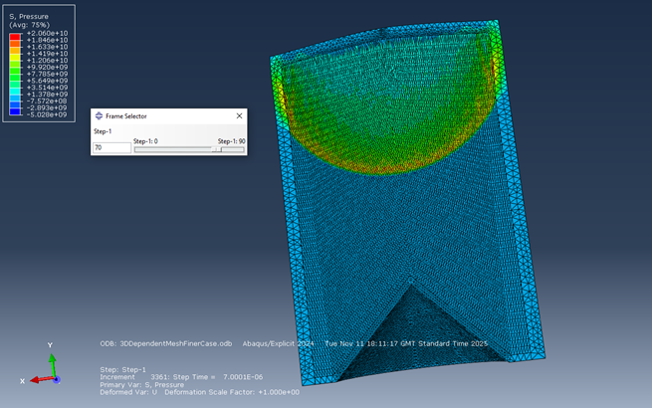
Figure 29
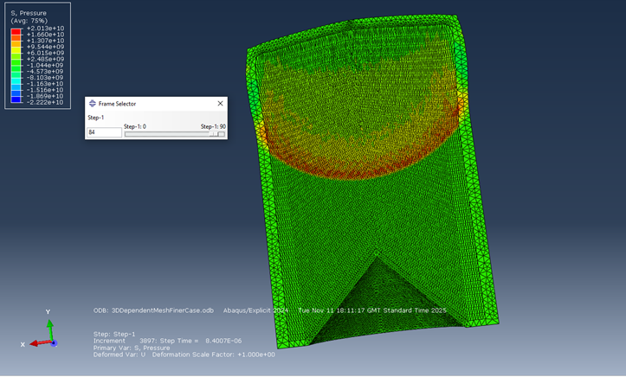
Figure 30 – Finer Mesh final step

4.2.3 ALE Adaptive Mesh
The simulation was able to run using and ALE adaptive mesh. The model was meshed while the parts were independent, and the liner was made adaptive with ALE.

4.2.2.1 S. Max Principal
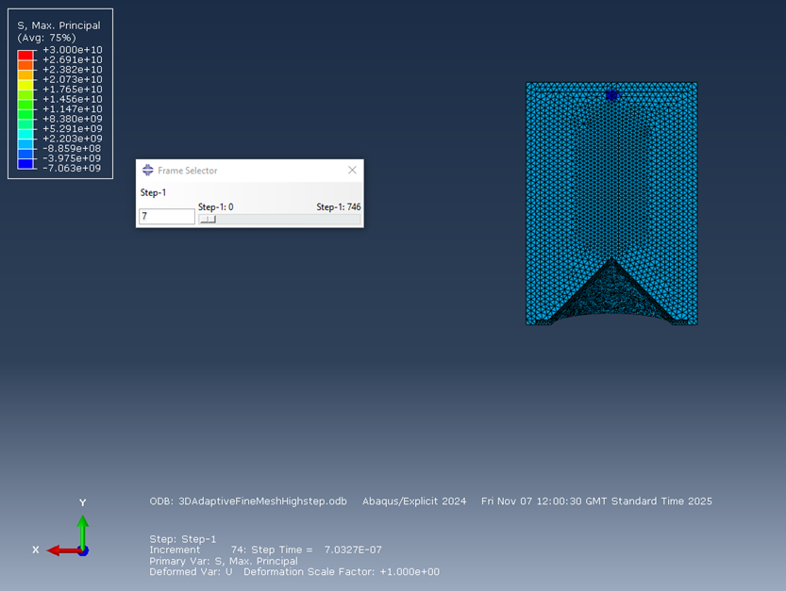
Figure 31
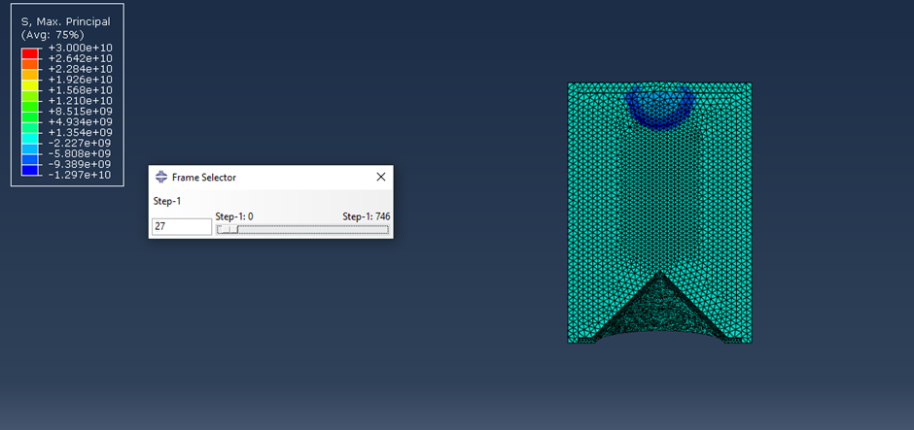
Figure 32
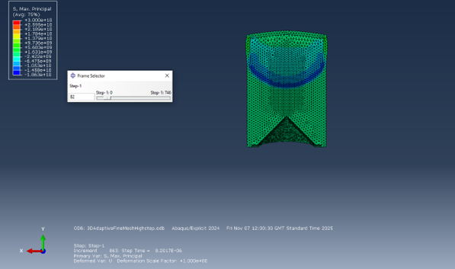
Figure 33
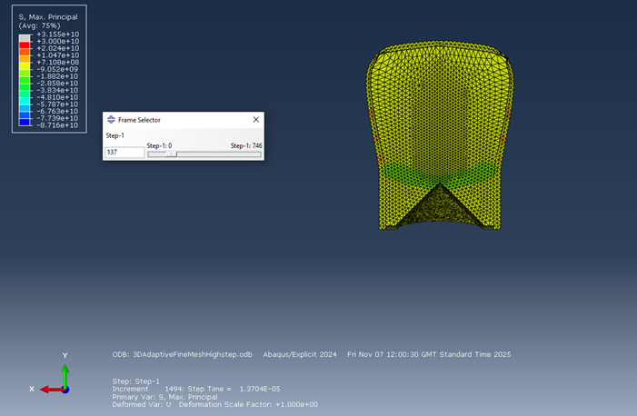
Figure 34
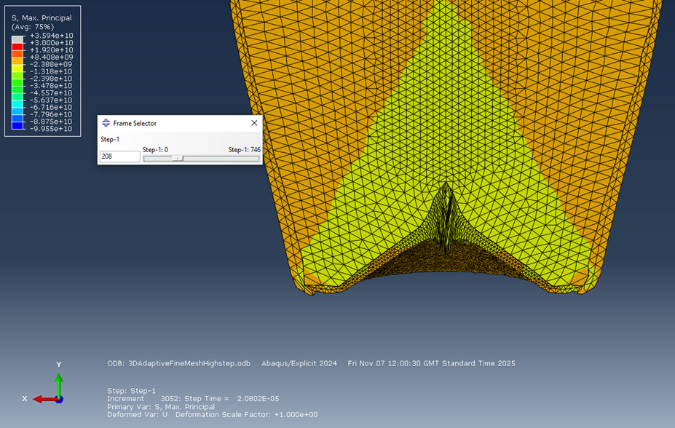
Figure 35
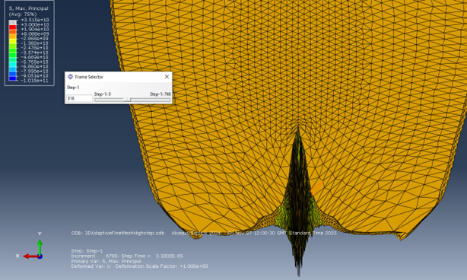
Figure 36
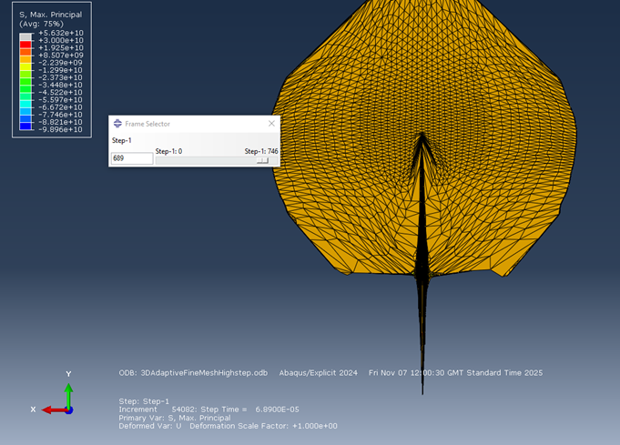
Figure 37

4.2.2.2 Pressure
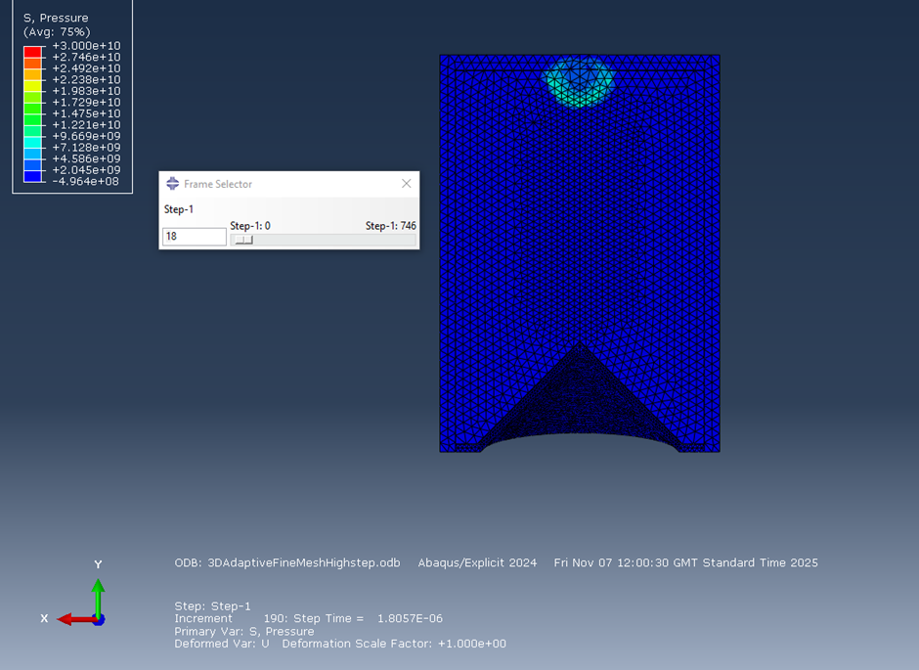
Figure 38
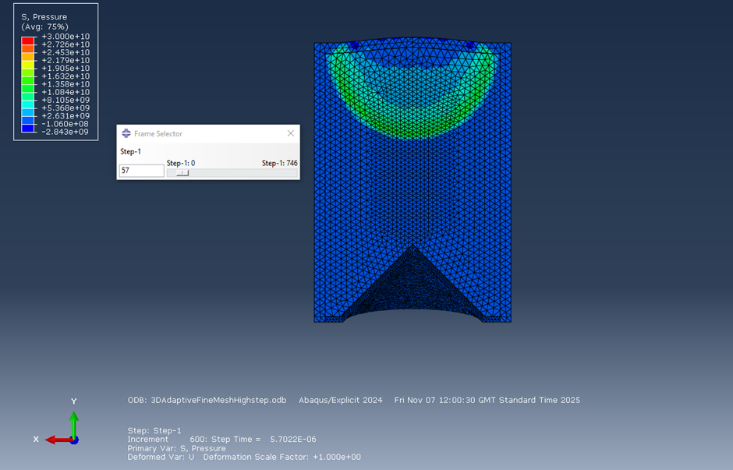
Figure 39
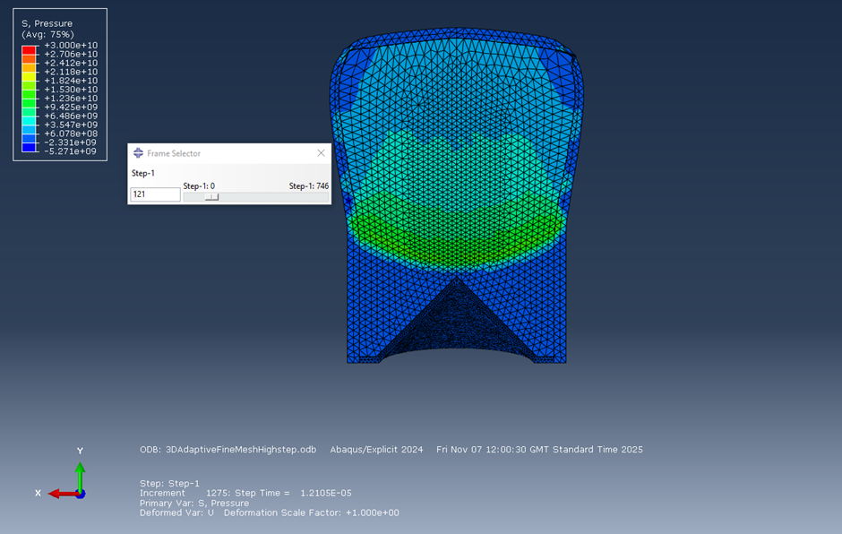
Figure 40
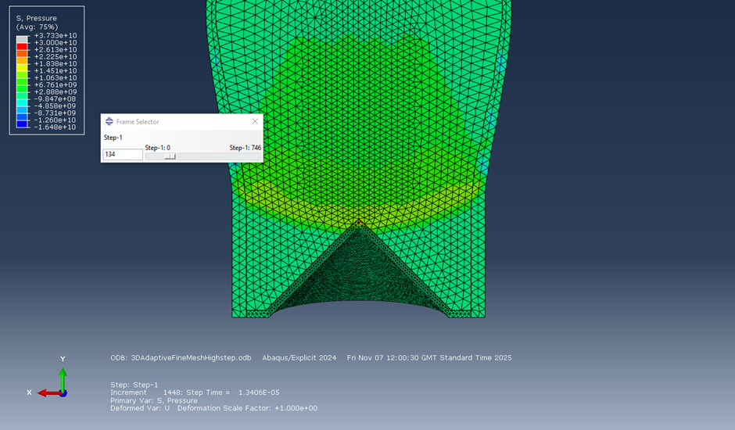
Figure 41
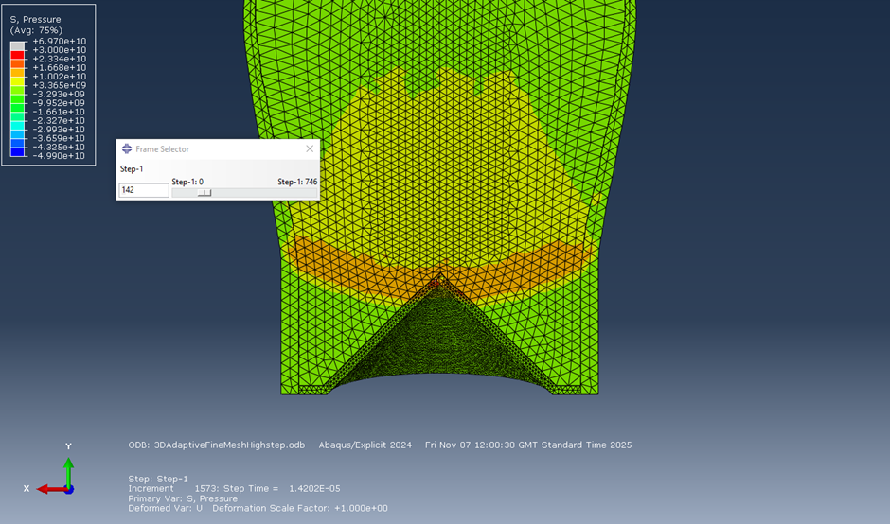
Figure 42
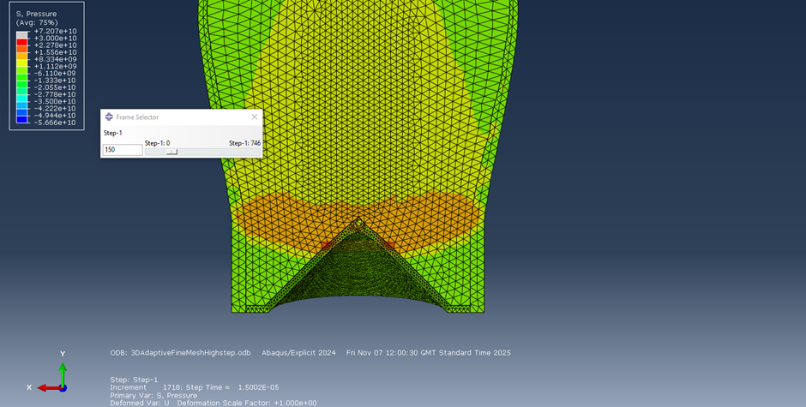
Figure 43
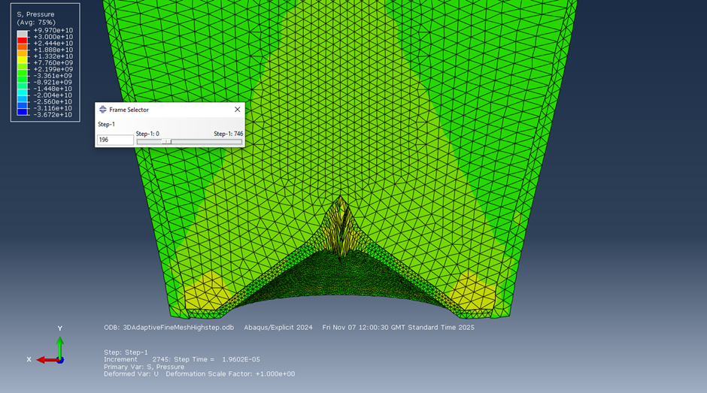
Figure 44

4.2.4 SPH Adaptive Mesh
The model would also run when an SPH adaptive mesh was added to the liner and used from the first step.
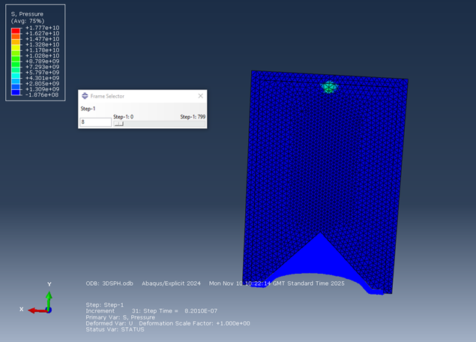
Figure 45
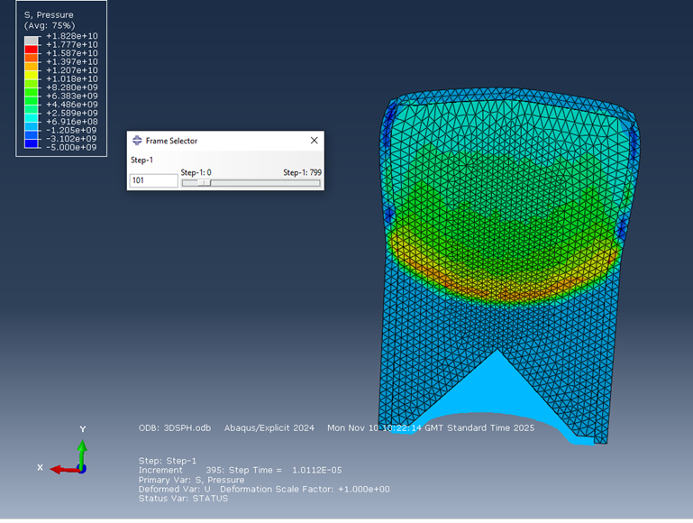
Figure 46
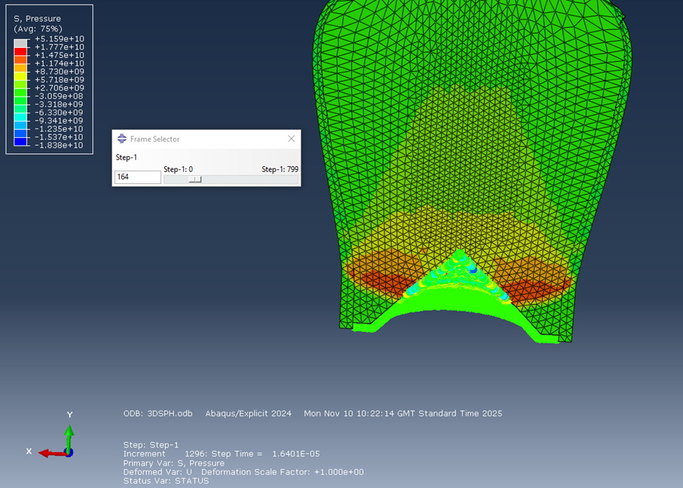
Figure 47
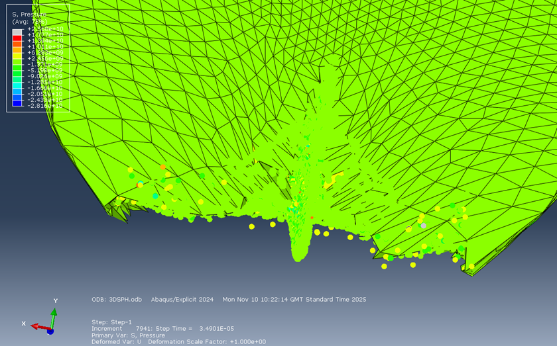
Figure 48
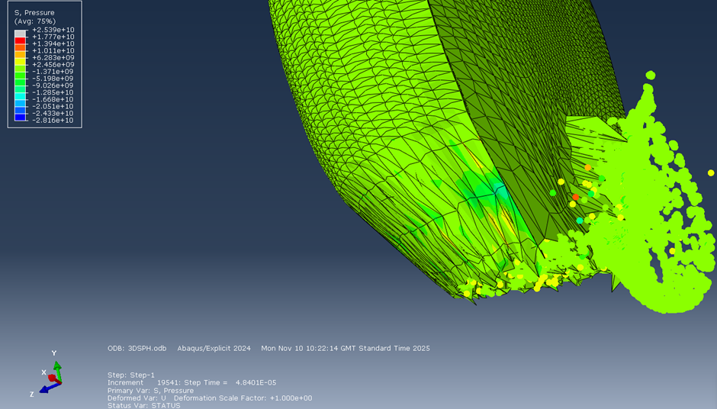
Figure 49
An Issue with using SPH is that it is not restricted to the 2D plane, this can be seen in Figure 49.

4.2.3 Velocity
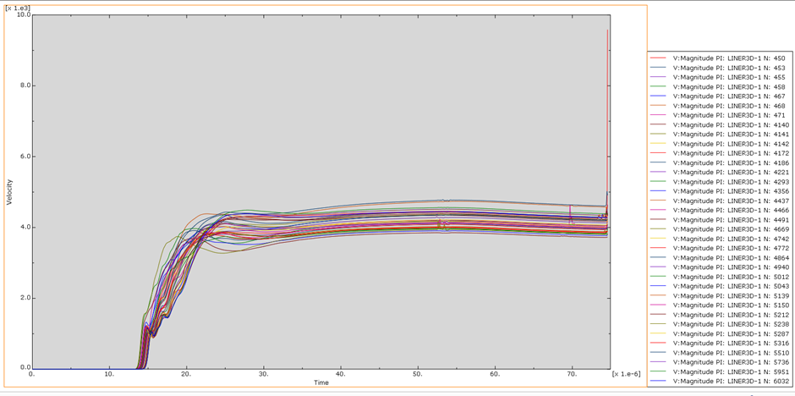
Figure 50 – Velocity Time Graph 3D SC

4.2.1 Comparison of 2D and 3D Results
The results seen in SC-2 and the 3D SC are very similar. The velocities seen in both align with one another. The 3D models took a greater amount of real time in order to run, this is due to it being much more complex for the computer to solve. Dependent on the situation, both ways could be very beneficial to engineers. For an approximate inexact, however, quick and easy result the 2D axisymmetric method would be sufficient. If a precise well computed result was required 3D would be a more effective approach.

Conclusion
Shaped charges are useful in many circumstances. The effect of them has helped and hindered soldiers on the battlefield for many years and will continue to do so for many more to come. It is essential that engineers can predict the effectiveness of such weapons. Both 2D and 3D modelling of shaped charges can be done. When using 3D design, using an ALE adaptive mesh allows for accurate computing of such a high speed, dynamic problem.

Bibliography

[1] | Walters, William, and Aberdeen Proving Ground, “An Overview of the Shaped Charge Concept,” 11th Annual ARL/USMA Technical Symposium,, vol. 5, 2003.
[2] | W. Walters, “A Brief History of Chaped Charges,” U.S. Army Research Laboratory , Aberdeen , 2008.
[3] | D. R. Kennedy, “History of the shaped charge effect: the first 100 years,” 1990.
[4] | Y. Miao, X. Li, X. Wang, H. Yan and X. Chen, “Muroe effect based on detonation wave collision,” IOP Conference Series Earth and Environmental Science, vol. 64, pp. 012081-012081, 2017.
[5] | J. Hall, “Shaped Charges: Harnessing Precision in Explosive Technology,” Alford Technologies, 20 Jan 2025. [Online]. Available: https://www.explosives.net/shaped-charges-explosive-technology/.
[6] | Ansys, “www.ansys.com,” 2025. [Online]. Available: https://www.ansys.com/simulation-topics/what-is-finite-element-analysis.
[7] | J. J. Milinazzo, “Energy Transfer of a Shaped Charge,” in OSTI OAI, Albuquerque, NM (United States), U.S. Department of Energy Office of Scientific and Technical Information, 2026.
[8] | P. W. Cooper, Explosives Engineering, New York: Wiley-VCH, Inc, 1997.
[9] | G. F. Kinney and K. J. Graham, Explosive Shock in Air Second Edition, Springer Science & Business Media , 2013.
[10] | abaqus-docs, “Johnson Cook Plasticity,” abaqus-docs.mit.edu, [Online]. Available: https://abaqus-docs.mit.edu/2017/English/SIMACAEMATRefMap/simamat-c-johnsoncook.htm.
[11] | G. Farag and A. Chinnayya, “On the Jones-Wilkins-Lee equation of state for high explosive products,” Propellants, Explosives, Pyrotechnics,, vol. 49, no. 3, 2024.
[12] | R. Liu, L. Tang, X. Jia, X. Jiao, R. Yan and X. Jiang, “JWL equation of state parameters for ideal detonation: A comparative study of literature reports, theoretical derivation, and artificial neural network prediction,” FirePhysChem, 2025.
[13] | Z. Yang, J. Rong and Z. Zhao, “Study on the prediction and inverse prediction of detonation properties based on deep learning,” Defence Technology , vol. 25, pp. 18-30, 2022.
[14] | Cranfield University, “Ammunition Technology Handbook,” in Warheads, Cranfield University , 2015.
[15] | D. M. Iordache, E. R. Oprescu, C. I. Malea, E. L. Nitu and C. Badulescu, “Determination of Johnson-Cook material constants for Copper using traction test and inverse identification,” IOP Publishing , 2021.
[16] | S. Akram, S. H. I. Jaffery, M. Khan, M. Fahad, A. Mubashar and L. Ali, “Numerical and experimental investigation of Johnson–Cook material models for aluminum (Al 6061-T6) alloy using orthogonal machining approach,” Advances in Mechanical Engineering, 2018.
[17] | S. E. Stapleton, E. J. Pineda, T. Gries and A. M. Waas, “Adaptive shape functions and internal mesh adaptation for modeling progressive failure in adhesively bonded joints,” International Journal of Solids and Structures , vol. 51, no. 18, pp. 3252-3264, 2014.

