

ACCA7028 - Data Security, Governance and Compliance



Enhancing Information System Security, Governance, and Compliance


2231139 – Jenishkumar Paghadar

Table of Contents

Abstract 2
List of Figure 3
List of Table 3
1. Introduction 4
List of Abbreviations 5
2. Literature Review (List of Frameworks and Security Model) 6
• ITG (IT Governance) 6
2.1 COBIT (Control Objectives for Information and related Technologies) 8
2.2 ITIL (Information Technology Infrastructure Library) 9
2.3 ISO/IEC 27001 Framework 10
2.4 ISAE 3402 (International Standard on Assurance Engagements 3402) 11
2.5 ISO/IEC 38500 12
3. Methodology 13
3.1 Establishing a Comprehensive Security Policy: 13
3.2 Focussing Compliance Requirements: 14
3.3 Risk Management Framework: 14
3.4 Security Policies and Procedures: 15
3.5 Continuous Monitoring and Improvement: 15
3.6 Updated Regulations and Standards: 17
4. Result and Analysis 18
5. Conclusion 19
References 20

Abstract

The importance of information security has become increasingly significant in the modern business environment, given that every action is influenced by technology. Considerable endeavours have been expended over time to ensure that organisations manage information security in a standardised and efficient manner. Various frameworks and protocols, such as COBIT, ITIL,[1] and ISO/IEC 27001, have been proposed to assist in this issue. The primary focus of this effort was ISO/IEC 27001. An international standard is a document that outlines the proper functioning of an Information Security Management System (ISMS). The objective of the industry norm is to improve the administration of information security procedures for organisations of all sizes, ensuring that they are in accordance with globally recognised standards.

List of Figure

Figure 1: Key Areas of ITG 7
Figure 2: Principals of COBIT 8
Figure 3: ITIL Service Cycle 9
Figure 4: PDCA Cycle 11
Figure 5: ISO/IEC 38500 Model 12

List of Table

Table 1: IoT Governance Requirement and Main Components 16
Table 2: Conceptual Framework for NatureGarden 17

1. Introduction

NatureGarden (NG) is a model organisation that promotes healthy lives in the digital age and global commerce. Due to its global presence and high reliance on cloud-based IT services, NG must urgently upgrade its digital infrastructure to address security issues. This approach conflicts with the company's main goal of preserving personal and client data and billion-dollar intellectual property.

In order to effectively address these difficulties, it is crucial to thoroughly explore established security frameworks and models, such as ITIL, ITG, COBIT and ISO 27000.[2] This will allow for the development of a customised strategy that aligns with NG's specific information system security, governance, and compliance needs. The objective of this research is to thoroughly examine these frameworks, assess their applicability to NG's security challenges, and eventually provide a complete strategy that successfully addresses the company's urgent security requirements. Furthermore, the research will thoroughly examine the importance of continuously changing legislation and standards in the field of information security, highlighting their essential role in guaranteeing the ability to adjust to emerging risks and changing business environments.

List of Abbreviations

ISMS – Information Security Management System
ISO – International Organization for Standardization
IEC – International Electrotechnical Commission
SMEs – Small and medium-sized enterprises
CIA – Confidential, Integrity and Availability
PCI DSS – Payment Card Industry Data Security Standard
ITIL – Information Technology Infrastructure Library
ITGI – IT Governance Institute
COBIT – Control Objectives for Information and Related Technology
IS – Information Security
DSR – Design Science Research
NIST - National Institute of Standards and Technology
CSA - Cloud Security Alliance
SMS – Service Management System

2. Literature Review (List of Frameworks and Security Model)

"Framework" in computer security refers to a method or set of rules that companies use to plan, set up, and oversee their security controls and processes. The methodical approach makes it possible to deal with security issues and dangers in a planned way. There are some frameworks described below which will cover security aspect for NatureGarden company.

ITG (IT Governance)

Organisation management includes the concept of IT governance, which relates to the procedure through which information technology resources are synchronised and improved in order to accomplish the objectives of the organisation. Information technology governance, denoted by the acronym ITG,[3] is a comprehensive framework comprising decision rights, leadership, organisation, scalable processes, and facilitating technologies, among other things. This is achieved through the allocation of duties and obligations that must be complied with to guarantee the optimal and productive utilisation of information technology infrastructures within institutions.[4] ITGI identifies five specific areas on which the governance of IT should focus: strategic alignment, value delivery, risk management,[5] resource allocation, and performance management. Which is define in Figure 1.
- Strategic alignment: as it pertains to this domain, signifies the imperative for IT governance strategies and plans to be compatible with the overarching strategy of the organisation. Alternatively, for information technology governance strategies to deliver the intended outcomes, they must be derived from the business plan.

- The benefit of implementing ITG is evident in the value it delivers to the organization, enhancing many parts of company processes to optimize earnings.

- IT governance controls and mitigates organizational risks, ensuring business continuity and resilience.

- Information technology governance prevents inappropriate allocation and use of resources. This ensures appropriate provision, investment, and usage of IT resources.

- Performance management: With ITG, businesses can find out how well they're using IT and get ideas for how to improve their efficiency in the future.

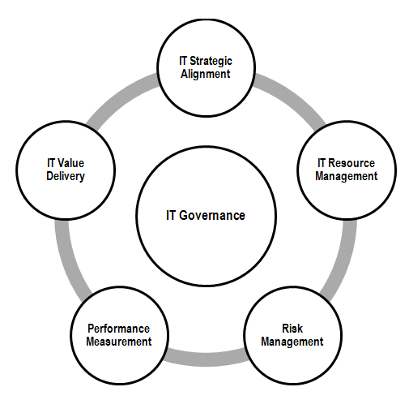
Figure 1: Key Areas of ITG

- List of Security Frameworks and Models:
1. COBIT (Control Objectives for Information and related Technologies)
2. ITIL (Information Technology Infrastructure Library)
3. ISO/IEC 27001
4. ISAE 3402 (International Standard on Assurance Engagements 3402)
5. ISO/IEC 38500

2.1 COBIT (Control Objectives for Information and related Technologies)

Businesses all over the world progressively use COBIT, a publicly available standard known as Control Objectives for Information Technologies and considered to be "trusted".[6] The Information Systems Audit and Control Association (ISACA) developed the COBIT framework specifically for information technology governance and management. The most recent version of COBIT 2019 builds on 20 years of good governance work. Basic principles of COBIT shown in Figure 2.

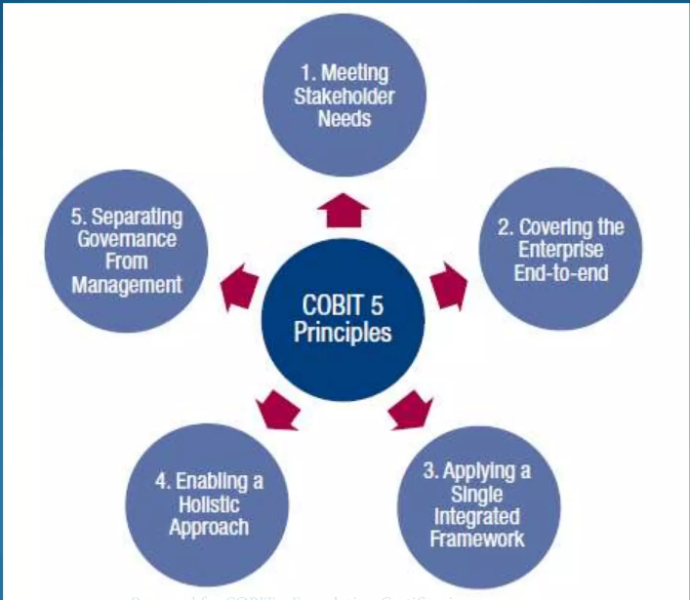
Figure 2: Principals of COBIT

The purpose of the COBIT framework is to provide managers with a useful tool. Because it places an emphasis on the business requirement that is addressed by each control objective, COBIT is likely the most suitable governance framework to assist an organisation in ensuring that its use of information technology is aligned with its business objectives.[7]

2.2 ITIL (Information Technology Infrastructure Library)

The Information Technology Infrastructure Library (ITIL) is a framework that was originally created by the Central Computer and Telecommunications (CCTA) and later combined with the Agency Office of Government Commerce (OGC) of Great Britain.[8] It encompasses the best practices for managing IT services (ITSM) and delivering them in alignment with business requirements. Since 2013, AXELOS, a joint venture between Capita and the UK Cabinet Office, has been responsible for managing the ownership of ITIL.
ITIL enables businesses to align their IT services with their business objectives, ensuring that they effectively contribute to achieving their goals. Businesses can rely on this information to effectively utilise their IT services to achieve their objectives and facilitate the development of their organisation.[9] ITIL offers a series of authorised certificates that instruct on the most effective methods for managing services and demonstrate how to apply this knowledge across the whole lifespan of an IT service. The compilation consists of five primary volumes that provide optimal guidance for a comprehensive approach to IT service management (ITSM).

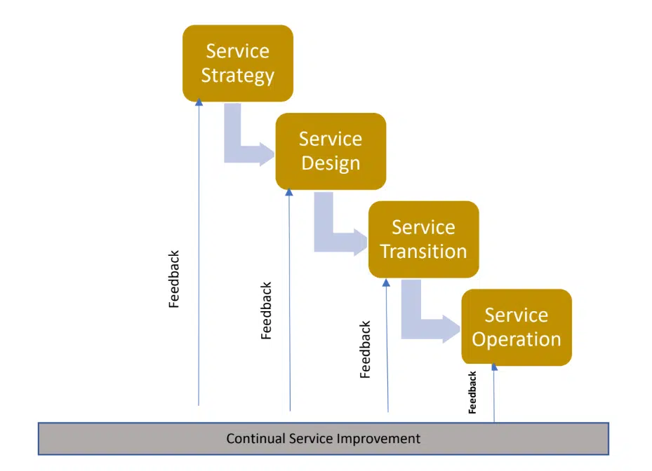
Figure 3: ITIL Service Cycle
ITIL encompasses a set of standardised processes, checklists, tasks, and procedures that are not specific to any particular organisation or technology. These can be implemented by an organisation to support its strategy, generate value, and ensure a baseline level of proficiency. It enables the organisation to define a fundamental starting point from which it may strategically plan, execute, and evaluate. Organizations use it to demonstrate attentiveness and measure improvement.

2.3 ISO/IEC 27001 Framework

ISO/IEC 27001 is a standard developed by the International Organisation for Standardisation (ISO) and the International Electrotechnical Commission (IEC) working together as the Joint Technical Committee (JTC) 1 and Subcommittee (SC) 27.[10] This standard is widely recognized and worldwide regarded as a prominent standard for Information Technology Governance (ITG), with a primary focus on information security. It was previously known as ISO 17799:2005. Approximately 84% of countries worldwide utilize ISO standards, establishing ISO as the predominant standardization organization.[11]
The primary objective of ISO/IEC 27001 is to define the essential criteria for creating, implementing, maintaining, and continuously enhancing an information security management system (ISMS) inside an organization. An Information Security Management System (ISMS), when properly implemented, ensures the confidentiality, integrity, and availability of organizational information by integrating risk management processes into an organization's business activities and structure.[12] Each clause represents a collection of needs that are briefly explained below.
- Context of organization: To completely understand the context of the organisation, must know the external and internal surroundings, as well as the stakeholders and their demands and requirements. This awareness is crucial to identify the scope of the Information Security Management System (ISMS).
- Leadership and dedication: senior management should assure compatibility of safety priorities with organisational goals, achieving desired outcomes, and implementing safety measures.
- Planning: Planning involves implementing procedures to address risks and opportunities identified through information risk assessment results and utilising information risk treatment methodologies.[13]
- Support - assist in the process of establishing an information security management system by allocating resources, assigning qualified and competent individuals who possess the appropriate competency set, ensuring that there is a transparent information exchange between the various components of the ISMS, and providing documentation of the entire process to the individuals who are dedicated to the process.
- Operation: Achieve information security goals by carefully planning, implementing, and overseeing necessary procedures.
- Internal inspections and senior management reviews should conduct performance evaluation of the ISMS.
- Continuous enhancement: Given that organisations function within a dynamic environment, the ISMS should actively evaluate this operational context and implement preventive steps.
As per Framework, basic model shown in below figure.[14] Which is work like Plan, Do, Check, Act.
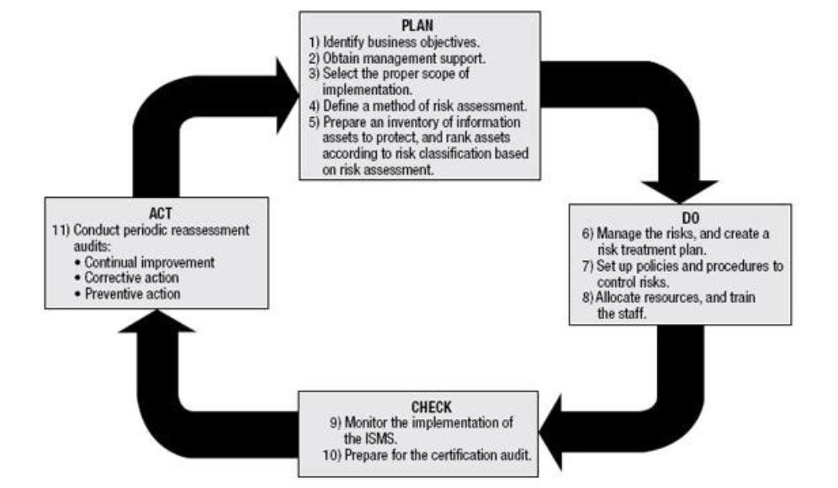
Figure 4: PDCA Cycle

2.4 ISAE 3402 (International Standard on Assurance Engagements 3402)

ISAE 3402 is an abbreviation for the International Standard on Assurance Engagements. The International Auditing and Assurance Standards Board (IAASB) introduced the 3402 standards in 2011 as a means of auditing service providers. [15]
This standard describes the steps that businesses should take to make sure their services meet the needs and demands of their users and customers. Customers will trust you more if you use this standard as a way to check the quality of your services. When businesses use ISAE 3402 to do audits on basic governance models like COBIT, they can make them more efficient and fit their own needs.

2.5 ISO/IEC 38500

This is an internationally recognized standard developed by a combined task force of ISO/IEC.[16] It provides a framework for effectively managing IT governance in organizations, while considering the legal, regulatory, and ethical duties that the top management must follow. Currently, ISO 38500: 2015 contains six principles of IT Governance.[17]
- Responsibility
- Strategy
- Acquisition
- Performance
- Conformance
- Human Behaviour
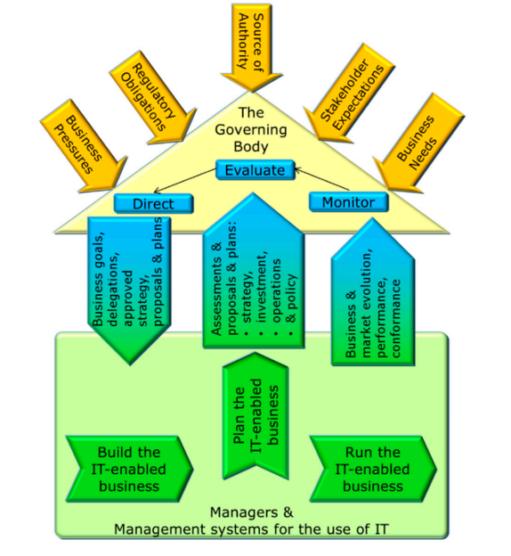
Figure 5: ISO/IEC 38500 Model

Organizations can implement ISO 38500 in conjunction with several other standards or frameworks. In the present era, the safeguarding of information security services, encompassing confidentiality, integrity, and availability, is of utmost importance for all organisations. The research aims to explore how ISO 38500 and ISO 27001, global standards for managing information security, can be incorporated with ITIL,[18] a widely accepted framework for IT service management. [19] When all three guidelines work together, they allow for the incorporation of the most effective security practices in IT governance. This helps organisations lower the expenses associated with maintaining an acceptable level of security and effectively decrease overall risks.[20]

3. Methodology

- Methodology for ensuring the security, governance, and compliance of NatureGarden's information system:

3.1 Establishing a Comprehensive Security Policy:

Security Governance Structure:
- This entails establishing a specialized security governance team consisting of seasoned personnel who are accountable for supervising and directing security policies, conducting risk assessments, and implementing compliance procedures.[21]

- An organized governance team guarantees a methodical and deliberate approach to security, ensuring that it is in line with the company's goals and consolidating decision-making and responsibility.

Information Security Management System (ISMS):
- Using ISO/IEC 27001 as the foundation for an Information Security Management System (ISMS) means setting up a structured way to keep an eye on private data. This includes managing risks, making improvements all the time, and making sure that security measures are in line with the goals of the organization.

- ISO 27001 offers an effective structure for methodically recognizing, controlling, and minimizing security risks, ensuring a methodical approach to governance and information security.

3.2 Focussing Compliance Requirements:

Legal and Ethical Compliance:
- Observing and complying with appropriate laws and ethical guidelines, such as GDPR and HIPAA, concerning the protection and confidentiality of data.

- Compliance assures that NatureGarden functions within the confines of the law upholds data privacy rights, and reduces legal risks related to misusing sensitive information.

Integration of Standards:
- Following international standards such as the ISO 27000 series ensures a strong compliance structure that utilizes widely acknowledged best practices.[22]

- Complying with international standards promotes standardization, compatibility, and acknowledgment of the organization's dedication to high-security measures.

3.3 Risk Management Framework:

Risk Identification and Assessment:
- Consistently recognizing and evaluating potential dangers linked to the use of personal devices and other operational factors, including techniques such as risk matrices.

- Identifying vulnerabilities and possible threats, resources can be emphasized, allowing for proactive efforts to successfully minimize risks.

Risk Mitigation Strategies:
- Implementing controls and security measures, such as access management, encryption, and staff training, is necessary to reduce the identified risks.

- Efficient risk mitigation strategies decrease the probability and consequences of security incidents, protecting critical information and ensuring uninterrupted operations.

3.4 Security Policies and Procedures:

Device Usage Policy:
- Creating specific rules for employees and clients that define security protocols and the appropriate usage of personal devices within the network.[23]

- Detailed regulations support responsible use, minimize any risks linked to personal devices, and provide standards for adhering to security protocols.

Data Protection Measures:
- Deploying encryption, robust data transmission protocols, and periodic data backups to protect sensitive information from unauthorized access or loss.

- Strong data protection procedures guarantee the privacy, accuracy, and accessibility of important information assets.

3.5 Continuous Monitoring and Improvement:

Incident Response and Contingency Planning:
- Establishing protocols and strategies for responding to security incidents, ensuring minimal disruption and quick resolution.

- Effective incident response minimizes potential damages and ensures a swift recovery from security breaches.

Regular Audits and Reviews:
- Conducting periodic audits to evaluate the effectiveness of security controls and making necessary adjustments for continual improvement.

- Regular audits help identify gaps or weaknesses in security measures, allowing for refinement and enhancement of the overall security posture.

As per IT Governance requirement table below all prospect need to be consider.

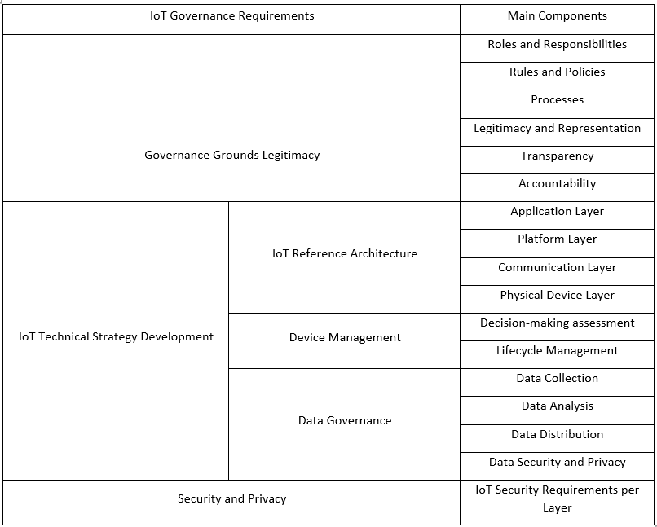
Table 1: IoT Governance Requirement and Main Components

The above IoT framework provides solid and complete security and privacy for NatureGarden Infrastructure. Considering IT Governance ISO 27001 framework model below suggested conceptual framework should be applied for NatureGarden company.

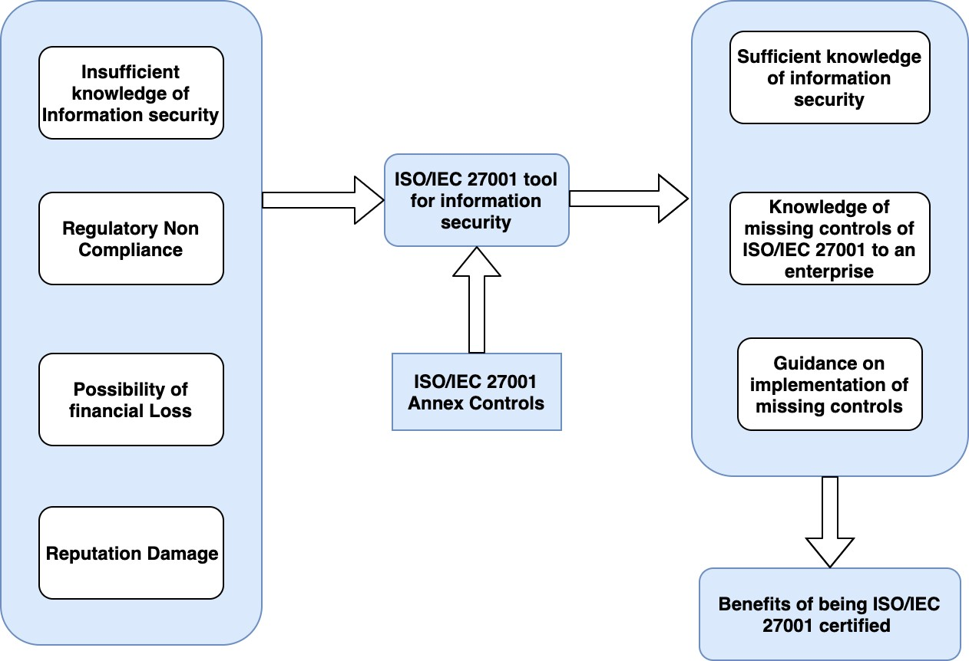
Table 2: Conceptual Framework for NatureGarden

3.6 Updated Regulations and Standards:

- Adaptation to Evolving Threat Landscape: New regulations often reflect emerging threats and vulnerabilities, prompting organizations to adopt better security measures aligned with current risks.
- Technological Advancements: The quick advancement in technology required the implementation of updated standards to guarantee that security practices remain in line with the latest tools and techniques adopted by attackers.
- Global Harmonization and Consistency: Updated regulations promote consistency and alignment of security practices across industries and geographical boundaries, fostering better international collaboration and understanding.
- Legal and Ethical Compliance: Regulations like GDPR and other privacy laws constantly evolve to address changing privacy concerns, ensuring organizations stay compliant and respect individuals' rights.
- Continuous Improvement: Updated standards encourage organizations to continually review and enhance their security practices, fostering a culture of ongoing improvement and resilience against new threats.
Organizations such as NatureGarden can maintain a proactive stance towards information security by consistently updating and complying with emerging regulations and standards. It enables them to sustain a resilient and flexible security framework that maintains balance with the constantly changing world of risks and technological advancements.

4. Result and Analysis

The report clarifies that all management systems founded on ISO standards will follow the PDCA approach, which stands for Plan, Do, Check, and Act. As we saw before different frameworks and security model, based on polices and security management. This methodology explains different aspect of IoT Standards and Impotence. The organization's Board should demonstrate a commitment to implementing a personalized SMS (Safety Management System) and ISMS (Information Security Management System) by allocating resources for the setting up process. Senior executives should take responsibility for monitoring the development process. The implementation team will be responsible for developing plans to accomplish the goals of the SMS and ISMS. In addition, the plan will incorporate a risk methodology, a risk register, and a risk mitigation strategy.

Using the findings of our analysis, we also explained the knowledge of every organization that implements the ISO standard. Participants must possess the necessary education in information security and service management, as well as the ability to explain the guidelines that will be used to achieve the goal. The process of internal auditing will identify any potential nonconformities and determine the level of implementation concerning the reference standard. This will allow the process to evaluate the top management of the organization, which is required to assess several entry points for the standard.

This research illustrates the individual contributions of each component to NatureGarden's overall security posture, emphasizing the significance of an integrated approach to information security, governance, and compliance. The objective of implementing these techniques is to improve data security, reduce risks, and assure adherence to applicable standards and legislation.

5. Conclusion

The implementation of a specific security governance framework and the incorporation of ISO/IEC 27001 as the fundamental basis for the Information Security Management System (ISMS) act as the fundamental principles. These components enable a methodical and purposeful approach to risk management, ensuring that security procedures are in line with business goals and promoting accountability throughout the organization.
In addition, following legal, ethical, and worldwide standards like the ISO 27000 series provides compliance with strict rules, promoting a culture of responsible data management and international acknowledgment of NatureGarden's dedication to strong security measures. With the risk management framework and mitigation strategies, vulnerabilities, especially those related to personal device use, can be identified and mitigated. Clear security rules and strong data protection procedures manage threats and protect sensitive data from unauthorized access or loss.
Continuous tracking, incident response methods, and audits demonstrate the company's resiliency and progress. These techniques ensure quick reactions to attacks and promote learning and improvement, creating a robust and dynamic security ecosystem in NatureGarden.
In conclusion, NatureGarden's information system security, governance, and compliance framework highlight the company's aim of protecting sensitive data, fulfilling global standards, and promoting security and continuous improvement. This strategy is to promote NatureGarden as a pioneer in strong and adaptable security, assuring stakeholder trust in a digital corporate landscape.

References

[1] J. A. Villanueva, “Information Technology Security Infrastructure Malware Detector System,” International Journal of Advanced Trends in Computer Science and Engineering, vol. 9, no. 2, pp. 1583–1587, Apr. 2020, Doi: 10.30534/ijatcse/2020/103922020.
[2] Y. Maleh, A. Sahid, M. Alazab, and M. Belaissaoui, IT Governance and Information Security: Guides, Standards, and Frameworks. in Advances in Cybersecurity Management. CRC Press, 2021. [Online]. Available: https://books.google.co.uk/books?id=qxpSEAAAQBAJ
[3] J. Merchan-Lima, F. Astudillo-Salinas, L. Tello-Oquendo, F. Sanchez, G. Lopez-Fonseca, and D. Quiroz, “Information security management frameworks and strategies in higher education institutions: a systematic review,” Annals of Telecommunications, vol. 76, no. 3–4, pp. 255–270, Apr. 2021, Doi: 10.1007/s12243-020-00783-2.
[4] R. Singh, B. Pandiya, C. K. Upadhyay, and M. K. Singh, “IT-Governance Framework Considering Service Quality and Information Security in Banks in India,” International Journal of Human Capital and Information Technology Professionals, vol. 11, no. 1, pp. 64–91, Jan. 2020, Doi: 10.4018/IJHCITP.2020010105.
[5] “scholar”.
[6] “https://www.coursesidekick.com/management/673771.”
[7] “https://www.coursesidekick.com/management/673771.”
[8] “https://www.itil.org.uk/itil-benefits.”
[9] U. Majeed, L. U. Khan, I. Yaqoob, S. M. A. Kazmi, K. Salah, and C. S. Hong, “Blockchain for IoT-based smart cities: Recent advances, requirements, and future challenges,” Journal of Network and Computer Applications, vol. 181, p. 103007, May 2021, Doi: 10.1016/j.jnca.2021.103007.
[10] A. Sedrati, A. Mezrioui, and A. Ouaddah, “IoT Governance: A state of the Art and a Comparative analysis,” in 2022 13th International Conference on Information and Communication Systems (ICICS), IEEE, Jun. 2022, pp. 76–81. Doi: 10.1109/ICICS55353.2022.9811219.
[11] “https://openrepository.aut.ac.nz/items/d86c5a2b-a1c3-4f33-bc45-4d77c8cf2301.”
[12] L. D. Fitrani, “Risk Risk Assessment and Development of Access Control Information Security Governance Based on ISO/IEC 27001:2013 At XYZ University,” JATISI (Jurnal Teknik Informatika dan Sistem Informasi), vol. 9, no. 2, pp. 891–907, Jun. 2022, doi: 10.35957/jatisi.v9i2.1643.
[13] L. C. S. Peters, “Data protection in Amazon Web Services Is the data of European data subjects sufficiently protected in Amazon Web Services?,” 2020.
[14] Y. D. Wijaya, “EVALUASI KEMANANAN SISTEM INFORMASI PASDEAL BERDASARKAN INDEKS KEAMANAN INFORMASI (KAMI) ISO/IEC 27001:2013,” Jurnal Sistem Informasi dan Informatika (Simika), vol. 4, no. 2, pp. 115–130, Aug. 2021, doi: 10.47080/simika.v4i2.1178.
[15] E. Atabay and E. Dinç, “Outsourced Services in Private Healthcare Organizations and ISAE 3402 Assurance Engagement: A Research Focused on Turkey,” in Integrity, Transparency and Corruption in Healthcare & Research on Health, Volume I, Springer, 2020, pp. 41–64.
[16] R. E. M. Saeed Al-Adili and S. A. Mohammed Al-Ani, “The Role Of IT Governance According To ISO 38500 To Reduce The Risk Of Electronic Fraud.,” Review of International Geographical Education Online, vol. 11, no. 9, 2021.
[17] B. Visitsilp and N. Bhumpenpein, “Guidelines for Information Technology Governance Based on Integrated ISO 38500 and COBIT 2019,” in 2021 Research, Invention, and Innovation Congress: Innovation Electricals and Electronics (RI2C), IEEE, Sep. 2021, pp. 14–18. doi: 10.1109/RI2C51727.2021.9559772.
[18] A. Almaawi, L. Alsaggaf, and H. Fasihuddin, “The Application of IT Governance Frameworks in Saudi Arabia: An Exploratory Study,” Int J Comput Appl, vol. 176, no. 30, pp. 40–44, 2020.
[19] C. Juiz and B. Gómez, “Evaluation of the Governance of IT at Universities: How to Assess Their IT Governance Maturity,” in COVID-19 Challenges to University Information Technology Governance, Cham: Springer International Publishing, 2022, pp. 1–42. doi: 10.1007/978-3-031-13351-0_1.
[20] F. Khoda Parast, C. Sindhav, S. Nikam, H. Izadi Yekta, K. B. Kent, and S. Hakak, “Cloud computing security: A survey of service-based models,” Comput Secur, vol. 114, p. 102580, Mar. 2022, doi: 10.1016/j.cose.2021.102580.
[21] F. Abdullayeva, “Cyber resilience and cyber security issues of intelligent cloud computing systems,” Results in Control and Optimization, vol. 12, p. 100268, Sep. 2023, doi: 10.1016/j.rico.2023.100268.
[22] “http://www.27000.org/.”
[23] C. Juiz and B. Gomez, “Delving Into the IT Governance-Management Communication Interface,” International Journal of Digital Strategy, Governance, and Business Transformation, vol. 11, no. 1, pp. 1–37, Nov. 2021, doi: 10.4018/IJDSGBT.291542.

