Student Handbook
  - Work-based Project

Individual Project Mentor
Name: __________________________
Email: __________________________
Phone: ____________________
Work-based Project Module Lead, PPF
Nick Samuel
n.samuel@uwtsd.ac.uk
6654
WIWBL Ethics Board Representative
Dr. Annette Fillery-Travis
A.Fillery-Travis@uwtsd.ac.uk
5177

Contents
Your Individual Project Mentor 5
Before the Module: Project Design 7
Effective research questions 7
Achievable Research 7
Designing for accuracy, validity, and reliability 8
Learning Outcomes 10
Module Learning Outcomes 10
Individual Learning Outcomes 10
Organisational Approval 11
Funding, material support, and other provisions 11
Data ownership 11
Ethics Form 13
Purpose 13
Basic Ethical Principles 13
Research Integrity 14
Ethics Approval Process 15
Step 1 – Tutor Sign-off 15
Step 2 – WIWBL Sign-off 15
The Faculty Ethics Board 15
The University Ethics Board 16
Research Instruments 17
Being an Insider Researcher 18
Credit value, word count, and presentation time 19
The Project Timeline 20
Tutorial Meetings 22
The Project Proposal 24
The Project Report 26
Expected sections and estimated word counts 26
Introduction 28
Literature Review 29
Methods 31
Findings 32
Conclusions and Recommendations 33
Appendices 34
Structure and Format 34
The Project Presentation 35
Project Submission 36
Support Resources 37
Your Module Moodle Page 37
The Learner Zone 37
The Faculty of Business and Management Subject Librarian 37
The Student Services Team 38
The Academic Office 38
Extenuating Circumstances and Interruption of Studies 39
Extenuating Circumstances 39
Interruption of Studies 40
FAQs 41
Appendices 45
Appendix 1 – Annotated Ethics Form 45
Appendix 2 – UWTSD Research Ethics and Integrity Code of Practice 59
Appendix 3 – Suggested Reading List – Ontology, Epistemology, Methodology, and Research Paradigms 60
Appendix 4 – Suggested Reading List – Research Methods 61
Appendix 5 – Suggested Reading List – Research Design 62
Appendix 6 – Suggested Reading List – Research Ethics 64
Appendix 7 – Suggested Reading List – Data Analysis 65

Your Individual Project Mentor

As a work-based project student, you will be assigned an Individual Project Mentor, who will be your primary source of guidance and support throughout your module. Your Individual Project Mentor will be responsible for supporting you in:
- writing a suitable research question around which to form your work-based project;
- designing and structuring a work-based project that is suitable for your research question, your workplace, and you as a student;
- developing individual learning outcomes that fully capture the work-based project you have designed and your level-appropriate learning;
- completing the University Ethics Form and securing ethical approval from the University for your work-based project;
- developing and approving your research instruments;
- supporting you in negotiating your project with your employer/organisation, both before and during the project;
- conducting your work-based project and managing any difficulties that arise over the course of your project; and
- preparing the written submissions that detail and describe your project as well as your final project presentation.

Your Individual Project Mentor is not responsible for:
- coming up with a research question for you, or turning your idea into a suitable research question for you;
- designing a work-based project for you based upon your research question;
- filling in your University Ethics Form for you;
- writing your individual learning outcomes for you;
- guaranteeing that the project you have proposed will receive ethical approval from the University;
- negotiating with your employer/organisation on your behalf regarding your work-based project;
- guaranteeing that your employer/organisation will approve the work-based project you have proposed;
- developing your research instruments for you;
- doing any of the active research necessary for you to complete your work-based project;
- guaranteeing that the circumstances of your employment will not change in any way that affects your work-based project; and
- providing more than one written edit of any written submission drafts for your final project submission.

Your Individual Project Mentor will be experienced in designing and conducting work-based research, though not necessarily in your field of work. Their guidance is meant to support you as you engage with your independent learning process through the work-based project module, and to help you make the most of your time spent studying. You will have meetings at least monthly with your Individual Project Mentor, and should never hesitate to contact them for additional guidance, support, and knowledge outside of these meetings.

As a work-based project student, you also have access to support and guidance from:
- the work-based project Module Lead, who may be able to offer a second opinion, further guidance, or just a fresh pair of eyes with any element of your project; or
- the WIWBL Ethics Board Representative, who can give you guidance and advice specific to the Ethics Form or the University ethics procedures and policies.

Finally, as a student of the University, you are encouraged to seek guidance and support wherever necessary from the additional services and resources available to you, detailed in the “Support Resources” section of this handbook.

Before the Module: Project Design

You will be asked to complete some basic steps towards your work-based project prior to the official start of the module on the Module Induction Day. Your chief responsibility, on which you may have already begun work, is to select a research question around which to frame your work-based project and to begin the early stages of designing your research.

Effective research questions

The first step in designing your work-based project is to settle on a question to study and explore. Your Individual Project Mentor will help support you through this process, but it is crucial that the question and design of your work-based project are your own. Research question development should, ideally, follow a five-step process:
- Choose a topic that interests you…
  - …and read everything you can find
- Find an interesting aspect of the topic
  - Ask yourself who/when/where questions
- Identify a question within that aspect
  - Ask yourself how/why questions
- Is your question
  - focused?
  - complex?
  - interesting?
  - researchable?
- What types of information will you need to answer the question? Are those types accessible to you?

Achievable Research

In addition to being an effective research question, it is crucial that your work-based learning project is achievable. Your Individual Project Mentor will support you through determining whether the project you’ve identified is achievable based around several key considerations:
- Time frame – can this project be completed within the level and credit value you are pursuing?
- Workplace support – is your workplace willing to support this project?
- Financing – is there financial outlay involved in pursuing this project and, if so, have you discussed this with your workplace and received a guarantee of support?
- Rules, laws, and guidelines – have you confirmed that the project conforms not just to the rules of the workplace and the University, but also to any additional rules, codes of practice, guidelines, etc. governing this area, such as laws of the country, region, or local authority, standards of practice of a profession, etc.
- Moral considerations – is the research proposed in keeping with the basic moral codes of conduct and behaviour acceptable in the culture hosting the research, as well as the culture of the University?
- Data availability – is the data necessary to complete the project reasonably available/accessible to you?
- Workplace impact – will the project have a demonstrable impact on your workplace and/or work practice?
You will work in collaboration with your Individual Project Mentor to ensure that your project meets these and any other criteria before beginning; a process which may require some renegotiation of your original research question as well as a narrowing or widening of the scope of your project. Remember that, while your Individual Project Mentor is here to provide you with expert advice and guidance, the project you conduct must ultimately be your own. Don’t hesitate to engage in several drafts and redrafts of the project during this process, until you are sure that you have settled upon a work-based project that is effective and achievable, but also still of interest to you and of impact to your workplace practice.

Designing for accuracy, validity, and reliability

Once you have settled upon the research question that will form the basis of your work-based project, you will need to work with your Individual Project Mentor to design the project you wish to conduct. Again, it is helpful to have a rough idea of the types of inquiry that interest you (e.g. a preference for qualitative over quantitative methods, an interest in conducting action research, a rough idea for a suitable experiment, etc.) prior to arriving at the project Induction Day.
Your Individual Project Mentor will help you to refine your ideas, based upon the final research question at which you arrive, to design a project that not only meets the needs of you as a learner and of your workplace, but also of:
- Accuracy
  - Has your project been designed in such a way that the research methods and research instruments you will employ are capable of measuring/recording what you are studying?
  - e.g. when measuring the temperature of a pot of water, is it more accurate to use a finger dipped in the water, or a submerged thermometer?
- Validity
  - Has your project been designed in such a way that your results will truly demonstrate what you are attempting to demonstrate? Are you employing the best possible methods for the task you have set yourself?
  - e.g. is measuring the temperature of a pot of water the most valid way to answer the question “at what temperature does water boil?” is it the most valid way to answer the question “how long does it take to cook pasta in 105° water?”
- Reliability
  - Has your project been designed in such a way that your results could be replicated by another researcher following your design?
    - e.g. have you put measures in place such as using the same thermometer to measure different pots of water, boiling all pots on the same setting on the same stove, etc.?
- Complexity
  - Has your project been designed in such a way that it will demonstrate your skills, knowledge, and abilities and your mastery of the module’s learning outcomes?

Learning Outcomes

Module Learning Outcomes
The Work-based Learning Project module has four key learning outcomes, each of which must be reflected in your work-based learning project submissions: the project proposal, the project report, and the project presentation. These learning outcomes are:
- design and negotiate an appropriate work-based study demonstrating due regard to ethical issues;
- analyse, interpret and report relevant research data;
- recommend future actions based on the findings;
- reflect on the outcomes of a project, including individual learning, lessons learned, and issues of insider research.

Individual Learning Outcomes
In addition to the five module learning outcomes, each student is expected to develop, with the support and guidance of their Individual Project Mentor, up to three individual learning outcomes. Your individual learning outcomes will relate directly to your specific project and what you hope and expect to achieve, and will form part of the aims and justifications for your work-based learning project. Your Individual Project Mentor will work with you to ensure that your individual learning outcomes capture the extent of the learning you will engage with through your work-based learning project and that they are appropriate to your level of study.

Organisational Approval

Before you can begin your work-based project you must receive approval, in writing, from your employer. This written approval must be shown to your Individual Project Mentor and submitted as an appendix to your Ethics Form.

It is your responsibility as a work-based learner to ensure that your employer/organisation and your direct supervisor, as well as any relevant colleagues or subordinates, understand the nature of your proposed project, its purpose, and its potential impact on the workplace. It is crucial that your project has both the understanding and support of those involved, and a project that does not receive this support must be renegotiated with your employer until they are willing to grant it.

If you are struggling to communicate with your employer or any other members of your workplace regarding your work-based project, or in securing their consent for you to proceed with your project as proposed, please do not hesitate to involve your Individual Project Mentor, who may be able to help you negotiate the process.

Funding, material support, and other provisions

Certain projects may, by the nature, require a financial outlay or professional concession from the employer. If, for example, your project requires testing a new piece of machinery, that machinery will need to be purchased. In other cases, the project may require special provisions/adjustments be made by the organization. If, for example, you wish to investigate the effects of changed shift patterns, then certain staff members’ shift patterns will need to be modified.

In situations where your project has special requirements such as funding, material support, changes to existing policies, etc. you must communicate these to your employer and seek their agreement prior to beginning your project. This approval should be explicitly mentioned in the letter of approval you receive.

Data ownership

The final step in ensuring that your employing organisation approves of the project is negotiating the final ownership of data generated by your work. It is necessary that the ownership of data is understood by both you and your employer, and that all terms and conditions agreed upon regarding ownership of data are explicitly mentioned within your letter of approval and made clear in your Ethics Form.
- Data generated by the organisation (e.g. readings from machinery owned by the organisation, information from files to which you have been given access, etc.) are the property of the organisation. You must acknowledge this in the Ethics Form and must make clear the terms under which this data is being accessed and used, and the methods of storage and protection employed.
- Data generated by you (e.g. results from questionnaires, notes from observations) are ordinarily considered to be your property and, under standard circumstances, would be destroyed. In certain, special circumstances however, the organisation may request that this data be shared with them. In such a situation, should you agree, it is necessary that:
  - this arrangement be made clear in the Ethics Form, and
  - any participants be made aware, as part of their informed consent process, the organisation will be accessing their data.

Ethics Form

See Appendix 1 for an annotated draft of the UWTSD E1 Ethics Form, to support you in drafting your own.

Purpose

Before you can begin your work-based project, you must receive approval from the University, in the form of a signed University Ethics Form. This form is not negotiable, cannot be avoided, and must be completed and signed off before you may begin any work on your project. The form is here to protect your participants, the University, and you as a researcher, so it is incredibly important that you commit the time and care necessary to effectively engage with the ethics approval process.

It’s important to remember that research ethics is not a black and white subject, and that the purpose of the Ethics Form is not to determine what research is or is not ethical. It is the baseline expectation of the University that all research undertaken by students and/or supported by staff will strive to be ethical. Please understand that the Ethics Form and approval process is not about determining, based on yes/no criteria, whether or not your research is ethical enough.

Rather, the University Ethics Form is about demonstrating consideration of the ethical implications of research and showing that strategies have been put in place wherever possible to mitigate impacts. Your research will be approved not when you have demonstrated that you are ethical enough but rather when the approving authorities (whether the Individual Project Mentor, the WIWBL Ethics Board Representative, the Faculty Ethics Board, or the University Ethics Board) deem that you have considered the full range of eventualities and possibilities, and thought through the full ramifications of your research and its wider impact.

Basic Ethical Principles

As a jumping-off point, you should work to ensure that the work-based project you design will be conducted in line with some basic ethical principles, including:
- Beneficence – the idea that all research should have the well-being of participants as an end goal.
- Non-malfeasance – the idea that research should “do no harm”.
- Respect – the idea that research will pay due regard to the feelings, wishes, and rights of all involved, including the researcher, participants, and the wider community.
- Justice – the idea that research will be fair and equal in treatment and outcomes.
- Participant interests – the idea that research will be conducted in a way that accounts for the best interests of participants.
- Participant safety – the idea that research will be designed for the safety of participants, and not expose them to unnecessary risk or harm.
- Researcher safety – the idea that research will be designed for the safety of the research, and not expose him/her to unnecessary risk or harm.
- Impact on others – the idea that research will be designed to account for its impact on others, including the wider community or future generations.
- Informed consent – the idea that all participatory parties will be given the opportunity to consent to participation, and that they will be given sufficient information to understand what that consent entails, requires, and implies.
- Debriefing – the idea that all participants should have the right and opportunity to discuss the research with the research, and receive information on what is being researched, why, their personal part in the research, and the findings.
- Withdrawal – the idea that all participants should have, and be made aware of, the right to leave research at any point without negative consequences.
- Confidentiality – the idea that all data should be protected and that participants have a right to know the degree to which the information they provide throughout the course of the research will be protected.
- Anonymity – the idea that research data should not reveal, or make it possible to discover, names or personal identifying information of participants.
While different research will work within these principles in different ways and to different degrees, it is crucial that you address, at minimum, all of these issues and the ways in which they are apparent in the research/project.

Research Integrity

In addition to paying due reference to ethical considerations in designing research and drafting an Ethics Form, it is paramount that you maintain your connection to the Basic Ethical Principles throughout the course of the research, in order to preserve its integrity. Your Individual Project Mentor will support and guide you through the stages of your research in tutorial meetings, helping you to stay on track and work to the University of Wales Trinity Saint David Research Ethics and Integrity Code of Practice (Appendix 2). While your tutor will help you to stay within the guidelines set by this document, it would be wise to familiarise yourself with its contents and strive to work within it.

Ethics Approval Process

Step 1 – Tutor Sign-off

You will work alongside your Individual Project Mentor to write and develop your Ethics Form. When your tutor is satisfied that you have completed your form, capturing the entirety of your proposed project and giving due consideration to ethical issues and carefully considering the risks, impacts, and ramifications of your project, he/she will “sign off” and pass your Ethics Form to the WIWBL Ethics Board Representative.

Step 2 – WIWBL Sign-off

The WIWBL Ethics Board Representative is our School’s authority on matters of research ethics. He/she acts as our School’s representative on the University Ethics Board, and has the authority to give final approval to all Ethics Forms for research conducted in taught undergraduate and taught postgraduate programmes. Once your Individual Project Mentor is satisfied with your Ethics Form, it will be reviewed by the WIWBL Ethics Board representative, who may ask for some clarifications, amendments, or reconsiderations. Once the WIWBL Ethics Board Representative is satisfied with your Ethics Form, he/she will sign it and you will be free to begin your work-based project.

Remember that your project timeline begins on the day you receive ethical approval for your project, and you will have 4 months from that day to complete your project. Your tutor will arrange a date for your final presentation and submission. Your Individual Project Mentor will send you a signed and dated electronic copy of your Ethics Form for your personal records. It is crucial that you retain this copy until your work-based project has been marked and that mark has been formally confirmed by a UWTSD Exam Board. You will also need to attach this signed and dated electronic copy as an appendix to your Project Report.

The Faculty Ethics Board

The Faculty of Business and Management, under which WIWBL sits, has a Faculty Ethics Board that meets on a monthly basis. The purpose of the Faculty Ethics Board is to review Ethics Forms submitted on behalf of non-taught programmes (MPhil, DProf, PhD, etc.) and to review individual cases referred to them by School Ethics Board Representatives.

On rare occasions, either your Individual Project Mentor or the WIWBL Ethics Board Representative may ask the Faculty Ethics Board to review your Ethics Form. Your form may be sent for review by the Faculty Ethics Board if:
- your project is ethically complex and has been deemed to require a further layer of vetting and approval, to ensure all necessary due diligence has been conducted;
- your project is in a field or area with which your Individual Project Mentor and the WIWBL Ethics Board Representative are unfamiliar, and they would like an additional opinion regarding the ethical considerations you have taken; or
- there is an irreconcilable disagreement between you and your Individual Project Mentor and/or the WIWBL Ethics Board Representative regarding the project.

Remember that, should you fundamentally disagree with the ethical guidance provided to you by your Individual Project Mentor or by the WIWBL Ethics Board Representative, you also have the right to ask that your Ethics Form be reviewed by the Faculty Ethics Board.

The University Ethics Board

In very rare instances, an Ethics Form may be sent to the University Ethics Board for final review. An Ethics Form will never be referred to the University Ethics Board unless it has already been sent to the Faculty of Business and Management Ethics Board for review. The University Ethics Board may become involved if:
- the Faculty of Business and Management Ethics Board wishes to pursue another opinion or an additional layer of vetting and approval; or
- the student, individual tutor, or WIWBL Ethics Board Representative wishes to appeal against the recommendations given by the Faculty of Business and Management Ethics Board.

Remember that, should you fundamentally disagree with the decision given by the Faculty Ethics Board regarding your Ethics Form, you also have the right to ask that it be reviewed by the University Ethics Board.

Research Instruments

Your research instruments are any of the tools you use to collect and analyse data for your work-based project. They may include things like questionnaires or interview questions, forms to be used for tracking observations, or details of experiment designs.

All research instruments must be reviewed and approved by your Individual Project Mentor before you may use them for data collection or analysis, and any amendments you want to make after approval (e.g. changing the wording of a question on a questionnaire) should be cleared with your Individual Project Mentor beforehand.

The research instruments you choose to use will be entirely dependent upon your work-based project, your workplace context, your selected methods, and your personal paradigm as a researcher. Your Individual Project Mentor can help you if you are struggling to find research instruments to suit your needs.

Remember that your research instruments need to be as clear, as project-appropriate, and as user-friendly as possible. Wherever the opportunity exists, it is a good idea to ask an independent party to sample your research instruments for clarity and ease of use (e.g. asking a family member to take a questionnaire).

Being an Insider Researcher

One of the most fundamental elements of your experience on the work-based learning project module will stem from your status as an “insider researcher” – someone who researches a community or space of which they are a member. Being an insider researcher is not necessarily a positive or a negative thing within your research; it is simply an unavoidable element that must be acknowledged and examined.

As you conduct your work-based learning project, always try to keep one eye on the impact of your status as an “insider” – how might it be affecting or impacting the data you collect? How might it be impacting or affecting your participants? How might it be impacting or affecting you as a researcher or as a professional?

Insider research and its impact will need to be included as a major theme within your analysis of the ethical implications of your work-based project, as well as your methodology, findings, and conclusions and recommendations, as appropriate.

Credit value, word count, and presentation time

The word count and presentation time for your work-based project is given within the Module Descriptor and is summarised in the table below.

Overall Word Counts and Presentation Times
Module Code | Level | Credit Value | Total Word Count | Proposal Word Count (10%) | Report Word Count (70%) | Presentation Time (20%)
BMPF4008 | 4 | 30 | 3,600 | 450 | 3,150 | 5 minutes

The Project Timeline

As a University student, there are strict rules governing the time that may be allocated to you to complete your work. You will be given a set period of time within which you must complete your work-based project, submit your written work, and make your final presentation. Please see the chart below to for the time allocation. Remember that your allocated time begins on the day your Ethics Form receives a signature of approval by the WIWBL Ethics Board representative.

Module Code | Level | Credit Value | Time Allocated from Signature of Ethics Form
BMPF40008 | 4 | 30 | 4 months

While you are welcome to present/submit a bit early in order to align more effectively with your schedule, please remember that these time allocations have been carefully chosen to align with the approximate time necessary to complete work at the level and credit value given. Your Individual Project Mentor will work with you throughout your work-based project to ensure that you have chosen a project of appropriate complexity, and that you are putting appropriate time and consideration into different sections, to work to the allocated times.

The time allocated to each unique project section will vary on a case-by-case basis, and every project is different. Depending on the specific needs of you and your project, your Individual Project Mentor may ask you to change the order of work, revisit previous work, or make other adjustments. The general order of work, however, tends to follow a similar path and timeline, shown overleaf.

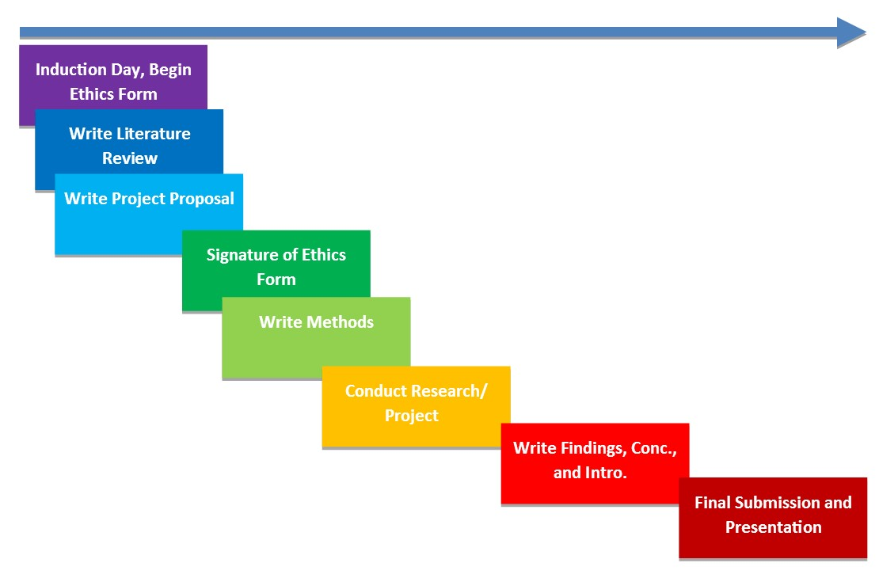

Tutorial Meetings

You will be expected to hold one-to-one tutorial meetings with your Individual Project Mentor approximately every 3 weeks. These meetings may face to face, by telephone or via Skype. Your one-to-one tutorial meetings will be an opportunity for you to discuss your progress, report on completed work, receive guidance on your next steps, and resolve any issues that may arise over the course of your project. It is crucial that you engage with your one-to-one tutorial meetings throughout the course of your work-based project, to stay on track for your submission deadline and ensure that you are completing your project in a suitable, ethically sound, and effective manner.

You will schedule your tutorial meetings with your Individual Project Mentor based upon your own professional schedule, the needs of your specific project, and the schedule of your tutor. As a rough guide, your tutorial meetings will focus on the following key project stages:

Session | Content
Tutorial 1 (Induction Day) | - Research question and research design  - The Ethics Form  - Beginning a Literature Review
Tutorial 2 | - The Ethics Form  - Writing the Literature Review (ongoing)  - Writing the Project Proposal
This is as far into the process as you can go without a signed Ethics Form. If your own Ethics Form needs more work, negotiation, or editing, you may have additional tutorials using the same format as “Tutorial 2” above. Once your Ethics Form has received approval, your project timeline will begin and you will move on to the tutorial topics below.
Tutorial 3 | - Ongoing support with Literature Review and Project Proposal as needed  - - Writing a Methods section
Tutorial 4 | - Ongoing support with Literature Review, Project Proposal, and Methods as needed  - Conduct and implementation of research, use of research instruments, etc.
Tutorial 5 | - Ongoing support in conduct and implementation of research, use of research instruments, etc.  - Support with Literature Review, Project Proposal, and Methods as needed
Tutorial 6 | - Help in wrapping up data collection processes  - Writing the Findings, Conclusion, and Introduction
Tutorial 7 | - Final support in written sections, draft edits  - Support in presentation preparation

The Project Proposal

*Bear in mind that every student, and every work-based project, is unique. While this handbook provides a basic outline of expectations for student submissions and their contents, your own submission will be marked primarily based upon its suitability for your own project and its reflection of the module learning outcomes and your individual learning outcomes.*
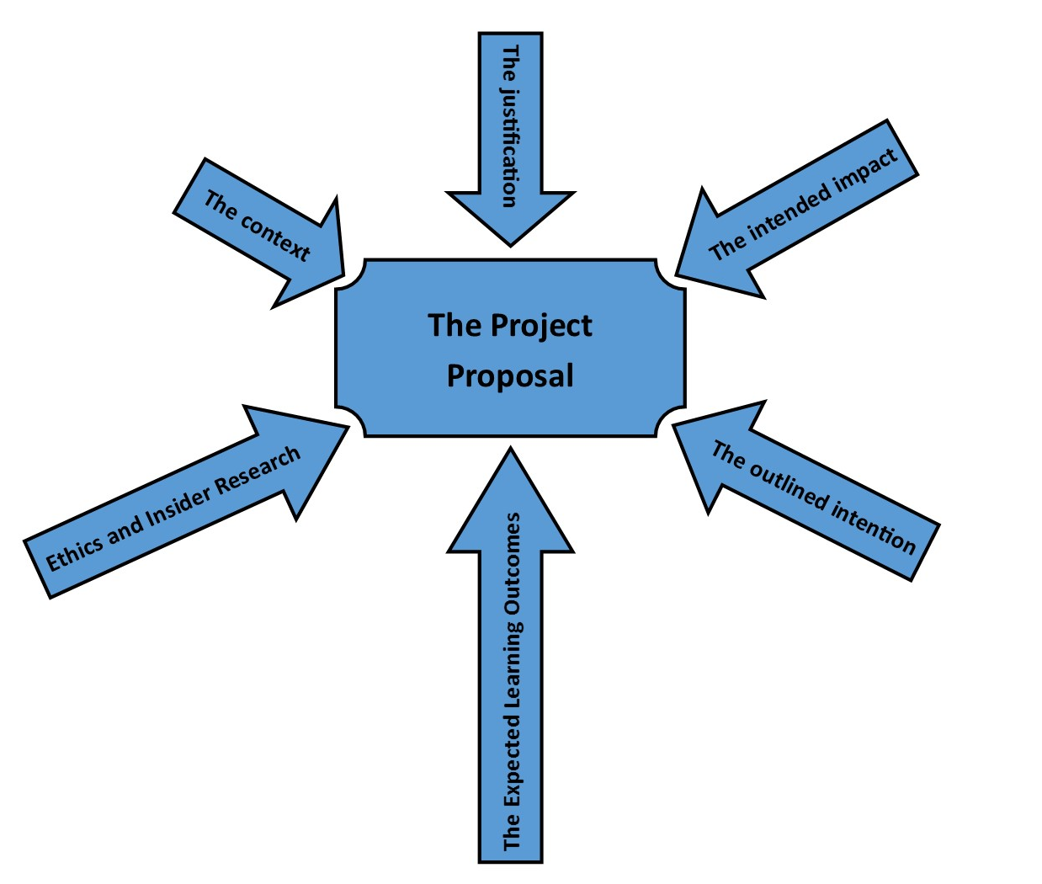
The Project Proposal document is expected to provide context, background, and justification and to introduce a work-based learning project. As a general rule, your Project Proposal document should provide:

- The context
  - What is the organisation/setting for the project?
  - What is the current (and, if relevant, historic) situation in this organisation and setting?
- The justification
  - Why are you undertaking this project?
  - How does this project sit within the context you have described?
- The intended impact
  - What do you hope to impact/achieve/accomplish through this project?
  - What might the wider ramifications of this project be to the context described?
- The outlined intention
  - In brief, what do you intend to do, how/when/where do you intend to do it?
  - Proposed methods, including a justification of those methods
  - An expected timeline
  - Graphics such as a GANTT chart may be helpful in some cases
- The ethics and insider research
  - A brief explanation of the ethical implications of the project, as well as the impact of being an insider researcher upon the project
- The expected learning outcomes
  - These will be your personal, specific learning outcomes, not the module learning outcomes
- References
  - The need for references will vary by case, but may be appropriate or even necessary in setting the context, providing background, providing justification, or explaining the reasons for the intended impact
- Writing style
  - While first person is acceptable, it is generally preferable to write the Project Proposal in the third person
    - E.g. “It was decided that…” or “It is proposed to…” or “The researcher will…”

The Project Report

*Bear in mind that every student, and every work-based project, is unique. While this handbook provides a basic outline of expectations for student submissions and their contents, your own submission will be marked primarily based upon its suitability for your own project and its reflection of the module learning outcomes and your individual learning outcomes.*

Expected sections and estimated word counts

Report – Approximate Word Counts by Section
Module Code | Introduction (~5%) | Lit. Review (~15%) | Methods (~15%) | Findings (~60%) | Conclusion (~5%)
BMPF4008 | 150 | 470 | 470 | 1,910 | 150

Introduction

The Introduction section is meant to do exactly that – introduce your work-based project to the reader. This section can feel as though you are repeating information contained in the Project Proposal, but it is important to focus on the two different intentions of these two different documents. It can help to imagine writing a Project Proposal as though one is trying to convince a boss/funder/etc. to allow a project to go forward, while a Project Report is providing a full summative write-up of a project from start to end.

While some information may be duplicated across the Project Proposal to the Introduction sections, you should never copy/paste content directly from one document to the other.

At its most basic, the Introduction section should include:
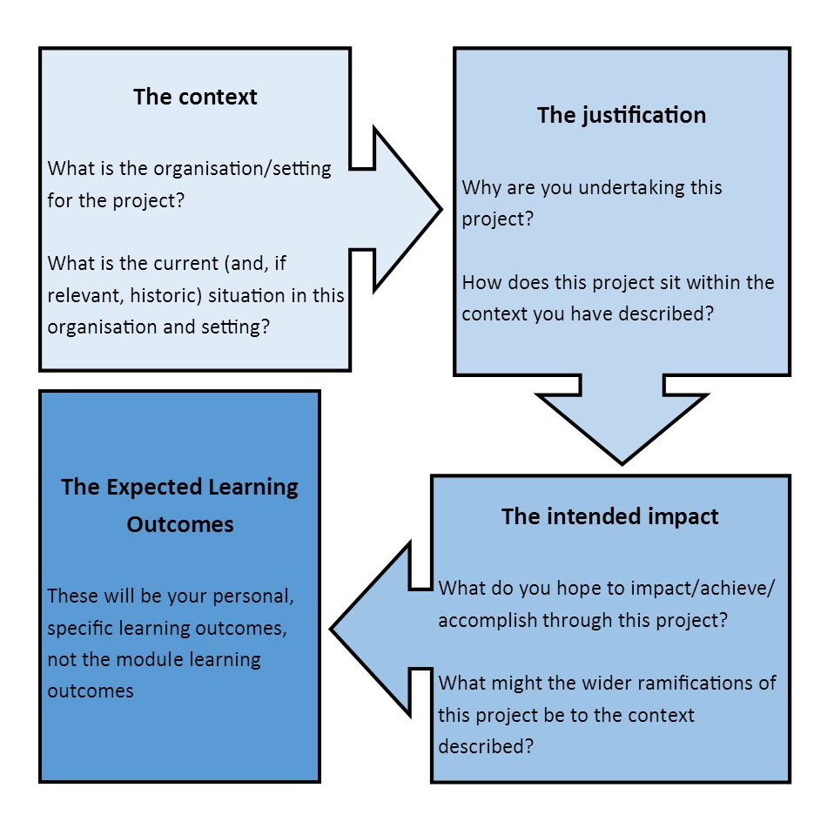

Literature Review

The purpose of the literature review is to provide a wider context in which your work-based project sits, and to explain and justify the question being asked/area being explored, the research design, and the methods chosen, based upon their connection to other published work.
By its nature, the literature review will vary significantly from project to project – some students may need to provide significantly more background information, while others may need to offer up significantly more justification of methods. Literature reviews will also vary significantly in the quantity of information available that relates directly to your project.
If you are struggling to develop their literature review or to find suitable sources, don’t forget that you can consult with the Faculty of Business and Management Subject Librarian, who has a range of support resources available.
As a general rule, a student’s literature review should:
- Provide the wider context in which the project sits – what other research has been conducted into this area? What is the current situation in this area? What is the history of research in this area? What is the trend of research in this area?
- Survey or summarise relevant policies, legislation, etc. such as workplace Codes of Practice, Health and Safety Policies, national strategies, national, international, or local legislation, government papers, etc.
- Provide the basic information that already exists in the area being studied (through documents such as industry reports, journal articles, internal company reports, etc.) and identify the gaps the project seeks to address.
- Connect the research design and methods to relevant theorists and/or already-conducted and published projects with similar context, objectives, etc.

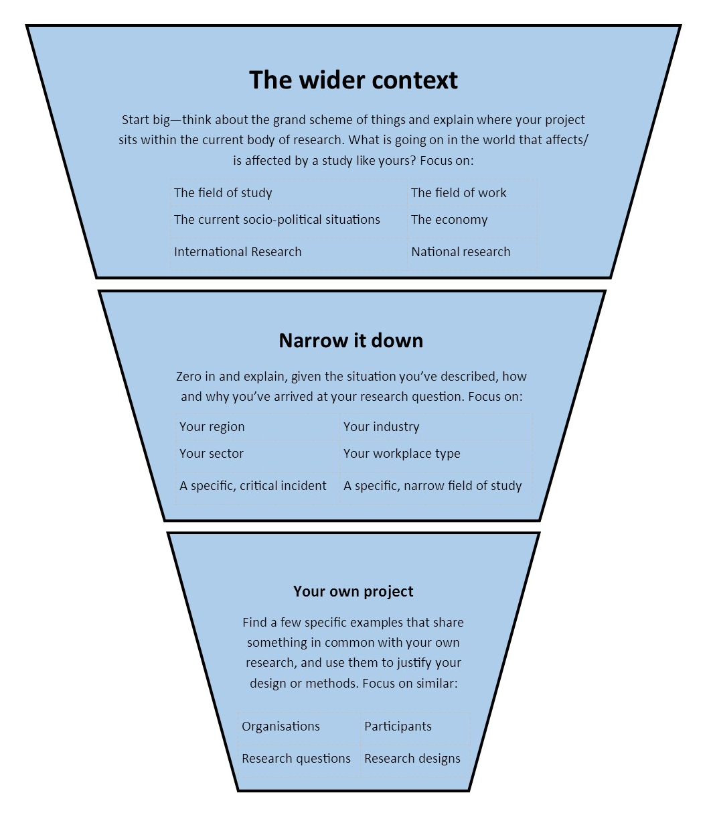

Methods
The methods section is intended to provide a step-by-step guide to how you intend to conduct the work-based project, as well as a justification of why the project will be conducted in this way and not others. It is important that the methods section not read as a “first this, then that, then that” narrative, but rather as an overall picture of what was done, when, where, how, with whom, and why that allows the reader to fully understand the project.
At its most basic, the methods section should include:
- A BRIEF explanation and justification of your research paradigm (ontological and epistemological positions) and how it might impact the study.
- An overview of your choice of methodology (quantitative, qualitative, or mixed) and a justification for this choice within the research context.
- An outline of the methods that you will use, potential other methods that you could have used, and a justification for your choice of methods within the research context and objectives.
- An examination of the ethical considerations of your research as it is designed, including an analysis of the impact of being an insider researcher. This examination and analysis should be grounded in both the University’s ethics policies and guidelines and the codes of practice of your workplace.
- An account of the research undertaken that follows the project timeline in a logical way, and explains:
  - what was done;
  - when;
  - where;
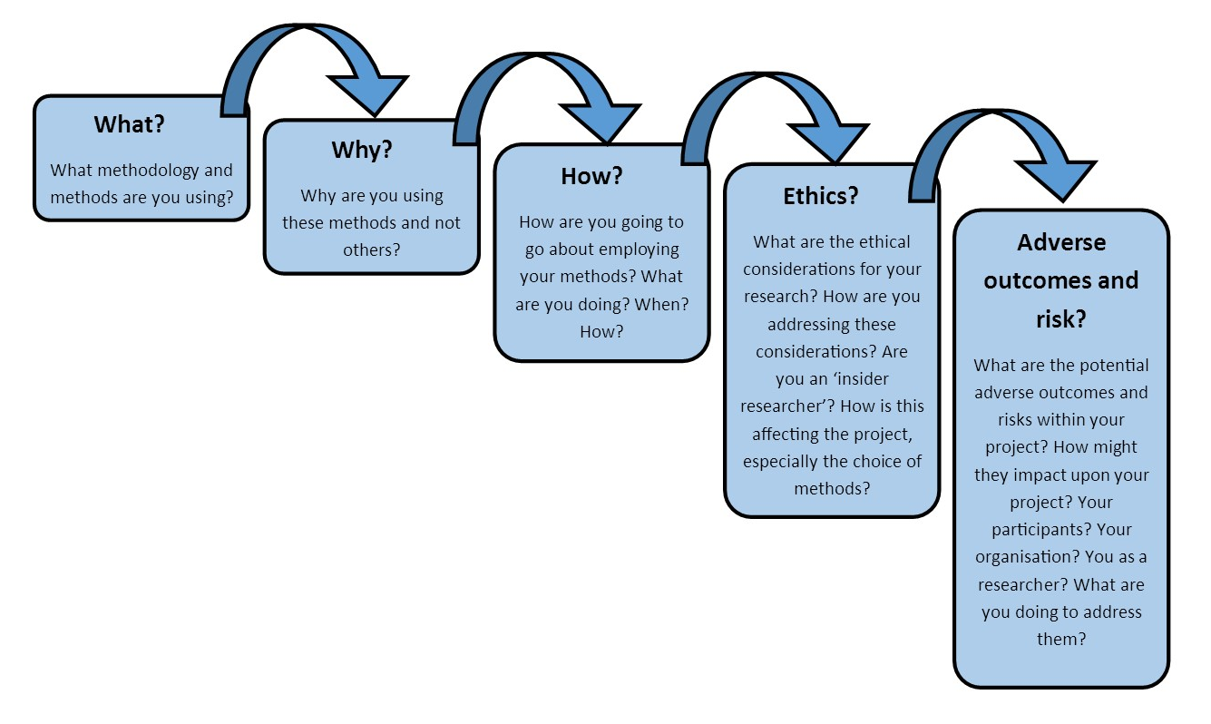
  - and with whom.

Findings
The findings section of the report is intended to provide the results of your work-based project. It should roughly follow the outline you have set in the methods section of what was done, when, where, and with whom and explain in detail what the results of this action were. It should then expand these results using critical quantitative and qualitative data analysis, as appropriate. The findings section should also explore any issues you encountered and analyse these issues (e.g. “participation in this questionnaire was low, potential explanations for this include…”).
There is no fixed list of information that should be included in the findings section, as it is so specific to your individual work, but it should be critical, thoughtful, analytical, and grounded firmly within the methodology as outlined in the preceding section.
Wherever appropriate, please feel free to include charts, graphs, tables, drawings, maps, diagrams, and other visual aids in support of the explanation and analysis in your findings section.
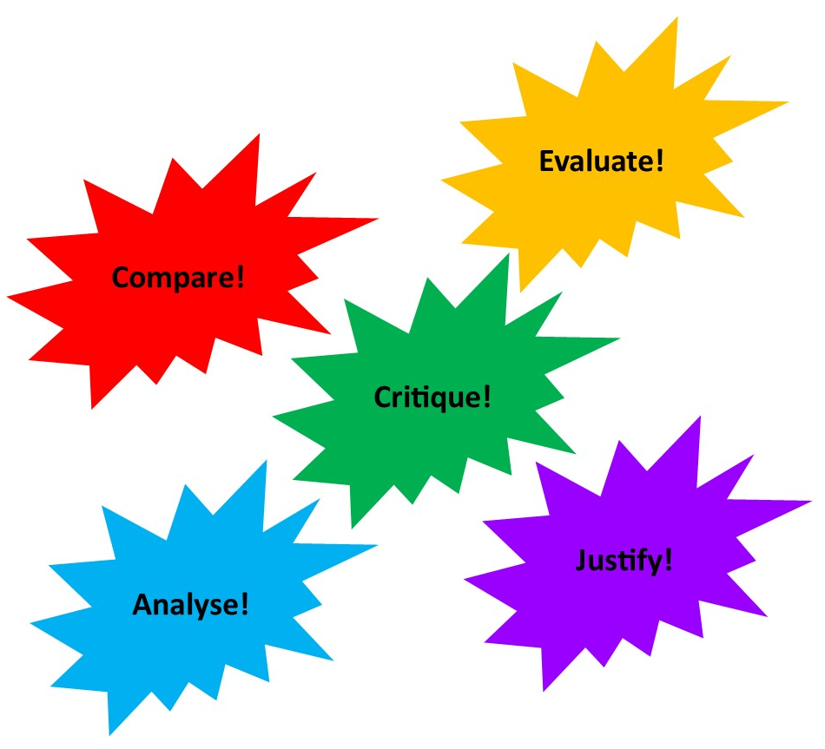

Conclusions and Recommendations

The conclusions and recommendations section is intended to “tie up” your project, linking the work you have conducted back to your stated aims, objectives, and justifications and providing insight into your learning, reflection on process and practice, and recommendations for future action based around your project experience.
At its most basic, the conclusions and recommendations section should include:
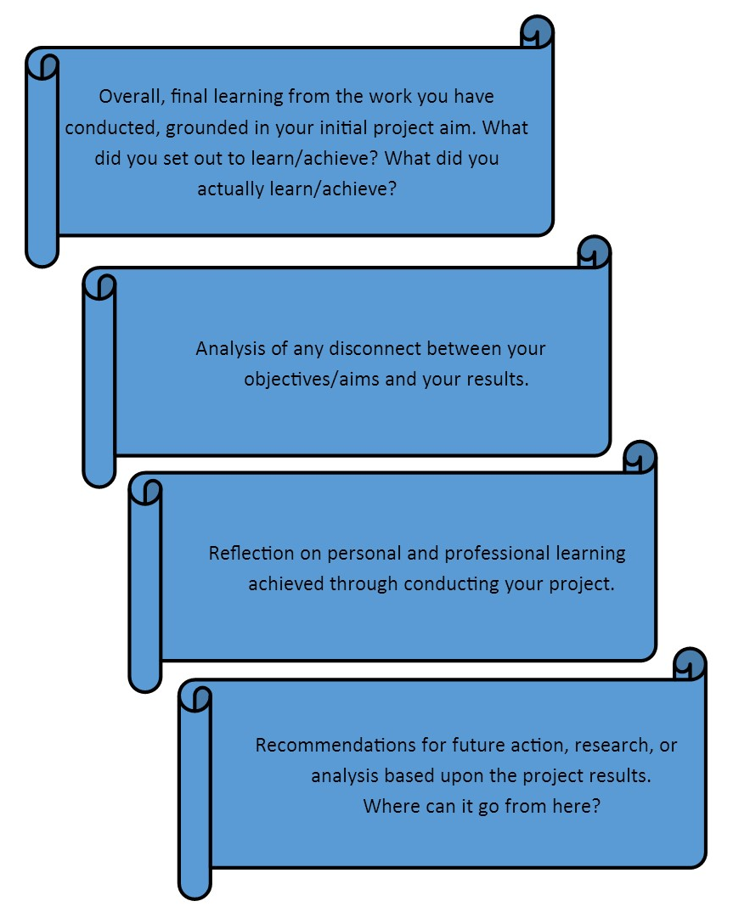

Appendices

You must include your signed and dated Ethics Form in your Project Report Appendix.

Your report must also include the signed and dated letter of approval from their employer in your Project Report Appendix.

Any remaining appendix documents will vary based upon your work-based project and the needs of reporting. Bear in mind that your appendices do not contribute to your overall work-based project word count, so you are welcome to include as much or as little information as is necessary/relevant in order to contextualise and understand your project. Some appendix documents that you may want to consider including are:
- research instruments used (e.g. questionnaires, consent forms, etc.);
- a glossary of terms, especially in situations where the report contains technical terminology and/or jargon;
- data analysis conducted over the course of the project;
- supplemental documents from the workplace, such as Codes of Practice, Health and Safety Guidelines, Codes of Behaviour, Job Descriptions etc. (especially in situations where these documents are referenced within your report but are not publicly available); or
- maps, diagrams, flow charts or process documents.

Structure and Format

There are no specific guidelines for structure and format of a student’s submission, as every project will have different needs. As a general rule, however, your submission should be neat and well-ordered, including such basic document elements as:
- page numbers;
- a table of contents and/or index;
- a list of tables/figures, as appropriate;
- a glossary of terms/abbreviation

The Project Presentation

*Bear in mind that every student, and every work-based project, is unique. While this handbook provides a basic outline of expectations for student submissions and their contents, your own submission will be marked primarily based upon its suitability for your own project and its reflection of the module learning outcomes and your individual learning outcomes.*
The Project Presentation is the final element of your work-based project portfolio, and is intended to provide an opportunity for you to explain and justify your work-based project and reflect upon your learning and personal and professional development.
The Project Presentation will be attended by both the first and second markers. Your employer or a member of your organisation is welcome to attend as well.
There is no set expectation for materials and/or visual aids to be used, however you are welcome to make use of hand-outs, PowerPoint presentations, Prezi presentations, etc. as you deem necessary.
While presentation times will vary based upon the level and credit value of the project (see table above) you should be prepared to answer approximately 5 minutes of questions from your first and second markers.
At its most basic, the Project Presentation should cover:
- A brief outline of the background, justification, aims and objectives.
- A more detailed outline of the methods, including exploration of ethical considerations and the impact of being an insider researcher.
- A more detailed outline of the findings and explanation of analysis.
  - Much like the findings section of the Project Report, students should be encouraged to use visual aids such as tables, charts, graphs, diagrams, maps, and drawings wherever possible/appropriate.
- An in-depth analysis of conclusions and recommendations.
- A reflective examination of the personal and professional learning experience.
The day of the Project Presentation is also your final submission deadline. Remember to follow the Project Submission guidelines detailed below.

Project Submission

Your final work-based project must be submitted by email (in .pdf format where possible), before or no later than 12:00 local time on your submission date. Please ensure your file is identified with your name.
- Electronic Submission must be emailed to tessao@lrmg.co.za and wbl@uwtsd.ac.uk and include:
  - The Project Proposal
  - The Project Report
  - Any Appendices, including:
    - A copy of your signed and dated Ethics Form
    - A copy of your signed and dated letter of approval from your employer/organisation
  - The Project Presentation slides

Support Resources

In addition to your Individual Project Mentor, who will be your primary source of guidance and support throughout the work-based project, you have access to many academic and support staff members from across the University who can help you achieve your goals and complete your work-based project on time and to the best of your ability. Over the course of your project, you may want to seek out one or more of these staff members or make use of these resources.

Your Module Moodle Page

Moodle is the University’s 24/7 online learning support platform, where your lecturers and Individual Project Mentors keep information, resources, and support materials that you can use to complete your work-based project. Your Module Moodle page is updated regularly, and should be your first stop when you are looking for information, guidance, or course materials.

The Learner Zone

As a WIWBL Learner, you also have access to our 24/7 online Learner Zone via Moodle. The Learner Zone is a great repository on information on everything from study support and learning guidance to contact information for student support teams at the University. This is a great place to begin if you’re looking for some guidance and help or just want to take a look through some resources.

The Faculty of Business and Management Subject Librarian

The University library can be a tricky system to navigate, and contains a huge volume of tools and resources that you will need to successfully complete your work-based project. While students are encouraged to explore on their own and make as extensive use as possible of the library resources, you may need an experienced hand to guide you through some specifics of the library, such as study skills, producing a literature review, or finding suitable peer-reviewed journals.

The Faculty of Business and Management Subject Librarian, Ellie Downes, is here to support you and can be contacted by phone or by email for an appointment.
Ellie Downes
Email: e.downes@uwtsd.ac.uk

The Student Services Team

The University of Wales Trinity Saint David have a fantastic and supportive Student Services Team, who can support students in a wide range of areas, including financial advice, study skills support, support for students with disabilities, counselling services, mental health services, and much more! You can contact their teams on any campus by phone or by email, or take some time to look over their website to find the resources that are right for you.
http://www.uwtsd.ac.uk/student-services/
Carmarthen Campus:
Tel: 01267 676830
Email: studentservices@uwtsd.ac.uk

The Academic Office

The Academic Office are there to support you through adhering to the rules and regulations of your programme. You may need to speak with the Academic Office if you are considering making a request for Extenuating Circumstances or an Interruption of your Studies, or if you have questions and concerns about the governance of your undergraduate or postgraduate taught programme and its management.
Academic Office
Tel: 01267 676855
Email: aocases@uwtsd.ac.uk

Extenuating Circumstances and Interruption of Studies

Becoming a work-based learner is a serious commitment, but we understand that sometimes in life we are faced with the unexpected. The University of Wales, Trinity St. David has procedures in place to help you ensure that a major life change, serious illness, or personal emergency doesn't mean the end of your studies.

If you have questions or concerns, or would like to discuss your own circumstances in more detail, please contact the Academic Office:
Student enquiries: aocases@uwtsd.ac.uk
Main Office: 01267 676855
Location: First Floor, Dewi Building, Carmarthen Campus

Extenuating Circumstances

Neither your Individual Project Mentor nor the Module Lead have the ability to grant you any form of extension on your work-based project. Submission of assessment is governed by strict, University-wide procedures and individual lecturers do not have the authority to intervene. In circumstances where you are unable to complete your work-based project by the submission date, however, your personal case may qualify as 'Extenuating Circumstances'.

The University of Wales Trinity Saint David's Extenuating Circumstances definition is:
A student who believes that his/her performance in or ability to complete an assessment has been adversely affected by extenuating circumstances may request that those circumstances are recognised by the University. Claims for extenuating circumstances are judged on clear and transparent criteria as set out in the regulations and where necessary are considered by a cross-University Extenuating Circumstances Panel.
For the purposes of this regulation, extenuating circumstances refer to immobilising ill health during the assessment period, bereavement of a close relative or friend during the assessment period, or other similarly profound experience or difficulty that is outside the control of the student. In respect of students in employment, where study is subsidiary to the employment, pressure from employment may also be considered as extenuating circumstances.

To find out more information about Extenuating Circumstances, or to download the appropriate application forms, please visit the Academic Office's Student Cases page: http://www.uwtsd.ac.uk/academic-office/procedures-for-academic-appeals-complaints-and-other-student-cases/

Interruption of Studies

As a University student, you do not have the automatic right to interrupt your studies; a request must be made to the Academic Office on the appropriate form and approved. Neither your Individual Project Mentor nor the Module Lead have the ability to grant you the right to interrupt your studies. In certain circumstances, however, your personal case may meet the necessary criteria to qualify for an ‘Interruption of Studies’:

The University of Wales Trinity Saint David’s Interruption of Studies policy defines an interruption of studies as “the formal pause in a student’s study for an extended period of time during which a student is not required to engage with his/her studies” and states that the grounds on which a student can request an interruption of studies are:
- Health or Medical;
- Maternity, paternity, or adoption leave;
- Compassionate (including bereavement and serious domestic difficulties);
- Financial;
- Exceptional Professional Commitments;
- Opportunities which contribute to academic development;
- Exceptional circumstances outside the control of the student that seriously compromises his/her ability to continue with his/her studies (including the impact of a situation in relation to learning difficulties/neurodiversity).

To find out more information about Interruption of Studies, or to download the appropriate application forms, please visit the Academic Office's Student Cases page: http://www.uwtsd.ac.uk/academic-office/procedures-for-academic-appeals-complaints-and-other-student-cases/

FAQs

What if I can’t think of a work-based project topic or research question?
Sometimes having the freedom to study whatever interests you can be a bit daunting, and it is difficult to narrow your interests down into just one topic or question. Your employer or organisation can be a good place to start. Are there any projects that have been looming for a while with no one to complete them? Are there any policies or practices that could be trialled/piloted? Any major questions that need to be answered? Questions like these can help you to frame your thinking and begin the process of finding a topic. If you are still struggling to refine your thoughts, your Individual Project Mentor is here to support you through all aspects of your work-based project, including helping you to settle on a topic.

What if I have a great idea for a work-based project, but my employer/organisation won’t allow me to conduct it?
It is frustrating, but remember that your employer/organisation is the host of your work-based project, and must be completely on board with the project you are going to do. Keep in mind that it is important to frame your project in terms of its potential contributions to your workplace and the benefits it might bring. If your employer/organisation has specific concerns, think seriously and honestly about how you can address them within your project. If things are still not progressing, don’t hesitate to ask your Individual Project Mentor to join you in a meeting with your employer/organisation to discuss the project further. Remember, however, that your Individual Project Mentor cannot demand that your project be allowed to go ahead, only advocate on its behalf. If, after hearing the project and any potential modifications explained, your employer/organisation is still not happy for it to go ahead, you will have no choice but to settle on a new topic of interest.

What if the nature of my role at work changes during my work-based project?
As a work-based learner, your professional and personal life will rarely be static and compliant while you attempt to focus on your academic life and complete your studies! Students of work-based learning are almost always working to navigate changes while studying, and the work-based project is no different. In the majority of cases, the change to the nature of your work will not have a major effect on your ability to complete the work-based project. Remember that it certainly will have an impact, however – think of this as a nice enhancement to your final report, and an opportunity to examine the way that dynamic, ever-changing workplaces affect the area you are studying!

What if my workplace changes in a fundamental way that affects my work-based project?
In very rare instances, your personal role or your workplace may change in a way that makes it impossible for you to continue with your work-based project as it has been designed. Should this happen, don’t panic. Simply contact your Individual Project Mentor as soon as possible, and they will help you to negotiate your existing project (or, if necessary, design a new project) that will allow you to complete the work-based project module.
What if my employer/organisation change their minds about allowing me to conduct my work-based project?
In the case of your employer/organisation, the best defence against a change of approval is a good offence – make sure that all relevant members of your organisation have a full understanding of your work-based project before you begin. Don’t hesitate to involve your Individual Project Mentor and ask them to attend meetings to support you and ensure that your employer and other relevant colleagues know what the organisation’s role will be, what you intend to do, when, with whom, for how long, and to what effect. If an issue still arises with an employer/organisation deciding after you have begun that they do not want your project to go forward, don’t panic. Simply contact your Individual Project Mentor as soon as possible, and they will help you to negotiate your existing project (or, if necessary, design a new project) that will allow you to complete the work-based project module.

What if I have a fundamental disagreement with my Individual Project Mentor about my work-based project research question or project design?
Your Individual Project Mentor is an expert in work-based learning research and projects, and is here to give you advice and guidance on making sure that your project is effective, achievable, and has a real impact on your workplace and on you as a professional. That said, this is your project, and it is important that you are fully comfortable and happy with the project you design. Don’t be afraid to be honest with your Individual Project Mentor about what you want to do and why. They are only ever offering advice to help, and if they know what you are trying to achieve they can usually find a way to get you there. If a disagreement arises that you just cannot resolve, don’t hesitate to involve the Module Lead in your meetings and discussions, to find a way to reach a project that you are happy with and that your Individual Project Mentor can support you in.

What if I have a fundamental disagreement with my Individual Project Mentor about my Ethics Form?
When it comes to the Ethics Form, there is a chain of command that dictates what is and is not considered ethically acceptable by the University. While your Individual Project Mentor is giving you guidance and advice on how to successfully produce an ethical assessment of your project, it is the University, and not your Individual Project Mentor, who make the ultimate decision on whether your ethical analysis is sufficient for your project to go ahead. Any ethical issues that cannot be resolved between you and your Tutor should be referred first to the WIWBL Ethics Board Representative, our School’s ethics expert. Should you disagree with their advice or want additional review, it is your right to request that your Ethics Form be reviewed by the Faculty Ethics Board and, if necessary, the University Ethics Board.

Why is it taking so long to negotiate my Ethics Form and begin my work-based project?
The Ethics Form is complex for a very good reason – its purpose it to protect your participants, you as a researcher, and the University itself. A proper Ethics Form demonstrates that you have paid due consideration to all of the ethical issues associated with your project, and this can take some time and effort, especially if your project is multi-faceted or involves working with specific groups or in specific circumstances. Make sure that you are in constant contact with your Individual Project Mentor during your ethics approval process, and stay on top of questions that are asked of you, requests for comments, etc. The sooner those responsible for reviewing your Ethics Form have complete information, the sooner they can render a verdict on your form. Have patience with the process and know that, in the long run, fully engaging with your Ethics Form will dramatically improve your work-based project.

Why can’t I begin my project while I’m waiting for my Ethics Form to be approved?
Remember that the Ethics Form is all about protection from harm – for you, for your participants, and for the University. Until your Ethics Form has been approved and the appropriate party (whether the WIWBL Ethics Board Representative, the Faculty Ethics Board, or the University Ethics Board) has confirmed that you have given due regard to the ethical issues associated with your project, we cannot be confident that your project will not inadvertently do harm to one of these parties, therefore you cannot be permitted to begin any data collection.

What if I really want to complete my work-based project early?
We understand that it can be very tempting to want to finish your work-based project early, but the allocated times exist for a reason. These are the times considered necessary to truly engage with the work-based project at the level and credit value you have selected, and if you find yourself needing significantly less time than given, the odds are that you have either designed a project that is not suitably complex or failed to engage fully with the project you have designed. Individual circumstances vary, and your Individual Project Mentor will work with you to ensure that your submission dates are suitable, but expect to take the full time allocated for your project to complete and submit.

What if I’m struggling to keep up with the schedule of tutorial meetings?
Your Individual Project Mentor will work with you to ensure that your tutorial meetings fit your specific needs and your personal and professional schedule. If you are having a hard time making meetings, or have fallen behind and haven’t completed the work you are planning to discuss at your next meeting, don’t hesitate to call/email your Individual Project Mentor and ask to reschedule. Just try not to make a habit of it – just a few delayed/missed meetings over the course of your project can set you behind and make it difficult to meet your final submission deadline.

What if I’m struggling to keep up with the timeline of my work-based project, and won’t finish in time?
Your work-based Project Mentorial and meeting schedule has been designed, in part, to help ensure that you are able to stay on track with your project, catch any issues early, and meet your submission deadlines. Sometimes, however, life happens, and you can end up in a situation where you feel you may not be able to complete your project by the submission deadline. If you’re starting to get concerned, speak to your Individual Project Mentor as quickly as possible. They can help you to get back on track with your timeline or, if appropriate, make an application for recognition of Extenuating Circumstance/Interruption of Studies to the University.

What if I want a second opinion regarding my project, from someone other than my Individual Project Mentor?
Sometimes you may disagree with the advice or guidance your Individual Project Mentor gives you, and sometimes you might just feel unsure or want a second opinion. Never hesitate to contact the Module Lead if you want another member of WIWBL staff to look over a piece of work or give an opinion.

What if I need study skills support in writing my proposal, writing my report, preparing my presentation, etc.?
As a work-based learner and a UWTSD student, there are many support services available that can help you make the most of your time as a student and achieve your best academically. Have a look at the “Support Resources” chapter of this handbook for contact information for Student Services, the UWTSD Library, and many other resource offices. Or, don’t hesitate to use the 24/7 online resources available on Moodle, both on your module page and on the WIWBL Learner Zone page.

What if I can’t find any suitable sources, references, studies, etc. to include in my literature review?
The Faculty of Business and Management have a “Subject Librarian” who has tons of resources available to support you in writing your report and developing a literature review for your project. The Subject Librarian can provide you with expert advice and guidance and make sure you have the tools and resources you need. Her contact information is available in the “Support Resources” chapter of this handbook.

Appendices

Appendix 1 – Annotated Ethics Form

(Click on ‘REVIEW’ tab and select ‘All Markup’ to see comments)
APPLICATION FOR ETHICAL APPROVAL

In order for research to result in benefit and minimise risk of harm, it must be conducted ethically. A researcher may not be covered by the University’s insurance if ethical approval has not been obtained prior to commencement.

The University follows the OECD Frascati manual definition of research activity: “creative work undertaken on a systematic basis in order to increase the stock of knowledge, including knowledge of man, culture and society, and the use of this stock of knowledge to devise new applications”. As such this covers activities undertaken by members of staff, postgraduate research students, and both taught postgraduate and undergraduate students working on dissertations/projects.

The individual undertaking the research activity is known as the “principal researcher”.

Ethical approval is not required for routine audits, performance reviews, quality assurance studies, testing within normal educational requirements, and literary or artistic criticism.

Please read the notes for guidance before completing ALL sections of the form.

This form must be completed and approved prior to undertaking any research activity. Please see Checklist for details of process for different categories of application.

SECTION A: About You (Principal Researcher)

Full Name: |  |  | Good Student
Tick all boxes which apply:
Member of staff: | ☐ | Student: |  | ☒ | Honorary research fellow: | ☐

Faculty/School/Centre: | WIWBL
Campus: | Carmarthen
E-mail address: | 12345@uwtsd.ac.uk
Contact Telephone Number:
For students:
Student Number: | 12345 | Undergraduate | ☒
Programme of Study: | Eg. MA in Professional Practice | Taught Postgraduate | ☒
Director of Studies/Supervisor: | [name of tutor] | Research | ☐

SECTION B: Approval for Research Activity

Has the research activity received approval in principle?  (please check the Guidance Notes as to the appropriate approval process for different levels of research by different categories of individual) |  | YES | ☒ | NO | ☐
 |  |  |  | Date
If Yes, please indicate source of approval (and date where known): | Research Degrees Committee |  | ☐
 | Faculty Research Committee |  | ☐
 | Other (write in)  WIWBL Ethics Board Representative |  | ☒
Approval in principle must be obtained from the relevant source prior to seeking ethical approval.

SECTION C: External Ethical Guidance Materials

Please list the core ethical guidance documents that have been referred to during the completion of this form (including any discipline-specific codes of research ethics, and also any specific ethical guidance relating to the proposed methodology). Please tick to confirm that your research proposal adheres to these codes and guidelines.
Guidelines for Tour Operators 2006; Guidelines for disabled clients, 2010; Tour Operators’ Code of Practice for Data Usage, 2007 | ☒
 | ☐
 | ☐

SECTION D: External Collaborative Research Activity

Does the research activity involve collaborators outside of the University? |  | YES | ☐ | NO | ☒
If Yes, please provide the name of the external organisation and name and contact details for the main contact person:
Institution
Contact person name
Contact person e-mail address

Where research activity is carried out in collaboration with an external organisation
Does this organisation have its own ethics approval system? | YES | ☐ | NO | ☐
If Yes, please attach a copy of any final approval (or interim approval) from the organisation

SECTION E: Details of Research Activity

Indicative title: | Client satisfaction with helpdesk service of a holiday company
Proposed start date: | 1.1.17 | Proposed end date: | 1.6.17
Purpose of research activity (including aims and objectives)
Outline the purpose, aims and objectives of the research activity, including key research questions. Show briefly how existing research has informed the proposed activity and explain what the research activity will add and how it addresses an area of importance. (Maximum 300 words)
Background
I have responsibility for the helpdesk service operating in a small holiday company based in West Wales. The company focuses on historical tours in the area. The helpdesk has been running for two years, and there is now a need to evaluate the service it provides. We are particularly keen to gauge the views of disabled clients so that we can make any required changes to increase the inclusivity of our service.
Aims
The aims of the research will therefore be:
- to find out how satisfied clients have with the helpdesk service over the past year
- to determine why clients have been particularly satisfied or dissatisfied
- to assess how useful the helpdesk has been to disabled clients over the past year
- to make recommendations for improvements to the service
Previous Research
Research on customer satisfaction has been carried out by large tour operators (Cook and Thomson, 2012), but and there is related research linked to specific areas of England (Bath et al, 2011), but there is little research relating to small holiday companies operating in Wales.
References
- Cook, A.B. and Thomson, B.A. (2012) ‘Trends in customer feedback from continental holidays taking during 2010’. J.Appl. Leisure 5 (2), p 11-16.
- Bath, A.B., London, I., Thames, F., and Avon, B.A. (2012) ‘Experiences of international travellers in England’. J.Tourism 4 (1), p 24-35.
(this box should expand as you type)
Proposed methods
Provide a brief summary of all the methods that may be used in the research activity, making it clear what specific techniques may be used. If methods other than those listed in this section are deemed appropriate later, additional ethical approval for those methods will be needed. (Maximum 600 words)
Methodological Position
Because this research is mainly concerned with people’s opinions, it is primarily subjectivist in ontology, and interpretivist in epistemology. However, there is also a need to establish trends, making use of quantitative data, and hence it is proposed that methodology is mixed, with both quantitative aspects (survey) and qualitative aspects (interviews).
Participants
Participants will comprise any adult client of the company who used our helpdesk during 2016 (total of 346). All contact details of such clients are kept securely on a company database.
Methods
- Survey: the purpose of the survey is to establish trends in client satisfaction with the helpdesk service. All participants will be emailed an invitation to take part in the survey which can be accessed via a hyperlink in the email. The purpose of the research will be explained, and anonymity assured. The survey will utilise the online platform ‘SurveyMonkey’ so that responses can be submitted anonymously, and results can be readily analysed. The online questionnaire will include questions on quality of interaction with company personnel, time taken to deal with queries, and overall satisfaction with the tour. The questionnaire will be relatively short, taking approximately 10 min to complete, so that participants do not become disengaged. It is anticipated that the response rate will be around 40%, and hence around 130 responses are expected. Questions will be predominantly quantitative in nature, using a 0-5 Likert Scale, with 5 indicating highest levels of satisfaction. At the end of the questionnaire, participants will be invited to indicate their disability status and potential availability for interview. The purpose of these points will be explained, and it will be made clear that response is optional to this, and any question present.
- Interviews: the purpose of interviews is to obtain more detailed qualitative information which could help to explain responses obtained via the survey. Clients indicating their availability for interview will be allocated a number, and 6 individuals will be randomly selected from these using random number tables. Interviews will be telephone-based, and should take approximately 20-30 minutes, with responses recorded by means of interviewer notes, and anonymised for the purposes of analysis. It is possible that some information may be lost using this method, but it is believed that audio recording may not be acceptable to some participants. Questions will ask about reasons for responses provided in the survey, and will be open-ended so that participants can give long, detailed responses if they wish. Participants will be asked if they are willing to indicate their disability status, and where appropriate, if disability status influenced their responses and opinions. Any discussion of disability issues will adhere to the company’s Guidelines for disabled clients, 2010, and all legislation relating to Equal Opportunities
Analysis

Survey: responses will involve percentage calculations for each aspect of client satisfaction for each scale value, and these will be summarised and tabulated.
Interview: responses will be analysed by themes, so that the key factors influencing responses can be ascertained. It is appreciated, however, that given the small sample size involved, outputs will be indicative only

Because this research does not involve company personnel, it is not anticipated that there would be any ‘insider researcher’ issues
(this box should expand as you type)

Location of research activity
Identify all locations where research activity will take place.
This will be based in the company’s office in West Wales. All interviews will be conducted by telephone
(this box should expand as you type)
Research activity outside of the UK
If research activity will take place overseas, you are responsible for ensuring that local ethical considerations are complied with and that the relevant permissions are sought. Specify any local guidelines (e.g. from local professional associations/learned societies/universities) that exist and whether these involve any ethical stipulations beyond those usual in the UK (provide details of any licenses or permissions required). Also specify whether there are any specific ethical issues raised by the local context in which the research activity is taking place, for example, particular cultural sensitivities or vulnerabilities of participants.
n/a
(this box should expand as you type)

SECTION F: Scope of Research Activity

Will the research activity include: | YES | NO
Use of a questionnaire or similar research instrument? | ☒ | ☐
Use of interviews? | ☒ | ☐
Use of diaries? | ☐ | ☒
Participant observation with their knowledge? | ☐ | ☒
Participant observation without their knowledge? | ☐ | ☒
Use of video or audio recording? | ☐ | ☒
Access to personal or confidential information without the participants’ specific consent? | ☐ | ☒
Administration of any questions, test stimuli, presentation that may be experienced as physically, mentally or emotionally harmful / offensive? | ☐ | ☒
Performance of any acts which may cause embarrassment or affect self-esteem? | ☐ | ☒
Investigation of participants involved in illegal activities? | ☐ | ☒
Use of procedures that involve deception? | ☐ | ☒
Administration of any substance, agent or placebo? | ☐ | ☒
Working with live vertebrate animals? | ☐ | ☒
Other primary data collection methods, please explain in this box | ☐ | ☐

If NO to every question, then the research activity is (ethically) low risk and may be exempt from some of the following sections (please refer to Guidance Notes).

If YES to any question, then no research activity should be undertaken until full ethical approval has been obtained.
SECTION G: Intended Participants

Who are the intended participants: | YES | NO
Students or staff at the University? | ☐ | ☒
Adults (over the age of 18 and competent to give consent)? | ☒ | ☐
Vulnerable adults? | ☐ | ☒
Children under 18? | ☐ | ☒
Prisoners? | ☐ | ☒
Young offenders? | ☐ | ☒
Those who could be considered to have a particularly dependent relationship with the investigator or a gatekeeper? | ☐ | ☒
People engaged in illegal activities? | ☐ | ☒
Others (please identify): | ☐ | ☒

Participant numbers and source
Provide an estimate of the expected number of participants. How will you identify participants and how will they be recruited?
Participants will comprise any adult client of the company who used the helpdesk during 2016. The maximum number is 346, but number of expected respondents is expected to be around 130
this box should expand as you type)

Information for participants: | YES | NO | N/A
Will you describe the main research procedures to participants in advance, so that they are informed about what to expect? | ☒ | ☐ | ☐
Will you tell participants that their participation is voluntary? | ☒ | ☐ | ☐
Will you obtain written consent for participation? | ☒ | ☐ | ☐
Will you explain to participants that refusal to participate in the research will not affect their treatment or education (if relevant)? | ☐ | ☐ | ☒
If the research is observational, will you ask participants for their consent to being observed? | ☐ | ☐ | ☒
Will you tell participants that they may withdraw from the research at any time and for any reason? | ☒ | ☐ | ☐
With questionnaires, will you give participants the option of omitting questions they do not want to answer? | ☒ | ☐ | ☐
Will you tell participants that their data will be treated with full confidentiality and that, if published, it will not be identifiable as theirs? | ☒ | ☐ | ☐
Will you debrief participants at the end of their participation, in a way appropriate to the type of research undertaken? | ☒ | ☐ | ☐
If NO to any of above questions, please give an explanation
(this box should expand as you type)

Information for participants: | YES | NO | N/A
Will participants be paid? | ☐ | ☒ | ☐
Is specialist electrical or other equipment to be used with participants? | ☐ | ☒ | ☐
Are there any financial or other interests to the investigator or University arising from this study? | ☐ | ☒ | ☐
Will the research activity involve deliberately misleading participants in any way, or the partial or full concealment of the specific study aims? | ☐ | ☒ | ☐
If YES to any question, please provide full details
(this box should expand as you type)

SECTION H: Anticipated Risks

Outline any anticipated risks that may adversely affect any of the participants, the researchers and/or the University, and the steps that will be taken to address them.
Risks to participants
For example: emotional distress, financial disclosure, physical harm, transfer of personal data, sensitive organisational information
No risks are anticipated
(this box should expand as you type)
If research activity may include sensitive, embarrassing or upsetting topics (e.g. sexual activity, drug use) or issues likely to disclose information requiring further action (e.g. criminal activity), give details of the procedures to deal with these issues, including any support/advice (e.g. helpline numbers) to be offered to participants. Note that where applicable, consent procedures should make it clear that if something potentially or actually illegal is discovered in the course of a project, it may need to be disclosed to the proper authorities
No such issues are anticipated, and any arising will be dealt with using company policies and codes of practice
(this box should expand as you type)
Risks to investigator
For example: personal safety, physical harm, emotional distress, risk of accusation of harm/impropriety, conflict of interest
No risks are anticipated. Any issues arising will be dealt with using company policies and codes of practice
(this box should expand as you type)
University/institutional risks
For example: adverse publicity, financial loss, data protection
No risks are anticipated
(this box should expand as you type)
Adverse outcomes
List measures put in place to limit any adverse effects or outcomes of research activity where appropriate. Include any emergency protocols.
- Low response rate of survey: if response rate is below 20%, the survey procedure will be repeated with 2015 clients
- No volunteers for interview: if there are no volunteers from 2016 clients, the survey procedure will be repeated with 2015 clients, and volunteers sought from this participant cohort
(this box should expand as you type)

Disclosure and Barring Service
If the research activity involves children or vulnerable adults, a Disclosure and Barring Service (DBS) certificate must be obtained before any contact with such participants. | YES | NO | N/A
Has a DBS certificate been obtained? | ☐ | ☐ | ☒

SECTION I: Feedback, Consent and Confidentiality

Feedback
What feedback will be provided to participants, how will this be done and when?
It will be explained to participants within the introductory email that feedback on outcomes of the research will be made available to them upon request
(this box should expand as you type)
Informed consent
Describe the arrangements to inform potential participants, before providing consent, of what is involved in participating. Describe the arrangements for participants to provide full consent before data collection begins. If gaining consent in this way is inappropriate, explain how consent will be obtained and recorded.
The purpose of the research will be explained to participants in the introductory email, and it will also be indicated clearly that participation is voluntary, with participation implying consent.

Participation in interviews will require participants to volunteer, and informed consent would be obtained via email from participants before interviews take place
(this box should expand as you type)
Confidentiality / Anonymity
Set out how anonymity of participants and confidentiality will be ensured in any outputs. If anonymity is not being offered, explain why this is the case.
Survey: the use of the online survey tool ‘SurveyMonkey’ ensure anonymity of responses
Interviews: interviewees will be randomly selected from those volunteering, and responses will be anonymised before analysis by the use of codes
(this box should expand as you type)

SECTION J: Data Protection and Storage

In completing this section refer to the University’s Research Data Management Policy and the extensive resources on the University’s Research Data Management web pages (http://uwtsd.ac.uk/library/research-data-management/).
 | YES | NO
Does the research activity involve personal data (as defined by the Data Protection Act)? | ☐ | ☒
If YES, provide a description of the data and explain why this data needs to be collected:
(this box should expand as you type)
Does it involve sensitive personal data (as defined by the Data Protection Act)? | ☐ | ☒
If YES, provide a description of the data and explain why this data needs to be collected:
(this box should expand as you type)

Will the research activity involve any of the following activities: | YES | NO
Electronic transfer of data in any form? | ☒ | ☐
Sharing of data with others at the University? | ☐ | ☒
Sharing of data with other organisations? | ☐ | ☒
Export of data outside the European Union or importing of data from outside the UK? | ☐ | ☒
Use of personal addresses, postcodes, faxes, emails or telephone numbers? | ☒ | ☐
Publication of data that might allow identification of individuals? | ☐ | ☒
Use of data management system? | ☒ | ☐
Data archiving? | ☐ | ☒
If YES to any question, please provide full details, explaining how this will be conducted in accordance with the Data Protection Act (and/or any international equivalent):
This study will make use of a company database which is used for normal commercial purposes. This is run in accordance with Tour Operators’ Code of Practice for Data Usage, 2007, and ensures client confidentiality. The database contains personal email addresses provided voluntarily by clients which will be used for initial participant contact.
Transfer of data is potentially involved in the use of ‘SurveyMonkey’, though all such data would be anonymous

(this box should expand as you type)

Will the research activity involve storing personal data on one of the following: | YES | NO
Manual files (i.e. in paper form)? | ☐ | ☒
University computers? | ☐ | ☒
Private company computers? | ☒ | ☐
Home or other personal computers? | ☐ | ☒
Laptop computers/ CDs/ Portable disk-drives/ memory sticks? | ☐ | ☒
“Cloud” storage or websites? | ☒ | ☐
Other – specify: | ☐ | ☒
For all stored data, explain the measures in place to ensure data confidentiality, including details of password protection, encryption and anonymisation:
The company database ensures client confidentiality via the use of specific operator passwords. No data is shared. All client-related email correspondence requires a specific operator password. The data generated by the research, including ‘SurveyMonkey,’ would be anonymised prior to storage.

(this box should expand as you type)

List all who will have access to the data generated by the research activity:
The researcher only

(this box should expand as you type)
List who will have control of, and act as custodian(s) for, data generated by the research activity:
The researcher only

(this box should expand as you type)
Give details of data storage arrangements, including where data will be stored, how long for, and in what form. Will data be archived – if so how and if not why not.
Data generated by this research will be stored on company computers which are password-protected. Data will be anonymous, and used only for the research purposes outlined. All data will be erased/ destroyed once analyses are complete.

(this box should expand as you type)

SECTION K: Declaration

The information which I have provided is correct and complete to the best of my knowledge. I have attempted to identify any risks and issues related to the research activity and acknowledge my obligations and the rights of the participants.

In submitting this application I hereby confirm that I undertake to ensure that the above named research activity will meet the University’s Research Ethics and Integrity Code of Practice
Signature of applicant: | Good Student | Date: | 1.11.18

For students:
Director of Studies/Supervisor:
Signature:
Date:

For staff:
Head of School/Assistant Dean:
Signature:
Date:

Checklist: Please complete the checklist below to ensure that you have completed the form according to the guidelines and attached any required documentation:
☒ | I have read the guidance notes supplied before completing the form.
☒ | I have completed ALL RELEVANT sections of the form in full.
☒ | I confirm that the research activity has received approval in principle
☒ | I have attached a copy of final/interim approval from external organisation (where appropriate)
☒ | I understand that it is my responsibility to ensure that the above named research activity will meet the University’s Research Ethics and Integrity Code of Practice.
☒ | I understand that before commencing data collection all documents aimed at respondents (including information sheets, consent forms, questionnaires, interview schedules etc.) must be confirmed by the DoS/Supervisor, module tutor or Head of School.

RESEARCH STUDENTS AND STAFF ONLY
All communications relating to this application during its processing must be in writing and emailed to pgresearch@uwtsd.ac.uk , with the title ‘Ethical Approval’ followed by your name.
You will be informed of the outcome of your claim by email; therefore it is important that you check your University and personal email accounts regularly.

STUDENTS ON UNDERGRADUATE OR TAUGHT MASTERS PROGRAMMES should submit this form (and receive the outcome) via systems explained to you by the supervisor/module leader.

This form is available electronically from the Academic Office web pages: http://www.uwtsd.ac.uk/academic-office/

Application Process

All staff research projects and all research students must submit the Ethical Approval Form to the University Ethics Committee via the Postgraduate Research office (pgresearch@uwtsd.ac.uk). Staff research directly in relation to personal study for taught undergraduate or Masters programmes should be submitted via the Faculty procedures explained below.

Taught masters and taught undergraduate research Ethical Approval Forms are considered within Faculties. Faculties will provide details of the specific processes for this. Where the Ethical issues within any single ethical application are of particular concern the Faculty will refer these to the University Ethics Committee. Any student activity that involves the collection of primary data needs to undergo Ethical approval, this includes assignment work as well as dissertations.

Notes for guidance in completion of this form

Section A: About You
Please complete all relevant sections

Section B: Approval for research activity
Research proposals must be approved in principle before applying for Ethical Approval. The proposal approval only becomes final when the ethical approval is received.

The process for proposal approval varies according the individual and programme of study:
- Research students, by application on form PG1 to the Research Degrees Committee
- Taught students by review of research proposal within Faculties (Faculties provide specific details of these processes)
- Staff, by agreement by the Head of School/Assistant Dean

Section C: External Ethical Guidance materials
Many discipline areas are required to operate with the discipline specific codes of research ethics (for example health, psychology, education etc.), any such codes must be listed and you must tick to confirm that you have consulted with these.

Section D: External Collaborative Research Activity
Provide details of the external collaborative partners, where appropriate you might want to submit a copy of the external collaboration agreement with the Ethical Approval Form. If the partner requires the research to be subject to its own internal Ethical approval process then please provide details of that process and a copy of any final (or interim) approvals received from the organisation.

Section E: Details of Research Activity
Remember that the individuals reviewing this Ethical Approval Form may not have seen your research proposal, and also may not be experts in the specific area of your research. The information provided should therefore be jargon free and clearly stated.
Indicative Title: please use the same title as used on the research proposal.
Purpose: the Ethical approval process will want to ensure that the methods you propose are adequate and appropriate to address the research aims and objectives. Excessive additional data collection can be seen as unethical.
Proposed Methods: the Ethical approval process seeks to ensure that you understand the methods that are intended, and that the implementation of those methods will be appropriate and without unnecessary impact on respondents. Please be specific.
Location: this needs to mention geographical location and also local situation (for example, within Local Authority Offices in Cardiff, using a private room but close to other individuals). If you are collecting data within an organisational setting then you need to explain the permissions that you have obtained to do this.
Research Activity outside of the UK: please complete this section in detail, and note any guidance you have received. Also describe your own familiarity (or not) with the location that you will be utilising.

Section F: Scope of Research Activity
Please tick ALL of the research activities that might be undertaken. If any additional types of activity are intended then please add an extra box and describe these.
If you have answered no to all questions in F then sections G and J do not need to be completed. Section H should be considered, and may be completed. Signatures are still required in section K.

Section G: Intended Participants
Please tick all categories that might apply.
Numbers & Source: if you are using a series of different methods or research activities please list numbers for each stage/phase. Be clear about how you will find respondents. Will you use intermediaries, and if so how? How will you ensure compliance with your sampling strategy?
Information for participants: all participants should be appropriately informed about the research, what is expected of them and what will happen to the information that they provide. The Ethical review process does not ask to see this documentation, but requires this to be reviewed and approved by the Director of Studies in the case of research students, the supervisor/module tutor in relation to students on taught programmes and the Head of School/Assistant Dean in relation to staff research.

Section H: Anticipate Risks
All research carries some level of risk. The answers you provide to questions in this section will be reviewed to ensure that you have an appropriate understanding of the type of risks involved and how you can mitigate against these risks.
Risk to participants Think very carefully about how your actions/questions/discussions might affect the people you are involving as participants. You might identify the risk as small but it would still be a risk. Many types of question have the potential to make respondents less content with their life / job; you need to recognise and try to ameliorate any such effects
If these are business owners, time with you may reduce profit.
In some locations physical risk is very real to both participants and yourself, please consider this.
Risk to you, the researcher Think about where you will meet people, if there are any dangers involved in the location. If you are meeting people as individuals think about using a public place. In general do not visit people in their own homes or remote locations. If you are talking to individuals about certain issues think about how their responses might affect you emotionally. What about the risk of collecting insufficient data?
Risk to the University When undertaking your research, you are acting as a member of the University (student or staff). Professionalism is important, so it is important to be well organised and well prepared. Punctuality, clarity etc. are all part of this. What will you do to ensure this? You must ensure you do not harm the good name of the University in any way and do nothing to undermine the reputation of the research it conducts and sponsors. Upholding high standards of conduct and integrity are vital in this regard. You must also conduct the research in such a way to minimise the potential for claims of negligence made against the University, its researchers and any collaborating individual or organisation. In this respect you should always comply with ethical, legal and professional frameworks, obligations and standards as required by statutory and regulatory authorities, as well as the university’s Research Integrity and Ethics Code of Practice. Research misconduct in this respect can take many forms, including:
- fabrication: making up results or other outputs (eg, artefacts) and presenting them as if they were real
- falsification: manipulating research processes or changing or omitting data without good cause
- plagiarism: using other people’s material without giving proper credit
- failure to meet ethical, legal and professional obligations: for example failure to declare competing interests; misrepresentation of involvement or authorship; misrepresentation of interests; breach of confidentiality; lack of informed consent; misuse of personal data; and abuse of research subjects or material
- improper dealing with allegations of misconduct: failing to address possible infringements such as attempts to cover up misconduct and reprisals against whistle-blowers

Adverse Outcomes. Think carefully about the possibilities, and cover here

Section I: Feedback, Consent and Confidentiality
Feedback to participants: outline your approach. Will interview transcripts be shared with respondents to check accuracy? Will summaries of questionnaire analysis be made available to respondents in some way? Will an overview report be provided? How and when?
Informed consent: Draft letter / e-mail / or heading (or footer) section of questionnaire must be approved by DoS/supervisor (if research student), supervisor/module tutor if taught student, or Head of School / Assistant Dean if a member of staff.
Confidentiality/Anonymity. Explain clearly how you will ensure confidentiality and anonymity.

Section J: Data Protection and Storage
Before completing this section it is necessary to read the University’s Research Data Management information. The questions that follow are designed to ensure compliance with the Data Protection Act as well as established research protocols.

Many research activities will involve electronic transfer of data and use of data management systems in the summarisation and analysis of data. You will need to explain these in relation to compliance with the Data Protection Act.
Think carefully about who will have access to your data, this will include supervisors and examiners. Also that a thesis will be made available via the University library and the British Library system. If you are seeking an access bar for a period of time after completion then mention it here. If you will provide a copy of your findings, or intend to give a presentation, to a facilitating/ supporting/accessing organisation then explain that in this section. But also think about the general principle of data sharing, as explained in the Research Data Management information.
In terms of storage of data please ensure security, and also mitigate against loss of data.

Section K: Declaration
Ensure the appropriate countersignatures have been provided
Look carefully at the checklist and ensure that you comply with and tick all that are relevant to your research.

Appendix 2 – UWTSD Research Ethics and Integrity Code of Practice

Click on this link:
https://www.uwtsd.ac.uk/media/uwtsd-website/content-assets/documents/academic-office/misc-forms/REICoP-17-20-v3-Final.pdf

Appendix 3 – Suggested Reading List – Ontology, Epistemology, Methodology, and Research Paradigms
Essential Texts:
- Cohen, L., Manion, L. and Morrison, K. (2011) Research Methods in Education. Abingdon: Routledge.
  - Part 1 (p. 1-72)
- Costley, C., Elliott, G., and Paul Gibbs (2012) Doing Work Based Research, Approaches to Enquiry for Insider-Researchers. London: Sage.
  - Chapter 2 (p. 8-24)
- Gill, J and Phil Johnson, (2012) Research Methods for Managers. (4th ed) London: Sage.
  - Chapter 3 (p. 38-68)
  - Part III (p. 185-213)
Recommended Texts:
- Davies, M.B., (2007) Doing a Successful Research Project - Using Qualitative and Quantitative Methods. London: Palgrave.
  - Chapter 2 (p. 17-34)
- Easterby-Smith, M., Thorpe, R., and Jackson, P., (2012) Management Research. (4th ed) London: Sage.
  - Chapter 1 (p. 1-12)
  - Chapter 4 (p. 55-80)
- Gray, D. E. (2004). Doing Research in the Real World. London: Sage.
  - Chapter 2 (p. 15-34)
- Reason, P. and Bradbury, H. (2001) Handbook of Action Research: Participative Inquiry and Practice. London: Sage.
  - Part 1 (p. 15-156)
- Saunders, M., Lewis, P. and Thornhill, A. (2009) Research Methods for Business Students. (5th ed) London: Pearson Education Ltd.
  - Chapter 4 (p. 106-135)
- Walliman, N. (2001) Your Research Project: A step-by-step guide for the first-time researcher. London: Sage
  - Chapter 2 (p. 57-86)
*Remember that if you are using different editions of these texts, the page numbers might not be accurate*

Appendix 4 – Suggested Reading List – Research Methods

Essential Texts:
- Cohen, L., Manion, L. and Morrison, K. (2011) Research Methods in Education. Abingdon: Routledge.
  - Part 3 (p. 217-374) and Part 4 (p. 375-534)
- Gill, J and Phil Johnson, (2012) Research Methods for Managers. (4th ed) London: Sage.
  - Part 2 (p. 69-184)
Recommended Texts:
- Blaxter, L., Hughes, C. and Tight, M. (2010) How to Research. (4th ed) Maidenhead: Open University Press.
  - Chapter 3 (p. 54-98)
- Davies, M.B., (2007) Doing a Successful Research Project - Using Qualitative and Quantitative Methods. London: Palgrave.
  - Part 2 (p. 51-134) and Part 3 (p. 135-206)
- Gray, D. E. (2004). Doing Research in the Real World. London: Sage.
  - Part B (p. 65-184) and Part C (p. 185-282)
- Saunders, M., Lewis, P. and Thornhill, A. (2009) Research Methods for Business Students. (5th ed) London: Pearson Education Ltd.
  - Chapters 9-11 (p. 288-413)
- Walliman, N. (2001) Your Research Project: A step-by-step guide for the first-time researcher. London: Sage
  - Chapter 7 (p. 268-333)

*Remember that if you are using different editions of these texts, the page numbers might not be accurate*

Appendix 5 – Suggested Reading List – Research Design

Essential Texts:
- Chevalier J. M. and Buckles, D. J. (2013) Participatory Action Research. Abingdon: Routledge.
  - Modules 1-3, p. 47-252
- Cohen, L., Manion, L. and Morrison, K. (2011) Research Methods in Education. Abingdon: Routledge.
  - Chapters 6-10, p. 105-216
  - Part 3, p. 217-374
- Costley, C., Elliott, G., and Paul Gibbs (2012) Doing Work Based Research, Approaches to Enquiry for Insider-Researchers. London: Sage.
  - Chapter 7, p. 80-101
  - Chapters 9&10, p. 115-158
- Gill, J and Phil Johnson, (2012) Research Methods for Managers. (4th ed) London: Sage.
  - Review Parts 1&2, p. 1-184
Recommended Texts:
- Bell, J. (2005) Doing your Research Project. (4th ed) Buckingham: Open University Press.
  - Chapter 2, p. 28-42
- Blaxter, L., Hughes, C. and Tight, M. (2010) How to Research. (4th ed) Maidenhead: Open University Press.
  - Chapters 4-6, p. 99-182
- Davies, M.B., (2007) Doing a Successful Research Project - Using Qualitative and Quantitative Methods. London: Palgrave.
  - Chapters 2&3, p. 19-50
- Easterby-Smith, M., Thorpe, R., and Jackson, P., (2012) Management Research. (4th ed) London: Sage.
  - Chapter 5, p. 81-112
- Gray, D. E. (2004). Doing Research in the Real World. London: Sage.
  - Chapters 2&3, p. 15-66
- Saunders, M., Lewis, P. and Thornhill, A. (2009) Research Methods for Business Students. (5th ed) London: Pearson Education Ltd.
  - Chapter 2, p. 20-57
  - Chapter 5, p. 136-167
- Walliman, N. (2001) Your Research Project: A step-by-step guide for the first-time researcher. London: Sage
  - Chapter 1, p. 1-56

*Remember that if you are using different editions of these texts, the page numbers might not be accurate*

Appendix 6 – Suggested Reading List – Research Ethics

Essential Texts:
- Cohen, L., Manion, L. and Morrison, K. (2011) Research Methods in Education. Abingdon: Routledge.
  - Chapter 5, p. 75-104
- Costley, C., Elliott, G., and Paul Gibbs (2012) Doing Work Based Research, Approaches to Enquiry for Insider-Researchers. London: Sage.
  - Chapter 1, p. 1-7
  - Chapters 3-6, p. 25-79
- Gill, J and Phil Johnson, (2012) Research Methods for Managers. (4th ed) London: Sage.
  - Chapter 8, p. 187-213
Recommended Texts:
- Bell, J. (2005) Doing your Research Project. (4th ed) Buckingham: Open University Press.
  - Chapter 3, p. 43-60
- Blaxter, L., Hughes, C. and Tight, M. (2010) How to Research. (4th ed) Maidenhead: Open University Press.
  - p. 156-169
- Easterby-Smith, M., Thorpe, R., and Jackson, P., (2012) Management Research. (4th ed) London: Sage.
  - Chapter 6, p. 113-140
- Gray, D. E. (2004). Doing Research in the Real World. London: Sage.
  - Chapter 4, p.67-96
- Saunders, M., Lewis, P. and Thornhill, A. (2009) Research Methods for Business Students. (5th ed) London: Pearson Education Ltd.
  - Chapter 6, p. 168-209
- Walliman, N. (2001) Your Research Project: A step-by-step guide for the first-time researcher. London: Sage
  - Chapter 6, p. 239-274

*Remember that if you are using different editions of these texts, the page numbers might not be accurate*

Appendix 7 – Suggested Reading List – Data Analysis

Essential:
- Cohen, L., Manion, L. and Morrison, K. (2011) Research Methods in Education. Abingdon: Routledge.
  - Part 5, p. 535-704
- Costley, C., Elliott, G., and Paul Gibbs (2012) Doing Work Based Research, Approaches to Enquiry for Insider-Researchers. London: Sage.
  - Chapter 7, p. 97-101

Recommended:
- Bell, J. (2005) Doing your Research Project. (4th ed) Buckingham: Open University Press.
- Blaxter, L., Hughes, C. and Tight, M. (2010) How to Research. (4th ed) Maidenhead: Open University Press.
  - Chapters 8-9, p. 211-249
- Davies, M.B., (2007) Doing a Successful Research Project – Using Qualitative and Quantitative Methods. London: Palgrave.
  - Chapters 8-10, p. 111 – 162
  - Chapters 14-15, p. 216-248
- Easterby-Smith, M., Thorpe, R., and Jackson, P., (2012) Management Research. (4th ed) London: Sage.
  - Chapters 6-11, p. 128-298
- Gray, D. E. (2004). Doing Research in the Real World. London: Sage.
  - Chapters 12-13, p. 285-347
- Saunders, M., Lewis, P. and Thornhill, A. (2009) Research Methods for Business Students. (5th ed) London: Pearson Education Ltd.
  - Chapters 12-13, p. 414-525
- Walliman, N. (2001) Your Research Project: A step-by-step guide for the first-time researcher. London: Sage
  - Chapter 5, p. 180-183, 199-227

*Remember that if you are using different editions of these texts, the page numbers might not be accurate*

