

Changemakers: Creativity and Value Creation
Professions (BMHP5014)

Component 1: Online portfolio of set exercises
BMHP5014-Changemakers: Creativity and Value Creation.
Student name: Magdalena Urbanek
Student number: 2337348
Lecturer’s name: Laila Surani

Table of Contents
Introduction 3
Task 1: Innovation, Creativity, Value Creation, and Change in Health and Social Care: 3
Task 2 - Mind Map 6
Problem to Solve: Burnout Among Health and Social Care Workers 6
Identifying the Problem: 6
Root Cause Analysis: 7
Root Cause Analysis: 7
Implementing Change: 7
Evaluating Outcomes: 7
Continuous Improvement: 8
TASK3 - Self – Reflection of Group Activity 9
Task 4 Case Study Analysis: 10
Task 5 - Research Task STAFF BURNTOUT 12
Task 6 - Exploring Digital Innovation in Health and Social Care 13
1. Benefit of wearable health technologies for managing chronic conditions: 13
2. How electronic health records (EHRs) improve communication and collaboration: 14
3. How digital technology supports preventative care and health promotion: 14
Task 7 Understanding the NHS Leadership Framework: 16
1. Summary of the NHS Leadership Framework: 16
2. Inspiring shared purpose to encourage creativity: 16
3. Personal reflection: 16
Task 8 Self-Reflection Journal Entry: 17
References 19

Introduction
This portfolio presents my engagement with the module focus highlights my engagement with the module, which focuses ed on creativity, leadership, value creation, and contemporary technologies within the health and social care sector. The tasks included in the document reflect the knowledge gained during the sessions and demonstrate how I applied it in practical activities. The portfolio shows my learning process, the development of key skills, and my reflections on how innovative approaches can support sol showcases my learning process, the development of key skills, and my reflections on how innovative approaches can support the solution of Ving real-world challenges in health and social care. The aim of this work is to present both the outcomes of the completed tasks and my personal development throughout the module.

Task 1: Innovation, Creativity, Value Creation, and Change in Health and Social Care:
Innovation refers to the introduction of new ideas, methods, or technologies that improve services or outcomes. According to West and Farr (1990), innovation is “the intentional introduction and application of ideas, processes, products or procedures, new to the unit of adoption, designed to significantly benefit the individual, the group, or wider society.” In health and social care, innovation is crucial for improving patient care, enhancing efficiency, and addressing emerging challenges.
For example, the use of telehealth services during the COVID-19 pandemic enabled continuity of care while reducing infection risk.

Creativity involves generating novel and useful ideas. Runco and Jaeger (2012) define creativity as “the interaction among aptitude, process, and environment by which an individual or group produces a perceptible product that is both novel and useful.” In health and social care, creativity can support person-centred care by tailoring interventions to individual needs.
For instance, using art therapy with patients with dementia can stimulate communication and emotional expression.

Value Creation in this context is the process of enhancing the quality, efficiency, and effectiveness of care to improve outcomes for service users. Porter (2010) describes value in health care as “the health outcomes achieved per dollar spent.” Value creation is essential to ensure resources are used effectively to deliver the best possible care.
An example is a community mental health team that coordinates services across multiple agencies, thereby reducing hospital admissions and improving the quality of life for service users.

Change refers to the process of moving from a current state to a desired future state. Kotter (1996) defines change as “the process by which individuals and organizations move from their current state to some desired future state to increase effectiveness.” Change is a constant in health and social care due to evolving policies, technologies, and service user needs.
For example, the shift towards integrated care models reflects changes aimed at improving continuity and coordination of care.

Together, these concepts drive progress and adaptation in health and social care, ensuring services meet current and future demands.

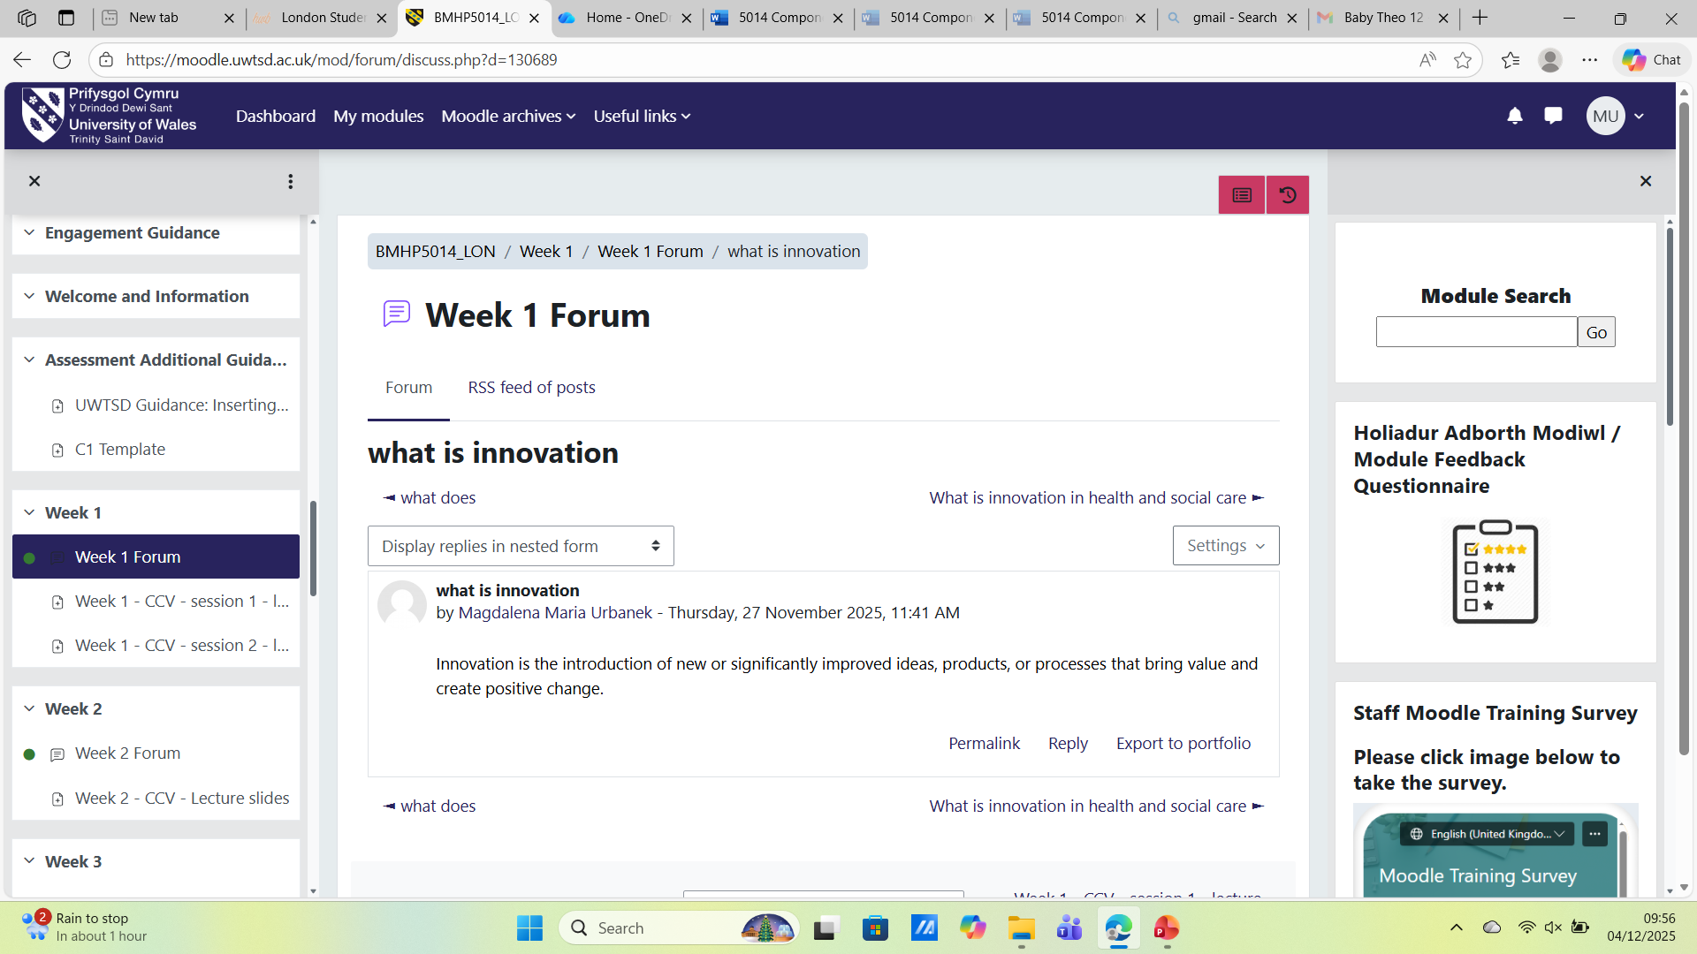

Task 2 - Mind Map

Problem to Solve: Burnout Among Health and Social Care Workers
Problem to Solve: Burnout Among Health and Social Care Workers
Identifying the Problem:
Identifying the Problem
Root Cause Analysis
Root Cause Analysis
Root Cause Analysis
Implementing Change
Implementing Change
mplementing Change
Evaluating Outcomes
Continuous Improvement

Problem to Solve: Burnout Among Health and Social Care Workers

Identifying the Problem:

- Increased number of sick leaves
- Decreased motivation and engagement
- Patient complaints about service quality

Root Cause Analysis:
- Work overload (staff shortages)
- Low emotional support
- Lack of professional development opportunities
- Poor work-life balance

Root Cause Analysis:
- Introduce psychological support programs
- Task rotation and reduced overtime
- Stress management workshops
- Increase the number of staff per shift

Implementing Change:
- Train management on staff wellbeing
- Create “quiet zones” or relaxation rooms
- Flexible work schedules

Evaluating Outcomes:
- Staff satisfaction surveys
- Monitoring sick leave statistics
- Observing staff turnover rates

Continuous Improvement:
- Regular team meetings
- Collect suggestions from staff
- Adjust HR policies to current needs

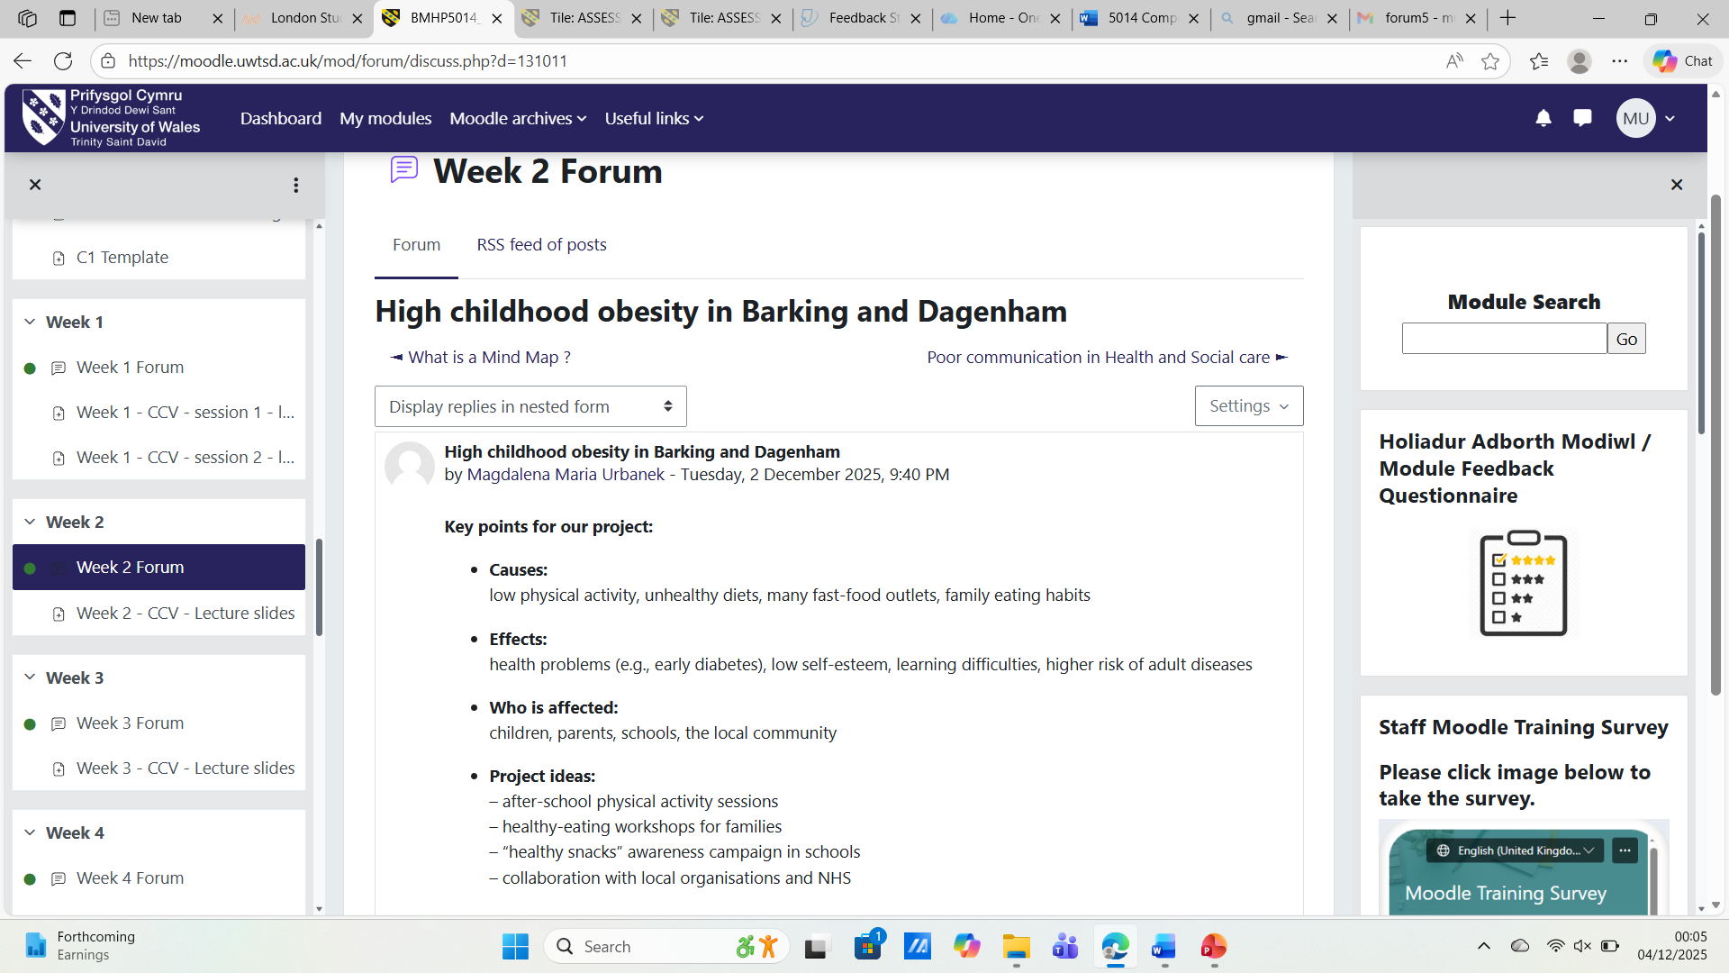

TASK3 - Self – Reflection of Group Activity
Self-Reflection (Gibbs’ Reflective Cycle)
In class, we explored divergent thinking, which focuses on generating many numerous ideas, and convergent thinking, which involves analyzing different ideas, and convergent thinking, which involves analyzing and narrowing those ideas to select the most effective solution. Guilford (1967) describes these two processes as complementary aspects of creative problem-solving.
Description & Feelings:
During the group activity, the divergent stage felt exciting because we were encouraged to share any idea without judging it. I enjoyed the freedom of this process, although at times I felt unsure when the ideas became too broad.
Evaluation:
Our team produced a wide range of suggestions, which showed that the divergent phase worked well. When we moved into convergent thinking, the discussion became more structured and focused. I felt more confident in this stage because we were evaluating options and making decisions together.
Analysis:
I realized that I naturally lean toward convergent thinking. While this helped the group stay organized, it also made me slightly hesitant to contribute more unusual ideas during the creative stage.
Conclusion & Action Plan:
I learned that effective teamwork requires a balance between both thinking styles. In future activities, I plan to push myself to be more open and experimental during the divergent stage before shifting into problem-solving mode.
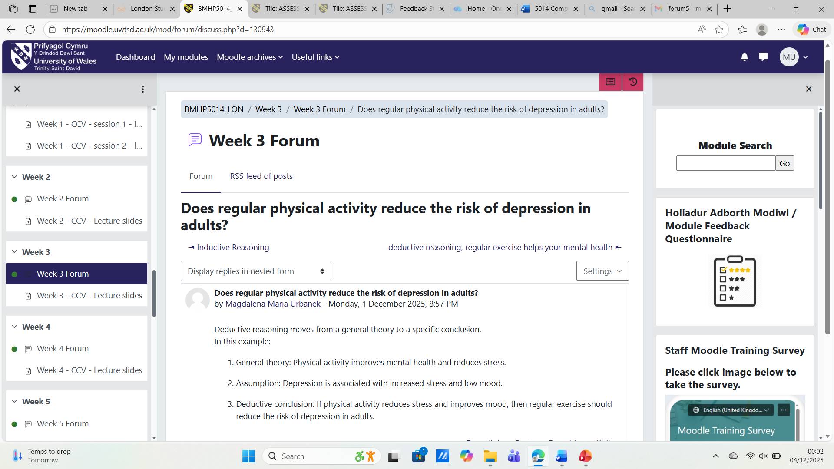

Task 4 Case Study Analysis:
NHS Virtual Wards:
The NHS Virtual Wards initiative is an innovative model of care allowing patients to receive hospital-level treatment at home use Virtual Wards initiative is an innovative model of care that allows patients to receive hospital-level treatment at home, utilising ng remote monitoring technology and multidisciplinary support teams. Creativity was applied by integrating digital tools (e.g., pulse oximeters, apps, and wearable tech) with clinical oversight to reimagine inpatient care outside traditional hospital settings.
The innovation aimed to address hospital overcrowding and improve care for patients with chronic conditions, especially during the COVID-19 pandemic. It also targeted reducing unnecessary admissions and promoting faster, safer discharges.
Value was created through improved patient satisfaction, increased bed capacity, and greater autonomy for service users. Staff also benefited from reduced pressure on emergency departments and better allocation of resources.
Evidence shows virtual wards can significantly reduce readmission rates and improve clinical outcomes. A study by Gardner et al. (2022) found virtual wards reduced hospital stays by up to 40% without compromising safety. Similarly, the King’s Fund (2023) reported enhanced patient experience and efficiency across pilot sites.
This innovation highlights how digital creativity and service redesign can respond effectively to systemic pressures in UK health care.

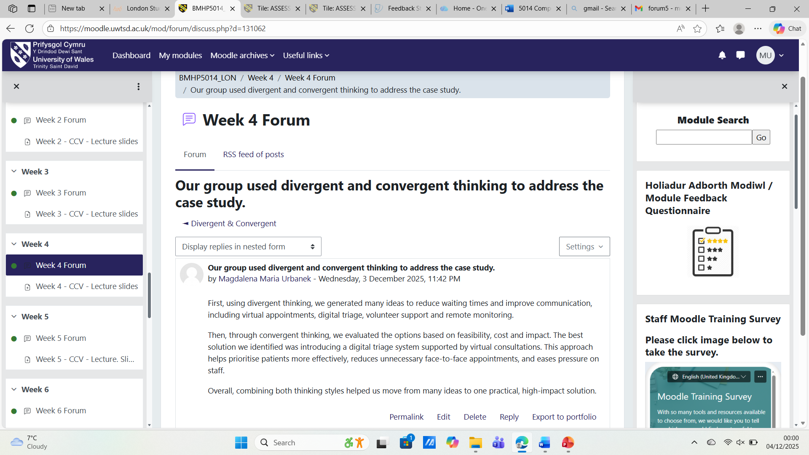

Task 5 - Research Task STAFF BURNTOUT
A major current issue in health and social care is staff burnout among nurses and other healthcare workers. Burnout is characterised by emotional, physical, and psychological exhaustion, which can reduce job satisfaction, impair mental well-being, and compromise patient care (Fernandes et al., 2025). Recent research shows that burnout is particularly prevalent among primary healthcare nurses, who often experience high workloads, extended shifts, and insufficient staffing levels (Fernandes et al., 2025).
Further analysis of nursing burnout reveals that systemic factors, such as lack of autonomy, poor social support, and organisational stress, significantly contribute to the problem (Shanafelt et al., 2020). These conditions create an environment in which nurses are at risk of emotional exhaustion and professional dissatisfaction, which can lead to higher turnover rates and decreased quality of care (Shanafelt et al., 2020).
From these studies, burnout is not merely an individual issue but a systemic challenge. Addressing it requires organisational interventions, including better staffing ratios, more flexible scheduling, stronger support systems, and recognition of staff contributions. By improving working conditions and supporting the well-being of healthcare workers, the quality of patient care can also be safeguarded (Fernandes et al., 2025; Shanafelt et al., 2020).

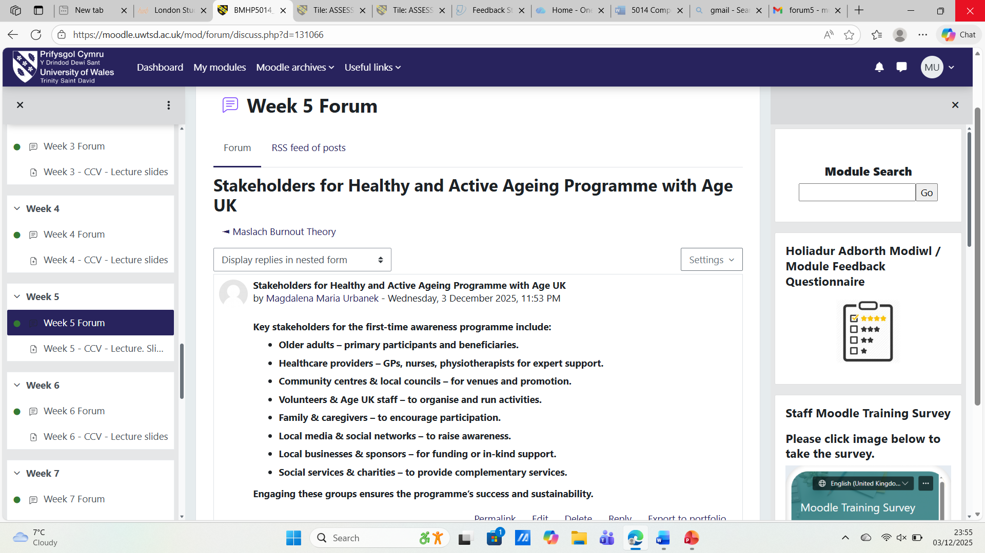

Task 6 - Exploring Digital Innovation in Health and Social Care

1. Benefit of wearable health technologies for managing chronic conditions:
Wearable devices, such as smartwatches and fitness trackers, support patients in managing chronic conditions by providing continuous monitoring of vital signs and physical activity. They track heart rate, steps, calories burned, sleep, and sometimes blood glucose levels. For patients with diabetes or cardiovascular disease, real-time monitoring enables timely lifestyle or treatment adjustments, such as increasing activity, modifying diet, or alerting healthcare providers to abnormal readings. Wearables enhance patient engagement and self-efficacy, encouraging adherence to treatment plans. Studies show they can improve quality of life, functional capacity, and health outcomes while potentially reducing healthcare costs by decreasing hospital visits (Banaee, Ahmed and Loutfi, 2013). Integration with mobile apps and cloud platforms allows trends to be analysed over time, supporting early intervention and better disease management. Such devices also encourage patients to take a more active role in their health, fostering preventative behaviours and healthier lifestyles.

2. How electronic health records (EHRs) improve communication and collaboration:
Electronic Health Records (EHRs) centralize patient data, including medical history, diagnoses, medications, lab results, and care plans, enabling multiple healthcare professionals to access and update information simultaneously. This improves coordination, reduces duplicated testing, and minimizes medication errors. EHRs provide a shared platform for general practitioners, specialists, nurses, and allied health staff to communicate effectively, ensuring decisions are based on the most current patient information. They support inter-professional collaboration, enhancing clinical decision-making and patient safety. EHRs also streamline workflows with alerts for drug interactions, follow-ups, and preventive screenings (Ajami and Bagheri‑Tadi, 2013). Secure sharing between healthcare facilities promotes continuity of care for patients with complex or chronic conditions, ensuring consistent treatment plans and informed decision-making across care settings. By improving communication and collaboration, EHRs contribute to better patient outcomes and more efficient care delivery.

3. How digital technology supports preventative care and health promotion:
Digital technologies, including wearables, health apps, and EHR-linked analytics systems, facilitate preventive care and health promotion by collecting continuous health data and detecting early risk signs. Wearables can identify irregular heart rhythms, elevated resting heart rates, or sleep disturbances, prompting early intervention before serious complications occur. Aggregated data helps identify trends, high-risk groups, and lifestyle factors contributing to disease. Healthcare providers can use this information to implement targeted health-promotion campaigns and personalized preventive plans. Digital interventions may include medication reminders, exercise prompts, or screening alerts, increasing patient engagement and proactive health management. By enabling early detection and timely action, digital technology reduces disease incidence, improves long-term outcomes, and decreases healthcare system burden (Steinhubl, Muse and Topol, 2015). These tools empower patients and providers to work together in maintaining and improving health.

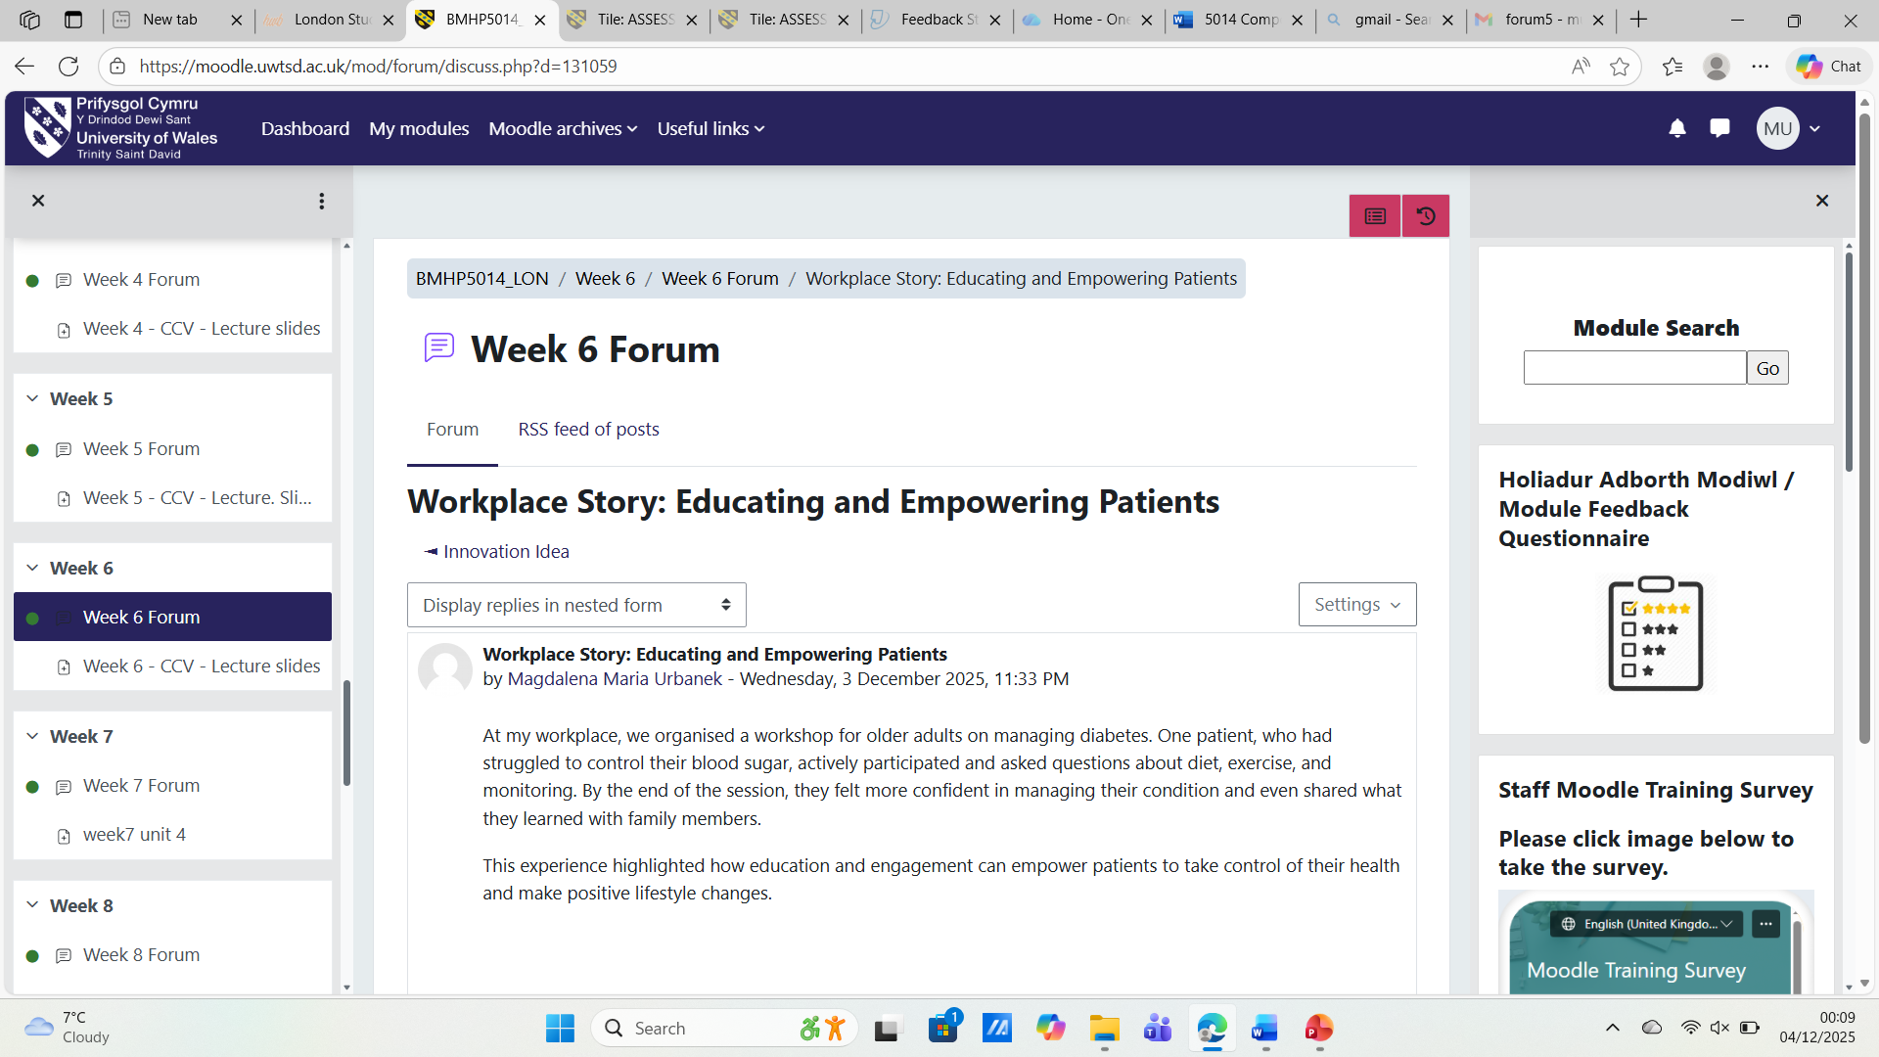

Task 7 Understanding the NHS Leadership Framework:

1. Summary of the NHS Leadership Framework:
The NHS Leadership Framework is a structured tool that supports the development of leadership skills across health and social care. It identifies nine leadership dimensions grouped into three areas: personal qualities, working with others, and setting direction and delivering results (NHS Leadership Academy, 2013). Personal qualities include self-awareness and learning from experience. Working with others focuses on teamworking, inspiring a shared purpose, and leading with care. Setting direction encompasses strategic thinking, evaluating information, and driving service improvement. The framework defines observable behaviours and competencies, helping organisations identify strengths, promote continuous learning, and create a culture of collaboration, creativity, and high-quality care (West et al., 2015).

2. Inspiring shared purpose to encourage creativity:
A key leadership behaviour is inspiring a shared purpose, which involves engaging the team around a common vision and motivating them to improve services. Leaders can foster creativity by creating an environment where staff feel valued and confident to share ideas. Examples include brainstorming sessions, open feedback forums, and recognition of innovative initiatives. This encourages the team to develop creative solutions for workflow challenges, service design, and patient experience improvements. Such an approach supports a culture of innovation, collaboration, and continuous improvement, directly benefiting patient care and service quality (West et al., 2015; NHS Leadership Academy, 2013).

3. Personal reflection:
This module has significantly enhanced my understanding of creativity and value creation in health and social care. I have learned that creativity is not just about generating ideas but also about improving patient outcomes, efficiency, and teamwork. Activities such as group problem-solving exercises, exploring convergent and divergent thinking, and examining digital innovations demonstrated how structured creativity supports service improvement. This experience has influenced my professional perspective, making me more proactive in implementing innovative solutions and supporting team collaboration. In my future career, I aim to integrate creative problem-solving and value-based leadership to enhance patient care and drive service excellence.
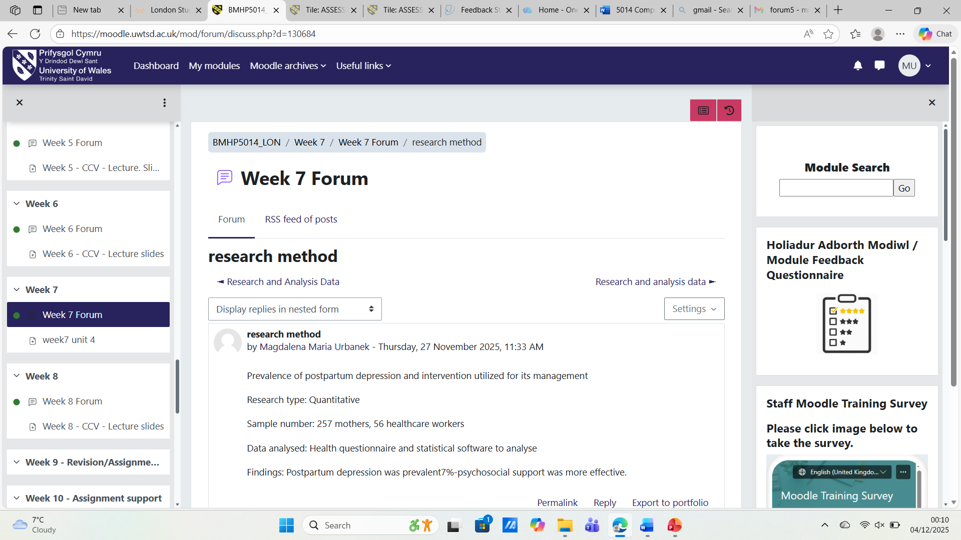

Task 8 Self-Reflection Journal Entry:
During this module, I learned that creativity in health and social care is not just about generating ideas but also about improving patient care and service efficiency. Group exercises and exploring convergent and divergent thinking showed me how a structured approach to creativity can lead to practical improvements in teamwork and service delivery.
I also realised that active listening, encouraging team members to share ideas, and combining different perspectives enhances team effectiveness. In my future practice, I aim to apply creative thinking and value-based approaches to improve patient experiences and the quality of care provided.


References
Ajami, S. and Bagheri-Tadi, T. (2013) ‘Electronic health records: advantages and disadvantages’, Journal of Research in Medical Sciences, 18(2), pp. 129–133.
Banaee, H., Ahmed, M.U. and Loutfi, A. (2013) ‘Data mining for wearable sensors in health monitoring systems: a review of recent trends and challenges’, Sensors, 13(12), pp. 17472–17500.
Gardner, T. et al. (2022) Remote care: Assessing the evidence. The Health Foundation.
Guilford, J.P. (1967) The Nature of Human Intelligence. McGraw-Hill.
Kotter, J.P. (1996) Leading Change. Harvard Business School Press.
NHS Leadership Academy (2013) The Healthcare Leadership Model. Leeds: NHS Leadership Academy. Available at: https://www.leadershipacademy.nhs.uk/resources/healthcare-leadership-model/ (Accessed: 1 December 2025).
Porter, M.E. (2010) ‘What is Value in Health Care?’, New England Journal of Medicine, 363(26), pp. 2477–2481.
Runco, M.A. and Jaeger, G.J. (2012) ‘The Standard Definition of Creativity’, Creativity Research Journal, 24(1), pp. 92–96.
Steinhubl, S.R., Muse, E.D. and Topol, E.J. (2015) ‘The emerging field of mobile health’, Science Translational Medicine, 7(283), pp. 283rv3.
The King’s Fund (2023) Virtual wards: A real solution to NHS pressures?”
West, M.A. and Farr, J.L. (1990) “Innovation and Creativity at Work”. Wiley.
West, M., Eckert, R., Collins, B. and Chowla, R. (2015) “Leadership and Leadership Development in Health Care: The Evidence Base”. London: The King’s Fund. Available at: https://www.kingsfund.org.uk/publications/leadership-health-care (Accessed: 1 December 2025).

