Research Project

NAME OF STUDENT: S. Leach

STUDENT ID: 2004817 EMAIL ADDRESS: 2004817@student.uwtsd.ac.uk

NAME OF AWARD: BSc Construction Management

MODE: Full-Time

Please complete the following and return to the Module Leader.

Contents
1 Title of Research Project 3
1.1 Introduction and Background 3
1.2 Aims and Objectives, Hypotheses to be Tested, Questions to Answer, etc.: 3
Chapter 2 Lit Review 4
2.1 Introduction to the Literature Review 4
2.2 Definition 4
2.3 History of Modern Methods of Construction 4
2.4 Modern Methods of Construction Framework 6
2.5 Advantages to using Modern Methods 7
2.5.1 Time 8
2.5.2 Cost and Quality 9
2.6 Barriers to Modern methods 10
2.7 A focus on 3D primary structural systems 10
2.9 Summary 11
3.0 Methodology 12
3.1 Type of Data 12
3.2 Data Analysis 12
3.3 Conclusion 12

1 Title of Research Project

Modern method of construction within the UK construction industry with a focus on 3D primary structural systems.

1.1 Introduction and Background

The researcher has limited knowledge of the construction industry and seeks to gain a greater understanding of modern methods of construction with a focus on 3D primary structural systems and how they are being implemented within the industry.
The research findings will be beneficial to new and less experienced members of the construction industry looking to expand their knowledge on modern methods of construction and those individuals or companies considering using use off-site manufacturing as a potential method of construction in the future.

1.2 Aims and Objectives, Hypotheses to be Tested, Questions to Answer, etc.:

The hypotheses for this research project is, ‘modern methods of construction are the future of the construction industry’.
Therefore, this research project aims to identify how modern methods of construction have been used within the construction industry if they have been successfully used to improve the U.K construction industry.
The objectives of this research project will be:
- To define what the modern methods of construction are.
- To establish how modern methods of construction originated within the UK construction industry.
- Identify in detail, category one of the Modern Methods of Construction framework.
- To analyse both the advantages and barriers to using Modern Methods of Construction.
- To reach a conclusion on whether the hypotheses is correct or not.

Chapter 2 Lit Review

2.1 Introduction to the Literature Review

Throughout this chapter, it aims to cover the origins of modern methods of construction and provide the reader with an understanding of how new methods of construction have evolved within the industry and have now become modern methods of construction. It aims to identify the framework of modern methods of construction with a focus on 2D primary structural systems. It aims to identify both benefits and drawbacks of modern methods of construction present to the industry by analysing secondary sources of information.

2.2 Definition

As Kier Group, a UK construction company state, on their published Modern Methods of Construction broacher, the aim of Modern Methods of Construction is to bring a range of innovative approaches to constructing infrastructure which results in increased productivity and efficiencies, (Kier, 2020),
It was noted by NHBC (2018), that there was some difficulty defining modern methods of construction due to the range of terminology used causing confusion. NHBC stated that many within the industry used to describe modern methods of construction as a generic term that consists of a range of construction techniques.
However, as time has progressed a greater understanding has been established. Kier (2020), define modern methods of construction as, “the design, planning, manufacture and pre-assembly of construction elements or components in a factory environment, prior to installation on site at their intended, final location”.

2.3 History of Modern Methods of Construction

Taylor (2009), prepared a report on behalf of the HSE which covered off-site production in the UK and gave a brief overview of its origins. Taylor states that the end of World War One caused major shortages on both labour and materials needed for traditional building methods. With the majority of working aged males having been diverted to the war effort, it caused a great shortage of housing. The shortage of housing forced industry professionals to look to new methods of construction to combat the shortages.
Between 1918 and 1939 4.5 million houses were built, however 95% of these houses were constructed using traditional methods. During this period, the 5% that were built using new methods of construction resulted in 20 steel frame housing systems being created and various other new methods of housing such as insitu and precast concrete and timber houses.
The end of World War 2 forced an even greater need to turn to new and modern methods of construction. Taylor (2009), explains that the government aimed to replace destroyed houses. With an abundance of steel and aluminium that was no longer needed for the war, a shift in the industry towards more prefabrication was needed and resulted in many varieties of steel, timber, concrete, and hybrid frame systems.
P.H (2016) states that between 1945 – 1948, 156,623 prefabricated buildings were erected all over the UK to house the returning servicemen and those affected by the Blitz bombing. With parts prefabricated off-site, they could be brought to the site and put together by semi or unskilled workers and although initially thought to only last 15 years, many are still function houses today over 70 years later.
The 1950’s and 1960’s saw a swing in the industry to more industrialised forms of building. Many in the industry who were in favour of off-site manufacturing were promoting modern methods of construction and had been growing in confidence. Yet those who lived in these new types of residential dwellings, especially those in high rise dwellings had growing concerns especially after the gas explosion in Ronan Point. BRE (2022) explains how a gas explosion on the 18th floor caused the collapse of one side of tower. Built using a panel system, which used precast concrete panels made off-site, the tower could be constructed at much greater speeds, but the cost savings led to inadequate quality. The decision was made to demolish the building only 17 years after commissioning, despite being forecasted to last 60 years.
Although first used in the 1940’s, volumetric construction became more widely used towards the late 1960’s. As Buildoffsite (2019) states, this involves large modular units constructed off-site that can be linked together onsite to form a complete building without the need for additional superstructure. Taylor (2009) then goes on to state that by the 1980’s 30% of new homes being built utilised an off-site prefabricated timber frame with timber wall and floor panels and usually either a brick or stone outer leaf. This was known as Rationalised Traditional Construction. However, after the live broadcast of the ‘World in Action’, severe damage was done to the new build sector. The programme was severely critical of group of timber framed houses in the West of England, stating that they were not watertight and that the timber would rot. The programme incited that this would be the same for all timber frame houses and that current owners would have this issue in the future.
400 houses were independently surveyed in areas identified that the houses would be most exposed to the elements and found that there was no evidence to back up the claims made on the programme, ‘World in Action’. No evidence of decay was found. But as Taylor (2009) explains, the public damning of timber houses on a live broadcast had already taken its effect It stalled the new build sector, and made the industry as a whole look unreliable. Some believe that the programme is still the reason today that many chose traditional building methods.

2.4 Modern Methods of Construction Framework

In 2017 the Modern Methods of Construction definition framework had been developed by a cross industry working group under the instruction of the UK government. Mark Farmer led this specialist group, just one year after releasing his damning report, ‘Modernise or Die’, (Farmer, 2017) on the industry.
As Buildoffsite (2019) states, groups such as RICS, Buildoffsite, Homes England and NHBC all had great input into creating the framework. The framework was created with an aim to improve stake holders’ education and understanding of modern methods of construction so that modern methods of construction could have access to mortgages, insurance, and assurance.
The definition framework separates different modern methods of construction into seven different categories. The first four categories seen in the image below count for all the Off-site manufacturing. Categories 5-7 account for on-site process improvements. A brief description for each category can be sign on the image.

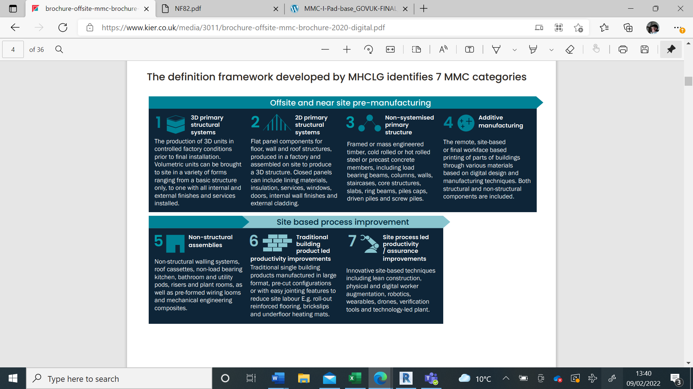

(Image taken from Kier, 2020)

2.5 Advantages to using Modern Methods

Modern methods of construction have gained momentum within the industry due to the huge advantages they can offer both contractor and client, however the advantages are often overlooked as many within the industry prefer the traditional methods as a simplistic option. As Farmer (2021) highlights the government is demanding more new houses year on year and the industry struggling to keep up with the demand. The advantages of using modern methods of construction and in particular pre-manufactured methods need to be highlighted in detail and demonstrated to the industry to encourage uptake.
Farmer (2021) emphasises the governments objective is to deliver 300000 new homes per a year, in aim to achieve the 3.9 million homes needed. It is recognised by the government and industry analysts this is not attainable with the use only traditional building techniques. Extensive use of modern methods will be required.
Listed below are some of significant benefits highlighted by Farmer and that many can claim from using modern methods of construction, major benefits will be discussed in greater detail further down.

- Time can be reduced from 20-60% compared to using traditional methods.
- Quality can be vastly improved.
- Reduced site waste.
- Reduced programme of works.
- Better standards of safety.

Branson (2020) explains how the labour shortage had already begun in the construction industry prior to Brexit. Below is an image taken from the report showing statistics for houses being built using MMC in 2020, in comparison to what is forecasted for the next decade.
Image 1, Labour forecast.
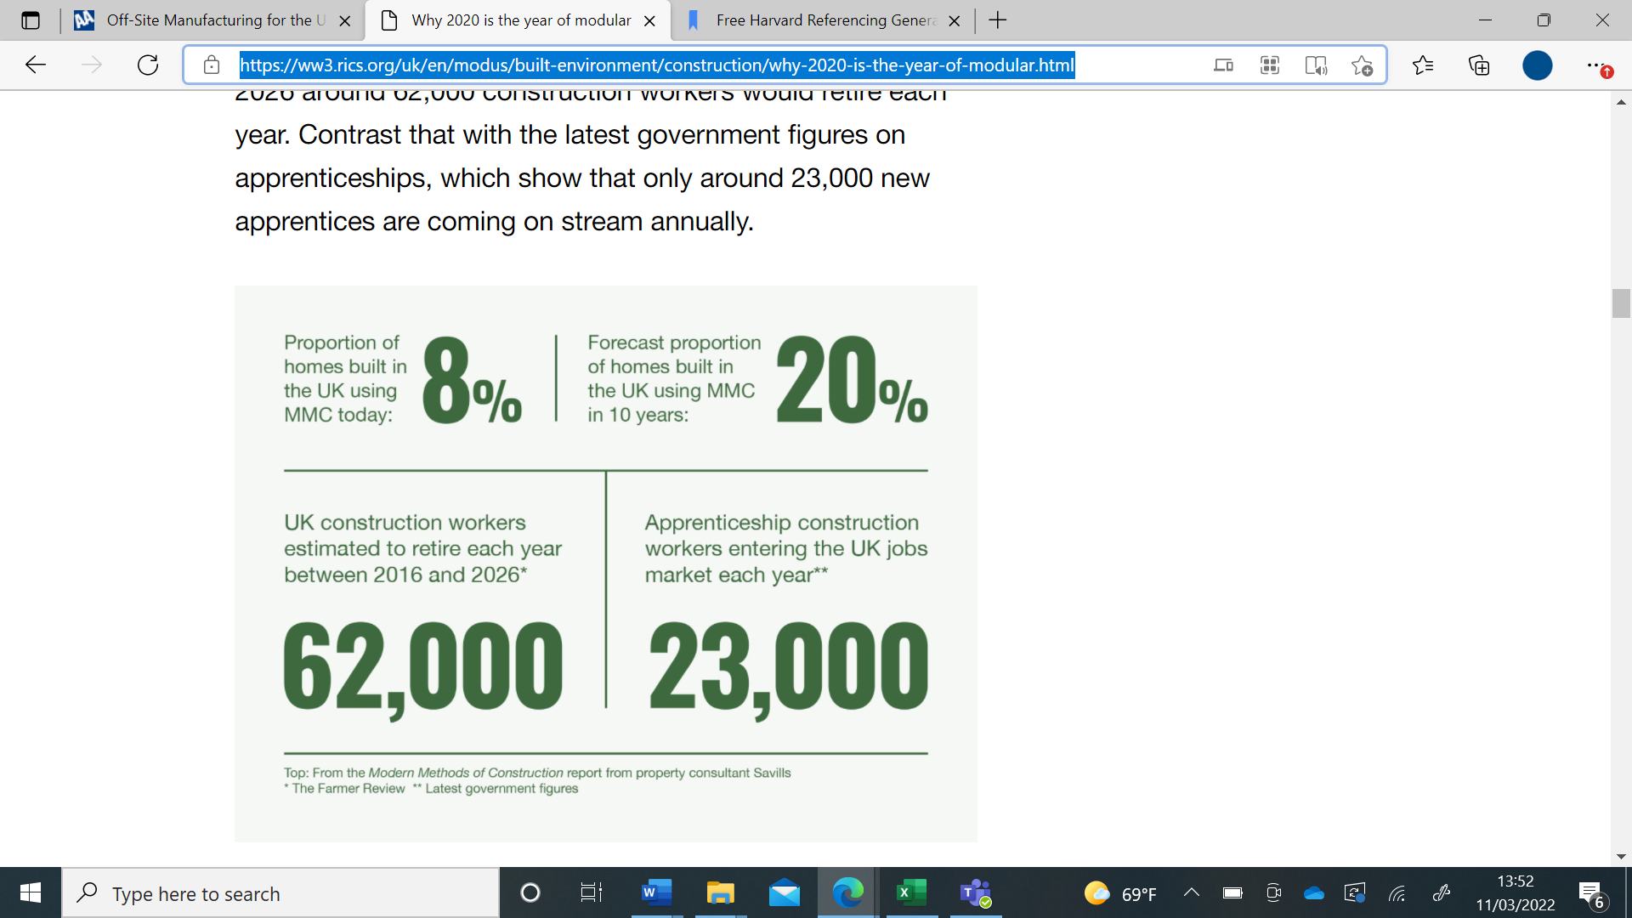
Image taken from (Branson,2020)
With 62000 construction workers forecasted to retire per year from 2016 to 2026 and only 23000 workers being onboarded annually into the industry, it is very evident a labour shortage is going to influence companies already established in the Industry. As Branson highlights, 10% of the UK construction force comes from European Union and an estimated 59% of these workers will be ineligible

2.5.1 Time

As seen in the ‘Iron Triangle’, often reduced time is accompanied by either lower quality or higher costs. Time spent on a project can be greatly reduced by using modern methods. With a range of methods allowing pre-manufacturing off-site to be done 24/7 in factory like conditions this eliminates the potential for any adverse weather conditions to cause delays in the programme but ensures high quality is maintained and consistent.
Image 2, The Iron Triangle.
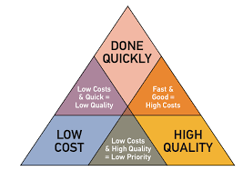
Image taken from (Digitalgenius, 2020)
In the Mckinsey report, (Bertham et al, 2019) it states that the use of modular construction to build houses has resulted in them being completed 20-50 percent quicker than those of traditional builds and RIBA (2019) similarly mentions, that a report carried out by Commons Housing, Communities and Local Government Select Committee in 2019 estimated that the construction programme could be reduced by 20-60% by using MMC.
The Mckinsey report highlights on average more time is spent on pre-construction stage, this is because designers need to make decisions earlier on in the project which can be costly and expensive to change later. As designers become more familiar with modular construction, they will develop their own modular libraries. The Mckinsey report highlighted that one of their clients had already started to save between 10-15 percent of time on the design phase using modular libraries.
Labour hours on-site are reduced, with the modules being pre-manufactured in factory conditions. Although this increases off-site construction time, overall construction time is significantly reduced. With modules turning up to site completed they can be fixed into place with extreme accuracy in good time. With modules being constructed to a high standard in the factory the time needed for snagging is reduced majorly.
A shorter construction programme can be seen as a major benefit by many developers. Clients building with the intention to sell or rent out residential units can start earning a revenue sooner.

2.5.2 Cost and Quality

As Taylor (2009) mentions, many of the cost savings are often neglected in tenders by those who prefer traditional methods of building. But there are several areas that cost savings can be found using modern methods of construction. Due to the nature of the build, sub-contractors are required to give their input at a much earlier stage within the project, greater collaboration at the earlier stages of a build is proven to result in less design changes which can be costly later in a project.
Cost savings will vary on a range of different projects. For example, highlighted in the Mckinsey report (Bertham et al, 2019), it is known that projects that are high labour intense repetitive designs such as student accommodation, hotels and even affordable housing will benefit greatly from workers repeating the same build, it will speed up and improve accuracy the more the project is completed. However, for high end designer projects which feature one off designs, these won’t benefit as much as the process will not be repeated and improved. As Taylor (2009) states, bulk orders of the same volumetric unit or 2D primary structure can give significant cost savings to both client and supplier.
Within the report conducted by RIBA (2019), it was noted that in 2017 a survey conducted on people moving into a new build home constructed by traditional methods found 99% of customers had reported problems with their home and out of those people that reported problems 41% of them had 10 or more problems. RIBA states that the precision of offsite manufacturing can lead to a change of perception and reverse the negative perception that currently plagues the industry.

2.6 Barriers to Modern methods

As highlighted in a report conducted by NHBC (2019), modern methods of construction require more space to be able to move pre-fabricated units to site. If the site has poor or difficult access, it can prevent any units being successfully delivered and potentially craned in, this forces the contractor to use traditional building methods. There is also a lack of flexibility for the client’s design once the early stages have concluded.
Also, within the report by NHBC to the government it states challenges with procurement can affect the method choice of construction. Stating that a higher capital cost upfront can put off many clients, as lowest cost is often still seen as the best value by many inexperienced individuals within the industry. Another barrier highlighted within their report is the lack of evidence for insurance and mortgage companies to feel comfortable offering their services to houses constructed with modern methods. Parliament.uk (2019) highlights that there is not enough long-term data on how modular buildings will react to flooding or the outbreak of a fire. Questioning whether their fire proofing is adequate after seeing the catastrophe of Grenfell. The Parliament report also states that modular buildings do not always comply with the building regulations set out in the approved documents and these need to be heavily considered and potentially revised to aid the uptake of MMC.
RIBA (2019) states that major uptake of modern methods can lead to a lack of creativity within the industry and that many contractors driven by cost will produce buildings lacking individuality.

2.7 A focus on 3D primary structural systems

As is stated in the definition framework by (buildoffsite, 2019), 3D primary structural systems are commonly known as volumetric construction. The volumetric units can be used for many purposes such as office spaces, bathrooms, and kitchens. However, the system includes structural performance.
Farmer (2021) discusses how Tide Construction and their manufacturing company Vision Modular systems have produced over 6000 modular dwellings using 3D primary structural systems. While completing these projects, they observed that a 50% increase in speed of construction was attainable over multiple projects while maintaining fewer defects then traditional build methods. Farmer states, up to 80% less waste was produced when compared to a traditional method and of the waste produced 97% of it was recycled.
Major developments in recent times have seen a boost in volumetric construction, with many successful case studies shining a positive light on modern methods of construction. Egege (2018) states that up to 90% of construction using volumetric units is done within a regulated factory setting, making this form of construction the most innovative way of delivering high quality and safety orientated projects.
Although many successful projects have used 3D primary structural systems Hořínková (2021) Highlights, in her report on modular construction and reiterated by many websites discussing modular construction found on the internet, that the maximum size of a modular room is limited by what can be transported to site. Therefore, room sizes are limited to specific constraints and those looking for open plan living will look outside of modular construction. Hořínková concluded her report on modular construction having identified advantages out weighed the disadvantages and those disadvantages identified could be resolved with the development of future technology However she could not conclude if modular construction was directly better then traditional methods and techniques due to every project in the industry being unique and that the choice of construction is not always so straight forward.

2.9 Summary

Many sources throughout this literature review are extremely keen to point out major advantages that can be gained for all parties by using modern methods of construction. Major benefits such as, reduced construction time while maintaining or improving the standards of quality. Site waste reduced and more recycled materials leading to more eco-friendly build, greater control on build quality and a certainty of good workmanship in factory conditions. With these advantages being at the forefront of many literature sources it would seem that modern methods of construction would be the obvious choice for all clients and contractors within the industry. However, as some sources highlighted major barriers currently prevent mass adoption such as the access requirements to needed to deliver pre-manufactured units to site, or the size constraints placed on units to be able to transport them to site. The current perception of lowest cost tendering is also hindering a move to modern methods of construction as these usually produce a much greater upfront cost.
As modern methods of construction have been Identified as a solution to meet the demand and quality needs requested by the government, literature suggests it is likely that barriers highlighted to mass adoption will be overcome with the advancement of new technology and further research.

3.0 Methodology

The aim of this chapter is to discuss the type of research conducted throughout this report. It will analyse the literature review.

3.1 Type of Data

Valentine (2022) states that secondary data is information that already exists, that has been collected by other people or organisations for a different purpose. It is often readily available and sometimes requires permission to view. Secondary data often contrasts with data that the researcher has collected first hand through interviews or questionnaires.
Qualitative research defined by Bhandari (2020), consists of collecting non-numerical data to understand concepts, opinions and experiences. It is often collected to gather in-depth insights into a problem or to generate new ideas for research.
Throughout this project the research gathered has been secondary data found on the web and in journals. The type of data gathered was qualitative data, analysing each source for their data to understand their opinion and experiences in the industry on modern methods of construction.

3.2 Data Analysis

The method for analysing data is this project is known as grounded theory. This is described as, researchers collecting rich data on a topic of interest and developing theories inductively, (Bhandari, 2020).

3.3 Conclusion

Due to constraints for the researcher, a qualitative, secondary data analysis approach was identified as the most efficient way to research for this project. The literature review highlighted many benefits the industry can gain from mass adopting of modern methods of construction and although highlighting current barriers that hinder modern methods of construction coming to mass adoption, it states that these will likely be overcome with the adoption of future technology and future research. However, it also highlighted that perception from clients towards upfront cost and the lack of ability to be able to make altercations stops many projects adopting modern methods of construction. With these conflicting views, it highlights the advantage that primary research would be able to give. A first-hand account of primary research from both clients and contractors would help identify current views from professionals working in the industry and would enable the research to contrast these the data found throughout the literature review.

4.0 Results from Research

The aim of this chapter is to analyse the results of the literature review and see if the aims or the project have been archived and whether the hypotheses has been tested and found to be correct or invalid.
4.1 Data Analysis
The general feelings presented by the literature reviewed, is that modern methods of construction are forward thinking and solve many issues that the industry if facing and will continue to face while recruitment into the industry falls. It showed that in some cases, costs and time can be reduced without compromise to the quality of the structures. However, many barriers still exist which are slowing down uptake of modern methods such as the access required for deliveries to sites, which are not able to accommodate the large pre-manufactured structures, and much larger upfront capital costs putting off inexperienced clients. These barriers can be overcome with more education on modern methods and future technologies.
As for the hypothesis, the literature review concenious points to modern methods being the future of the industry, but it is extremely difficult to prove correct or not without primary data to be able to compare it to. Further research with the inclusion of case studies and interviewing current industry professionals would help in proving the hypotheses correct or not. Without being able to compare literature to current industry professionals experiences of modern methods of construction in real time its extremely difficult to gauge whether the literature is inline with what is happening on local sites using these methods.
Sources found through secondary data have allowed all other objectives of the project to be completed.

Review of Research Project

TBC

References

(P.H) - Prefab Museum. (2016). History. [online] Available at: https://www.prefabmuseum.uk/content/history/history. [Accessed 24 Jan. 2022].

BRE (2022). BRE Group: 1968 - Ronan Point gas explosion. [online] Available at: https://www.bre.co.uk/page.jsp?id=2855. [Accessed 23 Jan. 2022].

‌
Offsitehub (2019). Volumetric Modular. [online] Available at: https://www.offsitehub.co.uk/offsite-technologies/volumetricmodular/. [Accessed 23 Jan. 2022].

Buildoffsite (2018). Construction Methods Modular. [online] Buildoffsite. Available at: https://www.buildoffsite.com/content/uploads/2018/07/Unlocking-the-Potential-of-Modular-Construction_Building-FINAL-by-Anilea.pdf [Accessed 11 Feb. 2022].

Buildoffsite (2019). MODERN METHODS OF CONSTRUCTION. (2019). [online] Available at: https://www.buildoffsite.com/content/uploads/2019/04/MMC-I-Pad-base_GOVUK-FINAL_SECURE-1.pdf. [Accessed 21 Jan. 2022].

Farmer, M. (2016). The FarmerReview of theUK Construction Labour Model. [online] cast-consultancy. Available at: https://www.cast-consultancy.com/wp-content/uploads/2021/03/Farmer-Review-1-1.pdf [Accessed 19 Nov. 2021].

Farmer, M. and De’Ath, M. (2020). Build Homes, Build Jobs, Build Innovation. [online] Hta.co.uk. Available at: https://www.hta.co.uk/storage/app/media/build-homes-build-jobs-build-innovation.pdf [Accessed 9 Feb. 2022].
‌
NHBC (2018). Primary research Modern methods of construction Who’s doing what? [online] Available at: https://www.nhbcfoundation.org/wp-content/uploads/2018/11/NF82.pdf. [Accessed 22 Jan. 2022].

‌
Kier (2020). Offsite and Modern Methods of Construction. [online] Available at: https://www.kier.co.uk/media/3011/brochure-offsite-mmc-brochure-2020-digital.pdf. [Accessed 12 Jan. 2022].

Taylor, S. (2009). Offsite Production in the UK Construction Industry. [online] HSE. Available at: https://www.buildoffsite.com/content/uploads/2015/04/HSE-off-site_production_june09.pdf [Accessed 19 Nov. 2021].

Branson, A. (2020). Why 2020 is the year of modular. [online] ww3.rics.org. Available at: https://ww3.rics.org/uk/en/modus/built-environment/construction/why-2020-is-the-year-of-modular.html.
‌
Eccleston, S. (2019). Traditional vs modular: Deconstructing building methods. [online] Planning, BIM & Construction Today. Available at: https://www.pbctoday.co.uk/news/planning-construction-news/modular-vs-traditional-construction/48139/.

DigitalGenius. (2020). The Iron Triangle of Customer Service: Speed, Quality, and Cost | Digital Genius. [online] Available at: https://digitalgenius.com/the-iron-triangle-of-customer-service-speed-quality-and-cost/.
‌
RICS (2021). Modern methods of construction: where are we now? [online] Available at: https://ww3.rics.org/uk/en/journals/built-environment-journal/modern-methods-of-construction--where-are-we-now-.html [Accessed 16 Mar. 2022].
‌
Parliament.uk. (2019). Modern methods of construction - Housing, Communities and Local Government Committee - House of Commons. [online] Available at: https://publications.parliament.uk/pa/cm201719/cmselect/cmcomloc/1831/183102.htm.
‌
RIBA (2019). Written evidence submitted by the Royal Institute of British Architects [MMC 030]. [online] Available at: http://data.parliament.uk/writtenevidence/committeeevidence.svc/evidencedocument/housing-communities-and-local-government-committee/modern-methods-of-construction/written/95725.pdf [Accessed 16 Mar. 2022].
‌
NHBC (2019). NHBC RESPONSE: HCLG Committee -Modern Methods of Construction inquiry. [online] Available at: http://data.parliament.uk/writtenevidence/committeeevidence.svc/evidencedocument/housing-communities-and-local-government-committee/modern-methods-of-construction/written/95728.pdf [Accessed 16 Mar. 2022].
‌
Egege, C.O. (2018). Off-site Modular Construction as a Method of Improving Construction Quality and Safety. International Journal of Structural and Civil Engineering Research, pp.259–268.

Hořínková, D. (2021). Advantages and Disadvantages of Modular Construction, including Environmental Impacts. IOP Conference Series: Materials Science and Engineering, 1203(3), p.032002.

Valentine, D. (2022). Secondary data — NCVO Knowhow. [online] knowhow.ncvo.org.uk. Available at: https://knowhow.ncvo.org.uk/organisation/impact/measuring-your-impact/secondary-data.
‌
Bhandari, P. (2020). An introduction to qualitative research. [online] Scribbr. Available at: https://www.scribbr.com/methodology/qualitative-research/.
‌

‌

Bilography
(PPH, 2021) publications.parliament.uk. (2021). House of Lords - Off-site manufacture for construction: Building for change - Science and Tecnology Select Committee. [online] Available at: https://publications.parliament.uk/pa/ld201719/ldselect/ldsctech/169/16905.htm [Accessed 18 Nov. 2021].

Buildoffsite, 2019. MODERN METHODS OF CONSTRUCTION. (2019). [online] Available at: https://www.buildoffsite.com/content/uploads/2019/04/MMC-I-Pad-base_GOVUK-FINAL_SECURE-1.pdf.

Constructionglobal, (2021). Top Six Benefits of Offsite Construction. [online] Constructionglobal. Available at: https://constructionglobal.com/construction-projects/top-six-benefits-of-offsite-construction [Accessed 22 Nov. 2021].

Egan, T. (1998). Rethinking Construction. [online] constructingexcellence.org. Available at: https://constructingexcellence.org.uk/wp-content/uploads/2014/10/rethinking_construction_report.pdf [Accessed 19 Nov. 2021].

Farmer, M. (2016). The FarmerReview of theUK Construction Labour Model. [online] cast-consultancy. Available at: https://www.cast-consultancy.com/wp-content/uploads/2021/03/Farmer-Review-1-1.pdf [Accessed 19 Nov. 2021].

Horn, S. (2021). How timber frame and offsite construction meet the housing demand. [online] Pbctoday. Available at: https://www.pbctoday.co.uk/news/mmc-news/timber-frame-housing-demand/75242/ [Accessed 22 Nov. 2021].

Kier (2020). Offsite and Modern Methods of Construction. [online] Available at: https://www.kier.co.uk/media/3011/brochure-offsite-mmc-brochure-2020-digital.pdf.

Bertham et al (2019). Modular construction: From projects to products. [online] Mckinsey & Company. Available at: https://www.mckinsey.com/~/media/mckinsey/business%20functions/operations/our%20insights/modular%20construction%20from%20projects%20to%20products%20new/modular-construction-from-projects-to-products-full-report-new.pdf [Accessed 11 Feb. 2022].

Taylor, S. (2009). Offsite Production in the UK Construction Industry. [online] HSE. Available at: https://www.buildoffsite.com/content/uploads/2015/04/HSE-off-site_production_june09.pdf [Accessed 19 Nov. 2021].

Theconstructor.org (2021). On and Offsite production. [online] Theconstructor.org. Available at: https://theconstructor.org/building/on-site-off-site-construction-pros-cons/38334/ [Accessed 22 Nov. 2021].

‌

