Programming in C/C++

For

Software Development

By Daniel O’Dwyer

Table of contents:

Exercise 1
  - Problems identified and solved easiest to hardest (page 3)
  - Notes (pages 3 – 6)
  - Stages of development (pages 7 – 9)
  - Tests conducted (pages 9 -10)

Exercise 2
  - Problems identified and solved easiest to hardest (page 11)
  - Notes (Pages 11 – 14)
  - Stages of development (Pages 15 – 18)
  - Tests conducted (Page 19)

Exercise 3
  - Problems identified and solved easiest to hardest
  - Notes
  - Stages of development
  - Tests conducted

Appendix (Pages 19 – 23)

Exercise 1
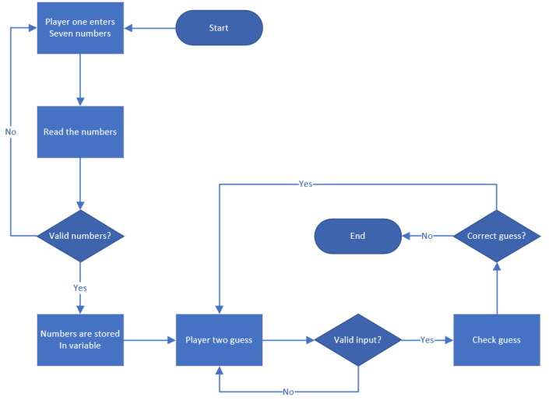
With this exercise the author identified three problems. The first and easiest problem was creating a simple input loop; this would allow the first player to enter seven number of their choice. A for loop would look something like this, for (index = 0; index < 6; index ++). This was the starting point for the programme. After this simple input was created, the more challenging aspects began to arise. The second problem was creating a function. This function was named “Playertwoinput”; since it was a function it was placed above the int main. The author made the function a void as he did not need to return a number from this function. Another for loop was created, this was to allow player two seven guesses. By making this a function instead of coding in the int main, the author is improving the efficiency of the program. The third problem was the hardest, this was the higher or lower input validation. This problem required the use of a significant amount of or (||), and (&&) and if statements. The tricky part was ordering them correctly. This meant placing them in the correct if statements and brackets. After coming out of the first draft of code relatively unscathed, the author decided it was time to make some necessary changes.
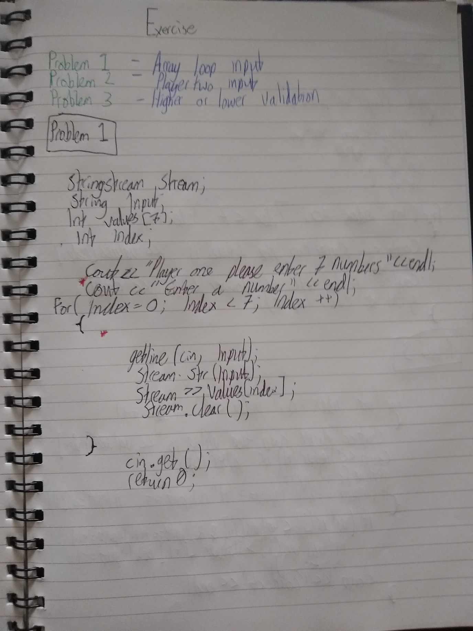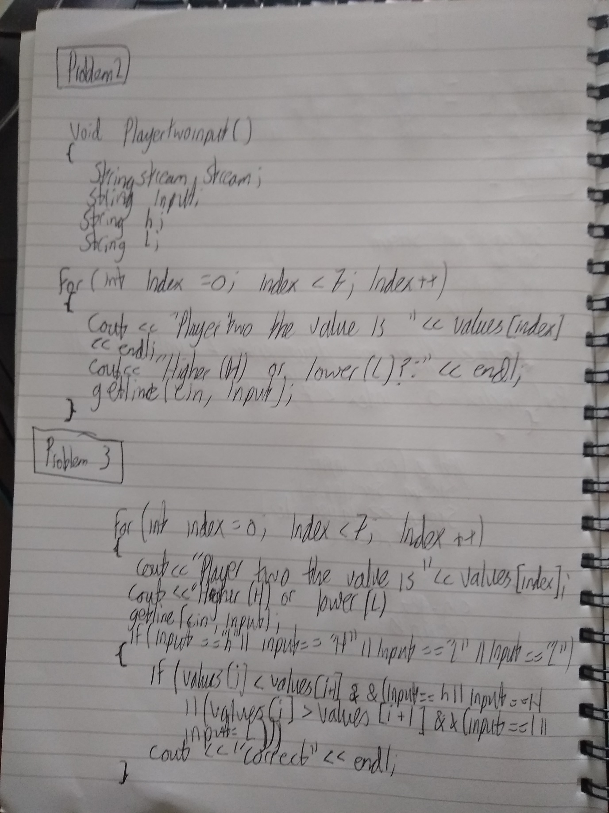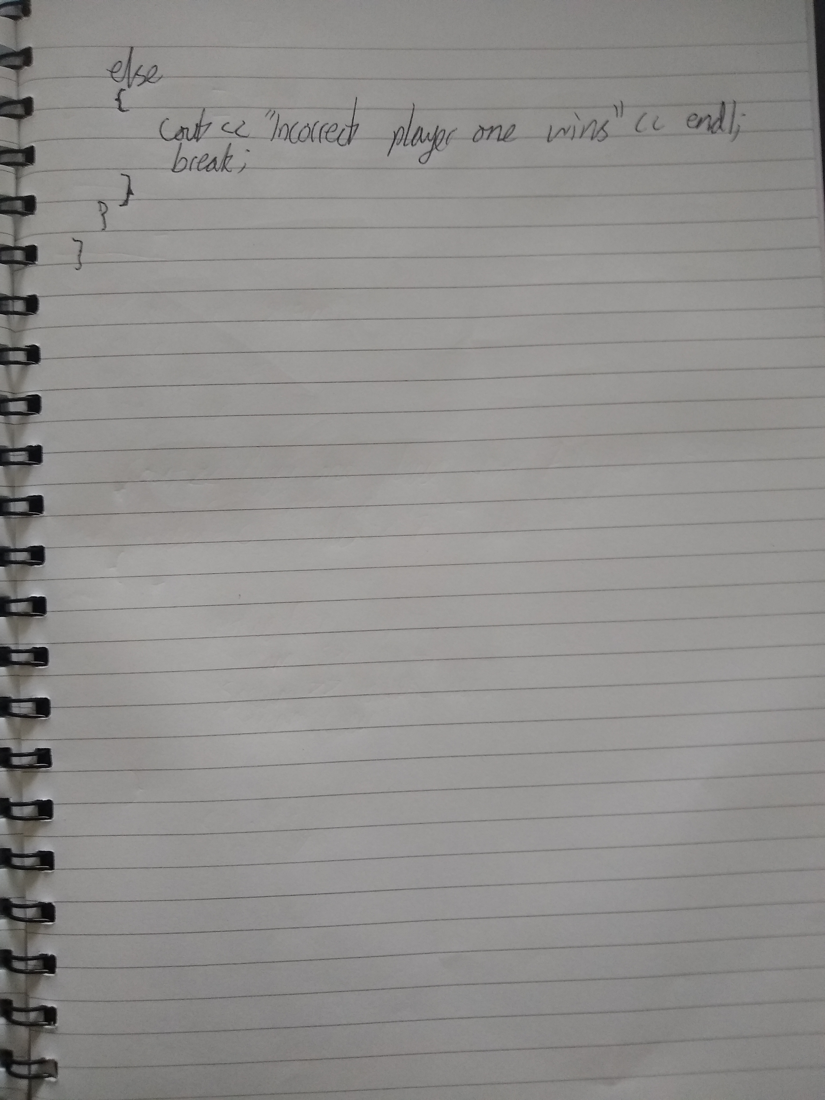

There were many stages of development during this exercise. When finished the code worked as expected, however there were two major problems. The first was that the input code didn’t see the difference between characters and numbers. This meant that player one could input values like “a” and it would store the value in the array. Of course this wasn’t meant to be the case so the author went about changing it. The solution came in the form of a new function “Number Check”. The code looked like this,
int NumberCheck(string input)
{
stringstream stream;

int number;
bool correct = false;

if (isdigit(input[0]))
{

correct = true;
}

return correct;
}
The function would check if the value inputted was a number. The function would then allow it to be stored in the array. However if the input was anything but a number, it would trigger the functions bool variable. This would reject the input until a valid number was inputted.
The second was that the player could enter in any size number. The range was supposed to be between 0 and 10. Again the solution to this took the form of another function. The code for the new function looked like this,
int Rangecheck(int number)
{
stringstream stream;
string input;

bool check = true;

if (number < 0 || number > 10)
{

check = false;
}
return check;
}
This function would check that the number inputted was between the range of 0 and 10. If not the functions bool variable would trigger, rejecting the incorrect value.

After these functions were implemented, the next big issue was getting them to all work together correctly. At first the author struggled to find the correct place to call the functions. After some head scratching, the function “player one input” seemed to be the most suitable location. The next problem was how to slot them into the function. Eventually the final result looked like this,
int Playeroneinput()
{
stringstream stream;
string input;
int number;
bool correct = false;

while (correct == false)
{

cout << "Enter a number: ";
getline(cin, input);

if (NumberCheck(input) == true)
{
stream.str(input);
stream >> number;
stream.clear();
if (Rangecheck(number) == false)
{
correct = false;
cout << "Not a valid number" << endl;
}
else
{
correct = true;
}

}
else
{
correct = false;
cout << "Not a valid number" << endl;
}
}

return number;
}
The solution contained a nested “if “and “else” statement which, coincidentally, was placed in an “if” and “else” statement. The input being stored in the number variable had to be separated. The input would first be checked by the “Number Check” function before being stored in the number variable. Then it would also have to pass the “Range check” function. All of this was nested in a while loop resulting in the final version of “Player one input”.

A nifty little feature was added to the final result. This was a simple line of code that looked like this, cout << string(40, '\n');. This produced 40 blank lines, it was created to separate player ones inputs from the player tow guesses. This made it more like a guessing game by hiding player ones numbers after they had been inputted.
A number of tests were conducted once the code was finished. Each had different aims and was made to test the programme.
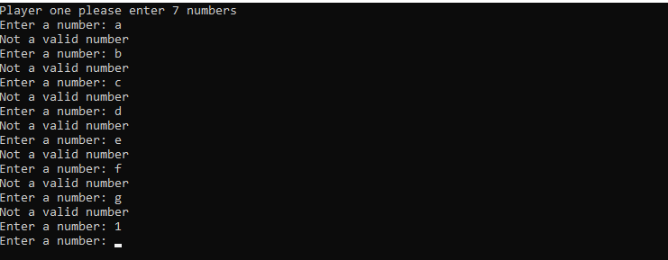
The first test was conducted by inputting characters instead of numbers. The aim of this test was to see if the programme would accept characters as valid inputs. Then the author would input a number to show the difference. The inputs were the letters “a, b, c, d, e, f, g” and the number 1. The expected output was the programme to display the text “Not a valid number”. This would then be followed by the normal loop function, after inputting a valid number.

Looking at the test results, the programme has rejected the characters and accepted the number. This test was a success.
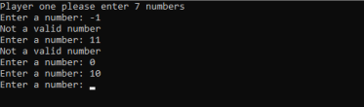
The second test was to see what the programmes response to number outside the range of 0 to 10 was. The author would input two number, -1 and 11. The expected response would be for the programme to display the message “not a valid input”. Then the programme should continue with its normal loop function.

Again looking at the test, the programme has rejected the number -1 and 11. It has accepted 0 and 10 and continued with its loop function. This test was a success.

The third test was to check what would happen if the author inputted two identical numbers. The inputs would be two 0’s; the outcome would be to accept either higher or lower as an answer from player two. Since technically they aren’t higher or lower than each other. The programme would then continue on with the loop as normal.
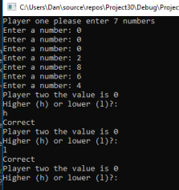

The programme has accepted both higher and lower as valid inputs. This test was a success.
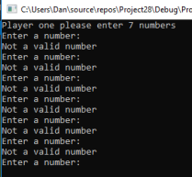
For the fourth test, the author was curious as to what would happen if the user entered nothing or just pressed enter. The author hoped that his programme would reject the input and ask for a valid number. Then the programme should continue with its normal loop function.

Looking at the result we can see that the programme has rejected the input of nothing. This test was a success.

Exercise 2
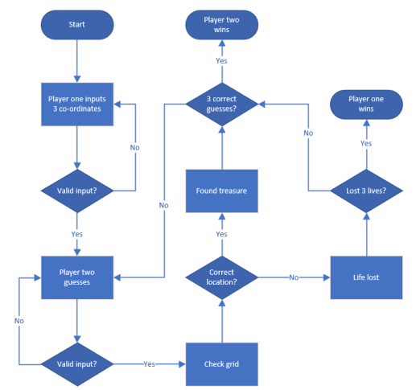
During this exercise the author identified five key problems. The easiest was making a grid, the author decided to use two. One grid was an int grid using arrays to specify the size, in this case [8] [8]. The purpose of the first grid was to allow player one to place the treasure using number co-ordinates. The second was a string grid that would be displayed when player two was guessing the location of the treasure. The second problem was input validation. Since the grid system relies on number inputs, only numbers should be inputted. Also a range check was needed as the grid was 8x8 so 8 would be the max value. A simple if statement, if (input < 0 && input > 8), managed to solve this. The next problem was implementing a lives system for the second player. The second player got three guesses, if all three were wrong the game should end and player one should win. The fourth problem was displaying the grid, particularly the string one. This was difficult because the author found out that two for loops were needed, also the right index were needed to make sure the grid displayed properly. The fifth and most difficult problem was displaying an “X” or “N” where player two’s co-ordinate guess was. In theory it didn’t sound too hard, if player two’s input was the same as player one’s then an “X” would be displayed. Similarly if the input was incorrect then an “N” would appear. The tricky part was getting it to display on the grid, grid[x2 [index]] [y2 [index]] = "X" was the calculation used. Placing it was tricky two, eventually the author placed it above the display loop and it worked.

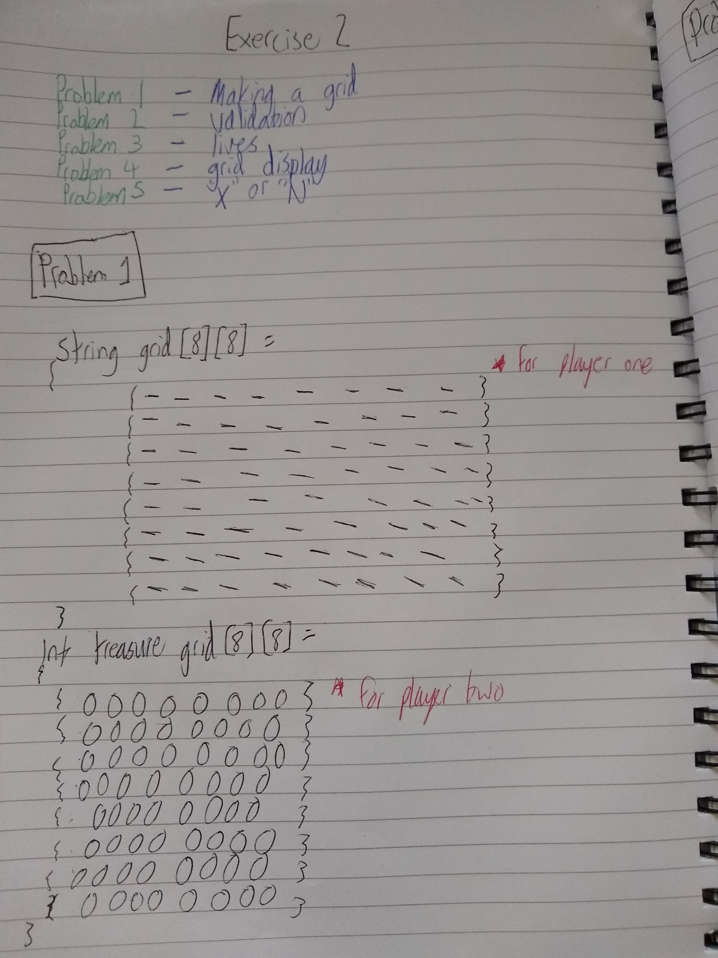

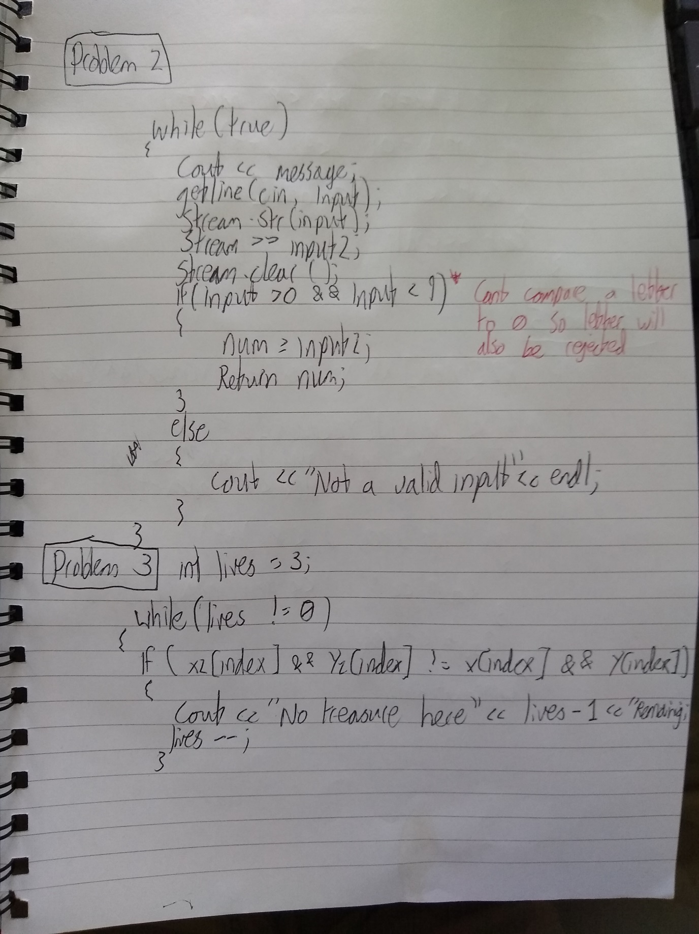

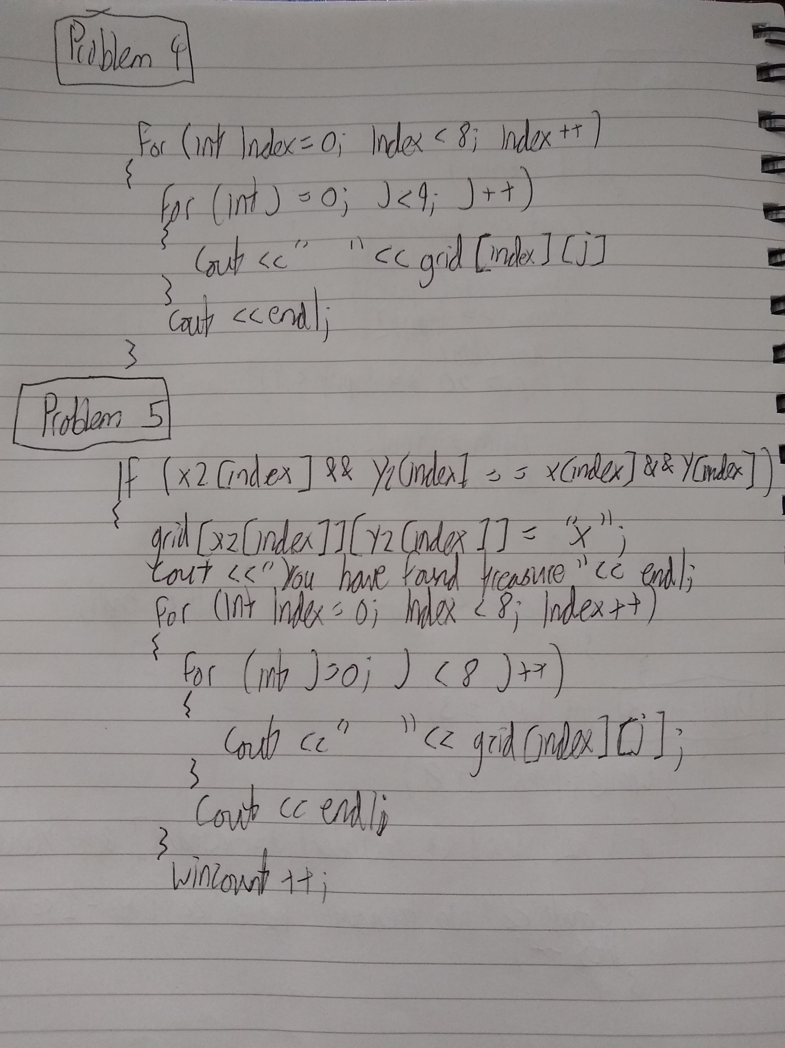

This exercise spent a long time in development and it went through many stages. In the first stages the code looked like this,
stringstream stream;
string input;
int index = 0;
int x;
int y;
string grid[9][9] =
{
{"0", "1", "2", "3", "4", "5", "6", "7", "8" },
{"1", "-", "-", "-", "-", "-", "-", "-", "-" },
{"2", "-", "-", "-", "-", "-", "-", "-", "-" },
{"3", "-", "-", "-", "-", "-", "-", "-", "-" },
{"4", "-", "-", "-", "-", "-", "-", "-", "-" },
{"5", "-", "-", "-", "-", "-", "-", "-", "-" },
{"6", "-", "-", "-", "-", "-", "-", "-", "-" },
{"7","-", "-", "-", "-", "-", "-", "-", "-" },
{"8", "-", "-", "-", "-", "-", "-", "-", "-" },
};

int treasureGrid[9][9] =
{
{0,1,2,3,4,5,6,7,8},
{1,0,0,0,0,0,0,0,0},
{2,0,0,0,0,0,0,0,0},
{3,0,0,0,0,0,0,0,0},
{4,0,0,0,0,0,0,0,0},
{5,0,0,0,0,0,0,0,0},
{6,0,0,0,0,0,0,0,0},
{7,0,0,0,0,0,0,0,0},
{8,0,0,0,0,0,0,0,0},
};

cout << "Player one place your treasure" << endl;
for (int index = 0; index < 3; index++)
{
x[index] = Gridinput("Enter X: ");
y[index] = Gridinput("Enter Y: ");
}
Grid input was a function created to ask the first player to input co-ordinates for the int treasure grid. Then the grid would display with the number 1 in the place of the inputted co-ordinates. This was the first step as it showed that co-ordinates could be correctly inputted onto a grid. The grid values were changed from [8] [8] to [9] [9] this was primarily to add an x and y number grid along the top and left side. By doing this the author hoped that it would make the co-ordinates easier to understand and input for the user. However this also added some interesting results to the input validation method.
For input validation two things were necessary, no letters and no negative numbers. Not inputting anything or just pressing enter was also a concern; however it wasn’t as big a deal as the first two. The input validation for the grid came in the form of an “if” statement and a range check between the numbers of 0 and 9. In code form the validation looked like this,

if (input2 > 0 && input2 < 9)
{
//If they have it stores it in the num variable
num = input2;
//This returns num so it can be used in other functions
return num;
}

For some reason the use of 0 as a condition stops letters from being inputted. This may be because you can’t compare a letter to 0? This also prevents the user from just pressing the enter button. This was an unexpected result but it saved the author a lot of trouble.
The next stage of development was creating a function for player one to input their chosen grid numbers. The function was made an int because it had to return a value. This would allow player one to input their chosen co-ordinates which would then be stored on the grid. This along with the input validation would complete the function. In code it looks something like this,
//This is player ones input for the int grid
int Gridinput(string message)
{
stringstream stream;
string input;
int num;
//Using a bool to keep the while loop running
bool check = true;
int input2 = 0;

//This loop will keep running until a break occurs
while (true)
{
//This will display any message written by the author
cout << message;
//This gets the users input
getline(cin, input);
stream.str(input);
//This line stores it in the variable input2
stream >> input2;
stream.clear();
//This checks if the user has entered a number between the values of 0 and 9
if (input2 > 0 && input2 < 9)
{
//If they have it stores it in the num variable
num = input2;
//This returns num so it can be used in other functions
return num;
}

//This else statement triggers when the conditions of the if statement weren't met
else
{
//Displays this message and the user has to enter another input
cout << "Not a valid input" << endl;
}
}
By using a bool variable the while loop will keep running until a specified action causes it to stop. In this case inputting a number greater than 9 or less than 0 as well as letters, will cause the loop to stop. Also if all six co-ordinate numbers are inputted the loop will stop, this would also be checked by the “if” statement. If the input is valid it’ll be stored in a new variable called num, after that it’ll be returned for use in another function.

Calling the function for player ones inputs and then storing then into two arrays, x [3] and y [3], was also a key part of the exercise. In code form it looked like this,

for (int index = 0; index < 3; index++)
{
//This line means that the input from the gridinput function will be stored in x and y
x[index] = Gridinput("Enter an X value between 1 - 8: ");
y[index] = Gridinput("Enter a Y value between 1 - 8: ");
}

A simple for loop that looped three times was enough to get all six inputs and store then correctly.

Then player two inputs were need, however the author did not make it a function. In code it looked like this,

//This loop will continue until the lives variable is equal to 0
while (lives != 0)
{
//This asks player two to enter a value between 1 and 8
cout << "Player two guess, values are between 1 - 8" << endl;
//Asks the user for X value
cout << "X: ";
//This gets the users input
getline(cin, input);
stream.str(input);
//This stores the inputs in x2 array
stream >> x2[index];
stream.clear();
//Asks the user for Y value
cout << "Y: ";
//This gets the users input
getline(cin, input);
stream.str(input);
//This stores the inputs in y2 array
stream >> y2[index];
stream.clear();

The while loop made sure that as long as player twos lives weren’t the same as 0 it would keep going. The author also made use of two new arrays x2[3] and y[3].

The next challenge in development was printing out the grid. Two for loops were required but this was unknown to the author at the time. After the author had figured out how to correctly display the grid the code for it looked like this,

for (int index = 0; index < 9; index++)
{
for (int j = 0; j < 9; j++)
{
cout << " " << grid[index][j];
}
cout << endl;
}

The first loop prints out the y axis while the second prints out the x axis. The loop will stop after nine times, which is the number of each row and column. Grid [index] [j] is what displays the string grid. By adding these lines,

if (x2[index] && y2[index] == x[index] && y[index])
{
//This line will make an X appear on the grid at the x2 and y2 input
grid[x2[index]][y2[index]] = "X";
cout << "You have found treasure" << endl;

The author can make the grid display an “X” if the x2, y2 and the x, y co-ordinates match, or an “N” if they don’t. This was the most challenging part of the exercise, but also the most rewarding.

Towards the end of the exercise the author noticed that some form or win or loss validation was required. Either player one or player two had to win the game, player one wins by keeping three treasures hidden and player two wins by finding them. The solution to this was two new “if” statements, in code they looked like this,

if (wincount == 3)
{
cout << "Player two has found all the treasures!, player two wins" << endl;
break;
}
if (lives == 0)
{
cout << "You are out of lives, player one wins" << endl;
break;
}

With these two new statements the author could successfully end the game if player twos win count was the same as 3 or if player twos lives were the same as 0. These were kept in check by using two new variables, int lives and int wincount. At the end of each for loop a small line of code would be added. If player two guessed correctly the line under the grid display loop would be wincount++. However if they guessed wrong the line would be lives--.
These would add, ++, or subtract, --, 1 from each variable. They would then trigger the “if" statements, display the outcome and then end the game.

For the first test the user inputted a letter instead of a number. The author expected that the programme would reject the input. It would then hopefully ask the user for a valid one. The expected result would be that the message “not a valid input” would display. The actual result was that the programme displayed the “not a valid input” message. This test was a success.
For the second test the author inputted the values 0 and 9. Since these were both out of the specified range, the expected result would be for them to be rejected. The actual result for this test was the programme displaying the “not a valid input” message. This test was a success.
For the third test the author inputted a negative value, -1, into the programme. This was out of the range specified in the “if” statement. That meant that the expected result would be that the programme would reject the value. The actual result was that the programme displayed the “not a valid input” message. Therefore this test was a success.
Fir the final test the author just pressed the enter button when asked to input values. The expected result was that the programme would reject the value and ask for a new one. The actual result was that the programme displayed the “not a valid input” message. This test was a success.

Appendix

#include <iostream>
#include <string>
#include <sstream>

using namespace std;
//This displays the int grid for player one
void GridDisplay(int grid[][9])
{
//This for loop will display the grids y co-ords up to 9
for (int y = 0; y < 9; y++)
{
//This for loop will display the grids x co-ords up to 9
for (int x = 0; x < 9; x++)
{
//This will display the final grid
cout << grid[y][x];
}
cout << endl;
}
}
//This is player ones input for the int grid
int Gridinput(string message)
{
stringstream stream;
string input;
int num;
//Using a bool to keep the while loop running
bool check = true;
int input2 = 0;

//This loop will keep running until a break occurs
while (true)
{
//This will display any message written by the author
cout << message;
//This gets the users input
getline(cin, input);
stream.str(input);
//This line stores it in the variable input2
stream >> input2;
stream.clear();
//This checks if the user has entered a number between the values of 0 and 9
if (input2 > 0 && input2 < 9)
{
//If they have it stores it in the num variable
num = input2;
//This returns it so it an be used in other functions
return num;
}
//This else statement triggers when the conditions of the if statement weren't met
else
{
//Displays this message and the user has to enter another input
cout << "Not a valid input" << endl;
}
}
}
void Treasuregame()
{
stringstream stream;
string input;
int index = 0;
//Using arrays for x,y,x2 and y2 to store multiple values
int x[3];
int y[3];
int x2[3];
int y2[3];
//Using a lives variable to keep track of life count
int lives = 3;
//Using a wincount varialbe to keep track of correct guesses
int wincount = 0;
//This string grid is used for player two, so they can see the co-ordinates
string grid[9][9] =
{
{"0", "1", "2", "3", "4", "5", "6", "7", "8" },
{"1", "-", "-", "-", "-", "-", "-", "-", "-" },
{"2", "-", "-", "-", "-", "-", "-", "-", "-" },
{"3", "-", "-", "-", "-", "-", "-", "-", "-" },
{"4", "-", "-", "-", "-", "-", "-", "-", "-" },
{"5", "-", "-", "-", "-", "-", "-", "-", "-" },
{"6", "-", "-", "-", "-", "-", "-", "-", "-" },
{"7","-", "-", "-", "-", "-", "-", "-", "-" },
{"8", "-", "-", "-", "-", "-", "-", "-", "-" },
};
//This int grid is used for player one, so they can place thier treasure
int treasureGrid[9][9] =
{
{0,1,2,3,4,5,6,7,8},
{1,0,0,0,0,0,0,0,0},
{2,0,0,0,0,0,0,0,0},
{3,0,0,0,0,0,0,0,0},
{4,0,0,0,0,0,0,0,0},
{5,0,0,0,0,0,0,0,0},
{6,0,0,0,0,0,0,0,0},
{7,0,0,0,0,0,0,0,0},
{8,0,0,0,0,0,0,0,0},
};
//This message asks player one to enter an input
cout << "Player one place your treasure" << endl;
//This loop will run 3 times to store 3 variables in x and y
for (int index = 0; index < 3; index++)
{
//This line means that the input from the gridinput function will be stored in x and y
x[index] = Gridinput("Enter an X value between 1 - 8: ");
y[index] = Gridinput("Enter a Y value between 1 - 8: ");
}
//This prints out 40 new lines, so that player two cant see player ones inputs
cout << string(40, '\n');
//This loop will continue until the lives variable is equal to 0
while (lives != 0)
{
//This asks player two to enter a value between 1 and 8
cout << "Player two guess, values are between 1 - 8" << endl;
//Asks the user for X value
cout << "X: ";
//This gets the users input
getline(cin, input);
stream.str(input);
//This sotres the inputs in x2 arary
stream >> x2[index];
stream.clear();
//Asks the user for Y value
cout << "Y: ";
//This gets the users input
getline(cin, input);
stream.str(input);
//This sotres the inputs in y2 arary
stream >> y2[index];
stream.clear();
//This if statement will trigger if x2 and y2 are the same inputs as x and y
if (x2[index] && y2[index] == x[index] && y[index])
{
//This line will make an X appear on the grid at the x2 and y2 input
grid[x2[index]][y2[index]] = "X";
//Displays the message
cout << "You have found treasure" << endl;
//This for loop will display the grids y co-ords up to 9
for (int index = 0; index < 9; index++)
{
//This for loop will display the grids x co-ords up to 9
for (int j = 0; j < 9; j++)
{
//This displays the string grid
cout << " " << grid[index][j];
}
cout << endl;
}
//The wincount variable gets increased by 1
wincount++;
}
//This if statement will trigger if x2 and y2 are not the same inputs as x and y
if (x2[index] && y2[index] != x[index] && y[index])
{
//This line will make an N appear on the grid at the x2 and y2 input
grid[x2[index]][y2[index]] = "N";
//Displays the message, also shows the current amount of lives player two has
cout << "No treasure here, you have " << lives - 1 << " lives remaining" << endl;
//This for loop will display the grids y co-ords up to 9
for (int index = 0; index < 9; index++)
{
//This for loop will display the grids x co-ords up to 9
for (int j = 0; j < 9; j++)
{
//This displays the string grid
cout << " " << grid[index][j];
}
cout << endl;
}
//The lives variable gets decreased by 1
lives--;
}
//This if statement triggers if the win count is the same as 3
if (wincount == 3)
{
//Displays the message
cout << "Player two has found all the treasures!, player two wins" << endl;
//This breaks the loop, ending the game
break;
}
//This if statement triggers if the lives is the same as 0
if (lives == 0)
{
//Displays the message
cout << "You are out of lives, player one wins" << endl;
//This breaks the loop, ending the game
break;
}
}
}

int main(int argc, char *argv[])
{
//This calls the treasuregame function and runs it
Treasuregame();

cin.get();
return 0;
}

