Business Report-Comparison of Two Hospitality Organisations

Student Name: Roxana Isabela Fodor
Student ID: 2123083
Module: Financial Management for the Hotel Industry
Module code: BMIH 5007
Lecturer name: Tristan Hawkins
Executive summary
The below report has prepared a detailed understanding regarding analysing the financial performances of the two most reputed companies of the UK named. Mandarin Oriental Hotel Group and Premier Inn. Both companies belong to the Hotel UK's hotel industry whose revenue earning capacity has been addressed by critically evaluating their statement of finances. Moving ahead, the comparison among both the businesses identifying their market position and all have been added. There are some of the most essential factors for both businesses highlighting their growth potential. In addition to this, the CSR as well as financial commitment of mentioned entities has been introduced in an effective manner.

Table of Contents
Introduction 4
Critically examining the total revenue of both the business Mandarin Oriental Hotel Group and Premier Inn 5
Revenue of Mandarin Oriental Hotel Group 5
Highlighting the marketing position of Market Position of Mandarin Oriental Hotel Group and Premier Inn 7
Marketing position of Mandarin Oriental Hotel Group 7
Marketing position of Premier Inn 7
Detecting the growth potential of the Market Position of Mandarin Oriental Hotel Group and Premier Inn 9
Assessing the growth potential for Mandarin Oriental Hotel Group 9
Assessing the growth potential for Premier Inn 9
Understanding the CSR activities of the Market Position of Mandarin Oriental Hotel Group and Premier Inn 11
Financial and CSR commitment of Mandarin Oriental Hotel Group 11
Financial and CSR commitment of Premier Inn 11
Conclusion 13
References 14
Appendix 16

Introduction
The concept of financial management is referred to as one of the most essential and critical tasks that needs to be completed by any type of business organisation for the sake of avoiding financial obligation and presenting their financial report in an effective manner. A company's success mainly depends on its financial activities. Hence, this section below is going to develop a detailed comparison of two different companies from the hotel industry which are Mandarin Oriental Hotel Group and Premier Inn. In order to develop the comparison it will examine various factors of both the companies to analyse their financial performances. This will include total revenue, position within the market, factors of growth potential and CSR commitment.

Critically examining the total revenue of both the business Mandarin Oriental Hotel Group and Premier Inn

Revenue of Mandarin Oriental Hotel Group
Revenue of the companies:
Budget hotel chain Premier Inn Hotels Limited has presented its financial statement for the monetary year that ended on February 27, 2020. In comparison to the £905.1 million in income from the prior year, the organisation reported an overall profit of £911.5 million. its profit before taxes was £163.1 million, while its operational profit was £266.5 million. Despite some revisions, these numbers show a steady rise in both sales and profitability during the year. Premier Inn, on the other hand, had a noticeable improvement in the way it made money. Whitbread's pre-tax profits for its fiscal year ending on March 3 saw a tremendous increase, hitting £375 million, which marked an enormous turnaround from the £58 million achieved in 2022, according to an official statement (whitbread, 2020). The pandemic-related slowdown in the global hospitality business is the main reason for the loss in the Mandarin Oriental Hotel Group's revenue in 2020, which dropped to $0.18 billion. However, in 2021 and 2022, the business's sales bounced back, hitting $0.31 billion and $0.45 billion, respectively, indicating a significant recovery and growth tendency (companiesmarketcap, 2022).
Sources of revenues of the mentioned businesses:
The majority of Premier Inn Hotels Limited's revenue comes from guests who reserve rooms, pay for lodging, and purchase ancillary services in the hotel business. Their on-site restaurants and other services can also bring in money. Their financial documents show an increase in revenue, which shows that consumer demand is rising. The parent company of Premier Inn, Whitbread, uses a variety of business models. In addition to managing hotels, Whitbread also oversees a number of restaurant brands, including Beefeater, Bar & Block, and Brewers Fayre, which also generates revenue for the company (whitbread, 2020). Whitbread recently put plans into place to fight rising costs, including as raising hotel rates and better diversifying its revenue streams.
Revenue trends of the businesses and factors that are driving change in the revenue earning process:
With revenues totalling £911.5 million, Premier Inn Hotels Limited's 2020 financial statement showed sustained revenue growth. The company's measurement, which allowed it to survive as smaller competitors struggled with shortages of employees and growing expenses, and the rise in demand for budget-conscious tourists were the main drivers of this success (Atrill, 2021). Premier Inn's parent business, Whitbread, saw impressive sales growth. Pre-tax revenues soared to £375 million in 2023 from £58 million in 2022, a 34% rise over the year concluding in February of that same year. This gain was influenced by a strong demand, higher hotel rates to combat inflation, greater occupancy rates, growing the company, and higher beverages along with food revenues (companiesmarketcap, 2022).

Highlighting the marketing position of Market Position of Mandarin Oriental Hotel Group and Premier Inn

Marketing position of Mandarin Oriental Hotel Group
With a market valuation of $1.99 billion, the specific business Group has made a name for itself as a high-end, luxury hospitality brand and belongs to the top tier of the hotel sector. The company's main goal is to give discriminating and wealthy guests opulent and unique experiences. Its significant revenue rise of 43% in 2022 over the previous year emphasises its appeal to this upscale market (mandarinoriental, 2023). The reputation of the Mandarin Oriental for refinement and first-rate service is well known. It is well known for its first-rate service, fine food, and opulent rooms, all of which are catered to a wealthy clientele looking for exceptional vacation experiences. It's crucial to remember that the net loss in 2022, despite being lower than the year before, reflects the difficulties suffered by upscale lodgings following the COVID-19 pandemic. As a result of the company's market positioning, which centres on confidentiality, refinement, and a dedication to the uppermost standards, it is an aspirational choice for people ready to splurge on a high-end travel encounter (Walker, 2021).

Marketing position of Premier Inn
Premier Inn markets itself as a budget-friendly and value-oriented hotel chain. Premier Inn has a 12% market share and 42% of all hotel guests in the UK choose it, solidifying its position as the top choice for both business and leisure travellers (Bhimani, 2006). The brand's main advantages are its stability, affordability, and dependability, which constantly place well in consumer brand choice surveys. A wide range of consumers is catered to by Premier Inn, which emphasises cost without sacrificing quality (statista, 2016). Its strong financial results, which include an important rise in pre-tax earnings, show that it has been successful in snatching up a sizeable share of the mid-range and price-conscious market. The company's peak days serve both leisure customers on weekends as well as those travelling for work during the week, highlighting its adaptability and attractiveness to a variety of clientele. Because of its reputation for pragmatism, Premier Inn is a dependable option for travellers on a tight budget without sacrificing comfort, sanitation, or service quality (Guilding, 2014).
Detecting the growth potential of the Market Position of Mandarin Oriental Hotel Group and Premier Inn

Assessing the growth potential for Mandarin Oriental Hotel Group
The luxury hospitality industry's well-known brand Mandarin Oriental has substantial room for growth. The company may take advantage of the expanding worldwide affluence and demand for upscale vacation experiences (Seal, 2019). In order to do this, they might think about entering developing nations, especially Asia, in order to capitalise on the growing demand for luxury travel among the middle class. Their brand visibility and offerings may be strengthened further by investigating partnerships and collaborations. Targeting newer groups such as younger, wealthy visitors who desire upscale experiences offers opportunities in the industry. In addition to that, Mandarin Oriental can find a niche market by catering to the demand for environmentally friendly and sustainable travel (Jagels, 2007). The luxury hotel industry is becoming more competitive, economic downturns may influence its target audience's purchasing power, and it may be difficult to get premium real estate for new properties, among other possible barriers to growth. There are dangers associated with ongoing global health problems, such as the COVID-19 pandemic's effects. The potential for expansion of Mandarin Oriental is increased by its powerful, iconic brand image. In order to adjust to shifting customer demands, the business has room to consider investigating novel approaches like health and sustainability programs (Seal et al., 2008).

Assessing the growth potential for Premier Inn
The solid market position and reputation of Premier Inn contribute to its positive growth prospects. Expansion tactics could involve furthering a company's entry into other markets, particularly those in Europe, by relying on that region's successful model of offering affordable but excellent lodging. Growth can also be stimulated by embracing advances in technology and online platforms to improve client experiences as well as streamline processes (Tranter et al., 2014). As tourists on a tight budget look for reputable and economical solutions outside of the UK, there are several market prospects. In order to broaden its reach, Premier Inn can look into joint ventures with airlines, tour companies, and online travel agencies. Economic turbulence that affects spending by customers, foreign market regulatory obstacles, and rivalry from regional budget hotel chains can all operate as growth inhibitors. In addition to this, constantly changing traveller tastes and technology disruptions might be necessary (Drury, 2021). Due to its established UK presence and devoted customer base, Premier Inn has enticing development potential. Entering foreign markets could present significant potential, particularly in regions where there is a great need for reasonably priced lodging.

Understanding the CSR activities of the Market Position of Mandarin Oriental Hotel Group and Premier Inn

Financial and CSR commitment of Mandarin Oriental Hotel Group
Mandarin Oriental has shown a substantial financial dedication to CSR initiatives, highlighting its deep dedication to long-term sustainability, involvement in the community, along ethical business methods. The company has undertaken a number of sustainability efforts, including as cutting back on water and energy use, minimising trash, and implementing eco-friendly technologies across all of its locations. In terms of involvement in the community, Mandarin Oriental regularly promotes philanthropic activities. Through their "Fans of M.O." initiative, which invites visitors to give during reservations with the money going to charitable causes, they demonstrate their dedication to social responsibility (mandarinoriental, 2023). The respective company also interacts with the neighbourhood through volunteer initiatives and relationships with nonprofits. One of the pillars of Mandarin Oriental's company values is ethical business conduct. In order to ensure the highest principles of business conduct, ranging from procurement to employment practices, they have created strict ethical codes and procedures. Their partnerships with businesses and suppliers who hold comparable principles demonstrate their dedication to doing business ethically.

Financial and SR commitment of Premier Inn
The largely low-cost hotel chain Premier Inn has made significant financial contributions to CSR programs. The stated business organisations have made investments in sustainable practices, paying special attention to minimizing their negative environmental effects. Their commitment to ethical environmental practices is demonstrated by these initiatives, which also include trash minimization programs along with energy-efficient building designs. A further area where Premier Inn has demonstrated dedication is community involvement. They have taken part in numerous community initiatives, including assisting local charities and schools. Their affiliation with the Great Ormond Street Hospital Children's Charity demonstrates their commitment to promoting social justice (premierinn, 2023). When it comes to ethical company procedures, Premier Inn prioritizes the welfare of its employees, including measures to advance acceptance and diversity, ethical purchasing, and educational opportunities for staff members. Their financial support includes maintaining a just and moral environment for partners and employees. In conclusion, Premier Inn's attention to CSR initiatives often associated with low-cost lodging reflects its steadfast commitment to sound ethical and accountable business practices.

Conclusion
Two well-known companies, Premier Inn and Mandarin Oriental Hotel Group, were thoroughly examined in the above report. It included a range of topics, including as their competitive positioning, development prospects, and level of financial support for Corporate Social Responsibility or CSR programs. According to the report, Premier Inn is positioned as a budget-friendly dependable hotel chain that serves a wider range of customers, whereas Mandarin Oriental targets affluent tourists seeking exclusivity and luxury. Both businesses displayed promising growth possibilities, with Mandarin Oriental concentrating on high-end travellers as well as Premier Inn growing its footprint, particularly abroad. The report also looked at how much money each company spends on CSR projects. Mandarin Oriental established an effective link between its luxury brand including ethical social and environmental campaigns by demonstrating its dedication to sustainability, community involvement, and business ethics. Premier Inn demonstrated commitment to environmental sustainability, community development, as well as ethical business practices despite its major concentration on low-cost accommodations.

References
Atrill P, McLaney E (2021) Management Accounting for Decision Makers, FT Prentice Hall
Bhimani A, (Ed) (2006) Contemporary Issues in Management Accounting, Oxford
Companies marketcap, (2022). Revenue history for Mandarin Oriental from 2001 to 2022. [Online] Available at: https://companiesmarketcap.com/mandarin-oriental/revenue/ [Accessed 12 October 2023].
Drury C (2021) (11th Ed) Management and Cost Accounting, London, Prentice Hall
Guilding, C.(2014) (3rd Edition) Accounting Essentials for Hospitality Managers, London, Routledge
Jagels, M. (2007) Hospitality Management Accounting, London, Wiley.
Mandarin oriental, (2023). Share Information. [Online] Available at: https://www.mandarinoriental.com/en/investors/share-information [Accessed 13 October 2023].
Mandarin oriental, (2023). Sustainability. [Online] Available at: https://www.mandarinoriental.com/en/our-company/sustainability [Accessed 13 October 2023].
premier inn, (2023). We're a Force for Good. [Online] Available at: https://www.premierinn.com/gb/en/why/force-for-good.html [Accessed 13 October 2023].
Seal W (2019) (6th Ed) Management Accounting, London, McGraw Hill
Seal W, Garrison RH, Noreen E (2008) Management Accounting, McGraw Hill
statista, (2016). Premier Inn's share of hotel rooms in the total hotel market in the United Kingdom (UK) from 2011 to 2021. [Online] Available at: https://www.statista.com/statistics/755691/premier-inn-share-of-hotel-market-rooms-united-kingdom-uk/ [Accessed 12 October 2023].
Tranter,K. Stuart-Hill,T. Parker,J. (2014) Introduction to Revenue Management for the Hospitality Industry, London, Pearson
Walker J (2021) Introduction to Hospitality, Harlow, Pearson
whitbread, (2020). Premier Inn Hotels Limited. [Online] Available at: https://cdn.whitbread.co.uk/media/2021/02/12122648/pihl-accounts-final-signed.pdf [Accessed 12 October 2023].

Appendix
Premier Inn Ltd.
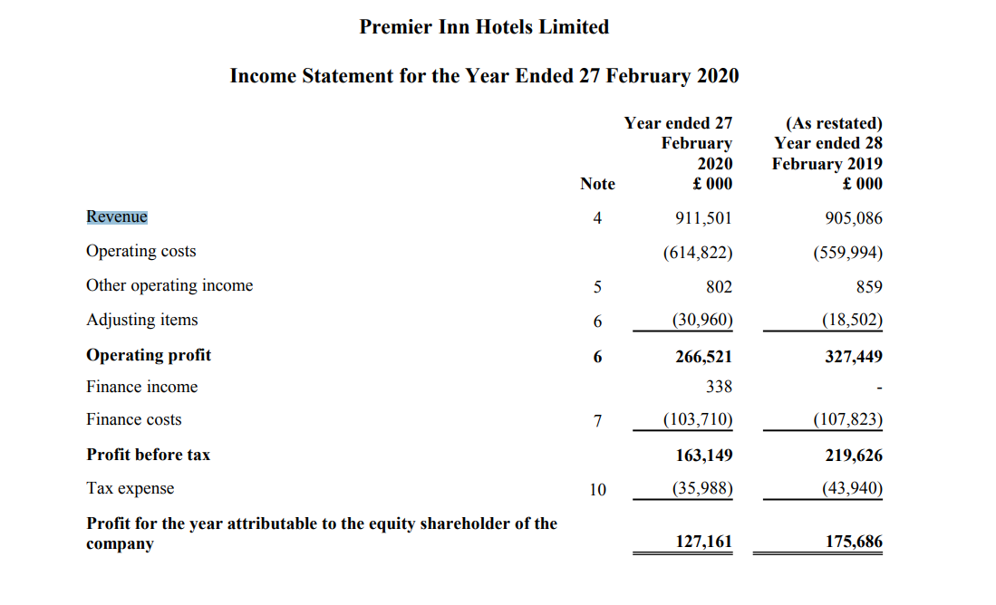
Figure 1- Income statement of Premier Inn Hotels Ltd.
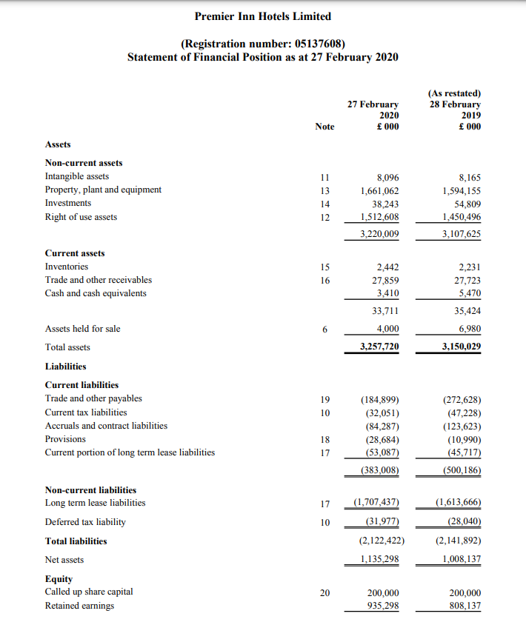
Figure 2- Balance sheet of Premier Inn
Mandarin Oriental Hotel Group
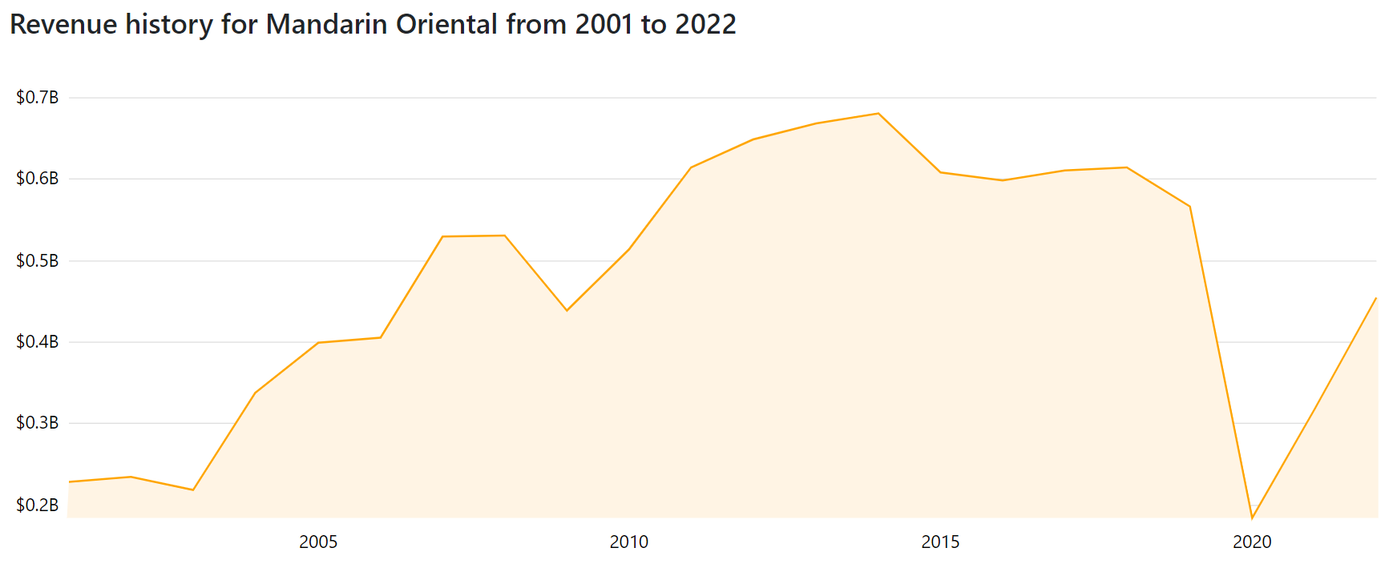
Figure 3- Revenue

